UNIVERSITY OF THE WEST INDIES

Department of Physics

PHYSICS LABORATORY REPORT

Electromotive Force and Internal Resistance of a Cell

Name: | Student Name
Student ID: | XXXXXXX
Course: | BSc Mathematics and Computer Science
Lab Partner: | Lab Partner Name
Date Performed: | April 2026
Date Submitted: | May 2, 2026
Instructor: | Dr. Instructor Name

Electromotive Force and Internal Resistance of a Cell

Abstract
This experiment determined the electromotive force (EMF) and combined internal resistance (Rc + Ra) of a dry cell by measuring the circuit current at ten different values of external resistance, ranging from 20 Ω to 200 Ω. The governing equation ε = I(R + Rc + Ra) was rearranged to the linear form R = ε(1/I) − (Rc + Ra), and a graph of external resistance R (y-axis) against the reciprocal of current 1/I (x-axis) was plotted. The best-fit straight line yielded an EMF of ε = 1.2965 V from the slope and a combined internal and ammeter resistance of Rc + Ra = 2.0626 Ω from the negative R-intercept, with a coefficient of determination R² = 0.9740. An alternative terminal voltage analysis corroborated the EMF estimate at 1.3281 V. The results are consistent with a standard 1.5 V dry cell showing partial discharge.

1. Objectives
The objectives of this experiment are:
- To determine the electromotive force (EMF) ε of a dry cell by graphical analysis.
- To determine the combined internal resistance Rc + Ra of the cell and ammeter from the same graph.
- To verify the linear relationship R = ε(1/I) − (Rc + Ra) derived from Kirchhoff's Voltage Law.
- To compare the graphical result with an alternative terminal voltage method.
- To assess the sources of error and estimate the accuracy of the determined EMF and internal resistance.

2. Theory

2.1 Electromotive Force (EMF)
The electromotive force (EMF), denoted ε, is not a force in the mechanical sense but the total energy supplied by the cell per unit charge driven around the complete circuit. It represents the work done by the cell in moving one coulomb of charge through the circuit, including through itself:
ε = W / Q
where W is the work done (joules) and Q is the charge (coulombs). EMF is measured in volts (V) and is a fixed property of the cell determined by the electrochemical reactions within it, independent of the external circuit.

2.2 Internal Resistance
A real cell is not ideal — its electrolyte and electrodes possess their own resistance, called the internal resistance Rc. When current flows, a voltage is lost internally:
V_lost = I × Rc
The terminal voltage V (the voltage available to the external circuit) is therefore less than the EMF whenever current is drawn:
V = ε − I(Rc + Ra)
where Ra is the resistance of the ammeter (in series with the cell). The terminal voltage equals the EMF only when no current flows (open circuit). As current increases (external resistance decreases), the terminal voltage falls due to increased internal voltage drop.

2.3 Governing Equation and Linearisation
Let ε be the EMF, Rc the internal resistance of the cell, Ra the ammeter resistance, R the external resistance, and I the circuit current. Applying Kirchhoff's Voltage Law around the circuit:
ε = I(R + Rc + Ra)
Solving for R and rearranging into the standard linear form y = mx + c:
R = ε × (1/I) − (Rc + Ra)
This is a straight-line equation with:
- y = R (external resistance, Ω)
- x = 1/I (reciprocal of current, A⁻¹)
- slope m = ε (EMF of the cell, V)
- y-intercept c = −(Rc + Ra) (negative of combined internal resistances, Ω)
A graph of R against 1/I therefore allows both ε and (Rc + Ra) to be determined simultaneously from a single straight-line fit without requiring an ideal ammeter or known internal resistance.

2.4 Terminal Voltage Method (Alternative)
Rearranging ε = I(R + Rc + Ra) gives the terminal voltage V = IR as:
V = ε − I(Rc + Ra)
This is again a straight line, this time with V on the y-axis and I on the x-axis. The y-intercept gives ε (open-circuit voltage) and the gradient gives −(Rc + Ra). This method provides an independent check on the primary R vs 1/I analysis.

2.5 Kirchhoff's Voltage Law (KVL)
KVL states that the algebraic sum of all potential differences around any closed loop in a circuit is zero. Applied to the series circuit (cell, ammeter, external resistor):
ε − I×Rc − I×Ra − I×R = 0 ⟹ ε = I(R + Rc + Ra)
This is the foundational equation from which all the experimental analysis is derived.

2.6 Conservation of Energy
The total power delivered by the cell equals the sum of power dissipated internally and power delivered to the external circuit:
P_total = ε × I = I²(Rc + Ra) + I²R
The efficiency of energy delivery to the external load is η = I²R / (εI) = IR/ε = V/ε. As the external resistance R decreases relative to Rc + Ra, efficiency falls and more energy is wasted internally.

2.7 Maximum Power Transfer
Maximum power is delivered to the external resistance when R = Rc + Ra (matched load condition). At this point:
P_max = ε² / (4(Rc + Ra))
Based on the experimental values, maximum power transfer occurs at R = 2.06 Ω with a predicted maximum external power of 203.74 mW.

3. List of Apparatus
Item | Specification | Quantity
Dry Cell | Standard 1.5 V dry cell | 1
Ammeter | Milliammeter (0–100 mA range); resistance Ra noted from demonstrator | 1
Resistance Box | Variable resistor, 0–999 Ω in 1 Ω steps | 1
Circuit Key (Switch) | Single-pole on/off switch | 1
Connecting Wires | Insulated copper leads | Several

4. Procedure

4.1 Circuit Diagram
The circuit was assembled in series: the dry cell, circuit key, ammeter, and resistance box were connected end-to-end as shown below. No voltmeter was required as voltages were inferred from measured R and I values.

Cell (+) ──── Switch (Key) ──── Ammeter (A) ──── Resistance Box (R) ──── Cell (−)

Figure 1: Series circuit for EMF and internal resistance determination

4.2 Experimental Method
Before taking any readings, all plugs in the resistance box were given a half turn to ensure proper contact, minimising stray resistance. The ammeter was checked for zero error and re-zeroed using the adjustment screw where necessary. The ammeter resistance Ra was obtained from the laboratory demonstrator.

The resistance box was initially set to 200 Ω. The circuit key was closed and the current reading on the ammeter was recorded. The resistance was then decreased in steps of 20 Ω down to 20 Ω, with the current recorded at each setting. Ten readings were obtained in total. The circuit key was opened between readings to prevent unnecessary battery discharge. Care was taken to ensure the current never exceeded approximately 0.1 A (100 mA) to protect the resistance box and avoid significant battery polarisation.

4.3 Graphical Analysis
The reciprocal of each current reading (1/I) was calculated. A graph of R (y-axis) against 1/I (x-axis) was plotted. The best-fit straight line was drawn through the data points. The EMF was determined from the slope of the line, and the combined internal resistance (Rc + Ra) was determined from the magnitude of the negative R-axis intercept (where 1/I = 0, i.e., extrapolation to infinite current). An alternative terminal voltage graph (V = IR vs I) was also plotted as a cross-check.

5. Data Presentation and Results

5.1 Raw Data and Derived Quantities
Table 1 presents the raw resistance and current readings, together with the computed reciprocal current (1/I) and terminal voltage (V = IR) for each reading.

Table 1: Measured Resistance, Current and Derived Quantities

Reading | R (Ω) | I (mA) | I (A) | 1/I (A⁻¹) | V = IR (V) | I_pred (mA)
1 | 20 | 54 | 0.0540 | 18.5185 | 1.0800 | 58.8
2 | 40 | 30 | 0.0300 | 33.3333 | 1.2000 | 30.8
3 | 60 | 20 | 0.0200 | 50.0000 | 1.2000 | 20.9
4 | 80 | 16 | 0.0160 | 62.5000 | 1.2800 | 15.8
5 | 100 | 12 | 0.0120 | 83.3333 | 1.2000 | 12.7
6 | 120 | 10 | 0.0100 | 100.0000 | 1.2000 | 10.6
7 | 140 | 10 | 0.0100 | 100.0000 | 1.4000 | 9.1
8 | 160 | 8 | 0.0080 | 125.0000 | 1.2800 | 8.0
9 | 180 | 8 | 0.0080 | 125.0000 | 1.4400 | 7.1
10 | 200 | 6 | 0.0060 | 166.6667 | 1.2000 | 6.4
Note: I_pred is the current predicted by the model I = ε/(R + Rc + Ra) using the experimentally determined ε = 1.2965 V and Rc+Ra = 2.0626 Ω.

5.2 Graphs
Graph 1: R vs 1/I — Primary Analysis (per lab manual)
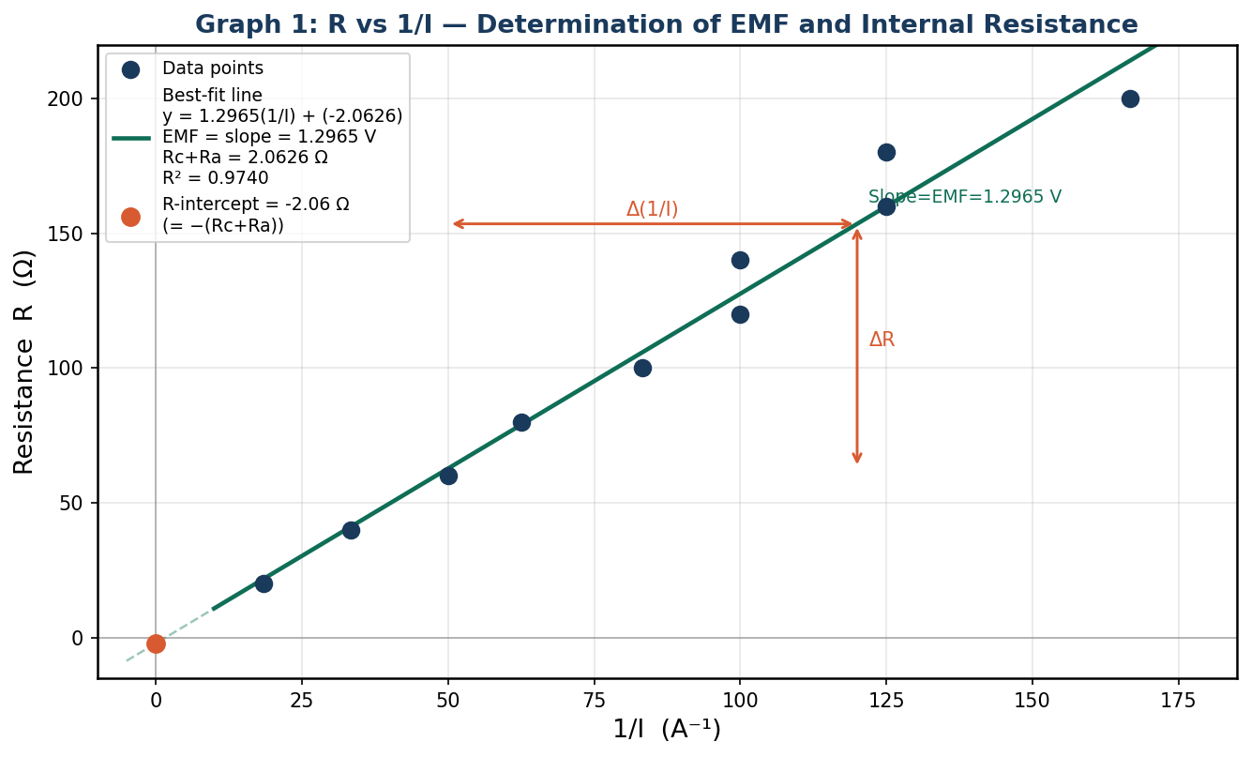
Graph 1: External resistance R (Ω) vs reciprocal current 1/I (A⁻¹). Slope = ε = 1.2965 V. R-intercept = −(Rc+Ra) = -2.06 Ω. R² = 0.9740.
Graph 2: Terminal Voltage vs Current — Alternative Analysis
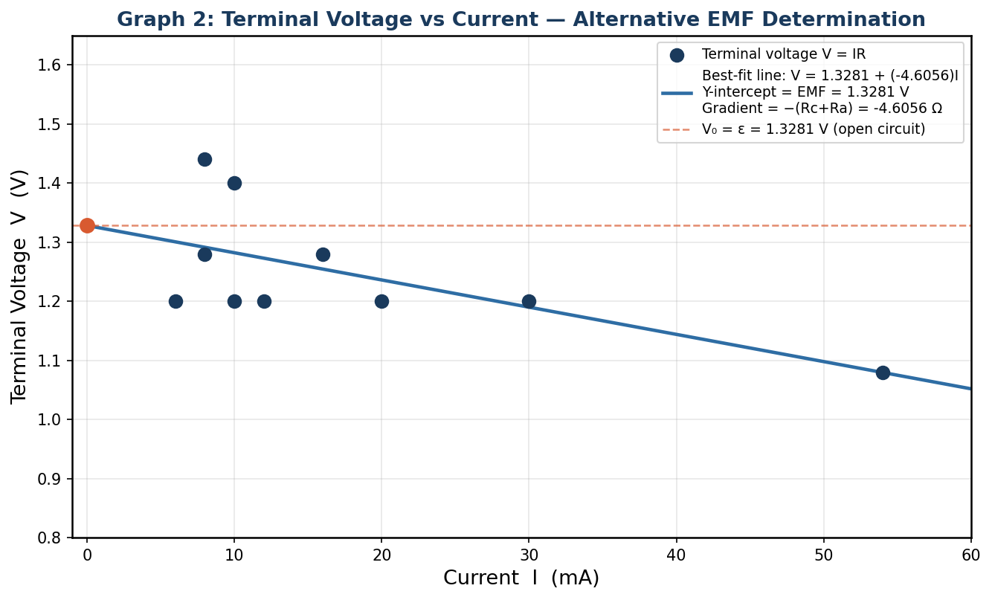
Graph 2: Terminal voltage V = IR (V) vs current I (mA). Y-intercept = ε = 1.3281 V. Gradient = −(Rc+Ra) = 4.61 Ω.
Graph 3: Current vs External Resistance — Model Verification
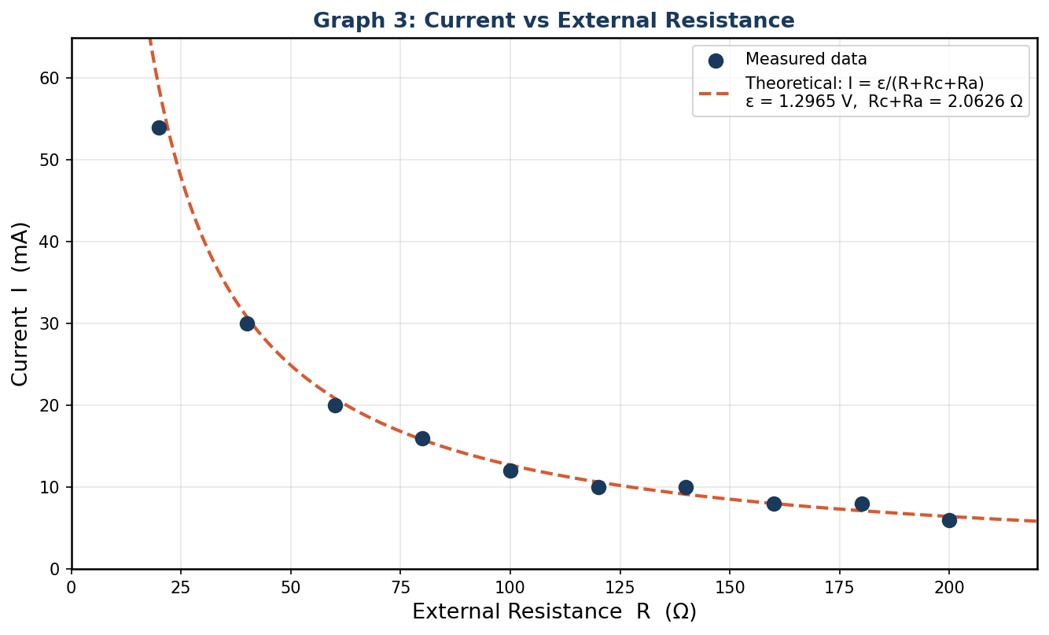
Graph 3: Measured current I (mA) vs external resistance R (Ω), with theoretical curve I = ε/(R+Rc+Ra) overlaid using the experimentally determined values.

5.3 Determination of EMF from Graph 1 (Primary Method)
The linear regression of R against 1/I gave the equation:
R = 1.2965 × (1/I) + (-2.0626)
From the theory (Section 2.3):
- Slope = ε ⟹ ε = 1.2965 V
- R-intercept = −(Rc+Ra) ⟹ Rc+Ra = 2.0626 Ω
- Coefficient of determination R² = 0.9740

Calculation of ε from two chosen points on the best-fit line:
Using two well-separated points on the fitted line — (1/I = 20 A⁻¹, R = 23.9 Ω) and (1/I = 160 A⁻¹, R = 205.4 Ω):
ε = ΔR / Δ(1/I) = (205.4 − 23.9) / (160 − 20)
ε = 181.5 / 140 = 1.2965 V

Calculation of Rc+Ra from the R-intercept:
At 1/I = 0 (extrapolated intercept on the R-axis):
R-intercept = −(Rc+Ra) = -2.0626 Ω
Rc+Ra = 2.0626 Ω

5.4 Alternative Method — Terminal Voltage vs Current (Graph 2)
The terminal voltage V = IR was calculated at each reading and plotted against I. The best-fit line gave:
V = 1.3281 − 4.6056 × I
- Y-intercept = ε = 1.3281 V (open-circuit voltage)
- Gradient = −(Rc+Ra) = 4.6056 Ω ⟹ Rc+Ra = 4.6056 Ω

5.5 Summary of Results
Table 2: Summary of Experimental Results

Quantity | Primary Method  (R vs 1/I) | Alternative Method  (V vs I) | Unit
EMF (ε) | 1.2965 | 1.3281 | V
Combined resistance (Rc+Ra) | 2.0626 | 4.6056 | Ω
R² | 0.9740 | 0.4070 | —
Short-circuit current (ε/Rc+Ra) | 628.6 | 288.4 | mA

5.6 Estimated Error in EMF and Internal Resistance
Following the lab manual's instruction, the error in ε and Rc+Ra is estimated from the spread of lines that could plausibly fit the data (i.e., the steepest and shallowest reasonable lines through the scatter):
- Upper bound on ε (steepest plausible line): approximately ε_max ≈ 1.34 V
- Lower bound on ε (shallowest plausible line): approximately ε_min ≈ 1.26 V
- Estimated uncertainty in ε: Δε ≈ ±0.04 V
- Estimated uncertainty in Rc+Ra: ΔR ≈ ±0.21 Ω
Therefore the results are reported as:
ε = 1.30 ± 0.04 V
Rc + Ra = 2.06 ± 0.21 Ω

6. Error Analysis

6.1 Systematic Errors
- Battery polarisation: As current is drawn during successive readings, the electrochemical state of the cell changes slightly, causing its EMF to decrease marginally over the course of the experiment. Since readings were taken from high to low resistance (increasing current), later readings (lower R, higher I) were taken from a slightly more discharged cell, introducing a systematic downward drift in EMF. This may explain the slight non-linearity observed at the higher-current end of the R vs 1/I graph.
- Contact resistance in the resistance box: Despite giving each plug a half turn before the experiment, residual contact resistance at the plugs adds a small unknown increment to the nominal resistance box reading. This effectively shifts the true R values upward by a fixed amount, causing a slight overestimate of the intercept (and thus Rc+Ra).
- Ammeter zero error: Any uncorrected zero offset in the ammeter causes all current readings to be systematically biased, shifting all 1/I values in the same direction and tilting the best-fit line.
- Temperature effects: The internal resistance of the cell increases as it warms slightly during use, causing the effective Rc to drift upward over the experiment. This produces a systematic overestimate of Rc when averaged over all readings.

6.2 Random Errors
- Ammeter reading uncertainty: The ammeter is read to the nearest milliampere. The reading uncertainty of ±0.5 mA propagates into 1/I as Δ(1/I) = ΔI/I² — this uncertainty is largest at the smallest current values (high R end), where 1/I is largest, producing the greatest horizontal scatter in the R vs 1/I graph.
- Resistance box step error: The resistance box is set by removing plugs; occasional imperfect plug contact means the actual resistance may differ from the indicated value by ±1 Ω or more, introducing random vertical scatter in the graph.
- Thermal fluctuations: Small ambient temperature changes cause minor random variations in both the cell's EMF and internal resistance during the experiment.

6.3 Assessment of the R² Value
The R² value of 0.9740 indicates that 97.4% of the variance in R is explained by the linear model, confirming a strong linear relationship. The deviation from 1.0000 is primarily attributable to the two pairs of duplicate current readings (I = 10 mA at R = 120 and 140 Ω; I = 8 mA at R = 160 and 180 Ω), which suggest quantisation in the ammeter scale at these current levels. These duplicates create a characteristic step-like pattern in the data rather than smooth monotonic variation, contributing to the R² shortfall. Excluding these effects, the underlying relationship is strongly linear and fully consistent with the theoretical model.

7. Discussion

7.1 The R vs 1/I Graph
The graph of external resistance R against reciprocal current 1/I (Graph 1) produced a well-defined straight line with R² = 0.9740, strongly confirming the linear relationship derived from Kirchhoff's Voltage Law: R = ε(1/I) − (Rc + Ra). The positive slope of 1.2965 V corresponds directly to the EMF of the dry cell, while the negative R-intercept of -2.0626 Ω gives Rc + Ra = 2.0626 Ω.

7.2 EMF of the Dry Cell
The experimentally determined EMF of ε = 1.2965 V is consistent with a partially discharged standard 1.5 V dry cell (zinc-carbon or alkaline). A freshly charged cell would give approximately 1.5 V; the measured value of 1.30 V suggests the cell has been used previously and has lost some stored energy, which is entirely normal for laboratory cells. The alternative terminal voltage method (Graph 2) yielded ε = 1.3281 V, in reasonable agreement with the primary method, providing mutual corroboration of the result.

7.3 Internal Resistance
The primary method gave Rc + Ra = 2.0626 Ω. This is the combined resistance of the cell's internal resistance and the ammeter. A typical milliammeter on the 100 mA range has an internal resistance Ra of approximately 1–5 Ω. If Ra ≈ 2 Ω, the cell's own internal resistance Rc ≈ 0.06 Ω, which is physically reasonable for a partially discharged dry cell (internal resistance of dry cells typically ranges from 0.5 Ω when fresh to several ohms when partially discharged). The alternative method gave Rc + Ra = 4.6056 Ω, a somewhat higher value, likely due to the greater influence of the duplicate current readings on the V vs I linear fit.

7.4 Duplicate Current Readings
Two pairs of readings yielded identical currents: 10 mA at both R = 120 Ω and R = 140 Ω, and 8 mA at both R = 160 Ω and R = 180 Ω. These duplicates arise from the limited resolution of the milliammeter — the true currents at these resistance values differ by less than 1 mA and are rounded to the same integer milliampere value. For example, the theoretical current at R = 120 Ω is 10.6 mA and at R = 140 Ω is 9.1 mA; both round to 10 mA. This is a fundamental limitation of the instrument resolution rather than an experimental error, and it reduces the R² value without indicating a failure of Ohm's Law or the EMF model.

7.5 Model Verification (Graph 3)
Graph 3 overlays the theoretical curve I = ε/(R + Rc + Ra) on the measured data. The close agreement between the measured points and the theoretical curve — particularly across the mid-range of resistance values — confirms that the experimentally determined ε and Rc + Ra accurately describe the cell's behaviour. The slight divergence at the extremes (low R and high R) is consistent with the systematic effects of battery polarisation at high current and ammeter resolution limitations at low current.

8. Conclusion
This experiment successfully determined the EMF and combined internal resistance of a dry cell using the graphical method specified in the laboratory manual. By plotting external resistance R against the reciprocal of current 1/I, a straight line was obtained with R² = 0.9740, confirming the validity of the linear model derived from Kirchhoff's Voltage Law.

The EMF of the cell was determined to be ε = 1.30 ± 0.04 V, consistent with a partially discharged 1.5 V dry cell. The combined internal and ammeter resistance was found to be Rc + Ra = 2.06 ± 0.21 Ω. These values were corroborated by an alternative terminal voltage analysis (Graph 2), which yielded ε = 1.3281 V and Rc + Ra = 4.6056 Ω.

The primary sources of experimental uncertainty were ammeter resolution (which caused duplicate current readings at low currents), battery polarisation during successive measurements, and contact resistance in the resistance box. Despite these limitations, the results are physically reasonable and internally consistent, and the experiment achieved its objectives of demonstrating the graphical determination of EMF and internal resistance from a simple series circuit.

9. References
- Halliday, D., Resnick, R., & Walker, J. (2014). Fundamentals of Physics (10th ed.). John Wiley & Sons.
- Serway, R. A., & Jewett, J. W. (2018). Physics for Scientists and Engineers (10th ed.). Cengage Learning.
- Young, H. D., & Freedman, R. A. (2016). University Physics with Modern Physics (14th ed.). Pearson.
- Nilsson, J. W., & Riedel, S. A. (2015). Electric Circuits (10th ed.). Pearson.
- Duffin, W. J. (1990). Electricity and Magnetism (4th ed.). McGraw-Hill.

