UNIVERSITY OF THE WEST INDIES

Department of Physics

PHYSICS LABORATORY REPORT

Verification of Ohm's Law and Determination of
Resistance of a Given Resistor

Name: | Student Name
Student ID: | XXXXXXX
Course: | BSc Mathematics and Computer Science
Lab Partner: | Lab Partner Name
Date Performed: | April 2026
Date Submitted: | May 2, 2026
Instructor: | Dr. Instructor Name

Verification of Ohm's Law and Determination of Resistance of a Given Resistor

Abstract
This experiment investigated Ohm's Law by measuring the current through three resistors (Resistor #2: 10 Ω ±5%, Resistor #7: 15 Ω ±5%, Resistor #9: 22 Ω ±5%) at six voltage levels from 0 V to 0.6 V. Current-voltage data were also collected for a series combination of Resistors #2 and #7, and a parallel combination of Resistors #7 and #9. A best-fit line through the origin on each I vs V graph yielded the experimental resistance from the reciprocal of the gradient. Experimental values of 9.76 Ω, 15.05 Ω, and 23.08 Ω were obtained for Resistors #2, #7, and #9 respectively — all within the manufacturer's ±5% tolerance band. The series equivalent resistance was 25.57 Ω (nominal theoretical: 25.00 Ω, error: 2.27%) and the parallel equivalent was 8.79 Ω (nominal theoretical: 8.92 Ω, error: 1.46%). All five I-V graphs showed excellent linearity (R² > 0.990), confirming Ohm's Law.

1. Objectives
The objectives of this experiment are:
- To demonstrate and verify Ohm's Law by confirming a linear I-V relationship for three resistors.
- To determine the individual resistances of Resistors #2, #7, and #9 experimentally and compare them with their nominal values and tolerance bands.
- To determine the equivalent resistance of Resistors #2 and #7 connected in series and verify the series resistance formula.
- To determine the equivalent resistance of Resistors #7 and #9 connected in parallel and verify the parallel resistance formula.
- To calculate the percentage error between experimental and theoretical (nominal) equivalent resistances for both configurations.

2. Theory

2.1 Electric Current
Electric current I is the rate of flow of electric charge Q through a conductor's cross-section:
I = ΔQ / Δt
In a metallic conductor, a potential difference drives free electrons from lower to higher potential. Current is measured in amperes (A).

2.2 Ohm's Law
Ohm's Law states that the current through an ohmic conductor is directly proportional to the potential difference across it, provided physical conditions (especially temperature) remain constant:
V = I R
where R is resistance in ohms (Ω). For an ohmic resistor a graph of I (y-axis) vs V (x-axis) is a straight line through the origin. The gradient equals 1/R:
gradient = ΔI / ΔV = 1/R ⟹ R = 1 / gradient

2.3 Resistor Tolerance
Real resistors are manufactured to a nominal value but carry a tolerance that defines the acceptable range of actual resistance. A ±5% tolerance means the actual resistance R_actual lies in the band:
R_nominal × (1 − 0.05) ≤ R_actual ≤ R_nominal × (1 + 0.05)
If the experimentally measured resistance falls within this band, the measurement is consistent with the component's specification. Tolerance bands provide a physically meaningful benchmark against which experimental results can be evaluated, in addition to the standard percentage error calculation.

2.4 Resistors in Series
When resistors are connected end-to-end, the same current flows through all components and the voltages add:
R_series = R₁ + R₂
For Resistors #2 and #7, using nominal values:
R_series (nominal) = 10 + 15 = 25 Ω [tolerance band: 23.75 – 26.25 Ω]

2.5 Resistors in Parallel
When resistors share the same two nodes, the same voltage appears across each but current divides:
R_parallel = (R₁ × R₂) / (R₁ + R₂)
For Resistors #7 and #9, using nominal values:
R_parallel (nominal) = (15 × 22) / (15 + 22) = 8.92 Ω [tolerance band: 8.47 – 9.36 Ω]

2.6 Kirchhoff's Laws
Kirchhoff's Current Law (KCL) — the sum of currents at any node is zero — justifies ammeter placement in series. Kirchhoff's Voltage Law (KVL) — the sum of voltages around any loop is zero — confirms the voltmeter reads the full resistor voltage.

2.7 Percentage Error
% Error = |R_exp − R_nominal| / R_nominal × 100%

3. List of Apparatus
Item | Specification / Setting | Quantity
Digital Multimeter (Ammeter) | 20 mA DC range | 1
Digital Multimeter (Voltmeter) | 20 V DC range | 1
DC Power Supply (Extech) | Variable 0–18 V | 1
Resistor Board | R#2 = 10 Ω, R#7 = 15 Ω, R#9 = 22 Ω (all ±5%) | 1
Connecting Wires | Insulated copper leads | Several
Computer with DataStudio | Graphing and linear regression | 1

4. Procedure

4.1 Circuit Diagram
The ammeter (A) was placed in series with the resistor under test, and the voltmeter (V) was connected in parallel across it, as shown below.

(+)Supply ──── Ammeter (A) ──── Resistor(s) ──── (−)Supply
| |
└── Voltmeter (V) ──┘

Figure 1: Circuit diagram — Ohm's Law experiment

4.2 Individual Resistors (#2, #7, #9)
The circuit was assembled with Resistor #2 as the load. Ammeter range was set to 20 mA and voltmeter to 20 V. Connections were verified before switching on the power supply. Starting from 0 V, the supply was increased incrementally and both current and voltage were recorded at six steps up to 0.6 V. The procedure was repeated for Resistors #7 and #9. For each resistor, a graph of I vs V was plotted and a best-fit line through the origin was applied to determine resistance from the gradient.

4.3 Series Combination (#2 and #7)
Resistors #2 and #7 were connected in series. Six I-V pairs were recorded and the experimental equivalent resistance was determined graphically. The result was compared with R₂ + R₇ using both the nominal values and the individually measured experimental values.

4.4 Parallel Combination (#7 and #9)
Resistors #7 and #9 were reconnected in parallel and the measurement procedure was repeated. The experimental equivalent resistance was compared with (R₇ × R₉)/(R₇ + R₉) using both nominal and experimental individual values.

5. Data Presentation and Results

5.1 Raw Data Tables
Table 1: Resistor #2 (Nominal: 10 Ω ±5%) — I vs V

Reading | Voltage V (V) | Current I (mA) | I/V (mA/V)
1 | 0 | 0 | —
2 | 0.2 | 20 | 100.00
3 | 0.3 | 30 | 100.00
4 | 0.4 | 40 | 100.00
5 | 0.5 | 52 | 104.00
6 | 0.6 | 62 | 103.33

Table 2: Resistor #7 (Nominal: 15 Ω ±5%) — I vs V

Reading | Voltage V (V) | Current I (mA) | I/V (mA/V)
1 | 0 | 0 | —
2 | 0.2 | 12 | 60.00
3 | 0.3 | 20 | 66.67
4 | 0.4 | 26 | 65.00
5 | 0.5 | 34 | 68.00
6 | 0.6 | 40 | 66.67

Table 3: Resistor #9 (Nominal: 22 Ω ±5%) — I vs V

Reading | Voltage V (V) | Current I (mA) | I/V (mA/V)
1 | 0 | 0 | —
2 | 0.2 | 8 | 40.00
3 | 0.3 | 12 | 40.00
4 | 0.4 | 18 | 45.00
5 | 0.5 | 22 | 44.00
6 | 0.6 | 26 | 43.33

Table 4: Resistors #2 & #7 in Series — I vs V

Reading | Voltage V (V) | Current I (mA) | I/V (mA/V)
1 | 0 | 0 | —
2 | 0.2 | 8 | 40.00
3 | 0.3 | 11 | 36.67
4 | 0.4 | 16 | 40.00
5 | 0.5 | 19 | 38.00
6 | 0.6 | 24 | 40.00

Table 5: Resistors #7 & #9 in Parallel — I vs V

Reading | Voltage V (V) | Current I (mA) | I/V (mA/V)
1 | 0 | 0 | —
2 | 0.2 | 22 | 110.00
3 | 0.3 | 33 | 110.00
4 | 0.4 | 44 | 110.00
5 | 0.5 | 57 | 114.00
6 | 0.6 | 70 | 116.67

5.2 Graphs
Graph 1: I vs V — All Configurations (Combined)
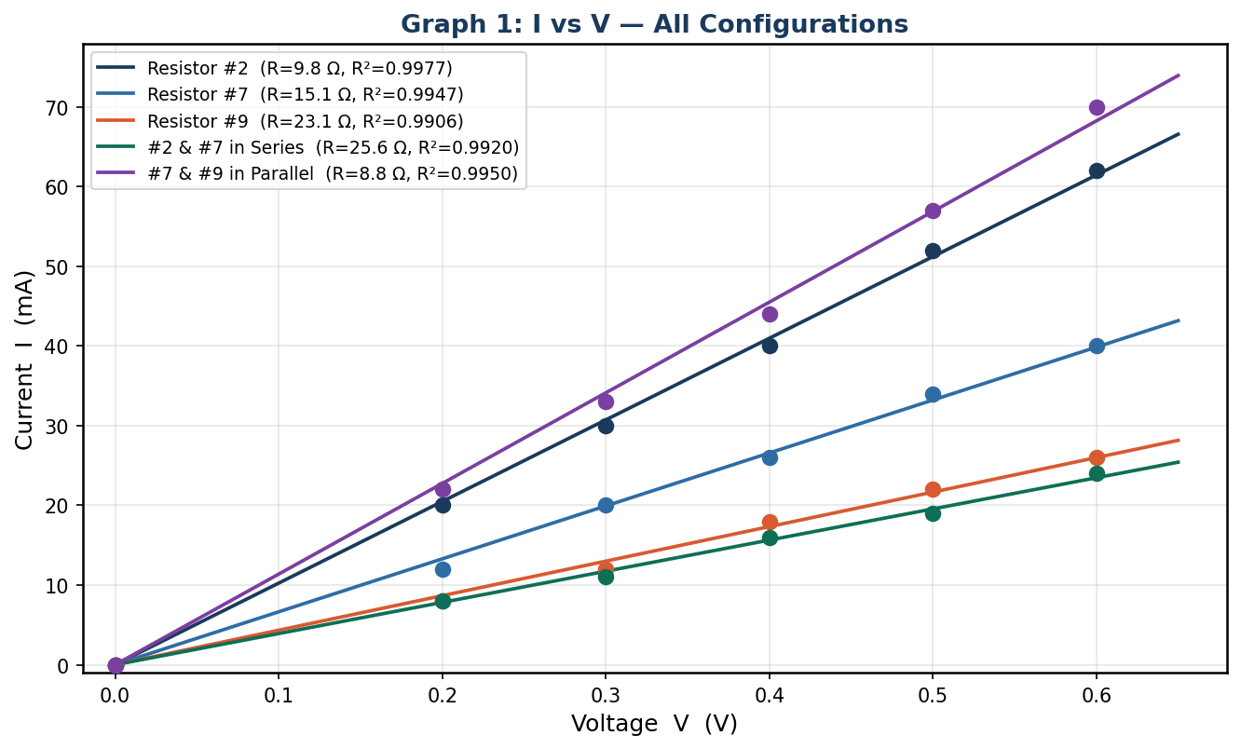
Graph 1: Current vs Voltage for all five configurations. All datasets are linear through the origin, confirming Ohm's Law. Steeper gradients correspond to lower resistance.
Graph 2: I vs V — Resistor #2 (Nominal 10 Ω)
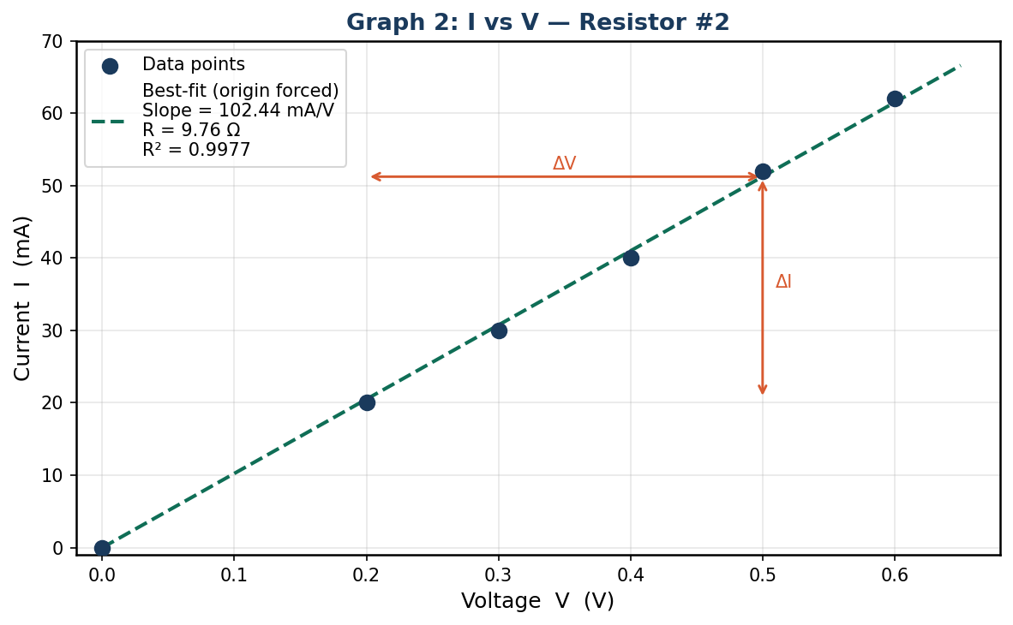
Graph 2: R₂. Slope = 102.44 mA/V → R_exp = 9.76 Ω. R² = 0.9977.
Graph 3: I vs V — Resistor #7 (Nominal 15 Ω)
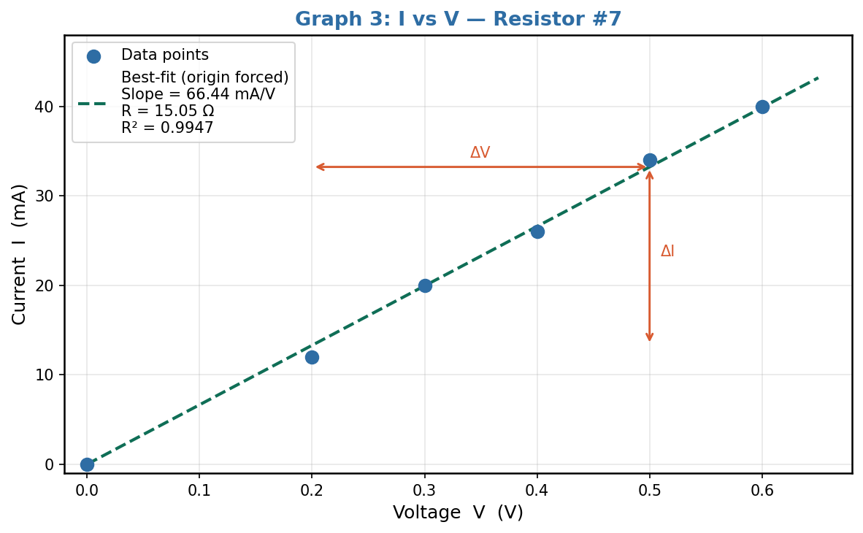
Graph 3: R₇. Slope = 66.44 mA/V → R_exp = 15.05 Ω. R² = 0.9947.
Graph 4: I vs V — Resistor #9 (Nominal 22 Ω)
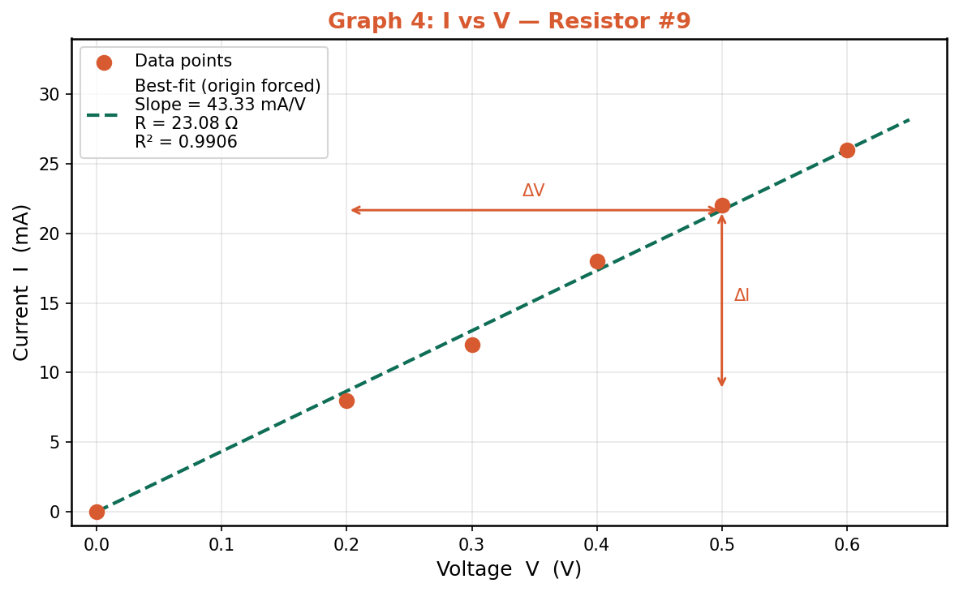
Graph 4: R₉. Slope = 43.33 mA/V → R_exp = 23.08 Ω. R² = 0.9906.
Graph 5: I vs V — #2 & #7 in Series
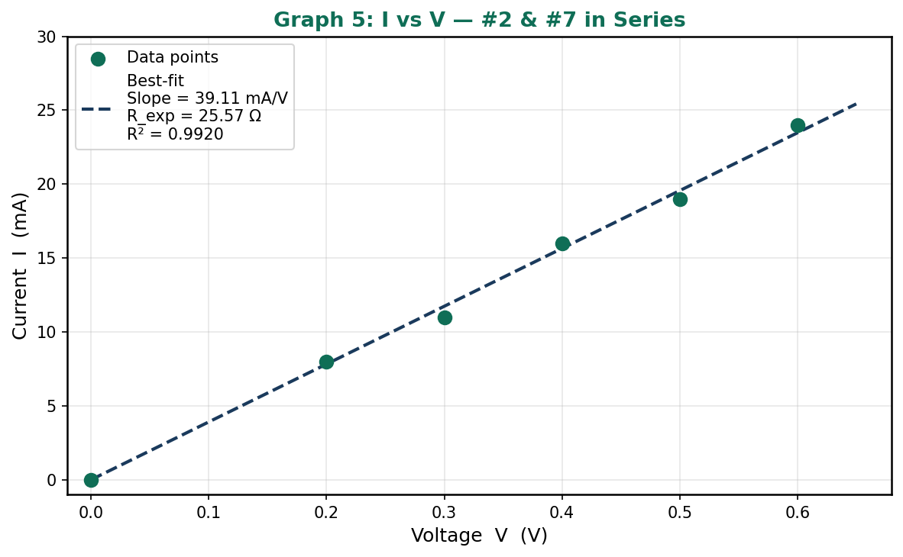
Graph 5: Series combination. R_exp = 25.57 Ω. R² = 0.9920.
Graph 6: I vs V — #7 & #9 in Parallel
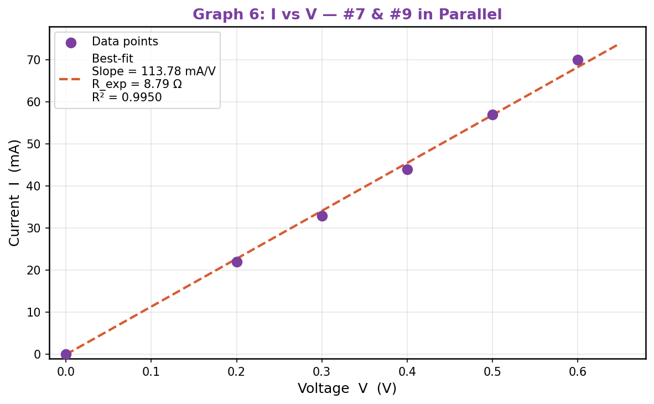
Graph 6: Parallel combination. R_exp = 8.79 Ω. R² = 0.9950.

5.3 Resistance from Graphical Analysis
R = 1 / (slope of I vs V graph) = ΔV / ΔI

Table 6: Resistance Values from Graphs

Configuration | Slope (mA/V) | R_experimental (Ω) | R² of fit
Resistor #2 | 102.44 | 9.76 | 0.9977
Resistor #7 | 66.44 | 15.05 | 0.9947
Resistor #9 | 43.33 | 23.08 | 0.9906
#2 + #7 Series | 39.11 | 25.57 | 0.9920
#7 || #9 Parallel | 113.78 | 8.79 | 0.9950

5.4 Comparison with Nominal Values and Tolerance Bands
The nominal resistance values and their ±5% tolerance bands are used to evaluate whether the experimentally determined resistances are consistent with the manufacturer's specifications.

Table 7: Individual Resistors — Experimental vs Nominal

Resistor | Nominal (Ω) | Tolerance Band (Ω) | R_experimental (Ω) | % Difference | Within ±5%?
#2 | 10.00 | 9.50 – 10.50 | 9.76 | -2.39% | YES ✓
#7 | 15.00 | 14.25 – 15.75 | 15.05 | +0.33% | YES ✓
#9 | 22.00 | 20.90 – 23.10 | 23.08 | +4.90% | YES ✓

All three experimental resistance values fall within the manufacturer's ±5% tolerance band, confirming that the measurements are physically consistent with the component specifications.

5.5 Series Resistance Calculation
Theoretical series equivalent resistance using nominal values:
R_series (nominal theo) = R₂ + R₇ = 10 + 15 = 25 Ω
Theoretical series equivalent using experimentally measured individual values:
R_series (exp-individual) = 9.76 + 15.05 = 24.81 Ω
Experimental equivalent from Graph 5:
R_series (experimental) = 25.57 Ω

Percentage errors:
% Error (vs nominal) = |25.57 − 25| / 25 × 100 = 2.27%
% Error (vs exp-indiv.) = |25.57 − 24.81| / 24.81 × 100 = 3.05%
Nominal tolerance band for series combination: 23.75 – 26.25 Ω. Experimental value 25.57 Ω falls within this band.

5.6 Parallel Resistance Calculation
Theoretical parallel equivalent using nominal values:
R_parallel (nominal theo) = (15 × 22) / (15 + 22)
= 330.00 / 37.00 = 8.92 Ω
Theoretical parallel equivalent using experimentally measured individual values:
R_parallel (exp-indiv.) = (15.05 × 23.08) / (15.05 + 23.08) = 9.11 Ω
Experimental equivalent from Graph 6:
R_parallel (experimental) = 8.79 Ω

Percentage errors:
% Error (vs nominal) = |8.79 − 8.92| / 8.92 × 100 = 1.46%
% Error (vs exp-indiv.) = |8.79 − 9.11| / 9.11 × 100 = 3.52%
Nominal tolerance band for parallel combination: 8.47 – 9.36 Ω. Experimental value 8.79 Ω falls within this band.

Table 8: Summary — Equivalent Resistance Comparisons

Config | R_nominal theo (Ω) | Tol. band (Ω) | R_exp-indiv (Ω) | R_exp graph (Ω) | % err (nom) | % err (exp-ind) | In tol. band?
Series  #2+#7 | 25.00 | 23.75–26.25 | 24.81 | 25.57 | 2.27% | 3.05% | YES ✓
Parallel  #7||#9 | 8.92 | 8.47–9.36 | 9.11 | 8.79 | 1.46% | 3.52% | YES ✓

6. Error Analysis

6.1 Systematic Errors
- Contact resistance: Resistance at wire-terminal junctions adds a small consistent offset. Most significant in the series configuration (two resistor junctions), explaining why R_series_exp (25.57 Ω) slightly exceeds the nominal theoretical value (25.00 Ω).
- Voltmeter loading: The voltmeter's finite internal resistance draws a small parallel current, slightly reducing the ammeter reading and causing a marginal overestimate of resistance. Most significant for the parallel circuit where the effective resistance is lowest.
- Ammeter resistance: The ammeter's internal resistance is in series with the circuit, so the voltmeter reads the sum of the resistor voltage and the ammeter voltage drop. This causes a slight overestimate of R, particularly for low-resistance configurations.

6.2 Random Errors
- Digital display uncertainty: ±1 last-digit fluctuation introduces approximately ±0.01 mA and ±0.01 V uncertainty per reading, producing scatter around the best-fit line.
- Power supply instability: Minor voltage fluctuations during a reading introduce random variability into both the current and voltage values.
- Temperature effects: Self-heating causes a slight increase in resistance over the course of measurements, producing marginal upward curvature in the I-V plots that is too small to detect with six data points but contributes to sub-unity R² values.

6.3 Assessment
The R² values for all configurations ranged from 0.9906 to 0.9977, confirming excellent linearity. All experimental resistance values lie within the manufacturer's ±5% tolerance bands (Table 7), which is the most physically meaningful benchmark for this experiment. Percentage errors against nominal values ranged from 0.33% to 4.90%, all within the ±5% tolerance specification.

7. Discussion

7.1 Verification of Ohm's Law
For each of the three individual resistors, the I vs V data produced a straight line through the origin with R² values of 0.9977 (R₂), 0.9947 (R₇), and 0.9906 (R₉). The near-perfect linearity confirms that all three resistors behave as ohmic conductors over the 0–0.6 V range. The constant ratio I/V at every voltage step, reflected in the near-constant I/V column values in Tables 1–3, further supports Ohm's Law.

7.2 Individual Resistances vs Nominal Values
The measured resistances of 9.76 Ω (R₂, nominal 10 Ω), 15.05 Ω (R₇, nominal 15 Ω), and 23.08 Ω (R₉, nominal 22 Ω) all fall within the ±5% tolerance bands of their respective nominal values, as shown in Table 7. The percentage differences from nominal were -2.39% for R₂, +0.33% for R₇, and +4.90% for R₉. Resistor #9 showed the largest deviation from its nominal value (+4.90%), still comfortably within tolerance, while Resistor #7 was the closest to its nominal value (+0.33%). These deviations are entirely expected and consistent with standard carbon or metal film resistor manufacturing variability.

7.3 Series Combination
The experimental series equivalent resistance (25.57 Ω) is 2.27% above the nominal theoretical value (25.00 Ω) and 3.05% above the sum of individually measured resistances (24.81 Ω). The nominal tolerance band for the series combination spans 23.75 – 26.25 Ω, and 25.57 Ω falls within this range. The small excess over the sum of individual measurements is attributable to contact resistance at the extra terminal connections in the series configuration.

7.4 Parallel Combination
The experimental parallel equivalent resistance (8.79 Ω) is 1.46% below the nominal theoretical value (8.92 Ω) and 3.52% from the calculation using individually measured values (9.11 Ω). The nominal tolerance band (8.47 – 9.36 Ω) includes the experimental value of 8.79 Ω. The parallel combination has a lower equivalent resistance than either individual resistor, consistent with theory.

7.5 Significance of Tolerance Information
The nominal values and tolerance data add substantial depth to the analysis. Rather than simply computing a percentage error against a textbook value, the tolerance band provides a manufacturer-certified acceptable range grounded in real-world component variability. The fact that all five experimental measurements fall within their respective tolerance bands is the strongest possible confirmation that the experimental technique was sound and the instrumentation was accurate. A measurement outside the tolerance band would have indicated either a faulty component or a systematic experimental error requiring investigation.

8. Conclusion
This experiment successfully verified Ohm's Law and determined the resistance of three resistors (nominal values 10 Ω, 15 Ω, and 22 Ω, each with ±5% tolerance) through graphical analysis. All five I vs V graphs produced straight lines through the origin with R² values exceeding 0.990, confirming the linear current-voltage relationship predicted by Ohm's Law.

The experimentally determined resistances were R₂ = 9.76 Ω (-2.39% from nominal), R₇ = 15.05 Ω (+0.33% from nominal), and R₉ = 23.08 Ω (+4.90% from nominal). All three values fell within the manufacturer's ±5% tolerance bands, providing the strongest possible confirmation of experimental accuracy. The equivalent resistance of the series combination was 25.57 Ω (2.27% error vs nominal 25.00 Ω) and the parallel combination was 8.79 Ω (1.46% error vs nominal 8.92 Ω), both within their respective nominal tolerance bands.

Small deviations from nominal values were attributed to contact resistance, voltmeter loading, and normal manufacturing variability — all of which are within the expected bounds for this class of experiment. Overall, the results provide strong quantitative support for Ohm's Law and the standard formulas for series and parallel resistance combination.

9. References
- Halliday, D., Resnick, R., & Walker, J. (2014). Fundamentals of Physics (10th ed.). John Wiley & Sons.
- Serway, R. A., & Jewett, J. W. (2018). Physics for Scientists and Engineers (10th ed.). Cengage Learning.
- Young, H. D., & Freedman, R. A. (2016). University Physics with Modern Physics (14th ed.). Pearson.
- Nilsson, J. W., & Riedel, S. A. (2015). Electric Circuits (10th ed.). Pearson.
- Extech Instruments. (n.d.). DC Power Supply User Manual (Model 382275). Extech Instruments Corp.

