The circuit:

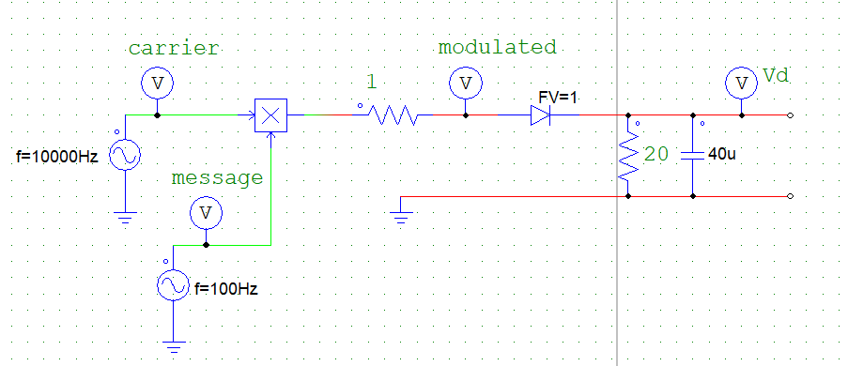

SIN WAVE EXAMPLE

Message signal and the carrier wave:

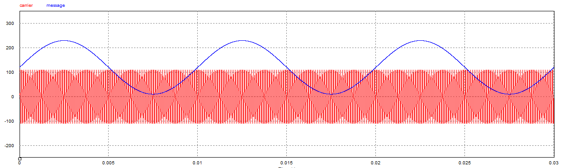The carrier wave is at a much higher frequency and the message is offset such that A+f(t)>=0 to prevent overmodulation.

The modulated signal is shown below in red. Th envelope detector then traces |f(t)| to produce a scaled version of the original message:

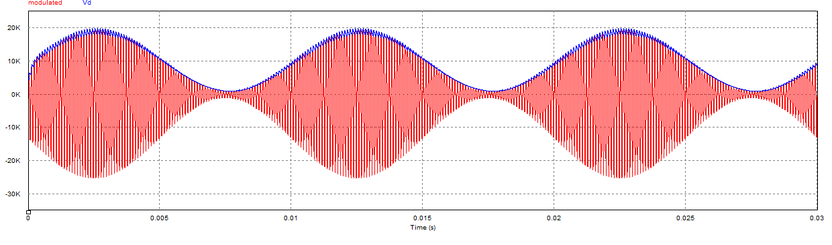

A capacitance of 40uF was sufficient to trace the sin wave accurately. An increase to 90uF in the capacitance value results in slow discharge resulting in an inaccurate reconstruction of the message as shown below:

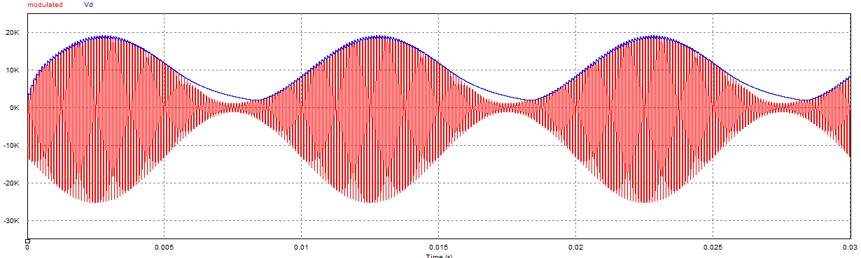

TRIANGULAR WAVE:

Message and carrier:

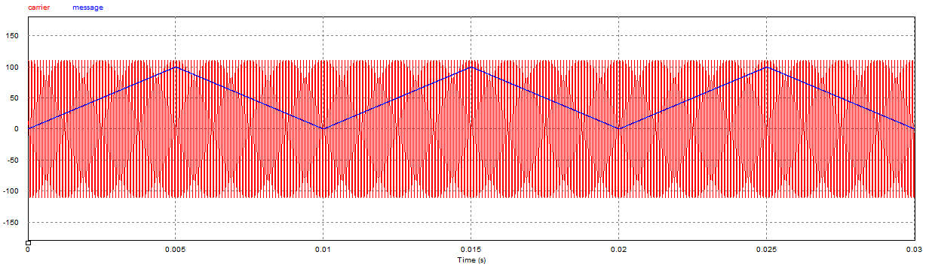

Modulated signal and output:

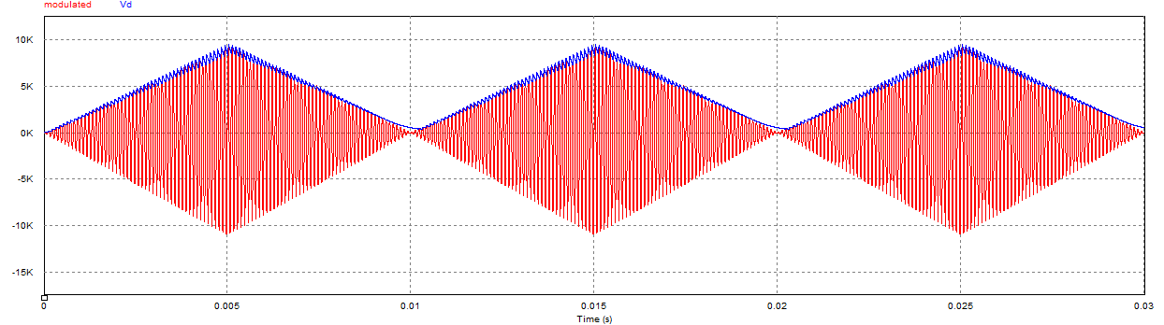

VOLTAGE PULSES EXAMPLE

A 40uF capacitor does not discharge fast enough in case of steep signal change such as a square wave:

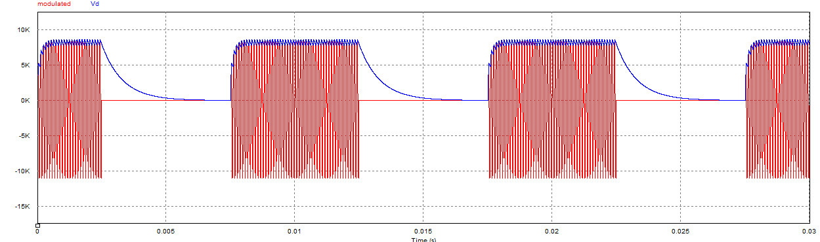

Decreasing the Capacitor value to 10uF results in much faster discharge that can more accurately reproduce the message:

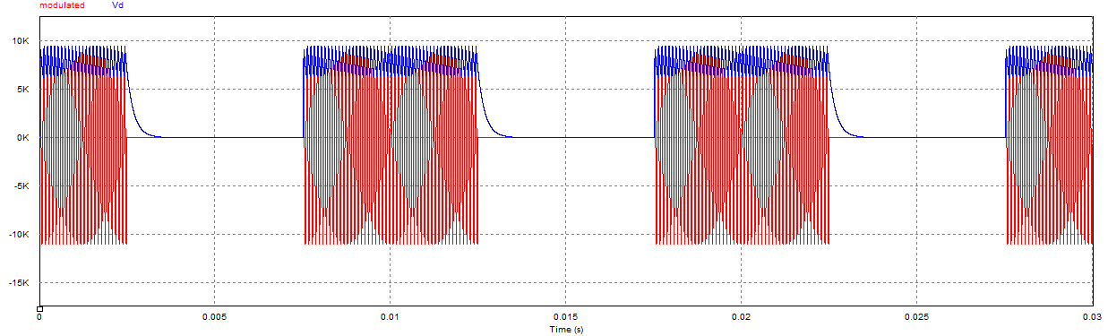

From this we can see that the discharge rate of the capacitor depends on the kind of signal being transmitted and that must be taken into account during the design.