Create Trile Account the first
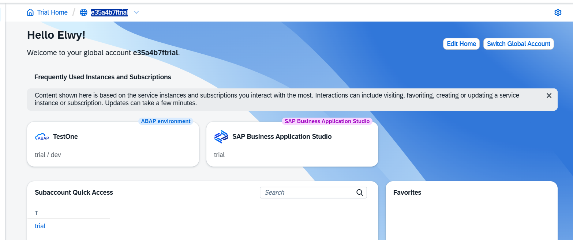
- Create the “Subaccount: trial - Instances and Subscriptions”
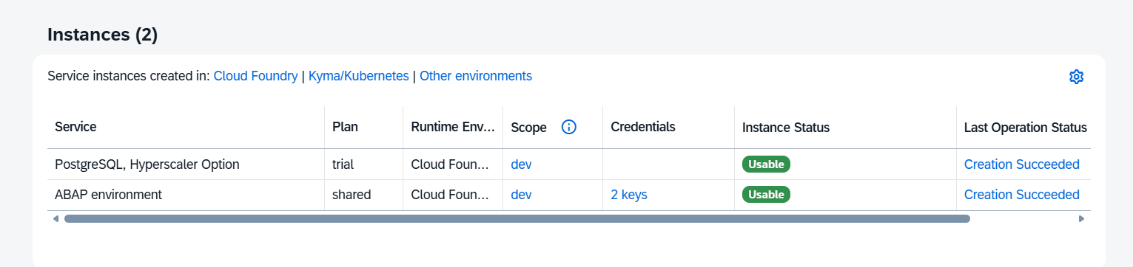
- Crete the service Key
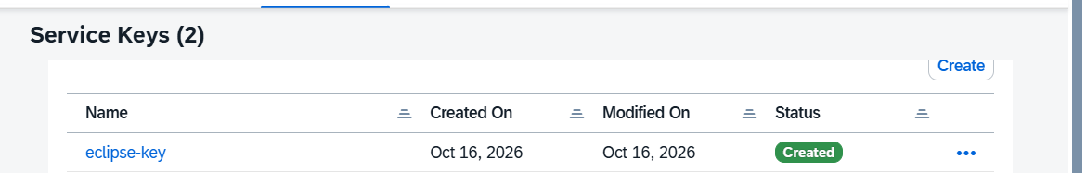

- on eclipse = > create a new Abap cloud project and create a new package
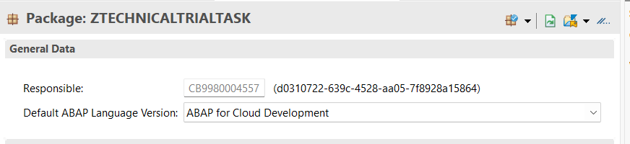
- create the table header
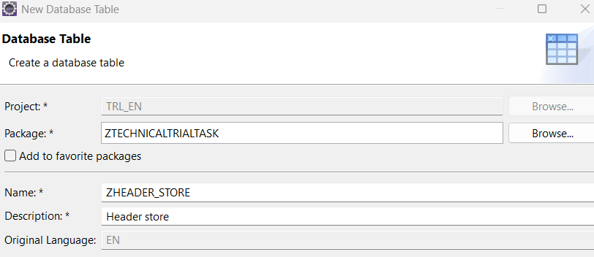
save the table and active
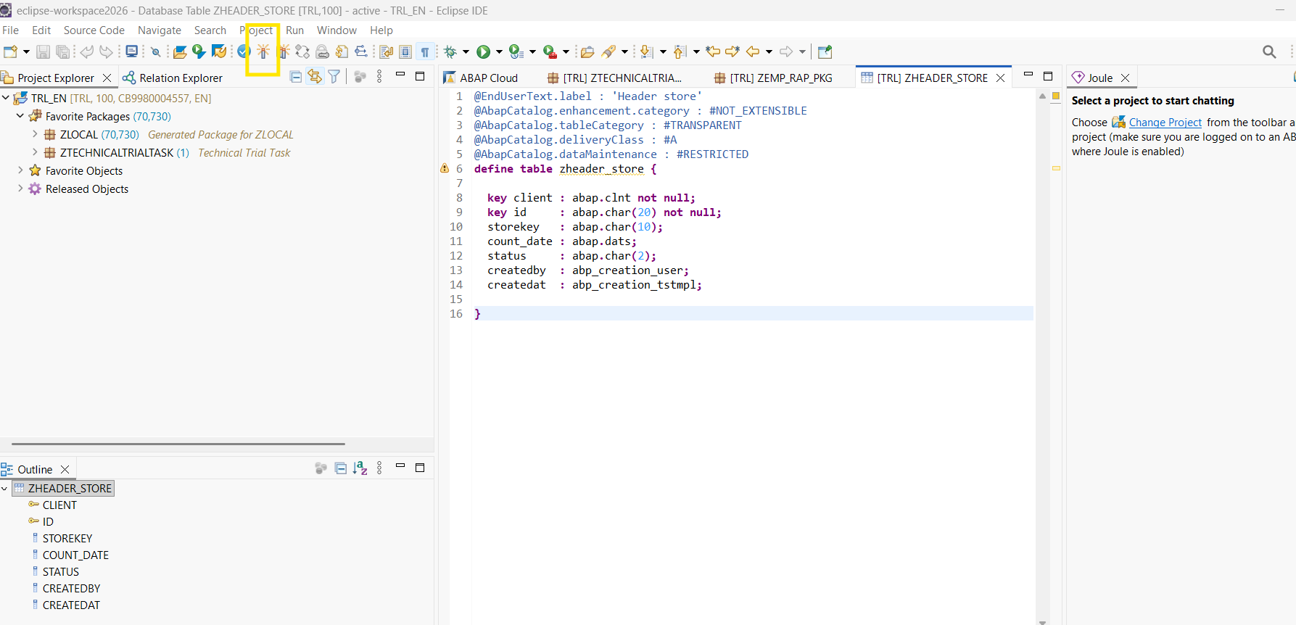

@EndUserText.label : 'Header store'
@AbapCatalog.enhancement.category : #NOT_EXTENSIBLE
@AbapCatalog.tableCategory : #TRANSPARENT
@AbapCatalog.deliveryClass : #A
@AbapCatalog.dataMaintenance : #RESTRICTED
define table zheader_store {

key client : abap.clnt not null;
key id : abap.char(20) not null;
storekey : abap.char(10);
count_date : abap.dats;
status : abap.char(2);
createdby : abp_creation_user;
createdat : abp_creation_tstmpl;

}
//-----------------------------------------------------------------------------------------------------//
- Create the zarticle_store table
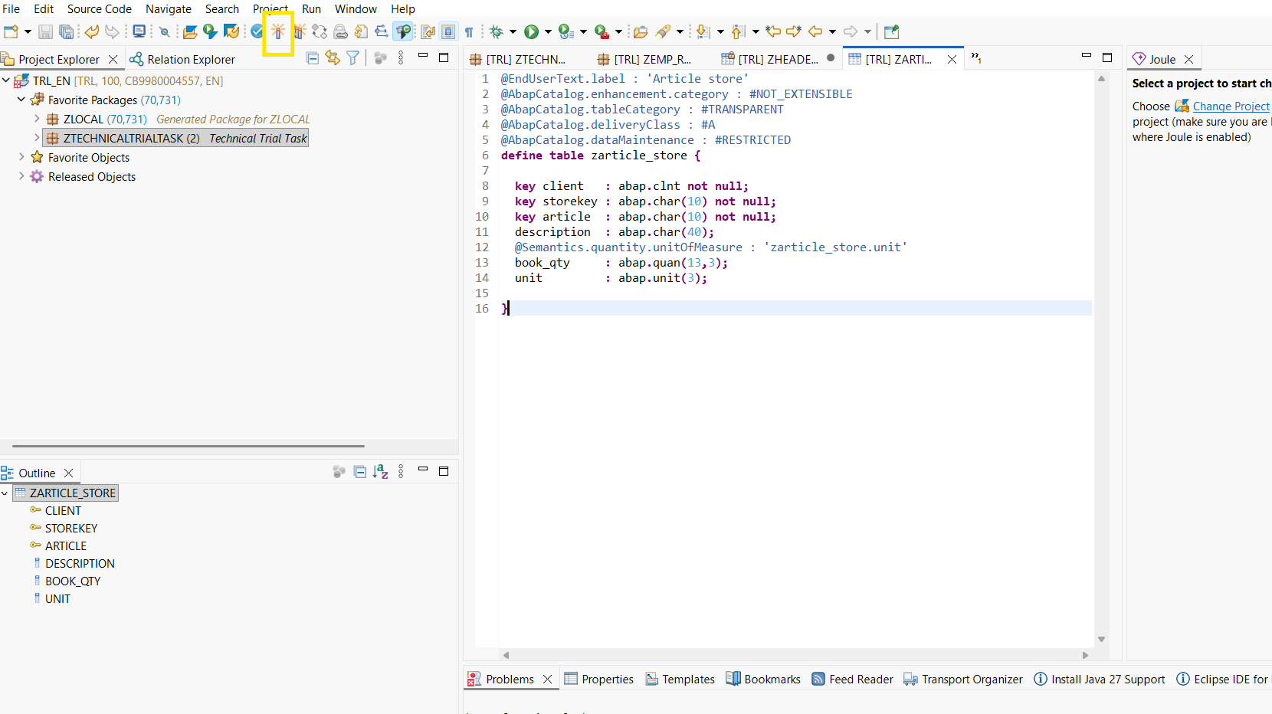
@EndUserText.label : 'Article store'
@AbapCatalog.enhancement.category : #NOT_EXTENSIBLE
@AbapCatalog.tableCategory : #TRANSPARENT
@AbapCatalog.deliveryClass : #A
@AbapCatalog.dataMaintenance : #RESTRICTED
define table zarticle_store {

key client : abap.clnt not null;
key storekey : abap.char(10) not null;
key article : abap.char(10) not null;
description : abap.char(40);
@Semantics.quantity.unitOfMeasure : 'zarticle_store.unit'
book_qty : abap.quan(13,3);
unit : abap.unit(3);

}

//-------------------------------------------------------------------------------------------------------------//
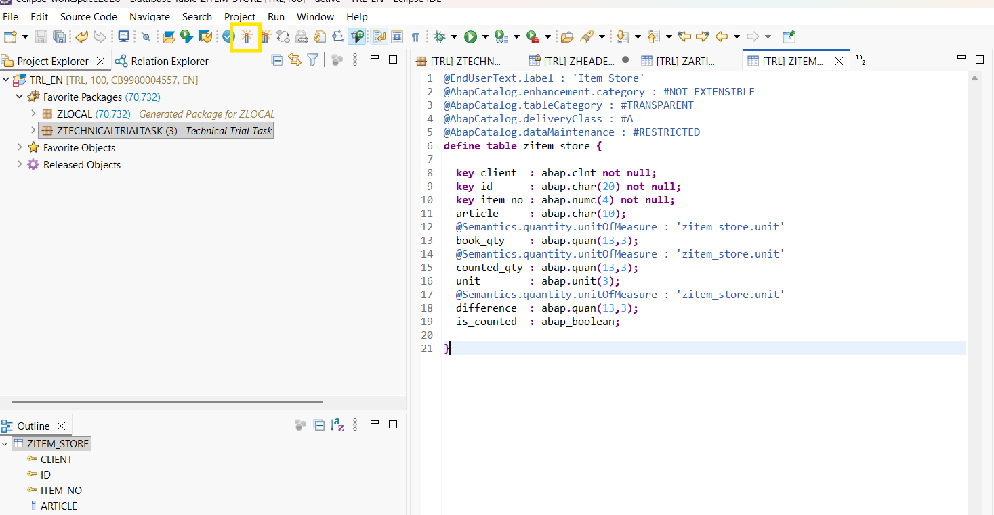

@EndUserText.label : 'Item Store'
@AbapCatalog.enhancement.category : #NOT_EXTENSIBLE
@AbapCatalog.tableCategory : #TRANSPARENT
@AbapCatalog.deliveryClass : #A
@AbapCatalog.dataMaintenance : #RESTRICTED
define table zitem_store {

key client : abap.clnt not null;
key id : abap.char(20) not null;
key item_no : abap.numc(4) not null;
article : abap.char(10);
@Semantics.quantity.unitOfMeasure : 'zitem_store.unit'
book_qty : abap.quan(13,3);
@Semantics.quantity.unitOfMeasure : 'zitem_store.unit'
counted_qty : abap.quan(13,3);
unit : abap.unit(3);
@Semantics.quantity.unitOfMeasure : 'zitem_store.unit'
difference : abap.quan(13,3);
is_counted : abap_boolean;

}

//---------------------------------------------------------------------------//
Then create Date Definition for header
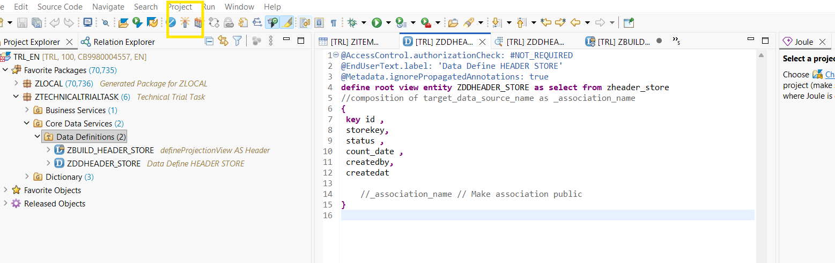

@AccessControl.authorizationCheck: #NOT_REQUIRED
@EndUserText.label: 'Data Define HEADER STORE'
@Metadata.ignorePropagatedAnnotations: true
define root view entity ZDDHEADER_STORE as select from zheader_store
//composition of target_data_source_name as _association_name
{
key id ,
storekey,
status ,
count_date ,
createdby,
createdat

//_association_name // Make association public
}

//--------------------------------------------------------------------------------------------//
Create “ define Projection View”

@AccessControl.authorizationCheck: #NOT_REQUIRED
@EndUserText.label: 'defineProjectionView AS Header'
@Metadata.ignorePropagatedAnnotations: true
@UI.headerInfo: { typeName: 'Count Document',
typeNamePlural: 'Count Documents',
title: { value: 'id' } }
define root view entity ZBUILD_HEADER_STORE as projection on ZDDHEADER_STORE
{
@UI.facet: [{ type: #FIELDGROUP_REFERENCE, targetQualifier: 'Main',
label: 'General Information', position: 10 }]

@UI: { lineItem: [{ position: 10 }], fieldGroup: [{ qualifier: 'Main', position: 10 }] }
key id,
@UI: { lineItem: [{ position: 20 }], fieldGroup: [{ qualifier: 'Main', position: 20 }],
selectionField: [{ position: 10 }] }
storekey,
@UI: { lineItem: [{ position: 30 }], fieldGroup: [{ qualifier: 'Main', position: 30 }],
selectionField: [{ position: 20 }] }
status,
@UI: { lineItem: [{ position: 40 }], fieldGroup: [{ qualifier: 'Main', position: 40 }] }
count_date,

@UI: { lineItem: [{ position: 50 }], fieldGroup: [{ qualifier: 'Main', position: 50 }] }
createdby,
@UI: { lineItem: [{ position: 60 }], fieldGroup: [{ qualifier: 'Main', position: 60 }] }
createdat

}

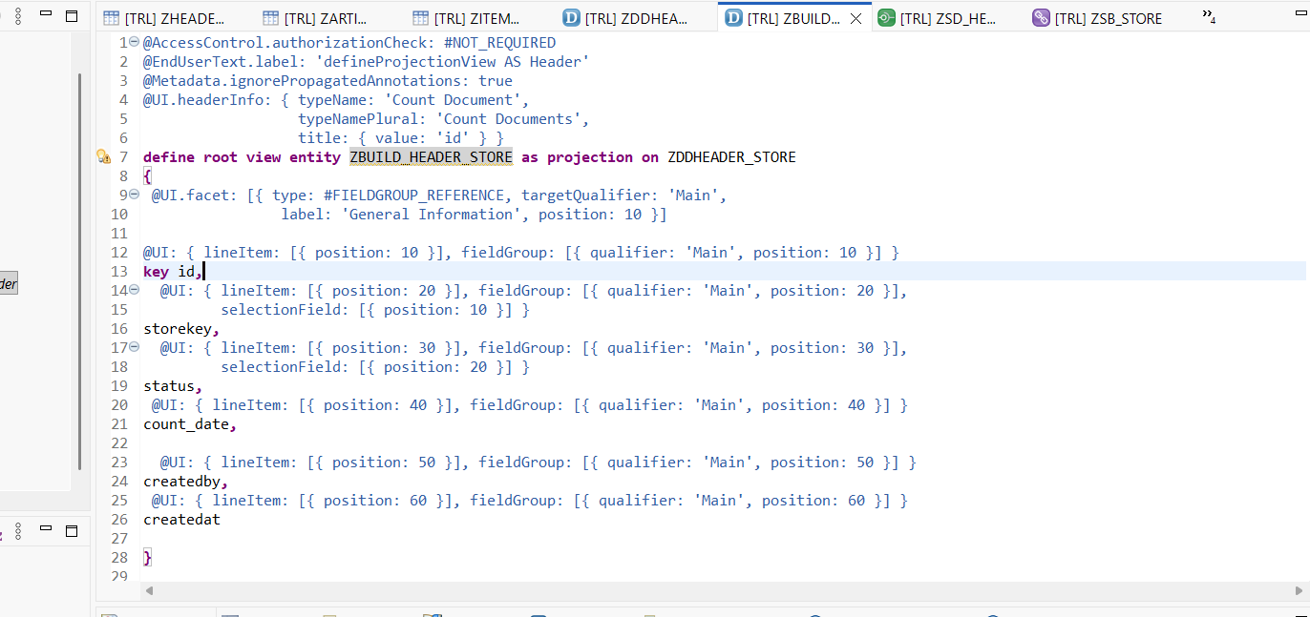

//------------------------------------------------------------------------/
Create “service definition “
@EndUserText.label: 'SD Header'
define service ZSD_HEADER {
expose ZBUILD_HEADER_STORE as Header_list;
}

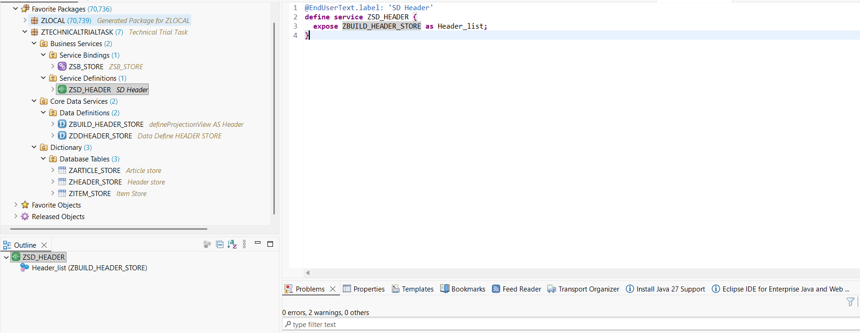
//------------------------------------------------------------------------------//
Add the Service Building
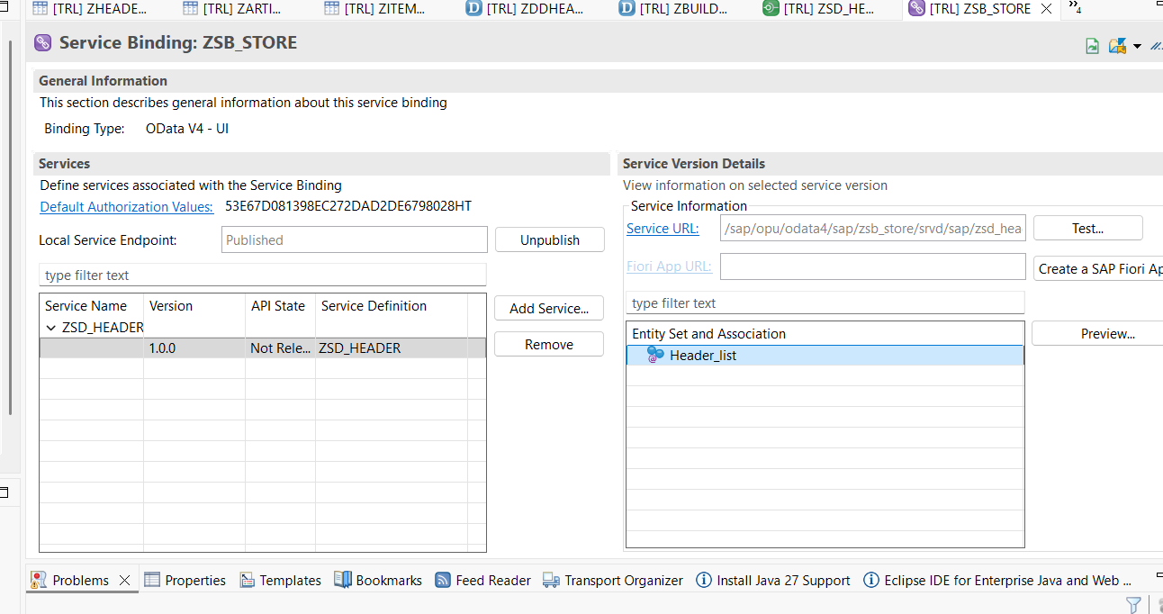

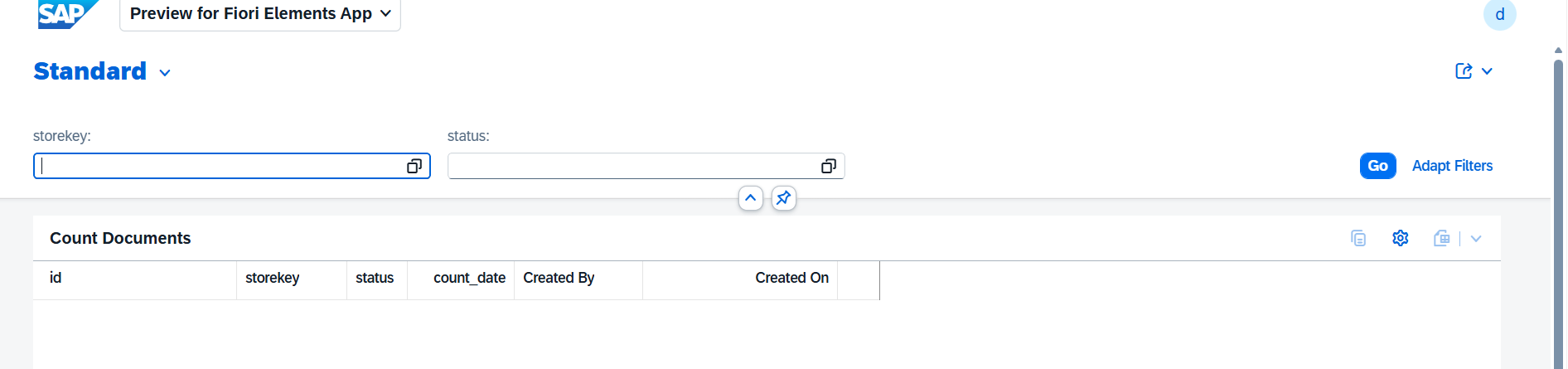

Create item Service building
@AccessControl.authorizationCheck: #NOT_REQUIRED
@EndUserText.label: 'Count Item - Projection'
@Metadata.ignorePropagatedAnnotations: true
@Metadata.allowExtensions: true
define view entity ZBUILD_ITEM_STORE
as projection on ZDDITEM_STORE
{
key id,
key item_no,
article,
@Semantics.quantity.unitOfMeasure: 'unit'
book_qty,
@Semantics.quantity.unitOfMeasure: 'unit'
counted_qty,
unit,
@Semantics.quantity.unitOfMeasure: 'unit'
difference,
is_counted,
DiffCriticality,
/* Associations */
_Header : redirected to parent ZBUILD_HEADER_STORE
}
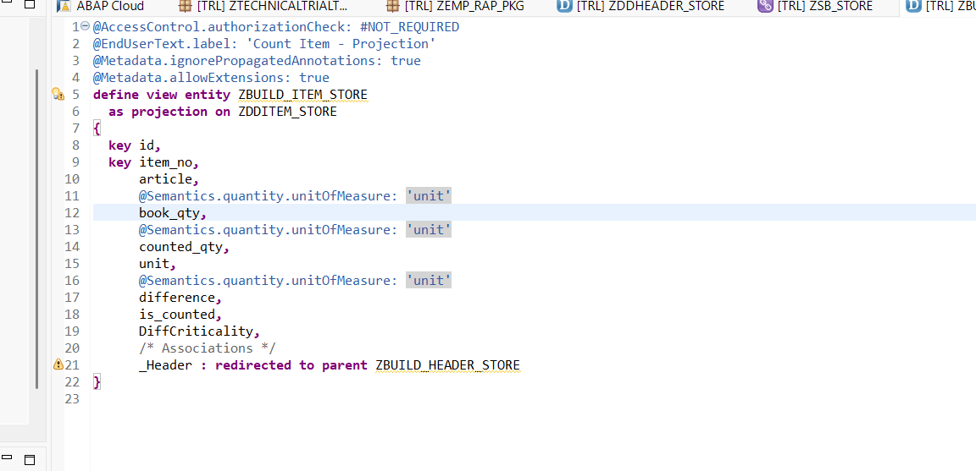

Service Definition
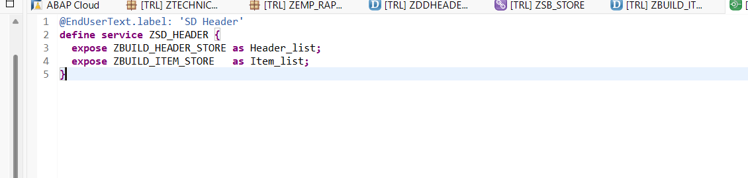
@EndUserText.label: 'SD Header'
define service ZSD_HEADER {
expose ZBUILD_HEADER_STORE as Header_list;
expose ZBUILD_ITEM_STORE as Item_list;
}

• Mobile counting: store employees will count on handhelds with unreliable Wi-Fi. How would you design a
freestyle UI5 app on top of your service so that no count is lost and nothing is posted twice?
Using local Json store

Classic landscape: how would you build the same solution on SAP ECC 6.0 EHP8 with a separate SAP
Gateway hub and classic ABAP only? What changes, and what would you do to make a later move to
S/4HANA easier?
You must change all code form old abap to new abap 7.4

