
College of Computing and Information Sciences
Department of Computing and Information Sciences
CSDS4105 B-Tech Course Project I
Final Review Report

A Multimodal AI Framework for Predicting Human Visual Attention in Web Interfaces

Submitted By:
Taha Ali 16J2337550
Deema Mas’Oud 16S2138
Elyas Ahmed Al Battashi 16J2332

Supervised by:
Dr. Ben George

Date of Submission: 16th May 2026
Academic Year: BTech Semester: 1

Declaration
(Semester - Fall, Academic Year 2025-2026)
To: Dr. Muna Saif Humaid Al Rahbi
Head of Department of Computing and Information Sciences
Thru: Dr. Ben George
Supervisor

I/we, the undersigned ___student(s) name(s)___ declare that:
1) the submitted work is my/our own work.
2) I/we understand the consequences of committing plagiarism.
3) I/we understand the evaluation criteria used to assess my/our work.

Student Signature: ID: Date:

Student Signature: ID: Date:

Acknowledgement
In the acknowledgement, the students thank their mentors/supervisors and colleagues for their support of the research. The acknowledgements should not exceed one page.

Abstract
Predicting human attention in webpages is not easy. Most models are trained on natural images, so they miss the point that webpages have structure. Elements like text, images, and buttons all change how users see a page. In this project, the idea is to use a multimodal deep learning model that mixes both visual and structural information to get better saliency prediction for webpages. The system takes a screenshot and the HTML/DOM, runs them through separate encoders, and then fuses the features before making a saliency heatmap with a decoder. First, the model is pretrained on SALICON to learn general attention, then fine-tuned on web datasets like UEyes and WebSaliency, and finally evaluated and tested on FiWi. Evaluation uses standard metrics such as CC, NSS, AUC-Judd, SIM, and KL-Divergence. The model uses both visual and structural features of webpages. The aim is to predict user attention accurately without eye-tracking.
Keywords: Multimodal Learning, Visual Attention, Saliency Prediction, Web Interfaces, Deep Learning, Human-Computer Interaction, Eye-Tracking, HTML/DOM Structure, Saliency Heatmaps, Transfer Learning

Table of Contents
Table of Figures 5
Table of Tables 5
Abbreviations 5
Chapter 1: Introduction 5
Background 6
1.1 Problem statement 6
1.2 Project objectives 7
1.3 Research Questions 7
1.4 Project Scope and Delimitations 7
1.5 Alignment with Oman Vision 2040 8
1.6 Academic, Scientific, and Innovation Significance: 8
1.7 Expected Outcomes & Contribution 8
1.8 Draft project plan (Gantt/timeline). 9
Project 1: 9
Project 2: 9
Chapter 2: Literature Review 9
Introduction 10
2.2 Foundational Concepts and Theoretical Framework 10
2.3 Critical Analysis and Synthesis of Related Studies: 11
2.4 Research Gap 20
2.5 Conclusion 21
Chapter 3: Research Methodology 21
Introduction 21
3.1 Research Design 22
3.2 Methodology 22
Data Collection 22
Model Development 23
Tools and Technologies 25
3.3 Conclusion: 26
Chapter 4: Preprocessing Datasets 26
4.2 Descriptive and Exploratory Data Analysis (EDA) 27
4.3 Data Pre-processing 31
4.3.1. Data Transformation: 31
4.3.2. Data Cleaning: 34
4.3.3. Data Reduction 36
Chapter 5: Model description: 37
Chapter 5 37
5.1 Overview of the Selected Model / Algorithm 37
5.2 Model Architecture / Structure 39
5.3 Implementation Plan 40
5.4 Evaluation Methods 42
5.5 Summary 43
Chapter 6: Conclusion & Future Work 43
6.1 Conclusion 44
6.2 Future Work (Sem 2 work) 44
Appendices 45
References: 45

Table of Figures
Figure 1: Gantt Chart - Project 1 11
Figure 2: Gantt Chart - Project 2 11

Table of Tables
Table 1: Literature Review Summary Table 17
Table 2: Dataset Description/Structure 25
Table 3: Model Selection Justification 32
Table 4: Tools & Libraries Summary 34
Table 5: Dataset Usage Summary 34
Table 6: Training and Testing Steps 35
Table 7: Evaluation Metrics Summary 37

Abbreviations
AI: Artificial Intelligence
HCI: Human-Computer Interaction
UI: User Interface
UX: User Experience
HTML: HyperText Markup Language
DOM: Document Object Model
EDA: Exploratory Data Analysis
CNN: Convolutional Neural Network
ResNet: Residual Neural Network
ViT: Vision Transformer
MLP: Multilayer Perceptron
SALICON: Saliency in Context
UEyes: User Interface Eye-Tracking Dataset
FiWi: Fixations in Webpage Images
CC: Correlation Coefficient
NSS: Normalized Scanpath Saliency
AUC-Judd: Area Under the Curve Judd Metric
SIM: Similarity Metric
KLD: Kullback-Leibler Divergence
GPU: Graphics Processing Unit
API: Application Programming Interface

Chapter 1: Introduction

Background
Human visual attention is basically how we focus on certain parts of a scene and ignore the rest, since we can't process everything at once. Computational models try to copy this by finding the spots in an image that people are most likely to look at. Usually, these spots are shown as saliency maps, which give an idea of where fixations happen across an image [1].
In computer vision, attention techniques help models focus on important features and ignore things that do not matter. Modern visual attention uses spatial and channel information. This helps the model see both small details and the bigger picture in images [1]. When we predict human visual attention on web pages, we use these ideas. Webpages have structure like text, images, and buttons. These elements guide where users look. Saliency heatmaps show us this. They help us check and improve webpage layouts without only using manual testing.
This report is divided into 5 chapters. Chapter 1 introduces the background of the study, the project objectives, and describes the problem statement that motivates the development of a multimodal framework for predicting human visual attention in web interfaces. Chapter 2 reviews the existing literature, focusing on existing work on visual attention modeling, saliency prediction, and datasets used in webpage attention analysis. Chapter 3 explains the research methodology, including datasets used, data preprocessing procedures, and the multimodal deep learning architecture developed for this project. Chapter 4 reports the experimental results and analyzes the performance of the proposed framework using established saliency evaluation metrics. Chapter 5 finally summarizes the study's outcomes and discusses potential directions for future research.

1.1 Problem statement
It is still hard to predict where users look on a webpage, even though computer models have gotten much better. The first problem is that most current models are trained on natural images, not webpages. Webpages are different because they are made up of things like text, buttons, images, and menus, all arranged in a certain way. This setup changes how people look around the page. Because of this, models trained only on natural images often struggle to perform well on web interfaces [2][6]. To address this, this project focuses on developing a multimodal deep learning model that uses both visual and structural data to better predict human attention on webpages.
The second problem is that there are not enough large eye-tracking datasets for webpages. Datasets like SALICON are helpful, but they are based on natural images and do not fully show how users interact with websites [3]. Webpage datasets are also much smaller, which can make it harder for the model to learn and generalize. As a result, this project focuses on improving the model’s ability to generalize effectively despite limited webpage datasets.
The third problem is that many models focus only on what is shown on the page and ignore how the webpage is set up. But the layout is important for guiding where people look. For example, where something is placed, how big it is, or if it is a button or text, can change where users look. To fix this, the project uses both images and HTML/DOM information to understand how the page structure [20]. A fusion mechanism combines visual and structural features so the model can learn how layout and content together influence user attention.
The fourth problem is that the output needs to be clear and useful. Predicting attention is not enough if the result cannot show where users are most likely to look. Therefore, this project generates saliency heatmaps that highlight the webpage areas expected to attract the most user attention. These heatmaps make the model output easier to understand.
The fifth problem is making sure the evaluation is reliable and fair. If models aren’t tested properly, it would be difficult to tell whether they are predicting human attention or just guessing. So in this project, the predicted saliency heatmaps are compared with real fixation maps from the FiWi dataset. The results are evaluated using saliency metrics like CC, NSS, AUC-Judd, SIM, and KL-Divergence. This way, the performance can be measured in a way that actually means something and the framework can be validated [4]. This approach makes sure the model performance is measured and validated using standard evaluation metrics.
This project helps advance multimodal AI methods for human-computer interaction and builds expertise in artificial intelligence and digital interface analysis, and it supports Oman Vision 2040 by encouraging innovation in AI system design and helping to develop national skills in AI, research, and digital innovation.

1.2 Project objectives
- To build a deep learning model that predicts human visual attention on webpages
- To improve the model’s performance on limited webpage eye-tracking datasets
- To combine visual webpage information with HTML/DOM structure in a multimodal framework
- To generate saliency heatmaps that visualize the webpage regions most likely to receive user attention
- To evaluate the model by comparing its predicted heatmaps with real fixation data using standard saliency metrics

1.3 Research Questions
- How can a multimodal deep learning model be used to predict human visual attention on webpages?
- How can the model maintain strong performance when trained on limited webpage eye-tracking datasets?
- How does combining visual features with structural (HTML/DOM) features improve the prediction of user attention?
- How well can the proposed multimodal framework generate saliency heatmaps that represent user attention on webpages?
- How accurately do the predicted saliency heatmaps match real user fixation data when evaluated using standard saliency metrics?

1.4 Project Scope and Delimitations
This project will build and test a multimodal AI model. The model will predict where people look on static desktop web pages. It will use different types of data. For example, it will use visual features and webpage structure like HTML and DOM. The main result is a 2D saliency heatmap. This heatmap shows which parts of the page people look at first. We only focus on static desktop pages. This helps us see how design and code structure change what people notice.
This project only studies desktop layouts. It does not include mobile or responsive web designs. These have different visual structures. We also only use static content. Dynamic or video elements are not included. The model does not use real-time webcam eye-tracking. It also does not use mouse movements or scrolling data.

1.5 Alignment with Oman Vision 2040
Education, Learning, Scientific Research, and National Capabilities
This project clearly supports the Scientific Research and Innovation priority. Oman Vision 2040 seeks to create a strong, independent research ecosystem that builds a knowledge-based society. By developing a Multimodal AI framework, this project helps Oman work toward its goal of being among the top 20 countries on the Global Innovation Index. It goes beyond theory by applying AI in practice, helping to develop skilled national talent for the 4th Industrial Revolution. This research not only produces a useful tool but also builds Omani expertise in a key future technology.
Economic Diversification and Fiscal Sustainability
Oman is working to build a digital economy in which non-oil sectors contribute more to GDP. This project supports that goal by offering something that can be commercialized to help the private sector dictate visual attention. This AI can help Omani e-commerce businesses and government websites improve user experience and lead to engagement. This directly supports the national goal of raising the digital economy’s share of technology-driven growth as an alternative to reliance on resources.

1.6 Academic, Scientific, and Innovation Significance:
In this study, we look at Human-Computer Interaction. We use a dual-stream approach. This means the model takes both raw visual data and web structure together. Our framework is cheaper and more automatic than using eye-tracking hardware. So, developers and researchers can do big simulations to test how people use websites. This helps make digital design better and more engaging. Also, our work helps Artificial Intelligence. We set new benchmarks for using multimodal data. This can help build digital environments that are easier for everyone to use.

1.7 Expected Outcomes & Contribution
This research develops a multimodal AI framework for predicting human visual attention on web interfaces. The model uses both visual screenshots and HTML or DOM data. The main outcomes and contributions are listed below.
Technical Deliverables:
Multimodal Prediction Model: The model uses two streams to process different types of data. It combines these features to predict saliency with high accuracy.
Saliency Heatmaps: The model creates 2D maps that show where users are likely to look on desktop web pages.
Scientific and Innovation Significance:
Addressing Model Bias: Many saliency models have a bias for natural images. This research trains the model for structured web environments to reduce this bias.
Structural Integration: The model uses w2ebpage code to improve the reliability of attention prediction. This helps in Human-Computer Interaction studies.
Cost-Effective UX Testing: The model gives an automated way to test user attention. Developers can use it to improve web layouts without expensive eye-tracking equipment.
National Alignment: The project supports Oman Vision 2040. It helps build local skills in Artificial Intelligence and supports national innovation.

1.8 Draft project plan (Gantt/timeline).

Project 1:

Figure 1: Gantt Chart - Project 1

Project 2:
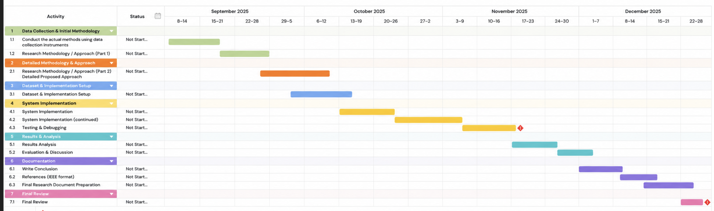
Figure 2: Gantt Chart - Project 2

Chapter 2: Literature Review

Introduction
Human visual attention is important in how users interact with web pages. When people visit a website, they do not look at everything equally. Instead, they focus on certain parts like images, titles, or buttons. This behaviour affects how users understand and use a webpage.
Most existing models that predict visual attention are trained on natural images. However, webpages are different because they have structure, such as text, menus, and layout elements. This makes it harder for these models to accurately predict attention on web interfaces.
In this project, a multimodal approach is used to solve this problem. The model takes both a webpage screenshot and its HTML/DOM structure as input. These are processed separately and then combined to improve prediction accuracy. The model is first trained on SALICON and then fine-tuned on webpage datasets like UEyes and WebSaliency, before being tested on FiWi.
This chapter introduces the project background, problem statement, objectives, and overall scope of the study.
2.1 Methodology of the literature review:
The methodology section illustrates the acquisition of associated research that this project is built upon. The papers were acquired from reputable sources such as IEEE xplore, ACM digital library, Springer, ScienceDirect, and Google scholar. These sites were chosen because they contain credible and peer-reviewed papers that focused on artificial intelligence, computer vision, and human computer interaction approaches/topics.
The keywords used to search for related works included: “visual attention”, “saliency prediction”, “webpage saliency”, “multimodal learning”, “eye-tracking”, and “deep learning”. These keywords were altered and combined throughout the search process to ensure that a sufficient number of papers were acquired. This search included saliency-related research in general as well as studies specific to web pages.
First, an initial broad search was conducted to acquire as many papers as possible. Then, the papers were sorted by those that were related to the project’s topic. Papers that were published more recently were given more consideration than others. Other deciding factors when selecting a paper included if the methodology and results were clear. Selected studies included ones that discussed saliency models, webpage saliency, multimodal approaches, and deep learning. Papers that were rejected consisted of ones that were not related to the topic at hand. Other reasons for rejection included older studies and papers that did not mention their experiment results.

2.2 Foundational Concepts and Theoretical Framework
This project uses some main concepts from artificial intelligence. One concept is human visual attention. This means when people look at a webpage, they do not look at every part the same. Some things catch the eye more, like images, titles, or buttons. We can show this using saliency maps. These maps highlight the places where people usually look first [2][6].
It is not easy to predict where people look on webpages. It is different from natural images. Old models learned from image datasets, where people look at colors or contrast. But webpages have more things, like menus, text, and buttons, in special places. So, models that only use natural images do not work well for webpages [2][6][14]. In this project, the model uses both screenshots and HTML structure. This helps it understand how the page looks and how it is made.
This project uses multimodal learning, where the model takes more than one type of input. It works with a webpage screenshot and HTML/DOM data at the same time. The screenshot captures visual features like layout, color, and spacing, while the HTML provides information about element type, position, and size. Since user attention is affected by both appearance and structure, combining these inputs improves attention prediction accuracy [7][20].
Deep learning is used to extract features from both inputs. In the visual branch, models such as ResNet and Vision Transformer (ViT) are used to learn visual patterns from webpage screenshots. These models can capture complex spatial relationships and adapt well to different types of visual data [6][8][10][18]. Fine-tuning deep models on webpage datasets improves their performance compared to using models trained only on natural images [14]. Work on cross-modality interaction also supports combining different types of features, where models learn relationships between inputs instead of treating them separately [19].
The structural part of the model focuses on understanding webpage layout. Features such as element type, position, and size are extracted from HTML and processed using a structural encoder, allowing the model to understand how layout affects attention, and not just the visual appearance. Combining HTML structure with visual features leads to better results in webpage attention prediction [7].
After that, the model combines the visual and structural features. This helps it learn how the look and the layout work together. For example, something in the center of the page can get more attention than the same thing at the side. The model learns these kinds of relationships in this step.
The model predicts saliency by making a heatmap. This heatmap shows where people look on the webpage. A decoder network takes the combined features and makes this map.
This project is also related to human-computer interaction. Where users look first affects how they interact with a website, and saliency maps can help designers improve layout and usability. Eye-tracking and interaction data are used to better understand user behavior [9]. At the same time, attention patterns are not always consistent and can vary depending on the user and context, which makes predictions more difficult [8][15].
Transfer learning is used because webpage datasets are limited. The model is first trained on SALICON, then fine-tuned on datasets like UEyes and WebSaliency, and tested using FiWi. The model is evaluated using metrics such as CC, NSS, AUC-Judd, SIM, and KL-Divergence to compare predicted heatmaps with real user data [4].

2.3 Critical Analysis and Synthesis of Related Studies:
    - Visual Attention and Saliency Prediction in User Interfaces
Many studies agree that predicting attention in user interfaces is different from working with natural images. Jiang et al. created the UEyes dataset using eye-tracking experiments on different interface types such as mobile apps and webpages [2]. They recorded where users looked and then tested several saliency models on this data. It became clear that models trained on natural images perform worse when put to UI data. The dataset and evaluation setup are strong, but it stops at benchmarking and does not provide a model to solve this problem.
Corradini et al. worked on reducing this gap by fine-tuning existing models like SalGAN and PathGAN using webpage screenshots [14]. They started with the FiWi dataset and expanded it by adding more webpages and user data. The models follow an encoder-decoder structure and were retrained to predict both saliency maps and gaze paths. This improved prediction accuracy compared to models trained only on natural images. The method works better in practice, but it still depends on visual input only rather than layout and structural features like HTML.
Kenely et al. looked more closely at how attention works in real interfaces, especially news websites [8]. Their framework is based on the SaRa model, but they replaced the saliency generator with DeepGaze IEE. Their pipeline includes three main steps, which is to generate a saliency map, divide the interface into grid segments, and assign scores based on factors such as entropy and center bias. They also applied Gaussian filtering to reduce noise. One strong part of this work is the data collection, where eye-tracking was used with 30 participants and mouse-tracking with 375 users to study attention across age groups. It gives both prediction and behavioural insights, but it is limited to news interfaces.
Schoop et al. took a slightly different approach by focusing on tappability in mobile interfaces. Their model uses visual features from UI screenshots and is trained on datasets like RICO and ERICA [12]. They mix saliency analysis with visual cues to guess which parts users think they can tap or click. This links attention with user actions, not just where people look. The method helps to understand behavior, but it only works for mobile apps and not for full webpages.
Gonzalez et al. added another layer by including demographic factors, especially gender [15]. They trained a deep learning model based on TranSalNet using the WIC640 dataset, which contains eye-tracking data from 85 participants. The model learns different attention patterns across user groups, and results showed noticeable differences in how users look at interfaces. The concept is important because it shows that attention is not the same for everyone, but the study only focuses on one factor and does not cover all possible influences.
All these points show that attention in user interfaces is not only about visual features. Layout, type of elements, and user differences also change where people look. Also, many models still rely on natural image data or only look at one part of the problem. So, we still need models that fit real webpages better.
    - Webpage Saliency Prediction
Predicting where people look on webpages is harder than with regular images. Faiz et al. reviewed deep learning methods and found that most models still use encoder-decoder structures. They usually rely on CNNs to get visual features and generate saliency maps [6]. The problem is, a lot of these models use transfer learning from natural image datasets, which doesn't really fit because webpages have their own layouts and patterns. The study points this out clearly, but it doesn't build a new model. It's just analysis.
Ingaki et al. tried to fix this by mixing visual saliency with HTML structure [7]. They start by taking a screenshot of the webpage and grabbing the HTML using web scraping. From the image, they make a visual saliency map (VSM) based on things like color and brightness. Then they pull out webpage elements like text, images, and menus from the HTML, and check their size and position. After that, they combine both sources to get saliency scores for each part. The results are shown as a Visual Saliency Area Map (VSAM). This method is good for showing how to add structure, but it's more about analysis and visualization than actually building a learning-based model.
Corradini et al. wanted to make these models work better for webpages. They took SalGAN and PathGAN, which were first trained on natural images, and retrained them using webpage data like FiWi [14]. The models still use an encoder-decoder structure, but now they actually learn patterns from webpages. This gives better results, but the method still mostly sticks to visual features. It doesn't really use other structural info like HTML or DOM.
Hossein et al. built a unified model (SUM) that works on different datasets, including webpages [10]. SUM uses a U-Net structure with a Mamba-based module and a Conditional Visual State Space (C-VSS) block. This setup helps the model catch both local and long-range patterns, and adapt to different data types. It does well across datasets, but since it's a general model, it doesn't really focus on webpage structure.
Some studies use transfer learning with CNN-based encoder-decoder models. Others try to add structural info step by step. A few go for general models that work on any dataset. Still, most models either stick to visual features or only use structure in a basic way. There's definitely room for better approaches that actually combine both.
    - Behavioral and Multimodal Attention Approaches
Some studies do not just treat attention as a visual task. They also look at user behavior and other signals. For example, Souza et al. used a model called AIT2-UX [9]. It combines eye-tracking, mouse movements, keyboard input, and user feedback. These signals are collected while users interact with the system. Then, models like Decision Trees (DT), Support Vector Machines (SVM), and Multilayer Perceptron (MLP) use these features to classify user experience levels. This means attention is not only about where people look, but also how they interact. But the model is more about classifying users, not predicting saliency maps.
Das et al. studied how attention changes in different situations [11]. They focused on things like visual highlighting and cognitive load. They collected eye-tracking data while users did tasks on webpages. They used a model based on SimpleNet. First, they trained it on SALICON. Then, they fine-tuned it on their own dataset. The results showed that highlighted elements get more attention. When cognitive load is high, users look at less of the page. This is closer to real user behavior, but the study used controlled experiments.
Bhargave et al. made a model called UniAR [13]. It predicts both attention and user responses together. The model is trained on several datasets. It uses a transformer-based architecture to find links between visual content and how people respond. This makes the model flexible. But it still mostly uses visual input. It does not use structure like HTML or user interaction data.
Wang et al. focused on scanpath prediction, which looked at attention as a sequence instead of a single heatmap [16]. Their model predicts scanpaths, which represent the order in which users look at different areas. This gives a more realistic view of how attention changes over time. The downside is that the model becomes more complex and harder to evaluate compared to standard saliency methods.
Cong et al. made a model called CIR-Net [19]. It uses both RGB and depth data. The model has three streams and uses modules like PAI, refinement units, and gated fusion to combine the data. They tested the model on datasets like NJUD, NLPR, STEREO797, CUT, LFSD, and SIP. The main idea is to use attention and dynamic weighting to get information from both types of data. The model works well, but it only uses visual data. It does not use behavioral signals.
    - Evaluation Methods and Modeling Challenges
Checking saliency models is not just about seeing if the predictions look right. Most studies compare the predicted saliency maps with real eye-tracking data. They use different metrics for this. But this way also has some problems. Sousa et al. studied this more, especially for complex things like $360°$ videos [17]. They did not just compare models. They used something called performance bounds to check model quality. They made two bounds: Equator Bias as a lower bound and Saliency Sum as an upper bound. Both use eye-tracking data from the PAVS10K dataset. Equator Bias uses a Gaussian distribution of fixation points. Saliency Sum combines fixation maps from many users into one map. They used metrics like AUC-Judd, NSS, and CC. This method gives a better idea of how good a model is, not just if it is better than another model. But this method is for immersive video. It is not used much for webpages.
Ignat et al. tried to improve both the model and the way we check it using transformer-based methods [18]. Their model is called MDS-ViTNet. It uses a Vision Transformer, called Swin Transformer, to find global relationships in the image. After that, it uses two CNN decoders to make the saliency maps. They trained the model on datasets like SALICON and CAT2000. They checked the results using metrics like AUC, CC, SIM, and KL-Divergence. The results were good. For example, AUC was 0.87 and CC was 0.89. These are better than many CNN-based models. This means finding long-range relationships helps. But the model is also more complex and needs more computation.
Hosseini et al. worked on a different problem. Most saliency models are made for just one dataset or one type of data [10]. They made the SUM model. It is based on a Mamba U-Net and uses a Conditional Visual State Space module. They trained it on many datasets like SALICON, MIT1003, CAT2000, OSIE, U-EYE, and SalECT. This helps the model work with different kinds of visual data, like natural images and also structured interfaces. Their results show strong performance on many benchmarks. The SUM model does better than several other models. Having one model that works for many domains is useful. But it also makes training harder and needs more resources.
    - Literature Review Summary
Table 2.3 shows a summary of the studies reviewed in this chapter. It includes the title, authors, research gap, methodology used, the outcomes and results, and the future work for each paper.
Table 1: Literature Review Summary Table
S.No | Title | Author(s) | Year | Research Gap | The Method has been used to solve the problem | Outcome/Result | The Future work
1 | UEyes: Understanding Visual Saliency across User Interface Types | Y. Jiang, L. A. Leiva, H. R. Tavakoli, P. R. B. Houssel, J. Kymala, A. Oulasvirta | 2023 | Many existing saliency models are trained using natural image datasets. Because of this, they often struggle to accurately predict where users look when viewing structured environments such as websites or mobile application interfaces. | The authors created the UEyes dataset using eye-tracking experiments on different types of user interfaces. They then evaluated several existing saliency prediction models to see how well they perform on UI layouts. | The results showed that many current saliency models perform much worse on user interfaces than on natural images, which makes predicting user attention in structured digital layouts more difficult. | Developing saliency models that better capture the structure and layout of user interfaces to improve attention prediction accuracy.
2 | A Systematic Review of Deep Learning Approaches to Visual Saliency Prediction on Webpage Images | Faadihilah Ahnaf Faiz, Sunu Wibirama, Hafzatin Nurlatifa, Noor Akhmad Setiawan | 2024 | Research on saliency prediction has its primary focus on natural images, while webpages have received much less attention. Webpages contain different visual elements such as text blocks, images, and advertisements, which makes attention prediction more complex. | the study conducted a systematic literature review following Kitchenham’s method. A total of 13 relevant studies publishes between 2014 and 2023 were analyzed to identify commonly used datasets, deep learning models, and evaluation metrics in webpage saliency prediction research. | the review showed that available datasets for webpage saliency are still limited. It also found that models trained on natural images often perform poorly when applied to webpages because the visual structure is very different. | Explore better feature representation and deep learning approaches that can capture the structure and layout of webpages more effectively.
3 | Webpage Validation by Visualizing Importance Area | Yuya Inagaki, Junko Shirogane, Hajime Iwata, Yoshiaki Fukazawa | 2023 | Traditional saliency approaches are usually designed for natural images and do not fully consider the structure and layout of webpages. Since webpages are built using HTML elements such as text blocks, images, and menus, it becomes difficult to accurately identify which areas attract the most user attention | A webpage-specific visual saliency map (VSM) was developed by combining visual saliency analysis with the HTML structure of the webpage. The system analyzes webpage screenshots and HTML layout information to calculate the importance of different webpage elements and then visualize them using Visual Saliency Area Maps (VSAMs) | The designed method was able to visualize important regions of webpages and provide useful insights into how users may visually interact with webpage elements using VSAM visualization and help evaluate whether important information is placed in noticeable positions. | Focus on improving prediction accuracy and applying the approach to a wider range of webpage layouts, design styles, and include additional user interaction data.
4 | A Deep Learning Framework for Visual Attention and Prediction and Analysis of New Interfaces | Matthew Kenely, Dylan Seychell, Carl James Debono, Chris Porter | 2025 | Current saliency datasets for user interfaces are often small and lack demographic diversity. This limits the ability of models to generalize across different groups of users and real-world interface designs | The study developed a deep learning framework that improve SaRa saliency ranking model by integrating DeepGaze IIE to generate saliency maps. The framework also includes grid-based segmentation and normalization steps to better rank important interface elements. Eye-tracking data from 30 participants and mouse-tracking data from 375 participants were collected to analyze attention patterns on news website interfaces. | The improved framework achieved better saliency performance, with a 10.7% improvement in Salient Object Ranking (SOR) compared to the original method. Results also found clear differences in attention patterns between age groups, where younger users tend to focus more on images and older users paid more attention to textual content. | Collecting larger datasets with more diverse participants and exploring how demographic factors influence visual attention in user interfaces
5 | An Evaluation Framework for User Experience Using Eye Tracking, Mouse Tracking, Keyboard Input, and Artificial Intelligence: A Case Study | Kennedy Edson Silva de Souza, Igor Leonardo de Aviz, Harold Dias de Mello, Karla Figueiredo, Marley Maria Bernardes Rebuzzi Vellasco, Fernando Augusto Ribeiro Costa, Marcos Cesar da Rocha Seruffo | 2022 | User experience evaluation often depends on questionnaires and subjective feedback, which may not fully reflect how people actually interact with the interface during real tasks. There is still a need for a framework that combines multiple sources, such as eye movements, mouse activity, and keyboard input, alongside AI techniques to better understand user behavior and usability. | This study built a UX evaluation framework called AIT2-UX that collects interaction data using eye-tracking, mouse-tracking, keyboard input, and questionnaires. Machine learning models including DT, SVM, and MLP were then used to classify users as experienced or non-experienced. | The Decision Tree model achieved the best performance in identifying experienced and non-experienced users. The framework also generates useful artifacts like heatmaps and usability metrics to analyze user behavior. | The authors suggest applying the framework to different types of websites and larger groups pf users to better understand interaction patterns across different contexts, they also suggested improving the framework and using it to automatically customize website interfaces for different types of users.
6 | SUM: Saliency Unification through Mamba for Visual Attention Modeling | Alireza Hosseini, Amirhossein Kazerouni, Saeed Akhavan, Michael Brudno, Babak Taati | 2025 | Saliency models are often designed for specific datasets or tasks, which can limit their ability to perform well across different visual environments | In this work, the researchers developed a model called SUM, which is built on Mamba-based U-Net architecture with a Conditional Visual State Space (C-VSS) module. The model was designed to handle different types of visual data within one framework. It was trained and tested using multiple datasets, including SALICON, MIT1003, CAT2000, OSIE, U-EYE, and SalECI, covering natural scenes, webpages, and e-commerce images. | Across the experiments, the SUM model performed strongly on different benchmarks. It successfully achieved state-of-the-art results in most evaluation metrics, outperforming many previous models. The results also show that the model can handle different types of visual data effectively | Further evaluation on more real-world interface datasets and improvements to the model architecture may help capture more complex visual attention patterns
7 | Shifting Focus with HCEye: Exploring the Dynamics of Visual Highlighting and Cognitive Load on User Attention and Saliency Prediction | Anwesha Das, Zekun Wu, Iza Skrjanec, Anna Maria Feit | 2024 | Interface designers often use visual highlighting to guide user attention, but its effect on attention behavior and cognitive load is still not fully clear. There is limited research on how highlighting changes where users focus when interacting with an interface. | The researchers collected eye-tracking data from 27 participants while they viewed 150 webpages under different conditions. Some pages had static or dynamic highlights, and participants also performed tasks that created different levels of cognitive load. They analyzed fixation patterns and used this data to train and evaluate saliency models based on SimpleNet, pre-trained on the SALICON dataset and then fine-tuned using the HCEye dataset. | The results showed that visual highlighting strongly influences where users look. Dynamic highlights attracted attention more effectively than static ones, even when users were under higher cognitive load. It was also shown that when cognitive load increases, users tend to look at fewer areas but focus on them for a longer time. | Exploring how these factors can be integrated into saliency models to better predict user attention in real web interfaces and testing the approach on a wider range of interface layouts may provide deeper insight into how highlighting shapes user attention.
8 | Predicting and Explain Mobile UI Tappability with Vision Modeling and Saliency Analysis | Eldon Schoop, Xin Zhou, Gang Li, Zhourong Chen, Bjoern Hartmann, Yang Li | 2022 | In many mobile interfaces, it is not always clear which elements are interactive. This can confuse users and make navigation harder. Existing models also struggle to reliably predict which elements users perceive as tappable. | A vision-based model was used to analyze mobile interface screenshots and predict which elements users are likely to tap. The model was trained using UI datasets such as RICO and ERICA, along with a cleaned subset of RICO with extra annotations for tappable elements. Saliency analysis was applied to examine which visual cues affect how users interpret interactive elements. | The model was able to identify and predict tappable elements with strong accuracy and provided insights into which visual cue affects user interaction with interface elements. | Evaluating the model on more interface designs and improving interpretability may help better understand how visual features affect user interaction
9 | UniAR: A Unified Model for Predicting Human Attention and Responses on Visual Content | Peizhao Li, Junfeng He, Gang Li, Rachit Bhargava, Shaolei Shen, Nachiappan Valliappan, Youwei Liang, Hongxiang Gu, Venky Ramachandran, Golnaz Farhadi, Yang Li, Kai J. Kohlhoff, Vidhya Navalpakkam | 2024 | Research on visual attention and user responses is often handled using separate models, which makes it harder to capture different aspects of human behavior within a single system. | UniAR was developed as a deep learning model that learns patterns of human attention and behavioral responses from visual content. The model analyzes visual features in images and predicts where viewers are likely to focus. The model was trained using 11 public datasets covering natural images, webpages, graphic designs, and mobile interfaces. | Experimental results showed that UniAR performed very well across several benchmark datasets. In many cases it performs better than previous models and is able to predict user attention patterns across different visual content. | Testing the model on more datasets and refining the architecture may help improve how well it captures complex attention patterns.
10 | Fine-tuning SalGAN and PathGAN for Extending Saliency Map and Gaze Path Prediction from Neural Images to Websites | Enrico Corradini, Gianluca Porcino, Alessandro Scopelliti, Domenico Ursino, Luca Virgili | 2022 | Most saliency models are trained using natural images. Because of this, they often do not perform well when applied to structured layouts such as webpages, which creates difficulties in predicting user attention on websites. | SalGAN and PathGAN models were fine-tuned using webpage screenshots so the models could better adapt to website layouts. The models were then used to predict both saliency maps and gaze paths on webpages. They started with the FIWI dataset and created a larger dataset by adding more webpages and participants for training and testing | The fine-tuned models produced more accurate predictions of user attention on webpages compared to models trained only on natural images. The results show that fine-tuning saliency models with webpage data improves attention prediction. | Applying the approach to larger webpage datasets and exploring additional model improvement may further improve prediction accuracy.
11 | A gender-aware saliency prediction system for web interfaces using deep learning and eye-tracking data | Pablo Villanueva Gonzalez, Cristobal Subiabre Cuevas, Lino Jeldez, Benjamin Torreabla Troncoso, Maria Flavia Guiñazú , Juan D. Velasquez | 2025 | Visual attention models for web interfaces rarely consider demographic factors such as gender, even though different groups may focus on different parts of a webpage | A deep learning saliency model based on TranSalNet was trained using a dataset called WIC640. The dataset contains 640 webpage screenshots and eye-tracking data collected from 85 participants. | The results showed noticeable differences in how male and female users view web interfaces. The model trained on the full dataset produced the most accurate attention predictions, likely because of the more diverse training data | Expanding the dataset and exploring additional demographic factors will help improve personalized attention prediction for web interfaces.
12 | Scanpath Prediction on Information Visualization | Yao Wang, Mihai Bace, Andreas Bulling | 2024 | Studies focus on predicting saliency maps more, but fewer examine scanpaths, which describe the order in which users look at elements in visualization | A unified model called UMSS was used to predict both saliency maps and scanpaths on information visualization. The model was trained and evaluated using eye-tracking data from the MASSVIS dataset, which contains gaze recordings from users viewing different visualization | The model generated realistic gaze sequences and showed improvements in scanpath prediction and saliency prediction performance compared to existing approached | Testing the model on other types of visual content may help improve how well it predicts user attention patterns
13 | Performance Bounds for Computational Models of Visual Saliency in 360 Videos | Aline F.G. Sousa, Clebson S. Silva, Ronaldo F. Zampolo | 2025 | Evaluating saliency models for immersive or 360 degrees videos is difficult because there are no clear reference limits to measure model performance. Without these limits, it becomes harder to understand how accurate a saliency model is when predicting human attention. | Two approaches were used to estimate the upper and lower performance bounds for saliency prediction in immersive videos, Equator Bias and Saliency Sum. Experiments were conducted using the PAVS10K eye-tracking dataset. | The experimental results showed that the Saliency Sum achieved the highest scores among metrics such as AUC-Judd, NSS, and CC, while Equator Bias produced the lowest scores, representing upper and lower performance bounds | The approach can be extended to larger immersive video datasets and additional saliency models to improve evaluation methods
14 | MDS-ViTNeT: Improving Saliency Prediction for Eye-Tracking with Vision Transformer | Polezhaev Ignat, Goncharenko Igor, lurina Natalya | 2024 | CNN models were commonly used for saliency prediction, but they mainly focus on small areas of the image. Because of that, they miss the bigger picture and have difficulty understanding long-range relationships across the image. | The model uses an encoder-decoder structure where a Vision Transformer (Swin Transformer) is used to extract multi-scale features from the image, and two CNN decoders generate saliency maps that are later combined into a final output. It was trained and evaluated using SALICON and CAT2000 datasets. | The model performed strongly with an AUC of 0.87, CC of 0.89, SIM of 0.79, and KL-divergence of 0.22, outperforming models like TranSalNet. | Further improvements can target efficiency and explore more advanced transformer-based designs.
15 | CIR-Net Cross-Modality Interaction and Refinement for RGB-D Salient Object | Cong Rui, Huo Qibin, Jiang Wei, Li Yao | 2022 | Most RGB-D saliency models don’t fully capture how RGB and depth complement each other, especially when combining features across both encoder and decoder stages. | They used a three-stream encoder-decoder model with a ResNet backbone to extract features from RGB and depth. Uses attention-based fusion in the encoder, gated fusion in the decoder, and a refinement module in between. Tested on NJUD, NLPR, STEREO797, CUT, LFSD, and SIP datasets. | The model achieved high and strong results, like F-measure 0.938 and S-measure 0.935 on NJUDm and F-measure 0.933 with MAE 0.0227 on NLPR | More efficient models and better handling of limited training data can still be explored.

2.4 Research Gap
Looking at the studies so far, there are still some problems with predicting visual attention on web interfaces. Most saliency models are trained on natural image datasets like SALICON. They work fine for regular images, but they don't really get how people look at webpages. Webpages have structure, things like text blocks, menus, and buttons. Because of that, models made for images don't always fit web environments.
Another problem is that there aren't many big eye-tracking datasets for webpages. This makes it harder for models to perform well or generalize. Also, most research only looks at certain parts of attention prediction instead of trying to solve the whole problem.
This project uses a multimodal approach. Visual features from webpage screenshots are combined with structural features from HTML or DOM data. Transfer learning is used by pretraining on large natural image datasets, then fine-tune on datasets made for webpages. This should help the model predict attention more accurately and actually match how people look at web interfaces.

2.5 Conclusion
Saliency prediction has developed over time. Early models such as SalGAN and TranSalNet perform well on natural images. These models do not capture the differences in web interfaces. The Natural Image Bias is a common problem. Models trained on photos do not handle webpage structure well. Studies such as Jiang et al. and Corradini et al. show that fine-tuning on webpage screenshots improves results. Most models still use only visual features. They do not include HTML structure, element types, or the position of elements on the page. These structural details affect where users look and how they interact.
There is a research gap in combining visual and structural data in one prediction model. Some studies such as Inagaki et al. combine these sources by hand for visualization. Automated learning-based frameworks that join these types of data during encoding are missing. This project proposes a multimodal deep learning framework. The model uses a dual-stream encoder to process webpage screenshots and structural data. Transfer learning from the SALICON dataset is used. Fine-tuning is done on web-specific data such as UEyes and WebSaliency. This method gives a cost-effective and validated alternative to physical eye-tracking. The approach supports research in Human-Computer Interaction and matches the digital innovation goals of Oman Vision 2040.

Chapter 3: Research Methodology
Introduction
This chapter goes through how the system was built using a multimodal pipeline. The goal is to predict where people look on webpages by using both the screenshot and the HTML structure. Each input goes through its own branch, and then they get combined to make a saliency heatmap that shows likely user attention.
This method uses multimodal deep learning. Attention on webpages is not just about how things look. Structure is important too. For example, the type of element, its position, and the layout all matter. By using both visual and structural data, the model can learn these patterns together. It does not just learn from images. This makes the method fit real web interfaces better and helps with the problems mentioned earlier.
The training process is clear. First, the model learns general attention patterns from a big dataset like SALICON. Then it gets fine-tuned on webpage datasets like UEyes and WebSaliency. In the end, it’s tested on the FiWI dataset. This way, the model gets better at handling real webpage data but still keeps good generalization.
This chapter has several main sections. Section 3.1 explains the research design and the reason for its selection. Section 3.2 describes the methodology. It includes data collection, preprocessing, and model development. The tools and technologies used are listed. The chapter ends with a summary of the methodology and its connection to the project objectives.

Research Design
This study uses a Design and Development approach. The main objective is to build a new multimodal AI model for predicting where users look on web interfaces. The method is suitable because the research creates and tests a new model. Most current saliency models do not use structural HTML data. The process has several steps. First, the system architecture is designed. Then, the model is implemented using transfer learning. After that, the model is validated. There is also an Experimental part for evaluation. The model is tested on the FiWi eye-tracking dataset. Metrics such as CC, NSS, and AUC-Judd are used. The model is checked with real user data.

Methodology

Data Collection
Public saliency and eye-tracking datasets are used to train and evaluate the proposed multimodal model, and these datasets are not merged into a single dataset but used in stages. SALICON is used for pretraining, UEyes and WebSaliency are used for webpage-specific training, and FiWi is used for final evaluation, while an additional image-to-HTML generated dataset supports the structural branch of the model.
Table 2: Dataset Description/Structure
Dataset | Data Type | Size | Main Content | Purpose in this project
SALICON | Natural image saliency dataset | 10,000 training images, 5,000 validation images, and 5,000 test images | Natural images, fixation points, gaze trajectories, and saliency maps for training and validation. The test set does not include gound-truth annotations | Used to pretrain the visual encoder so the model can learn general human attention patterns
UEyes | UI eye-tracking dataset | 1,980 UI screenshots from 62 participants | UI screenshots, gaze data, saliency maps, scanpaths, and UI metadata | Used for fine-tuning the model on interface attention patterns
WebSaliency | Webpage saliency dataset | 450 webpage images viewed by 41 participants | Webpage screenshots, fixation points, and saliency maps | Used for webpage-specific training and fine-tuning
FiWi | Webpage eye-tracking dataset | 149 webpage screenshots | Webpage screenshots, fixation maps, and saliency maps | Used for final testing and evaluation on unseen webpage data
Image-to-HTML Generated Dateset | Structural webpage representation | One generated HTML layout per webpage or UI screenshot | Generated HTML/DOM layout, element types, positions, sizes, hierarchy, text length, and font information | Used to create structural features for the HTML/DOM branch of the model

SALICON is the largest dataset in the project, containing 10,000 training images, 5,000 validation images, and 5,000 test images [5]. Ground-truth saliency annotations are available only for the training and validation sets, while the test set is mainly used for challenge evaluation. In this project, SALICON is used to pretrain the visual encoder, allowing the model to learn general human attention patterns before training on webpage-specific data.
UEyes and WebSaliency are used for training and fine-tuning. UEyes includes 1,980 UI screenshots from 62 participants, covering different interface types such as webpages, desktop UIs, mobile UIs, and posters [2]. WebSaliency has 450 webpage images with gaze fixation data, making it useful for webpage-specific saliency training [21]. These datasets help the model adapt from general image saliency to interface and webpage attention prediction.
In the structural branch, the process starts by converting webpage screenshots into approximate HTML layouts using image-to-HTML conversion, and from the generated HTML/DOM structure, features like element type, x and y position, width, height, text length, font style, and hierarchy are extracted. These structural features are paired with the original screenshot, and then the screenshot is sent to the visual encoder while the HTML/DOM features go to the structural encoder. After that, the outputs from both branches are combined by a fusion module, allowing the decoder to generate the final predicted saliency heatmap.
FiWi is used as the final evaluation dataset, and it contains 149 webpage screenshots with fixation maps and saliency maps, so the trained model can be tested on unseen webpage data by comparing the predicted heatmaps with real human fixation maps using CC, NSS, AUC-Judd, SIM, and KL-Divergence. This staged process helps the model learn general attention first and then focus on webpage-specific attention, so the final evaluation on unseen webpage data is fairer.

Model Development
The model predicts attention on webpages using multimodal deep learning. The process starts by sorting the datasets. First, it is trained on SALICON, a dataset of natural images. This helps the model learn general attention patterns before it handles web-specific content. After that, it is retrained on datasets such as UEyes and WebSaliency, so it can learn how users look at real webpages. For evaluation, FiWi is used to check how accurate the model really is.
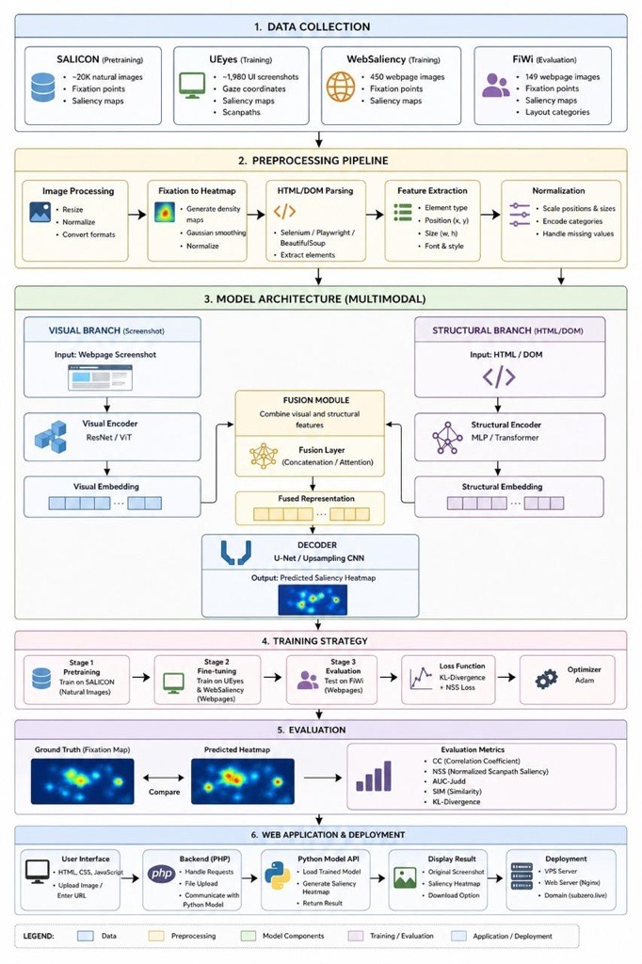
Figure 3: Proposed Multimodal Web Attention Prediction Workflow
As shown in Figure II, the proposed model follows a dual-branch multimodal architecture that combines visual webpage features with structural HTML/DOM features before generating a saliency heatmap.
The system uses two types of input. One is the screenshot of the webpage. The other is the webpage's HTML structure. These go into two branches. The first branch is for visual processing. Here, the screenshot is resized and normalized. Then it feeds into a visual encoder, such as ResNet or Vision Transformer. This part of the model looks at features like color, contrast, layout, and where the text sits. It makes a visual embedding vector from these features.
The structural branch process the HTML content. The HTML is converted into structured features. Tools such as Salenium, Playwright, or BeauitfulSoap are used. The features include element type, position, size, and font properties. These features are processed by a structural encoder. The encoder can be MLP or Transformer. The output is a structural embedding vector.
The visual embedding and structural embedding are combined in a fusion layer. This creates a unified representation. The model can learn the relationship between visual layout and webpage structure in this step.
The fused representation goes into a decoder network. An upsampling CNN or U-Net style model can be used as the decoder. The decoder produces a saliency heatmap. The output shows predicted user attention on the webpage.
The model is evaluated using the FiWi dataset. Predicted saliency maps are compared with real human fixation maps. Metrics like CC, NSS, SIM, KL-Divergence, and AUC-Judd are used to measure performance. The main thing is to see how close the model’s predictions are to actual human gaze.

Tools and Technologies
This project utilizes a range of programming languages and software tools to develop a multimodal saliency prediction model and a supporting web-based interface.
Programming Language
The primary language used is Python, due to its strong capabilities in artificial intelligence, data processing, and scientific computing.
Deep Learning Frameworks
The model is developed and trained using TensorFlow and PyTorch, which provide efficient tools for building and optimizing neural networks.
Model Architecture
To extract visual features, the project employs advanced encoder models such as ResNet and Vision Transformer (ViT). For generating saliency maps, a decoder architecture such as U-Net is used, enabling accurate spatial predictions.
Data Processing and Image Handling
Libraries including NumPy and Pandas are used for data manipulation and numerical operations. OpenCV is applied for image preprocessing tasks such as resizing, normalization, and filtering.
Web Scraping and Data Collection
Web data is collected using Selenium, Playwright, and BeautifulSoup. These tools extract webpage structural information (DOM), including element types, positions, and sizes, which are essential for multimodal analysis.
Development Environment
Experiments and model development are conducted in Jupyter Notebook and Google Colab, both of which support GPU acceleration to improve training performance.
Version Control
Git and GitHub are used for version control, allowing efficient tracking of changes and project management.
Data Visualization
To analyze and present results, Matplotlib and Seaborn are used to generate saliency heatmaps and performance visualizations.
Web Application Development
A web-based interface is developed to allow users to interact with the model. The frontend is built using HTML, CSS, and JavaScript, providing a simple and responsive user interface for uploading images or entering webpage URLs.
The backend is implemented using PHP, which handles user requests, manages file uploads, and communicates with the Python-based model for processing. The system returns the generated saliency maps to the user through the web interface.
Deployment
The application is deployed on a VPS server and configured using standard web server tools, making it accessible online through a domain.

Conclusion:
This chapter goes through how the project This chapter goes through how the project works, step by step. It starts with collecting data from different places, like webpage screenshots and HTML structure. After that, the data gets cleaned up and ready for the model. The model has two branches. One handles the visual features, the other handles the structure. Then both are combined to make saliency heatmaps. These maps show where users are most likely to look.
The way the project matches the main objectives, especially when it comes to mixing visual and structural information for better predictions on webpages. Using transfer learning and testing on different dataset helps the model learn both general attention patterns and those that are specific to web layouts. The process is clear and follows a fixed pipeline from data collection to result evaluation. This approach keeps the results consistent and reliable. The pipeline also supports future explanation or improvement of the system.

Chapter 4: Preprocessing Datasets
4.1 Introduction
The datasets were collected, explored, and prepared for the multimodal saliency prediction model, and because the project focuses on predicting human visual attention on web interfaces, the data includes webpage screenshots, UI screenshots, fixation data, saliency maps, heatmaps, and structural/layout features.
The datasets used in this project are SALICON, UEyes, WebSaliency, and FiWi. SALICON is used for pretraining because it contains a large number of natural images with fixation and saliency annotations. UEyes and WebSaliency are used for the interface and webpage-specific training because they contain UI or webpage screenshots with gaze and saliency data. FiWi is used for final evaluation because it contains webpage images with real fixation data and saliency maps.
This chapter also includes exploratory data analysis to better understand the dataset structure, image sizes, fixation patterns, and saliency map examples. Visualizations such as dataset file count charts, image size distribution charts, sample image grids, sample heatmaps, and fixation distribution plots are used to show the data more clearly. These charts help explain why preprocessing is needed before model training.
The preprocessing steps include resizing images, normalizing pixel values, resizing saliency maps, cleaning missing or invalid values, preparing structural/layout features, encoding categorical features, and selecting only the useful features for the model. After preprocessing, the data is organized into three main forms, where visual input is used for the screenshot branch, structural/layout input is used for HTML/DOM branch, and saliency heatmaps are used as the target output, making the datasets ready for model development and evaluation.

4.2 Descriptive and Exploratory Data Analysis (EDA)
Exploratory Data Analysis (EDA) was performed to understand the structure and quality of the datasets before preprocessing and model training. Since this project uses different types of data, including natural images, UI screenshots, webpage screenshots, fixation logs, heatmaps, and saliency maps, EDA was needed to check whether the datasets are suitable for the proposed multimodal model.
The first part of the EDA focused on checking the dataset files and file counts. The dataset folder check confirmed that the main files were available, including SALICON images, SALICON fixation files, SALICON saliency maps, UEyes screenshots, UEyes fixation logs, UEyes heatmaps, UEyes scanpaths, and FiWi webpage data. This helped confirm that the required datasets were successfully loaded before preprocessing.
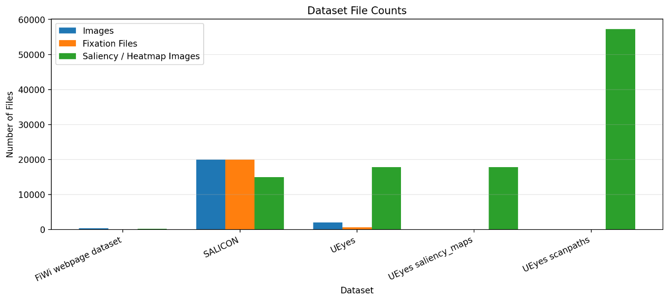
Figure 4: Dataset File Count
A dataset summary was also created to show the size and purpose of each dataset. SALICON contains 10,000 training images, 5,000 validation images, and 5,000 test images. UEyes contains 1,980 interface images, 554 fixation log files, and 17,820 saliency-related map images. FiWi contains webpage stimuli, raw fixation data, and eye maps. This summary shows that each dataset supports a different stage of the project, so SALICON is used for pretraining, UEyes is used for interface-based analysis and fine-tuning, and FiWi is used for webpage evaluation.
Image size analysis shows that the datasets do not all use the same image resolution. SALICON images are fixed at 640 × 480 pixels, while FiWi webpage images are mostly around 1360 × 768 pixels. UEyes images and heatmaps have more variation because they come from different interface types and screen formats. Because of these differences, image resizing is needed before training. This makes all images the same size, so the deep learning model can process them properly and learn from consistent input dimensions.
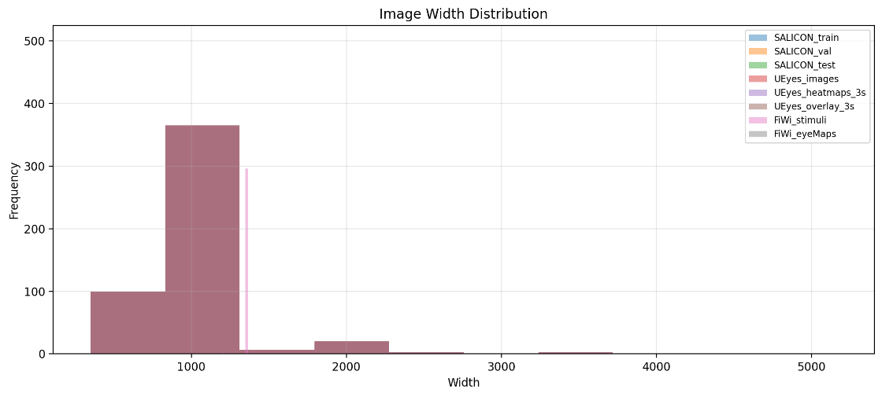
Figure 5: Image Width Distribution
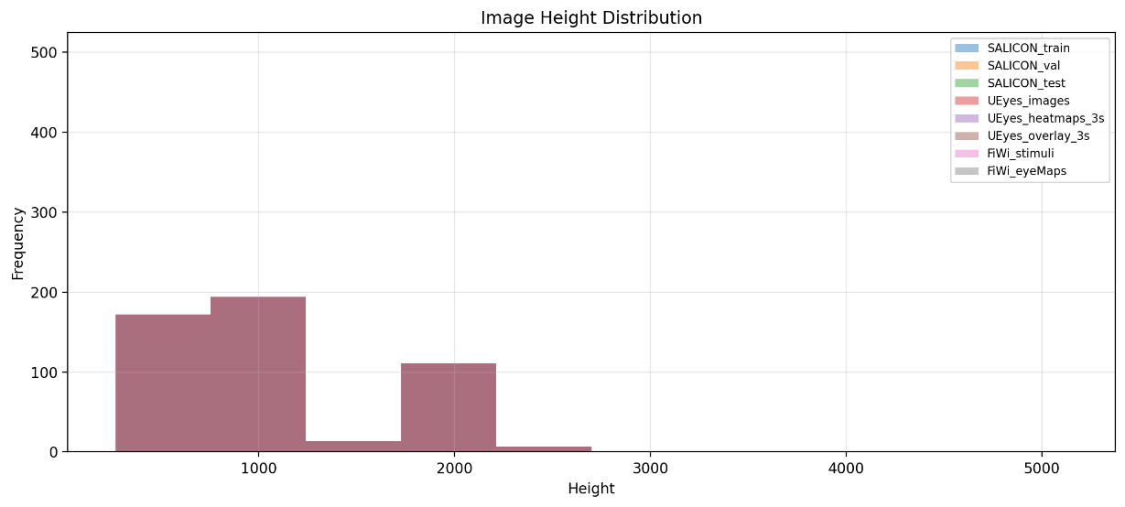
Figure 6: Image Height Distribution
Sample images were displayed from the datasets to visually compare the data. SALICON samples show natural scene images, UEyes samples show user interface screenshots, and FiWi samples show webpage screenshots. Sample saliency maps and heatmaps were also displayed to show the target output that the model is expected to predict. These visual examples help explain the difference between natural image saliency and webpage/interface saliency.

Figure 7: Sample SALICON Training Images
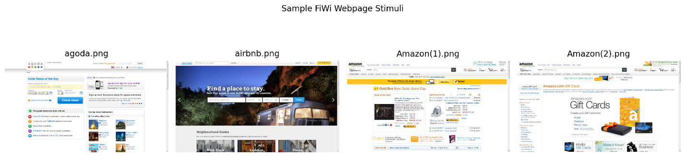
Figure 8: Sample FiWi Webpage Stimuli
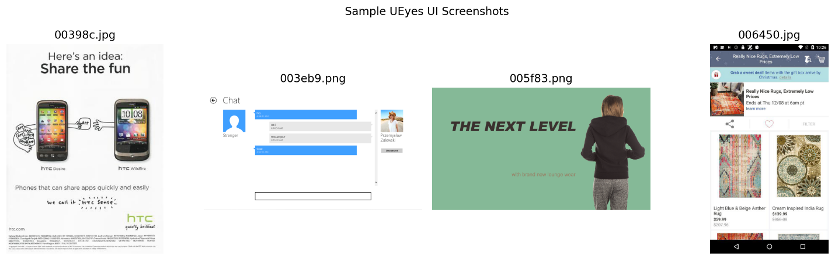
Figure 9: Sample UEyes UI Screenshots
The fixation data was explored for the UEyes dataset, where a sample fixation log had 3,327 rows and 57 columns, and important columns such as MEDIA_NAME, FPOGX, and FPOGY show the viewed image and fixation coordinates, so a fixation distribution plot was made to visualize where users looked on UI screenshots, which confirmed that the dataset has usable gaze information for saliency prediction.
The EDA shows that the datasets have useful visual and eye-tracking information, and they also come with different resolutions, formats, and structures, so preprocessing steps like resizing, normalization, saliency map preparation, missing value checking, and structural feature preparation are needed before using the data in the proposed multimodal model.
Table 3: EDA Outputs and Their Purpose
EDA Output | Purpose
Dataset summary table | Shows the datasets used, their main content, and their purpose in the project
Dataset file count chart | Shows the number of files available in each dataset folder
Image size statistics table | Shows differences in image dimensions across datasets
Image width distribution chart | Shows variation in image widths
Image height distribution chart | Shows variation in image heights
Sample SALICON images | Shows natural image examples used for pretraining
Sample UEyes images | Shows UI screenshot examples used for interface analysis
Sample FiWi images | Shows webpage screenshot examples used for evaluation
Sample SALICON saliency maps | Shows saliency map targets from natural images
Sample UEyes heatmaps | Shows interface heatmap targets
Sample UEyes overlay heatmaps | Shows heatmaps overlaid on UI screenshots
Sample FiWi eye maps | Shows webpage eye-tracking saliency maps
UEyes fixation distribution plot | Shows the spread of fixation coordinates across UI screenshots

4.3 Data Pre-processing

4.3.1. Data Transformation:
Data transformation was used to change the raw dataset files into a format that works for model training. The transformation steps included resizing, normalization, and turning layout information into numerical features.
Image Resizing
The webpage and UI screenshots were resized to a fixed size of 384 × 216 pixels. This size was selected because it keeps a 16:9 webpage-style ratio, which is more suitable for webpage and interface screenshots than a square image size. Keeping this ratio helps preserve the relative layout of webpage elements such as headers, images, buttons, menus, and text sections.
For example, a sample UEyes image originally had a shape of 500 × 372 × 3, and after resizing, it became 216 × 384 × 3. This shows that the image was successfully resized into the selected target size.
After resizing, image pixel values were normalized from the original range of 0-255 to the range of 0-1. This was done because deep learning models train better when input values are scaled to a smaller and consistent range.
The normalization formula used is:
$$Normalized Value=\frac{Pixel Value}{255}$$
This helps the model learn more efficiently because it prevents large pixel values from having too much influence on the training process.
Saliency Map Resizing
The saliency maps and heatmaps were also resized to 384 × 216 pixels, the same size as the input screenshots. This is important because the model output and the ground-truth saliency map must have the same dimensions during training and evaluation.
For example, a sample UEyes heatmap originally had a shape of 500 × 372, and after resizing, it became 216 × 384. This makes the saliency map match the resized input image.
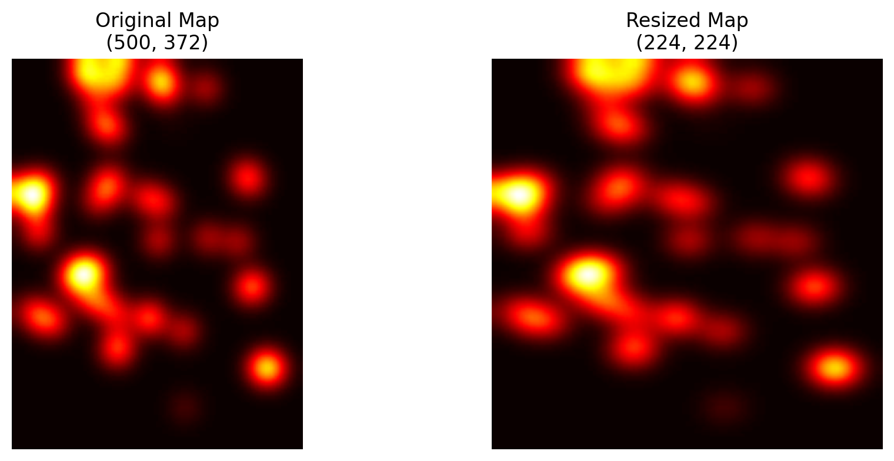
Figure 10: Resized Saliency Maps
Saliency Map Normalization
The saliency maps were normalized to the range of 0-1. This makes the heatmap values easier for the model to learn and compare. High values represent stronger attention areas, while low values represent areas with less user attention.
Structural/Layout Feature Transformation
For the structural branch, the project prepares layout features that represent webpage structure. Since the final image-to-HTML module is still a planned part of the system, prototype structural/layout features were extracted from real screenshots. These features are used to demonstrate how the structural branch data will be prepared. These features convert webpage layout information into numerical values that can be processed by the structural encoder, such as an MLP or Transformer.
The extracted structural/layout features include:
Table 4: Structural/Layout Feature Description
Feature | Description
x | Horizontal position of the layout region
y | Vertical position of the layout region
width | Width of the region
height | Height of the region
brightness | Average lightness of the region
contrast | Pixel intensity variation
edge_density | Amount of visual edges or details
non_white_ratio | Amount of visible content compared with plain background
area | Total space occupied by the region
relative_area | Region size compared with the full page

Encoding Categorical Features
The element_type feature was converted into numerical form using one-hot encoding. This is needed because machine learning models cannot directly understand text categories. For example, layout regions such as header, background, text block, or content block are converted into separate numeric columns. This transformation allows the structural branch to use categorical layout information during model training.
Example encoded columns include:
Table 5: Encode Features
Encoded Feature
element_type_background
element_type_header_region
element_type_layout_region
element_type_text_or_content_block

Standardization
Standardization may be applied to numerical structural/layout features such as width, height, area, brightness, contrast, and edge density. This helps keep all numerical features on a similar scale so that features with larger values do not dominate the model. This is mainly useful for the structural branch because the HTML/layout features have different ranges.
The standardization formula is:
$$Standardized Value=\frac{x-mean}{standard deviation}$$
Discretization
Discretization is not needed for the main visual data because the model works with continuous image pixels and saliency heatmap values, but layout regions can be grouped into categories like header region, content region, background region, or text block region, and these categories are encoded using one-hot encoding.

4.3.2. Data Cleaning:
Data cleaning was used to check and handle missing values, invalid values, noisy data, and irrelevant attributes. Since the project includes images, fixation logs, saliency maps, and structural or layout features, the cleaning process was adjusted for each type of data.
The process started by checking if the required dataset files were present in the project folder, and this check showed that the main files such as SALICON images, SALICON fixation files, SALICON saliency maps, UEyes images, UEyes fixation logs, UEyes heatmaps, UEyes scanpaths, and the FiWi webpage dataset were available, so the preprocessing code could access the needed data before training.
Missing values were then checked in the fixation logs and structural/layout feature tables. In the UEyes fixation logs, some columns contained missing values, such as user-related columns, AOI columns, and timestamp-related fields. However, the most important fixation coordinate columns, such as FPOGX and FPOGY, were available and used for gaze visualization and fixation analysis. Therefore, columns that were not useful for the project were ignored, while useful fixation coordinates were kept.
For the structural/layout features, missing values were also checked before cleaning. Since the final image-to-HTML conversion module is not fully implemented yet, the code generated prototype structural/layout features from real screenshots. The output showed that some columns, such as raw_html and css_class, had missing values. This is expected because these columns were not extracted from real HTML at this stage. These columns were not used for model training and were later removed during data reduction.
Invalid layout rows were checked, and any row with zero or negative width or height was removed because it would not represent a valid webpage region, but in the current structural or layout feature table, the cleaned data still contained 320 rows and 15 columns, so no valid rows were lost during cleaning, and useful numerical features like x, y, width, height, brightness, contrast, edge_density, non_white_ratio, area, and relative_area were kept because they describe the position, size, and visual properties of webpage regions.
Noise was handled by removing or ignoring features that do not help the model generalize. For example, raw HTML text, CSS class names, unique element IDs, style text, and file paths can create unnecessary noise because they may be too specific to one webpage. Instead of using these raw values directly, the project keeps cleaner numerical layout features that are more useful for the structural encoder.
Outlier handling was also considered for layout features. Extremely large or very small regions can affect the model if they do not represent meaningful webpage elements. Therefore, invalid regions were checked using width, height, and area values. Valid layout regions were kept, while impossible layout regions, such as regions with zero size, would be removed.
Table 6: Data Cleaning Techniques Applied
Cleaning Step | What Was Checked | Technique Applied
Dataset folder check | Missing dataset files or folders | Confirmed that required dataset folders and files were available
Missing value check | Null values in fixation logs and structural/layout features | Checked missing values using summary tables
Fixation log cleaning | Missing or irrelevant UEyes columns | Kept important fixation columns such as FPOGX and FPOGY
Structural feature cleaning | Missing raw_html and css_class values | Ignored or removed columns not used for model training
Invalid region removal | Zero or negative width and height | Removed invalid layout rows if found
Noise reduction | Raw HTML, CSS text, file paths, and unique IDs | Removed noisy or non-generalizable attributes
Outlier checking | Extremely invalid layout dimensions or area values | Checked width, height, and area to keep only valid regions

After cleaning, the dataset became more suitable for the proposed multimodal model, and the visual input stayed as resized and normalized screenshots, while the structural input included only useful layout-based numerical features, so the visual branch and structural branch received cleaner and more consistent data during training.

4.3.3. Data Reduction
Data reduction was applied to remove irrelevant attributes and keep only the features that are useful for saliency prediction. Since this project uses visual data, fixation data, saliency maps, and structural/layout features, not all available attributes are needed for model training. Removing unnecessary features helps reduce noise, improve model efficiency, and make the structural branch easier to train.
Feature selection was mainly applied to the structural/layout feature dataset. The visual branch uses resized images directly, while the target output uses resized saliency maps. However, the structural branch depends on selected numerical and encoded features that describe webpage regions. Therefore, irrelevant columns were removed and useful layout features were kept.
The first step was checking the available structural/layout attributes. Some features were useful because they describe the position, size, and visual importance of webpage regions. These include x, y, width, height, area, relative_area, brightness, contrast, edge_density, and non_white_ratio. These features are important because user attention can be affected by where an element is placed, how large it is, how visually detailed it is, and how much it stands out from the background.
Feature engineering was also applied before final feature selection. New features were created from the original layout features to give the model more useful information. For example, area was calculated from width and height, aspect_ratio was calculated to describe the shape of the region, and center_x and center_y were calculated to represent the center position of each region. These engineered features help the model understand webpage layout more clearly.
The element_type column was kept because it describes the estimated region type, such as background, header region, layout region, or text/content block. Since this is a categorical feature, it was converted into numerical form using one-hot encoding. This allows the structural encoder to process element types as numerical input.
4.4 conclution
In this chapter, we prepared the dataset for the proposed multimodal saliency prediction model by using SALICON, UEyes, and FiWi. SALICON for pretraining the UEyes for fine-tuning and EDA, and FiWi for webpage evaluation.
EDA was used to examine image sizes, saliency maps, fixation logs, and dataset structure. Since the datasets had different formats and resolutions, preprocessing was required.
Images and saliency maps were resized to 384 × 216 pixels to maintain a 16:9 webpage layout ratio, and pixel values were normalized from 0–255 to 0–1. Data cleaning removed missing or invalid data and prepared fixation and layout features.
Prototype layout features extracted from screenshots were used because the final image-to-HTML module is not yet complete. Feature engineering created useful layout features such as area, aspect ratio, brightness, and edge density, while unnecessary attributes were removed.
After preprocessing, the datasets were ready for model training and evaluation.

Chapter 5: Model description:
This chapter explains the selected model for predicting human visual attention on webpages and describes why it is suitable. The main components of the proposed multimodal architecture are introduced, including the visual branch, structural branch, fusion module, and saliency decoder. The chapter also covers how the model will be implemented and how its performance will be evaluated using standard saliency metrics.
This chapter shows how the proposed model connects to the project problem, objectives, and the gap in the literature review. Since webpage attention depends on both visual appearance and structure, the selected approach uses multimodal deep learning to combine screenshot features with generated HTML or DOM features before producing the final saliency heatmap.

Chapter 5

5.1 Overview of the Selected Model / Algorithm
This project uses a multimodal deep learning algorithm to predict human visual attention on webpages. This model is chosen because webpage attention depends on different types of information, since a webpage is not only an image but also has structure, such as text blocks, buttons, menus, images, positions, sizes, and layout hierarchy. The model takes two main inputs, which are the webpage screenshot and the generated HTML/DOM structural features.
The visual branch reads the webpage screenshot and extracts visual features; therefore, ResNet and Vision Transformer (ViT) are used for this purpose. ResNet can learn from deep image layers without losing important details, which helps it capture webpage visuals such as colors, contrast, edges, images, buttons, and text areas [22], while ViT divides the screenshot into small patches and studies how different parts of the page relate to each other, making the model understand the full webpage layout and not only small visual details [23].
The structural branch processes the generated HTML/DOM features, such as element type, position, width, height, font size, text length, and layout hierarchy. An MLP can be used for simple numerical structural features, but when the model needs to learn relationships between webpage elements, a Transformer-based encoder is used because the transformer architecture uses attention mechanisms to model how different parts of the input sequence are related.
After both branches extract their features, the model uses a fusion module to join the visual embedding from the screenshot branch with the structural embedding from the HTML/DOM branch, creating one combined representation of webpage and the fused features are passed in a decoder like U-Net or an upsampling CNN to generate the final saliency heatmap. U-Net works well for this task because it has a contracting path that captures context and an expanding path that supports precise localization, making it useful for producing spatial outputs such as heatmaps [24].
The final model is therefore a multimodal saliency prediction model that combines screenshot-based visual features with generated HTML/DOM structural features. The model is selected because it matches the main research gap found in the literature review since many existing models depend mainly on visual information, while webpage attention is also affected by structure and layout.
Table 7: Model Selection Justification
Model | Input | Why This Model Was Chosen | Purpose of Evaluation | Evaluation Metrics
ResNet-only model | Webpage screenshot | Extracts local visual features such as edges, colors, contrast, text areas, images, and buttons | Tests how well screenshot features alone predict user attention | CC, NSS, AUC-Judd, SIM, KL-Divergence
ViT-only model | Webpage screenshot | Captures global relationships across the full webpage layout | Tests whether global layout understanding improves prediction | CC, NSS, AUC-Judd, SIM, KL-Divergence
MLP-only model | Generated HTML/DOM features | Works with structured numerical features such as position, size, font size, and text length | Tests whether webpage structure alone can predict attention | CC, NSS, AUC-Judd, SIM, KL-Divergence
Transformer-only model | Generated HTML/DOM features | Learns relationships between webpage elements such as headings, buttons, images, and containers | Tests whether structural relationships improve prediction | CC, NSS, AUC-Judd, SIM, KL-Divergence
Fusion model using concatenation | Screenshot features + generated HTML/DOM features | Combines visual and structural embeddings in a simple direct way | Tests whether combining both inputs improves over single-input models | CC, NSS, AUC-Judd, SIM, KL-Divergence
Fusion model using attention | Screenshot features + generated HTML/DOM features | Learns which visual or structural features are more important for predicting attention | Tests whether adaptive fusion improves saliency prediction | CC, NSS, AUC-Judd, SIM, KL-Divergence
U-Net / Upsampling CNN decoder | Fused features | Reconstructs the fused representation into a spatial saliency heatmap | Tests how well the model generates accurate heatmaps | CC, NSS, AUC-Judd, SIM, KL-Divergence
Final multimodal model | Webpage screenshot + generated HTML/DOM features | Combines visual appearance and webpage structure in one model | Tests whether multimodal learning gives the best prediction of human visual attention | CC, NSS, AUC-Judd, SIM, KL-Divergence

5.2 Model Architecture / Structure
The proposed model predicts human visual attention on webpages using a dual-branch multimodal architecture, where one branch processes the webpage screenshot as visual input and the other branch processes HTML or DOM features as structural input, so the outputs from both branches are combined using a fusion module, and a decoder produces the final saliency heatmap.
The visual branch uses the webpage screenshot as input, and before it enters the model, the screenshot is resized and normalized so that all images follow the same format. A visual encoder like ResNet or ViT extracts visual features from the screenshot, where ResNet focuses on local details such as edges, colors, contrast, text areas, buttons, and images, while ViT captures the global layout across the whole webpage. The result from this branch is a visual embedding vector that shows the appearance of the webpage.
The structural branch uses HTML/DOM features that are taken from the webpage layout, and these features include element type, x and y position, width, height, font size, text length, and layout hierarchy, so the data can be processed as numerical feature vectors using an MLP, or a Transformer encoder can be used when the model needs to learn relationships between webpage elements like headings, buttons, images, cards, menus, and containers. The output from this branch is a structural embedding vector that shows how the webpage is organized.
Both branches extract their embeddings and the model then uses a fusion module to combine them, so two fusion methods are considered, where the first method is concatenation that joins the visual and structural embeddings into one feature vector, and the second method is attention-based fusion, where the model learns which features are more important for predicting user attention and can decide if visual appearance or structural layout should have more influence in different regions of the webpage.
The fused representation is passed into a decoder network, which can use a U-Net style decoder or an upsampling CNN. This approach is suitable because the output is a spatial saliency heatmap rather than a class label, the decoder reconstructs the fused features into a 2D heatmap in which high-attention areas are highlighted more strongly, and this heatmap shows the webpage regions where users are most likely to look.
The main parameters and hyperparameters for this model are input image size, encoder type, embedding size, fusion method, learning rate, batch size, number of training epochs, optimizer, and loss function. The optimizer is planned to be Adam, as it is widely used in deep learning, while the loss function may include KL-Divergence and NSS loss because the model output is compared with real saliency or fixation maps, and the evaluation will use CC, NSS, AUC-Judd, SIM, and KL-Divergence.
This project uses generated HTML and DOM features as a second input branch, so the model does not only rely on screenshots but also includes webpage structure. There is also a staged training strategy where the model first learns general attention patterns from SALICON, then fine-tunes on webpage-related datasets like UEyes and WebSaliency, and finally evaluates performance on FiWi, which helps the model move from general image attention to webpage-specific attention prediction.
The architecture combines the webpage's appearance with its structure, making the model more suitable for web interfaces than a purely visual saliency model.

5.3 Implementation Plan
This implementation uses the same workflow as before, starting from data collection and preprocessing, then building the multimodal model architecture, training and evaluating it, and optional deployment. The main goal is to produce saliency heatmaps that show where users are likely to look on webpage and UI screenshots.
Important update from the previous workflow
WebSaliency was included in the original plan, but no reliable public download link was available. Therefore, the current implementation uses SALICON, UEyes, and FiWi. Generated HTML/layout features are planned; until the image-to-HTML module is complete, prototype structural/layout features are extracted from real screenshots for preprocessing evidence.
    - Tools and Libraries
Table 8: Tools & Libraries Summary
Tool / Library | Purpose
Python | Main programming language for preprocessing, training, and evaluation.
Jupyter Notebook | EDA, charts, preprocessing screenshots, and experiment documentation.
NumPy / Pandas | Numerical processing, dataset tables, cleaning, and feature handling.
Matplotlib | Charts and visualizations for EDA.
Pillow / OpenCV | Image loading, resizing, normalization, and processing.
SciPy | Reading MATLAB .mat fixation files.
Scikit-learn | Data splitting, preprocessing, and baseline support.
PyTorch | Building and training the multimodal deep learning model.

    - Datasets Used
Table 9: Dataset Usage Summary
Dataset | Use in Project | Notes
SALICON | Pretraining | Natural image saliency dataset used to teach general attention patterns.
UEyes | Fine-tuning / EDA | UI screenshots, fixation logs, heatmaps, overlays, and scanpaths.
FiWi | Webpage evaluation | Webpage screenshots, raw fixation data, and eye maps.
Structural/Layout features | Structural branch input | Real generated HTML features if available; otherwise prototype layout features from screenshots.

    - Model Implementation
The model is implemented as a multimodal saliency prediction system with two input branches:
• Visual branch: receives the webpage or UI screenshot and extracts visual features using ResNet or Vision Transformer.
• Structural branch: receives generated HTML or prototype structural/layout features and processes them using an MLP or Transformer encoder.
• Fusion module: combines visual and structural embeddings using concatenation or attention fusion.
• Decoder: uses a U-Net or upsampling CNN decoder to generate the predicted saliency heatmap.
    - Training and Testing Steps
Table 10: Training and Testing Steps
No. | Step | Description
1 | Load datasets | Load SALICON, UEyes, FiWi, and structural/layout features.
2 | Preprocess data | Resize images and saliency maps to 384 x 216 to keep a 16:9 webpage ratio; normalize values to 0-1.
3 | Prepare inputs | Each sample contains an image, structural/layout features, and a ground-truth saliency map.
4 | Split data | Use training, validation, and testing sets such as 70%, 15%, and 15%.
5 | Train baselines | Train ResNet-only, ViT-only, MLP-only, Transformer-only, and center-bias baselines.
6 | Train final model | Train the multimodal model using screenshot features plus structural/layout features.
7 | Tune parameters | Adjust learning rate, batch size, epochs, optimizer, and fusion method if needed.
8 | Evaluate model | Compare predicted heatmaps with ground-truth maps using saliency metrics.
9 | Save model | Save the best model weights and preprocessing settings.

    - Implementation Flow
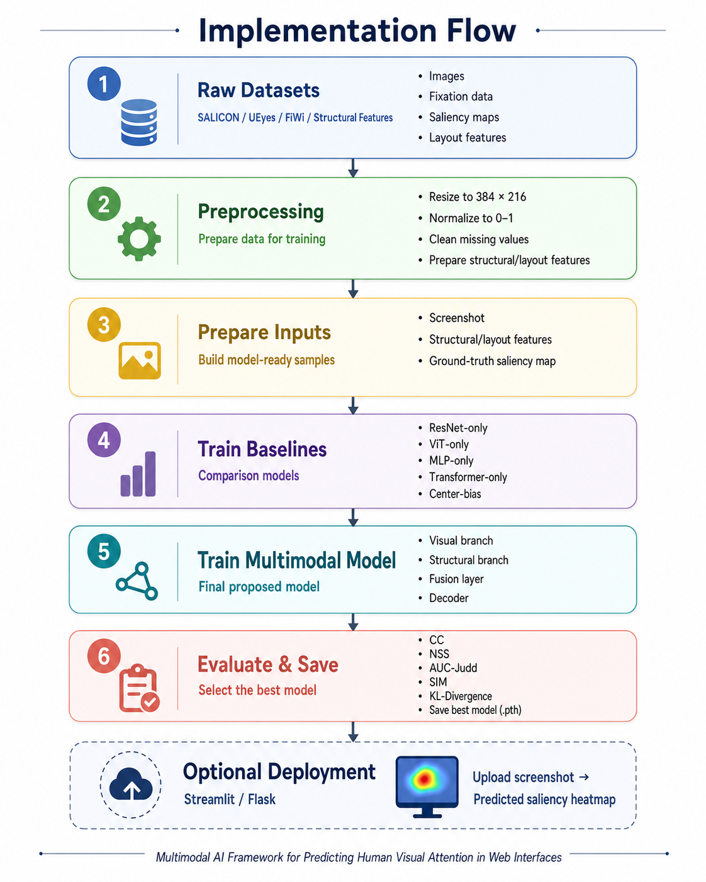
Figure 11: Implementation Flow
5.3.7. Save or Deploy the Model
After evaluation, the best model will be saved as best_multimodal_model.pth. The preprocessing settings, selected features, and evaluation results will also be saved. If time allows, the model can be deployed using Streamlit or Flask, where a user uploads a webpage screenshot and receives a predicted saliency heatmap.

5.4 Evaluation Methods
The model is evaluated by comparing the predicted saliency heatmaps with real human fixation maps, and because this project focuses on saliency prediction, normal classification metrics like accuracy, precision, recall, and F1-score are not suitable. Saliency evaluation metrics are used because the output is a heatmap rather than a class label, and all baseline models and the final multimodal model are evaluated with the same metrics to keep the comparison fair.
Table 11: Evaluation Metrics Summary
Metric | What It Measures | Interpretation
CC | Measures the correlation between the predicted saliency heatmap and the real fixation heatmap. | A higher CC value means the predicted heatmap is more similar to the real human attention map.
NSS | Measures whether real fixation points fall on areas that the model predicted as highly salient. | A higher NSS value means the model is better at predicting where users actually looked.
AUC-Judd | Measures how well the model separates fixated areas from non-fixated areas. | A higher AUC-Judd value means the model is better at distinguishing attention areas from ignored areas.
SIM | Measures the similarity between the predicted saliency distribution and the real saliency distribution. | A higher SIM value means the predicted attention distribution is closer to the real one.
KL-Divergence | Measures the difference between the predicted and real saliency distributions. | A lower KL-Divergence value means the prediction is closer to the real fixation map.

5.5 Summary
This chapter explained the proposed multimodal deep learning model for predicting human visual attention on web interfaces. The model uses two main inputs: webpage screenshots and generated HTML/DOM structural features. The visual branch extracts screenshot features using ResNet or Vision Transformer, while the structural branch processes layout-related features using an MLP or Transformer encoder.
The extracted visual and structural features are combined through a fusion module, using either concatenation or attention-based fusion. After fusion, a decoder such as U-Net or an upsampling CNN generates the final saliency heatmap, which highlights the webpage areas most likely to attract user attention. The model will be implemented using Python and PyTorch, with datasets such as SALICON, UEyes, and FiWi used for pretraining, fine-tuning, and evaluation. The expected outcome is a model that predicts user attention more accurately than visual-only approaches by combining both webpage appearance and structure. The model performance will be evaluated using standard saliency metrics such as CC, NSS, AUC-Judd, SIM, and KL-Divergence, as outlined in the evaluation section of the report.

Chapter 6: Conclusion & Future Work

6.1 Conclusion
A multimodal AI framework is proposed for predicting human visual attention on webpages. The main problem is that many saliency prediction models are trained on natural images, as they do not fully understand webpage structure. Webpages have organized elements like text, buttons, images, menus, and layout sections, and these elements strongly affect where users look.
The framework uses both webpage screenshots and generated HTML or DOM structural features. The screenshot is processed through a visual branch, and the HTML or DOM features are processed through a structural branch. Then, these outputs are combined using a fusion module, and a decoder generates a saliency heatmap that shows the webpage areas most likely to attract user attention.
A staged training strategy is used, where SALICON helps the model learn general attention patterns first, then UEyes and WebSaliency are used to fine-tune the model on interface and webpage-specific attention data, and finally FiWi is used for evaluation by comparing the predicted saliency heatmaps with real human fixation maps, and the model performance is measured using standard saliency metrics such as CC, NSS, AUC-Judd, SIM, and KL-Divergence.
This project gives a clear approach for combining visual and structural webpage information in one saliency prediction framework. The model aims to provide a more suitable method for predicting attention in web interfaces than visual-only models, thereby supporting future work in human-computer interaction, web design evaluation, and automated user attention analysis.

6.2 Future Work (Sem 2 work)
In the next phase, the proposed multimodal AI framework will be fully implemented and tested. The first step will be to complete the dataset preparation process by organizing the selected datasets, including SALICON, UEyes, and FiWi. The webpage screenshots and saliency maps will be resized, normalized, and prepared for model training. The generated HTML/DOM structural features will also be extracted and arranged so that they can be used as input for the structural branch of the model.
The visual branch of the model will be developed using deep learning architectures such as ResNet or Vision Transformer. This branch will be responsible for extracting visual features from webpage screenshots, including colors, contrast, layout, images, text areas, and buttons. At the same time, the structural branch will be implemented using an MLP or Transformer-based encoder to process HTML/DOM features such as element type, position, size, font size, text length, and layout hierarchy.
After developing both branches, the next step will be to combine the visual and structural features using a fusion module. Different fusion methods, such as feature concatenation and attention-based fusion, will be tested to identify which method gives better saliency prediction results. A decoder network, such as U-Net or an upsampling CNN, will then be used to generate the final saliency heatmaps.
The model will be trained using a staged training approach. First, the model will be pretrained on SALICON to learn general human visual attention patterns. Then, it will be fine-tuned using interface and webpage-related datasets such as UEyes. Finally, the model will be evaluated using the FiWi dataset by comparing the predicted saliency heatmaps with real human fixation maps.
The model performance will be evaluated using standard saliency evaluation metrics, including CC, NSS, AUC-Judd, SIM, and KL-Divergence. These metrics will help measure how closely the predicted heatmaps match real user attention patterns. Baseline models, such as visual-only and structural-only models, may also be tested to compare their performance with the final multimodal model.
Finally, if time allows, a simple web-based prototype may be developed to allow users to upload a webpage screenshot or enter a webpage URL and receive a predicted saliency heatmap. This will make the system more practical and useful for web designers, UX researchers, and developers who want to understand which areas of a webpage are likely to attract user attention.

Appendices

References:
- M.-H. Guo, C.-Z. Lu, Z.-N. Liu, M.-M. Cheng, and S.-M. Hu, “Visual attention network,” Comp. Visual. Med., vol. 9, no. 4, pp. 733–752, Dec. 2023, doi: 10.1007/s41095-023-0364-2.
- Y. Jiang, L. A. Leiva, H. Rezazadegan Tavakoli, P. R. B. Houssel, J. Kylmälä, and A. Oulasvirta, “UEyes: Understanding Visual Saliency across User Interface Types,” in Proceedings of the 2023 CHI Conference on Human Factors in Computing Systems, Hamburg Germany: ACM, Apr. 2023, pp. 1–21. doi: 10.1145/3544548.3581096.
- X. Huang, C. Shen, X. Boix, and Q. Zhao, “SALICON: Reducing the Semantic Gap in Saliency Prediction by Adapting Deep Neural Networks,” in 2015 IEEE International Conference on Computer Vision (ICCV), Santiago, Chile: IEEE, Dec. 2015, pp. 262–270. doi: 10.1109/ICCV.2015.38.
- Z. Bylinskii, T. Judd, A. Oliva, A. Torralba, and F. Durand, “What do different evaluation metrics tell us about saliency models?,” Apr. 06, 2017, arXiv: arXiv:1604.03605. doi: 10.48550/arXiv.1604.03605.
- M. Jiang, S. Huang, J. Duan and Q. Zhao, “SALICON: Saliency in Context,” in Proc. IEEE Conf. Computer Vision and Pattern Recognition (CVPR), Boston, MA, USA, 2015, pp. 1072–1080, doi: 10.1109/CVPR.2015.7298710.
- F. A. Faiz, S. Wibirama, H. Nurlatifa, and N. A. Setiawan, “A Systematic Review of Deep Learning Approaches to Visual Saliency Prediction on Webpage Images,” in 2024 7th International Conference on Informatics and Computational Sciences (ICICoS), Semarang, Indonesia: IEEE, Jul. 2024, pp. 479–484. doi: 10.1109/ICICoS62600.2024.10636890.
- Y. Inagaki, J. Shirogane, H. Iwata, and Y. Fukazawa, “Webpage Validation by Visualizing Importance Area,” IEEE Access, vol. 11, pp. 120334–120345, 2023, doi: 10.1109/ACCESS.2023.3327743.
- M. Kenely, D. Seychell, C. J. Debono, and C. Porter, “A Deep Learning Framework for Visual Attention Prediction and Analysis of News Interfaces,” in 2025 IEEE Conference on Artificial Intelligence (CAI), Santa Clara, CA, USA: IEEE, May 2025, pp. 278–283. doi: 10.1109/CAI64502.2025.00050.
- K. E. S. D. Souza et al., “An Evaluation Framework for User Experience Using Eye Tracking, Mouse Tracking, Keyboard Input, and Artificial Intelligence: A Case Study,” International Journal of Human–Computer Interaction, vol. 38, no. 7, pp. 646–660, Apr. 2022, doi: 10.1080/10447318.2021.1960092.
- A. Hosseini, A. Kazerouni, S. Akhavan, M. Brudno, and B. Taati, “SUM: Saliency Unification Through Mamba for Visual Attention Modeling,” in 2025 IEEE/CVF Winter Conference on Applications of Computer Vision (WACV), Tucson, AZ, USA: IEEE, Feb. 2025, pp. 1597–1607. doi: 10.1109/WACV61041.2025.00163.
- A. Das, Z. Wu, I. Skrjanec, and A. M. Feit, “Shifting Focus with HCEye: Exploring the Dynamics of Visual Highlighting and Cognitive Load on User Attention and Saliency Prediction,” Proc. ACM Hum.-Comput. Interact., vol. 8, no. ETRA, pp. 1–18, May 2024, doi: 10.1145/3655610.
- E. Schoop, X. Zhou, G. Li, Z. Chen, B. Hartmann, and Y. Li, “Predicting and Explaining Mobile UI Tappability with Vision Modeling and Saliency Analysis,” in CHI Conference on Human Factors in Computing Systems, New Orleans LA USA: ACM, Apr. 2022, pp. 1–21. doi: 10.1145/3491102.3517497.
- R. Bhargava et al., “UniAR: A Unified model for predicting human Attention and Responses on visual content,” in Advances in Neural Information Processing Systems 37, Vancouver, BC, Canada: Neural Information Processing Systems Foundation, Inc. (NeurIPS), 2024, pp. 106346–106369. doi: 10.52202/079017-3374.
- E. Corradini, G. Porcino, A. Scopelliti, D. Ursino, and L. Virgili, “Fine-tuning SalGAN and PathGAN for extending saliency map and gaze path prediction from natural images to websites,” Expert Systems with Applications, vol. 191, p. 116282, Apr. 2022, doi: 10.1016/j.eswa.2021.116282.
- P. V. González, C. S. Cuevas, L. Jeldez, B. T. Troncoso, M. F. Guiñazú, and J. D. Velásquez, “A gender-aware saliency prediction system for web interfaces using deep learning and eye-tracking data,” Brain Inf., vol. 12, no. 1, p. 25, Dec. 2025, doi: 10.1186/s40708-025-00274-x.
- Y. Wang, M. Bâce, and A. Bulling, “Scanpath Prediction on Information Visualisations,” IEEE Trans. Visual. Comput. Graphics, vol. 30, no. 7, pp. 3902–3914, Jul. 2024, doi: 10.1109/TVCG.2023.3242293.
- A. F. Sousa, C. I. Silva, and R. F. Zampolo, “Performance Bounds for Computational Models of Visual Saliency in 360 Videos”.
- P. Ignat, G. Igor, and I. Natalya, “MDS-ViTNet: Improving saliency prediction for Eye-Tracking with Vision Transformer,” May 29, 2024, arXiv: arXiv:2405.19501. doi: 10.48550/arXiv.2405.19501.
- R. Cong et al., “CIR-Net: Cross-Modality Interaction and Refinement for RGB-D Salient Object Detection,” vol. 31, pp. 6800–6815, Jan. 2022, doi: https://doi.org/10.1109/tip.2022.3216198.
- I. Prazina, D. Pozderac, and V. Okanović, “Beyond DOM: Unlocking Web Page Structure from Source Code with Neural Networks,” AI, vol. 6, no. 9, p. 228, Sep. 2025, doi: 10.3390/ai6090228.
- S. Chakraborty et al., “Predicting Visual Attention in Graphic Design Documents,” IEEE Trans. Multimedia, vol. 25, pp. 4478–4493, 2023, doi: 10.1109/TMM.2022.3176942.
- K. He, X. Zhang, S. Ren, and J. Sun, “Deep Residual Learning for Image Recognition,” 2015, arXiv. doi: 10.48550/ARXIV.1512.03385.
- A. Dosovitskiy et al., “An Image is Worth 16x16 Words: Transformers for Image Recognition at Scale,” 2020, arXiv. doi: 10.48550/ARXIV.2010.11929.
- O. Ronneberger, P. Fischer, and T. Brox, “U-Net: Convolutional Networks for Biomedical Image Segmentation,” 2015, arXiv. doi: 10.48550/ARXIV.1505.04597.

Chapter 7: Experimental Results
This chapter records the implemented system. SALICON was used to pretrain the visual encoder, UEyes webpage screenshots were used to fine-tune the models, and FiWi was held out for the final test. WebSaliency was not used because no reliable public download was available. Screenshots and saliency maps were resized to 384 by 216. Layout features were extracted from each screenshot for the structural branch. When the demo is given a URL, the same feature columns are filled from the live DOM. The saved model is the concat fusion variant, chosen by FiWi correlation.
The held-out FiWi test contains 149 webpage screenshots. CC, NSS, AUC-Judd, and SIM are higher when the prediction is closer to human attention. KL-Divergence is lower when the predicted distribution is closer to the human map.
Model | CC | NSS | AUC-Judd | SIM | KL-Divergence
center_bias | 0.1817 | 0.5952 | 0.6734 | 0.2422 | 2.1649
resnet_only | 0.2793 | 0.9599 | 0.7606 | 0.2873 | 1.7724
mlp_only | 0.1533 | 0.5011 | 0.6300 | 0.1994 | 1.9998
transformer_only | 0.1568 | 0.5143 | 0.6372 | 0.2093 | 1.9704
vit_only | 0.1652 | 0.5400 | 0.6540 | 0.2008 | 1.9928
concat | 0.3146 | 1.0902 | 0.7745 | 0.2974 | 1.6580
attention | 0.3037 | 1.0553 | 0.7598 | 0.2960 | 1.7608
Figure. FiWi metric comparison.
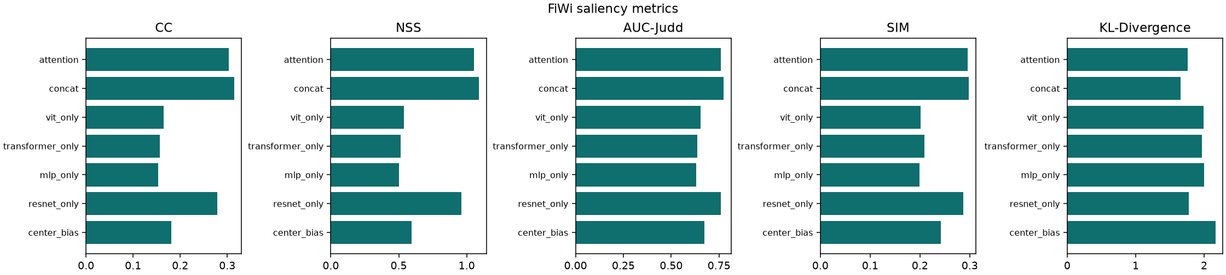
Figure. Validation correlation while training.
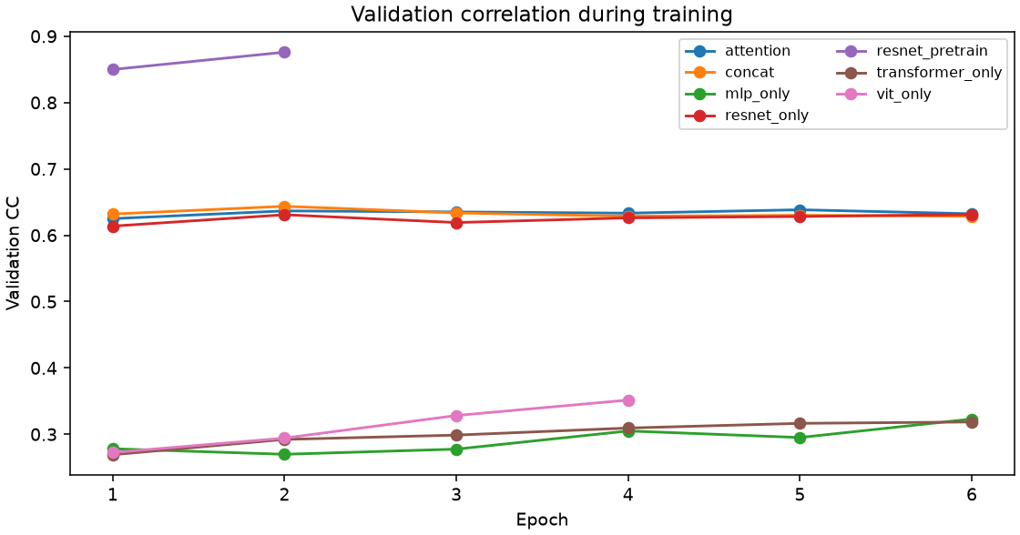
Figure. Qualitative FiWi predictions from the saved multimodal model.
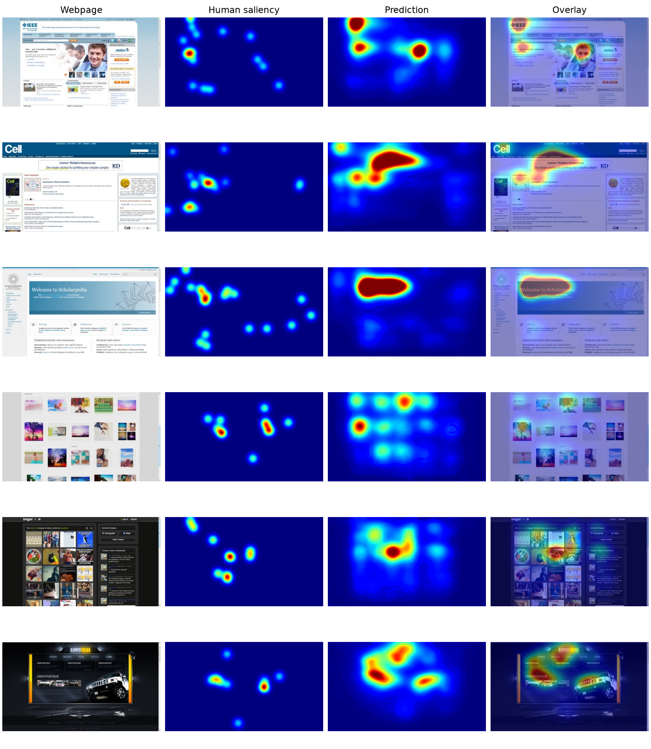
Figure. Dataset counts and image-size distributions from preprocessing.
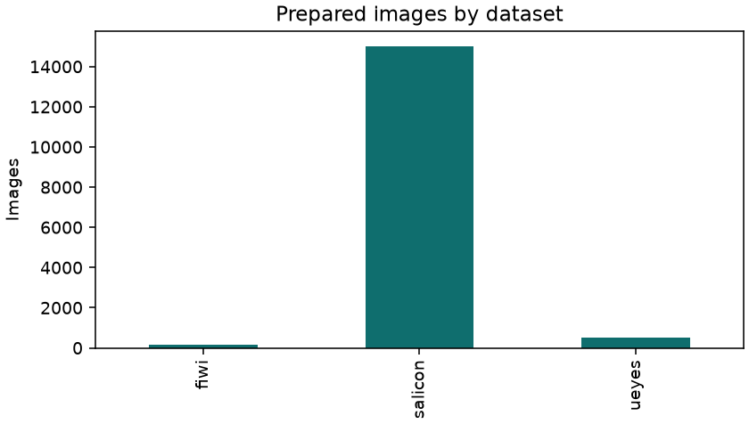
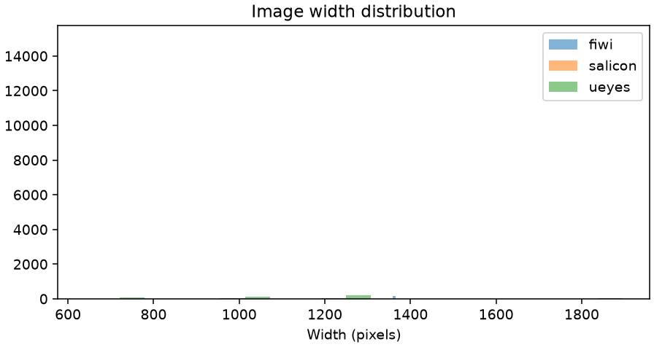
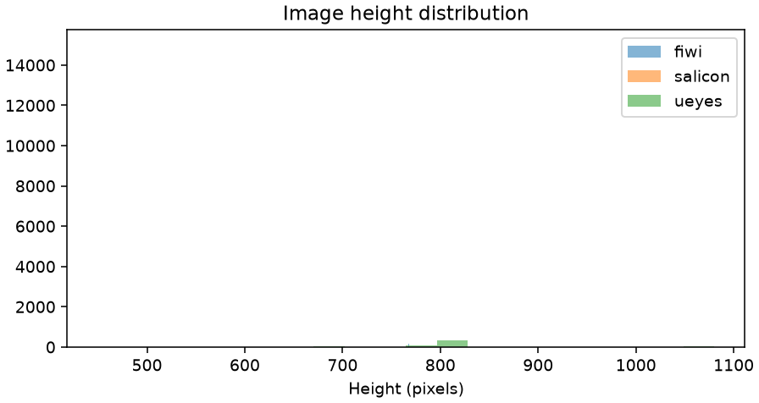
On FiWi, the saved concat model reached CC 0.3146, NSS 1.0902, AUC-Judd 0.7745, SIM 0.2974, and KL-Divergence 1.6580. The screenshot-only ResNet reached CC 0.2793. The center-bias baseline is included because webpage fixations often fall near the middle of the screen. Layout-only models score lower, which matches the idea that structure helps most when it is fused with the screenshot.

