Credit Name:CSE3010

Assignment Name:BreakAPlate

Describe the errors you've encountered while working on this assignment. What caused the error and how do you overcome the error?

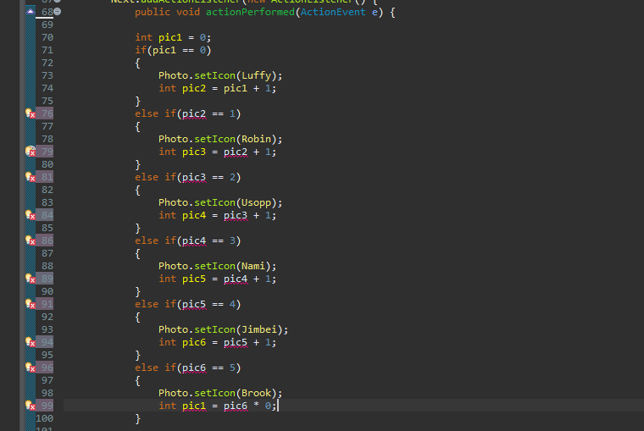

I did not actually find a way to fix this and tried a different method.

Edit: Just finished the project and realized this could have worked if I had initialized the pic1 = 0 outside of the public void making it a local variable.

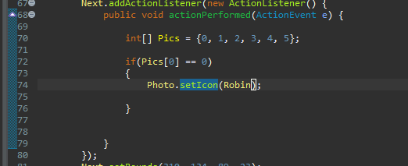

Honestly, I tried an array, but gave up because I completely forgot how to do it.

So I moved on.

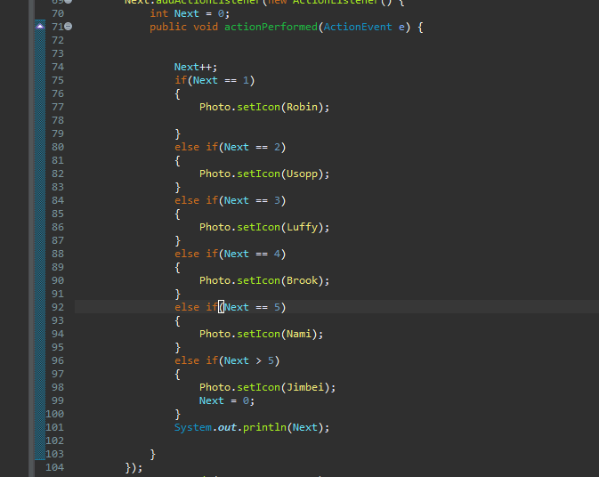

This isn’t an error, but before this, I was getting a huge error. This was because my Next variable was inside the public void. When I brought it out and made it a local variable, it worked perfectly.