Credit Name:CSE3010

Assignment Name:MetricConversion

Describe the errors you've encountered while working on this assignment. What caused the error and how do you overcome the error?

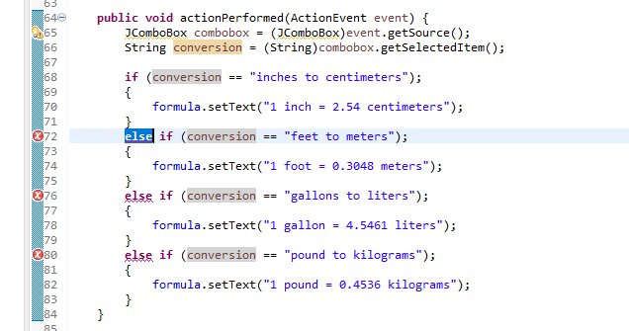

Had to delete the semi colons after each else if statement and it worked

Had the longest time struggling to display the words after each time the user clicks the type of conversion from the combobox. Miles asked me if I had put the ActionListener, and I realized I didn’t. This solved my problem and completed the code for me.