
Faculty of Engineering and Technology
Department of Computer Science

COMP338 – Artificial Intelligence | Course Project 1
Exam Timetable Scheduling Using Genetic Algorithm

Submitted by:
Waleed Noubani – 1231452
Elyas Ehmod – 1230892

Submitted to: Dr. Mohammad Helal

1. Introduction and Problem Formulation
In this project we implemented a Genetic Algorithm (GA) from scratch in Python to generate an optimized exam schedule for 95 students enrolled in 22 courses at Birzeit University. The scheduling window is 6 exam days with 3 slots per day (18 slots total). Our goal is to produce a schedule that eliminates hard constraint violations and minimizes soft constraint penalties.

1.1 Solution Representation
- Gene: An integer (1–18) representing the exam slot assigned to one course. Slots 1–3 = Day 1, slots 4–6 = Day 2, and so on.
- Chromosome: A list of 22 genes — one per course. The index is the course index; the value is the assigned slot. Example: genes[0] = 15 means COMP2110 is in slot 15 (Day 5, 15:00–17:00).
- Population: 100 independently generated random chromosomes at the start, giving the algorithm a diverse set of candidate solutions.

1.2 Dataset

Component | Value
Students | 95
Courses | 22
Enrollment Records | 481
Exam Days | 6
Slots per Day | 3
Total Slots | 18
Courses per Student | 4 – 7

2. Background on Genetic Algorithms
Genetic Algorithms are population-based metaheuristic techniques inspired by natural selection (Holland, 1975). They are well-suited for large combinatorial problems like exam timetabling where exact methods are computationally infeasible.

2.1 Algorithm Steps
- Initialization: Generate a population of N random chromosomes.
- Fitness Evaluation: Score each chromosome using a fitness function — in our case, based on a penalty score (lower penalty = higher fitness).
- Selection: Choose parents using Roulette Wheel Selection — better chromosomes have a higher chance of being picked.
- Crossover: Combine two parents at a random cut point (Single-Point Crossover) to produce two children.
- Mutation: Randomly replace individual genes with a small probability to maintain diversity.
- Replacement: The new generation replaces the old population. Repeat until the stopping condition is met.

2.2 Parameters Used
- Population Size: 100
- Generations: 200
- Mutation Rate: 0.05 (5%)
- Crossover: Single-point, applied to every parent pair
- Selection: Roulette Wheel (fitness-proportionate)

3. Fitness Function
The fitness function evaluates how good each schedule is. We use a penalty-based system: start at 0 and add points for every constraint violated. Fitness is then:

fitness = 1 / (1 + total_penalty)

A perfect schedule (zero penalty) gets fitness = 1.0. Higher penalties push fitness toward 0. This range works naturally with Roulette Wheel Selection.

3.1 Penalty Weights

Constraint | Type | Penalty
Two exams at the same slot | Hard | 1000
More than 2 exams in one day | Hard | 800
4 exams in 2 consecutive days | Hard | 500
2 exams in the same day | Soft | 50
Each extra day above 5 | Soft | 100 / day

3.2 Penalty Components
- Same-Slot Conflict (1000): For every student, all pairs of their courses are checked. If two courses share the same slot, +1000. This is the highest weight to make the GA treat it as the top priority.
- Same-Day (50 or 800): If a student has exactly 2 exams in one day, +50 (soft, allowed but not preferred). If more than 2, +800 (hard constraint violation).
- Consecutive Days (500): If a student has 4 or more exams across any two consecutive days, +500.
- Extra Days (100/day): The preferred maximum is 5 exam days. Each day used beyond 5 adds +100.

The core fitness calculation in code:

def calculate_fitness(chromosome, students, courses, slots):
penalty = same_slot_conflicts(chromosome, students, courses)
penalty += same_day_penalty(chromosome, students, courses, slots)
penalty += consecutive_days_penalty(chromosome, students, courses, slots)
penalty += used_days_penalty(chromosome, slots)
chromosome.fitness = 1 / (1 + penalty)
return chromosome.fitness

4. Algorithm Implementation

4.1 Population Initialization
100 chromosomes are created, each with 22 randomly chosen slot numbers (1–18):

def generate_population(population_size, number_of_courses, number_of_slots):
population = []
for _ in range(population_size):
genes = [random.randint(1, number_of_slots)
for _ in range(number_of_courses)]
population.append(Chromosome(genes))
return population

4.2 Roulette Wheel Selection
A random point is placed on the cumulative fitness sum. The chromosome at that position is selected. Better chromosomes occupy a larger segment and are more likely to be chosen:

def select_parent(population):
total_fitness = sum(c.fitness for c in population)
random_point = random.uniform(0, total_fitness)
current_sum = 0
for chromosome in population:
current_sum += chromosome.fitness
if current_sum >= random_point:
return chromosome

4.3 Single-Point Crossover
A random cut point splits both parents; the children swap the right halves:

def crossover(parent1, parent2):
point = random.randint(1, len(parent1.genes) - 1)
child1 = Chromosome(parent1.genes[:point] + parent2.genes[point:])
child2 = Chromosome(parent2.genes[:point] + parent1.genes[point:])
return child1, child2

4.4 Mutation
Each gene has a 5% chance of being replaced by a new random slot, maintaining diversity and avoiding local optima:

def mutate(chromosome, mutation_rate, number_of_slots):
for i in range(len(chromosome.genes)):
if random.random() < mutation_rate:
chromosome.genes[i] = random.randint(1, number_of_slots)
return chromosome

4.5 Main Loop
Each generation: evaluate all chromosomes → record best → select parents → crossover + mutate → replace population:

for generation in range(generations):
for chromosome in population:
calculate_fitness(chromosome, students, courses, slots)
current_best = max(population, key=lambda c: c.fitness)
best_fitness_history.append(current_best.fitness)
new_population = []
while len(new_population) < population_size:
p1, p2 = select_parent(population), select_parent(population)
c1, c2 = crossover(p1, p2)
mutate(c1, mutation_rate, len(slots))
mutate(c2, mutation_rate, len(slots))
new_population += [c1, c2]
population = new_population[:population_size]

5. Parameter Tuning and Convergence Analysis
We ran the algorithm multiple times with different settings. The final configuration (population = 100, generations = 200, mutation rate = 0.05) gave the following convergence:

Generation | Best Penalty | Improvement
0 | ~7470 | –
20 | 700 | 90.6%
40 | 270 | 96.4%
100 | 270 | 96.4%
140 | 230 | 96.9%
199 | 230 | 96.9%

Over 90% of the improvement happens in the first 40 generations as hard constraint violations (same-slot conflicts) are eliminated. The fitness then rises more gradually, stabilizing near generation 100 and finishing at approximately 0.00110 — all hard constraints fully satisfied.

5.1 Convergence Plot

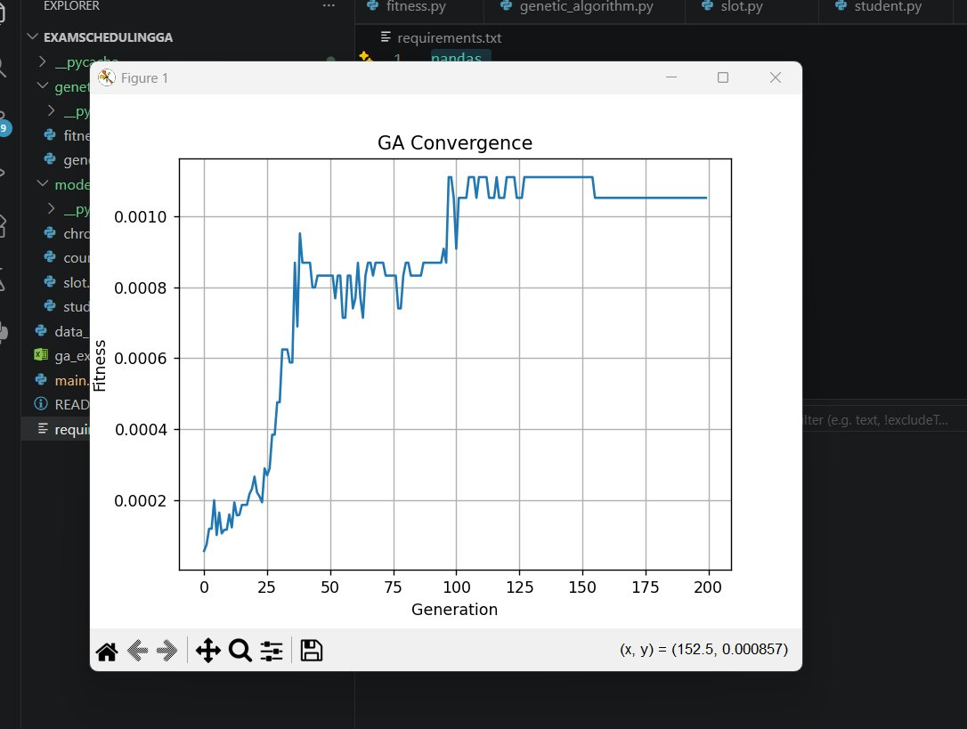
Figure 1 – GA Convergence: Best Fitness Score vs. Generation

The steep rise in early generations reflects rapid hard-constraint resolution. The fluctuations in the mid-section are a healthy sign of exploration via mutation. The curve flattens after generation 100, indicating convergence on a near-optimal solution.

6. Results and Discussion
After 200 generations the best chromosome achieved a fitness of 0.00110. The terminal output below shows the best genes, best fitness, and the final course-to-slot assignment for all 22 courses:

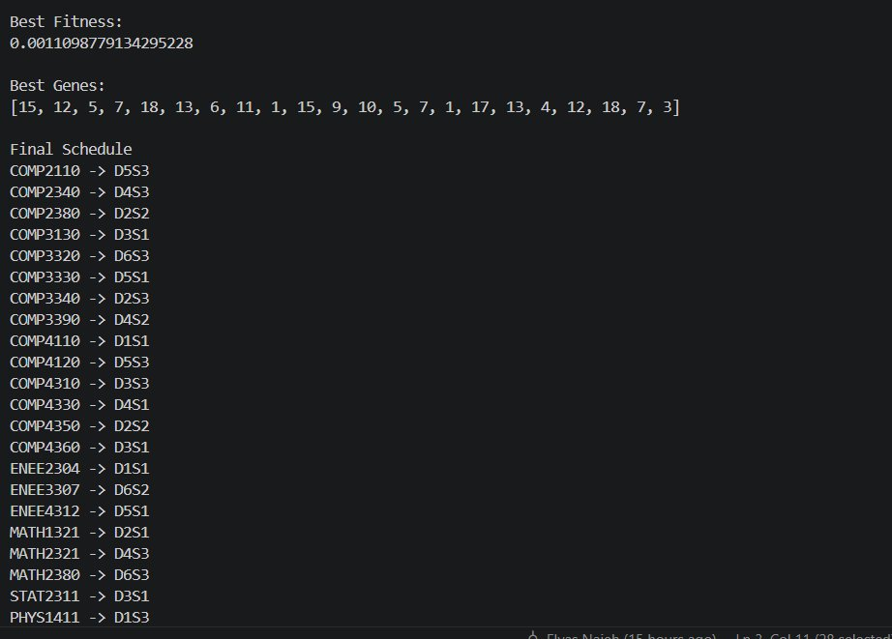
Figure 2 – Terminal Output: Best Fitness, Best Genes, and Final Schedule

The GA successfully eliminated all same-slot conflicts across all 95 students. The remaining penalty comes only from soft constraints (a small number of students having two exams on the same day), which is mathematically unavoidable given 22 courses sharing 18 slots.

The penalty weight design was critical: the 1000-point weight for same-slot conflicts ensured the GA resolved this hard constraint first, while the softer weights (50, 100) provided gentle pressure on the remaining constraints without destabilizing the search. A possible future improvement is adding elitism — preserving the top 1–2 chromosomes unchanged into the next generation — to reduce fluctuations and guarantee the best solution found is never lost.

