**Object Detection / Sentiment Analysis:**

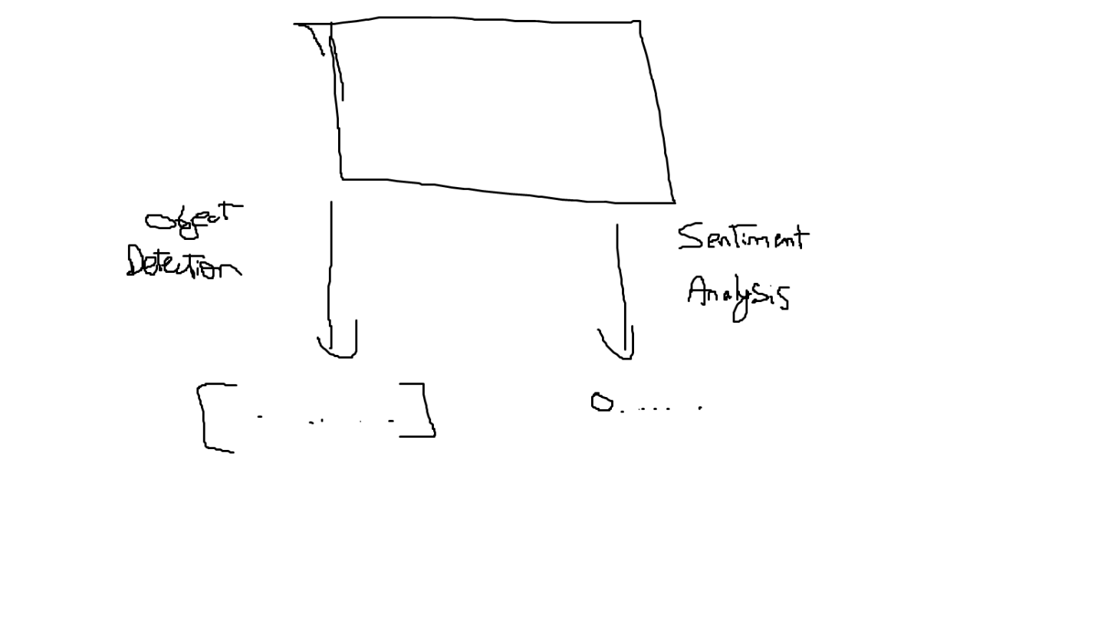

**RL Implementation**

**Problem Statement:**

"Combining rule-based approaches with reinforcement learning to generate structured poetry in the absence of annotated data specific to the desired poetic structure."

**Agent:**

* The agent will be a constrained LM or LSTM or RNN.
* The action space for the agent will be the suggested words that will be chosen based on the reward after multiple iterations.

**LM:**

* Takes in the first line of the haiku and constructs the rest
* What the RL algorithm should do:
  + Create the first line
  + Revise the whole haiku to make sure sentiment and objects are correctly assigned

**Environment:**

Init:

Observation space:

Unchangable:

* Objects
* Sentiment
* Syllables_remaining: [5, 7, 5]

Action space:

How should it generate Haikus based on the observation space

* Haiku: [“line_1”, “line_2”, “line_3”]

Environment state:

* Objects
* Sentiment
* Syllables_remaning

Reward function:

Rule-Based:

* + For Structure we have to make sure that the 3 line and syllable count is maintained
  + For Sentiment we have to match the emotion
  + For Objects we can just make sure that they are included in the haiku

RL-Based:

In case we don’t get a poetic style

* Sense of poeticness (Use an LM to give a score)

**Training:**

* Generate random objects and sentiment for each episode