*Eitan Coronel 315468132*

*Elyashiv Newman 206387177*

1. **Explain the problem space**:

Our project addresses privacy concerns in peer-to-peer (P2P) file-sharing networks. In traditional P2P systems, users share and download file segments across a decentralized network where each peer acts as both a client and a server. Files are split into chunks, and peers download these chunks from multiple sources simultaneously, often with the help of a Distributed Hash Table (DHT) that tracks file availability.

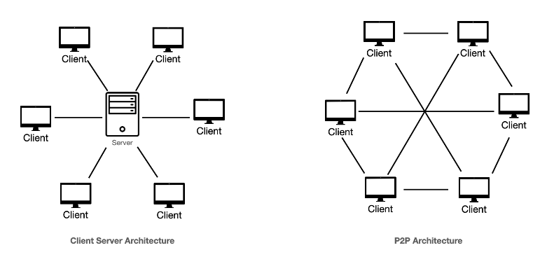

As we can see in this picture, the P2P network (right) differs significantly from a traditional client-server network (left). In a client-server model, all clients connect to a centralized server to download or upload data. This means that the server is the sole distributor of files, creating a potential bottleneck and single point of failure. In contrast, in a P2P network, all peers communicate and exchange data directly with each other without relying on a central server. Each peer can download file chunks from multiple other peers, increasing efficiency and resilience.

While this decentralized approach makes file sharing faster and more robust, it also exposes users to privacy risks, as adversaries can observe network traffic and track which files or file segments are being requested and downloaded by specific peers.

1. **Motivate the importance of the problem you’re targeting:**

The need for privacy in digital communication and file-sharing is critical in today's data-driven world. P2P networks are widely used for various applications, including money transfers (through cryptocurrencies like Bitcoin), sharing large files via platforms like BitTorrent, and even use to power streaming services such as Spotify (which previously used P2P technology to distribute music).  
However, without privacy protections, users in these networks are vulnerable to surveillance and tracking by malicious actors. This exposure allows adversaries to monitor and analyse which files users are downloading, which could lead to potential risks, especially in regions where internet usage is closely monitored, or for users accessing politically sensitive or copyrighted content. The ability to observe user behaviour in P2P networks can result in privacy breaches, data mining, or even legal consequences for individuals who unintentionally expose their downloading activity to the public or adversaries.

1. **Describe your solution and how it compares to the state of the art:**
   1. **What is the attacker model? What assumptions does it make?**
   2. **Motivate your design given the attacker model:**
2. **Evaluate your solution**