A Computer Academy in France Defies Conventional Wisdom

(…)

The school breaks with the often-rigid methods and philosophy of the government education system whenever it can, and Mr. Niel believes that the result will be more innovative, more employable, more diverse graduates who are more useful to the stagnant French economy.

But the French revere their school system, the Éducation Nationale. And Project 42, presented as an affront to tradition, has turned out to be a minor scandal here.

Its very name is a cryptic provocation: In “The Hitchhiker’s Guide to the Galaxy,” the zany science-fiction novel by Douglas Adams, which is a favorite of technology types here, the number 42 is proclaimed the “Answer to the Ultimate Question of Life, the Universe and Everything.”

“People say to us, ‘But why didn’t you see about working with the Éducation Nationale?’” said Mr. Niel, who has put up 70 million euros, or about $94 million, for 42’s first decade of operations.

“Well,” he said in an interview, “do you want this thing to work or not?”

The new academy promotes what many French call the Anglo-Saxon virtues of entrepreneurship and creative thinking, Mr. Niel said, whereas the standard French approach relies heavily on rote learning.

The Ministry of Higher Education declined to comment on the new academy. But public officials acknowledge that existing institutions are failing to train students in skills that are in demand. Critics deride universities as “unemployment factories.” Despite a national jobless rate of nearly 11 percent, as many as 60,000 computer coding jobs are thought to be vacant in France, the government says, for lack of qualified candidates

“In France, there are always excellent engineers — the Germans recruit them hand over fist, for that matter,” said Nicolas Baverez, a historian and economist at the Institut Montaigne, a nonpartisan think tank. But 42 marks “the French educational system’s inability to address innovation, upward social movement, the emergence of new technologies and sectors,” Mr. Baverez said.

Typically, French students learn specific rules for specific situations, said Nicolas Sadirac, 42’s director. “The problem is that for inventing stuff,” Mr. Sadirac said, “that’s a catastrophe.”

By Scott Sayare

Nov. 15, 2013

<https://www.nytimes.com/2013/11/16/world/europe/in-france-new-tech-academy-defies-conventional-wisdom.html>

Are Coding Bootcamps Worth It?

College tuition in the U.S. is on the rise, making traditional degrees less accessible for many students. For those pursuing tech careers, coding bootcamps offer an efficient, affordable option. Still, coding bootcamps are intensive programs that require a significant commitment of time, money and energy.

Is a Coding Bootcamp Worth It?

While a coding bootcamp is not a substitute for a college degree, it may allow you to quickly enter the tech field, start making money and begin building a fulfilling career. So, are coding bootcamps worth it?

If you want to launch a new tech career, a coding bootcamp may be your best option. The benefits of completing a coding bootcamp include:

Bang for your buck. A coding bootcamp costs a lot less than a typical college degree.

Help finding a job. Most coding bootcamps offer job search assistance, so you won’t be completely alone in your search.

No degree required. You don’t need to have a college degree in most instances, although a degree in a related discipline may help you have a broader understanding of your field.

Valuable skills. You’ll gain in-demand skills in a short amount of time, so you’ll be ready to find a relevant job quickly.

Versatility. Coding bootcamps are typically comprehensive, so you’ll learn a variety of skills to make you a marketable job candidate.

Reasons Why a Coding Bootcamp May Not Be the Best Choice for You

You’re unsure about the type of career you want to have.

You do not have the bandwidth to complete a comprehensive, intensive and demanding program.

You are interested in a management career or another career path that may require a traditional college degree.

 How Much Does a Coding Bootcamp Cost?

Coding bootcamp costs vary depending on program length, material covered and whether you study full or part time. 2022 research by Forbes Advisor into bootcamp tuition prices found that the average bootcamp costs $10,762.

By comparison, tuition and fees for a traditional undergraduate degree costs an average of $9,349 per year for in-state schools and $27,023 per year for out-of-state schools, according to the [National Center for Education Statistics](https://nces.ed.gov/programs/digest/d20/tables/dt20_330.20.asp). If it takes you four years to complete an undergraduate program, it might cost a total of $37,396 or $108,092, respectively. Private schools are often even more expensive.

By [Sheryl Grey](https://www.forbes.com/advisor/author/sgrey/) - Updated: Jul 6, 2022, 1:31pm

Contributor

<https://www.forbes.com/advisor/education/are-coding-bootcamps-worth-it/>

<!DOCTYPE html>

<html lang="en">

<head>

<title>Bootstrap 5 Example</title>

<meta charset="utf-8">

<meta name="viewport" content="width=device-width, initial-scale=1">

<link href="https://cdn.jsdelivr.net/npm/bootstrap@5.2.3/dist/css/bootstrap.min.css" rel="stylesheet">

<script src="https://cdn.jsdelivr.net/npm/bootstrap@5.2.3/dist/js/bootstrap.bundle.min.js"></script>

</head>

<body>

<div class="container-fluid p-5 bg-primary text-white text-center">

<h1>My First Bootstrap Page</h1>

<p>Resize this resp²onsive page to see the effect! </p>

</div>

<div class="container mt-5">

<div class="row">

<div class="col-sm-4">

<h3>Column 1</h3>

<p>Lorem ipsum dolor sit amet, consectetur adipisicing elit...</p>

<p>Ut enim ad minim veniam, quis nostrud exercitation ullamco laboris...</p>

</div>

<div class="col-sm-4">

<h3>Column 2</h3>

<p>Lorem ipsum dolor sit amet, consectetur adipisicing elit...</p>

<p>Ut enim ad minim veniam, quis nostrud exercitation ullamco laboris...</p>

</div>

<div class="col-sm-4">

<h3>Column 3</h3>

<p>Lorem ipsum dolor sit amet, consectetur adipisicing elit...</p>

<p>Ut enim ad minim veniam, quis nostrud exercitation ullamco laboris...</p>

</div>

</div>

</div>

</body>

</html>

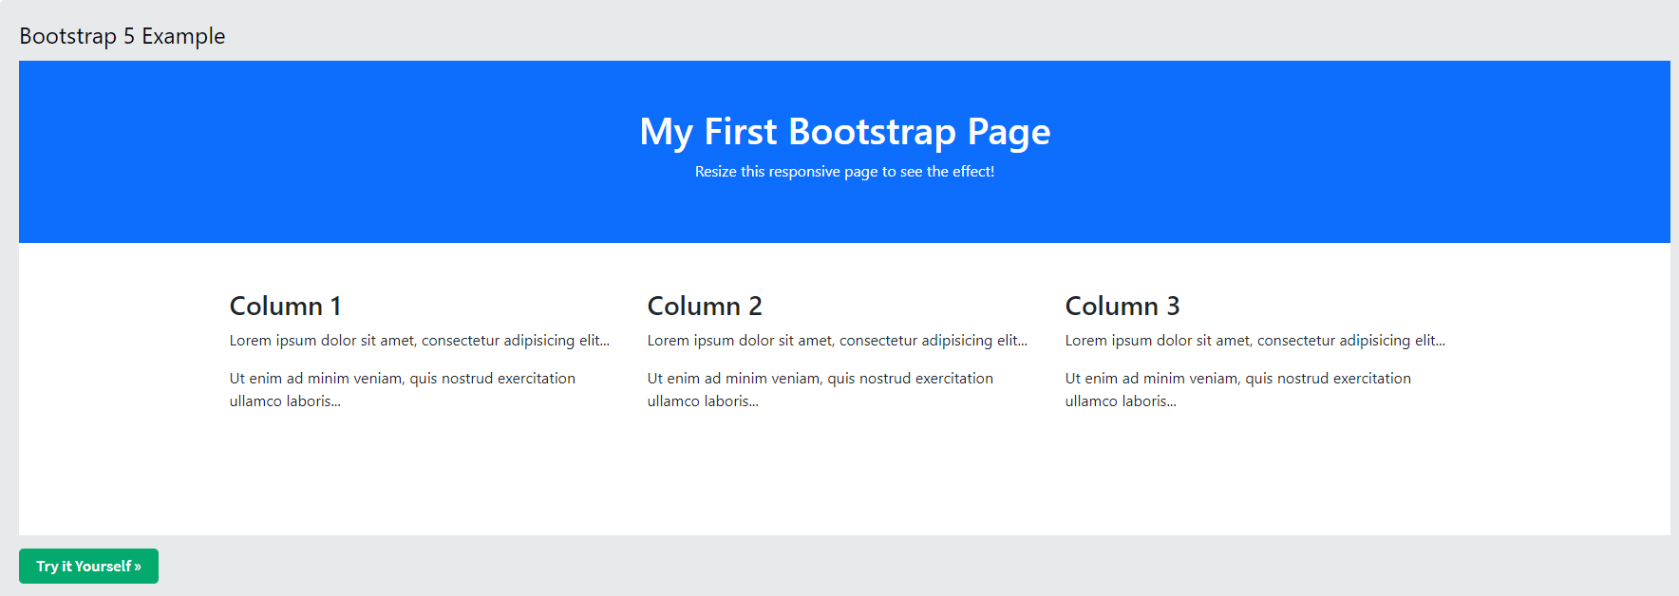

<https://www.w3schools.com/bootstrap5/tryit.asp?filename=trybs_default&stacked=h>

Example internship: (“OPEN RUSH.HTML”)

<!DOCTYPE html>

<html>

<head>

<title>Responsive Navbar</title>

<meta name="viewport" content="width=device-width, initial-scale=1.0">

<link href="https://cdn.jsdelivr.net/npm/bootstrap@5.2.0-beta1/dist/css/bootstrap.min.css" rel="stylesheet" integrity="sha384-0evHe/X+R7YkIZDRvuzKMRqM+OrBnVFBL6DOitfPri4tjfHxaWutUpFmBp4vmVor" crossorigin="anonymous">

<link href="https://fonts.googleapis.com/css2?family=Source+Sans+Pro:wght@400;700&display=swap" rel="stylesheet">

<link rel="stylesheet" href="https://cdnjs.cloudflare.com/ajax/libs/font-awesome/5.14.0/css/all.min.css" integrity="sha512-1PKOgIY59xJ8Co8+NE6FZ+LOAZKjy+KY8iq0G4B3CyeY6wYHN3yt9PW0XpSriVlkMXe40PTKnXrLnZ9+fkDaog==" crossorigin="anonymous" />

<link rel="stylesheet" href="https://fonts.googleapis.com/css?family=Sofia">

<div class="container" >

<div class="section-title">

<h2 id="About">About</h2>

</div>

<p class="about">Magnam dolores commodi suscipit. Necessitatibus eius consequatur ex aliquid fuga eum quidem. Sit sint consectetur velit. Quisquam quos quisquam cupiditate. Et nemo qui impedit suscipit alias ea. Quia fugiat sit in iste officiis commodi quidem hic quas.</p>

<section id="resume" class="resume">

<div class="container" >

<div class="section-title">

<h2>Resume</h2>

<p>Magnam dolores commodi suscipit. Necessitatibus eius consequatur ex aliquid fuga eum quidem. Sit sint consectetur velit. Quisquam quos quisquam cupiditate. Et nemo qui impedit suscipit alias ea. Quia fugiat sit in iste officiis commodi quidem hic quas.</p>

</div>

<div class="row">

<div class="col-lg-6">

<h3 class="resume-title">Sumary</h3>

<div class="col-lg-6">

<h3 class="resume-title">Professional Experience</h3>

<footer id="footer">

<div class="container">

<h3 id="Contact">Contact</h3>

<center><p>Et aut eum quis fuga eos sunt ipsa nihil. Labore corporis magni eligendi fuga maxime saepe commodi placeat. </p></center>

<div class="social-links">

<a href="https://fr-fr.facebook.com/"><i class="fab fa-facebook-f fa-1x"></i></a>

<a href="https://twitter.com/i/flow/login"><i class="fab fa-twitter fa-1x"></i></a>

<a href="https://www.google.com/intl/fr/account/about/"><i class="fab fa-google fa-1x"></i></a>

<a href="https://www.instagram.com/?hl=fr"><i class="fab fa-instagram fa-1x"></i></a>

<a href="https://fr.linkedin.com/"><i class="fab fa-linkedin fa-1x"></i></a>

</div>

<div class="copyright">

&copy; Copyright <strong><span>MyResume</span></strong>. All Rights Reserved

</div>

</div>

</footer>

</main>

<script src="https://cdn.jsdelivr.net/npm/bootstrap@5.2.0-beta1/dist/js/bootstrap.bundle.min.js" integrity="sha384-pprn3073KE6tl6bjs2QrFaJGz5/SUsLqktiwsUTF55Jfv3qYSDhgCecCxMW52nD2" crossorigin="anonymous"></script>

</body>

</html>