PPFE

Table of contents
1.Conception 2
1.1)Purpose 2
1.2)Data Model 2
1.3)Sequence Diagram : Business logic 3
2.Development 3
2.1)Environment 3
2.2)Architecture 3
2.3)Class’s role : 4
2.4)Resources 6
3.Dashboard 6
3.1)Access 6
3.2)Login 6
3.3)Display 7

Conception

Purpose
The purpose of this application is to compare daily today’s purchases and yesterday’s purchases on different voucher types. In terms of those differences, this application is able to create warnings and send a daily report by mail to the team.
This application is also used in aim to display a dashboard where the user can see informations about warnings over different periods.

Data Model
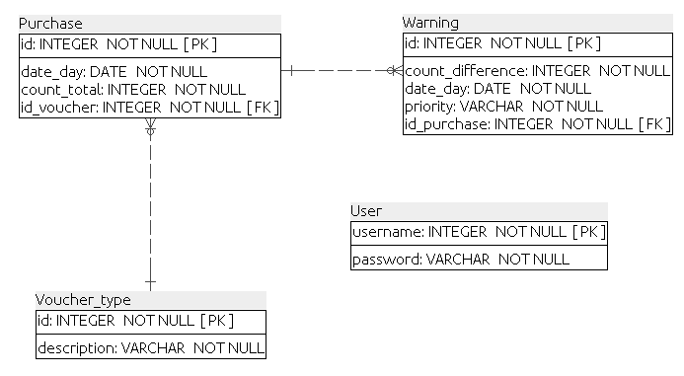

Data will be collected ...

Sequence Diagram : Business logic
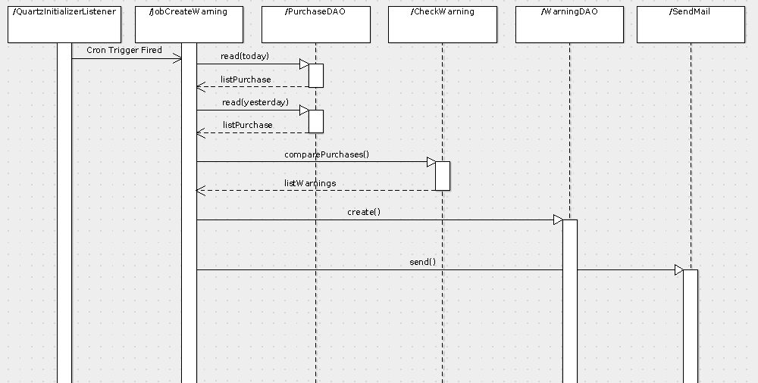

Development

Environment
Application Server : WildFly 13.0.0 (ex Jboss AS)
Client port : 8090 (username : elyes, password 78963214)
Go to ${WILDFLYHOME}/bin/add-user.sh to add a new user
Management port : 9990
In the management console, the DataSource is already set up.
Go to Configuration -> Datasources & drivers -> DataSources
Also need to configure the JDBC Driver : add mysql (com.mysql.cj.jdbc.Driver)
Database : MySQL 5.7.23
Port : 3036
To manage the database, used MySQL Workbench

Architecture
This application is based on the MVC (Model-View-Controller) architectural pattern.
For the data persistance this application uses EJB3 with Hibernate which is native from WildFly.
Packages :
- com.ppfe.entities
- com.ppfe.dao
- com.ppfe.business
- com.ppfe.servlets
- com.ppfe.forms
- com.ppfe.filters

Scheduler : Quartz API using CRON Trigger
Config files :
- quartz.properties
In this file we define the scheduler, the jobStore type and his pool and the plugin for jobInitializer by giving to it the name of the config’s file.
- quartz-config.xml
In this file we define the job and the trigger.
Here, the job is the class com.ppfe.business.JobCreateWarning.
The trigger is attached to the job and is based on a cron-expression. This is this expression which is responsible to define the moment when we want the job to execute. (Means that if you want to schedule at which time you want the job execute, it’s the <cron-expression> you need to change.

Logger : Log4j
Config file :
- log4j.properties
In this file, we initialize the logger’s output and format.
We also enable the debugging for SQL queries.

Class’s role :
- Entities
- Purchase
- VoucherType
- Warning
These classes correspond to EJB entities (@Entity) : They are objects mapped to database’s table which will be persisted.
- DAO (Data Access Object)
- DAOException
This class define exceptions which can occurs during persistence into the database.
- PurchaseDAO
- VoucherTypeDAO
- WarningDAO
These classes are stateless EJB : They provides methods for each entity to realize specific data operations on the database. They are directly connected to the database through persistence unit in the persistence.xml file.

- Business
- JobCreateWarning
This class provides the Quartz Job : This is the class called when the trigger is fired.
It read purchases for today and yesterday then compare it through the class CheckWarning, persist the warnings then send report by mail through the class SendMail.
- CheckWarning
This class compare and calculate the difference between the purchases then depending on this difference, add warnings to a list and return it to the Job.
- SendMail
This class provides the sending mail service.
You can configure here the sender/recipient, subjet, content... of the mail

- Servlet
- IndexServlet
Classic servlet which permit to access to the index.jsp page through the HTTP GET method.
- PurchaseServlet
Classic servlet which permit to access to the purchase.jsp page through the HTTP GET method.
Parameters required in the URL to get the specific warning and purchases
- AjaxServlet
This is the servlet call by the view, which is responsible to create the JSON and send it back to the view.
- LoginFormServlet
This is the servlet reached by the HTML POST method from the login’s form.

- Filters
  - RestrictionFilter
Filter in order to restrict the application for users who are not connected. Will redirect you to the login page if you are not connected and want to access to the index page.

- Forms
Class which contains validation method for the login form.

Resources
Under the folder /WebContent/inc :
There are all resources needed to be included for the view, including JS and CSS, images.
For the graphs, used the library chartJs
Also using of CSS library : Bootsrap
The main JS file is chart.Js → This file is used for the AJAX call, creating/updating graphs and the whole dynamic elements of the view in general.

Dashboard

Access
The dashboard is accessible through the URL /PPFE/index
This view is attached to the Servlet IndexServlet

Login
A user can login to the application through his username and password.
If the filter is enabled, it will give the permission to the user to have access to the whole application.
Username : admin
Password : admin

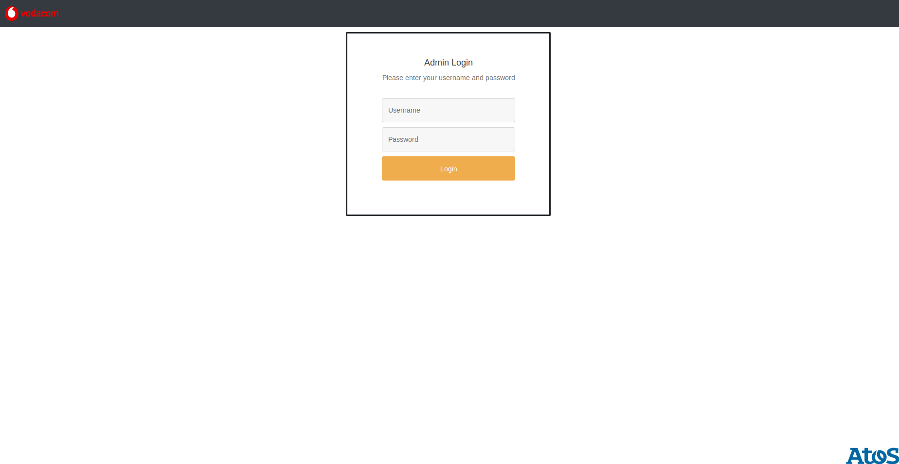

Display
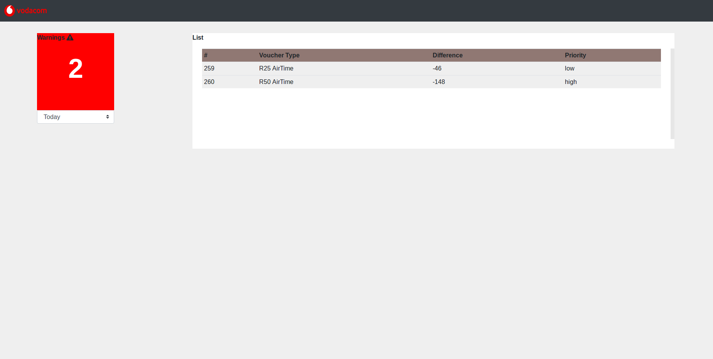
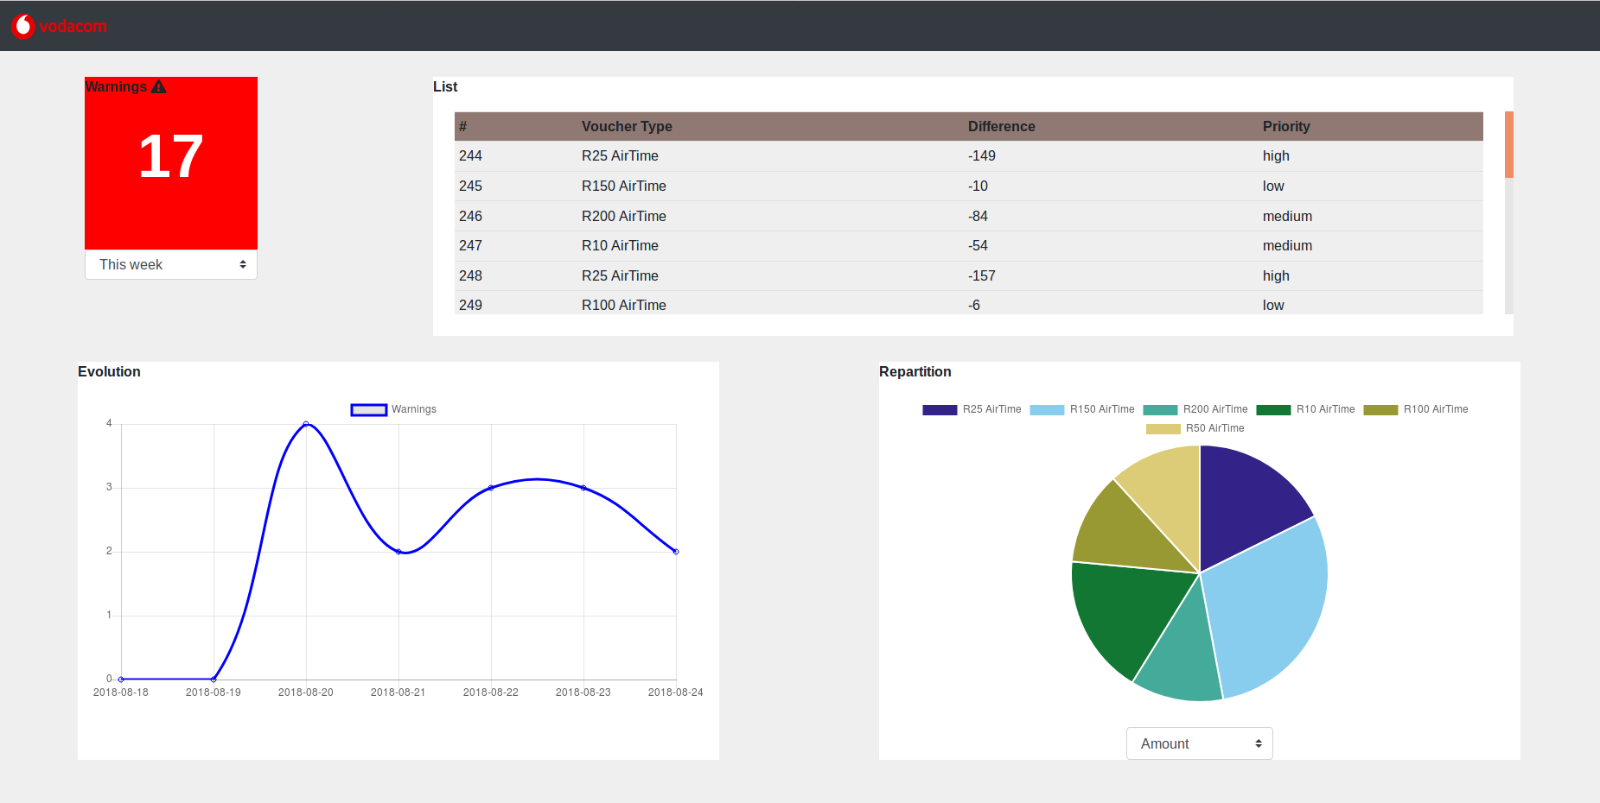
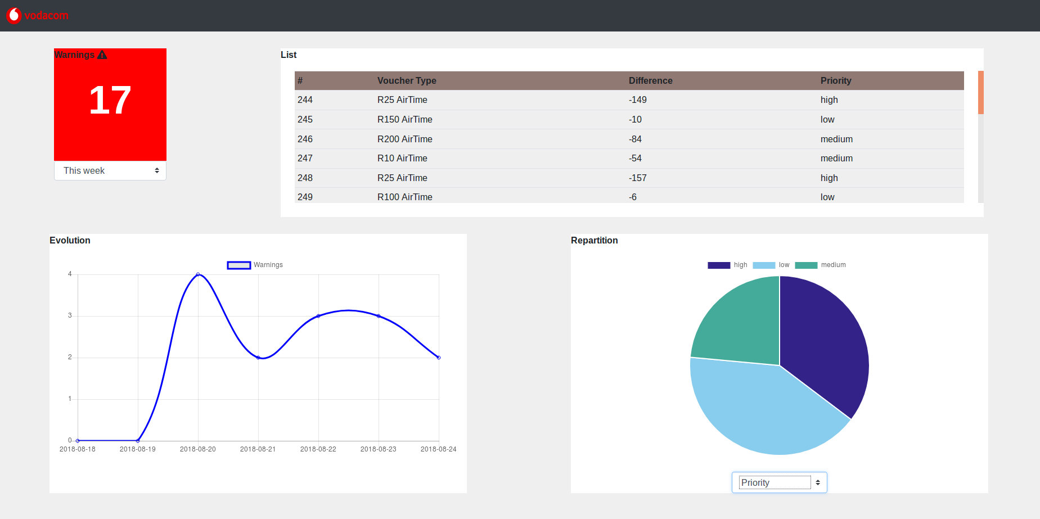
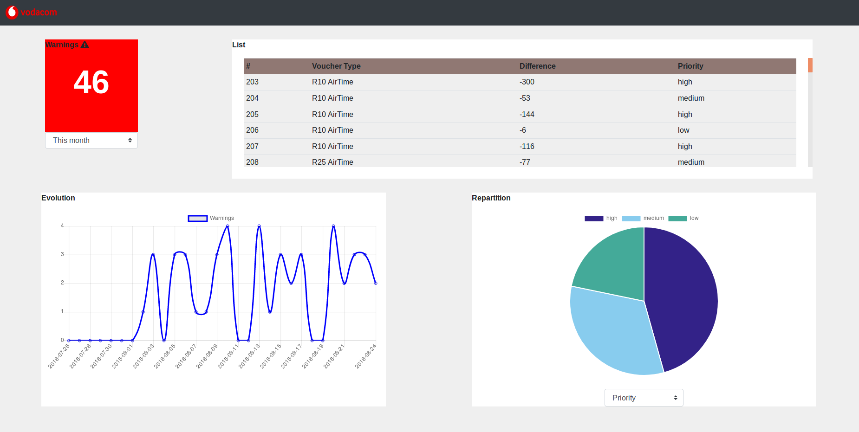
If you click on a table’s line :
