**ESP32 chip energy consumption**

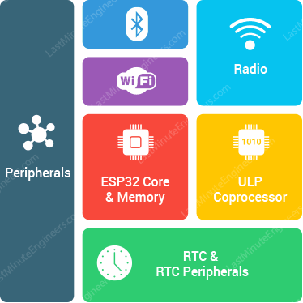

The ESP32 chip contains a dual-core 32-bit microprocessor along with 448 KB of ROM, 520 KB of SRAM, and 4 MB of flash memory.In addition, the chip contains a WiFi module, a Bluetooth module, a cryptographic accelerator (a co-processor designed specifically to perform cryptographic operations), an RTC module, and a number of peripherals.

## ESP32 Power Modes

* Active Mode
* Modem Sleep Mode
* Light Sleep Mode
* Deep Sleep Mode
* Hibernation Mode

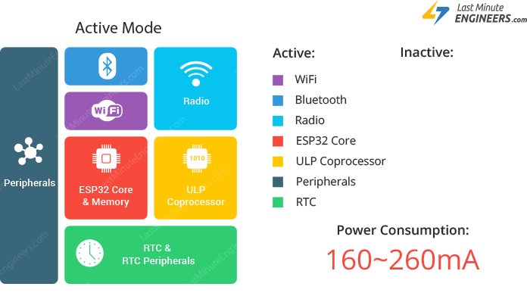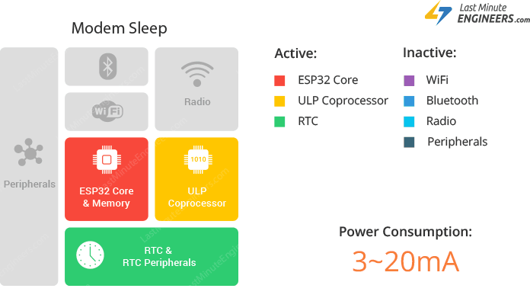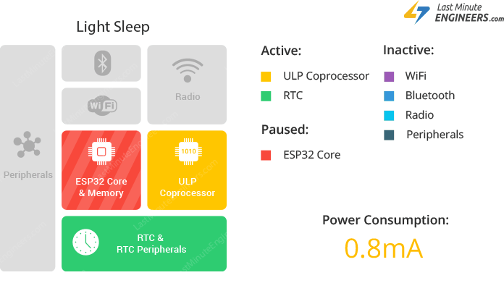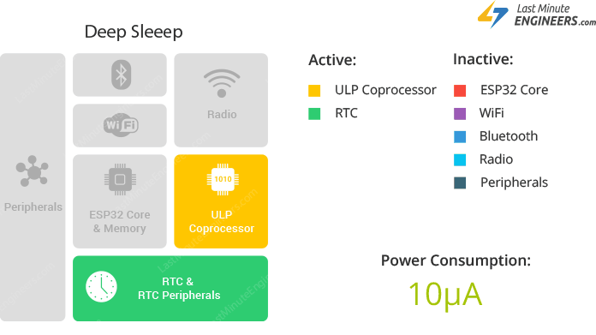

| **Name** | **Pros** | **Cons** | **Price** | **Characteristics** | **Image** |
| --- | --- | --- | --- | --- | --- |
| [**Beetle ESP32-C3**](https://2betrading.com/cartes-de-developpement/6787-module-beetle-esp32-c3-risc-v-core-development-board.html) | * **Low power consumption, making it suitable for battery-powered applications** * **Dual-core microcontroller running up to 160 MHz** * **Compact size and low cost** | * **Single-band Wi-Fi (2.4GHz only)** * **Limited availability of support and community resources compared to other ESP32-based boards** | **52 DT** | **Operating Voltage: 3.3V**  **Type-C Input Voltage: 5V DC**  **VIN Input Voltage: 5V DC**  **Operating Current: 25mA**  **Maximum Charging Current: 400mA**  **Operating Temperature: -40~105℃**  **Size: 25 x 20.5mm** |  |
| [**ESP32-DevKitC V4**](https://2betrading.com/accueil/5370-carte-de-developpement-wifi-bluetooth-iot-esp32-wroom-32d.html)  [**ESP32-WROOM-32D**](https://2betrading.com/accueil/5370-carte-de-developpement-wifi-bluetooth-iot-esp32-wroom-32d.html) | * **Dual-core microcontroller running up to 240 MHz More memory (520KB SRAM and 4MB flash memory)** * **Dual-band Wi-Fi (2.4GHz and 5GHz)** * **Wide availability of support and community resources** * **Wide range of development boards and modules based on the ESP32-WROOM-32D** | * **Consume more power compared to the Beetle ESP32-C3** | **42 DT** | **USB to Serial Port Chip: CP2102-GMR**  **Operating Voltage: DC 5V**  **Operating Current: 80mA**  **Current Supply: 500mA**  **Size 55mm*26mm*13mm**  [**Datasheet**](https://asset.conrad.com/media10/add/160267/c1/-/gl/002490159DS00/datasheet-2490159-espressif-pcb-design-board-esp32-devkitc-vie.pdf) |  |
| [**ESP32 CH340C CP2102**](https://2betrading.com/accueil/6856-nouvelle-version-carte-esp32-esp-32-cp2102-wifi-bluetooth-usb-type-c.html) | * **Dual-core microcontroller running up to 240 MHz** * **More memory options (520KB SRAM and 4MB flash memory)** * **Dual-band Wi-Fi (2.4GHz and 5GHz)** | * **Limited availability of support and community resources compared to other ESP32-based boards** * **May consume more power compared to the Beetle ESP32-C3** * **May require additional components, such as voltage regulator and crystal oscillator, to operate** | **39 DT** |  |  |