

Ministry of High Education

And Scientific Research

*** * ***

University of Carthage

*** * ***

National Institute of Applied

Sciences and Technology

**Personal Professional Project**

**Major: Industrial Computing and Automation**

**Grade :** 3rd year

**Subject :**

**Mechanical study of industrial packaging for the production of snacks for children**

*Realized by:* **Amer DJOBBI**

**Dorra BOUSRIH**

**Elyes KHECHINE**

**Nermine GHARBI**

INSAT Supervisor : Mr Atef BOULILA

**Academic year: 2021/2022**

**Table of Contents**

Contents

I. Research on Industrial Packaging Materials: For Date Syrups 2

A. Introduction to Packaging 2

1. Definition of Packaging 2

2. Packaging Levels 2

3. Technical Purposes of Packaging 2

B. Packaging Development 3

1. Considerations for Selecting a Packaging Material 3

2. Packaging as a Medium of Communication 3

3. Packaging as a Salesman 4

4. Considerations for Producing a Successful Package 4

C. Material Comparison 5

1. Industrial Food Packaging Materials: 4 Main Types 5

2. Breakdown Comparison Between Food Packaging Materials 9

3. Comparison Between Plastic Food Packaging 10

II. Snack Products 10

A. Dates Juice Drink 10

1. Choice of the packaging material: 10

2. Packaging Design: 14

3. Industrial Manufacturing of the Packaging: 14

A. Dates Milk Drink 14

1. Choice of the packaging material: 14

2. Packaging Design: 14

3. Industrial Manufacturing of the Packaging: 14

B. Dates Nougat 14

1. Choice of the packaging material: 14

2. Packaging Design: 14

3. Industrial Manufacturing of the Packaging: 14

**General Introduction……………………………………………………………….…………………………1**

**Chapter 1 : Project Context…………………………………………………………………..…………...…2**

**I. Definition of packaging**

**1. Primary packaging**

**2. Secondary packaging**

**3. Tertiary packaging**

**II. Introduction and history of package development**

**III. Functions of packaging**

**IV. Requirements for producing a successful package**

**1. The product**

**2. Transport hazards**

**3. Contamination**

**V. Selection of packaging materials**

**VI. Characteristics of an ideal package**

**Chapter 2 : Presentation of the products………………………………………………………………...4**

**I. Marshmallow………………………………………………………………………………………………...4**

**1. Choice of the packaging material………………………………………………………………………..**

**1.1. Polypropylene (PP)……………………………………………………………………………………**

**1.2. Advantages of PP……………………………………………………………………………………**

**1.3. Recycling PP…………………………………………………………………………………………..**

**2. Packaging & Design……………………………………………………………………………………….**

**2.1 Technical requirements………………………………………………………………………………**

**2.2 Marketing requirements………………………………………………………………………………**

**2.3 Boxes VS Bags…………………………………………………………………………………………**

**2.4 Product's name…………………………………………………………………………………………**

**2.5 3D Design………………………………………………………………………………………………..**

**3.** **Industrial Manufacturing of the packaging…………………………………………………………….**

**3.1 How Are Reclosable Bags Made?...........................................................................................**

**3.2 How Does the Zipper Closure Work?.....................................................................................**

**II. Milk Drink**

**1. Sequence of layers of the bottle**

**1.1. Paperboard**

**1.2. Polymers**

**1.3. EVA « Ethylene-Vinyl Acetate »**

**1.4. Aluminium**

**1.5. Remarques**

**2. The Bottle cap**

**3. Label & package design**

**3.1. Label design**

**3.2. package design**

**4. Lamination technique used in the manufacture of the packaging**

**4.1. What is lamination :**

**4.2. Advantages of lamination technique :**

**III. Nougat**

**1. Description of the Product**

**2. Material choice**

**2.1. Why use aluminum foil ?(advantages)**

**2.2. Statistics about aluminum foil :**

**3. PACKAGING & DESIGN:**

**3.1. Logo:**

**3.2. Package labeling :**

**4. INDUSTRIAL STUDY:**

**4.A. GENERAL STUDY**

**4.1. THE MANUFACTURING PROCESS**

**4.2. THE FILLING & ASSEMBLING PROCESS**

**4.3. THE TRANSPORTATION OF THE PRODUCT**

**4.4. THE SHELF LIFE**

**4.5. THE USER EXPERIENCE**

**4.B. MANUFACTURING PROCESS OF THE PACKAGING :**

#### 4.1. Material

#### 4.2. Equipment

**4.3. Machine specifications**

**4.4. Features**

**IV. Juice**

**Chapter 3 : Future of Food Packaging Materials**

**Conclusion**

**Bibliography**

**Annexes**

**General Introduction:**

The product quality is a crucial requirement, starting from the designing process up to that of manufacturing, and ending with the product’s delivery.

In a world of never-ending brand competitiveness to produce environmentally-friendly products, that would both appeal to their consumers, and minimize wastes and thus global pollution, businesses, and specifically the food industry, finds itself in a constant journey of product improvement and quality enhancement.

As part of this PPP report, we offer you this dissertation which is organized into 3 chapters.

The first will present general information on food products’ packaging , the second will deal with the four products we were in charge of designing and the third will study the possible future advanced packaging processes .

# Chapter 1: Project Context

# 

## Definition of Packaging:

Packaging is defined as "enclosing a product, item or package in a bag, box, cup or other container". It performs the following functions:

* Containment
* Protection or preservation
* Communication
* Utility or performance

A device or container is considered a wrapper/package if it performs one or more of these functions. Therefore, packaging is a multifunctional service.

Packaging functions range from technical ones to marketing oriented ones as shown in the following table:

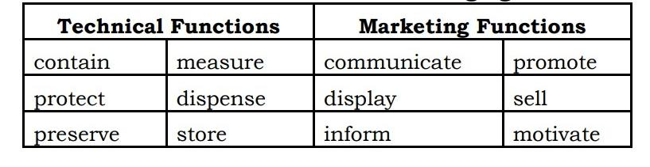

***Figure 1: Packaging Functions***

## Packaging Levels

Packaging may be looked at as several different types. For example, a transport package or distribution package is the package form used to ship, store, and handle the product or inner packages. Some identify a consumer package as one which is directed toward a consumer or household. It is sometimes convenient to categorize packages by layer or function: "primary", secondary", etc…

#### Primary Packaging

It is the material that first envelops the product and holds it. This usually is the smallest unit of distribution or use and is the package which is in direct contact with the contents.

#### Secondary Packaging

It is outside the primary packaging, used to group primary packages together.

#### Tertiary Packaging

It is used for bulk handling, warehouse storage and transport shipping. The most common form is a palletized unit load that packs tightly into containers

**Tertiary**

**Packaging**

**Secondary**

**Packaging**

**Primary**

**Packaging**

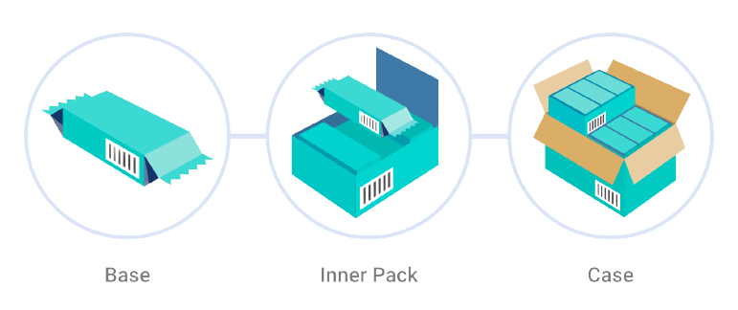

## Introduction and history of package development:

Packaging is not a recent phenomenon, but rather an activity closely associated with the evolution of society, and can be traced back to human beginnings.

The nature, degree, and amount of packaging at any stage of a society‘s growth reflect the needs, cultural patterns, material availability and technology of that society.

A study of changing roles of packaging and forms over the centuries is a study of the growth of civilization.

. Social changes are inevitably reflected in the way we package, deliver and consume goods.

**III. Functions of packaging:**

The functions of a package are ―to preserve the quality and freshness of food, to add appeal to the food to attract consumers, and to facilitate its storage and distribution.‖ The basic functions required of a package can be grouped under four major categories.

* **To Contain the Product :**

The primary function of any package is to contain the food and facilitate handling, storage, and distribution all the way from the manufacturer to the ultimate user or even the time the rest portion is utilized by the consumer. However, there are usually various levels of packaging. A primary package is one that comes into direct contact with the contained product, e.g., metal cans, glass jars, and plastic pouches. By law, a primary package must not yield any substance that may be injurious to the health of the consumer. Further development to facilitate handling is to bundle a series of primary packages together, and this lead to the concept of secondary packages. Examples of secondary package is corrugated box in which tins of apple juice are packed. As methods of handling and transportation have become more sophisticated, these secondary packages are often palletized and secured by strapping with metal or, more commonly, by shrink- or stretch-wrapped film to give yet another level of packaging,i.e tertiary packaging. In turn, these pallet loads may be packed into large metal containers, i.e., quaternary packaging for transportation over long distances by air, land, or sea. The secondary, tertiary and quaternary packaging are also known as packing.

1. Adequate size and shape.

2. Proper constructional features. No leakage, spillage, diffusion…

3. Package: Must contain the commodity in natural form (biscuits packed in Pillow pack, prevent damage)

4. No subsequent damage after packaging during handling transportation and storage, thus package must be strong enough to contain the commodity as it is.

5. Optimum compatibility (nontoxic, non soluble with product… No physical, chemical or biochemical changes/alteration…)

6. Containment or agglomeration (small objects are typically grouped together in one package for reasons of efficiency).

* **To Protect the Product :**

One of the most important functions of any container is to protect the product contained against any form of loss, damage, deterioration, spoilage, or contamination that might be encountered throughout the distribution chain. Packaging can prevent physical damage, e.g., bruising caused by vibrational shocks during transportation or stacking in a warehouse. Proper packaging will also prevent material loss, e.g., potatoes from a weak sack or juice from a leaky can. Packaging can also protect products against moisture loss or gain, dust, and light, especially UV light, which causes deterioration of some light-sensitive products. It can also protect the package contents against temperature fluctuations in the transit of chilled and frozen foods. Packaging can also be used to control the availability of oxygen to fruits and vegetables and to protect against loss of flavor or fragrance and help products retain their nutritional value. Proper packaging may also protect the product against microbial spoilage by bacteria, yeasts, and molds. It can also protect against microbiological spoilage of stored products due to rodents and insects.Packaging protects the product against damages which may be due to different hazards (a) Mechanical, (b) Environmental (c) Microbial and Biochemical hazard. (d) Social Hazards.

* **Medium of communication:**

An important function of any food package is to identify the product and its origin; to inform the consumer how to use the contents; to provide any other information needed or required; and very importantly, to attract the user and encourage purchase of the product. Package design has been an important and constantly evolving phenomenon for many years. Marketing communications and graphic design are applied to the surface of the package and in many cases the point of sale/display. The information a package can convey to the consumer may include the following:

1. Product manufacturing and best buy dates

2. Proper storage conditions

3. Cooking instructions

4. Size and number of servings or portions per pack

5. Nutritional information per serving

6. Manufacturer‘s name and address

7. Cost

8. Suggested recipes

9. Country of origin

10.Information transmission - Packages and labels communicate how to use,

transport recycle, or dispose of the package or product

* **Means of selling product:**

The packaging and labels can be used by marketers to encourage potential buyers to purchase the product. Packaging is often referred to as the ―silent salesman.‖ Robertson (1992) concisely summarized the multifunctions of packaging when he stated that ―a package must protect what it sells and sell what it protects.‖ Packages can have features which add convenience in distribution, handling, display, sale, opening, reclosing, use, and reuse. According to Jelen (1985), primary packages should have the following characteristics to facilitate the sale of products**:**

1. Sanitary

2. Non toxic

3. Transparent

4. Lightweight

5. Tamper evident

6. Easy to pick up and handle

7. Easy to fit into cupboards, shelves, refrigerators, etc.

8. Easy to open and dispense from

9. Easy to reclose

10.Returnable, recyclable, or reusable

11.Safe and presents no hazards in the way of broken glass or sharp jagged metal edges

12.Display the product

13.Glamorize: Create an illusion of something very precious, by decoration, embossing techniques and exotic closures, but it should not deceive the people.

**IV. Requirements for producing a successful package:**

Four sets of facts are necessary to be known for producing a successful package:

**1. The product:**

The nature of the product, the material from which it is made and the manner in which it can deteriorate.

Its size and shape.

Its weight and density: eg. Powder – Bulk Density … size of tins

Its weakness-which parts will break, move about, become bent or scratch or abrase the box easily.

Its strengths: which part will withstand loads or pressures and which might be suitable for loading the product in the pack.

The effect of moisture and temperature changes on the product and whether it will absorb moisture or corrode.

Compatibility: whether the product is likely to be affected by any of the possible packaging materials, which items can be packed together, with protection if necessary and which items must not be packed together under any circumstances.

How far stripping down may be carried out to reduce the package size to a minimum such that the customer can handle them. (Generally for merchandize foods like kitchen machine, blender etc.)

**2. Transport hazards:**

The type of transport-road, rail, sea or air.

The degree of control over the transport. Is it private or public transport?

The form of transport- bulk, freight container, Unitized load, postal, passenger train, etc.

The mechanical conditions and duration of storage (manufacturer State Distributor District Distributor … Taluka / CityRetailer. The longer the journey or handling more strength is required in packaging & packing materials leading to higher cost).

The nature and intensity of mechanical and climatic hazards in transport, storage, retailing and use. Packaging / packing material has to withstand wide range of temperatures and relative humidity

Whether handling aids are available for loading and off-loading at all points between maker and user. (Viz. Lifts, Trolleys, Slip conveyers etc.)

The importance of minimum volume in relation to transport costs. Over packaging must be prevented.

**3. Contamination:**

-By materials of adjacent packs

-By leaking contents of adjacent packs

-Radioactivity.

**V. Selection of packaging materials:**

The food processor has a variety of packaging materials to choose from for food packaging, specifically, paper,glass, metal, and plastics. The choice of the proper packaging material will be made by the food processor based on the requirements:

1. Composition of the food (solid or liquid)

2. Physical, chemical, and microbiological and deteriorative reactions that might

occur

3. Storage conditions and time of storage

4. Socioeconomic situation of the anticipated customer or market

5. Desired package attractiveness

6. Cost of the packaging material

7. Packaging technology selected

8. Specific functional properties of the packaging material

There are several reasons for selecting or rejecting a particular packaging material over another, as summarized in the following Table:

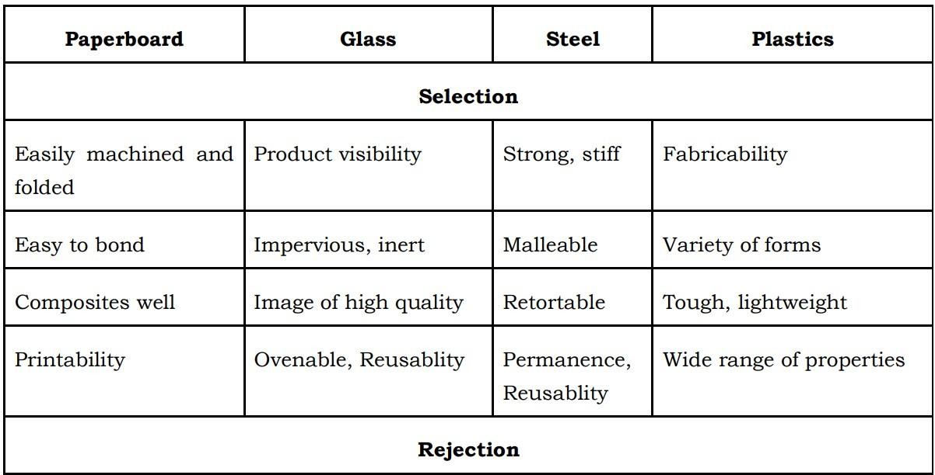

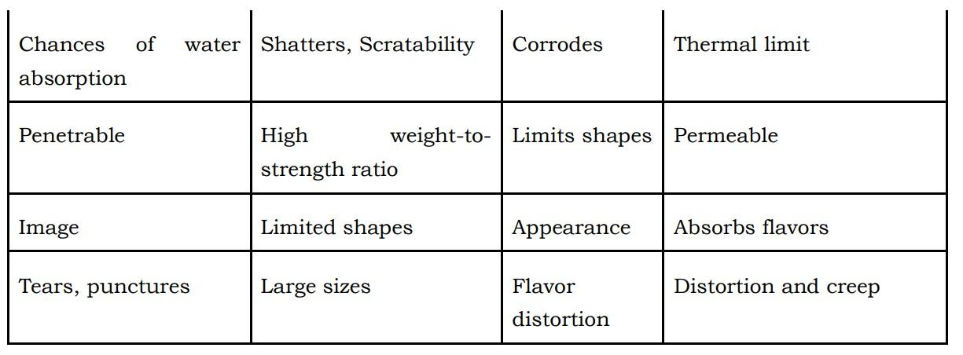

**VI. Characteristics of an ideal package:**

1. Compatible with product.

2. Protection from Mechanical hazards especially transportation. climatic hazards, microorganisms : Packaging do not harbour bacteria, restrict their growth….Flavour gain/loss/salts/difference in temperature.

3. Fit into a production line.

4. Advertising potential.

5. Attractive appearance.

6. Easy to handle during…Production, storage and Distribution

7. Moisture proof/resistance.

8. Sufficient mechanical strength to withstand drop, vibration, compression etc.

9. Acid, alkali resistance.

10.Grease & oil resistance.

11.Resistance to photo-chemical changes in product.

12.Resistance to insects and rodents.

13.Fire proof resistant to smoke, fume and water.

14.Pilfer proof (malpractice).

15.Inert: No effect on flavour/aroma.

16.Not injurious to health.

17.Economic.

18.Easy availability.

19.Protect against climatic hazards.

20.Protect against microorganisms. It should not harbour microbes rather restrict their growth by controlling growth factor like.

**Chapter 2 : Presentation of the products**

**I) Marshmallow :**

**1) Choice of the packaging material :**

According to researchers, consumers normally purchase marshmallows in simple polypropylene (PP) pouch packaging.

So what is PP ?

**1.1. Polypropylene (PP)**

A polypropylene bag is high clarity and crystal clear in order to enhance the image of whatever product is inside. This PP bag offers a highly protective barrier against both moisture and vapors. These poly bags delay evaporation and dehydration to preserve the freshness and taste of packaged foods. Generally, PP plastics are stronger, clearer, and more expensive than their PE plastic counterparts. Polypropylene bags are great for the following industries — food, electronics and electronics manufacturing, hospitals, agriculture, and more.

**1.2. Advantages of PP :**

-More resistant to chemicals, high temperatures, and scratches

-Crystal clear for great product presentation

-Stiff and hard plastic

-Rough surface has the potential to produce scratches

-Outstanding vapor and moisture barrier

-Meets FDA and USDA specifications

-Difficult to break, but not very flexible

**1.3. Recycling PP :**

While PP is easily among the most popular plastic packaging materials in the world, only around 1-3% is recycled in the US, which means most PP is headed for the landfill. Here it degrades slowly and takes around 20-30 years to completely decompose.

Again you may ask: “if it’s recyclable, why do we throw so much of it away?” And the answer, again, is that unfortunately, it doesn’t always make sense financially to reuse this material. Polypropylene recycling is difficult and expensive and, in many cases, it’s hard to get rid of the smell of the product this plastic contained in its first life.

For this reason, PP is usually included in plastic lumbers, park benches, auto parts, speed bumps, and it’s used for other industrial applications.

**2) Packaging & Design :**

After brainstorming for the marshmallow packaging, we came out with these packaging Must-Haves that would make the product both presentable and alluring :

**2.1 Technical requirements :**

-Re-sealability: and that is to ensure that the marshmallows remain spongy and soft.

-Transparency : the content inside will be clearly visible and more inviting to the buyer.

**2.2 Marketing requirements :**

-Fun gentle colors.

-Fun diverse games on the packaging’s back : Riddles, labyrinths, crosswords, spot the differences games, etc…

-Packaging that makes a crisp cracking sound: Children find products inviting and more exciting if they have such sounds.

Exemple: Chips’ packages..

**2.3 Boxes VS Bags :**

A bag is the best choice. Why ?

-Better visibility of the product

-A zipped bag is better for the preservation of the product after it’s been opened.

-Better audible features (cracking...)

**2.4 Product's name :**

Marshmallow + Dates = Mallow-Date

**2.5 3D Design :**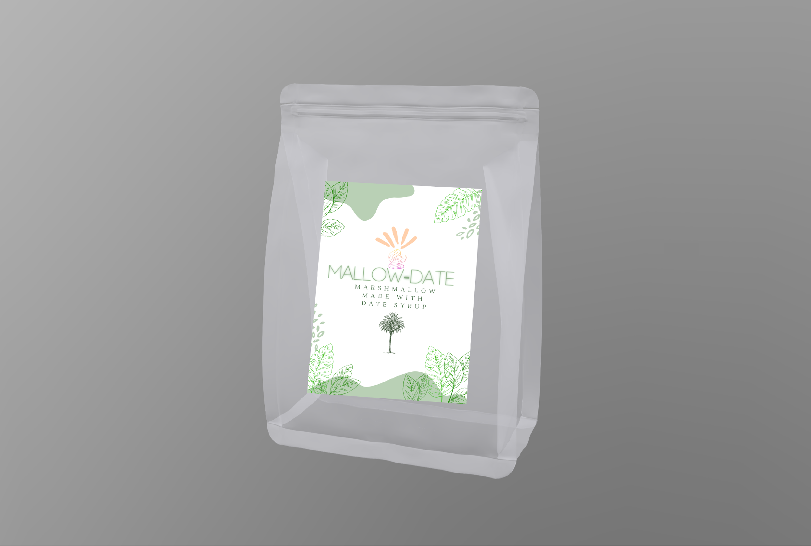

Marshmallow Package :Front view

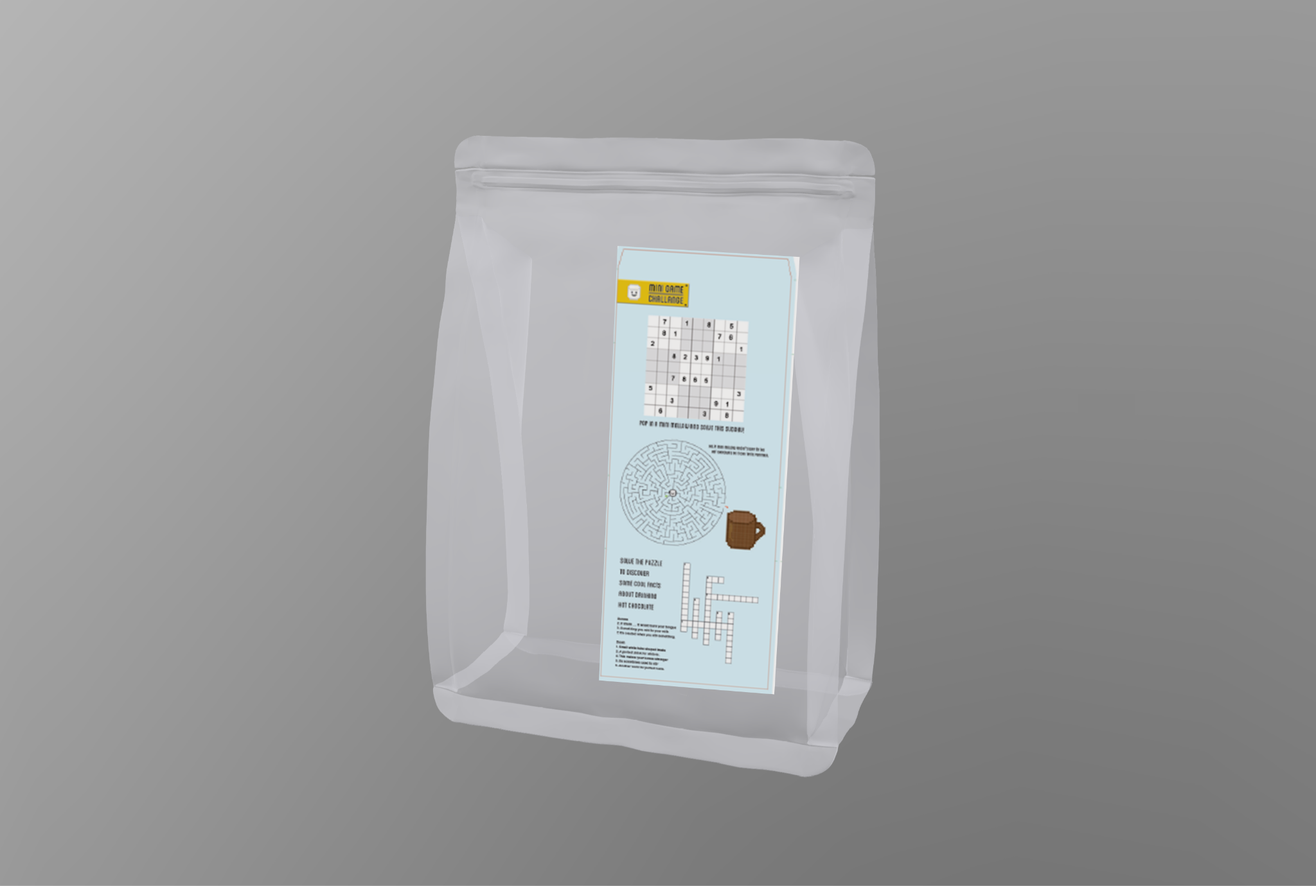

Marshmallow Package :Back view

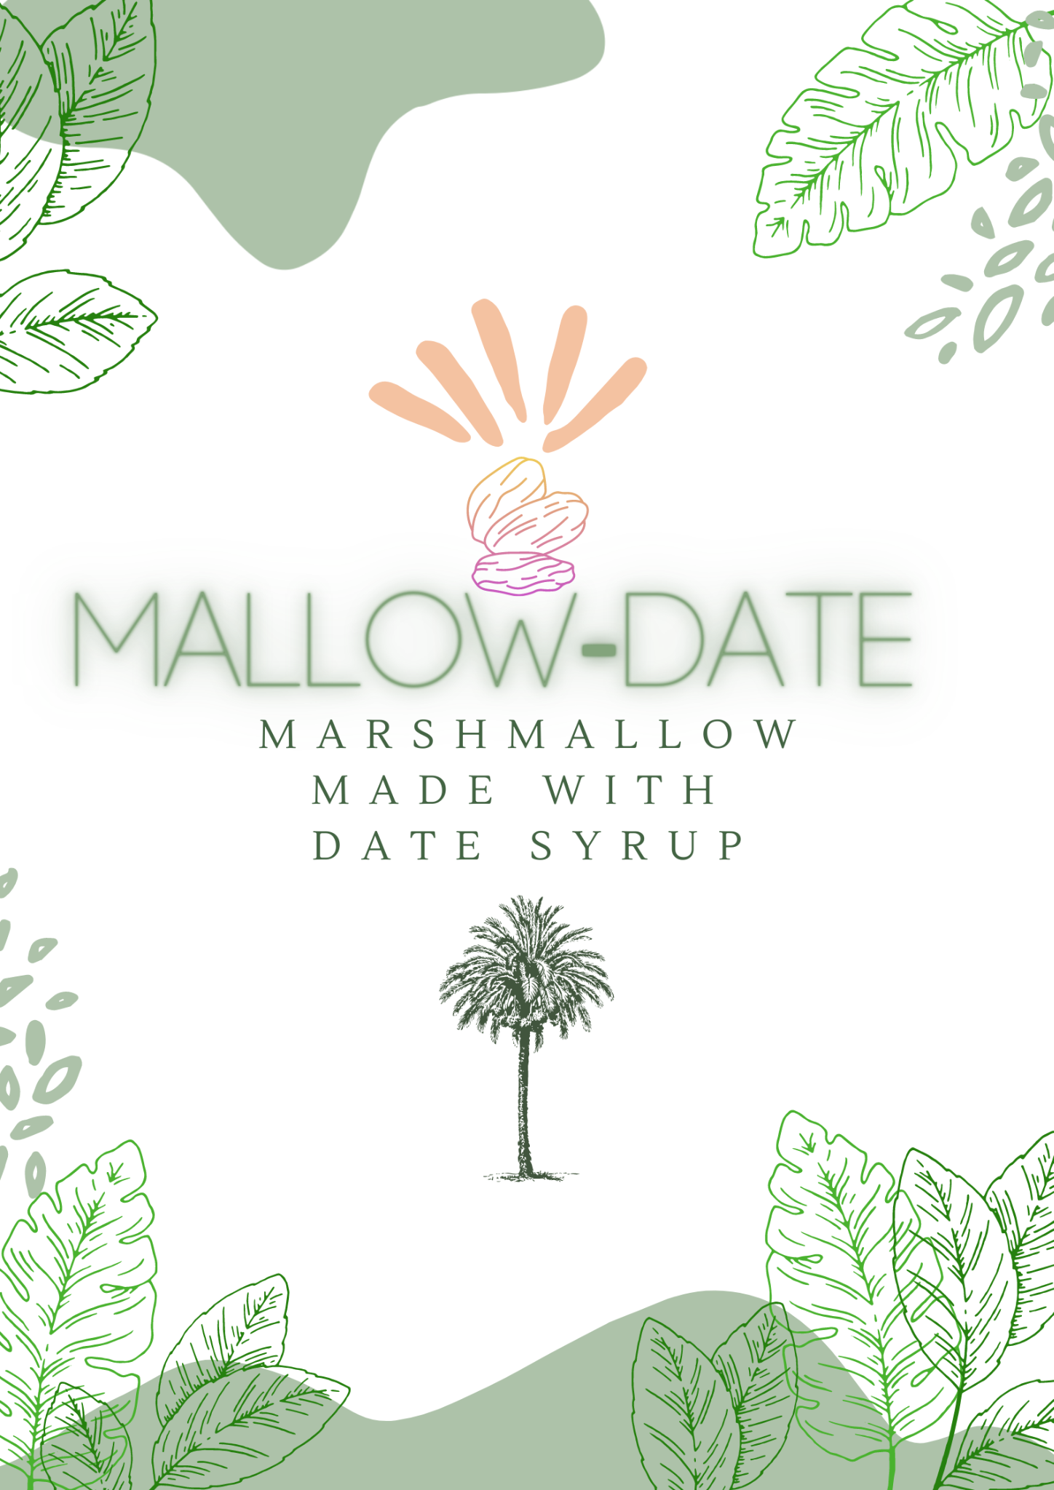

Marshmallow Design

**3) Industrial Manufacturing of the packaging :**

**3.1 How Are Reclosable Bags Made?**

The plastic is melted down to a point in which it is pliable. It is then poured into a very thin mold that is in the shape and size of the bag being made. The closures on the bags are formed in separate molds out of stronger, thicker plastic. The closure tracks are then transfixed to the lips of the baggies. The most common brand bags are made a little differently. The common brand bags offer a zipper closure bag as well; these zipper bags have a plastic slider zipper used to push the lips of the bag closed and to fasten them shut.

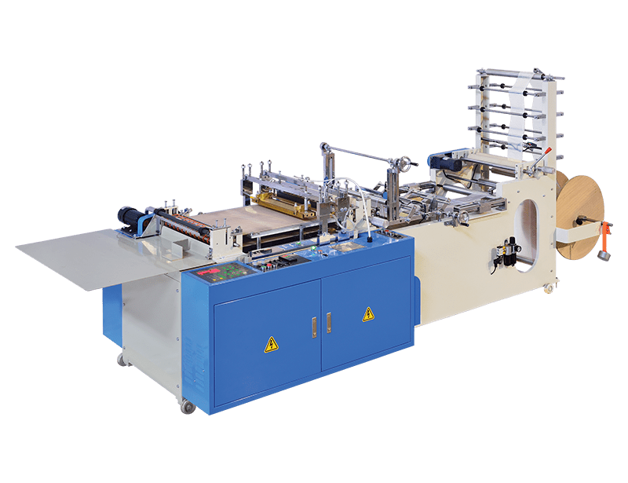

Zipper Bag Manufacturing Machine

After the zipper bag is made, these 8 stages will terminate the packaging of the product :

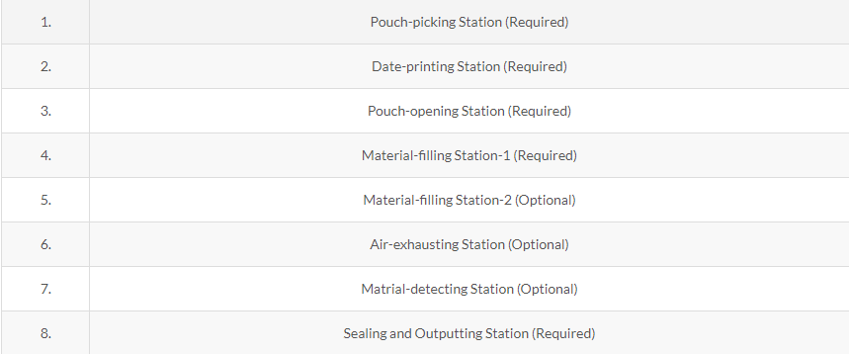

**II) Milk Drink:**

**1-Sequence of layers of the bottle  :**

- 2 layers of HDPE

- Aluminium layer

- EVA « ethylene-vinyl acetate »

- Paperboard



**1.1. Paperboard :** is eco-friendly as it is based on wood .

**1.2. Polymers :**

In order to preserve the product and to enhance the storage life , we have used 2 layers of HDPE . Our paperboard is laminated externally and internally with these 2 layers

* **Factors that are behind the polymer selection  :**

• Moisture in the atmosphere.

• Oxygen.

• Preservation and safety of the product.

• Barrier properties.

• Cost.

We have chosen HDPE layers over the PP (polypropylene) , the two most used plastics for milk drinks, because :

- HDPE’s Chemical resistance is superior as well as resistance to oil and grease.

- HDPE has 90% crystallinity which increases its stiffness.

- The HDPE film offers excellent moisture protection and significantly decreases

gas permeability.

**1.3. EVA « ethylene-vinyl acetate » :**

It has excellent sticking or gluing properties, it is used between the aluminium and the inner layer for better tightening. EVA is a copolymer, EVA film is tough and tacky so we have used it with HDPE as a tie-layer

**1.4. ALUMINIUM :**

Aluminum foil acts as a complete barrier to light and oxygen (which cause fats to oxidize or become rancid), odors ,flavors, moisture, and bacteria. Aluminium foils are a good choice for dairy products; they also help in preservation of dairy products for some time without refrigeration.

**1.5. Remarks :**

* The packaging materials proposed for this product aims to minimize losses and wastages of the product caused by its transportation or because of the environmental hazards
* This product is not a recyclable product because of the complexity of the recycling of multilayer packaging compared to monolayer packaging

**2- The Bottle cap :**

We have chosen high density polyethylene (HDPE) because of its strength and its excellent properties .

**3. Label & package design :**

**3.1. Label design**

**3.2. package design**

**4. Lamination technique used in the manufacture of the packaging :**

**4.1. What is lamination :**

Laminating is the process through which two or more flexible packaging webs are joined together using a bonding agent. The substrates making up the webs may consist of films, papers or aluminum foils.

**4.2. Advantages of lamination technique in this product :**

**Lamination of paperboard with polymers serves following purposes :**

**•** Provide protection to the food and to the paperboard against hazardous environmental effects like sunshine, moisture, air, dust, oxygen.

**•** These layers give extra strength and stiffness to the packaging.

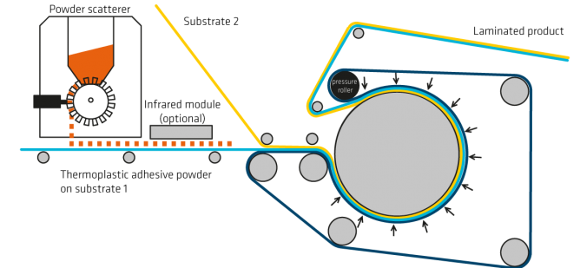

**III) NOUGAT :**

**1- Description of the Product :**

The product will be Nougat based on dates and covered with Chocolate for extra sweetness and more attractiveness to kids who are most likely to be chocolate lovers

**2-Material choice :**

Most chocolate product use Aluminum foil ,we will use that as well or laminate and we’re going to add Sulphite paper for the external coverage .

**2.1. Why use aluminum foil ? (advantages)**

**• Light weight • Corrosions Resistant • Excellent electrical and thermal conductivity. • Malleable, Ductile • Reflectivity • Impermeable and odorless**

Many chocolate goods are kept for lengthy periods of time, but when they are exposed to moisture and light, they deteriorate and the surface loses its appealing sheen. Aluminum foil or laminate offers the best protection, providing a total barrier to light, moisture, and any penetration of aroma and flavor.

Another benefit is that foils are simple to fold, allowing customers to keep what's left of a chocolate bar for later use. The bright color of the wrapper gives a feeling that it’s very clean and well preserved. The bright color of the wrapper gives a feeling that it’s very clean and well preserved. The wrapper's tightness provides more protection, prevents bacterial spread, and makes the chocolate bar safer to eat. The light weight of the foil makes no discernible difference to the original product, hence the price and sales calculations are unaffected.

**2.3.Disadvantages of aluminum foil** :

A negative aspect of tin foil is that the assembly process of aluminium may be a very high energy consuming process. However the recycling, smelting and recasting of aluminium consumes less energy and is a relatively simple process. On the contrary to other aluminium products, tin foil seems to be difficult to recycle due to its thin thickness which can make it burn within the smelting process.Due to the thickness and production process of foil the mechanical characteristics vary from bulk aluminium.

**2.2. Statistics about aluminum foil :**

The share of retail packaging is between 1% (eutrophication) and 9% (CED non-renewable). About two thirds of this burden stems from the use of aluminum and one third derives from the wrapping paper. It must be considered that the aluminum and the paper part of the packaging fulfill different functions contributing to a single packaging solution. The influence of distribution and selling of chocolate is second most important in the indicator non-renewable cumulative energy demand and ozone layer depletion.

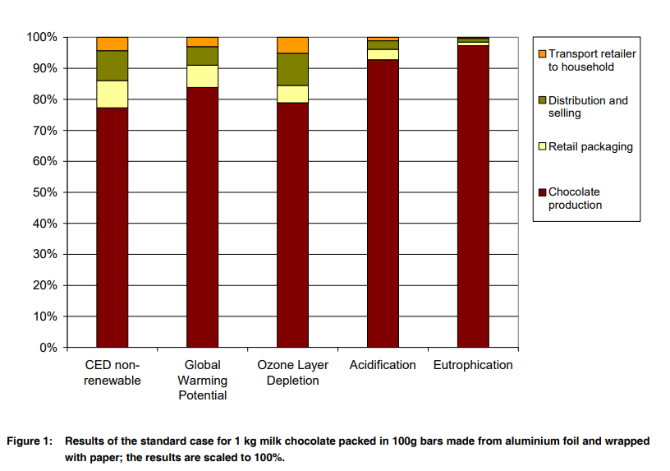

The [aluminum foil pape](https://www.htmmalufoil.com/products/flexible-packaging-aluminium-foil/)r is not for the purpose of chocolate, but the heat conductivity of the metal is very good. If it is a mold, the plastic is obviously plastic. Then why use aluminum foil? The raw materials of chocolate are: cocoa cake made from cocoa beans and cocoa butter, sugar, milk, etc. If the chocolate is directly exposed to light, the cocoa butter will react with the moisture and oxygen in the air, the smell of chocolate. And the taste will be lost, there will be no chocolate scent when peeling chocolate paper and delicious when eating, aluminum foil paper used to keep the chocolate delicious, in addition to the role of insect proof and bacteria. 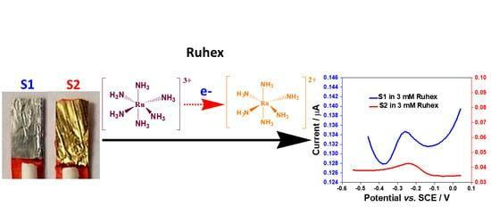

**3. PACKAGING & DESIGN:**

**3.1. Logo:**

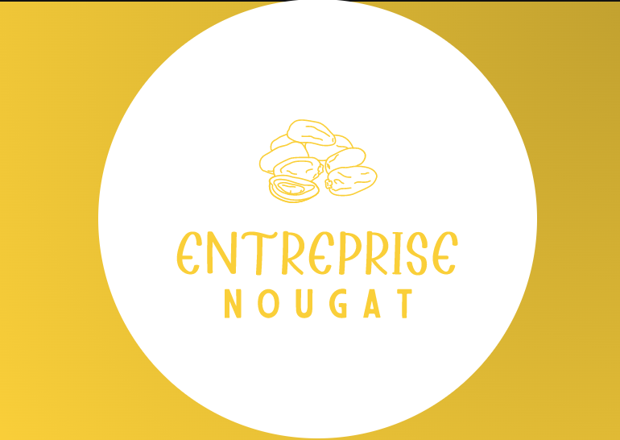

**3.2. Package labeling :**

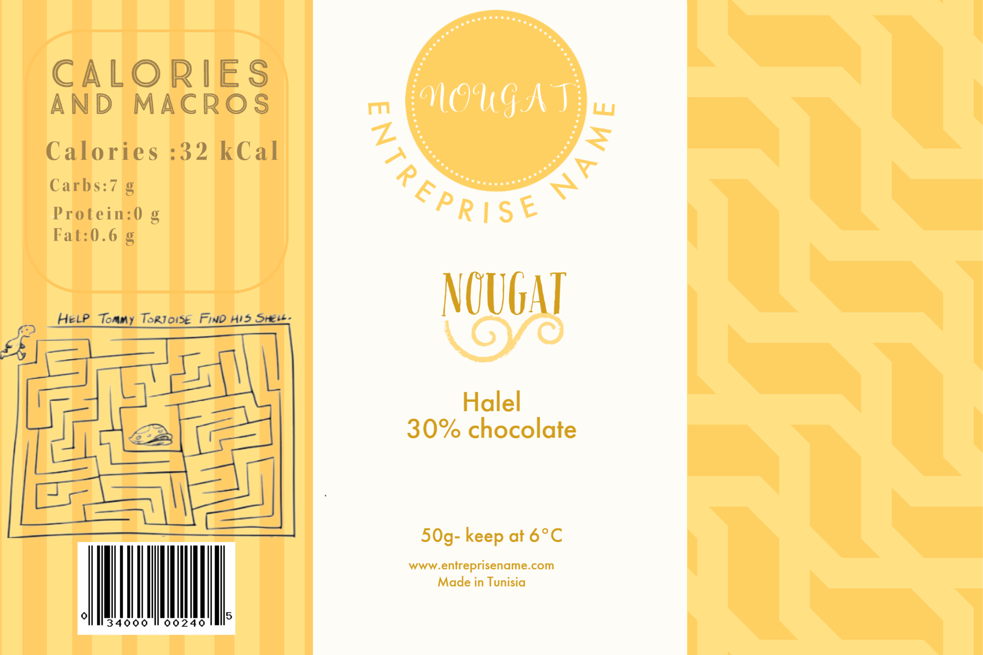

**4. INDUSTRIAL STUDY:**

**4.A. GENERAL STUDY**

**4.1. THE MANUFACTURING PROCESS**

The first step in the packaging process is the manufacturing of that packaging. The manufacturing process needs to be considered when thinking about the design of the packaging. Some of the factors that will impact the manufacturing process include:

-The material or substrate of the packaging

-The cost of these materials

-Where the packaging is going to be manufactured

-The time it will take to manufacture the packaging

-Whether automation or hand assembly will be utilized

**4.2. THE FILLING & ASSEMBLING PROCESS**

After the manufacturing process is completed, the packaging needs to be filled and assembled. This can take many forms depending on the nature of the product. Some of the examples include:

- Is the package a simple box inside of which the product will sit?

- Does the packaging require a separate tray or insert to encompass the product?

- Is assembly and filling automated or manual?

These are only a few of the many points that need to be considered during the filling and assembly process. Both the product and packaging have to be protected while expediting the process.

**4.3. THE TRANSPORTATION OF THE PRODUCT:**

Once the packaging has been fulfilled, the product will be transported to wherever it is being sold. It is imperative for the product to be protected during this important step. Whether it is being moved by land, sea, or air, steps need to be taken to protect the integrity of the product. This needs to be incorporated into the design of the packaging. Consider the transportation of the product and take steps to protect it. In addition to protecting the packaging and final product, it’s important to note that packaging efficiency is also important when it comes to logistics. Well thought-out packaging means more efficiency in transportation which can reduce costs. In our case chocolate needs to be preserved at a lower temperature to stay in the same shape and avoid being spoiled .

**4.4. THE SHELF LIFE:**

Shelf life is yet another area to consider when designing a packaging design. While we’re mostly familiar with shelf life in terms of perishable items, shelf life also represents how well the product will appear on the shelf. From tamper protection to fragility, these have to be considered well in advance. A design that is too intricate and fragile might easily damage on a store shelf or on display, making it unattractive to consumers.

**4.5. THE USER EXPERIENCE:**

The last step in the packaging process is the experience of the user. Industry-leading brands know this and value this part of the packaging process significantly. They understand that packaging is a vehicle for communicating with the customer. In addition to protecting the product, packaging should create an experience for the consumer. It should tell a story and build the customer’s loyalty. This alone, provides a solid return on the brand’s marketing investment.

**4.B. MANUFACTURING PROCESS OF THE PACKAGING :**

#### Horizontal Flow Wrapping Machine, PSA-200NT For Nougat And Marshmallow Biscuits Solutions

What we need is to have a pillow pack for single products of nougat .We need flow wrapping machine with high speed to support our production line. After consideration, we chose Flow Wrapping Machine PSA-200NT. With PSA-200NT nougat and chocolate products can be wrapped in a more efficient way.

#### 4.1-Material

In this case, laminated film PET/CPP (non-shrink material) is used for pillow packs. It consists of PET film which has high printability as the first layer and laminated with CPP film as inner heat sealing material. Therefore, laminated Film PET/CPP has a good air barrier with high printing quality.

#### 4.2-Equipment

To meet the company requirements, Benison technical team adjusted the speed up to 125packs/minute by dual knives seal which packaging speed can be double comparing to standard model. In addition, the company intends to use printing material for this pillow pack. Therefore, the printing sensor is equipped to precisely seal the designated space to avoid cut & damage products. Besides, Our PSA 200NT is highly versatile which makes the production of different product sizes possible. Within 10-15 minutes of small adjustment on the machine, users can change the Former size based on product size. No trained-technician needed. Ultimately, Flow wrapping machine PSA-200NT is recommended by solution to increase efficiency of the production line for pillow pack products.

**4.3. Machine Specifications**

- Flow Wrapper Machine PSA-200 NT

- Packaging Capacity: 125packs/minute (depends on product size)

- Output: Single Pillow Pack Product

#### 4.4. Features

- Easy to operate.

- Printing sensor can be installed to make sure printed packs be in the right position

- Two-side knife sealer can double the machine speed comparing to standard model

- Enable to pack different size of products, with easy adjustment

- Suitable for food and non-food industries

- All machinery and equipment comply with food safety production regulations

- The equipment, material, and quantity can be adjusted based on actual production needs

-Benison can provide consultation about plant layout planning, production line optimization, and labor allocation.

## Chapter 3 : Future of Food Packaging Materials

Innovations and advancements in material science have given food packaging a positive future in terms of efficiency and environmental impacts.

*Smart packaging* (or Intelligent packaging) has been gaining publicity lately, with an expected market of $26.7 billion by 2024 . Smart packaging represents packaging systems carrying sensors that help prolong the shelf life of foods, reveal information on freshness and quality, and enhance the safety of the product and consumer.

Another technology in packaging systems is *active packaging*, which is the integration of additives with the packages to improve food shelf-life and quality

*Nanotechnology*, as well, has been able to penetrate the food packaging industry. It helps augment the thermal and mechanical properties of food packages. Nanosensors embedded within the packaging systems can also help monitor, identify, and warn about the safety and quality of the foods. Although the effect of nanoparticles on human health is yet to be well understood, nanotechnology displays a promising future .When it comes to waste management, packaging waste has occupied a large portion of municipal solid waste (MSW), resulting in a rise in environmental concerns  .*Biodegradable polymers* have arisen as alternatives to traditional plastics in food packaging. These polymers decompose into CO2, water, inorganic compounds, and biomass.

**Conclusion:**

**Bibliography:**

[1] [https://www.plasticsforchange.org/blog/which-plastic-can-be-recycled?fbclid=](https://www.plasticsforchange.org/blog/which-plastic-can-be-recycled?fbclid=IwAR1w0BkxkKfb77kG2Xj-hgvN14pfmxlt7c_Pi87faFwPIJ1KwtQNHfD3jR8)

[IwAR1w0BkxkKfb77kG2Xj-hgvN14pfmxlt7c_Pi87faFwPIJ1KwtQNHfD3jR8](https://www.plasticsforchange.org/blog/which-plastic-can-be-recycled?fbclid=IwAR1w0BkxkKfb77kG2Xj-hgvN14pfmxlt7c_Pi87faFwPIJ1KwtQNHfD3jR8)

[2] <https://www.ipack.com/solutions/post/pe-pp>

[3] <https://wz-xinda.com/product/rfq_500c_zipper_bag_making_machine>

[4] https://homesteady.com/4965916-how-are-reusable-bags-made.html

[5] https://www.gruener-punkt.de/en/

[6] <https://www.sciencedirect.com/>

[7] <https://www.cuttosize.com.au/technical-support/plastic-properties-comparison/>

[8] <https://www.mdpi.com/1420-3049/26/1/21>

[9] [https://www.flexpack-europe.org/files/images/Inhaltsbilder/Sustainability/](https://www.flexpack-europe.org/files/images/Inhaltsbilder/Sustainability/Food%20LCAs/ESU-Chocolate2009-ExecSum.pdf)

[Food%20LCAs/ESU-Chocolate2009-ExecSum.pdf](https://www.flexpack-europe.org/files/images/Inhaltsbilder/Sustainability/Food%20LCAs/ESU-Chocolate2009-ExecSum.pdf) :LCA of Chocolate Packed in Aluminium Foil Based Packaging

[10] [https://www.overwrappingmachines.com/promote/flow-wrapping-machine-](https://www.overwrappingmachines.com/promote/flow-wrapping-machine-manufacturer.html?gclid=CjwKCAjwkMeUBhBuEiwA4hpqEMz-3bEidDA-wWeNkGdZr6jE3CvZUbZw7wfkK_pIC1bX9piUfH_sLBoC384QAvD_BwE)

[manufacturer.html?gclid=CjwKCAjwkMeUBhBuEiwA4hpqEMz-3bEidDA-wWeNkGdZr6jE3CvZUbZw7wfkK_pIC1bX9piUfH_sLBoC384QAvD_BwE](https://www.overwrappingmachines.com/promote/flow-wrapping-machine-manufacturer.html?gclid=CjwKCAjwkMeUBhBuEiwA4hpqEMz-3bEidDA-wWeNkGdZr6jE3CvZUbZw7wfkK_pIC1bX9piUfH_sLBoC384QAvD_BwE)

[11] [https://www.alufoil.org/en/main-markets/confectionery.html#:~:text=Many](https://www.alufoil.org/en/main-markets/confectionery.html#:~:text=Many%20chocolate%20products%20are%20stored,penetration%20of%20aroma%20and%20flavour)

[%20chocolate%20products%20are%20stored,penetration%20of%20aroma%20and%20flavour](https://www.alufoil.org/en/main-markets/confectionery.html#:~:text=Many%20chocolate%20products%20are%20stored,penetration%20of%20aroma%20and%20flavour).

[12] [https://www.htmmalufoil.com/news/industry-news/why-are-good-chocolates-](https://www.htmmalufoil.com/news/industry-news/why-are-good-chocolates-wrapping-in-aluminium-foil-metal-paper.html)

[wrapping-in-aluminium-foil-metal-paper.html](https://www.htmmalufoil.com/news/industry-news/why-are-good-chocolates-wrapping-in-aluminium-foil-metal-paper.html)

[13] <https://www.benison.com.tw/en/page/packaging-solutions-6.html>

[14] <https://youtu.be/LFAYVfAerVI>

[15] https://core.ac.uk/download/pdf/289944656.pdf

**Annexes:**