**I) Marshmallow :**

**1) Choice of the packaging material :**

According to researchers, consumers normally purchase marshmallows in simple polypropylene (PP) pouch packaging.

So what is PP ?

**1.1. Polypropylene (PP)**

A polypropylene bag is high clarity and crystal clear in order to enhance the image of whatever product is inside. This PP bag offers a highly protective barrier against both moisture and vapors. These poly bags delay evaporation and dehydration to preserve the freshness and taste of packaged foods. Generally, PP plastics are stronger, clearer, and more expensive than their PE plastic counterparts. Polypropylene bags are great for the following industries — food, electronics and electronics manufacturing, hospitals, agriculture, and more.

**1.2. Advantages of PP :**

-More resistant to chemicals, high temperatures, and scratches

-Crystal clear for great product presentation

-Stiff and hard plastic

-Rough surface has the potential to produce scratches

-Outstanding vapor and moisture barrier

-Meets FDA and USDA specifications

-Difficult to break, but not very flexible

**1.3. Recycling PP :**

While PP is easily among the most popular plastic packaging materials in the world, only around 1-3% is recycled in the US, which means most PP is headed for the landfill. Here it degrades slowly and takes around 20-30 years to completely decompose.

Again you may ask: “if it’s recyclable, why do we throw so much of it away?” And the answer, again, is that unfortunately, it doesn’t always make sense financially to reuse this material. Polypropylene recycling is difficult and expensive and, in many cases, it’s hard to get rid of the smell of the product this plastic contained in its first life.

For this reason, PP is usually included in plastic lumbers, park benches, auto parts, speed bumps, and it’s used for other industrial applications.

**2) Packaging & Design :**

After brainstorming for the marshmallow packaging, we came out with these packaging Must-Haves that would make the product both presentable and alluring :

**2.1 Technical requirements :**

-Re-sealability: and that is to ensure that the marshmallows remain spongy and soft.

-Transparency : the content inside will be clearly visible and more inviting to the buyer.

**2.2 Marketing requirements :**

-Fun gentle colors.

-Fun diverse games on the packaging’s back : Riddles, labyrinths, crosswords, spot the differences games, etc…

-Packaging that makes a crisp cracking sound: Children find products inviting and more exciting if they have such sounds.

Exemple: Chips’ packages..

**2.3 Boxes VS Bags :**

A bag is the best choice. Why ?

-Better visibility of the product

-A zipped bag is better for the preservation of the product after it’s been opened.

-Better audible features (cracking...)

**2.4 Product's name :**

Marshmallow + Dates = Mallow-Date

**2.5 3D Design :**

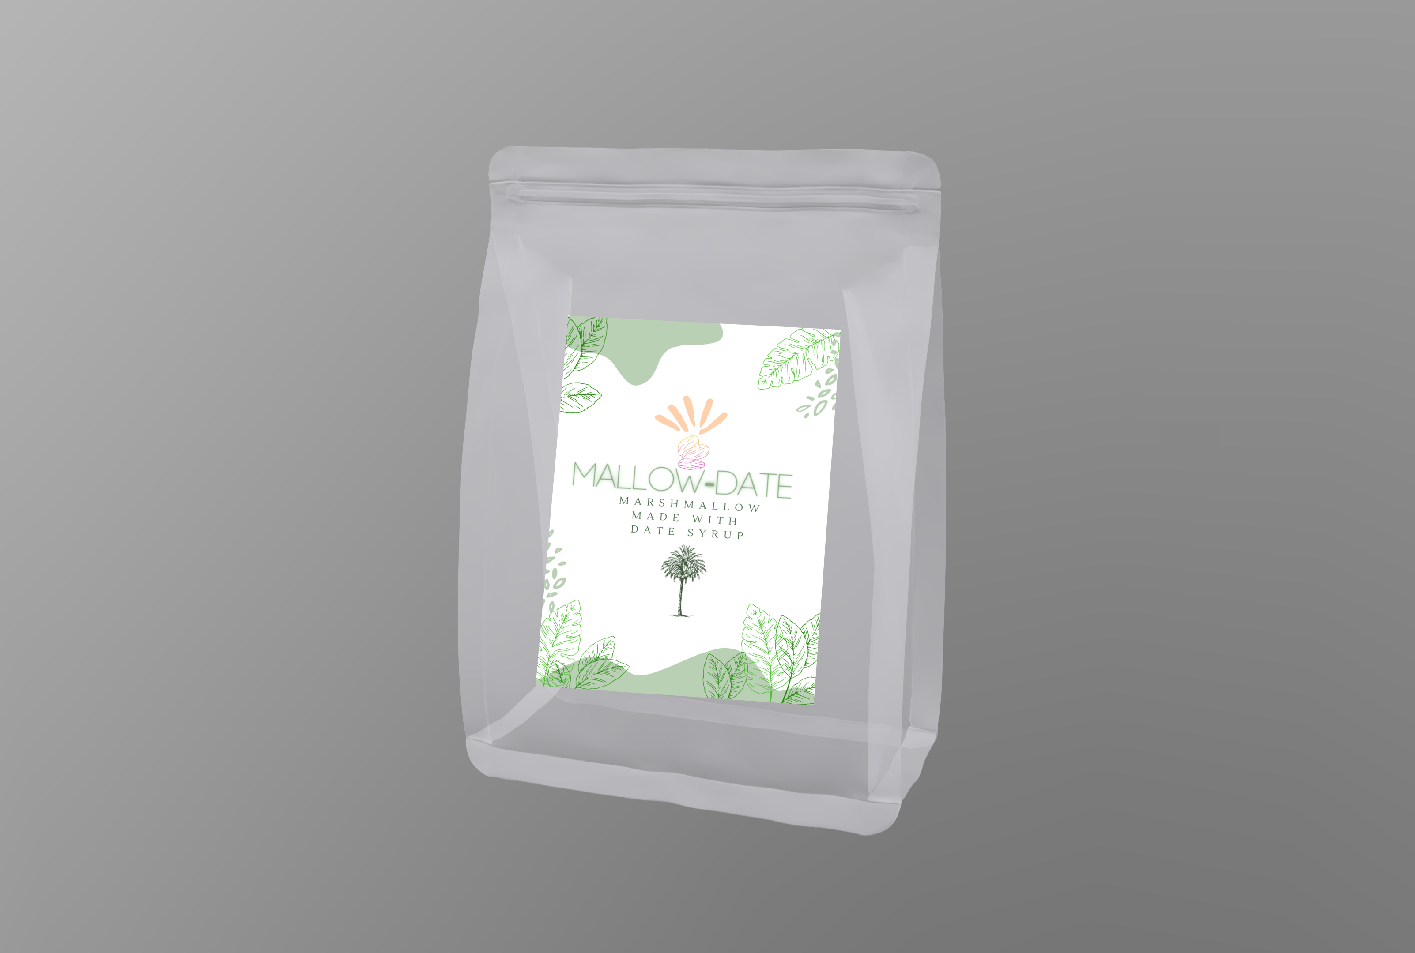

Marshmallow Package :Front view

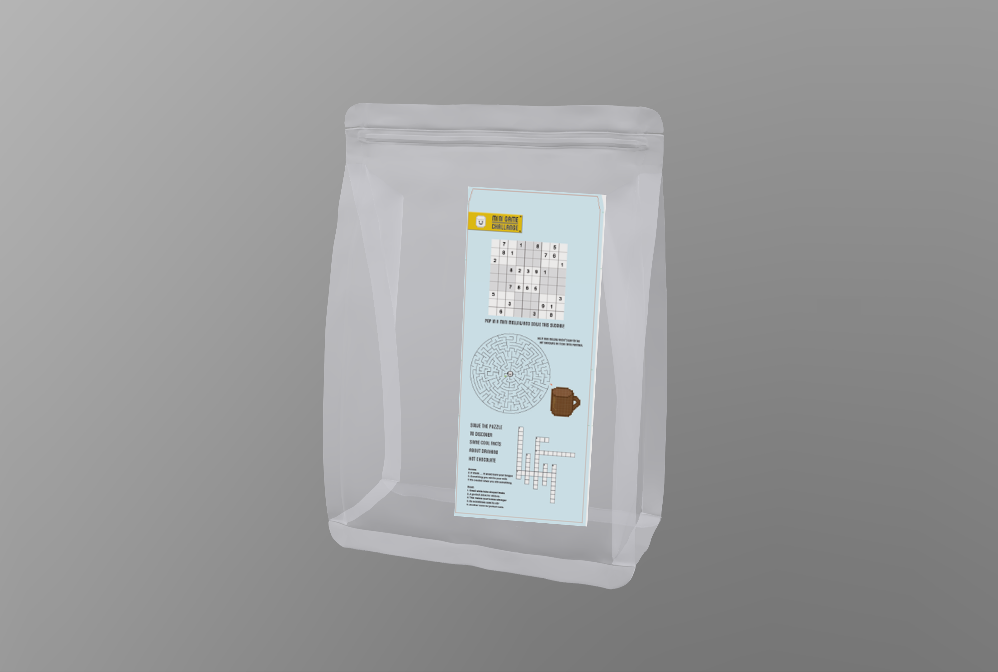

Marshmallow Package :Back view

**3) Industrial Manufacturing of the packaging :**

**3.1 How Are Reclosable Bags Made?**

The plastic is melted down to a point in which it is pliable. It is then poured into a very thin mold that is in the shape and size of the bag being made. The closures on the bags are formed in separate molds out of stronger, thicker plastic. The closure tracks are then transfixed to the lips of the baggies. The most common brand bags are made a little differently. The common brand bags offer a zipper closure bag as well; these zipper bags have a plastic slider zipper used to push the lips of the bag closed and to fasten them shut.

**3.2 How Does the Zipper Closure Work?**

The tracks on each lip of the bag connect together like puzzle pieces. There is male and a female track. The male track locks into the female track fastening closed and requiring quite a tug to be opened again. The closure is durable enough that you can hold the bag upside down and the contents will not spill out onto the floor.

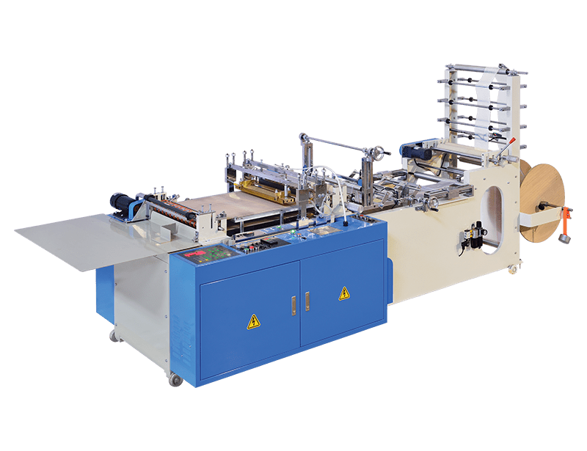

Zipper Bag Manufacturing Machine

After the zipper bag is made, these 8 stages will terminate the packaging of the product :

**4) References:**

<https://www.plasticsforchange.org/blog/which-plastic-can-be-recycled?fbclid=IwAR1w0BkxkKfb77kG2Xj-hgvN14pfmxlt7c_Pi87faFwPIJ1KwtQNHfD3jR8>

<https://www.ipack.com/solutions/post/pe-pp>

Consumer Attitude and Sensory Evaluation of Marshmallow:Article in Proceedings of the Latvian Academy of Sciences Section B Natural Exact and Applied Sciences · November 2013

<https://wz-xinda.com/product/rfq_500c_zipper_bag_making_machine>

https://homesteady.com/4965916-how-are-reusable-bags-made.html