Contents

I. Research on Industrial Packaging Materials: For Date Syrups 2

A. Introduction to Packaging 2

1. Definition of Packaging 2

2. Packaging Levels 2

3. Technical Purposes of Packaging 2

B. Packaging Development 3

1. Considerations for Selecting a Packaging Material 3

2. Packaging as a Medium of Communication 3

3. Packaging as a Salesman 4

4. Considerations for Producing a Successful Package 4

C. Material Comparison 5

1. Industrial Food Packaging Materials: 4 Main Types 5

2. Breakdown Comparison Between Food Packaging Materials 9

3. Comparison Between Plastic Food Packaging 10

II. Snack Products 10

A. Dates Juice Drink 10

1. Choice of the packaging material: 10

2. Packaging Design: 14

3. Industrial Manufacturing of the Packaging: 14

A. Dates Milk Drink 14

1. Choice of the packaging material: 14

2. Packaging Design: 14

3. Industrial Manufacturing of the Packaging: 14

B. Dates Nougat 14

1. Choice of the packaging material: 14

2. Packaging Design: 14

3. Industrial Manufacturing of the Packaging: 14

# Research on Industrial Packaging Materials: For Date Syrups

## Introduction to Packaging

### Definition of Packaging

Packaging is defined as ―the enclosure of products, items, or packages in a wrapped pouch, bag, box, cup, or other container to perform the following functions:  
- Containment  
- Protection or preservation  
- Communication  
- Utility or performance  
If the device or container performs one or more of these functions, it is considered a package. This definition implies that packaging serves more than one function; i.e., it is multifunctional.

### Packaging Levels

#### Primary Packaging

It is the smallest unit of distribution and is in direct contact with the contents.

#### Secondary Packaging

This is the outside of the primary packaging. It is used to group primary packages together.

#### Tertiary Packaging

It is used for bulk handling, warehouse storage and transport shipping.

**Primary**

**Packaging**

**Secondary**

**Packaging**

**Tertiary**

**Packaging**

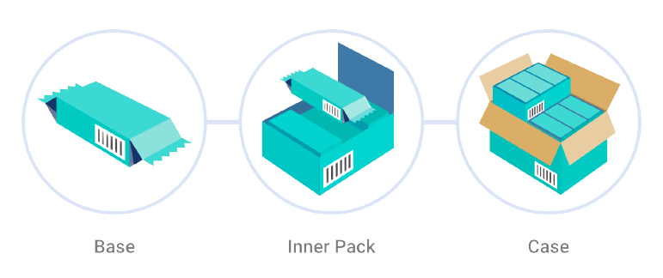

### Technical Purposes of Packaging

#### Food Containment

Hold the contents and keep them clean and secure without leakage or breakage until they are used.

#### Food Protection

To protect foods against a range of hazards during distribution and storage (dirt, contaminants, insects…).

#### Convenient Handling

Easy opening, dispensing and re-sealing, and being suitable for easy disposal, recycling or re-use.

#### Consumer friendly

To enable the consumer to identify the food, and give instructions so that the food is stored and used correctly.

## Packaging Development

### Considerations for Selecting a Packaging Material

#### Technical Suitability

How well the package protects a food for the required shelf life?

#### Availability

Is the packaging material already in use or do we have to invest more on manufacturing equipment and expertise?

#### Cost

How cheap can we manufacture the package without compromising its technical integrities?

#### Marketing

Marketing considerations that favor choosing a certain type of package over another.

### Packaging as a Medium of Communication

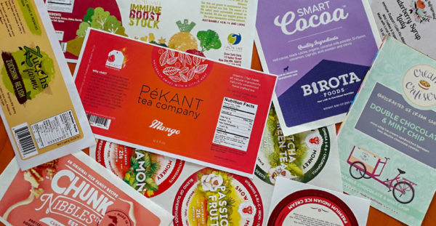An important function of any food package is to:

* Identify the product and its origin,
* Inform the consumer how to use the contents,
* Provide any other information needed or required,
* Attract the user and encourage purchase of the product.

The information a package can convey to the consumer may include the following:

* 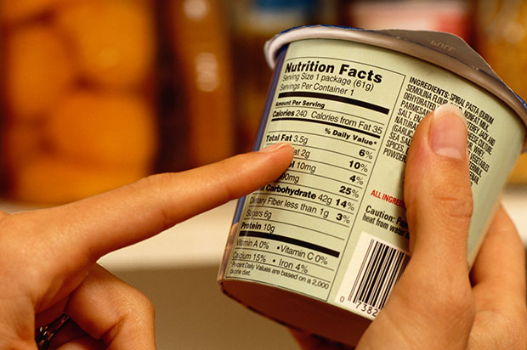Product manufacturing and best buy dates
* Proper storage conditions
* Nutritional information per serving
* Manufacturer ‘s name and address
* Cost
* Suggested recipes
* Country of origin
* Information transmission - Packages and labels communicate how to use, transport, recycle, or dispose of the package or product

### Packaging as a Salesman

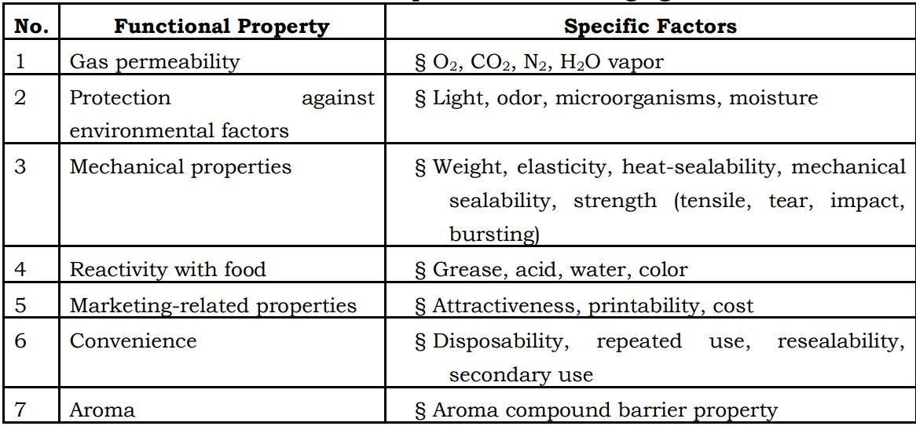

***Figure 4: Functional Requirements of Packaging Materials***

*Source: Jelen, P. 1985. Food packaging technology. In Introduction to Food*

*Processing, Reston Publishing, Reston, VA, pp. 249–266.*

“A package must protect what it sells and sell what it protects.” —Robertson (1992)

### Considerations for Producing a Successful Package

1. Compatible with product.

2. Protection from Mechanical hazards especially transportation. climatic hazards, microorganisms: Packaging do not harbor bacteria, restrict their growth3. Fit into a production line.

4. Advertising potential.

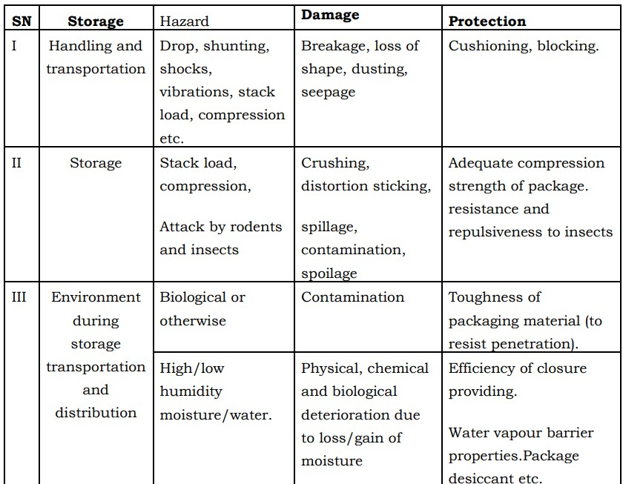5. Attractive appearance.

6. Easy to handle during…Production, storage and Distribution

7. Moisture proof/resistance.

8. Sufficient mechanical strength to withstand drop, vibration, compression etc.

9. Acid, alkali resistance.

10. Grease & oil resistance.

11. Resistance to photo-chemical changes in product.

12. Resistance to insects and rodents.

13. Fire proof resistant to smoke, fume and water.

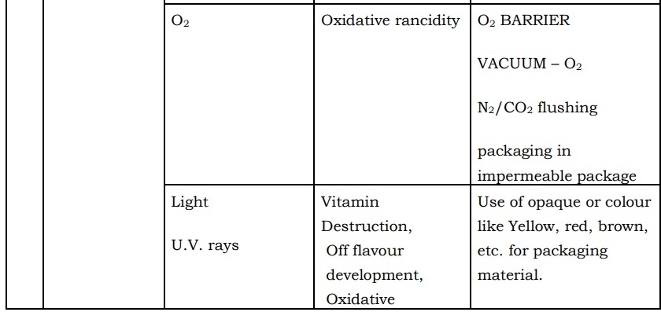14. Pilfer proof (malpractice).

15. Inert: No effect on flavor/aroma.

16. Not injurious to health.

17. Economic.

18. Easy availability.

19. Protect against climatic hazards.

20. Protect against microorganisms. It should not harbor microbes rather restrict their growth by controlling growth factor like.

## Material Comparison

### Industrial Food Packaging Materials: 4 Main Types

#### Metal

Made from tinplated steel or aluminum and is the result of mined bauxite that is smelted into alumina.

##### Advantages

* Protection: Total protection of contents when sealed with a double-seam.
* Tamperproof: Designed to resist access to the product contained within the package
* Versatility: Can be made in a wide range of shapes and sizes.

##### Drawbacks

* High Costs: High manufacturing costs make metal packages expensive compared to other containers.
* Heavy: They are heavier than plastic containers and therefore have higher transport costs.
* Unavailability: Lack of can-making factories in developing countries and small-scale food processors.

#### Plastic

Polypropylene, polystyrene, polyvinyl chloride, polyethylene terephthalate and polyethylene, all of which are derived from fossil fuels and are used in food packaging.

##### Advantages

* Light & Durable: Durable plastics consume less energy during the production process than metals, too, in part due to how light they are.
* Lightweight: The lightness of plastic is closely tied to its superior sustainability. Its comparatively low weight contributes to its lower energy consumption and greenhouse gas emissions over other materials.
* Versatile: You can mold plastic into essentially limitless shapes. Think of the vast variety of plastics packaging you see all the time.

##### Drawbacks

* Degradation: Plastics are non-degradable materials. The decay of this material is not easy. It might take centuries and cause pollution in the environment.
* Harmful: The plastic material that is used in means of human consumption purposes, such as food packaging bags contains harmful components.
* Low Melting Point: Plastic packaging doesn’t withstand in an area where the temperature is a little high.

#### Glass

Made of three natural ingredients: silica sand, soda ash and limestone.

##### Advantages

* Total Protection: Impervious to micro-organisms, pests, moisture, oxygen and odors
* Heat Processable: Subjecting the annealed glass to a thermal process to increase its resistance, and to make it safer in case of breakage.
* Recyclable: 100% recyclable and can be recycled endlessly without loss in quality or purity.
* Re-usable: Glass bottles can be reused for an extremely long time. They are one of the most sustainable drinking containers that you can use because their lifespan is so long.

##### Drawbacks

* Higher weight: Higher weight than most other types of packaging, which incurs higher transport costs.
* Fragility: Containers are easily broken, especially when transported over rough roads.
* Hazards: There are potentially serious hazards from glass splinters or fragments that can contaminate foods.

#### Paper

Uses plant fibers like cotton, linen and hemp, as well as grasses like straw, wheat and kenaf

##### Advantages

- More Biodegradable Than Other Materials: Paper has higher biodegradation rates when compared to other kinds of packaging – especially plastic. This means that paper packaging breaks down in natural environments quickly when exposed to bacteria, yeast, and other organisms.

- Easy to Recycle: Paper is one of the most recyclable materials in the world. In fact, paper and paperboard made up nearly 67% of the total municipal solid waste (MSW) recycled in the U.S. in 2018 – the highest of any other kind of material. Plus, according to the American Forest & Paper Association, the U.S. paper recycling rate has met or exceeded 63% since 2009.

- Bio-based: Paper is primarily composed of forestry materials found in nature (i.e., fiber). This is beneficial because when the material decomposes, it reverts back to natural materials from our environment. Since paper is based on wood, it’s one of the world’s few truly sustainable products.

- Better for the Environment: At 1% of the world’s greenhouse gas emissions, the pulp, paper and print value chain is one of the lowest industrial emitters in the world.

And when managed sustainably, younger forests can actually help reduce carbon dioxide emissions through carbon sequestration, defined as “the process of capturing and storing atmospheric carbon dioxide.” Since carbon dioxide is the most frequently produced kind of greenhouse gas, this can be significant. Here’s how:

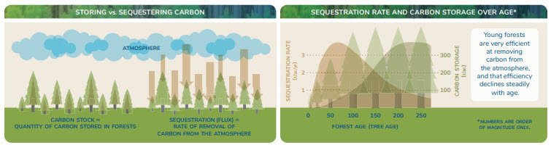Though older forests store more carbon than younger ones, younger forests sequester more carbon dioxide than older forests.

***Figure 5: How Carbon Sequestration Works with Trees***

*Source: National Council for Air and Stream Improvement, Inc. (NCASI)*

As trees get older, their ability to sequester carbon lowers. That’s because of their growth rate. “Biological growth in trees is very rapid at young ages, and this growth rate declines as the trees age,” Steve Prisley, a principal research scientist with NCASI, explains. Since younger trees (and forests) grow faster than their older counterparts, they can remove more carbon dioxide than older forests that have the same area coverage.

Consequently, sourcing fiber from forests for paper products can be better for the environment when managed in a sustainable way. And what is a sustainably managed forest?

“The bottom line [of a sustainably managed forest] is that we’re not removing more trees than can be regrown, or we’re not harvesting faster than the forest is growing. The goal is to balance the growth and harvest with the removals from the forest and ensure our harvesting rate is sustainable relative to growth.”

- Steve Prisley, Principal Research Scientist, NCASI

- Reusable: Paper isn’t just more recyclable than other materials – it’s also easier to reuse with little environmental impact. That’s because it can re-pulped without the use of chemicals. The life cycle of paper is long, too – recycled paper fibers can be reused up to 5 to 7 times to make new products.

- You Can Print Directly on Paper: Paper is advantageous for brand visibility because you can easily print your logo or other designs right on the material.

- Versatile: You can easily combine paper with other materials to achieve unique aesthetics, which can influence purchasing decisions. Per a national study conducted by the Paper and Packaging Board and IPSOS, 7 in 10 consumers – 72% – reported that packaging design can influence whether or not they purchase a product, and 83% of consumers said that paper and cardboard design can be innovative. In addition, 63% of consumers said that paper and cardboard packaging makes a product seem premium or high quality.

- Positive Public Perception: According to a recent study conducted by GlobeScan for the Forest Research Council (FSC) of 12,000 participants from 15 countries, climate change was the #2 most concerning global issue.

Not surprisingly, stainability is on consumers’ minds as they make purchasing decisions. In another study of conducted by McKinsey, 55% of U.S. consumers surveyed said they were either extremely or very concerned about how product packaging impacts the environment. Since paper is bio-based, biodegradable, reusable, and recyclable, it’s a popular option for packaging materials.

##### Drawbacks

* Poor Barrier Properties: Paper offers less of a barrier to oxygen, light, and microbes than other packaging materials such as plastic. As a result, the items it stores – food products especially – have shorter shelf lives when stored in mainly paper packaging. (For paper to have better barrier properties, plastic usually needs to be added in plastic layers of laminates.)
* Often Ends Up in Landfills: Even though paper is very recyclable and reusable, it still fills up landfills. In 2018, paper and paperboard (that is, cardboard) materials made up the largest component of U.S. MSW at 11.8%, or 17.2 million tons.

While paper does have a high biodegradation rate, this happens in aerobic environments, which are environments where paper materials are broken down by the action of oxygen-breathing microorganisms. Conversely, paper has a slow anaerobic (oxygen-absent) biodegradation rate in environments without oxygen, like landfills, because it’s resistant to degeneration when compacted.

Within less than a year of being brought to a landfill, anaerobic conditions get created, no matter what type of MSW has been deposited – including paper. Bacteria then decompose MSW in landfills and produce methane, a potent greenhouse gas.

* Takes Up More Space in Landfills: Paper takes up more space than the same weight of plastic in landfills because it’s less dense than other types of waste. For example, 1 lb. of paper will occupy more space in a landfill than 1 lb. of food waste, glass, or even some plastics.
* Weight: Higher weight than most other types of packaging, which incurs higher

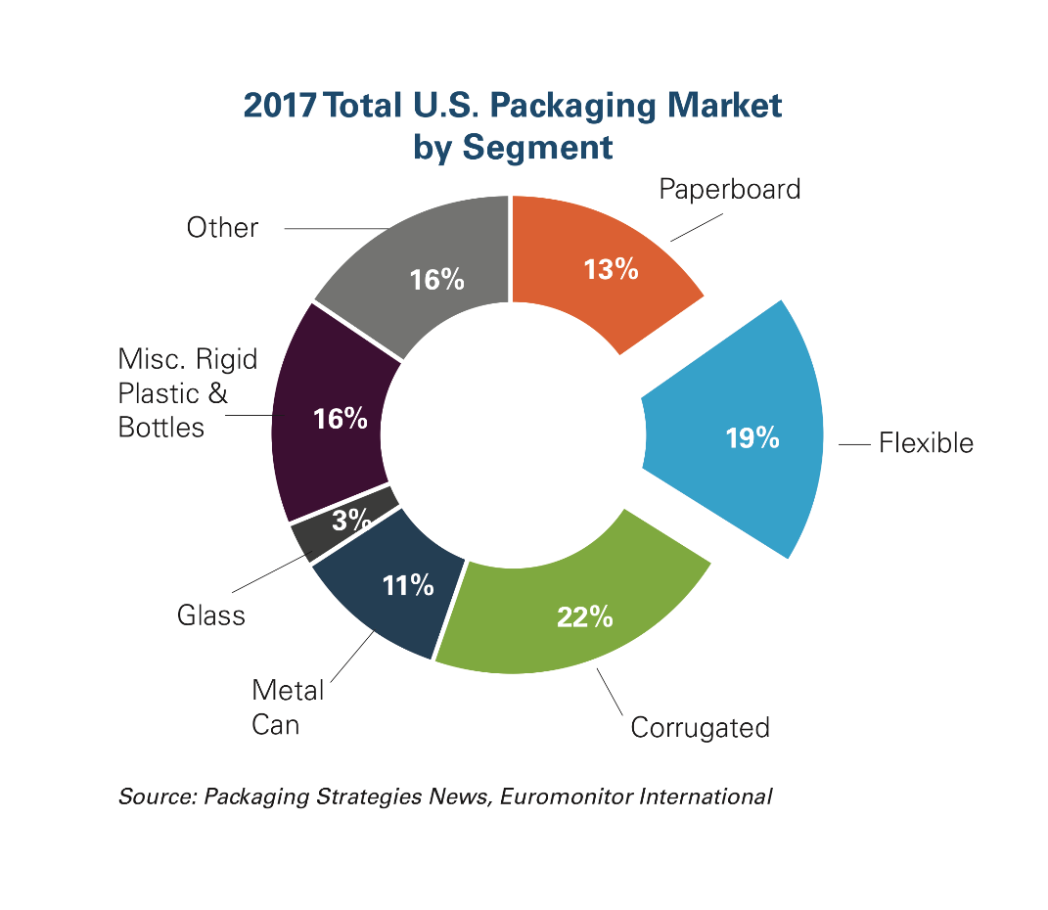

***Figure 4: U.S. Packaging Materials***

*Source: Annual Survey of Manufacturers*

*U.S. Census Bureau 2013-2017*

*.*

### Breakdown Comparison Between Food Packaging Materials

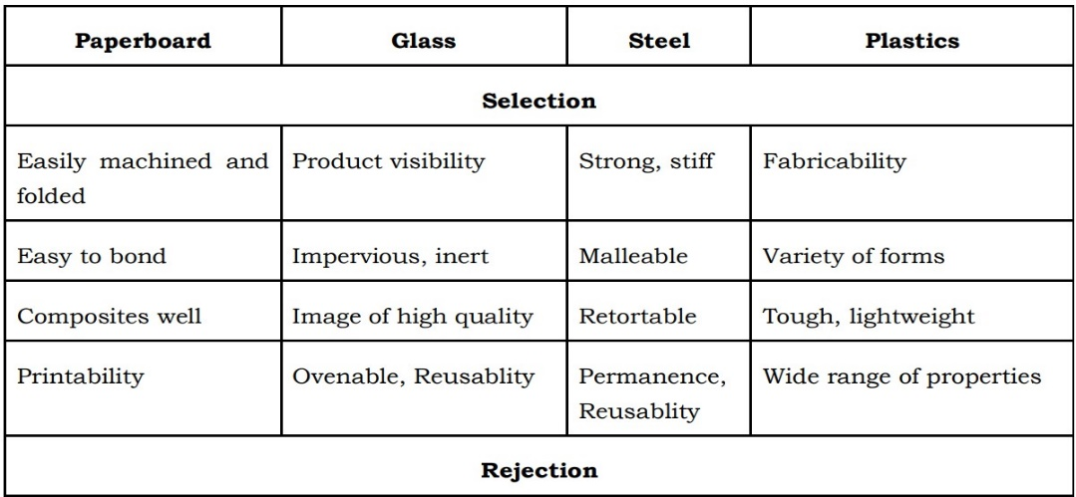

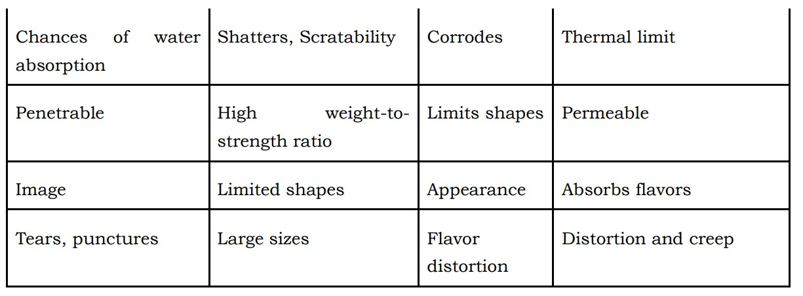

### Comparison Between Plastic Food Packaging

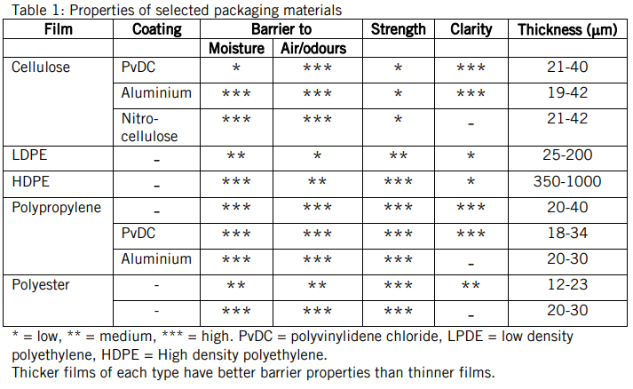

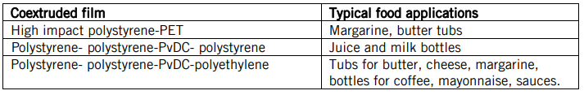

# Snack Products

## Dates Juice Drink

### Choice of the packaging material:

A tetra pack comes under the category of aseptic packages. For a material to be aseptic, it should have the following features:

* The packaging material must be compatible with the product intended to be packed.
* The physical integrity of the package is necessary to assume containment of the product and maintenance of sterility.
* The packaging material must be able to withstand sterilization and be compatible with the methods of sterilization.

The package must protect the product from oxygen; also, the package must retain the product’s aroma.

#### What is Tetra pack?

Tetra pack is the most common name for aseptic cartons used for liquid food items which have to be stored for up to one year without refrigeration. Aseptic here means “free from pathogenic micro-organisms”, so this packaging process eliminates the food and packages from harmful elements. This type of packaging also blocks light completely to preserve vitamins A, B2, B6, B12, C and K, which are all photosensitive and would become damaged in the presence of light.

Functional Layer: Aluminum

Heat Seal: LDPE

Basic Level: BOPP

#### Laminate Structure of a Tetra pack:

A tetra pack is made of six layers i.e.

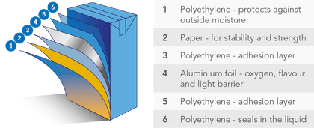

* + 1. **PE**: Contributes 15% of the total packaging; it’s water proof, anti-corrosive, and protects the printing from outside moisture.

**Bonding layer**: Reinforcing the lamination of PE and paper.

* + 1. **Paper**: Substrate for printing and a support layer that contributes 80% of the total packaging providing strength, stability, smoothness, tenacity and stiffness.
    2. **PE**: Acts as an adhesive bonding paper layer. It’s water proof, and moisture proof.

**Bonding layer:** Reinforce the lamination of PE and aluminum foil.

* + 1. **Aluminum foil**: Contributes 5% of the total packaging. It forms a barrier against light, flavor, and oxygen, eliminating the need for refrigeration and preventing spoilage without using preservatives.

**Bonding layer**: Reinforce the lamination of PE and aluminum foil.

* + 1. **PE**: – Acts as an adhesion layer. Increases strength of laminate and thickness.
    2. **Modified PE**: Modifying heat sealing performance, increase sealing quality.

#### Diagrammatic Representation of Tetra pack acting as a Barrier.

#### Types Of Tetra packs:

These packages come in various sizes and shape configurations. These packages also have a variety of openings and closures appropriate to product and consumer needs. Depending on the two points mentioned, following diagrams shows the types of tetra packs available.

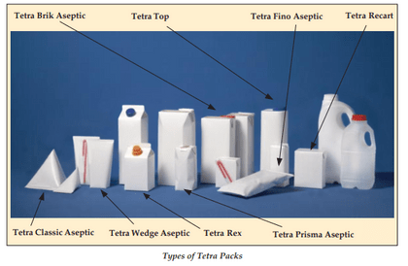

#### Co-extrusion coating with Soarnol

Soarnol is an ethylene-vinyl alcohol copolymer developed by Mitsubishi Chemical’s own technology.

It has high gas barrier properties, oil resistance and high transparency derived from vinyl alcohol structure as well as moisture resistance and extrudablity comes from ethylene unit.

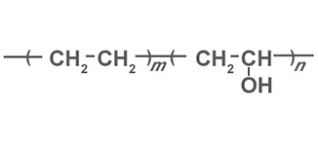Additionally, Soarnol is consist of carbon, oxygen and hydrogen so no harmful gases is generated when incineration and its combustion heat is a half of polyethylene.

Soarnol can be coated onto base film and paper. Not only a pellet type for extrusion coating application, but also Soarnol solution type is available.

One example for co-extrusion coating of Soarnol is a paper carton for orange juice. Conventional paper carton has polyethylene as innermost layer but it absorbs limonene which is a main substrate of orange flavor so that it loses original taste. On the other hands, Soarnol has abilities to protect such absorption and migration so by coating Soarnol, it’s possible to reduce a deterioration of a taste. Additionally, Soarnol prevent an oxidation of vitamin C and this keeps original taste of orange juice longer.

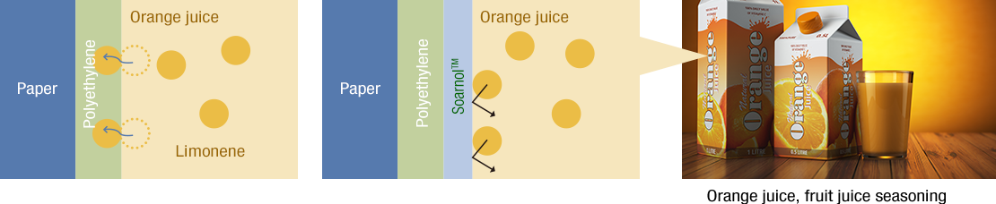

##### Effect of the Innermost Layer “SoarnoL

##### Effect of the Outermost Layer “SoarnoL

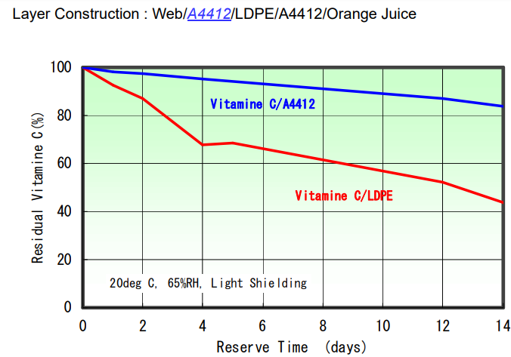

#### Recyclability & Sustainability:

The Tetra pack carton is the future packaging – being primarily made using paperboard (a renewable forest-based resource) and fully recyclable. Not only this it offers consumers convenience, easy opening, optimal shelf life.

Tetra packs are recycled, but the recycled part is not used for manufacturing of tetra packs, hence they are said as non-sustainable. It is unclear whether this is because their paperboard needs to come from virgin sources to avoid contamination, or whether the quality of the recycled paperboard isn’t high enough to make new cartons, or there is some other reason. Whatever the reason, it is turned into office paper.

#### Material of the Cap: HDPE

HDPE is a high-density plastic with a semi- to non-porous surface that is very stiff, has a good temperature resistance and water vapor barrier. It makes for excellent push fit caps and plugs, offering smooth and simple assembly, and can protect package contents from damage. As one of the most versatile plastic materials around, HDPE is used in many different applications, including plastic bottles, milk jugs, shampoo bottles, bleach bottles, cutting boards, and piping. Known for its outstanding tensile strength and large strength-to-density ratio, this plastic has a high-impact resistance.

### Packaging Design:

#### Case

#### Label

### Industrial Manufacturing of the Packaging:

## Dates Milk Drink

### Choice of the packaging material:

### Packaging Design:

#### Case

#### Label

### Industrial Manufacturing of the Packaging:

## Dates Nougat

### Choice of the packaging material:

### Packaging Design:

#### Case

#### Label

### Industrial Manufacturing of the Packaging: