**II) NOUGAT :**

**1- Description of the Product :**

The product will be Nougat based on dates and covered with Chocolate for extra sweetness and more attractiveness to kids who are most likely to be chocolate lovers

**2-Material choice :**

Most chocolate product use Aluminum foil ,we will use that as well or laminate and we’re going to add Sulphite paper for the external coverage .

**2-1Why use aluminum foil ?(advantages)**

Many chocolate goods are kept for lengthy periods of time, but when they are exposed to moisture and light, they deteriorate and the surface loses its appealing sheen. Aluminum foil or laminate offers the best protection, providing a total barrier to light, moisture, and any penetration of aroma and flavor.

Another benefit is that foils are simple to fold, allowing customers to keep what's left of a chocolate bar for later use. The bright color of the wrapper gives a feeling that it’s very clean and well preserved. The bright color of the wrapper gives a feeling that it’s very clean and well preserved. The wrapper's tightness provides more protection, prevents bacterial spread, and makes the chocolate bar safer to eat. The light weight of the foil makes no discernible difference to the original product, hence the price and sales calculations are unaffected.

-Aluminum foil is endlessly recyclable and can be reformed into thousands of different items without the need for any new material. Producing items from recycled aluminum requires only 5% of the energy required to produce new foil from raw resources.

**2-2 Statistics about aluminum foil :**

The share of retail packaging is between 1% (eutrophication) and 9% (CED non-renewable). About two thirds of this burden stems from the use of aluminum and one third derives from the wrapping paper. It must be considered that the aluminum and the paper part of the packaging fulfill different functions contributing to a single packaging solution. The influence of distribution and selling of chocolate is second most important in the indicator non-renewable cumulative energy demand and ozone layer depletion.

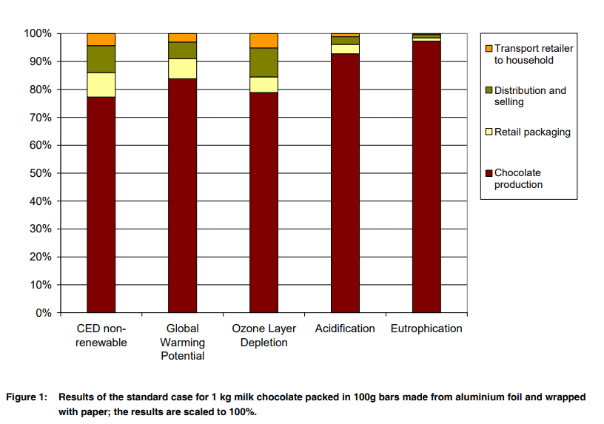

The [aluminum foil pape](https://www.htmmalufoil.com/products/flexible-packaging-aluminium-foil/)r is not for the purpose of chocolate, but the heat conductivity of the metal is very good. If it is a mold, the plastic is obviously plastic. Then why use aluminum foil? The raw materials of chocolate are: cocoa cake made from cocoa beans and cocoa butter, sugar, milk, etc. If the chocolate is directly exposed to light, the cocoa butter will react with the moisture and oxygen in the air, the smell of chocolate. And the taste will be lost, there will be no chocolate scent when peeling chocolate paper and delicious when eating, aluminum foil paper used to keep the chocolate delicious, in addition to the role of insect proof and bacteria. 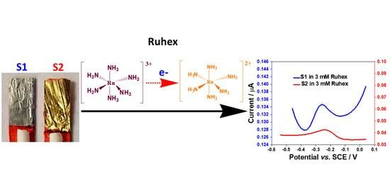

**3-PACKAGING & DESIGN:**

**3-1-Logo:**

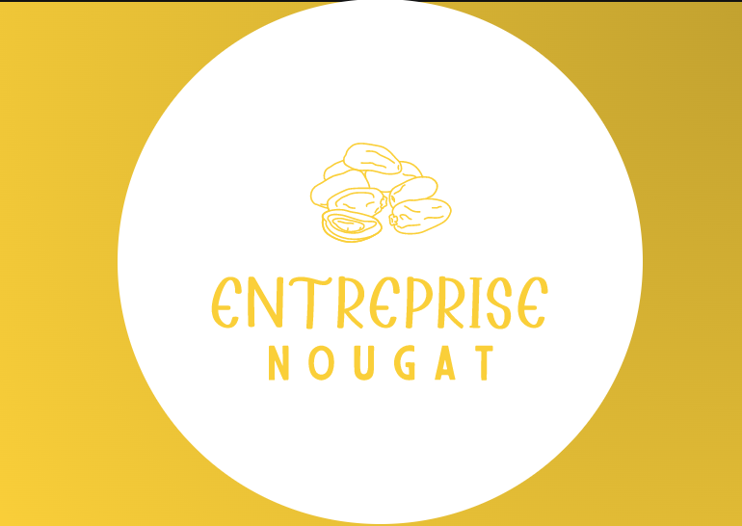

**3-2-Package labeling :**

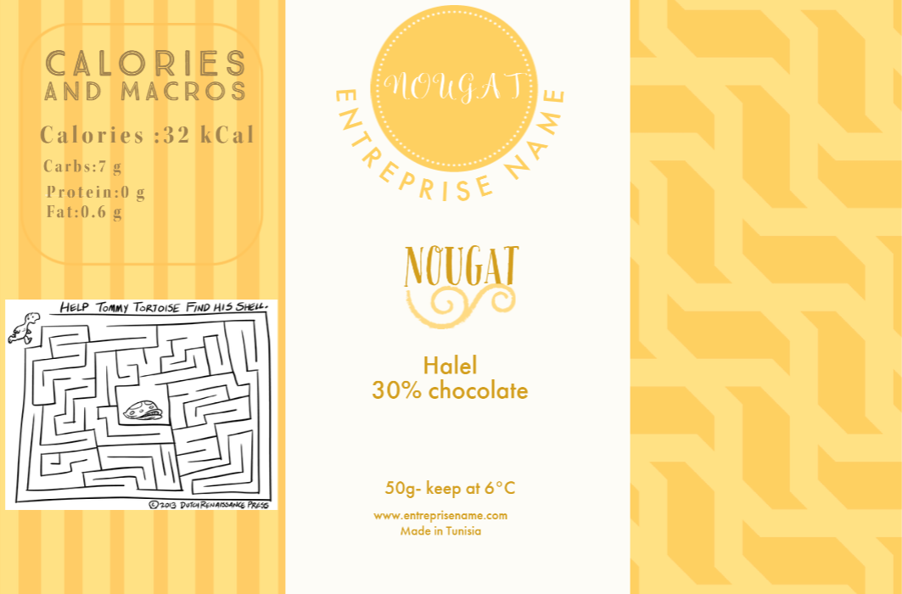

**4-INDUSTRIAL STUDY:**

**4-A-GENERAL STUDY**

**4.1- THE MANUFACTURING PROCESS**

The first step in the packaging process is the manufacturing of that packaging. The manufacturing process needs to be considered when thinking about the design of the packaging. Some of the factors that will impact the manufacturing process include:

* The material or substrate of the packaging
* The cost of these materials
* Where the packaging is going to be manufactured
* The time it will take to manufacture the packaging
* Whether automation or hand assembly will be utilized

**4.2- THE FILLING & ASSEMBLING PROCESS**

After the manufacturing process is completed, the packaging needs to be filled and assembled. This can take many forms depending on the nature of the product. Some of the examples include:

* Is the package a simple box inside of which the product will sit?
* Does the packaging require a separate tray or insert to encompass the product?
* Is assembly and filling automated or manual?

These are only a few of the many points that need to be considered during the filling and assembly process. Both the product and packaging have to be protected while expediting the process.

**4.3- THE TRANSPORTATION OF THE PRODUCT**

Once the packaging has been fulfilled, the product will be transported to wherever it is being sold. It is imperative for the product to be protected during this important step. Whether it is being moved by land, sea, or air, steps need to be taken to protect the integrity of the product. This needs to be incorporated into the design of the packaging. Consider the transportation of the product and take steps to protect it. In addition to protecting the packaging and final product, it’s important to note that packaging efficiency is also important when it comes to logistics. Well thought-out packaging means more efficiency in transportation which can reduce costs. In our case chocolate needs to be preserved in lower temperature to stay in the same shape and avoid being spoiled .

**4.4- THE SHELF LIFE**

Shelf life is yet another area to consider when designing a packaging design. While we’re mostly familiar with shelf life in terms of perishable items, shelf life also represents how well the product will appear on the shelf. From tamper protection to fragility, these have to be considered well in advance. A design that is too intricate and fragile might easily damage on a store shelf or on display, making it unattractive to consumers.

**4.5- THE USER EXPERIENCE**

The last step in the packaging process is the experience of the user. Industry-leading brands know this and value this part of the packaging process significantly. They understand that packaging is a vehicle for communicating with the customer. In addition to protecting the product, packaging should create an experience for the consumer. It should tell a story and build the customer’s loyalty. This alone, provides a solid return on the brand’s marketing investment.

**4-B-MANUFACTURING PROCESS OF THE PACKAGING :**

#### Horizontal Flow Wrapping Machine, PSA-200NT For Nougat And Marshmallow Biscuits Solutions

What we need is to have pillow pack for single products of nougat .We need flow wrapping machine with high speed to support our production line. After consideration, we chose Flow Wrapping Machine PSA-200NT. With PSA-200NT nougat and chocolate products can be wrapped in a more efficient way.

#### **4.1-Material**

In this case, laminated film PET/CPP (non-shrink material) is used for pillow pack. It consists of PET film which has high printability as first layer and laminated with CPP film as inner heat sealing material. Therefore, laminated Film PET/CPP has good air barrier with high printing quality.

#### **4.2-Equipment**

To meet the company requirements, Benison technical team adjusted the speed up to 125packs/minute by dual knives seal which packaging speed can be double comparing to standard model. In addition, the company intends to use printing material for this pillow pack. Therefore, printing sensor is equipped to precisely seal the designated space to avoid cut & damage products. Besides, Our PSA 200NT is highly versatile which makes the production of different product sizes be possible. Within 10-15 minutes of small adjustment on the machine, user can change the Former size basing on products size. No trained-technician needed. Ultimately, Flow wrapping machine PSA-200NT is recommended by solution to increase efficiency of production line for pillow pack product.

**4.3-Machine Specifications**

* Flow Wrapper Machine PSA-200 NT
* Packaging Capacity: 125packs/minute (depends on product size)
* Output: Single Pillow Pack Product

#### **4.4-Features**

* Easy to operate.
* Printing sensor can be installed to make sure printed packs be in the right position
* Two-side knife sealer can double the machine speed comparing to standard model
* Enable to pack different size of products, with easy adjustment
* Suitable for food and non-food industries
* All machinery and equipment comply with food safety production regulations
* The equipment, material, and quantity can be adjusted based on actual production needs
* Benison can provide consultation about plant layout planning, production line optimization, and labor allocation.

## 5-Future of Food Packaging Materials

Innovations and advancements in material science have given food packaging a positive future in terms of efficiency and environmental impacts.

*Smart packaging* (or Intelligent packaging) has been gaining publicity lately, with an expected market of $26.7 billion by 2024 . Smart packaging represents packaging systems carrying sensors that help prolong the shelf life of foods, reveal information on freshness and quality, and enhance the safety of the product and consumer.

Another technology in packaging systems is *active packaging*, which is the integration of additives with the packages to improve food shelf-life and quality

*Nanotechnology*, as well, has been able to penetrate the food packaging industry. It helps augment the thermal and mechanical properties of food packages. Nanosensors embedded within the packaging systems can also help monitor, identify, and warn about the safety and quality of the foods. Although the effect of nanoparticles on human health is yet to be well understood, nanotechnology displays a promising future .When it comes to waste management, packaging waste has occupied a large portion of municipal solid waste (MSW), resulting in a rise in environmental concerns  .*Biodegradable polymers* have arisen as alternatives to traditional plastics in food packaging. These polymers decompose into CO2, water, inorganic compounds, and biomass. The types and applications of some biodegradable polymers are listed in Table  
**6-REFERENCES:**

<https://www.mdpi.com/1420-3049/26/1/21>

<https://www.flexpack-europe.org/files/images/Inhaltsbilder/Sustainability/Food%20LCAs/ESU-Chocolate2009-ExecSum.pdf> :LCA of Chocolate Packed in Aluminium Foil Based Packaging

<https://www.overwrappingmachines.com/promote/flow-wrapping-machine-manufacturer.html?gclid=CjwKCAjwkMeUBhBuEiwA4hpqEMz-3bEidDA-wWeNkGdZr6jE3CvZUbZw7wfkK_pIC1bX9piUfH_sLBoC384QAvD_BwE>

<https://www.alufoil.org/en/main-markets/confectionery.html#:~:text=Many%20chocolate%20products%20are%20stored,penetration%20of%20aroma%20and%20flavour>.

<https://www.htmmalufoil.com/news/industry-news/why-are-good-chocolates-wrapping-in-aluminium-foil-metal-paper.html>

<https://www.benison.com.tw/en/page/packaging-solutions-6.html>

<https://youtu.be/LFAYVfAerVI>