Rapport :

Choix des materiaux :

Packeging design

Etude industrielle

Autres points :

introduction

Passionnément

The product :NOUGAT(with dates and covered with chocolate)

What is nougat (Composition) ?:

Nougat is a fluffy, aerated confection that is made of sugar or honey and egg whites. It often contains fruits and nuts. Traditional nougat resembles fudge and is a far cry from the processed candy fillings you might be familiar with, which are generally made with hydrolyzed proteins and corn syrup.

Chocolate Composition:Cacao -milk

Material choice :

Aluminum foil or laminate and Sulphite paper .

WHY?

Many chocolate products are stored for long periods but, when exposed to moisture and light, it deteriorates and the surface can quickly lose its attractive gloss. Aluminum foil or laminate offers the best protection, providing a total barrier to light, moisture, and any penetration of aroma and flavor.

Another advantage is that foils are easy to fold, which helps the customer save what’s left of a chocolate bar for later. The bright color of the wrapper gives a feeling that it’s very clean and well preserved. The tightness of the wrapper gives more protection, doesn’t allow bacterial spread and makes the chocolate bar safer for consumption. The light weight of the foil adds no noticeable change to the original product, which means that the price and the sales calculations will not be affected.

-Aluminum foil is endlessly recyclable and can be reformed into thousands of different items without the need for any new material. Making products from recycled aluminium uses only five per cent of the energy it takes to make new foil from raw materials.

STATISTICS :

The share of retail packaging is between 1% (eutrophication) and 9% (CED non-renewable). About two thirds of this burden stems from the use of aluminum and one third derives from the wrapping paper. It must be considered that the aluminum and the paper part of the packaging fulfil different functions contributing to a single packaging solution. The influence of distribution and selling of chocolate is second most important in the indicator non-renewable cumulative energy demand and ozone layer depletion.

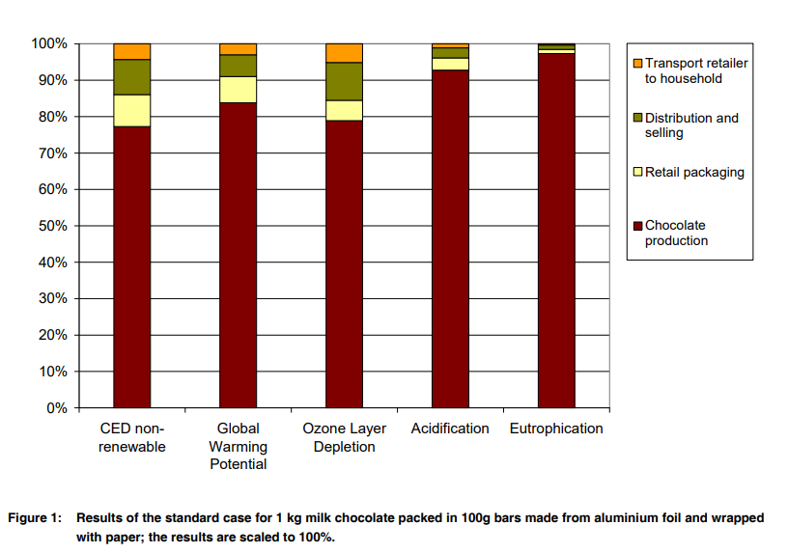

The [aluminum foil pape](https://www.htmmalufoil.com/products/flexible-packaging-aluminium-foil/)r is not for the purpose of chocolate, but the heat conductivity of the metal is very good. If it is a mold, the plastic is obviously plastic. Then why use aluminum foil? The raw materials of chocolate are: cocoa cake made from cocoa beans and cocoa butter, sugar, milk, etc. If the chocolate is directly exposed to light, the cocoa butter will react with the moisture and oxygen in the air, the smell of chocolate. And the taste will be lost, there will be no chocolate scent when peeling chocolate paper and delicious when eating, aluminum foil paper used to keep the chocolate delicious, in addition to the role of insect proof and bacteria.

The development of low-cost electrode devices from conductive materials has recently attracted considerable attention as a sustainable means to replace the existing commercially available electrodes. In this study, two different electrode surfaces (surfaces 1 and 2, denoted as S1 and S2) were fabricated from chocolate wrapping aluminum foils. Energy dispersive X-Ray (EDX) and field emission scanning electron microscopy (FESEM) were used to investigate the elemental composition and surface morphology of the prepared electrodes. Meanwhile, cyclic voltammetry (CV), chronoamperometry, electrochemical impedance spectroscopy (EIS), and differential pulse voltammetry (DPV) were used to assess the electrical conductivities and the electrochemical activities of the prepared electrodes. It was found that the fabricated electrode strips, particularly the S1 electrode, showed good electrochemical responses and conductivity properties in phosphate buffer (PB) solutions. Interestingly, both of the electrodes can respond to the ruthenium hexamine (Ruhex) redox species. The fundamental results presented from this study indicate that this electrode material can be an inexpensive alternative for the electrode substrate. Overall, our findings indicate that electrodes made from chocolate wrapping materials have promise as electrochemical sensors and can be utilized in various applications.

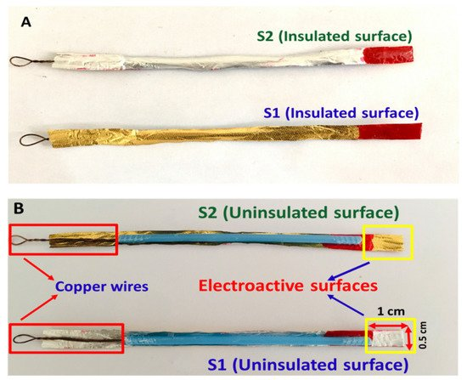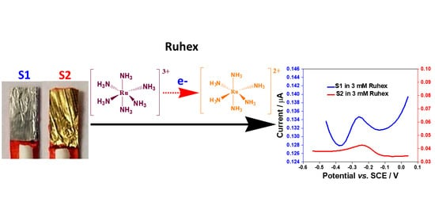

PACKEGING :

*Logo:*

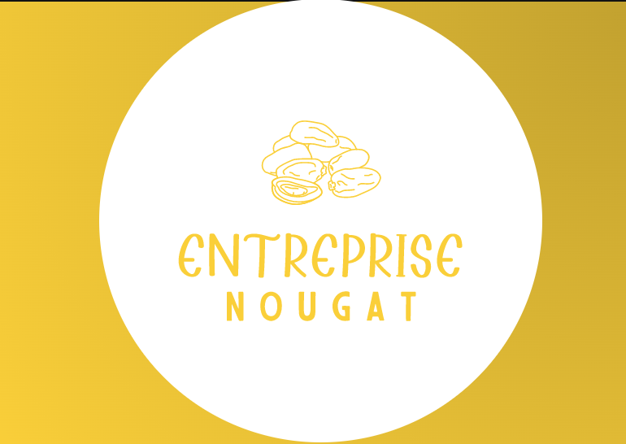

*Package labeling :*

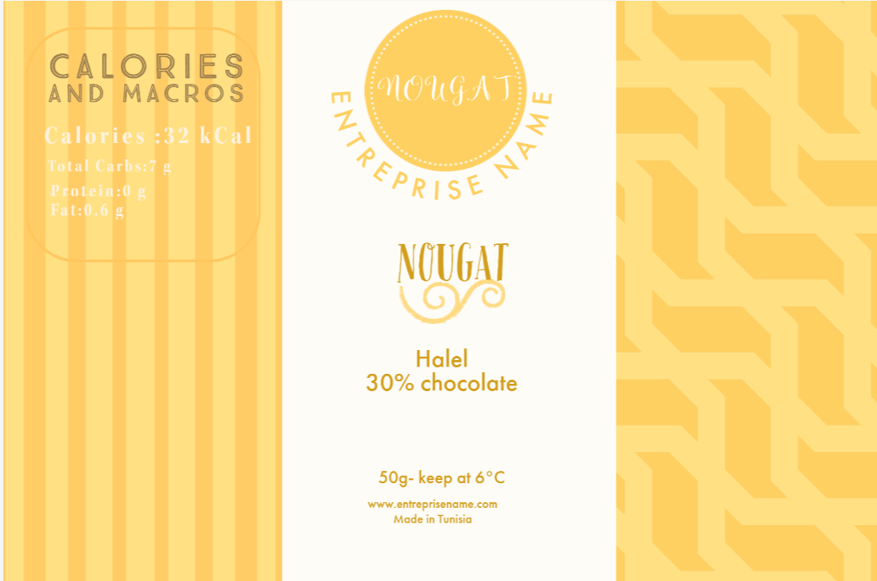

**INDUSTRIAL STUDY:**

**1. THE MANUFACTURING PROCESS**

The first step in the packaging process is the manufacturing of that packaging. The manufacturing process needs to be considered when thinking about the design of the packaging. Some of the factors that will impact the manufacturing process include:

* ***The material or substrate of the packaging***
* ***The cost of these materials***
* ***Where the packaging is going to be manufactured***
* ***The time it will take to manufacture the packaging***
* ***Whether automation or hand assembly will be utilized***

When thinking about the design of the packaging, all of these factors need to be considered. They will impact not only the manufacturing process but also the overall cost of the product and your timeline.

**2. THE FILLING & ASSEMBLING PROCESS**

After the manufacturing process is completed, the packaging needs to be filled and assembled. This can take many forms depending on the nature of the product. Some of the examples include:

* ***Is the package a simple box inside of which the product will sit?***
* ***Does the packaging require a separate tray or insert to encompass the product?***
* ***Is assembly and filling automated or manual?***

These are only a few of the many points that need to be considered during the filling and assembly process. Both the product and packaging have to be protected while expediting the process.

**3. THE TRANSPORTATION OF THE PRODUCT**

Once the packaging has been fulfilled, the product will be transported to wherever it is being sold. It is imperative for the product to be protected during this important step. Whether it is being moved by land, sea, or air, steps need to be taken to protect the integrity of the product. This needs to be incorporated into the design of the packaging. Consider the transportation of the product and take steps to protect it. In addition to protecting the packaging and final product, it’s important to note that packaging efficiency is also important when it comes to logistics. Well thought-out packaging means more efficiency in transportation which can reduce costs.

**4. THE SHELF LIFE**

Shelf life is yet another area to consider when designing a packaging design. While we’re mostly familiar with shelf life in terms of perishable items, shelf life also represents how well the product will appear on the shelf. From tamper protection to fragility, these have to be considered well in advance. A design that is too intricate and fragile might easily damage on a store shelf or on display, making it unattractive to consumers.

**5. THE USER EXPERIENCE**

The last step in the packaging process is the experience of the user. Industry-leading brands know this and value this part of the packaging process significantly. They understand that packaging is a vehicle for communicating with the customer. In addition to protecting the product, packaging should create an experience for the consumer. It should tell a story and build the customer’s loyalty. This alone, provides a solid return on the brand’s marketing investment.

**CONSIDERING THE PACKAGING CAREFULLY**

In order for a brand’s packaging be successful in the marketplace, it be well thought-out and for each of the different stages of packaging development. Each stage must be considered carefully. With this goal in mind, it is crucial for every brand to enlist the help of trained professionals. At JohnsByrne, we have extensive experience in helping countless brands achieve their end goal when it comes to packaging. Contact us today to learn how we can guide you and your brand through each of these stages.

A packaging bag can be made of a single roll of film by using flow wrapping machine. Flow wrapping machine can work with shrink or non-shrink material. This machine is using seal system by heat to both ends and bottom of the bag. Pillow pack is one of the outcomes for flow wrapping machine which is airtight to protect your product from contaminations.  
  
Benison is able to give solutions and provide all the required materials and equipment, including selections of packaging materials, machines and compatible connection equipment, etc. Benison team is ready to help you by giving customized solutions with professional service to increase production efficiency.

Solutions below can be changed basing on the actual product size and output requirements. You are welcome to contact us for consultation.

#### Horizontal Flow Wrapping Machine, PSA-200NT For Nougat And Marshmallow Biscuits Solutions

#### Horizontal Flow Wrapping Machine, PSA-200NT For Nougat And Marshmallow Biscuits Solutions

Homemade nougat and biscuits manufacturer contacted Benison to provide them with flow wrapping machine. What they need is to have pillow pack for their single products of nougat and single products of biscuit. They need flow wrapping machine with high speed to support their production line. After consideration, Benison recommends Flow Wrapping Machine PSA-200NT. With PSA-200NT, both nougat and biscuit products can be wrapped in a more efficient way.

#### Material

In this case, laminated film PET/CPP (non-shrink material) is used for pillow pack. It consists of PET film which has high printability as first layer and laminated with CPP film as inner heat sealing material. Therefore, laminated Film PET/CPP has good air barrier with high printing quality.

#### Equipment

To meet the company requirements, Benison technical team adjusted the speed up to 125packs/minute by dual knives seal which packaging speed can be double comparing to standard model. In addition, the company intends to use printing material for this pillow pack. Therefore, printing sensor is equipped to precisely seal the designated space to avoid cut & damage products. Besides, Our PSA 200NT is highly versatile which makes the production of different product sizes be possible. Within 10-15 minutes of small adjustment on the machine, user can change the Former size baseing on products size. No trained-technician needed. Ultimately, Flow wrapping machine PSA-200NT is recommended by solution to increase efficiency of production line for pillow pack product.

#### Machine Specifications

* Flow Wrapper Machine PSA-200NT
* Packaging Capacity: 125packs/minute (depends on product size)
* Output: Single Pillow Pack Product

#### Features

* Easy to operate.
* Printing sensor can be installed to make sure printed packs be in the right position
* Two-side knife sealer can double the machine speed comparing to standard model
* Enable to pack different size of products, with easy adjustment
* Suitable for food and non-food industries
* All machinery and equipment comply with food safety production regulations
* The equipment, material, and quantity can be adjusted based on actual production needs
* Benison can provide consultation about plant layout planning, production line optimization, and labor allocation.