**1.DEFINITIONS OF PACKAGING**

Packaging is defined as ―the enclosure of products, items, or packages in a wrapped pouch, bag, box, cup, tray, can, tube, bottle, or other container to

perform the following functions: containment; protection or preservation; communication; and utility or performance.‖ If the device or container performs one or more of these functions, it is considered a package. This definition implies that packaging serves more than one function; i.e., it is multifunctional.

Packaging functions range from technical ones to marketing oriented ones as shown in the following Table :

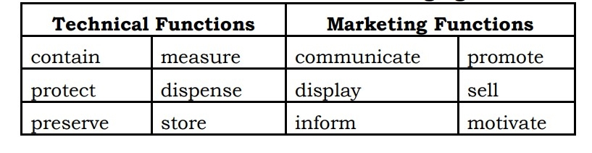

Technical packaging professionals need science and engineering skills, while marketing professionals need artistic and motivational understanding.

NB :

**Packaging** may be looked at as several different types. For example a transport package or **distribution package** is the package form used to ship, store, and handle the product or inner packages. Some identify a **consumer package** as one which is directed toward a consumer or household. It is sometimes convenient to categorize packages by layer or function: "primary", secondary", etc.

**1. Primary packaging** is the material that first envelops the product and holds it. This usually is the smallest unit of distribution or use and is the package which is in direct contact with the contents (viz. butter in parchment paper).

**2. Secondary packaging** is outside the primary packaging – perhaps used to group primary packages together (viz. paper board pack containing butter wrapped in veg. parchment paper).

**3. Tertiary packaging** is used for bulk handling, warehouse storage and transport shipping. The most common form is a palletized unit load that packs tightly into containers (viz. Boxes containing 20-25 or 50 butter packs are put together).

**2.INTRODUCTION AND HISTORY OF PACKAGE DEVELOPMENT**

Changes in packaging to meet society’s needs

. Packaging is not a recent phenomenon.

. Packaging is an activity closely associated with the evolution of society and, can be traced back to human beginnings.

. The nature, degree, and amount of packaging at any stage of a society‘s growth reflect the needs, cultural patterns, material availability and technology of that society.

. A study of changing roles of packaging and forms over the centuries is a study of the growth of civilization.

. Social changes are inevitably reflected in the way we package, deliver and consume goods.

**3.FUNCTIONS OF PACKAGING**

The functions of a package are ―to preserve the quality and freshness of food, to add appeal to the food to attract consumers, and to facilitate its storage and distribution.‖ The basic functions required of a package can be grouped under four major categories.

**\* To Contain the Product :**

The primary function of any package is to contain the food and facilitate handling, storage, and distribution all the way from the manufacturer to the ultimate user or even the time the rest portion is utilized by the consumer. However, there are usually various levels of packaging. A primary package is one that comes into direct contact with the contained product, e.g., metal cans, glass jars, and plastic pouches. By law, a primary package must not yield any substance that may be injurious to the health of the consumer. Further development to facilitate handling is to bundle a series of primary packages together, and this lead to the concept of secondary packages. Examples of secondary package is corrugated box in which tins of apple juice are packed. As methods of handling and transportation have become more sophisticated, these secondary packages are often palletized and secured by strapping with metal or, more commonly, by shrink- or stretch-wrapped film to give yet another level of packaging,i.e tertiary packaging. In turn, these pallet loads may be packed into large metal containers, i.e., quaternary packaging for transportation over long distances by air, land, or sea. The secondary, tertiary and quaternary packaging are also known as packing. The following are considered in this regard.

1. Adequate size and shape (biscuit package, tubs for detergent)

2. Proper constructional features. No leakage, spillage, diffusion, i.e. loss prevention.

3. Package: Must contain the commodity in natural form (biscuits packed in Pillow pack, prevent damage)

4. No subsequent damage after packaging during handling transportation and storage.

5. Thus package must be strong enough to contain the commodity as it is.

6. Optimum compatibility (nontoxic, non soluble with product… No physical, chemical or biochemical changes/alteration… i.e. inert to the product.)

7. Containment or agglomeration - Small objects are typically grouped together in one package for reasons of efficiency. For example, a single box of 1000 pencils requires less physical handling than 1000 single pencils. Liquids, powders, and granules need containment.

**\* To Protect the Product :**

One of the most important function of any container is to protect the product contained against any form of loss, damage, deterioration, spoilage, or contamination that might be encountered throughout the distribution chain. Packaging can prevent physical damage, e.g., bruising caused by vibrational shocks during transportation or stacking in a warehouse. Proper packaging will also prevent material loss, e.g., potatoes from a weak sack or juice from a leaky can. Packaging can also protect products against moisture loss or gain, dust, and light, especially UV light, which causes deterioration of some light-sensitive products. It can also protect the package contents against temperature fluctuations in the transit of chilled and frozen foods. Packaging can also be used to control the availability of oxygen to fruits and vegetables and to protect against loss of flavor or fragrance and help products retain their nutritional value. Proper packaging may also protect the product against microbial spoilage by bacteria, yeasts, and molds. It can also protect against microbiological spoilage of stored products due to rodents and insects.Packaging protects the product against damages which may be due to different hazards viz. (a) Mechanical, (b) Environmental (c) Microbial and Biochemical hazard. (d) Social Hazards.

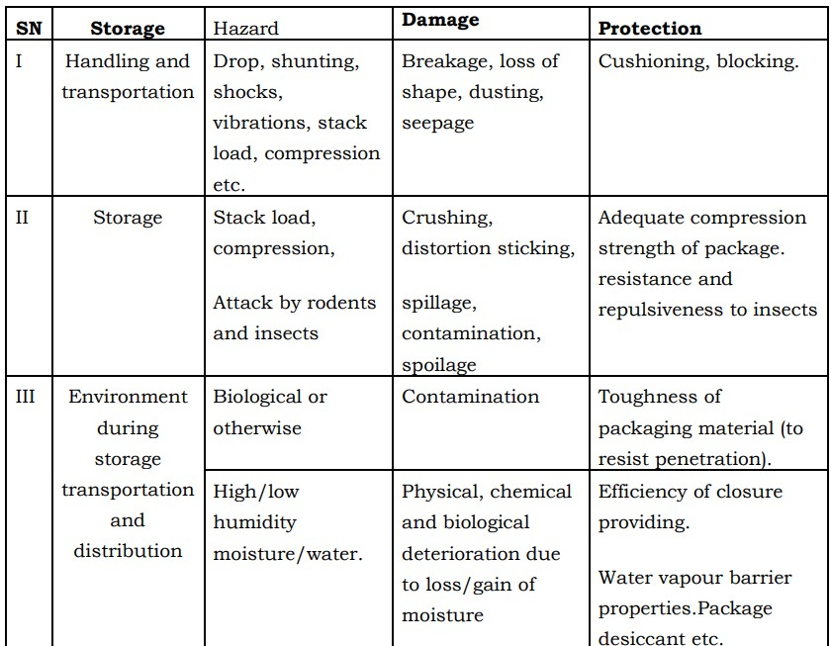

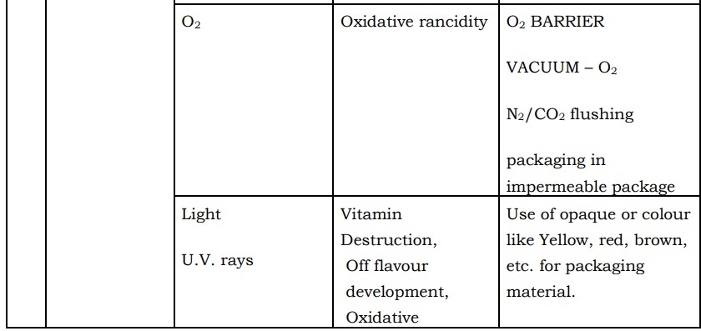

***Hazard, damage and protection of packaging materials***

Barrier protection - A barrier from oxygen, water vapor, dust, etc., is often required. Permeation is a critical factor in design. Some packages contain desiccants or Oxygen absorbers to help extend shelf life. Modified atmospheres or controlled atmospheres are also maintained in some food packages. Keeping the contents clean, fresh, and safe for the intended shelf life is a primary function of the package.

**\* Medium of communication**

An important function of any food package is to identify the product and its origin; to inform the consumer how to use the contents; to provide any other information needed or required; and very importantly, to attract the user and encourage purchase of the product. Package design has been an important and constantly evolving phenomenon for many years. Marketing communications and graphic design are applied to the surface of the package and in many cases the point of sale/display. The information a package can convey to the consumer may include the following:

1. Product manufacturing and best buy dates

2. Proper storage conditions

3. Cooking instructions

4. Size and number of servings or portions per pack

5. Nutritional information per serving

6. Manufacturer‘s name and address

7. Cost

8. Suggested recipes

9. Country of origin

10.Information transmission - Packages and labels communicate how to use,

transport recycle, or dispose of the package or product

**\* Means of selling product:**

The packaging and labels can be used by marketers to encourage potential buyers to purchase the product. Packaging is often referred to as the ―silent salesman.‖ Robertson (1992) concisely summarized the multifunctions of packaging when he stated that ―a package must protect what it sells and sell what it protects.‖ Packages can have features which add convenience in distribution, handling, display, sale, opening, reclosing, use, and reuse. According to Jelen (1985), primary packages should have the following characteristics to facilitate the sale of products**:**

1. Sanitary

2. Non toxic

3. Transparent

4. Lightweight

5. Tamper evident

6. Easy to pick up and handle

7. Easy to fit into cupboards, shelves, refrigerators, etc.

8. Easy to open and dispense from

9. Easy to reclose

10.Returnable, recyclable, or reusable

11.Safe and presents no hazards in the way of broken glass or sharp jagged metal edges

12.Display the product

13.Glamorize: Create an illusion of something very precious, by decoration, embossing techniques and exotic closures, but it should not deceive the people.

The desirable polyfunctional properties of packaging materials are summarized in Table

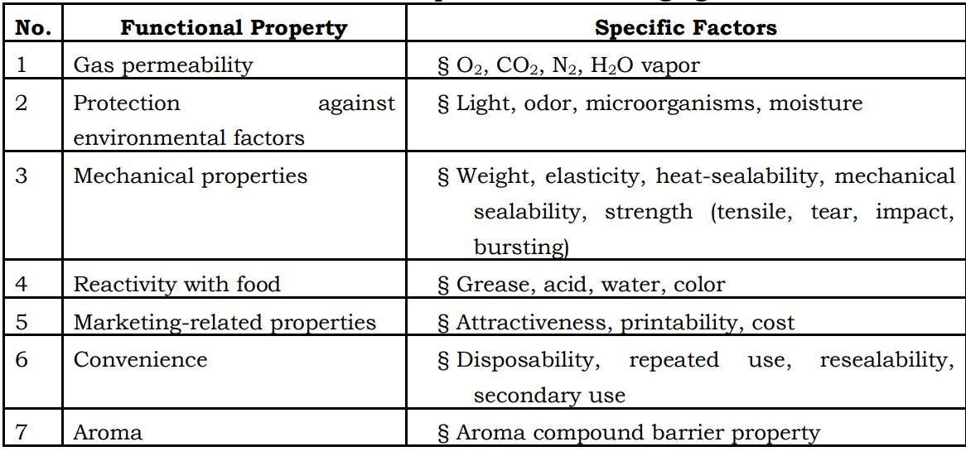

**Functional Requirements of Packaging Materials**

Source: Jelen, P. 1985. Food packaging technology. In Introduction to Food

Processing, Reston Publishing, Reston, VA, pp. 249–266.

**OTHER FUNCTIONS OF A PACKAGE:**

**1. Dispensing :** Consumers: Product not used all at once, remove a portion…without destroying/damaging the remaining product/container.

**2. Preserve:** Remaining product in container-Protection and preserve it for extended/desired period.

**3. Measuring :** Portion control: Single serving or single dosage package has a precise amount of contents to control usage. Bulk commodities (such as salt) can be divided into packages that are a more suitable size for individual households. It also aids the control of inventory: selling sealed one-liter-bottles of milk, rather than having people bring their own bottles to fill themselves.

**4. Security :** Packaging can play an important role in reducing the security risks of transport. Packages can be made with improved tamper resistance to deter tampering and also can have tamper-evident features to help indicate tampering. Packages can be engineered to help reduce the risks of package pilferage: Some package constructions are more resistant to pilferage and some have pilfer indicating seals. Packages may include authentication seals to help indicate that the package and contents are not counterfeit. Packages also can include anti-theft devices, such as dye-packs, RFID tags, or electronic article surveillance tags, that can be activated or detected by devices at exit points and require specialized tools to deactivate. Using packaging in this way is a means of loss prevention.

**4.REQUIREMENTS FOR PRODUCING SUCCESSFUL PACKAGE:**

Four sets of facts are necessary to be known for producing a successful package:

a.Facts about the product:

1. The nature of the product, the material from which it is made and the manner in which it can deteriorate.

2. Its size and shape.

3. Its weight and density: eg. Powder – Bulk Density … size of tins

4. Its weakness-which parts will break, move about, become bent or scratch or abrase the box easily.

5. Its strengths: which part will withstand loads or pressures and which might be suitable for loading the product in the pack.

6. The effect of moisture and temperature changes on the product and whether it will absorb moisture or corrode.

7. Compatibility: whether the product is likely to be affected by any of the possible packaging materials, which items can be packed together, with protection if necessary and which items must not be packed together under any circumstances.

8. How far stripping down may be carried out to reduce the package size to a minimum such that the customer can handle them. (Generally for merchandize foods like kitchen machine, blender etc.)

b.Facts about the transport hazards:

1. The type of transport-road, rail, sea or air.

2. The degree of control over the transport. Is it private or public transport?

3. The form of transport- bulk, freight container, Unitized load, postal, passenger train, etc.

4. The mechanical conditions and duration of storage (manufacturer State Distributor District Distributor … Taluka / CityRetailer. The longer the journey or handling more strength is required in packaging & packing materials leading to higher cost).

5. The nature and intensity of mechanical and climatic hazards in transport, storage, retailing and use. Packaging / packing material has to withstand wide range of temperatures and relative humidity

6. Whether handling aids are available for loading and off-loading at all points between maker and user. (Viz. Lifts, Trolleys, Slip conveyers etc.)

7. The importance of minimum volume in relation to transport costs. Over packaging must be prevented.

c.Hazards may be:

**1. Mechanical:** Impact (vertical, horizontal), stationary package impacted by another, vibration, compression, Racking or deformation, piercing, puncturing, tearing etc.

**2. Climatic hazard:** (High / low temperature / pressure) light, liquid/water (fresh / polluted), dust, and water vapour, R.H.

**3. Biological**: (Microorganisms, fungi, moulds, bacteria, beetles, moths, flies, ants, termites, mites, rodents (rats and mice), birds.

d.Contamination by other goods:

1. By materials of adjacent packs

2. By leaking contents of adjacent packs

3. Radioactivity.

**5.Selection of Packaging Materials**

The food processor has a variety of packaging materials to choose from for food packaging, specifically, paper,glass, metal, and plastics. The choice of the proper packaging material will be made by the food processor based on **the requirements:**

1. Composition of the food (solid or liquid)

2. Physical, chemical, and microbiological and deteriorative reactions that might

occur

3. Storage conditions and time of storage

4. Socioeconomic situation of the anticipated customer or market

5. Desired package attractiveness

6. Cost of the packaging material

7. Packaging technology selected

8. Specific functional properties of the packaging material

There are several reasons for selecting or rejecting a particular packaging material over another, as summarized in the following Table:

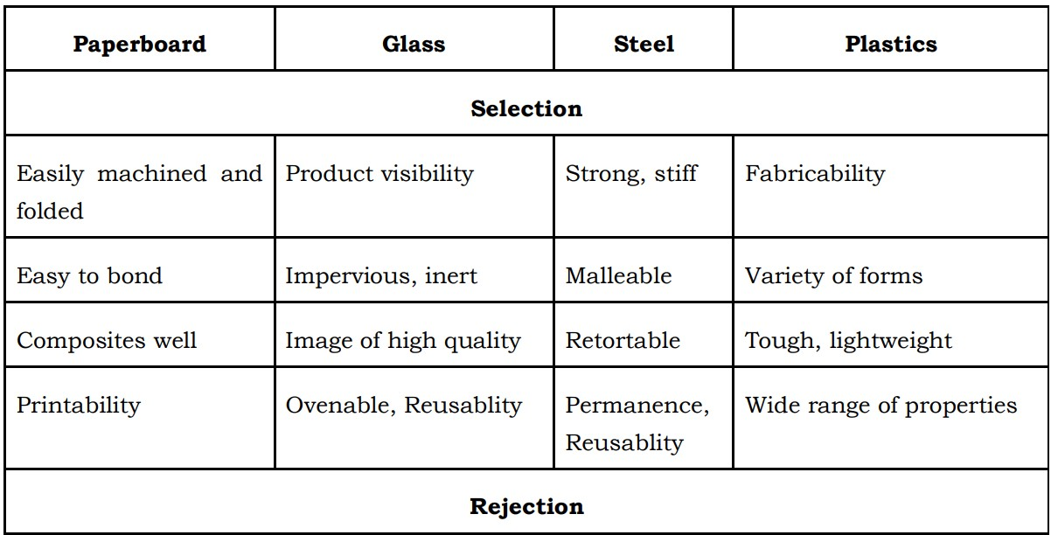

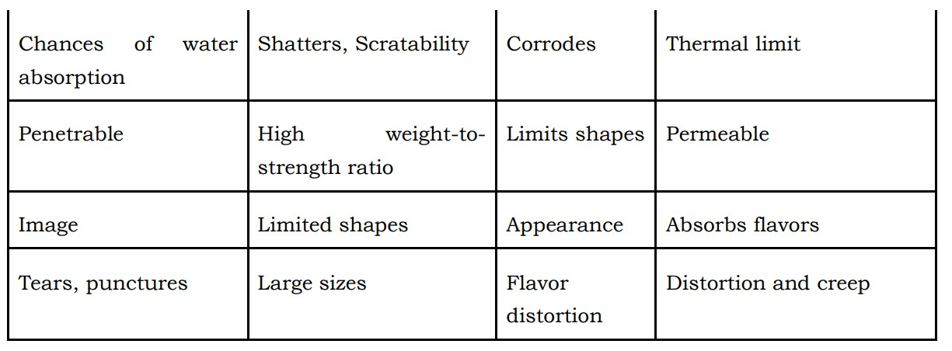

**6.CHARACTERISTIC OF AN IDEAL PACKAGE**

1. Compatible with product.

2. Protection from Mechanical hazards especially transportation. climatic hazards, microorganisms : Packaging do not harbour bacteria, restrict their growth….Flavour gain/loss/salts/difference in temperature.

3. Fit into a production line.

4. Advertising potential.

5. Attractive appearance.

6. Easy to handle during…Production, storage and Distribution

7. Moisture proof/resistance.

8. Sufficient mechanical strength to withstand drop, vibration, compression etc.

9. Acid, alkali resistance.

10.Grease & oil resistance.

11.Resistance to photo-chemical changes in product.

12.Resistance to insects and rodents.

13.Fire proof resistant to smoke, fume and water.

14.Pilfer proof (malpractice).

15.Inert: No effect on flavour/aroma.

16.Not injurious to health.

17.Economic.

18.Easy availability.

19.Protect against climatic hazards.

20.Protect against microorganisms. It should not harbour microbes rather restrict their growth by controlling growth factor like.