学 校 代 码 10459
学 号 202206010223
密 级 公开


外文文献和翻译

题目：1. 个体化放射栓塞计算流体动力学模型体内验证的概念验证研究
2. 多孔介质中微塑料纤维输运与滞留的孔隙尺度认识

作 者 姓 名：徐子昂
导 师 姓 名：王小峰 教授
学 科 门 类：工学
专 业 名 称：工程力学
培 养 单 位：力学与安全工程学院
完 成 时 间：2026年05月
目 录
1 外文文献原文1 1
2 外文文献原文2 20
3 外文文献翻译1 46
4 外文文献翻译2 61

1 外文文献原文1
A proof-of-concept study of the in-vivo validation of a computational fluid dynamics model of personalized

Radioembolization (RE) with yttrium-90 ( 90 Y) microspheres, a transcatheter intraarterial therapy for patients with liver cancer, can be modeled computationally. The purpose of this work was to correlate the results obtained with this methodology using in vivo data, so that this computational tool could be used for the optimization of the RE procedure. The hepatic artery three-dimensional (3D) hemodynamics and microsphere distribution during RE were modeled for six 90 Y-loaded microsphere infusions in three patients with hepatocellular carcinoma using a commercially available computational fluid dynamics (CFD) software package. The model was built based on in vivo data acquired during the pretreatment stage. The results of the simulations were compared with the in vivo distribution assessed by 90 Y PET/CT. Specifically, the microsphere distribution predicted was compared with the actual 90 Y activity per liver segment with a commercially available 3D-voxel dosimetry software (PLANET Dose, DOSIsoft). The average difference between the CFD-based and the PET/CT-based activity distribution was 2.36 percentage points for Patient 1, 3.51 percentage points for Patient 2 and 2.02 percentage points for Patient 3. These results suggest that CFD simulations may help to predict 90 Y-microsphere distribution after RE and could be used to optimize the RE procedure on a patient-specific basis.

Introduction
Radioembolization (RE) with yttrium-90 ( 90 Y) microspheres is a transcatheter intraarterial therapy that has emerged as a safe and effective treatment option for patients with primary or secondary liver cancer, such as hepatocellular carcinoma (HCC) 1 . RE consists of the intraarterial infusion of 90 Y-loaded microspheres that are transported to the tumoral bed, where they emit tumor-killing doses of radiation 2 . Currently, a simulation of the RE procedure is performed with the intraarterial administration of 99m Tc-Macroaggregated of Albumin ( 99m Tc-MAA) on the assumption that the distribution of 99m Tc-MAA and 90 Y-microspheres are similar. Nevertheless, systematic errors (e.g. differences in catheter position, injection techniques) or hemodynamic changes during both procedures can result in a poor correlation between 99m Tc-MAA and 90 Y-microspheres distribution 3 . There have been in vitro studies where the density, flow dynamics and the embolization effect of several types of particles are experimentally analyzed 4 – 6 .
Three-dimensional (3D) simulation of hemodynamics and microsphere transport using computational fluid dynamics (CFD) has been designed to improve RE. These in silico (performed on computer) simulations allow the flow patterns of a fluid and the trajectories of some particles (in this case microspheres) to be predicted in a certain region of space, or computational domain, over time. This in silico approach has been successfully evaluated experimentally using a scaled model of a generalized hepatic artery 7 . Numerous investigations based on CFD models have analyzed the influence that local 3D parameter modifications (e.g., type of catheter, catheter-tip location, microsphere infusion velocity, etc.) have on the final distribution of the microspheres 8 – 14 . This information may contribute to enhance antitumor efficacy and minimize complications due to radiation of nontarget tissues. These simulations could also complement the conventional planning with 99m Tc-MAA by defining the ideal injection speed and catheter placement in standard scenarios. If the information provided by CFD models could be calculated for individual patients, it would enable the development of more efficient and personalized RE procedures. However, the results from CFD simulations have not yet been compared to the actual microsphere distribution in real patients to assess to what extent the model represents the real-life hepatic artery hemodynamics during RE.
In RE, 90 Y PET/CT is commonly used to assess microsphere distribution. This imaging modality has been shown to be a reliable tool to assess activity deposition 15 , to accurately quantify the total activity delivered 16 and to estimate the absorbed doses 17 .
The aim of this study was to assess the ability of personalized CFD models to predict the microsphere distribution observed in the 90 Y PET/CT study performed in each patient after the RE procedure. The average activity (estimation of the number of 90 Y-microspheres) that the computational simulation study predicted would reach the liver irrigated by the artery in which the 90 Y-microspheres were injected was compared with the real average activity obtained in the 90 Y PET/CT study after RE.

Materials and methods
The University of Navarra ethics committee approved the protocol (186/2018) for this study and it was performed in accordance with the ethical standards laid down in the 1964 Declaration of Helsinki and all subsequent revisions. Informed consent was signed by each patient.

Patient-specific model development

RE work-out
All patients were scanned on a third-generation dual-source CT (SOMATOM Force, Siemens Healthineers, Forchheim Germany) prior to the RE procedure. To analyze arterial liver perfusion 18 , 19 , sequential CT scanning of the hepatic volume was performed over time. Perfusion CT (pCT) consisted of a pre-contrast image, followed by dynamic image acquisitions during and after intravenous administration of the iodinated contrast agent. The pCT was also used for the patient-specific 3D geometry of the liver (i.e., tumor and non-tumor volumes, the hepatic arteries, the portal and hepatic veins, and the corresponding territories) using an automatic liver segmentation software package (MeVis Medical Solutions AG, Bremen, Germany). Additionally, dynamic CT images were processed on an external workstation equipped with commercially available CT perfusion software (“CT Body Perfusion”, Syngo.via, Siemens Healthineers, Erlangen, Germany) to obtain the arterial blood flow rate that irrigates the tumoral and the healthy tissue 20 of each segment, parameters needed for building the computational simulation.
After being considered as candidates for RE by a hepatobiliary multidisciplinary team (MDT), on the same day all patients received planning and treatment as explained in Ezponda et al 21 . During the RE procedure, SIR-Spheres resin microspheres (Sirtex Medical Europe Gmbh, Bonn, Germany) were administered and some parameters related to the infusion of the 90 Y-microspheres, such as the precise location of the catheter, injection velocity and volume infused, were prospectively collected. The exact position of the catheter was captured in a planar angiographic image acquired during the RE procedure and later visually placed in the 3D MeVis images with the help of the interventional radiologist that administered the treatment. The injection velocity was obtained from video recordings of the RE procedure, considering also the geometric information of the syringe and the microcatheter. Total volume was the sum of the SIR-spheres delivery-vial (V-vial) and Glucose 5% solution volumes infused during RE.
The morning after the RE treatment, a 90 Y PET/CT scan centred on the liver region (two beds, 10 min/bed) was performed using a Biograph mCT-TrueV (Siemens Healthineers, Erlangen, Germany). The reconstruction protocol used for 90 Y was previously optimized 16 .

Methodology of the simulation
As previously mentioned, the CFD model predicts the fluid flow pressure, velocity and microsphere trajectory at any point, both temporal and spatial (computational domain) for the 3D geometry studied. CFD models are based on three main components: (1) the computational domain, (2) the boundary conditions (BCs) and (3) the equations governing the fluid-flow phenomena. (1) The computational domain is the part of the hepatic arterial tree analyzed (an artery branches successively giving rise to a tree-shaped pattern). In this study this included from the hepatic artery where the catheter was located up to the sub-segmental branches. The definition of the arterial boundaries of the domain is called truncation of the arterial tree. This truncation generates arterial inlets and outlets of the domain. To develop the computational domain, the MeVis liver segmentation computer-aided design (CAD) files containing the geometrical domain (hepatic artery) were used. This liver segmentation study also provided the vascular supply of the different liver segments and their volumetry (both healthy and tumor tissue). The catheter position was also included in the computational model (see Fig. 1 ) using SpaceClaim (ANSYS Inc., Canonsburg, PA, USA). (2) The BCs refer to the coupling of the hemodynamic conditions both inside and outside the computational domain. Therefore, there was one artery inlet and several domain outlets, each one supplying a different liver segment. Ideally, the BC should be measured in vivo. However, the most common approach is to model the flow circulation outside the computational domain 10 . For this model, the following parameters are needed: (a) volumes (ml) of healthy and tumoral tissue in each segment; (b) arterial perfusion (ml/min/ml) for healthy and tumor tissue in each segment, and (c) the segments irrigated by each of the outlets of the computational domain as is explained in detail in 22 . In this study, (a) and (c) were obtained from MeVis liver segmentation. In order to define (b), the following equation developed 22 was used:
(1)$q_{s} = V_{0,s} k_{1,s}^{*} + V_{c,s} k_{2,s}, ∀ s ∈ \{S_{1}, …, S_{8}\}$
where q s is the arterial blood flow rate (ml/min) that feeds segment s, V 0 , s is the normal tissue volume and V c , s is the tumor tissue volume contained in segment s (ml) (see Table 1 ), and k 1 , s ∗ and k 2 , s are the normal and tumor tissue arterial perfusions, both specific for segment s (ml/min/ml). These two perfusions ( k 1 , s ∗ and k 2 , s ) were calculated in the pCT study. S1 to S8 correspond to segment 1 to segment 8.

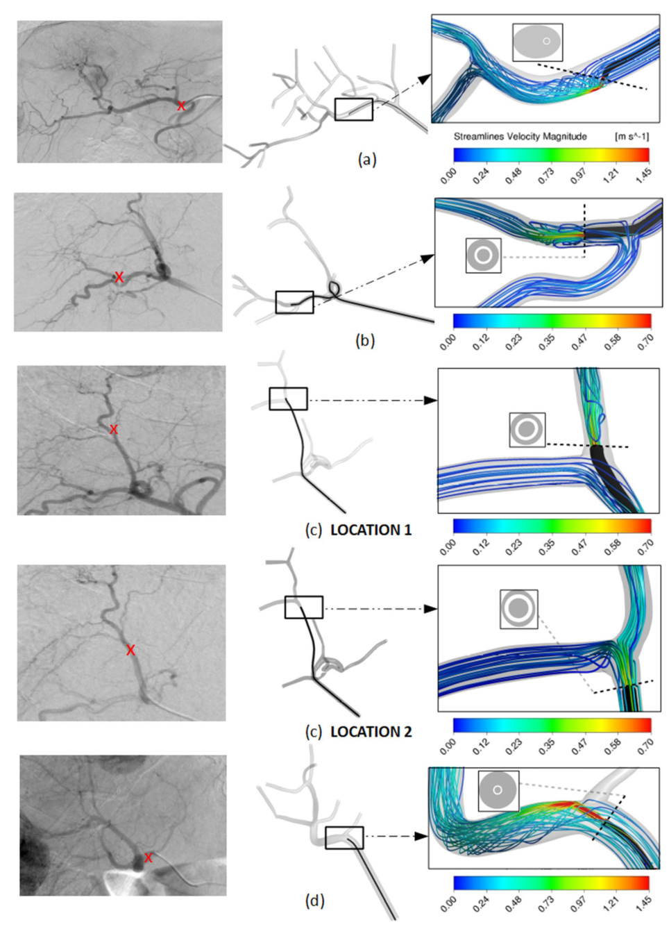
Figure 1. Visualization of microcatheter in the arteriography with the tip location indicated by a red cross (left) and in the CAD model (right) for ( a ) Patient 1, ( b ) Patient 2 and injection for tumors in segment 7, ( c ) Patient 2 and injection for tumors in segment 8, and ( d ) Patient 3. For each case, a detail of the CFD simulation results are shown in terms of flow streamlines colored by velocity magnitude, together with the microcatheter-tip position in the arterial lumen cross-section.
Table 1. Tumoral and healthy volume distribution for each of the three patients.
Patient | Segment | Tumoral volume (ml) | Healthy volume (ml)
Patient 1 | Segment 1 | 0.0 | 62.0
 | Segment 2 | 0.8 | 127.2
 | Segment 3 | 10.8 | 170.2
 | Segment 4a | 0.0 | 73.0
 | Segment 4b | 0.0 | 11.0
 | Segment 5 | 0.0 | 124.0
 | Segment 6 | 0.0 | 169.0
 | Segment 7 | 23.4 | 349.6
 | Segment 8 | 4.0 | 200.0
Patient 2 | Segment 1 | 0.0 | 0.0
 | Segment 2 | 0.0 | 119.7
 | Segment 3 | 0.0 | 213.6
 | Segment 4 | 0.0 | 70.0
 | Segment 5 | 0.0 | 130.7
 | Segment 6 | 0.0 | 119.0
 | Segment 7 | 2.5 | 327.3
 | Segment 8 | 4.5 | 156.8
Patient 3 | Segment 1 | 0.0 | 16.0
 | Segment 2 | 0.0 | 204.0
 | Segment 3 | 0.0 | 188.0
 | Segment 4 | 0.0 | 0.0
 | Segment 5 | 30.7 | 122.3
 | Segment 6 | 0.0 | 82.0
 | Segment 7 | 38.1 | 389.9
 | Segment 8 | 10.2 | 219.8

Depending on the number of outlets that irrigate one same segment, it is then assigned the healthy and tumor tissue volumes contained in that segment that each outlet irrigates. When assigning the healthy volume to each outlet, we assume that all the outlets will irrigate the same amount of healthy tissue within the segment, which means that the healthy volume irrigated by one outlet will be the total healthy volume divided by the number of outlets that irrigate that segment. For the tumor volume assignment, we rely on a manual process where we take into account the proximity of the relative position of the tumor to each outlet and then determine if the tumor volume is irrigated equally by the outlets or not.
The blood flow leaving each outlet is the segment’s healthy volume assigned to that outlet multiplied by the healthy perfusion for that segment, plus the tumor volume assigned to that outlet multiplied by the tumor’s perfusion of that segment. If a tumor is contained in x segments, we consider it as x tumors that are contained in each of those x segments.
The BC at the inlet is defined by the arterial flow rate that is the sum of the arterial flow rates of all the outlets. The boundary condition at the inlet of the microcatheter is defined by its injection velocity which was obtained from video recordings of the RE procedure for each patient. In this modeling approach, in order to reduce the time spent, only four cardiac cycles were simulated. 90 Y-microspheres injected during the first cardiac cycle, and three additional cardiac cycles were modeled to ensure that most of the injected microspheres exit the computational domain. It assumes that the segment-to-segment microsphere distribution in the outlets of the computational domain during this period of time is representative of the whole procedure. With the simulation results, the segment-to-segment microsphere distribution is computed (it is beyond the scope of this model to account for the intrasegmental effects).
Once the geometry and the BCs are known, in order to obtain the fluid flow pressure, velocity and microsphere trajectory, it is necessary to solve 3) the equations governing the fluid (conservation of mass and conservation of linear momentum) and microsphere motion (Newton’s Second Law). For this purpose, the computational domain must be divided into millions of cells, a process called discretization of the domain. Nearby the catheter tip the mesh is fine enough to be able to resolve the jet that is formed at the microcatheter outlet. The discretization was performed using Fluent Meshing (ANSYS Inc.) as described in 10 . In this case, blood was assumed to be isothermal, incompressible, and non-Newtonian, and flowing in laminar regime, as in Aramburu et al. 10 . The gravity component was taken into consideration as 9.8 m/s 2 in absolute value and the direction that corresponded to the patient in recumbent position. It is inside these cells where the equations are numerically solved by the commercial software (Fluent, ANSYS Inc. Canonsburg, PA, USA). The two-way coupled blood flow (continuous phase) and particle transport (discrete phase) models were solved. With regard to the equations governing the flow, the pressure–velocity coupling SIMPLE algorithm was used to solve the velocity and pressure in a segregated way. Spatial discretization was done by using the least squares cell-based algorithm for gradient computations and the second-order upwind scheme for the convection term of the momentum equations. For pressure interpolation, the second-order algorithm was employed. The transient solver settings were a second-order implicit transient formulation with a time step of 2 × 10 –3 s.

CFD model assessment
In order to compare the segment-to-segment number of 90 Y-microspheres predicted by the simulation vs. the actual treatment, the mean activity per volume for each segment was obtained by the CFD simulation and the 90 Y PET/CT.
For the CFD simulation, the number of microspheres that reached each segment was calculated considering the number of microspheres contained in a same-day calibration 3 GBq vial (44.48 ± 2.6 millions) 23 and that the activity that reaches one segment in the simulations is the sum of the activity that leaves the truncated geometry through the outlets that irrigate that segment. With an average activity by microsphere of 50 Bq, the mean activity concentration for a selected segment (Bq/ml) was then estimated in order to compare with the data obtained from the 90 Y PET/CT scan. The relative position between the hepatic artery branch outlets and tumors and segments of the liver was provided by MeVis files.
Using a dedicated voxel-based dosimetry software (PLANET Dose, DOSIsoft SA, Paris, France), 90 Y PET/CT was anatomically co-registered to the pCT using an automated rigid registration method. This was manually corrected in case of matching errors assessed by visual inspection. Segmented liver MeVis DICOM files (the same as the ones used in the CFD model) obtained from the pCT were fused in the co-registered 90 Y PET-pCT images study. The mean activity per volume (Bq/ml) of each liver segment (including tumor and healthy parenchyma) was obtained.
The results from the CFD simulation and 90 Y PET/CT were compared in three patients treated with RE. Patients will be referred to as Patients 1, 2 and 3 and the different tumors from each patient will be designated as a, b, c, etc. Patient, tumor and treatment characteristics are summarized in Table 2 .
Table 2. Information of the tumors and the RE procedures in each of the three patients.
Patient | Tumor name | Tumor volume (ml) | Activity (GBq) | k 2, s (ml/min/100 ml) a | k * 1,s (ml/min/100 ml) b | Segment location by MeVIS | Injection velocity (m/s) | Comments
Patient 1 | 1a | 11.64 | 0.19 | 54.7 | 6.9 | Segment 2 | 0.684 | Two injections for tumor 1a and one injection for tumors 1b, 1c, 1d, and 1e
 | 1a | 11.64 | 0.19 | 54.7 | 6.9 | Segment 3 | 0.778
 | 1b | 2.81 | 0.8 | 40.2 | 6.2 | Segment 8 | 2.01
 | 1c | 2.67 | 0.8 | 39.3 | 4.2 | Segments 7 and 8 | 2.01
 | 1d | 6.22 | 0.8 | 38.3 | 2.3 | Segment 7 | 2.01
 | 1e | 15.65 | 0.8 | 41.4 | 5.0 | Segment 7 | 2.01
Patient 2 | 2a | 2.53 | 0.50 | 36.7 | 3.1 | Segment 7 | 0.52 | One injection per tumor
 | 2b | 4.47 | 0.20 | 42.7 | 5.2 | Segment 8 | 0.45
Patient 3 | 3a | 63.87 | 0.82 | 96.7 | 12.0 | Segments 5, 6 and 7 | 1.85 | One injection for the three tumors
 | 3b | 8.92 | 0.82 | 129.4 | 11.4 | Segment 8 | 1.85
 | 3c | 6.21 | 0.82 | 103.4 | 11.9 | Segments 7 and 8 | 1.85
a Tumoral arterial perfusion. b Healthy parenchyma arterial perfusion.

Patient 1
Patient 1 had a multinodular (5 nodules) HCC involving both liver lobes. The calculated Hepatopulmonary Shunt (HPS) was 6.4%. During angiographic mapping evaluation, an accessory left gastric artery was embolized to avoid the undesired gastric deposition of microspheres. Three microsphere infusions were performed through segment 2 (0.19 GBq) and segment 3 (0.19 GBq) arteries and the right hepatic artery (0.8 GBq). A Direxion Transend-14 System’s microcatheter (Boston Scientific, Watertown, MA, USA) with a curved end, was used during the procedure. The right hepatic artery injection allowed all tumors in the right lobe to be reached (tumors 1b, 1c, 1d and 1f.); while segment 2 and 3 artery injections covered a tumor located between both segments (1a). (see Fig. 2 ).

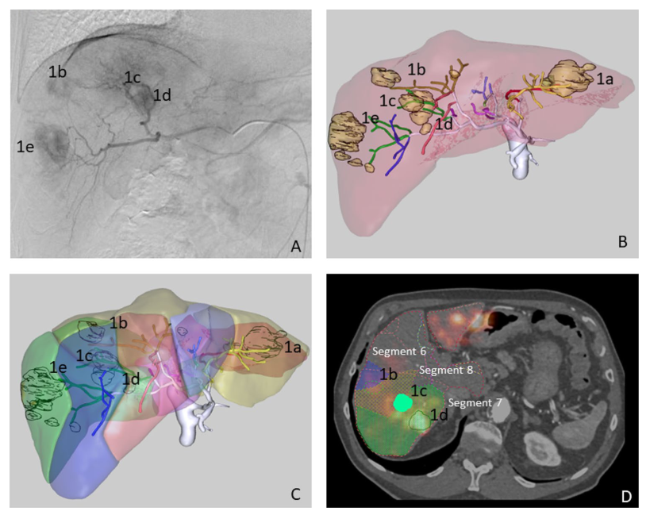
Figure 2. Patient 1. Multinodular HCC in the arteriography study ( A ). MeVis study showing arterial and liver segment territories ( B , C ) as well as tumor nodules (1a to 1e). MeVis liver segment contours imported on co-registered 90 Y PET-pCT images ( D ) showing that tumor 1b was mainly irrigated by segment 8 artery (and slightly by segment 6 artery); 1c by segment 7 and 8 segment arteries; and 1d exclusively by segment 7 artery.

Patient 2
Patient 2 had a multinodular (2 nodules) HCC with one nodule in the liver dome and another in segment 6. The calculated HPS was 5%. Anatomically normal hepatic vasculature and a partial thrombosis of the main portal vein were observed during the angiographic procedure. Microspheres were injected through segments 5–6 (0.5 GBq) and 7–8 (0.2 GBq) arteries for the total coverage of both lesions (see Fig. 3 ). A Progreat MC-PP27131 (Terumo Medical Corporation, Somerset, NJ, USA) microcatheter was used.

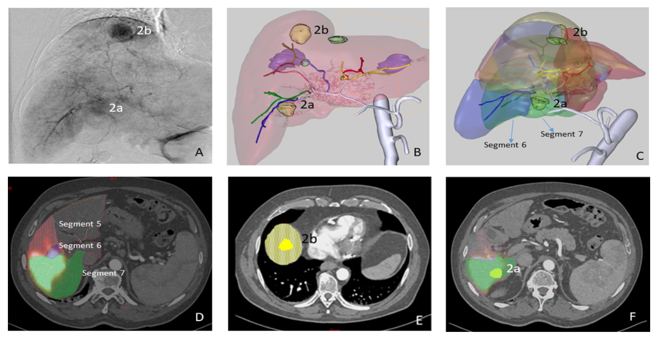
Figure 3. Patient 2. HCC with two hypervascular nodules in the arteriography study ( A ). MeVis study showing the arterial and liver segment territories ( B , C ) as well as the tumoral nodules (2a irrigated only by segment 7 artery and 2b only by segment 8 artery). Since the treatment was administered through 5–6 and 7–8 segment arteries, 90 Y-microspheres deposition was seen in segments 5, 6, 7 ( D , F ) and 8 ( E ) in the MeVis liver segmentation fused on co-registered PET-pCT images.

Patient 3
Patient 3 presented a multinodular (3 nodules) HCC, with nodules located in segments 8, 7–8 and 5–7 (see Fig. 4 ). The calculated HPS was 3.5%. No anatomical variants were observed during the angiographic procedure. In this case, a single injection (0.82 GBq) was performed through the right hepatic artery. A Progreat MC-PP27131 (Terumo Medical Corporation, Somerset, NJ, USA) microcatheter was used.

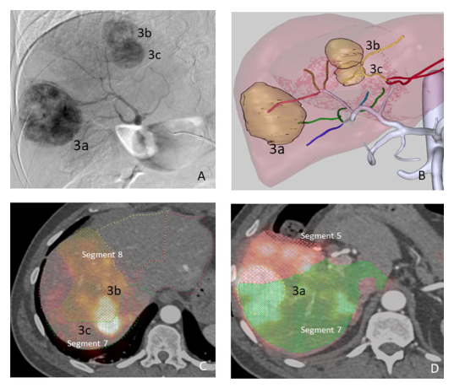
Figure 4. Patient 3. Multinodular HCC in the arteriography study ( A ). MeVis study showing arterial liver segment territories ( B ) as well as tumor nodules (3a to 3c). Using the imported MeVis liver segment contours on co-registered 90 Y PET-angioCT (E and D), it is posible to define that tumor 3b is feeded by segment 8 artery, 3C by segment 7 and 8 arteries and tumor 3a by segment 5 and 7 arteries.

Statistical analysis
Statistical analysis was performed using MedCalc Version 19.6.1. Correlation between variables was tested using the Spearman´s rank correlation coefficient (r s ). Bland–Altman bias plot was used to analyze the differences (mean) between activity distribution values (%) obtained with CFD and with 90 Y PET/CT and also between the predicted blood flow distribution and the actual activity distribution measured in 90 Y PET/CT; limits of agreement (LoA) were calculated as the mean of differences ± [1.96·standard deviation] 24 ; the 95% confidence interval of the LoA was also obtained.

Results
Figure 1 shows some the CFD details for patients 1, 2 and 3 together with an image of the computational domain and the angiography on which it is based.

Patient 1
For this patient, the percentage point difference between 90 Y PET/CT activity and CFD prediction [that is defined as |% Simulated distribution (CFD) - % Measured distribution( 90 Y PET/CT)|] was < 3 in all segments except in segment 2, which showed a difference of 6 percentage points (10.1% vs. 16.1%). The average difference between the distribution predicted by CFD and the actual distribution measured in the 90 Y PET/CT was 2.36 percentage points (Fig. 5 ). The blood flow distribution presented higher differences with the CFD simulation (5.6 percentage points) and with 90 Y PET/CT (4.16 percentage points) in the same segments.

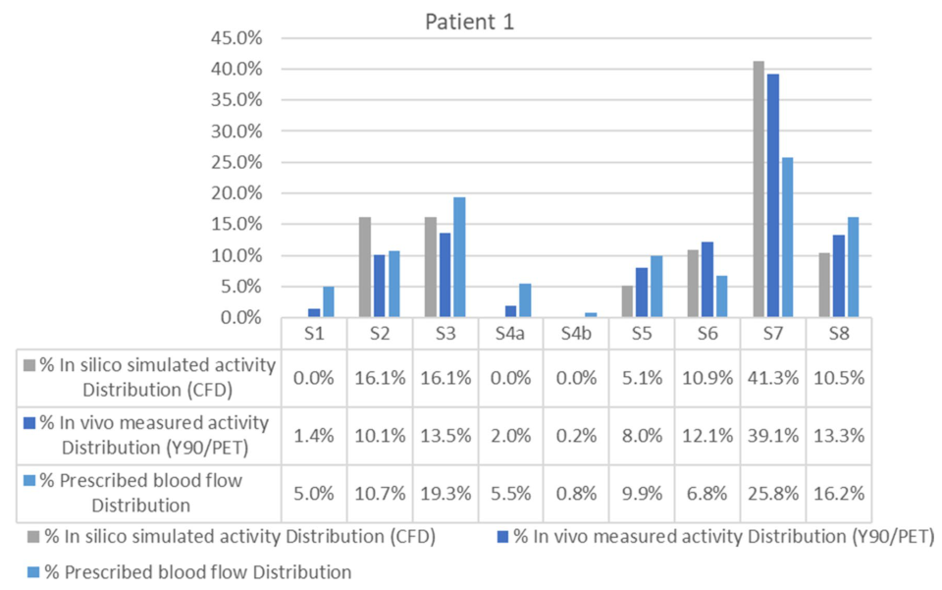
Figure 5. Segment-to-segment calculated activity distribution (CFD), measured activity distribution ( 90 Y/PET), and prescribed blood flow split for Patient 1.

Patient 2
The average difference between the activity distribution predicted by the simulation and that measured by the 90 Y PET/CT was 4.12 percentage points (Fig. 6 ).This difference was mainly due to discrepancies in one segment. The CFD model, developed according to the catheter position defined in the angiographic image captured during RE, predicted no deposition of 90 Y-microspheres in segment 5. However, the PET/CT (Fig. 3 ) showed that 90 Y-micropsheres did reach segment 5. The proximity of the catheter tip to an arterial bifurcation and the misinterpretation of the precise location of the tip may have been the cause of this discrepancy. As a consequence, the simulation was repeated after placing the microcatheter tip just before the bifurcation. The difference obtained with the new simulation was 3.51 percentage points (see position 2 in Figs. 1 and 6 ).

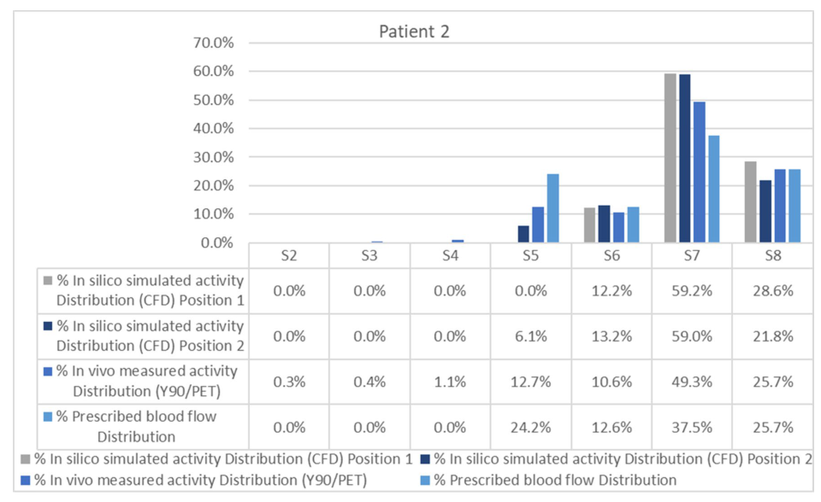
Figure 6. Segment-to-segment calculated activity distribution (CFD), measured activity distribution ( 90 Y/PET), and prescribed blood flow split for Patient 2.
In this patient the blood flow distribution showed an average difference of 3.87 percentage points with the 90 Y-microspheres deposition.

Patient 3
The average difference between the activity distribution according to the CFD simulation and that measured by the 90 Y PET/CT was 2.02 percentage points (see Fig. 7 ). In this patient, the blood flow distribution showed an average difference with 90 Y PET/CT activity of 5.4 percentage points and of 4 with CFD simulation.

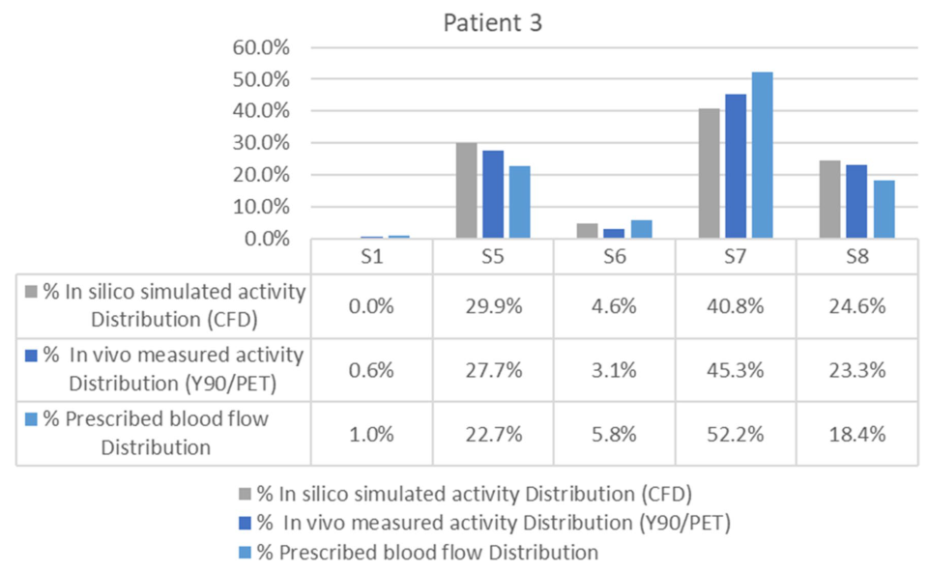
Figure 7. Segment-to-segment calculated activity distribution (CFD), measured activity distribution ( 90 Y/PET), and prescribed blood flow split for Patient 3.
Spearman´s coefficient analysis showed a strong correlation (r s = 0.951) between the activity distribution (%) predicted by CFD and that obtained with 90 Y PET/CT for all patients ( p ≤ 0.001). Likewise, the analysis of Bland–Altman plot of the 21 segments (Fig. 8 ) revealed a very good agreement between CFD and 90 Y PET/CT activity distribution (mean difference = 0.1%; LoA of the differences = − 7.1% and 7.2%; confidence intervals of the 95% LoA = − 9.9 to − 4.2% and 4.3 to 10.1%). The prescribed blood flow distribution (%) also demonstrated a strong correlation with 90 Y PET/CT activity distribution (r s = 0.96; p ≤ 0.001). Nonetheless, Bland–Altman plot analysis showed a wider LoA than for CFD and 90 Y PET/CT (mean difference = 0.1%; LoA of the differences = − 11.2% and 11.3%; confidence intervals of the 95% LoA = − 15.7 to − 6.6% and 6.8 to 15.8%).

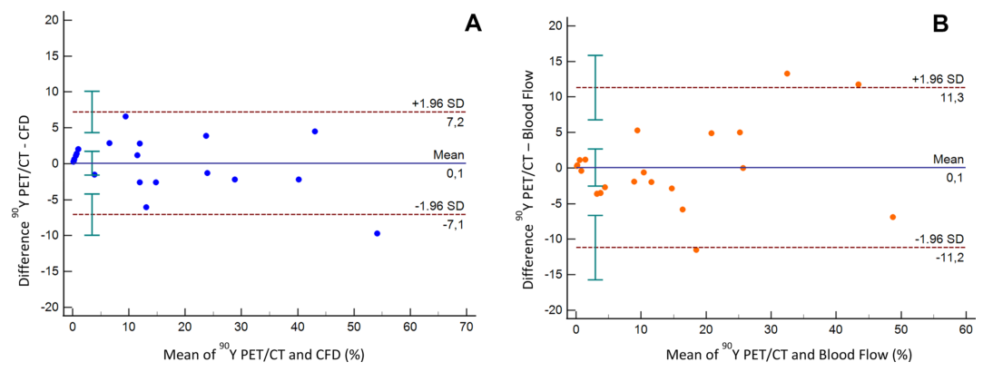
Figure 8. Bland–Altman plots for the differences in distribution in the 21 liver segments studied. ( A ) Difference between in vivo ( 90 Y PET/CT) measured activity distribution and in silico (CFD) simulated activity distribution (%). ( B ) Difference between in vivo ( 90 Y PET/CT) measured activity distribution and prescribed blood flow distribution (%). Solid blue lines indicate the mean of differences, dotted lines indicate upper and lower limits of agreement (LoA) and error bars the 95% confidence interval for both the upper and lower LoA and the mean difference.

Discussion
In this study, a patient-specific CFD model of the hemodynamics of the hepatic artery during RE has been compared with in vivo data obtained from 90 Y PET/CT post-RE. To the best of our knowledge, this kind of in vivo validation has not been reported before.
The CFD simulated segment-to-segment 90 Y-microsphere distribution was compared with the measured segment-to-segment activity distribution in 90 Y PET/CT. The results obtained in three patients and six different simulations (one for each infusion) showed a high level of agreement, with an average percentage points of 2.36 and 2.02 for two patients. One patient (Patient 2) presented a higher discrepancy, due to a misinterpretation of the exact position of the catheter tip, further aggravated by its proximity to an arterial bifurcation. As previously shown, minimal changes in the position of a catheter when it is close to an arterial bifurcation can cause dramatic changes in the results obtained by the simulation. The exact radial position is not known, and this is a limitation and a source of error. Furthermore, as happened in this case, if the artery has a curved shape proximal to the bifurcation, the microcatheter may tend to be "eccentric" and the microspheres would be released not in the center but close to the vascular wall. Although a new simulation was modeled and the agreement obtained was improved, it still showed worse results than in the other two patients. These results highlight the importance of the careful location of the catheter when it is in the proximity of a bifurcation with the aforementioned characteristics and the advisability of using curved microcatheters for a better adaptation to the shape of the artery.
An important aspect of the study refers to 90 Y-microsphere distribution per segment. Overall, both the CFD model and the prescribed blood flow results showed a good agreement with the actual distribution in 90 Y PET/CT. However, as can be seen in the segment-to-segment distribution figures and in the Bland–Altman plot, the latter was relatively different to the blood flow distribution on several occasions. This indicates that particle distribution is influenced, but not determined, by blood flow. This claim is supported by other studies in which blood flow distribution was also studied 8 , 11 , 13 . 90 Y-microsphere deposition is also affected by local parameters such as the distance between the catheter tip and an arterial bifurcation, the ratio of microsphere velocity to blood flow velocity, the type of catheter tip, and the radial position of the catheter in the artery 8 . This gives rise to two considerations. On the one hand, that all these parameters can be optimized for a better patient-specific treatment design using CFD models. The aforementioned local factors can be numerically analyzed and provide some useful information to the interventional radiologist about the most effective injection location, type of device, and injection velocity. The methodology presented here could pave the way toward personalized RE planning supported by numerical simulations from a CFD model of the patient-specific hemodynamics during RE. On the other hand, since all these local parameters are referred to as modifications in the 3D space, adoption of a 3D approach in the development of the CFD model, as used in this study, seems unquestionable. Not using a complete 3D approach or Bcs based on perfusions are the main limitations affecting some previous studies investigating the use of computational models to predict microsphere distribution after RE 25 – 27 .
In order to reduce the time spent on the simulation, only four cardiac cycles were modeled. The simulation of four cardiac cycles requires about 12 h on a 120-core workstation. This means that for the simulation of a whole RE procedure several weeks or months would be necessary. Whether microsphere distribution in the outlets of the computational domain during the first seconds of the injection is representative of the whole procedure, is an unanswered question. Moreover, this model does not take into consideration the occlusive effect that the consecutive deposition of the microspheres can have in small vessels or the possible alteration of the vascular wall by progressive handling during the procedure. Although there is indeed an occlusive effect inside the segments (outside the computational domain), it is hypothesized that the occlusive effect does not influence the blood flow along the first branches which are those included in the computational domain. It is important to state that the microsphere concentration in the vial decreases exponentially with time, meaning that most microspheres are infused during the first phase of the treatment. The occlusive effect will be present in the late stages but, at that time, most of the microspheres are already inside the segments. In this study, the focus is on the percentage of activity that goes to each segment and not in the activity distribution inside the segment. However, and in view of the results obtained, our hypothesis is not far from the reality and the simulation of just four cycles allows the final distribution of the 90 Y-microspheres to be adequately predicted.
A personalized multidisciplinary strategy for RE would allow those patients who can benefit the most from the treatment to be selected, defining the adequate indication (curative, neoadjuvant to surgical or palliative); the best strategy depending on the tumor type, lesion location and the vascular anatomy; the optimal infusion point; and the use of tailored dosimetry for an effective but safe procedure. In this setting, CFD simulations performed before the conventional planning with 99m Tc-MAA could also complement it, determining the appropriate injection characteristics to effectively direct the 90 Y-microspheres. Once this methodology has been validated, the next step would be the development of a user-friendly platform for the personalization of RE. This would only require a pCT to obtain the arterial liver segmentation and calculate segmental perfusion. With some improvements to the CFD model implemented in this study (such as removing from the computational domain the arterial branches that are not essential in determining the segment-to-segment microsphere distribution or reducing the order of the governing equations to 1D or even 0D equations in some branches), the results of the simulation could be obtained within a few hours. Nevertheless, before considering the implementation of the CFD model in RE planning, the inverse validation must be performed: to direct the injection point and velocity of 90 Y-microspheres using the CFD model simulation and to confirm that the distribution of microspheres is as expected.
This study presents a number of limitations. Firstly, it includes a small number of patients from a single institution. Nevertheless, although we believe that six 90 Y-microspheres injections and simulations provide sufficient information to validate the approach, prospective studies with a higher number of patients are warranted. Secondly, as mentioned above, the model does not consider whether a certain degree of stasis occurs during the RE procedure and the hemodynamic changes that it produces. However, stasis usually occurs at the final stages of the procedure, and by that time, a high proportion of microspheres has already been introduced. Moreover, the possible influence that the presence of the catheter or the microspheres inside the vessels can have on the precise estimation of the segment perfusion with the pCT scan, and the impact on flow obstruction induced by the catheter, were not evaluated.

Conclusion
The distribution of 90 Y-microspheres after injection into a hepatic artery is governed not only by the flow distribution but also by other 3D local factors. We have developed a 3D computational model that includes pre-treatment patient-specific data but also local factors that can affect microsphere distribution. The capability of this model to predict the 90 Y-microspheres distribution has been validated in vivo, showing that CFD models could be used to personalize RE treatments.

2 外文文献原文2
A Pore-Scale Insights into Microplastic Fiber Transport and Retention in Porous Media

Abstract
Agricultural soils have been identified as sinks for microplastic fibers (MPFs); however, little is known about their transport and behavior in these environments. This study tracked polypropylene microfibers (20-150 μm) in a microfluidic cell (dimensions) to better understand their potential movement and entrapment in soil-like porous media. The effects of MPF dimensions and elasticity on their mobility and retention were examined, along with how fiber trapping influenced the overall flow dynamics of the system. Results showed that fiber transport depends strongly on size and flexibility: fibers longer than 50 μm were highly retained, while shorter fibers followed preferential flow paths and experienced higher flow velocities. The retention mechanisms of fibers differed from those of spherical particles, and even a small number of trapped fibers were found to alter pore-scale flow patterns. In addition, several properties were identified as crucial for improving models and predictions of MPF behavior in porous systems. These findings provide insight into the dynamics of fiber entrapment and the complexities of nonspherical particle transport in porous media, emphasizing the need for further research in this field.
KEYWORDS: microfibers, microplastics, retention, transport, microfluidics, soil, porous media

Introduction
Microplastics (MPs) are prevalent in terrestrial ecosystems like agricultural fields,[1] beaches[2] and landfill refuse.[3] Agricultural soils, particularly those treated with sludge or plastic mulch films, contain exceptionally high levels of MPs, predominantly as textile fibers or film-like fragments.[4-8] These MPs can change the soil properties and may pose risks to soil health and threaten agricultural sustainability.[6] There is general evidence suggesting that MPs can move into horizons below the mixed layer,[8,9] and potentially contaminate groundwater aquifers.[10,11] However, research on particle transport in soils has largely focused on micron-sized spherical or rod-shaped particles, overlooking the behavior of longer fibers, which are the most prevalent in soils.[12,13] Unlike rods and spheres, fiber transport is strongly influenced by shear forces along their length, resulting in unique dynamics such as bending, tension to maintain inextensibility, long-range hydrodynamic interactions, and surface effects.[14-16] Thus, a true gap in current understanding remains, particularly regarding how MP fiber properties (e.g., length, radius and flexibility) govern transport and retention, and how these may impact soil properties.
The limited studies that have investigated the transport mechanisms of MPFs have used experimental soil columns, microfluidic cells, or numerical simulations. A few column studies have shown that fiber retention in soils strongly depends on fiber length, diameter, and soil characteristics like pore dimensions and pore throat size.[17] For example, Waldschläger and Schüttrumpf found that in columns packed with glass spheres (>1.5 mm) and long fibers (length >5 mm, diameter >0.5 mm) fiber diameter had a greater effect on infiltration than fiber length or density, with thinner fibers being more mobile.[17] However, their study focused on fibers larger than those typically found in the environment and their transport was examined using glass beads, which are larger than typical soil particles. A similar artificial setup was later used by Qiao et al., who visualized fiber transport in real time using transparent columns packed with hydrogel beads (7-14 mm).[18] While this approach enabled direct observation of particle motion, the millimeter-scale fibers (∼1 mm diameter, 1-4 mm length) and oversized, deformable beads are far from soil-like conditions, limiting environmental relevance and neglecting the flexibility effects that dominate the motion of micron-scale fibers. In contrast, Cohen and Radian examined the mobility of environmentally relevant MPFs in quartz sand (∼700 μm grain diameter). They observed significant retention of fibers longer than 50 μm in the sand’s top layer.[19] Although soil columns better represent natural textures, visualizing fiber transport and retention remains challenging, as extraction and polymer-specific quantification (e.g., pyrolysis-GC-MS or LC(SEC)-MS) must be performed postexperiment.[20] Consequently, while these methods enable sensitive, polymer-specific quantification at trace levels, they lack the real-time visualization required to resolve dynamic pore-scale processes.
Since the early 2000s, microfluidics has become a powerful tool for investigating microscale processes by enabling microscopic observation within transparent microfluidic cells.[21] Although these cells do not replicate real soils, they provide a means to closely study particle interactions and behaviors under controlled conditions at the microscale.[21,22] These setups enable detailed observation of fiber dynamics; such as rolling, tumbling, and more complex behaviors like bending, buckling, and coiling. These fiber dynamics are driven by the interplay between bending stiffness and hydrodynamic forces, which are difficult to capture in other experimental systems.[14,23,24] Still, only a few studies have explored MPF using microfluidics.[25-27]
Recent work by Fouty and Engdahl visualized fiber transport in a simple idealized porous media cell using 0.3 mm diameter monofilament fishing lines, which, although thicker and more rigid than typical microplastic fibers, allowed for a simpler experimental setup.[28] Dong et al. also studied fiber transport with relevant MPF in a flow cell filled with quartz sand (0.75-0.85 mm).[29] While these soil particles better represent soil pores, the relatively large cell size made it difficult to track fiber movement and manual adjustments were needed, which unintentionally influence fiber behavior and prevent velocity measurements. Thus, microfluidic data can provide valuable insight into fiber behavior, but it has not been fully analyzed or standardized. Furthermore, most studies looking at the behavior of microfibers have focused on microchannels rather than porous media.
The microfluidics studies mentioned above have identified flexibility and fiber dynamics as key parameters affecting fiber behavior. Thus, these properties have been incorporated into metrics designed to help quantify fiber dynamics. For example, Xue et al. proposed a dimensionless parameter, A_eff, to help represent the impact of fiber flexibility on its behavior by comparing the viscous force on a fiber perpendicular to the flow with its bending stiffness.[23] A higher viscous force increases the fiber’s deformability, while higher bending stiffness reduces it. This parameter is influenced by liquid viscosity, shear rate, fiber length, diameter, and Young’s modulus. The resulting parameter can help distinguish rigid fibers (A_eff < 2 × 10^2) from deformable ones.[30] Similar parameters, such as the Sperm number[31] and the elasto-viscous number[32] have also been used to describe fiber bending behavior, but variations in definitions across studies complicate comparisons and conclusions.[23,24] Additionally, A_eff assumes fibers are straight and thin in linear shear flow, overlooking factors like side-wall effects, inertia, and flow disturbances caused by the fiber, which limit its applicability in confined environments like soil.[30]
From these studies it is clear that column and microfluidic experiments alone cannot capture the full range of natural conditions or scales needed to evaluate the risks and challenges associated with MPF occurrence. Therefore, mathematical or numerical models for fiber behavior are crucial. Models enable predictions, data integration, and exploration of key parameters, helping generalize findings and apply insights effectively. However, the modeling of MPF transport in porous media is limited by the lack of specialized models and insufficient data for validation. Most general fiber dynamic models, such as the bead model and slender body theory (SBT), simplify fiber behavior and face limitations.[14] The bead model discretizes the fiber into rigid beads connected by springs and struggles to capture fiber flexibility and long-range interactions.[14] Engdahl addressed this by maintaining minimum separation between beads to prevent folding, but this oversimplifies fiber stiffness, creating unrealistic angles.[26]
Both bead and SBT models further simplify calculations by ignoring fiber-obstacle hydrodynamic interactions and attractive forces, leading to slowed fiber motion rather than full trapping, which may not accurately reflect real soil conditions. Additionally, fibers are usually assumed to be influenced by hydrodynamic forces without altering the fluid, though large fibers can disturb flow, as shown by Cappello et al.[32,33] The validity of this assumption, that the fibers are not influencing the flow field, requires experimental verification, as well as the need for a detailed pore-scale investigation outlining the various mechanisms influencing fiber fate in porous media.
In this study, we tracked the behavior of polypropylene microfibers in a microfluidic cell to examine previous findings on microfiber properties and their impact on their mobility in porous media. Additionally, we examined how fiber trapping influences the properties of the system itself such as local and overall flow field regimes. While fiber parameters such as modulus and aspect ratio are critical for the initial onset of trapping, we expected flow field changes to emerge later as clogging progressed. Experimental studies addressing both the above-mentioned aspects are scarce but essential for improving models of fiber transport in soil.

Materials and Methods

Materials
Polypropylene (PP) fibers were extracted from a N95 mask that was purchased from a local store. Polyethylene glycol (PEG-1500), Tween-80, humic acid sodium salt (HA), Ethanol (99%), and polycarbonate filters (Whatman Nuclepore Track-Etched membranes) were purchased from Sigma-Aldrich (Rehovot, Israel). Carboxylate-modified polystyrene (PS) 1.0 μm fluorescent beads (FLUOSPHERES, Catalog number: F8814, Excitation/Emission: 365/415 nm) were purchased Thermo Fisher Scientific (Waltham, MA, USA). These beads were provided at a concentration of 2% solids, equating to 4.2 × 10^10 particles/mL. The microfluidic porous structure was fabricated using polydimethylsiloxane (PDMS) with a 10:1 elastomer-to-curing agent ratio (Sylgard 184 Silicone Elastomer Kit, Dow Corning, USA). Details on the cell preparation can be found in the Supporting Information (Figure S1).

MF and Inlet Solution Preparation
PP fibers were obtained from the middle layer of an N95 face mask, which mainly comprises melt-blown fabric. The fabric is composed of directional or random PP fibers with diameter typically ranging from 1 to 3 μm.[34,35] We used the method described by Cole (2016) using Leica CM1900 cryostat (Nussloch, Germany).[36] Briefly, slices from the PP layer were embedded in tissue freezing medium (Leica) and then frozen (-80 °C). Then, the block was mounted on the cryostat using the same freezing medium and sectioned to slices of 50 μm. Since the fibers in the layer are not aligned, the resulting microfibers varied somewhat in size. The sections were cleaned and stored in water containing Tween 80 (0.001%·v/v) and 30% ethanol to achieve complete dispersion and prevented particle flotation. The surfactant concentration was on par or lower than environmentally relevant levels of natural surfactants typically found in soil pore water,[37] and zeta potential measurements under the experimental conditions confirmed that the surface charge of PP fibers was within the expected range (see Table S1). Before the microfluidic experiment the solution was sonicated using a sonication bath to ensure thorough dispersion. Neutral buoyant PS 1.0 μm fluorescent beads were added to help visualize the flow. A low concentration of 0.0007% w/v was used to avoid flow interfaces. An intermediate 0.1% (w/v) stock solution was prepared once from the 2% bead suspension and sonicated prior to dilution. This stock was stored and resonicated before each use; 35 μL were added to 5 mL of medium to obtain the final 0.0007% (w/v) concentration. We should note that this study focused on PP fibers, chosen for their low density and relatively high mobility in water-saturated porous media. As such, the results represent a conservative case for retention. Furthermore, surfactants were added to aid dispersion in the experimental system and allow better flow through the cell. This means that in natural environments we may find lower dispersibility which can reduce fiber mobility.

ATR-FTIR Analyses
Polymer type was verified using attenuated total reflectance (ATR) FTIR (Nicolet iS10 spectrometer, Thermo Fisher Scientific Inc.). Measurements were conducted over 4000-650 cm^-1 spectral range at 4 cm^-1 resolution, coadding 32 scans for each spectrum (Figure S2).

Microfluidic Cell Preparation
A microfluidic cell consisting of uniformly sized micropillars was fabricated using PDMS technique. The cell was designed as a 2D porous medium with dimensions of 4.5 mm in length, 1.3 mm in width, and 0.05 mm in depth. To introduce heterogeneity, a mold was created using photolithography and etched onto a silicon wafer. This mold defined the arrangement of 100 μm diameter pillars, placed on a square lattice with slight disorder, resulting in a normalized standard deviation (σ/R) of 0.5. The final configuration achieved a porosity of 0.57, with pore throat sizes ranging primarily from 20 to 70 μm (Figure 1). The PDMS was prepared according to the standard protocol provided by Dow Corning. Low density polyethylene (LDPE) tubing was directly inserted into the cell. The tubes had an inner diameter of 0.86 mm and outer diameter of 1.32 mm (Scientific Commodities Inc., USA; catalog number: BB31695-PE/5).
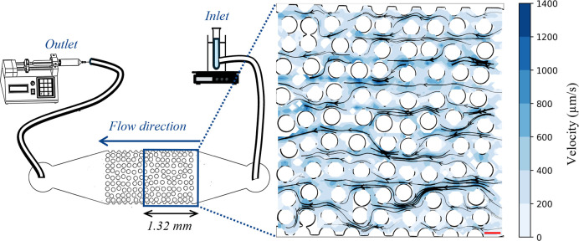
Figure 1. Schematic configuration of the microfluidic cell, using syringe pump and a magnified view of the imaged flow field. The scale bar represents 100 μm.

Experiment Setup
The microfluidic cell was connected to the inlet using a short LDPE tube leading to a glass tube with an inner diameter of 163 μm, which was directly connected to the inlet solution. The diameter of the tube was crucial to ensure a sufficient flow rate, preventing fibers from getting stuck in the inlet tube. The outlet was connected to the cell solely by an LDPE tube, as shown in Figure S1.
To avoid bubbles and particle contamination, the cell was first filled with a clean, filtered solution, then with a solution containing the fluorescent beads until a steady-state transport rate was achieved. After that a solution containing both beads and fibers was introduced. The inlet solution was continuously stirred to prevent fiber sedimentation and ensure uniform concentration throughout the experiment. The fluid was drawn using a syringe pump at a flow rate of 0.8 μL/min, producing a Darcy velocity of approximately 200 μm/s based on the cross-sectional area of the inner cell, with a Reynolds number below 0.1 (using 50 μm as the characteristic length and a peak local velocity of 1000 μm/s).[38] The median flow velocity of the PS spheres was 270 μm/s (as shown in the results section), this velocity is slightly above the typical range reported for groundwater flow in sandy or gravelly aquifers (up to ∼200 μm/s), but remains representative of fast-flowing pathways in unconsolidated porous media.[39] Using significantly lower flow rates in this horizontal setup led to particle sedimentation in the inlet tube. This flow rate ensures viscous-dominated conditions and minimizes inertial effects. The Stokes number (St ≪ 1) was also calculated to confirm that the tracer beads closely follow the fluid streamlines.[40]
Videos of the fiber flow were recorded using a confocal microscope (Nikon Eclipse Ti2-FP) and a camera (Prime Sigma BSI Express) at a frame rate of 43.7 frames per second. For convenience, the videos presented in the Supporting Information (SI) were converted to a frame rate of 24 frames per second. The images had a resolution of 2048 × 2048 pixels, with each pixel representing 0.645 μm. As a result, only a portion of the cell was imaged, as illustrated in the schematic configuration in Figure 1. Videos of the fibers and beads were recorded separately because the fibers were only visible under transmitted light (brightfield), while the beads were visible under (blue) fluorescent signal. Fibers were recorded for approximately 3 min, followed by 1 min of widefield fluorescence imaging of beads, capturing ∼2000 frames with 250-350 tracked beads. This frame count, based on previous experiments, was sufficient for flow analysis, as additional frames did not alter the results. The experiment was stopped when no more fibers were observed entering the cell (after approximately 28 min), likely due to plugging and/or aggregation of fibers in the inlet solution or tube. The experiment was repeated twice, with a total of 122 fibers examined overall.

Quality Assurance and Quality Control (QA/QC)
Experiments were conducted in a cleanroom environment with cleanroom-grade airflow and sticky mats at the entrances. Additionally, the equipment was rinsed with 50% ethanol and covered with aluminum foil to minimize airborne contamination. Sunlight was excluded by blinds and darkened windows, and MPF solutions were stored in the dark to prevent UV degradation. All solutions were freshly filtered through 0.4 μm polycarbonate filters prior to use. To ensure data reliability, each experiment was repeated to confirm consistency in fiber behavior and measurement robustness.

Data Analysis
Data analysis was performed using Python version (3.12.0), using different libraries such as OpenCV, Pandas, Numpy, Matplotlib, Seaborn, nd2reader, PIL, and Scipy. The main Python scripts used for image processing and fiber tracking, along with a list of required packages, is provided as part of the Supporting Information.

Image Processing
Images were preprocessed to optimize and facilitate further analysis: To enhance the structures of interest (beads and fibers), both the fluorescence and brightfield images were converted to binary images by applying a manually determined, constant threshold for each image type. The first image of each video was subtracted from the remaining images to remove background interfaces. The fiber images were then processed by removing isolated pixels, dilation, skeletonization, and another round of dilation to achieve a fiber diameter of approximately 1 μm.

Particle Tracking
The beads were tracked using TrackPy package (version 0.6.1),[41] which is designed for tracking blob-like features in video images, following them through time, and analyzing their trajectories. The velocities of the tracked PS beads were then averaged over a 32 × 32 pixel area to determine the flow velocity field within the imaged cell. For tracking fibers, we developed a simple Python code that identifies and tracks individual fibers based on their closed contours and length. For each image, measurements such as the fiber’s minimum bounding box, area, perimeter, and angle relative to the x-axis were extracted. The fiber’s persistence length (fully stretched length) was calculated from each image using the fiber area or perimeter, with the 0.75 quantile across all images selected to represent its length. Variations in fiber length between images may occur due to focus issues or interactions with other objects. The 0.75 quantile was chosen based on a manual examination of fiber length across the video. Images where the fiber length fell below the 0.25 interquartile range were excluded from evaluation, as these fibers were likely out of focus. Fiber velocity vectors and scalar speeds were continuously calculated along each fiber’s trajectory based on the distance and time between consecutive frames and measured as the displacement of the fiber’s bounding box center of mass. Velocity measurements were discontinued when the fiber’s center of mass stopped advancing. Fiber speeds were normalized to the average flow speed within each fiber’s minimum enclosing box, as measured in the corresponding bead video. Tortuosity was calculated as the ratio of the cumulative distance traveled to the straight-line distance between the initial and final positions of the fiber’s center of mass. Additional information regarding the minimum pore size through which fibers passed, pore sizes where fibers were stuck, flipping events, flexibility and retention mechanisms were evaluated manually.

Statistical Information
Box-and-whisker plots were used to present the full spread of data, including average, median, interquartile, and inner and outer fences (Q1/Q3 ± 1.5IQR). Differences in velocities between fibers of different length groups were statistically compared using the Mann-Whitney U test. Correlation between two parameters was assessed using Pearson’s correlation coefficient or point-biserial correlation for a continuous variable and a binary variable. Flow regimes were compared using the Wilcoxon signed-rank test. Significance was defined as p < 0.05.

Results and Discussion
To gain direct insight into how microplastic fibers move and become retained within porous structures, we developed a microfluidic system that enables real-time visualization of their transport at the pore scale (Figure S1). Polypropylene (PP) microfibers extracted from N95 face masks were used, cut to lengths representative of environmentally relevant microfibers commonly detected in soils.[3,8,42,43,44,45] This source provided a consistent and well-characterized material while still capturing key morphological features-length, aspect ratio, and flexibility-that govern fiber transport and retention in porous media.
The flow trajectories of 120 PP fibers with varying morphological properties were analyzed. The raw fiber length distribution is shown in Figure S3. The fibers were not simply linear; therefore, both their minor and major axis lengths were measured by calculating the width and length of a minimum enclosing box. Figure 2 shows the minor and major axes plotted against fiber length (fiber length is the persistence length of a fully stretched fiber), indicating whether fibers passed through or were trapped. It also includes an image of a PP fiber in its bounding box. The minor axis is generally larger than the maximum fiber diameter, while the major axis is consistently shorter than the fiber length. We would like to note the fiber size is often a key factor in transport studies and is typically described by length (L) and diameter (D).[19,46,47] Some studies combine these dimensions using metrics like the equivalent diameter (∼ $\sqrt[3]{D^{2}L}$),[17] however, such measures can be unreliable for predicting transport of nonspherical particles, particularly when dealing with nonaxisymmetric fibers, which are commonly found in weathered environmental samples.[45,48,49] To address the fact that fibers do not have axis symmetry, shape parameters like aspect ratio, straightness, curliness, and curvature are used.[50,51] The aspect ratio is calculated as the length-to-width ratio of the enclosing box, while straightness and curliness are based on the longest dimension and the geodesic length (fully stretched length, L).[50,51] Curvature is defined as the inverse of the radius of a circle through three consecutive segments, with the average curvature computed along the fiber’s length.[24] However, these parameters do not explicitly account for the smallest dimension (width), which is crucial for understanding fiber movement through pores. In this study, we chose to define fiber size using both length (fully stretched) and minor axis dimensions.
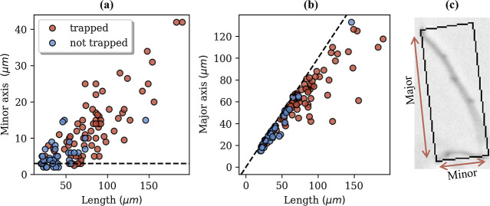
Figure 2. Correlation between fiber length and geometric axes. (a) Minor axis (R ^2 = 0.67) and (b) major axis (R ^2 = 0.83) plotted against fiber length for trapped (red) and nontrapped (blue) fibers. In (a), the dashed line indicates 3 μm as the minimum minor axis threshold, while in (b), the dashed line represents a 1:1 ratio between the major axis and fiber full length. (c) Representative image of a fiber enclosed in a minimum bounding box, with arrows indicating the minor and major axes.
The results show that, based on Pearson’s correlation coefficient, the major axis had a stronger correlation with fiber length (and behavior) than the minor axis (R ^2 = 0.83 vs 0.67). Additionally, fibers longer than 50 μm with a minor axis greater than 10 μm were significantly retained in the cell (Figure 2, Table S2). Overall, this aligns with our results from our previous study,[19] where we observed that polyester and nylon fibers longer than 50 μm were highly retained in sand.[52]

Microfiber Speed and Trajectory within the Cell
To compare fiber behavior within the microfluidic cell, fiber velocities were normalized to the average flow speed within each fiber’s minimum enclosing box. Flow velocity fields were measured by tracking 1 μm neutrally buoyant tracer particles and spatially averaging over 20 × 20 μm regions, corresponding to the minimal pore size. In Figure 3a, fibers were divided into three groups based on their lengths because fibers longer than 50 μm exhibited markedly lower mobility than shorter ones, and almost no fibers longer than 80 μm traversed the entire cell. Statistical analysis showed no significant difference (p > 0.05, Table S3) between the velocities of short and long fibers that became trapped. In contrast, mobile fibers moved significantly faster than trapped ones, and smaller mobile fibers exhibited higher relative velocities on average (p < 0.05, Tables S3 and S4), likely due to reduced wall friction.[53] In several cases, fiber speeds even exceeded the average local flow speed (relative velocity >1), which may reflect the spatial averaging method used for flow estimation. The averaging methods applied may explain the relatively high flow velocity of the fibers. However, even when fiber velocity was compared to the maximum local speed within the enclosing box, it remained higher. This observation is consistent with a particle flow enhancement effect, in which larger objects are transported faster than passive tracers or smaller particles.[54]
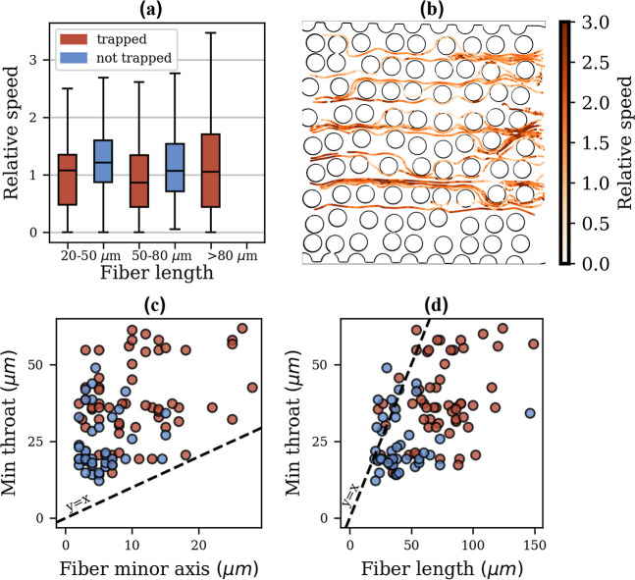
Figure 3. (a) Relative speeds of fibers normalized to the average local flow velocity, categorized by fiber length (20-50 μm, 50-80 μm, >80 μm). A significant reduction in mobility was observed for fibers longer than 50 μm, with almost no fibers longer than 80 μm able to traverse the cell. Boxplots show trapped (red) and nontrapped (blue) fibers. (b) Trajectories of 45 fibers categorized by their relative speed. (c) Minimum pore throat size traversed by each fiber plotted against its minor axis, and (d) against its length, with fibers categorized as trapped (red) or nontrapped (blue).
Size (steric) exclusion also influenced fiber motion.[54] Larger fibers were unable to enter narrower pores and therefore followed preferential, higher-velocity pathways, while smaller fibers and tracer particles explored multiple flow channels, producing complex and tortuous trajectories. Correspondingly, tracer particles-representing local flowlines-showed significantly greater tortuosity than fibers (p < 0.05, Figure S4).
Video S1 further illustrates these effects: both long and short fibers initially follow a similar flow path, but as they approach the porous surface, their behaviors diverge. The longer fiber spans regions of different flow velocities, experiencing a stronger velocity gradient (shear rate) along its length. This differential drag causes it to flip and maintain its speed more effectively, whereas the shorter fiber, moving closer to the slower near-wall zone, decelerated. Consistent with this, fiber trajectories generally avoid slower regions near the walls (Figure 3b) and tend to sample higher-velocity streamlines. Interestingly, fibers entering at similar positions do not always follow identical paths or end up in the same locations, reflecting stochastic variability and gradual accumulation effects discussed in the section Impact of fiber trapping on the flow regime.
Similar effects have been observed with spherical particles in porous microfluidic systems.[55,56] In porous media, trajectories depend on microscopic factors like local geometry,[57] particle position,[58] and flow patterns,[59] which are also affected by the positions of other particles.[60] De Vries et al. demonstrated that even particles with similar paths can exhibit different attachment behaviors and flow velocities along their trajectories.[61] Sirivithayapakorn and Keller found that size or steric exclusion occurs when the ratio of pore throat to particle diameter is at least 1.5 for spherical particles (3-20 μm pore throats to 0.05-3 μm particles), with measured colloid velocities reaching 4-5.5 times the estimated pore water velocities.[56] Here, the smallest ratio between pore throat and minor axis size was 1.1 - slightly below the threshold observed for spherical particles - while fiber velocities were up to three times faster than estimated pore water velocities.
The fibers were not observed passing through pore throats smaller than their minor axis; however, fibers could traverse pore throats narrower than their lengths (Figure 3c,d), with the smallest observed pore throat-to-length ratio being 0.2. This finding is derived from the current experiments, which included smaller pore throat sizes than those previously examined, thereby extending the observed range of fiber-pore interactions beyond that reported in earlier studies. Engdahl used numerical simulations to predict microfiber mobility in saturated porous media, and found that fiber retardation depended on the length-to-average-pore-throat ratio.[26] In contrast to our findings, his model predicted only retardation, but no actual retention, for fibers longer than the pore throat, with maximum retardation of 1.3 relative to fibers equal in length to the pore throat. However, his study did not account for fiber diameter, nor did it consider ratios below 0.625 (longer fibers).[26] Furthermore, fibers in his simulations tended to fold more extensively than the PP fibers due to the assumptions of the bead model, which oversimplifies stiffness and flexibility. Still, in line with Engdahl’s results, we found that fibers equal in length to the pore throat showed no additional retardation compared to a conservative tracer. Yet, we occasionally observed retention of very short fibers (<50-60 μm) in pores larger than their length, likely due to accumulation effects, as further elaborated in the section on microfiber retention patterns.

Impact of Fiber Dynamics on Their Trajectories
Fiber dynamics (such as flipping, rolling or tumbling) play a crucial role in allowing fibers to escape low-flow regions, which in turn influences their mobility (Figure 4). Flipping behavior is influenced by fiber flexibility and flow conditions, with rigid fibers typically showing rolling (rotation along their axis) and tumbling (end-overend rotation), while flexible fibers exhibit bending, buckling, and more complex dynamics.[14] Fiber tumbling and bending were strongly influenced by fiber length (Figure 4a,b) - meaning shorter fibers had a higher tendency to tumble flip, and bend (though not all bending events led to flipping, Figure 4c). Rolling was also observed but was more challenging to detect unless the fibers were highly nonaxisymmetric (Figure 4c). Most mobile fibers, particularly those longer than 50 μm, exhibited flipping, whereas trapped fibers rarely flipped or bent (Figure 4d). Notably, the minor axis of the fiber remained consistent throughout most of its trajectory (data not shown). This indicates that while fibers are generally flexible, their overall structure remains relatively stable under the tested flow conditions.
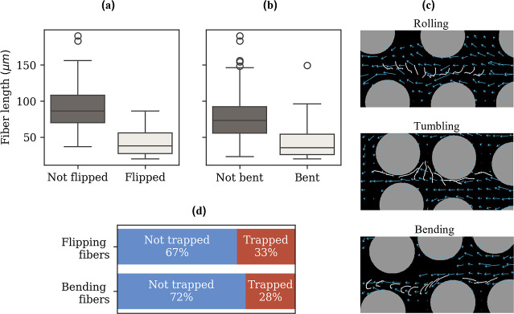
Figure 4. Box plots of (a) fiber length for flipped vs nonflipped fibers and (b) fiber length for bent vs nonbent fibers. Statistical differences were assessed using point-biserial correlation between fiber length (continuous variable) and flipping or bending behavior (binary variable). (c) Trajectories of fibers exhibiting rolling, tumbling, or bending. The trajectories are overlaid on the flow field derived from the preceding bead-tracking video. (d) Distribution of fibers based on flipping and bending behaviors categorized into trapped and not trapped fibers.
Similar flipping behavior has been observed in microchannels; Stowicka et al. noted that fibers tumbled and migrated toward the channel center, while those aligned along the channel’s symmetry line retained their orientation as they flowed.[27] These findings are consistent with our observations that fibers primarily flip when entering low-velocity regions. Nagel et al. found that fibers move faster when oriented perpendicular to the flow, causing them to drift when not aligned.[53] This could explain the higher velocity of shorter fibers that flip in the current cell. Still, the perpendicular orientation is not stable, and fibers eventually align with the flow direction.[32,53] More recently, Dong et al. observed that fibers in a quartz sand-filled cell exhibit sliding, tumbling, and saltating when in contact with the sand surface, though they did not provide statistical data on these motions.[29]
Another intriguing phenomenon in our study was the bending behavior of the fibers. As outlined in the introduction, Xue et al. (2022) introduced a dimensionless parameter A_eff to quantify fiber flexibility in flow.[23] Assuming water viscosity, we calculated a maximum shear rate of 100 s^-1 for our setup. Given a fiber diameter of 1 μm, and Young’s modulus of 1.5 GPa,[62] A_eff is calculated as 1.4 × 10^-13·L^4. According to their study, fibers with this low a A_eff should behave like rigid objects in flow, which is not what we observed. The observed differences may be due to the experimental setup resulting in significant differences such as confined flow, where fibers align with the flow, and are not perpendicular to the flow at low A_eff. The PP fibers used were also curved to begin with (Figure 2c), with surface pits and nodes likely acting as structural weak points, enhancing flexibility.[30] Curved fibers may disrupt flow lines and exhibit behaviors distinct from straight fibers.[30] Furthermore, the Young’s modulus of plastics, typically >1 GPa, can be reduced by manufacturing defects or aging.[63,64] Confinement effects may also play a role, Cappello et al. for example, found that confined flow increases fiber deformation, especially when fibers are perpendicular to the flow.[32] Using local slender body theory, Chakrabarti et al. showed that porous media flows allow fibers to deform and bend, enabling more complex motions than microchannels, even in weak flows.[65] Similarly, Fouty and Engdahl[28] reported behavior resembling the observations in this study: MPFs alternated between brief tumbling or rolling and smooth motion, deforming slightly when navigating constrictions, particularly when misaligned with the flow.[28] These findings highlight the complex interplay between fiber flexibility, flow conditions, and confinement effects in determining fiber mobility and dynamics. Furthermore, the ability of fibers to flip, roll, and deform influences their transport behavior, demonstrating the critical role of fiber structure and flow alignment in governing movement through constricted environments.

Microfiber Retention Patterns
We identified several mechanisms of fiber-retention in the porous cell (Figure 5). These include fibers initially attaching to one edge of a pillar and then flipping to the other edge before becoming stuck, accounting for 46% of the examined fibers. Additionally, 39% of the fibers were trapped by colliding with fibers that were already trapped. Another observed mechanism, known as inertial impaction, involved 7% of the fibers crashing into a pillar with their front minor axis and then becoming stuck. Furthermore, 5% of the fibers attached to a pillar while moving parallel and adjacent to it, this mechanism is known as interception. Finally, 4% of the fibers wrapped around a pillar before becoming stuck.
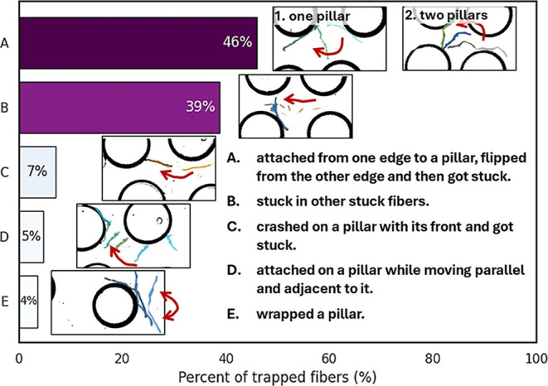
Figure 5. Retention mechanisms of microfibers in the cell.
Chakrabarti et al. previously identified two main transport modes: trapping, where fibers wrap around obstacles, and gliding, where fibers slide past them. Gliding can transition to squeezing in dense pores.[65] In our experiment, we observed minimal retention caused by trapping around a pillar (category E, Figure 5), and occasional trapping during gliding over a pillar (category D, Figure 5). No squeezing mode was observed, likely due to fibers flowing through wide pores with limited flexibility. Dong et al. observed fibers retained in quartz sand-filled porous media through deposition on sand surfaces or clogging in pore throats, though they did not provide statistical details on these mechanisms.[29] In our study, with horizontal flow, deposition due to gravity was not a factor, but clogging emerged as a primary retention mechanism.
Herein, most fibers were trapped in pore throats smaller than their length (Figure S5), with most trapped fibers falling below the 1:1 ratio line between pore throat size and fiber length. The exceptions were fibers shorter than 50-60 μm, which were trapped in pores larger than their length, potentially due to an accumulation effect (Figure S5). In contrast, the largest ratio of throat size to fiber minor axis was less than 18, suggesting that if the fiber’s minor axis is less than 0.05 the size of the pore throat, it will likely pass through.

Two-Way Coupling Effects
Most studies assume that particles are dispersed and primarily influenced by hydrodynamic forces, with minimal effect on fluid motion or other particles, this is referred to as one-way coupling. At higher particle concentrations or for larger particles, particle motion can influence fluid streamlines, known as two-way coupling.[66] Additionally, interparticle interactions, where particles affect each other, have been experimentally observed. For example, a particle trapped in a pore can be released when another particle passes nearby.[67] Cappello et al. demonstrated that a perpendicular rigid fiber causes flow disturbance, creating a nonhomogeneous pressure distribution along its length.[32] In our experiment, we observed that a fiber passing near a trapped fiber could cause it to be released suggesting a more complex affect (see Video S2). Although Video S2 also shows a shorter fiber overtaking a longer one, this does not contradict the behavior observed in Video S1-the former results from fiber-length-dependent velocity differences, while the latter reflects variability in the flow paths sampled by individual fibers. Despite the relevance of these interactions in real porous media, to date, research on this topic remains limited, thus we suggest that further studies should address this phenomenon.

Impact of Fiber Trapping on the Flow Regime
One of the main goals of the study was to understand how the addition of fibers to porous media changes the overall flow of the system. For this, the velocity in the cell was tracked as a function of trapped fibers (Figure 6). More than half of the fibers (55%) were retained perpendicular to the main flow direction (x-axis), 7% were retained perpendicular to the minor flow direction (y-axis), and 38% were retained parallel to the flow direction. Previous studies have shown that accumulation in high-velocity regions can lead to flux reduction, pressure redistribution, and flow diversion,[57] suggesting that fibers trapped perpendicular to the flow may influence the flow regime. The flow velocity and tortuosity histograms indicate that as the number of fibers trapped in the cell increased, significant changes occurred in the flow field (Figure 6). Using Wilcoxon test, there is a significant difference (p_val < 0.05) between time 0 and other time points, and between each adjacent time (Table S5). This increase in the number of retained fibers overall led to a gradual decrease in the mean and variance of tortuosity, suggesting that fiber accumulation constrains the flow to fewer, more direct paths within the pore network.
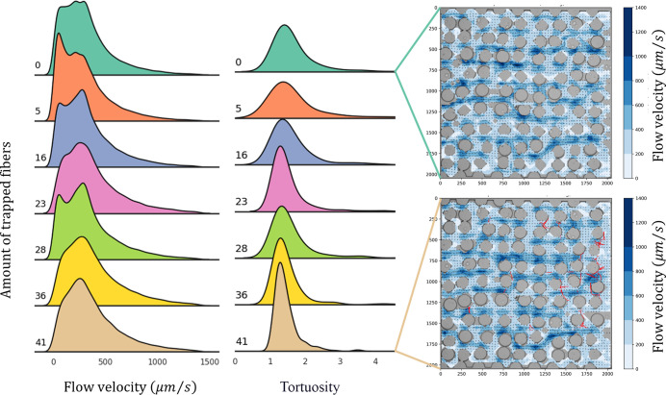
Figure 6. Histograms of flow speed and tortuosity, and flow speed contour plots, shown as a function of the number of retained fibers. Statistical values corresponding to these results are provided in Table S5.
Specifically, depending on how and where the fibers became trapped, they either increased or decreased the local speed, thereby influencing the entire velocity field within the cell. Endo Kokubun et al. demonstrated through numerical simulation that particle accumulation in high-velocity regions of porous media led to flux reduction, pressure redistribution, and flow diversion.[57] However, they also found that particle accumulation in low-velocity areas, not aligned with the flow, had minimal impact on the flow regime.[57] This may explain the varying effects on velocity, with some pores experiencing increased velocity while others - a decrease. Retained particles can alter flow by accumulating and increasing deposition opportunities, leading to localized clogging that reduces permeability more effectively than uniform clogging.[22,40,59] We observed similar accumulation of fibers in adjacent pores.
It is difficult to predict what this means on a larger scale. Assessing these effects in column experiments, for example, is challenging, often requiring high microfiber concentrations. de Souza Machado et al. found that soils with over 0.1%·w/w polyester fibers had larger soil clumps, decreased water-stable aggregates, higher water holding capacity, and lower bulk density.[68] Han et al. (2022) observed that adding 0.06%·w/w polyester fibers to a sand column increased effective porosity and nanoparticle transport.[69] However, environmental microfiber concentrations in agricultural areas are typically less than 0.00001%·w/w.[45,70] Therefore, although significant pore-scale changes were detected in our study, these effects may be difficult to translate to macro-scale impacts at the typical environmental microfiber concentrations found in soils.

Environmental Implications
In this research, the behavior of PP fibers in a porous media was studied. Our results demonstrate that fiber transport is highly dependent on size and flexibility; In the microfluidic cell used, fibers longer than 50 μm were highly retained, while shorter microfibers followed preferential routes and were exposed to high flow velocities in the porous media. The fiber retention mechanisms differed from those of spheres, and fiber diameter and shape were identified as important features that need to be further investigated.
To date, most studies have focused on spherical particles, and studies examining fiber movement have primarily relied on numerical simulations, often employing oversimplified and unrealistic initial or boundary conditions, such as stiff or flexible fibers having an initial straight configuration.[26,27] The results of this work highlight two main properties that need to be incorporated into future models: The first is the definition of size (length vs width); fibers found in the environment have an initial configuration that is usually nonlinear,[45,48,49] which complicates mass-center based calculations. The second is that the fibers’ initial orientation is not always aligned with the flow,[26,27] and that the initial orientation affects their rotational motion and dynamics, which in turn impacts their mobility.[25]
Beyond the transport dynamics of MP fibers, our findings reveal that their retention can significantly alter local velocity fields by reducing flow heterogeneity and clogging critical bottleneck pores. These microscale disruptions may scale up to affect soil permeability, water retention, and nutrient distribution - processes essential for sustaining microbial communities and plant health. Preferential flow paths, which play a key role in delivering water, solutes, and nutrients, may evolve or collapse because of these structural changes. Over time, such alterations could affect soil function, crop productivity, and water quality, highlighting the broader environmental and agricultural consequences of microfiber accumulation in soil systems.
Still, it is important to emphasize that the goal of this work was not to reproduce the full complexity of soils, but rather to isolate and examine the fundamental mechanisms governing fiber mobility and clogging at the pore scale. Natural soils contain a wide range of mineral types, grain sizes, organic matter content, and surface chemistries, all of which can affect particle behavior. The microfluidic platform used provides valuable pore-scale insight into microfiber transport and retention, yet it represents a simplified (and idealized) system that diverges from natural soils in several ways: it is two-dimensional (2D) rather than three-dimensional (3D), it is conducted under horizontal flow where gravitational settling is negligible, and the experiments were performed in low-ionic-strength conditions. Although the 2D geometry limits flow variability,[71] the observed fiber tumbling, flipping, and bending mechanisms are general and primarily governed by pore-scale heterogeneity, which similarly controls transport behavior in both 2D and 3D porous media.[72,73] Thus, fiber deformation and rotation mechanisms are expected to occur in both 2D and 3D environments, with variations primarily in magnitude rather than nature due to differing degrees of heterogeneity. In terms of solution chemistry, for plastic fibers with low surface charge and cation exchange capacity, ionic strength is expected to play a minor role in governing mobility and retention at the tens-of-micron scale, as hydrodynamic and geometric factors dominate.[74-76] However, salt concentrations may still exert indirect effects through interactions with organic matter, mineral coatings, or biofilms in natural systems. Lastly, the polypropylene fibers used here provided a consistent, well-defined model system that allowed isolation of key hydrodynamic mechanisms. However, environmentally weathered fibers may differ in flexibility, surface chemistry, and morphology, potentially influencing their retention behavior. Thus, the findings presented here should be viewed as a necessary first step, illustrating how individual fibers behave under pore-scale flow and how their trapping can alter local flow regimes. Future work will extend this approach to include other microplastic shapes, such as weathered fibers and films, and will include experiments under environmentally relevant conditions that better imitate natural soil variability. Future work should also aim to integrate these microscale observations with larger-scale models to assess the robustness of the observed trends and better predict microfiber fate in the terrestrial environment.

3 外文文献翻译1
个体化放射栓塞计算流体动力学模型体内验证的概念验证研究

使用钇-90（90Y）微球的放射栓塞（RE）是一种用于肝癌患者的经导管动脉内治疗，可以用计算方法建模。本工作的目的是使用体内数据对这种方法获得的结果进行关联验证，以便这种计算工具可以用于 RE 操作的优化。使用一种商用计算流体动力学（CFD）软件包，对 3 例肝细胞癌患者中的 6 次 负载 90Y 的微球输注，在 RE 期间的肝动脉三维（3D）血流动力学和微球分布进行了建模。该模型基于预治疗阶段获取的体内数据建立。仿真的结果与由 90Y PET/CT 评估的体内分布进行了比较。具体而言，预测的微球分布使用一种商用 3D 体素剂量学软件（PLANET Dose，DOSIsoft），与每个肝段的实际 90Y 活度进行了比较。基于 CFD 的活度分布与基于 PET/CT 的活度分布之间的平均差异，患者 1 为 2.36 个百分点，患者 2 为 3.51 个百分点，患者 3 为 2.02 个百分点。这些结果提示，CFD 仿真可能有助于预测 RE 后 90Y 微球分布，并且可以用于在患者特异性基础上优化 RE 操作。

引言
使用钇-90（90Y）微球的放射栓塞（RE）是一种经导管动脉内治疗，它已经成为原发性或继发性肝癌患者的一种安全且有效的治疗选择，例如肝细胞癌（HCC）[1]。RE 包括动脉内输注 负载 90Y 的微球，这些微球被输送到肿瘤床，在那里它们发射杀伤肿瘤剂量的辐射[2]。目前，RE 操作的模拟是通过动脉内给予 99mTc-标记大聚合白蛋白（99mTc-MAA）进行的，其假设是 99mTc-MAA 和 90Y 微球的分布相似。然而，系统误差（例如导管位置、注射技术的差异）或两种操作期间的血流动力学变化，可能导致 99mTc-MAA 和 90Y 微球分布之间相关性差[3]。已有一些体外研究，在这些研究中，几种类型颗粒的密度、流动动力学和栓塞效应得到了实验分析[4–6]。
使用计算流体动力学（CFD）进行血流动力学和微球输运的三维（3D）仿真，已经被设计用于改进 RE。这些计算机模拟（在计算机上执行的仿真）可以预测某一空间区域，或计算域中，流体的流动模式和一些颗粒（在此情况下为微球）的轨迹随时间的变化。这种计算机模拟方法已经使用一个广义肝动脉的缩放模型通过实验成功评价[7]。许多基于 CFD 模型的研究已经分析了局部 3D 参数改变（例如，导管类型、导管尖端位置、微球输注速度等）对微球最终分布的影响[8–14]。这些信息可能有助于增强抗肿瘤疗效，并最大限度减少非靶组织受照射导致的并发症。这些仿真也可以通过在标准场景中定义理想注射速度和导管放置，来补充使用 99mTc-MAA 的常规规划。如果 CFD 模型提供的信息可以为个体患者计算，它将能够促进更高效和个体化 RE 操作的发展。然而，来自 CFD 仿真的结果尚未与真实患者中的实际微球分布进行比较，以评估该模型在多大程度上代表 RE 期间实际肝动脉血流动力学。
在 RE 中，90Y PET/CT 通常用于评估微球分布。该成像方式已经显示为一种可靠工具，用于评估活度沉积[15]，准确量化递送的总活度[16]，并估计吸收剂量[17]。
本研究的目的是评估个体化 CFD 模型预测在每名患者 RE 操作后进行的 90Y PET/CT 检查中观察到的微球分布的能力。计算仿真研究预测将到达由注入 90Y 微球的动脉灌注的肝脏的平均活度（90Y 微球数量的估计），与 RE 后 90Y PET/CT 检查中获得的实际平均活度进行了比较。

材料与方法
纳瓦拉大学伦理委员会批准了本研究的方案（186/2018），并且该研究按照 1964 年《赫尔辛基宣言》及所有后续修订所规定的伦理标准进行。每名患者均签署了知情同意书。
患者特异性模型开发
RE 流程
所有患者在 RE 操作前均接受第三代双源 CT（SOMATOM Force，Siemens Healthineers，德国 Forchheim）上扫描。为分析肝脏动脉灌注[18,19]，随时间对肝脏体积进行连续 CT 扫描。灌注 CT（pCT）包括一幅增强前图像，随后是在静脉给予碘造影剂期间和之后的动态图像采集。pCT 还使用一种自动肝脏分割软件包（MeVis Medical Solutions AG，德国 Bremen），用于患者特异性肝脏三维几何结构（即，肿瘤和非肿瘤体积、肝动脉、门静脉和肝静脉以及相应区域）。此外，动态 CT 图像在配备商用 CT 灌注软件（“CT Body Perfusion”，Syngo.via，Siemens Healthineers，德国 Erlangen）的外部工作站上处理，以获得供应每个肝段肿瘤组织和健康组织[20]的动脉血流量，这是建立计算仿真所需要的参数。
在经肝胆多学科团队（MDT）评估为 RE 候选者之后，在同一天，所有患者接受了规划和治疗，如 Ezponda 等[21]所述。在 RE 操作期间，给予 SIR-Spheres 树脂微球（Sirtex Medical Europe Gmbh，德国 Bonn），并且前瞻性收集了一些与 90Y 微球输注相关的参数，例如导管的精确位置、注射速度和输注体积。导管的准确位置在 RE 操作期间采集的平面血管造影图像中捕获，随后在实施治疗的介入放射科医生帮助下，在 3D MeVis 图像中目视定位。注射速度从 RE 操作的视频记录中获得，同时也考虑注射器和微导管的几何信息。总体积是 RE 期间输注的 SIR-Spheres 输送瓶（V-vial）和 5% 葡萄糖溶液体积之和。
RE 治疗后的次日早晨，使用 Biograph mCT-TrueV（Siemens Healthineers，德国 Erlangen）进行了以肝脏区域为中心的 90Y PET/CT 扫描（两个床位，10 分钟/床位）。用于 90Y 的重建方案此前已经被优化[16]。

仿真方法
如前所述，对于所研究的 3D 几何结构，CFD 模型可预测任一点的流体流动压力、速度和微球轨迹，既包括时间上的，也包括空间上的（计算域）。CFD 模型基于三个主要组成部分：（1）计算域，（2）边界条件（BCs）和（3）控制流体流动现象的方程。（1）计算域是被分析的肝动脉树的一部分（一条动脉连续分支，形成树状结构）。在本研究中，这包括从导管所在的肝动脉到亚肝段分支。计算域的动脉边界的定义被称为动脉树截断。该截断生成域的动脉入口和出口。为了建立计算域，使用了包含几何域（肝动脉）的 MeVis 肝脏分割计算机辅助设计（CAD）文件。该肝脏分割研究还提供了不同肝段的血管供应及其体积数据（健康组织和肿瘤组织两者）。导管位置也使用 SpaceClaim（ANSYS Inc.，Canonsburg，PA，USA）被包括在计算模型中（见图 1）。（2）BCs 指计算域内部和外部的血流动力学条件的耦合。因此，有一个动脉入口和几个域出口，每个出口供应一个不同的肝段。理想情况下，BC 应该在体内测量。然而，最常见的方法是对计算域外部的流动循环建模[10]。对于该模型，需要以下参数：（a）每个肝段中健康和肿瘤组织的体积（ml）；（b）每个肝段中健康和肿瘤组织的动脉灌注（ml/min/ml）；以及（c）计算域每个出口所灌注的肝段，如文献[22]中详细解释。在本研究中，（a）和（c）从 MeVis 肝脏分割获得。为了定义（b），使用了所开发的以下方程[22]：
(1)$q_{s} = V_{0,s} k_{1,s}^{*} + V_{c,s} k_{2,s}, ∀ s ∈ \{S_{1}, …, S_{8}\}$
其中，q_s 是供应肝段 s 的动脉血流量（ml/min），V_0,s 是肝段 s 中包含的正常组织体积，V_c,s 是肝段 s 中包含的肿瘤组织体积（ml）（见表 1），并且 k*_1,s 和 k_2,s 分别是正常和肿瘤组织动脉灌注，两者均特异于肝段 s（ml/min/ml）。这两种灌注（k*_1,s 和 k_2,s）是在 pCT 研究中计算的。S1 至 S8 对应于第 1 肝段至第 8 肝段。


图 1 血管造影中微导管的可视化，尖端位置由红色十字指示（左），以及 CAD 模型中微导管的可视化（右），分别用于（a）患者 1，（b）患者 2 和第 7 段肿瘤注射，（c）患者 2 和第 8 段肿瘤注射，以及（d）患者 3。对于每个病例，显示了 CFD 仿真结果的一个细节，形式为按速度大小着色的流动流线，同时显示动脉腔横截面中的微导管尖端位置。
表 1 三例患者中每例的肿瘤和健康体积分布。
患者 | 肝段 | 肿瘤体积（ml） | 健康体积（ml）
患者 1 | 第 1 肝段 | 0.0 | 62.0
 | 第 2 肝段 | 0.8 | 127.2
 | 第 3 肝段 | 10.8 | 170.2
 | 第 4a 肝段 | 0.0 | 73.0
 | 第 4b 肝段 | 0.0 | 11.0
 | 第 5 肝段 | 0.0 | 124.0
 | 第 6 肝段 | 0.0 | 169.0
 | 第 7 肝段 | 23.4 | 349.6
 | 第 8 肝段 | 4.0 | 200.0
患者 2 | 第 1 肝段 | 0.0 | 0.0
 | 第 2 肝段 | 0.0 | 119.7
 | 第 3 肝段 | 0.0 | 213.6
 | 第 4 肝段 | 0.0 | 70.0
 | 第 5 肝段 | 0.0 | 130.7
 | 第 6 肝段 | 0.0 | 119.0
 | 第 7 肝段 | 2.5 | 327.3
 | 第 8 肝段 | 4.5 | 156.8
患者 3 | 第 1 肝段 | 0.0 | 16.0
 | 第 2 肝段 | 0.0 | 204.0
 | 第 3 肝段 | 0.0 | 188.0
 | 第 4 肝段 | 0.0 | 0.0
 | 第 5 肝段 | 30.7 | 122.3
 | 第 6 肝段 | 0.0 | 82.0
 | 第 7 肝段 | 38.1 | 389.9
 | 第 8 肝段 | 10.2 | 219.8
根据灌注同一肝段的出口数量，随后将该肝段中包含的健康和肿瘤组织体积分配给每个出口灌注的部分。在向每个出口分配健康体积时，我们假定所有出口将在该肝段内灌注相同数量的健康组织，这意味着一个出口灌注的健康体积将是总健康体积除以灌注该肝段的出口数量。对于肿瘤体积分配，我们采用一个人工流程，在该流程中，我们考虑肿瘤相对位置与每个出口的接近程度，然后确定肿瘤体积是否由出口同等灌注。
离开每个出口的血流量是分配给该出口的肝段健康体积乘以该肝段的健康灌注，加上分配给该出口的肿瘤体积乘以该肝段的肿瘤灌注。如果一个肿瘤包含在 x 个肝段中，我们将其视为包含在这 x 个肝段中每一个肝段内的 x 个肿瘤。
入口处的 BC 由动脉血流量定义，该动脉血流量是所有出口动脉血流量的总和。微导管入口处的边界条件由其注射速度定义，该注射速度从每名患者的 RE 操作视频记录中获得。在这种建模方法中，为了减少花费的时间，仅仿真四个心动周期。90Y 微球在第一个心动周期期间注入，并且额外建模三个心动周期，以确保大多数注入的微球离开计算域。该方法假定在这段时间期间计算域出口处的肝段间微球分布能够代表整个操作过程。利用仿真结果，计算肝段间微球分布（考虑肝段内效应超出了该模型的范围）。
一旦几何结构和 BCs 已知，为了获得流体流动压力、速度和微球轨迹，需要求解（3）控制流体的方程（质量守恒和线动量守恒）以及微球运动的方程（牛顿第二定律）。为此，计算域必须划分为数百万个单元，这一过程称为域的离散化。在导管尖端附近，网格足够精细，以能够解析在微导管出口处形成的射流。离散化使用 Fluent Meshing（ANSYS Inc.）进行，如文献[10]中所描述。在这种情况下，血液被假定为等温、不可压缩和非牛顿，并且以层流状态流动，如 Aramburu 等[10]所述。重力分量按绝对值 9.8 m/s² 考虑，并采用与患者卧位对应的方向。方程正是在这些单元内由商业软件（Fluent，ANSYS Inc. Canonsburg，PA，USA）进行数值求解。求解了双向耦合的血流（连续相）和颗粒输运（离散相）模型。关于控制流动的方程，使用压力—速度耦合 SIMPLE 算法以分离方式求解速度和压力。空间离散化通过使用基于单元的最小二乘算法进行梯度计算，以及动量方程对流项的二阶迎风格式来完成。对于压力插值，采用二阶算法。瞬态求解器设置为二阶隐式瞬态格式，时间步长为 2 × 10^-3 s。

CFD 模型评估
为了比较仿真预测的肝段间 90Y 微球数量与实际治疗，每个肝段的单位体积平均活度由 CFD 仿真和 90Y PET/CT 获得。
对于 CFD 仿真，计算到达每个肝段的微球数量时，考虑同日校准的 3 GBq 药瓶中包含的微球数量（44.48 ± 2.6 百万个）[23]，并且仿真中到达一个肝段的活度是通过灌注该肝段的出口离开截断几何结构的活度之和。以每个微球平均活度 50 Bq，随后估计所选肝段的平均活度浓度（Bq/ml），以便与从 90Y PET/CT 扫描获得的数据进行比较。肝动脉分支出口与肿瘤和肝段之间的相对位置由 MeVis 文件提供。
使用专用的基于体素的剂量学软件（PLANET Dose，DOSIsoft SA，法国 Paris），90Y PET/CT 使用自动刚性配准方法与 pCT 进行解剖配准。如果通过目视检查发现匹配错误，则进行人工校正。从 pCT 获得的分割肝脏 MeVis DICOM 文件（与 CFD 模型中使用的文件相同）被融合到配准后的 90Y PET-pCT 图像检查中。获得了每个肝段（包括肿瘤和健康肝实质）的单位体积平均活度（Bq/ml）。
CFD 仿真和 90Y PET/CT 的结果在 3 名接受 RE 治疗的患者中进行了比较。患者分别称为患者 1、2 和 3，并且每名患者的不同肿瘤分别标记为 a、b、c 等。患者、肿瘤和治疗特征总结于表 2。
表 2 三例患者中每例的肿瘤和 RE 操作信息。
患者 | 肿瘤名称 | 肿瘤体积（ml） | 活度（GBq） | k_2,s（ml/min/100 ml）a | k*_1,s（ml/min/100 ml）b | MeVIS确定的肝段位置 | 注射速度（m/s） | 备注
患者 1 | 1a | 11.64 | 0.19 | 54.7 | 6.9 | 第 2 肝段 | 0.684 | 肿瘤 1a 两次注射，肿瘤 1b、1c、1d 和 1e 一次注射
 | 1a | 11.64 | 0.19 | 54.7 | 6.9 | 第 3 肝段 | 0.778
 | 1b | 2.81 | 0.8 | 40.2 | 6.2 | 第 8 肝段 | 2.01
 | 1c | 2.67 | 0.8 | 39.3 | 4.2 | 第 7 和第 8 肝段 | 2.01
 | 1d | 6.22 | 0.8 | 38.3 | 2.3 | 第 7 肝段 | 2.01
 | 1e | 15.65 | 0.8 | 41.4 | 5.0 | 第 7 肝段 | 2.01
患者 2 | 2a | 2.53 | 0.50 | 36.7 | 3.1 | 第 7 肝段 | 0.52 | 每个肿瘤一次注射
 | 2b | 4.47 | 0.20 | 42.7 | 5.2 | 第 8 肝段 | 0.45
患者 3 | 3a | 63.87 | 0.82 | 96.7 | 12.0 | 第 5、6 和 7 肝段 | 1.85 | 三个肿瘤一次注射
 | 3b | 8.92 | 0.82 | 129.4 | 11.4 | 第 8 肝段 | 1.85
 | 3c | 6.21 | 0.82 | 103.4 | 11.9 | 第 7 和第 8 肝段 | 1.85
a 肿瘤动脉灌注。b 健康肝实质动脉灌注。

患者 1
患者 1 为多结节性（5 个结节）HCC，累及两个肝叶。计算得到的肝肺分流（HPS）为 6.4%。在血管造影定位评价期间，为避免微球非预期的胃部沉积，栓塞了一条副左胃动脉。通过第 2 段（0.19 GBq）和第 3 段（0.19 GBq）动脉以及右肝动脉（0.8 GBq）进行了三次微球输注。在操作期间使用了一条带弯曲末端的 Direxion Transend-14 System 微导管（Boston Scientific，Watertown，MA，USA）。右肝动脉注射允许到达右肝叶中的所有肿瘤（肿瘤 1b、1c、1d 和 1e）；而第 2 和第 3 段动脉注射覆盖了位于两个肝段之间的一个肿瘤（1a）。（见图 2）。


图 2 患者 1。血管造影研究中的多结节性 HCC（A）。MeVis 研究显示动脉和肝段区域（B，C）以及肿瘤结节（1a 至 1e）。导入到经配准的 90Y PET-pCT 图像（D）上的 MeVis 肝段轮廓显示，肿瘤 1b 主要由第 8 段动脉灌注（并且少量由第 6 段动脉灌注）；1c 由第 7 和第 8 段动脉灌注；并且 1d 仅由第 7 段动脉灌注。

患者 2
患者 2 为多结节性（2 个结节）HCC，其中一个结节位于肝顶，另一个位于第 6 肝段。计算得到的 HPS 为 5%。在血管造影操作期间观察到解剖正常的肝血管系统和门静脉主干的部分血栓形成。为了完全覆盖两个病灶，微球通过第 5–6 段（0.5 GBq）和第 7–8 段（0.2 GBq）动脉注入（见图 3）。使用了一条 Progreat MC-PP27131（Terumo Medical Corporation，Somerset，NJ，USA）微导管。


图 3 患者 2。血管造影研究中有两个富血管结节的 HCC（A）。MeVis 研究显示动脉和肝段区域（B，C）以及肿瘤结节（2a 仅由第 7 段动脉灌注，2b 仅由第 8 段动脉灌注）。由于治疗通过第 5–6 和第 7–8 段动脉给药，在融合到经配准 PET-pCT 图像上的 MeVis 肝脏分割中，可见 90Y 微球沉积在第 5、6、7 段（D，F）和第 8 段（E）。

患者 3
患者 3 表现为多结节性（3 个结节）HCC，结节位于第 8 段、第 7–8 段和第 5–7 段（见图 4）。计算得到的 HPS 为 3.5%。在血管造影操作期间未观察到解剖变异。在该病例中，通过右肝动脉进行一次单次注射（0.82 GBq）。使用了一条 Progreat MC-PP27131（Terumo Medical Corporation，Somerset，NJ，USA）微导管。


图 4 患者 3。血管造影研究中的多结节性 HCC（A）。MeVis 研究显示动脉肝段区域（B）以及肿瘤结节（3a 至 3c）。使用经配准 90Y PET-angioCT（E 和 D）上的导入 MeVis 肝段轮廓，可以确定肿瘤 3b 由第 8 段动脉供血，3c 由第 7 和第 8 段动脉供血，并且肿瘤 3a 由第 5 和第 7 段动脉供血。

统计分析
统计分析使用 MedCalc 19.6.1 版进行。变量之间的相关性使用 Spearman 秩相关系数（r_s）检验。Bland–Altman 偏倚图用于分析使用 CFD 和 90Y PET/CT 获得的活度分布值（%）之间的差异（均值），并且也用于分析预测血流分布和 90Y PET/CT 中测得的实际活度分布之间的差异；一致性界限（LoA）计算为差异均值 ± [1.96·标准差][24]；还获得了 LoA 的 95% 置信区间。

结果
图 1 显示了患者 1、2 和 3 的一些 CFD 细节，同时显示了计算域的图像以及它所基于的血管造影。

患者 1
对于该患者，90Y PET/CT 活度与 CFD 预测之间的百分点差异[其定义为 |% 仿真分布（CFD）− % 测量分布（90Y PET/CT）|]在除第 2 段以外的所有肝段中均 < 3，第 2 段显示出 6 个百分点的差异（10.1% 对 16.1%）。CFD 预测的分布与 90Y PET/CT 测量的实际分布之间的平均差异为 2.36 个百分点（图 5）。血流分布在相同肝段中与 CFD 仿真（5.6 个百分点）和与 90Y PET/CT（4.16 个百分点）相比呈现更高差异。


图 5 患者 1 的肝段间计算活度分布（CFD）、测量活度分布（90Y/PET）和处方血流分配。

患者 2
由仿真预测的活度分布与由 90Y PET/CT 测量的活度分布之间的平均差异为 4.12 个百分点（图 6）。这一差异主要是由于一个肝段中的不一致。根据 RE 期间捕获的血管造影图像中定义的导管位置开发的 CFD 模型，预测在第 5 段中没有 90Y 微球沉积。然而，PET/CT（图 3）显示 90Y 微球确实到达第 5 段。导管尖端接近一个动脉分叉，以及对尖端精确位置的误解，可能是这种不一致的原因。因此，在将微导管尖端放置在分叉之前后重复仿真。用新仿真获得的差异为 3.51 个百分点（见图 1 和图 6 中的位置 2）。


图 6 患者 2 的肝段间计算活度分布（CFD）、测量活度分布（90Y/PET）和处方血流分配。
在该患者中，血流分布与 90Y 微球沉积显示出 3.87 个百分点的平均差异。

患者 3
根据 CFD 仿真的活度分布与由 90Y PET/CT 测量的活度分布之间的平均差异为 2.02 个百分点（见图 7）。在该患者中，血流分布与 90Y PET/CT 活度显示出 5.4 个百分点的平均差异，并且与 CFD 仿真显示出 4 个百分点的平均差异。


图 7 患者 3 的肝段间计算活度分布（CFD）、测量活度分布（90Y/PET）和处方血流分配。
Spearman 相关系数分析显示，对于所有患者，由 CFD 预测的活度分布（%）与由 90Y PET/CT 获得的活度分布之间存在强相关（r_s = 0.951）（p ≤ 0.001）。同样，对 21 个肝段的 Bland–Altman 图分析（图 8）显示，CFD 和 90Y PET/CT 活度分布之间有非常好的一致性（平均差异 = 0.1%；差异的 LoA = −7.1% 和 7.2%；95% LoA 的置信区间 = −9.9 至 −4.2% 和 4.3 至 10.1%）。处方血流分布（%）也显示出与 90Y PET/CT 活度分布的强相关（r_s = 0.96；p ≤ 0.001）。尽管如此，Bland–Altman 图分析显示其 LoA 比 CFD 和 90Y PET/CT 的 LoA 更宽（平均差异 = 0.1%；差异的 LoA = −11.2% 和 11.3%；95% LoA 的置信区间 = −15.7 至 −6.6% 和 6.8 至 15.8%）。


图 8 所研究的 21 个肝段中分布差异的 Bland–Altman 图。（A）体内（90Y PET/CT）测量活度分布与计算机模拟（CFD）仿真活度分布（%）之间的差异。（B）体内（90Y PET/CT）测量活度分布与处方血流分布（%）之间的差异。蓝色实线表示差异均值，虚线表示一致性上限和下限（LoA），误差棒表示 LoA 上限、LoA 下限和均值差异的 95% 置信区间。

讨论
在本研究中，RE 期间肝动脉血流动力学的患者特异性 CFD 模型，已经与 RE 后 90Y PET/CT 获得的体内数据进行了比较。据我们所知，这种体内验证此前尚未被报道。
CFD 仿真的肝段间 90Y 微球分布与 90Y PET/CT 中测量的肝段间活度分布进行了比较。在 3 名患者和 6 个不同仿真（每次输注一个）中获得的结果显示出高度一致，其中两名患者的平均百分点差异为 2.36 和 2.02。一名患者（患者 2）表现出更大的差异，这是由于对导管尖端准确位置的误判，且其接近动脉分叉进一步加重。如先前所示，当导管接近动脉分叉时，导管位置的微小改变可以导致仿真获得的结果发生剧烈变化。准确的径向位置未知，这是一个限制和误差来源。此外，如本病例中发生的那样，如果动脉在分叉近端具有弯曲形状，微导管可能趋向于“偏心”，并且微球将不是在中心释放，而是在靠近血管壁处释放。虽然建立了一个新的仿真，并且获得的一致性得到改善，但它仍然显示出比另外两名患者更差的结果。这些结果强调了当导管位于具有上述特征的分叉附近时仔细定位导管的重要性，以及使用弯曲微导管以更好适应动脉形状的可取性。
本研究的一个重要方面是每个肝段的 90Y 微球分布。总体而言，CFD 模型和处方血流结果两者均与 90Y PET/CT 中的实际分布显示出良好一致。然而，如在肝段间分布图和 Bland–Altman 图中可以看到的，实际分布在若干情况下与血流分布存在相对差异。这表明颗粒分布受到血流影响，但并不由血流决定。这一观点得到其他同样研究血流分布的研究支持[8,11,13]。90Y 微球沉积也受到局部参数影响，例如导管尖端和动脉分叉之间的距离、微球速度与血流速度之比、导管尖端类型，以及导管在动脉中的径向位置[8]。由此产生两点认识。一方面，所有这些参数都可以使用 CFD 模型为更好的患者特异性治疗设计进行优化。上述局部因素可以被数值分析，并且向介入放射科医生提供一些关于最有效注射位置、装置类型和注射速度的有用信息。这里提出的方法可能为由 RE 期间患者特异性血流动力学的 CFD 模型数值仿真支持的个体化 RE 规划铺平道路。另一方面，由于所有这些局部参数均被称为 3D 空间中的修改，因此在 CFD 模型开发中采用 3D 方法，如本研究所使用的，似乎是不容置疑的。未采用完整的 3D 方法，或未采用基于灌注的 BCs，是影响一些先前研究的主要限制，这些研究调查了使用计算模型预测 RE 后微球分布[25–27]。
为了减少仿真所花费的时间，仅建模了四个心动周期。四个心动周期的仿真在 120 核工作站上需要约 12 小时。这意味着对于整个 RE 操作的仿真，将需要数周或数月。注射最初几秒期间计算域出口中的微球分布是否能够代表整个操作过程，是一个未回答的问题。此外，该模型没有考虑微球连续沉积可能在小血管中产生的闭塞效应，或操作期间逐步处理对血管壁可能发生的改变。尽管在肝段内部（计算域外部）确实存在闭塞效应，但假设闭塞效应不影响沿最初分支的血流，而这些分支是被包括在计算域中的分支。需要说明的是，药瓶中的微球浓度随时间呈指数下降，意味着大多数微球在治疗的第一阶段被输注。闭塞效应将在后期阶段存在，但是，在那时，大多数微球已经进入肝段内部。在本研究中，重点是进入每个肝段的活度百分比，而不是肝段内部的活度分布。然而，鉴于获得的结果，我们的假设与现实相距不远，并且仅仿真四个周期即可较充分地预测 90Y 微球的最终分布。
一种用于 RE 的个体化多学科策略将允许选择那些可以从治疗中获益最多的患者，明确合适适应证（根治性、手术前新辅助或姑息性）；依据肿瘤类型、病灶位置和血管解剖确定最佳策略；确定最佳输注点；以及使用个体化剂量学以实现有效且安全的操作。在这种设置中，在使用 99mTc-MAA 进行常规规划之前开展 CFD 仿真，也可以对其形成补充，确定适当的注射特征以有效引导 90Y 微球。一旦这种方法已经被验证，下一步将是开发一个用于 RE 个体化治疗的用户友好平台。这将仅需要一个 pCT 来获得肝动脉分割并计算肝段灌注。通过对本研究中实施的 CFD 模型进行一些改进（例如从计算域中移除在确定肝段间微球分布方面并非必要的动脉分支，或在某些分支中将控制方程的阶数降低到 1D 甚至 0D 方程），仿真结果可以在几小时内获得。然而，在考虑将 CFD 模型实施于 RE 规划之前，必须进行反向验证：使用 CFD 模型仿真来指导 90Y 微球的注射点和速度，并确认微球分布如预期。
本研究存在若干限制。首先，它包括来自单一机构的少量患者。尽管如此，虽然我们认为 6 次 90Y 微球注射和仿真提供了足够信息来验证该方法，但仍有必要进行患者数量更多的前瞻性研究。其次，如上所述，该模型没有考虑 RE 操作期间是否发生一定程度的淤滞以及由此产生的血流动力学变化。然而，淤滞通常发生在操作的最终阶段，并且到那时，高比例的微球已经被注入。此外，导管或血管内微球的存在可能对用 pCT 扫描精确估计肝段灌注具有的影响，以及对由导管诱导的流动阻塞的影响，未被评价。

结论
90Y 微球注入肝动脉后的分布不仅由血流分布支配，也由其他 3D 局部因素支配。我们已经开发了一个 3D 计算模型，该模型包括治疗前患者特异性数据，也包括可能影响微球分布的局部因素。该模型预测 90Y 微球分布的能力已经在体内得到验证，显示 CFD 模型可用于个体化 RE 治疗。

4 外文文献翻译2
多孔介质中微塑料纤维输运与滞留的孔隙尺度认识

摘要
农业土壤已经被确定为微塑料纤维（MPFs）的汇；然而，关于它们在这些环境中的输运和行为，人们所知甚少。本研究在一个微流控池（尺寸）中追踪聚丙烯微纤维（20-150 μm），以更好地理解它们在类土壤多孔介质中的潜在运动和截留。研究考察了 MPF 尺寸和弹性对其迁移性和滞留的影响，同时考察了纤维捕获如何影响该系统的整体流动动力学。结果显示，纤维输运强烈依赖于尺寸和柔性：长度大于 50 μm 的纤维被高度滞留，而较短纤维沿优先流动路径运动，并经历更高的流动速度。纤维的滞留机制不同于球形颗粒，并且发现即使少量被捕获的纤维也会改变孔隙尺度流动模式。此外，若干性质被确定为改进多孔系统中 MPF 行为模型和预测的关键。这些发现提供了关于纤维截留动力学和多孔介质中非球形颗粒输运复杂性的认识，强调了该领域需要进一步研究。
关键词：微纤维；微塑料；滞留；输运；微流控；土壤；多孔介质

引言
微塑料（MPs）广泛存在于农业田地、海滩和填埋废弃物等陆地生态系统中[1-3]。农业土壤，特别是经过污泥或塑料覆盖膜处理的土壤，含有异常高水平的 MPs，主要表现为纺织纤维或膜状碎片[4-8]。这些 MPs 可以改变土壤性质，并可能对土壤健康造成风险和威胁农业可持续性[6]。已有一般证据表明，MPs 可以移动到混合层以下的土层[8,9]，并可能污染地下水含水层[10,11]。然而，关于土壤中颗粒输运的研究主要集中在微米级球形或棒状颗粒上，忽视了较长纤维的行为，而较长纤维是土壤中最常见的形态[12,13]。不同于棒和球，纤维输运强烈受到沿其长度方向剪切力的影响，产生诸如弯曲、维持不可伸长性的张力、长程流体动力学相互作用和表面效应等独特动力学[14-16]。因此，目前理解中仍然存在真实缺口，特别是关于 MP 纤维性质（例如长度、半径和柔性）如何控制输运和滞留，以及这些性质可能如何影响土壤性质。
有限的研究已经调查 MPFs 的输运机制，这些研究使用了实验土柱、微流控池或数值模拟。一些柱实验研究已经显示，土壤中的纤维滞留强烈取决于纤维长度、直径以及孔隙尺寸和孔喉尺寸等土壤特征[17]。例如，Waldschläger 和 Schüttrumpf 发现，在填充玻璃球（>1.5 mm）和长纤维（长度 >5 mm，直径 >0.5 mm）的柱中，纤维直径对渗入的影响大于纤维长度或密度，较细纤维具有更高迁移性[17]。然而，他们的研究聚焦于比环境中通常发现的纤维更大的纤维，并且其输运使用玻璃珠进行考察，玻璃珠大于典型土壤颗粒。Qiao 等人随后使用了类似的人工装置，他们使用填充水凝胶珠（7-14 mm）的透明柱实时可视化纤维输运[18]。虽然这种方法能够直接观察颗粒运动，但毫米尺度纤维（约 1 mm 直径，1-4 mm 长度）和过大的可变形珠远离类土壤条件，限制了环境相关性，并忽略了主导微米级纤维运动的柔性效应。相比之下，Cohen 和 Radian 在石英砂（约 700 μm 颗粒直径）中考察了环境相关 MPFs 的迁移性。他们观察到长度大于 50 μm 的纤维在砂的上层显著滞留[19]。尽管土柱更好地代表自然质地，纤维输运和滞留的可视化仍然具有挑战，因为提取和聚合物特异性定量（例如热裂解-GC-MS 或 LC(SEC)-MS）必须在实验后进行[20]。因此，虽然这些方法能够在痕量水平实现灵敏的聚合物特异性定量，但它们缺少解析动态孔隙尺度过程所需的实时可视化。
自 21 世纪初以来，微流控已经成为研究微尺度过程的有力工具，因为它能够在透明微流控池内进行显微观察[21]。虽然这些池不能复制真实土壤，但它们提供了一种在微尺度受控条件下细致研究颗粒相互作用和行为的方法[21,22]。这些装置能够详细观察纤维动力学；例如滚动、翻滚，以及弯曲、屈曲和卷曲等更复杂行为。这些纤维动力学由弯曲刚度和流体动力学力之间的相互作用驱动，而这些相互作用在其他实验系统中难以捕捉[14,23,24]。不过，只有少数研究使用微流控探索了 MPF[25-27]。
Fouty 和 Engdahl 的近期工作使用 0.3 mm 直径单丝钓鱼线，在一个简单理想化多孔介质池中可视化纤维输运；虽然这种纤维比典型微塑料纤维更厚且更刚硬，但它允许使用更简单的实验装置[28]。Dong 等人也在填充石英砂（0.75-0.85 mm）的流动池中使用相关 MPF 研究了纤维输运[29]。虽然这些土壤颗粒更好地代表土壤孔隙，但相对较大的池尺寸使纤维运动难以追踪，并且需要手动调整，这会无意中影响纤维行为并阻碍速度测量。因此，微流控数据可以提供关于纤维行为的有价值认识，但尚未被充分分析或标准化。此外，大多数观察微纤维行为的研究聚焦于微通道，而不是多孔介质。
上述微流控研究已经确定柔性和纤维动力学是影响纤维行为的关键参数。因此，这些性质已经被纳入旨在帮助量化纤维动力学的度量中。例如，Xue 等人提出了一个无量纲参数 A_eff，以通过比较垂直于流动的纤维所受黏性力与其弯曲刚度，来帮助表示纤维柔性对其行为的影响[23]。较高的黏性力增加纤维的可变形性，而较高的弯曲刚度降低它。该参数受到液体黏度、剪切率、纤维长度、直径和杨氏模量影响。所得参数可以帮助区分刚性纤维（A_eff < 2 × 10^2）和可变形纤维[30]。类似参数，例如 Sperm number[31] 和 elasto-viscous number[32]，也已被用于描述纤维弯曲行为，但不同研究之间定义的差异使比较和结论复杂化[23,24]。此外，A_eff 假定纤维在直线剪切流中是直的和细的，忽略了侧壁效应、惯性以及纤维引起的流动扰动等因素，这限制了它在土壤这类受限环境中的适用性[30]。
从这些研究可以看出，仅靠柱实验和微流控实验无法捕捉评估 MPF 出现相关风险和挑战所需的全部自然条件或尺度。因此，用于纤维行为的数学或数值模型是至关重要的。模型能够进行预测、数据整合和关键参数探索，帮助推广发现并有效应用认识。然而，多孔介质中 MPF 输运的建模受到缺乏专门模型和验证数据不足的限制。大多数通用纤维动力学模型，例如珠链模型和细长体理论（SBT），简化了纤维行为并面临限制[14]。珠链模型将纤维离散为由弹簧连接的刚性珠，并且难以捕捉纤维柔性和长程相互作用[14]。Engdahl 通过维持珠之间的最小间距以防止折叠来处理这一问题，但这过度简化了纤维刚度，产生不现实的角度[26]。
珠链模型和 SBT 模型还通过忽略纤维-障碍物流体动力学相互作用和吸引力来进一步简化计算，导致纤维运动减慢而不是完全捕获，这可能不能准确反映真实土壤条件。此外，通常假定纤维受流体动力学力影响而不改变流体，尽管 Cappello 等人显示，大纤维可以扰动流动[32,33]。这一假设，即纤维不影响流场，其有效性需要实验验证，同时也需要详细的孔隙尺度研究来概述影响多孔介质中纤维归趋的各种机制。
在本研究中，我们在一个微流控池中追踪聚丙烯微纤维的行为，以考察先前关于微纤维性质及其对多孔介质中迁移性影响的发现。此外，我们考察了纤维捕获如何影响系统自身性质，例如局部和整体流场状态。虽然模量和长径比等纤维参数对于捕获初始发生是关键的，但我们预期随着堵塞发展，流场变化会在随后出现。处理上述两个方面的实验研究很少，但对于改进土壤中纤维输运模型是必要的。

材料与方法

材料
聚丙烯（PP）纤维从当地商店购买的 N95 口罩中提取。聚乙二醇（PEG-1500）、Tween-80、腐殖酸钠盐（HA）、乙醇（99%）和聚碳酸酯滤膜（Whatman Nuclepore Track-Etched membranes）购自 Sigma-Aldrich（以色列 Rehovot）。羧酸盐修饰的聚苯乙烯（PS）1.0 μm 荧光珠（FLUOSPHERES，目录号：F8814，激发/发射：365/415 nm）购自 Thermo Fisher Scientific（美国 Waltham，MA）。这些珠以 2% 固体浓度提供，相当于 4.2 × 10^10 个颗粒/mL。微流控多孔结构使用聚二甲基硅氧烷（PDMS）制备，弹性体与固化剂比例为 10:1（Sylgard 184 Silicone Elastomer Kit，Dow Corning，美国）。关于池制备的细节可见补充信息（Figure S1）。

MF 和入口溶液制备
PP 纤维取自 N95 面罩的中间层，该层主要由熔喷织物组成。织物由定向或随机 PP 纤维组成，其直径通常范围为 1 到 3 μm[34,35]。我们使用 Cole（2016）描述的方法，采用 Leica CM1900 冷冻切片机（德国 Nussloch）[36]。简要地说，将 PP 层切片嵌入组织冷冻介质（Leica），随后冷冻（-80 °C）。然后，使用相同冷冻介质将该块安装到冷冻切片机上，并切成 50 μm 切片。由于该层中的纤维并不对齐，所得微纤维在尺寸上有一定变化。切片被清洗并储存在含 Tween 80（0.001%·v/v）和 30% 乙醇的水中，以实现完全分散并防止颗粒上浮。表面活性剂浓度与土壤孔隙水中通常发现的天然表面活性剂环境相关水平相当或更低[37]，并且实验条件下的 zeta 电位测量确认 PP 纤维的表面电荷处于预期范围内（见 Table S1）。

ATR-FTIR 分析
聚合物类型使用衰减全反射（ATR）FTIR（Nicolet iS10 spectrometer，Thermo Fisher Scientific Inc.）验证。测量在 4000-650 cm^-1 光谱范围内进行，分辨率为 4 cm^-1，每个光谱叠加 32 次扫描（Figure S2）。

微流控池制备
由均一尺寸微柱组成的微流控池使用 PDMS 技术制备。该池被设计为二维多孔介质，尺寸为长度 4.5 mm、宽度 1.3 mm、深度 0.05 mm。为引入非均质性，使用光刻创建模具，并蚀刻到硅片上。该模具定义了 100 μm 直径柱的排列，这些柱被放置在具有轻微无序的方形晶格上，得到归一化标准差（σ/R）为 0.5。最终构型实现了 0.57 的孔隙率，孔喉尺寸主要范围为 20 到 70 μm（Figure 1）。PDMS 按照 Dow Corning 提供的标准方案制备。低密度聚乙烯（LDPE）管直接插入池中。管的内径为 0.86 mm，外径为 1.32 mm（Scientific Commodities Inc.，美国；目录号：BB31695-PE/5）。

图 1 微流控池的示意配置，使用注射泵，并显示成像流场的放大视图。比例尺表示 100 μm。

实验装置
微流控池通过一段短 LDPE 管连接到入口，该管通向内径为 163 μm 的玻璃管，而玻璃管直接连接入口溶液。管径对于确保足够流量是至关重要的，从而防止纤维卡在入口管中。出口仅通过 LDPE 管与池连接，如 Figure S1 所示。
为避免气泡和颗粒污染，首先用洁净过滤溶液填充池，然后用含有荧光珠的溶液填充，直到达到稳态输运速率。之后引入同时含有珠和纤维的溶液。入口溶液被持续搅拌，以防止纤维沉降并确保整个实验中的均一浓度。流体使用注射泵以 0.8 μL/min 的流量抽取，基于内池横截面积产生约 200 μm/s 的 Darcy 速度，并且 Reynolds 数低于 0.1（使用 50 μm 作为特征长度，峰值局部速度为 1000 μm/s）[38]。PS 球的中位流速为 270 μm/s（如结果部分所示），该速度略高于砂质或砾质含水层中地下水流动所报道的典型范围（最高约 200 μm/s），但仍代表未固结多孔介质中的快速流动路径[39]。在这种水平装置中使用显著更低的流量会导致颗粒在入口管中沉降。该流量确保黏性主导条件，并使惯性效应最小化。还计算了 Stokes 数（St ≪ 1），以确认示踪珠紧密跟随流体流线[40]。
纤维流动的视频使用共聚焦显微镜（Nikon Eclipse Ti2-FP）和相机（Prime Sigma BSI Express）记录，帧率为每秒 43.7 帧。为方便起见，补充信息（SI）中呈现的视频被转换为每秒 24 帧。图像分辨率为 2048 × 2048 像素，每个像素代表 0.645 μm。因此，只成像了池的一部分，如 Figure 1 中的示意配置所示。纤维和珠的视频分别记录，因为纤维仅在透射光（明场）下可见，而珠在（蓝色）荧光信号下可见。纤维记录约 3 min，随后进行 1 min 珠的宽场荧光成像，捕获约 2000 帧，并跟踪 250-350 个珠。根据先前实验，这一帧数足以进行流动分析，因为增加帧数不会改变结果。当不再观察到更多纤维进入池时（约 28 min 后），实验停止，这可能是由于入口溶液或管中纤维堵塞和/或聚集导致。实验重复两次，总共考察了 122 根纤维。

质量保证和质量控制（QA/QC）
实验在洁净室环境中进行，该环境具有洁净室级气流，并在入口处设置黏尘垫。此外，设备用 50% 乙醇冲洗，并用铝箔覆盖，以尽量减少空气污染。通过百叶窗和遮光窗排除阳光，并将 MPF 溶液储存在暗处以防止 UV 降解。所有溶液在使用前均通过 0.4 μm 聚碳酸酯滤膜新鲜过滤。为确保数据可靠性，每个实验均重复进行，以确认纤维行为的一致性和测量稳健性。

数据分析
数据分析使用 Python 版本（3.12.0）进行，使用不同库，例如 OpenCV、Pandas、Numpy、Matplotlib、Seaborn、nd2reader、PIL 和 Scipy。用于图像处理和纤维追踪的主要 Python 脚本，以及所需包列表，作为补充信息的一部分提供。

图像处理
图像被预处理以优化并便于进一步分析：为增强感兴趣结构（珠和纤维），荧光图像和明场图像均通过对每种图像类型应用人工确定的恒定阈值转换为二值图像。每个视频的第一幅图像从其余图像中减去，以去除背景界面。随后通过去除孤立像素、膨胀、骨架化以及另一轮膨胀来处理纤维图像，以获得约 1 μm 的纤维直径。

颗粒追踪
珠使用 TrackPy 包（版本 0.6.1）进行追踪[41]，该包被设计用于追踪视频图像中的斑点状特征，使其随时间被跟随，并分析其轨迹。随后，将被追踪 PS 珠的速度在 32 × 32 像素区域内平均，以确定成像池中的流速场。对于纤维追踪，我们开发了简单的 Python 代码，该代码基于闭合轮廓和长度识别并追踪单根纤维。对于每幅图像，提取纤维的最小外接框、面积、周长以及相对于 x 轴的角度等测量量。纤维的持久长度（全伸展长度）通过骨架图像计算。

统计信息
箱线图用于呈现数据的完整分布，包括平均值、中位数、四分位距以及内围栏和外围栏（Q1/Q3 ± 1.5IQR）。不同长度组纤维之间的速度差异使用 Mann-Whitney U 检验进行统计比较。两个参数之间的相关性使用 Pearson 相关系数，或用于连续变量和二元变量的点二列相关进行评估。流动状态使用 Wilcoxon 符号秩检验进行比较。显著性定义为 p < 0.05。

结果与讨论
为了直接了解微塑料纤维如何在多孔结构内移动并被滞留，我们开发了一个微流控系统，该系统能够在孔隙尺度实时可视化它们的输运（Figure S1）。使用从 N95 面罩中提取的聚丙烯（PP）微纤维，切割成代表土壤中常见环境相关微纤维的长度[3,8,42-45]。该来源提供了一种一致且表征良好的材料，同时仍然捕捉控制多孔介质中纤维输运和滞留的关键形态特征——长度、长径比和柔性。
分析了 120 根具有不同形态性质的 PP 纤维的流动轨迹。原始纤维长度分布显示于 Figure S3。纤维并非简单线性；因此，通过计算最小外接框的宽度和长度来测量它们的短轴和长轴长度。Figure 2 显示了短轴和长轴相对于纤维长度（纤维长度是完全拉伸纤维的持久长度）的关系，并指示纤维是通过还是被捕获。它还包括一幅位于其外接框中的 PP 纤维图像。短轴通常大于最大纤维直径，而长轴始终短于纤维长度。我们想指出，纤维尺寸通常是输运研究中的关键因素，并通常由长度（L）和直径（D）描述[19,46,47]。一些研究使用等效直径（约 $\sqrt[3]{D^{2}L}$）等度量来组合这些尺寸[17]；然而，此类度量在预测非球形颗粒输运时可能并不可靠，特别是在处理非轴对称纤维时，而这种纤维常见于风化环境样品中[45,48,49]。为处理纤维不具有轴对称这一事实，使用了长径比、直线度、卷曲度和曲率等形状参数[50,51]。长径比计算为外接框的长宽比，而直线度和卷曲度基于最长维度和测地长度（全伸展长度，L）[50,51]。曲率定义为通过三个连续片段的圆的半径的倒数，平均曲率沿纤维长度计算[24]。然而，这些参数没有明确考虑最小维度（宽度），而该维度对于理解纤维通过孔隙的运动至关重要。在本研究中，我们选择同时使用长度（完全伸展）和短轴尺寸来定义纤维尺寸。

图 2 纤维长度与几何轴之间的相关性。（a）短轴（R^2 = 0.67）和（b）长轴（R^2 = 0.83）相对于被捕获（红色）和未被捕获（蓝色）纤维的纤维长度作图。在（a）中，虚线表示 3 μm 作为最小短轴阈值，而在（b）中，虚线表示长轴和纤维全长之间的 1:1 比例。（c）被最小外接框包围的纤维代表性图像，箭头指示短轴和长轴。
结果显示，基于 Pearson 相关系数，长轴与纤维长度（和行为）的相关性强于短轴（R^2 = 0.83 对 0.67）。此外，长度大于 50 μm 且短轴大于 10 μm 的纤维在池中显著滞留（Figure 2，Table S2）。总体而言，这与我们先前研究的结果一致[19]，在该研究中我们观察到长度大于 50 μm 的聚酯和尼龙纤维在砂中高度滞留[52]。

池内微纤维速度和轨迹
为比较微流控池内的纤维行为，将纤维速度归一化为每根纤维最小外接框内的平均流速。流速场通过追踪 1 μm 中性浮力示踪颗粒并在 20 × 20 μm 区域内进行空间平均来测量，该区域对应最小孔隙尺寸。在 Figure 3a 中，纤维根据其长度分为三组，因为长度大于 50 μm 的纤维表现出明显更低的迁移性，并且几乎没有长度大于 80 μm 的纤维穿过整个池。统计分析显示，在被捕获的短纤维和长纤维速度之间没有显著差异（p > 0.05，Table S3）。相比之下，可移动纤维显著快于被捕获纤维，并且较小的可移动纤维平均表现出更高的相对速度（p < 0.05，Tables S3 and S4），可能是由于壁面摩擦减小[53]。在若干情况下，纤维速度甚至超过平均局部流速（相对速度 >1），这可能反映了用于流动估计的空间平均方法。所应用的平均方法可能解释了纤维相对较高的流速。然而，即使将纤维速度与外接框内的最大局部速度进行比较，它仍然更高。这一观察与颗粒流动增强效应一致，在该效应中，较大物体比被动示踪剂或较小颗粒输运得更快[54]。

图 3 （a）纤维相对速度，归一化为平均局部流速，并按纤维长度分类（20-50 μm、50-80 μm、>80 μm）。观察到长度大于 50 μm 的纤维迁移性显著降低，几乎没有长度大于 80 μm 的纤维能够穿过池。箱线图显示被捕获（红色）和未被捕获（蓝色）纤维。（b）45 根纤维按相对速度分类的轨迹。（c）每根纤维穿过的最小孔喉尺寸相对于其短轴作图，以及（d）相对于其长度作图，纤维分类为被捕获（红色）或未被捕获（蓝色）。
尺寸（空间）排除也影响了纤维运动[54]。较大纤维无法进入较窄孔隙，因此沿优先的较高速度路径运动，而较小纤维和示踪颗粒探索多个流动通道，产生复杂且曲折的轨迹。相应地，示踪颗粒——代表局部流线——显示出显著大于纤维的曲折度（p < 0.05，Figure S4）。
Video S1 进一步说明了这些效应：长纤维和短纤维最初都沿相似流动路径运动，但当它们接近多孔表面时，其行为发生分化。较长纤维跨越不同流速区域，沿其长度经历更强的速度梯度（剪切率）。这种差异阻力使它翻转并更有效地保持其速度，而较短纤维在更接近较慢近壁区运动时减速。与此一致，纤维轨迹通常避开壁面附近较慢区域（Figure 3b），并倾向于采样更高速度流线。有趣的是，从相似位置进入的纤维并不总是沿相同路径运动或最终到达相同位置，这反映了随机变异性和在“纤维捕获对流动状态的影响”部分讨论的渐进积累效应。
类似效应已经在多孔微流控系统中的球形颗粒上观察到[55,56]。在多孔介质中，轨迹取决于局部几何[57]、颗粒位置[58]和流动模式[59]等微观因素，而这些因素也受到其他颗粒位置的影响[60]。De Vries 等人证明，即使路径相似的颗粒，也可以在其轨迹上表现出不同的附着行为和流速[61]。Sirivithayapakorn 和 Keller 发现，当孔喉与颗粒直径之比至少为 1.5 时，球形颗粒会发生尺寸或空间排除（3-20 μm 孔喉对应 0.05-3 μm 颗粒），测得的胶体速度达到估计孔隙水速度的 4-5.5 倍[56]。在这里，孔喉与短轴尺寸之间的最小比值为 1.1，略低于球形颗粒观察到的阈值，而纤维速度最高比估计孔隙水速度快三倍。
没有观察到纤维通过小于其短轴的孔喉；然而，纤维可以穿过窄于其长度的孔喉（Figure 3c,d），观察到的最小孔喉-长度比为 0.2。该发现来自当前实验，该实验包括比先前考察更小的孔喉尺寸，因此将观察到的纤维-孔隙相互作用范围扩展到早期研究报道之外。Engdahl 使用数值模拟预测饱和多孔介质中的微纤维迁移性，并发现纤维阻滞取决于长度与平均孔喉之比[26]。与我们的发现相反，他的模型对长于孔喉的纤维仅预测阻滞，而不预测实际滞留，相对于长度等于孔喉的纤维，最大阻滞为 1.3。然而，他的研究没有考虑纤维直径，也没有考虑低于 0.625 的比值（较长纤维）[26]。此外，由于珠链模型的假设过度简化了刚度和柔性，他模拟中的纤维比 PP 纤维倾向于更广泛地折叠。不过，与 Engdahl 的结果一致，我们发现长度等于孔喉的纤维与保守示踪剂相比没有显示额外阻滞。然而，我们偶尔观察到非常短的纤维（<50-60 μm）在大于其长度的孔隙中滞留，可能是由于积累效应，如微纤维滞留模式部分进一步阐述。

纤维动力学对其轨迹的影响
纤维动力学（例如翻转、滚动或翻滚）在允许纤维逃离低流动区域方面起关键作用，而这又影响其迁移性（Figure 4）。翻转行为受纤维柔性和流动条件影响，刚性纤维通常表现为滚动（沿其轴线旋转）和翻滚（端对端旋转），而柔性纤维表现出弯曲、屈曲和更复杂动力学[14]。纤维翻滚和弯曲受到纤维长度的强烈影响（Figure 4a,b），这意味着较短纤维具有更高的翻滚、翻转和弯曲倾向（尽管并非所有弯曲事件都会导致翻转，Figure 4c）。也观察到滚动，但除非纤维高度非轴对称，否则更难检测（Figure 4c）。大多数可移动纤维，特别是长度大于 50 μm 的纤维，表现出翻转，而被捕获纤维很少翻转或弯曲（Figure 4d）。值得注意的是，在其大部分轨迹中，纤维短轴保持一致（数据未显示）。这表明，虽然纤维通常是柔性的，但在测试流动条件下，它们的整体结构保持相对稳定。

图 4 （a）翻转与未翻转纤维的纤维长度和（b）弯曲与未弯曲纤维的纤维长度箱线图。统计差异使用纤维长度（连续变量）与翻转或弯曲行为（二元变量）之间的点二列相关评估。（c）表现出滚动、翻滚或弯曲的纤维轨迹。轨迹叠加在由前一珠追踪视频得到的流场上。（d）基于翻转和弯曲行为分布的纤维，并分类为被捕获和未被捕获纤维。
类似翻转行为已经在微通道中被观察到；Stowicka 等人指出，纤维会翻滚并向通道中心迁移，而沿通道对称线排列的纤维在流动时保持其取向[27]。这些发现与我们的观察一致，即纤维主要在进入低速区域时翻转。Nagel 等人发现，当纤维取向垂直于流动时会移动得更快，导致它们在未对齐时漂移[53]。这可以解释当前池中会翻转的较短纤维速度更高。不过，垂直取向并不稳定，纤维最终会与流动方向对齐[32,53]。更近地，Dong 等人观察到，石英砂填充池中的纤维在与砂表面接触时表现出滑动、翻滚和跃移，尽管他们没有提供这些运动的统计数据[29]。
我们研究中的另一个有趣现象是纤维的弯曲行为。如引言中所述，Xue 等人（2022）引入了一个无量纲参数 A_eff 来量化流动中的纤维柔性[23]。假定水黏度，我们计算出本装置的最大剪切率为 100 s^-1。给定纤维直径为 1 μm，杨氏模量为 1.5 GPa[62]，A_eff 计算为 1.4 × 10^-13·L^4。根据他们的研究，具有如此低 A_eff 的纤维应当在流动中表现得像刚性物体，但这并不是我们观察到的情况。观察到的差异可能是由于实验装置产生了显著差异，例如受限流动，在该流动中纤维与流动对齐，并且在低 A_eff 下不垂直于流动。所使用的 PP 纤维一开始也是弯曲的（Figure 2c），其表面凹坑和节点可能作为结构弱点，增强柔性[30]。弯曲纤维可能扰乱流线，并表现出不同于直纤维的行为[30]。此外，塑料的杨氏模量通常 >1 GPa，但可以因制造缺陷或老化而降低[63,64]。受限效应也可能发挥作用，例如 Cappello 等人发现，受限流动增加纤维变形，特别是当纤维垂直于流动时[32]。使用局部细长体理论，Chakrabarti 等人显示，多孔介质流动允许纤维变形和弯曲，使其即使在弱流中也能产生比微通道中更复杂的运动[65]。类似地，Fouty 和 Engdahl[28] 报道了与本研究观察相似的行为：MPFs 在短暂翻滚或滚动和平滑运动之间交替，并在通过狭窄处时略微变形，特别是在与流动不对齐时[28]。这些发现突出了纤维柔性、流动条件和受限效应之间的复杂相互作用，它们决定纤维迁移性和动力学。此外，纤维翻转、滚动和变形的能力影响其输运行为，表明纤维结构和流动对齐在控制其通过受限环境的运动中具有关键作用。

微纤维滞留模式
我们在多孔池中识别出几种纤维滞留机制（Figure 5）。这些机制包括纤维首先附着到柱的一侧边缘，然后翻转到另一侧边缘，最后被卡住，占所考察纤维的 46%。此外，39% 的纤维通过与已经被捕获的纤维碰撞而被捕获。另一种观察到的机制称为惯性碰撞，涉及 7% 的纤维以前短轴撞击柱，然后被卡住。此外，5% 的纤维在平行并邻近柱运动时附着到柱上，这种机制称为拦截。最后，4% 的纤维在被卡住前缠绕在柱周围。

图 5 池中微纤维的滞留机制。
Chakrabarti 等人此前识别出两种主要输运模式：捕获，其中纤维缠绕在障碍物周围；以及滑移，其中纤维从障碍物旁滑过。滑移可以在致密孔隙中转变为挤压[65]。在我们的实验中，我们观察到由缠绕柱造成的滞留很少（类别 E，Figure 5），并且偶尔在纤维滑过柱期间发生捕获（类别 D，Figure 5）。未观察到挤压模式，可能是由于纤维通过宽孔隙流动且柔性有限。Dong 等人观察到，在填充石英砂的多孔介质中，纤维通过沉积在砂表面或堵塞在孔喉中而滞留，尽管他们没有提供这些机制的统计细节[29]。在我们的研究中，在水平流动条件下，由重力造成的沉积不是因素，但堵塞成为主要滞留机制。
在这里，大多数纤维被捕获在小于其长度的孔喉中（Figure S5），大多数被捕获纤维位于孔喉尺寸与纤维长度之间 1:1 比例线以下。例外是短于 50-60 μm 的纤维，它们被捕获在大于其长度的孔隙中，可能是由于积累效应（Figure S5）。相比之下，喉部尺寸与纤维短轴的最大比值小于 18，这表明如果纤维短轴小于孔喉尺寸的 0.05，则它可能通过。

双向耦合效应
大多数研究假定颗粒是分散的，并且主要受流体动力学力影响，对流体运动或其他颗粒的影响很小，这被称为单向耦合。在较高颗粒浓度或较大颗粒情况下，颗粒运动可以影响流体流线，这被称为双向耦合[66]。此外，颗粒间相互作用，即颗粒彼此影响，已经被实验观察到。例如，当另一个颗粒从附近通过时，被捕获在孔隙中的颗粒可能被释放[67]。Cappello 等人证明，垂直的刚性纤维会造成流动扰动，沿其长度产生非均匀压力分布[32]。在我们的实验中，我们观察到一根纤维从被捕获纤维附近通过时可能导致其释放，这提示了一种更复杂的影响（见 Video S2）。尽管 Video S2 也显示较短纤维超过较长纤维，但这并不与 Video S1 中观察到的行为相矛盾；前一种结果可能是由积累效应和局部流动条件的改变造成的。这些观察结果显示了纤维如何相互影响，从而影响多孔介质中的纤维输运。

纤维捕获对流动状态的影响
本研究的主要目标之一是理解向多孔介质中加入纤维如何改变系统的整体流动。为此，追踪了池中速度随被捕获纤维的变化（Figure 6）。超过一半的纤维（55%）垂直于主流方向（x 轴）滞留，7% 垂直于次要流动方向（y 轴）滞留，38% 平行于流动方向滞留。先前研究显示，高速区域中的积累可以导致通量降低、压力重新分布和流动改道[57]，这表明垂直于流动被捕获的纤维可能影响流动状态。流速和曲折度直方图显示，随着池中被捕获纤维数量增加，流场中发生显著变化（Figure 6）。使用 Wilcoxon 检验，时间 0 与其他时间点之间以及每个相邻时间之间（T0 到 T1，T1 到 T2，等等）存在显著差异（p_val < 0.05），但 T3 与 T4 之间没有显著差异（p > 0.05，Table S5）。

图 6 流速和曲折度直方图以及流速等值图，作为被滞留纤维数量的函数显示。与这些结果对应的统计值见 Table S5。
具体而言，根据纤维被捕获的方式和位置，它们会增加或降低局部速度，从而影响池内整个速度场。Endo Kokubun 等人通过数值模拟证明，多孔介质高速区域中的颗粒积累导致通量降低、压力重新分布和流动改道[57]。然而，他们还发现，低速区域中且不与流动对齐的颗粒积累对流动状态影响很小[57]。这可能解释了对速度的不同影响，一些孔隙速度增加，而另一些孔隙速度降低。被滞留颗粒可以通过积累和增加沉积机会来改变流动，导致局部堵塞，从而比均匀堵塞更有效地降低渗透性[22,40,59]。我们观察到相邻孔隙中也有类似的纤维积累。
很难预测这在更大尺度上意味着什么。例如，在柱实验中评估这些效应具有挑战性，通常需要高微纤维浓度。de Souza Machado 等人发现，含有超过 0.1%·w/w 聚酯纤维的土壤具有更大的土壤团块、降低的水稳定性团聚体、更高的持水能力和更低的容重[68]。Han 等人（2022）观察到，向砂柱中添加 0.06%·w/w 聚酯纤维增加了有效孔隙率和纳米颗粒输运[69]。然而，农业区域中的环境微纤维浓度通常低于 0.00001%·w/w[45,70]。因此，尽管在我们的研究中检测到显著的孔隙尺度变化，但在土壤中发现的典型环境微纤维浓度下，这些效应可能难以转化为宏观尺度影响。

环境含义
在本研究中，研究了 PP 纤维在多孔介质中的行为。我们的结果证明，纤维输运高度依赖于尺寸和柔性；在所使用的微流控池中，长度大于 50 μm 的纤维高度滞留，而较短微纤维沿优先路径运动，并暴露于多孔介质中的高流速。纤维滞留机制不同于球体，并且纤维直径和形状被确定为需要进一步研究的重要特征。
迄今为止，大多数研究聚焦于球形颗粒，而考察纤维运动的研究主要依赖数值模拟，常常采用过度简化且不真实的初始或边界条件，例如刚性或柔性纤维具有初始直线构型[26,27]。本工作的结果突出显示了需要纳入未来模型的两个主要性质：第一是尺寸的定义（长度与宽度）；环境中发现的纤维具有通常非线性的初始构型[45,48,49]，这使基于质心的计算复杂化。第二是纤维的初始取向并不总是与流动对齐[26,27]，并且初始取向影响其旋转运动和动力学，而这又影响其迁移性[25]。
除了 MP 纤维的输运动力学之外，我们的发现揭示，它们的滞留可以通过降低流动非均质性和堵塞关键瓶颈孔隙，显著改变局部速度场。这些微尺度扰动可能放大并影响土壤渗透性、持水性和养分分布，而这些过程对于维持微生物群落和植物健康是必要的。优先流动路径在输送水、溶质和养分方面发挥关键作用，但可能由于这些结构变化而演化或崩塌。随着时间推移，此类改变可能影响土壤功能、作物生产力和水质，突出微纤维在土壤系统中积累的更广泛环境和农业后果。
不过，重要的是强调，本工作的目标不是复制土壤的全部复杂性，而是分离并考察控制孔隙尺度纤维迁移性和堵塞的基本机制。天然土壤包含范围广泛的矿物类型、粒径、有机质含量和表面化学性质，所有这些都可以影响颗粒行为。所使用的微流控平台提供了关于微纤维输运和滞留的有价值孔隙尺度认识，但它代表了一个简化的（并且理想化的）系统，在若干方面偏离天然土壤：它是二维（2D）而非三维（3D），在重力沉降可忽略的水平流动下进行，并且实验在低离子强度条件下执行。尽管 2D 几何限制了流动变异性[71]，观察到的纤维翻滚、翻转和弯曲机制是一般性的，并且主要受孔隙尺度非均质性控制，而孔隙尺度非均质性同样控制 2D 和 3D 多孔介质中的输运行为[72,73]。因此，纤维变形和旋转机制预计会同时发生在 2D 和 3D 环境中，由于非均质程度不同，其差异主要体现在幅度而不是性质上。就溶液化学而言，对于具有低表面电荷和阳离子交换容量的塑料纤维，离子强度预计在控制数十微米尺度的迁移性和滞留方面起次要作用，因为流体动力学和几何因素占主导[74-76]。然而，盐浓度仍可能通过与天然系统中的有机质、矿物涂层或生物膜相互作用而产生间接影响。最后，此处使用的聚丙烯纤维提供了一种一致且定义清楚的模型系统，使关键流体动力学机制能够被分离。然而，环境风化纤维在柔性、表面化学和形态方面可能不同，潜在影响其滞留行为。因此，此处呈现的发现应被视为必要的第一步，说明单根纤维如何在孔隙尺度流动下行为，以及它们的捕获如何改变局部流动状态。未来工作将扩展该方法，以包括其他微塑料形状，例如风化纤维和薄膜，并将在更好模拟天然土壤变异性的环境相关条件下开展实验。未来工作还应旨在将这些微尺度观察与更大尺度模型整合，以评估所观察趋势的稳健性，并更好地预测陆地环境中微纤维归趋。

