**ORGANIZATION NAME :** CDK Global.

**PROBLEM STATEMENT:** Portal for Farmers to sell the product at a better rate.

• Problem statement in Description:

1. System that provides farmers an interface to sell their product, and connect with the buyers all over India.

2. Simple interface that works on mobile, SMS to upload product details and respond via phone and SMS (taking care of digital divide).

3. Interface for anyone to buy the produce/vegetable – initially visit the place and buy or have courier service integrated to deliver the vegetables so Farmers can get a better price for their produce, no additional cost spent in marketing and delivery of goods, however they can choose to charge more by delivering the items themselves.

**PROBLEM CODE**: RA27 **TEAM NAME:** AgroCraft.

**TEAM LEADER NAME:** Abhishek Gupta. **COLLEGE CODE:** #2274

|  |  |  |  |
| --- | --- | --- | --- |
| Name | Gender | Email id | Phone |
| Abhishek Gupta | Male | [abhig0209@gmail.com](mailto:abhig0209@gmail.com) | 8169193145 |
| Gladina Raymond | Female | [rrcg2000@gmail.com](mailto:rrcg2000@gmail.com) | 9820835824 |
| Omkar Bhabal | Male | [omkarbhabal11@gmail.com](mailto:omkarbhabal11@gmail.com) | 8828071232 |
| Calista Gonsalves | Female | gonsalvescalista21@gmail.com | 8369051225 |
| Ansh Chhadva | Male | anshmiteshchhadva@gmail.com | 9819104641 |
| Arpit Bhat | Male | [arpitbhat48@gmail.com](mailto:arpitbhat48@gmail.com) | 7666610976 |

**TEAM MEMBERS:-**

**SOLUTION PROTOTYPE:**

We present to you, Agrocraft , is an online portal with a pure vision to consolidate farmers and buyers who can both be consumers or restaurant owners, and abolish the system of middlemen. Its a farmer buyer portal, a user friendly website which has been designed keeping in mind the current state of our farmers.

We have had our fair share of discussions with the framers travelling from various places to Mumbai, which helped us immensely in getting into their shoes, knowing their side of the story and providing solutions for the same.

The farmer disclosed hat 75% of the output is taken away by middlemen or traders and from the rest 25% they have to pay for the equipments and pesticides, etc.

Agrocraft primarily eliminates the broker and helps in giving the farmer licit revenue for his output.

Agrocraft itself becomes the delivery system and supplies the produce from the farmer to the buyer, liberatingthe farmer from the colossal delivery fee.

**FARMER**

1. The farmers have to **register(basic details)** on the **Multilingual Portal** which allows the farmer to choose his preferred language, following which a **Verification team** will verify the legal documents(we don’t want any random person uploading) and the quality of the products on site. Verification team will give him an **overview** of how the entire system works. With that being done, the farmer will now be **Certified** which makes him eligible to upload his products online after logging in. He will be **familiarized with the statistics** of the number of farmers and buyers in his domain and vicinity on the farmer homepage which helps in building trust.
2. The farmer can **insert his product, update/edit his product** details and delete the product from the portal via the **Website,** **SMS (multilingual) and Call system** (Call Centres). Sms system which is made from scratch, will be **multilingual** so will the call system. The sms will have a specific **format**. He will be **notified after every activity**. Along with the contact information of the buyer made available to the farmer to call and commune, the portal also provides a personalized **Chat Section** with the buyer which succours in bridging the gap between remote farmers and buyers. The farmer will be **notified via SMS/website** when a buyer buys his product. If farmer does not use any smart devices then he can update the buyer, about delivery process via SMS, and the result will also be reflected on the website.
3. When the farmer enters his price for his product, he will be **shown the MSP (minimum selling price)** of that particular price, for that particular product which assists in giving him a rough estimate, with the help of algorithms.
4. He will have to enter the **expiry date** of the product. As the date gets closer to the expiry date, the price of the product will **decrease by a certain percentage.** Once the date of expiry arrives, the product will be taken down.
5. The farmer can **keep track of all his previous transactions** in his account on the website.
6. Farmers who don’t produce much yield, have an opportunity to **create groups** among themselves to serve the buyer together. The admin of the group will be sent all the messages and he will be responsible in dividing the revenue.

**BUYER**

1. On the other hand, once the buyer is registered and logged in, he gets to access and buy all the products put up by the various farmers according to his choice. If a buyer has a preference of any location, from where he desires his product to emerge from, he can **search the products on the basis of location (state and district), and price(sorting)**, thereby implementing the **filter system**. He can search the products **categorically** according to his preference.
2. The **review system(rating and comments)** backed by the feedback from the previous customers and the **bestsellers feature** enables the buyer to buy the best products and the **reporting system** helps to maintain mutual integrity on the platform. If five negative reviews is noted against a particular farmer, he no longer stands eligible to use the portal. The verification team will respond and once again verify, after which necessary actions would be taken. If the farmer is found guilty, he will be **barred and a certain amount of penalty** will be extracted from him and given to the buyer.
3. If there’s any product that the buyer needs on a regular basis, he can use the **subscription feature** by which he has to order that product only once and specify the duration and also the days he requires the product. The **recommendation system** displays the product frequently bought by the buyer, and also specifies the products bought together which helps in easy use of the website.
4. If a buyer **bookmarks a particular farmer**, everytime the farmer uploads a product, that product will be displayed in a section on his homepage. If he chooses to receive notifications, he will receive the same.
5. If **scarcity** of a particular product arises at any instant of time, at a particular location, the buyer will be given **suggestions of locations closest to his vicinity where the product is available.**
6. The buyer is in a position to **bargain** with the farmer. Once the order is placed, the farmer enters the revised price and the buyer can confirm, after which the order is confirmed and the invoice is produced. He can also keep tab on all his transactions.
7. The buyer can keep **track of the delivery** of the product he ordered , and can pay the amount via Paytm, cash on delivery or directly to farmer’s bank account.

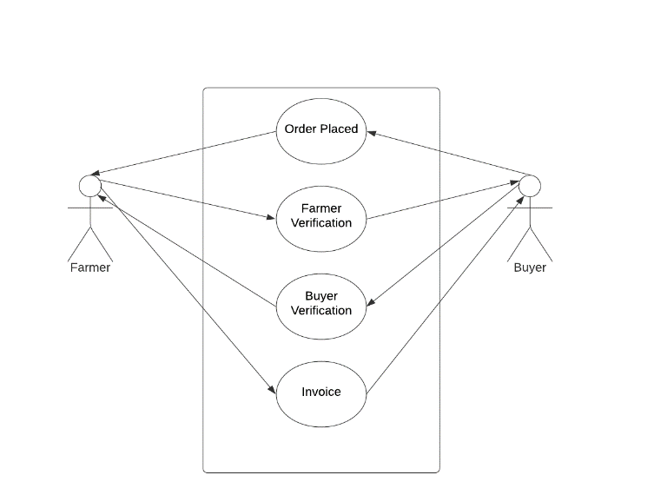

**CDK GLOBAL:**

In the initial stages, the farmer does not have to pay any commission. Once he has earned a significant amount though this website, he begins to pay commission of a certain percentage. The buyer, however, has to pay commission on every purchase.

**TECHNOLOGY STACK:**

1. Web Technology: - (HTML, CSS, JavaScript, AJAX, Bootstrap,) ==> client ; Flask and nodeJS ==> server

2. Programming languages: - Python.

3. Mobile Development:-Android Studio, Android SDK and Jellybean version and above.(b this and firebase is used for sms system. Later server room and automatically done by a bot using pythonscript -flask and ml)

4. Backend Development: -My SQL Database and Firebase (SMS) .

5. Modern Technology:- Big Data , Data Analytics ,Visualization and Machine learning to implement model.

**USE CASE DESCRIPTION:**

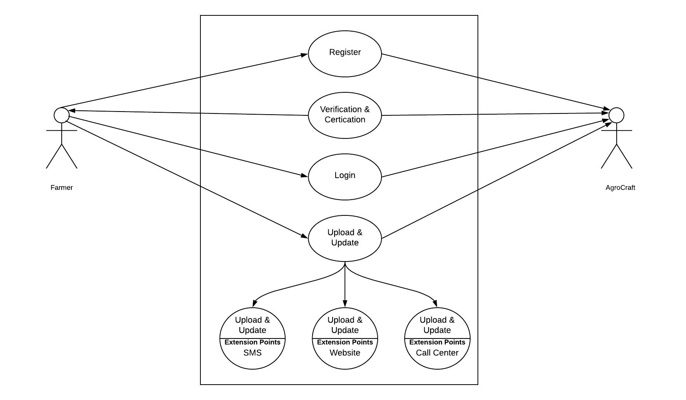

**DEPENDENCIES:**

1. The farmer must possess a **basic phone and legal docx .**

2. This application can be installed in all devices having Android version Jellybean and higher.

3. An online portal generated shall require IE v9 or higher, Google Chrome, Mozilla Firefox, or any other web browser.

**SHOWSTOPPERS:**

1. A percentage of farmers **do not have access to smartphone** , therefore SMS/Call System has been made available.

2. Farmer profits increases owing to the fact that farmers sell their products at **better rates, eliminating the middleman.**

3. Buyers can get their hands directly on fresh products according to their choice of product, variety and time, straight from the fields in reasonable prices **from all over India.**

4. Multiple farmers (many of which reside in remote areas) **get in direct touch with buyers** in capital cities and the prices are negotiable between them with no involvement of the admin whatsoever.

5. The farmer **does not have to spend any extra cost in delivery and marketing.**