Power Shutoff Optimization Framework

Introduction
This document outlines a data-driven framework to recommend power shutoffs for utility companies, balancing debt recovery, operational efficiency, and ethics.
Utility companies often face the challenge of determining which customers to shut off from service when payments are overdue. The objective is to maximize recovered revenue under operational constraints, such as:
- Worker travel time
- The limited number of shutoffs possible per month
- Social and ethical considerations (e.g., customer hardship)
The core business problem is that the power company needs to decide which customers should have their power shut off each month due to non-payment, under a constraint of limited capacity. Capacity in this case refers primarily to the number of shutoffs the company can execute, given limitations such as workforce availability and travel time between customer locations.
This isn’t a simple task of turning off power to everyone who hasn’t paid. Some customers might pay eventually even without being shut off. Others might never pay unless shut off. So, the key is to optimize shutoff decisions such that the company can recover the most revenue, while not wasting capacity or risking shutting off customers who would pay voluntarily. The company also wants to do this while minimizing the travel time between shutoffs so that workers can accomplish more in a single day.
So our goal is two-fold:
- Predict which customers are unlikely to pay unless their power is shut off.
- Among those, prioritize shutoffs in a way that maximizes revenue recovery under limited operational resources.

Data Requirements
Since we do not have access to real-world data, we start by simulating customer data. This provides a controlled environment to build and validate our analytics models.
What we simulate:
- customer_id: A unique identifier for each customer.
- days_overdue: A measure of how late the customer is in paying the bill. Higher values might correlate with higher risk of non-payment.
- balance: The outstanding bill amount, which is financially significant when considering shutoffs.
- payment_prob: Simulated probability of whether the customer is likely to pay. This is used to define our binary classification label.
- lat and lon: Latitude and longitude of customer locations. These are required for route and spatial optimization.
Why this matters:
This simulated dataset mimics the real-world scenario a utility company faces: trying to manage unpaid bills, assess customer behavior, and make logistical decisions about who to shut off and when.
Target variable creation:
We define a binary paid variable to simulate whether a customer eventually paid or not. This is our dependent variable for classification.
Key datasets include customer payment history, geospatial coordinates, and worker capacity data. Below is an example R script to simulate data:
Listing 1: Simulate Customer Data
set . seed ( 123 )
customers <− data . frame ( customer id = 1 : 1 0 0 0 ,
days overdue = sample ( 3 0 : 1 8 0 , 1000 , replace = TRUE) , balance = runif ( 1000 , 100 , 5000 ) ,
payment prob = runif ( 1000 , 0 , 1 ) ,
l a t = runif ( 1000 , 3 7 . 7 , 3 7 . 8 ) ,
lon = runif ( 1000 , −122.5 , −122.4)
)

Predictive Model
Purpose:
To build a machine learning model that can predict whether a customer will pay or not based on their historical behavior. This helps prioritize whom to shut off.
Steps:
- Data Split:
We split the data into training (80%) and testing (20%) sets to evaluate model generalizability.
- Model Training:
We use XGBoost, a high-performance gradient boosting library. It is known for handling binary classification well, especially in tabular data like this.
- Features Used:
  - days_overdue: Suggests financial behavior.
  - balance: Suggests financial stakes.
  - payment_prob: A proxy for internal or external scoring.
- Model Objective:
Set as "binary:logistic" to produce probabilities (between 0 and 1) that a customer will pay.
- Prediction and Evaluation:
We compute prediction probabilities and then generate an ROC curve to assess model performance visually.
- AUC Score:
Area Under the Curve quantifies overall model ability to distinguish between paying and non-paying customers. Higher AUC means better predictive power.
Why this matters:
The model helps avoid unnecessary shutoffs by predicting which customers are likely to pay. This can improve customer relations and reduce service disruption errors.
Use XGBoost to predict payment probability:
Listing 2: Train XGBoost Model
library ( c a re t )
library ( xgboost )
# Sp l i t data
t r a in idx <− c re a te Da ta Pa rtitio n ( customers$paid , p = 0 . 8 , l i s t = FALSE) t r a in <− customers [ t r a in idx , ]
t e s t <− customers [− t r a in idx , ]
# Train model
xgb model <− xgboost (
data = as . matrix ( t r a in [ , c ( ” days overdue ” , ” balance ” , ”payment prob” ) ] ) , l a b e l = t r a in $paid ,
nrounds = 100 ,
o b j e c t i v e = ” binary : l o g i s t i c ”
)
# Generate ROC curve
library (pROC)
roc obj <− roc ( t e s t $paid , t e s t $pred prob )
png ( ” roc curve . png” , width =800 , he ight =600)
plot ( roc obj , main = ”ROC- Curve - f o r - Payment - Pre d i c t io n ” )
dev . off ()
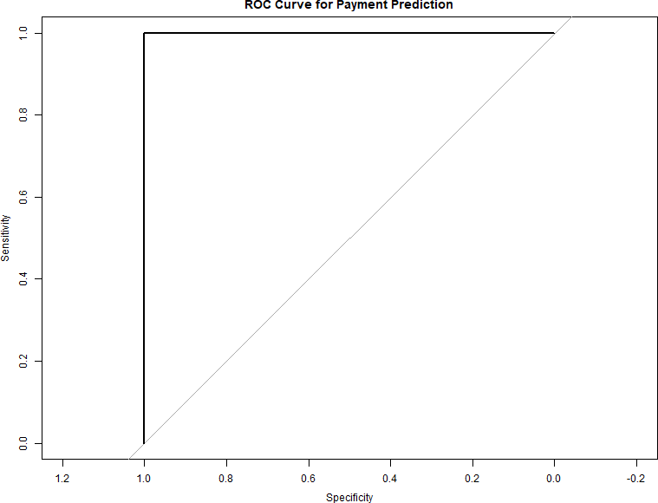

Figure 1: ROC Curve for Payment Prediction

Prioritization Scoring
Purpose:
To rank customers based on a combination of risk (non-payment probability) and financial value (balance). This creates a priority score for shutoff decisions.
Score Definition:
r
CopyEdit
priority_score = (1 - payment_prob) * balance
This ensures:
- High balance customers with low probability of payment are prioritized.
- Low-risk or low-balance customers are deprioritized.
Visualization:
We plot a histogram to understand the distribution of shutoff priority scores. This helps visually confirm that our scoring method yields variability, enabling better decision thresholds.
Why this matters:
This step transitions us from pure modeling to real-world operationalization. The utility company needs actionable scores for policy enforcement.

Section 4: Route Optimization using TSP (Travelling Salesman Problem)
Purpose:
To reduce total travel time or distance for field workers who perform shutoffs. If the shutoffs are geographically optimized, more can be done within the same time.
Steps:
- Clustering:
  - We use K-Means clustering to group customers into 10 geographic regions.
  - This ensures that each worker can handle a localized area.
- TSP Application:
  - We use the TSP package to compute the shortest route within a cluster (e.g., cluster 1).
  - The TSP minimizes travel costs by returning to the starting point after visiting each customer once.
- Visualization:
  - The optimized tour is plotted to show how worker movement is planned.
Why this matters:
Worker time is limited and expensive. Reducing travel can increase the number of shutoffs performed, which is critical under operational constraints.
Priority scores are calculated as:
Priority Score = (1 − Payment Probability) × Outstanding Balance (1)

Listing 3: Priority Score Calculation
customers$ p r i o r i t y s c o re <− ( 1 − customers$payment prob ) ∗ customers$ balance
# Visua l i z e scores
library ( ggplot 2 )
ggplo t ( customers , aes ( x = p r i o r i t y s c o re )) + geom histogram ( f i l l = ” tomato” , bins = 30 ) +
la b s ( t i t l e = ” Shuto f f - P r i o r i t y - Score - Dis t r ib u t i o n ” ) ggsave ( ” p r i o r i t y histogram . png” )

Route Optimization
Purpose:
To formally select the best subset of customers to shut off, given worker time constraints (e.g., 480 minutes per shift). We aim to maximize priority under these constraints.
Steps:
- Define Job Times and Priorities:
  - Each shutoff takes a different amount of time (30 to 60 minutes).
  - Each job has a priority score based on earlier calculations.
- Formulate Linear Program:
  - Objective: Maximize total priority of selected jobs.
  - Constraint: Total job time ≤ available worker minutes.
  - Binary decision variables (job done = 1 or not = 0).
- Solution:
  - Use lpSolve to find the optimal combination of jobs.
  - Output includes the list of selected jobs to shut off.
Why this matters:
This ensures that under limited capacity, the most valuable shutoffs (from a risk and cost recovery perspective) are performed first. This is crucial for strategic resource allocation.
Cluster customers geographically and solve the Travelling Salesman Problem (TSP):
Listing 4: Route Optimization
library ( c l u s t e r )
library (TSP)
# Cluster customers

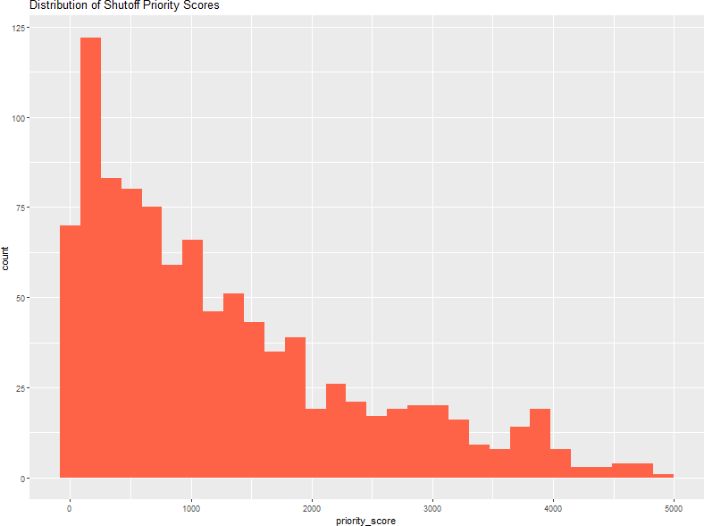

Figure 2: Distribution of Priority Scores

c l u s t e r s <− kmeans ( customers [ , c ( ” l a t ” , ” lon ” ) ] , c e n te r s = 10 ) customers$ c l u s t e r <− c l u s t e r s $ c l u s t e r
# Solve TSP f or Cluster 1
c l u s t e r data <− subset ( customers , c l u s t e r == 1 ) tsp data <− ETSP( c l u s t e r data [ , c ( ” lon ” , ” l a t ” ) ] ) tour <− solve TSP( tsp data )
# Plot route
png ( ” tsp route . png” , width =800 , he ight =600) plot ( tsp data , tour , col = ” blue ” , pch = 20 ) dev . off ()

Capacity Planning
Use integer programming to maximize priority scores within worker capacity:
Listing 5: Integer Programming
library ( lp So lve)
job time <− c ( 30 , 45 , 60 , 25 , 40 ) # Time per job ( minutes )
p r i o r i t y <− c ( 100 , 200 , 150 , 300 , 80 )
r e s u l t <− lp (
d i r e c t i o n = ”max” ,
o b j e c t i v e . in = p r i o r i t y ,
const . mat = matrix ( job time , nrow = 1 ) , const . dir = ”<=” ,
const . rhs = 480 ,
a l l . bin = TRUE
)
s e l e c t e d jo bs <− which ( r e s u l t $ s o l u t i o n == 1 )

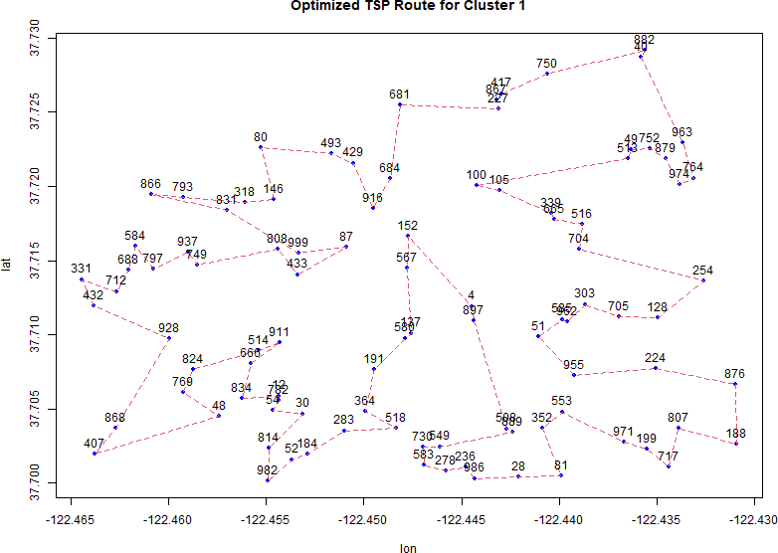

Figure 3: Optimized TSP Route

Case Study: PGE
PGE reduced costs by 18% using similar methods, combining Random Forest and Google OR-Tools.

Conclusion

Summary of Why Each Step Is Necessary
- Simulating data gives us a framework to build and test without proprietary data.
- XGBoost classification predicts customer behavior, helping avoid unnecessary shutoffs.
- Priority scoring translates prediction into a practical decision metric.
- Route optimization minimizes costs and time, increasing efficiency.
- Integer programming ensures that limited resources are used optimally.
This pipeline forms a complete decision-making system integrating data science, machine learning, spatial optimization, and operations research. In real-world deployments, each part of the pipeline would rely on real customer billing data, geographical information systems (GIS), and business rules from utility providers.
The framework includes predictive modeling, prioritization, route optimization, and capacity planning.

Code:
