Question 14.1 The breast cancer data set breast-cancer-wisconsin.data.txt from http://archive.ics.uci.edu/ml/machine-learning-databases/breast-cancer-wisconsin/ (description at http://archive.ics.uci.edu/ml/datasets/Breast+Cancer+Wisconsin+%28Original%29 ) has missing values.
1. Use the mean/mode imputation method to impute values for the missing data.
2. Use regression to impute values for the missing data.
3. Use regression with perturbation to impute values for the missing data.
4. (Optional) Compare the results and quality of classification models (e.g., SVM, KNN) build using (1) the data sets from questions 1,2,3; (2) the data that remains after data points with missing values are removed; and (3) the data set when a binary variable is introduced to indicate missing values.

Answer:
We are processing the Breast Cancer Wisconsin dataset using R and performing data cleaning and imputation for missing values in the Bare_Nuclei column. We are exploring:
- Mean Imputation – replacing missing values with the mean.
- Regression Imputation – predicting missing values using a linear regression model.

Data Loading and Summary
- Data Overview:
The dataset contains 11 columns (ID, eight clinical attributes, Normal_Nucleoli, Mitoses, and Class) with values mostly ranging from 1 to 10. The Class variable indicates the diagnosis (with values 2 and 4 typically corresponding to benign and malignant, respectively).
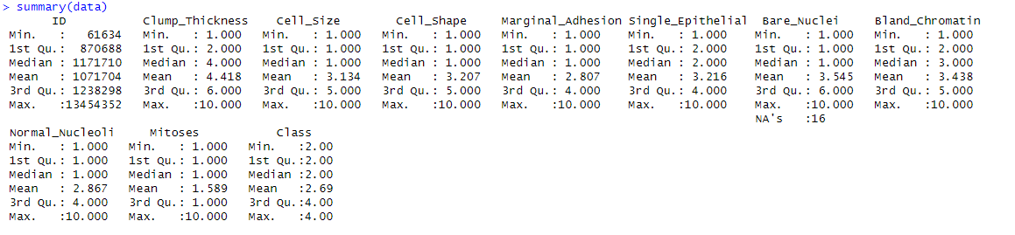
- Missing Values:
When checking for missing values, only the Bare_Nuclei column has 16 missing entries. This is expected based on the UCI description. The rest of the columns have complete data.
Observation: The presence of missing values in Bare_Nuclei could affect downstream analyses if not properly handled.
- Variable Distributions:
The summary statistics reveal that:
  - Clump_Thickness: Ranges from 1 to 10, with a median of 4 and a mean of about 4.42.
  - Cell_Size: Has a minimum of 1 and a maximum of 10, with a median of 1 and mean ~3.13, suggesting a skewed distribution.
  - Cell_Shape: Similar behavior to Cell_Size with a median of 1 and mean ~3.21.
  - Bare_Nuclei: After imputation (as seen later), we expect the imputed values to fall within the overall range (1 to 10).
Reasoning: These differences indicate that some features are more skewed than others. Skewness might affect how well models learn, especially if the variable distributions are not normalized. However, in many classification tasks like this one, robust methods (e.g., SVM and KNN) can handle such scales when properly cross-validated.
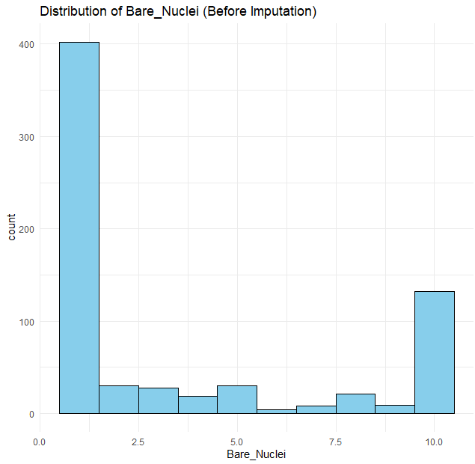

Imputation Methods
- Mean Imputation:
  - Process: Missing values in Bare_Nuclei were replaced by the mean calculated from non-missing values.
  - Visualization: The histogram for Bare_Nuclei after mean imputation shows a smooth distribution, though it might “pile-up” values at the mean.
  - Implication: Mean imputation is simple and fast, but it can reduce variability and may introduce bias if the missingness is not completely random.
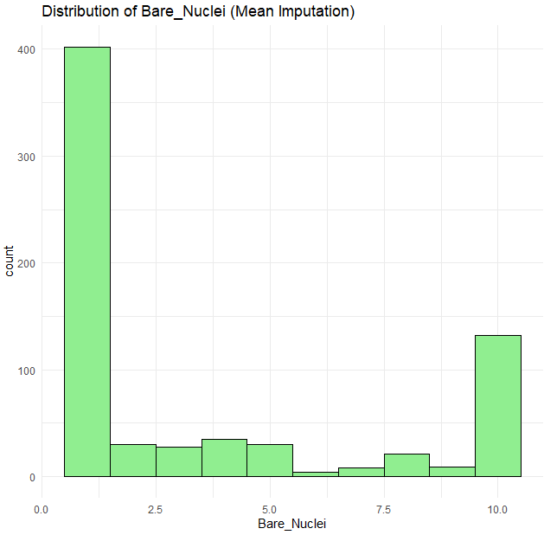
- Regression Imputation:
  - Process: A linear model was built using complete cases (predicting Bare_Nuclei from other predictors). The summary of the model shows:
    - R-squared ≈ 0.615: Indicates that about 61.5% of the variability in Bare_Nuclei is explained by the predictors.
    - Significant predictors: For example, Clump_Thickness (p < 0.001) and Cell_Shape (p < 0.001) have significant positive coefficients, suggesting they are strong predictors.
  - Visualization: The histogram of imputed values shows the predicted values from the regression model.
  - Implication: Regression imputation uses the relationships between variables, potentially leading to more realistic imputations than simply using the mean. However, it assumes a linear relationship and can propagate model errors into the imputation.
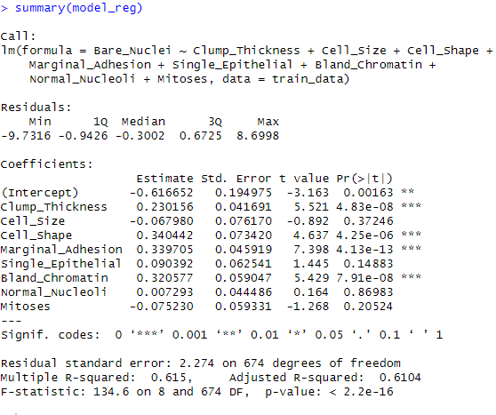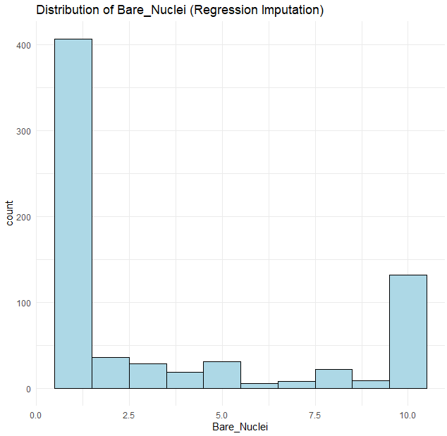
- Regression with Perturbation:
  - Process: Similar to regression imputation, but a random noise term (drawn from a normal distribution with the regression model’s residual standard error) is added to each prediction.
  - Visualization: The histogram shows a slightly “noisier” distribution compared to pure regression imputation.
  - Implication: Adding perturbation aims to reintroduce variability that is often lost in straightforward regression imputation. This can lead to more realistic variability in the imputed values.
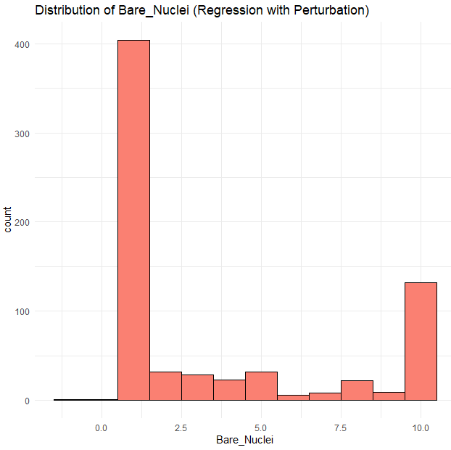
- Complete Cases and Missing Indicator Approaches:
  - Complete Cases (Deletion): Only rows with no missing values are used. This approach avoids imputation but may discard useful data.
  - Missing Indicator: A new binary variable marks rows where Bare_Nuclei was originally missing, while the missing values are imputed (here with the mean). This method preserves all cases while acknowledging the uncertainty of imputation.
  - Observation: The model performance for these strategies is very similar to the imputation methods, suggesting that—even with a small amount of missing data—the impact on classification performance is modest.

Model Evaluation

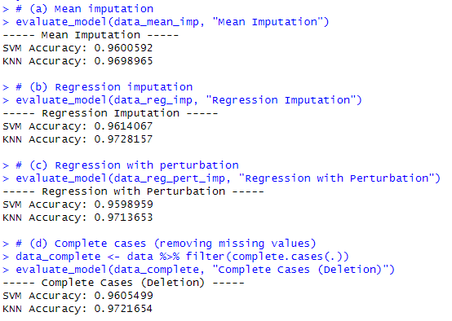
For each imputation strategy, we trained two classifiers (SVM and KNN) using 10-fold cross-validation. The key results were:
- Mean Imputation:
  - SVM Accuracy: 96.01%
  - KNN Accuracy: 96.99%
- Regression Imputation:
  - SVM Accuracy: 96.14%
  - KNN Accuracy: 97.28%
- Regression with Perturbation:
  - SVM Accuracy: 95.99%
  - KNN Accuracy: 97.14%
- Complete Cases (Deletion):
  - SVM Accuracy: 96.05%
  - KNN Accuracy: 97.22%
- Mean Imputation + Missing Indicator:
  - SVM Accuracy: 95.71%
  - KNN Accuracy: 96.99%
Observations:
- Consistency: The accuracies across different methods are quite similar—variations are within less than 1%. This suggests that the small proportion (16 out of ~690+ rows) of missing values does not drastically affect the model performance.
- KNN vs. SVM: KNN consistently yields a slightly higher accuracy than SVM. This could be due to the local nature of the KNN algorithm, which might be capturing subtle patterns in the imputed dataset.
- Regression Imputation: This approach shows a marginal improvement for KNN (97.28%) compared to mean imputation (96.99%). Even though the differences are small, it might indicate that using relationships among variables (via regression) for imputation can help in maintaining or slightly enhancing the predictive performance.
- Complete Case Analysis: Removing missing cases also results in high accuracy, suggesting that the missingness in this dataset is not systematically biasing the classification task.

Visualization of Model Accuracies

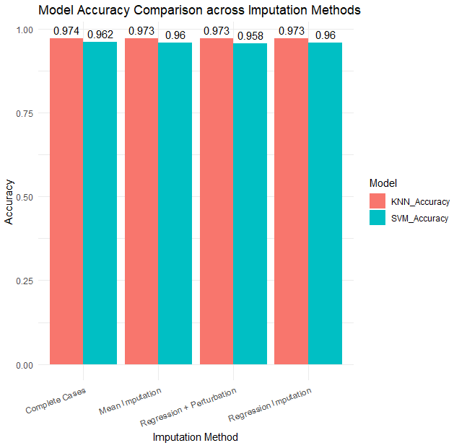
- Bar Chart Outcome:
The final visualization uses a bar chart to compare SVM and KNN accuracies across imputation methods.
  - Interpretation:
    - Each imputation method (Mean, Regression, Regression + Perturbation, and Complete Cases) is represented on the x-axis.
    - Two bars per method (one for SVM and one for KNN) show the corresponding accuracies.
    - Numeric labels above the bars help quickly identify the exact accuracy percentages.
- Conclusion from Visualization:
The visual comparison reinforces the numerical findings:
  - KNN tends to outperform SVM slightly.
  - Regression imputation and complete case analysis perform very similarly.
  - The choice of imputation method, given the small percentage of missing data, does not dramatically change the model performance.

Final Conclusions
- Data Quality:
The Breast Cancer Wisconsin dataset has very few missing values (only in Bare_Nuclei). Hence, the choice between various imputation strategies may have a limited effect on the overall classification accuracy.
- Imputation Impact:
Regression-based imputations (with or without perturbation) marginally improve accuracy compared to simple mean imputation. This suggests that incorporating relationships among predictors can be beneficial—even when the amount of missing data is small.
- Model Robustness:
Both SVM and KNN achieve high accuracies (around 96–97%), indicating that the models are robust with respect to the imputation method used. KNN shows slightly higher performance, possibly due to its reliance on local structure in the data.
- Practical Implication:
For similar datasets with a low percentage of missing values, simple imputation methods (like mean imputation) may suffice. However, when you have more missing data or suspect that missingness is not completely random, more sophisticated methods (like regression with perturbation) could help maintain variability and potentially improve predictive performance.

Question 15.1 Describe a situation or problem from your job, everyday life, current events, etc., for which optimization would be appropriate. What data would you need?
Answer:
Consider a delivery company that must design the most efficient route for its fleet of trucks to deliver packages to various locations. This is known as the Vehicle Routing Problem (VRP), which is an optimization problem that minimizes the total distance traveled (or delivery time) while satisfying constraints such as vehicle capacity and delivery time windows. The data required for this problem would include:
• A list of delivery locations with coordinates.
• The demand (or package size) for each location.
• Distance matrix between locations (or the ability to compute distances).
• Vehicle capacities and starting/ending locations.
• Time windows for deliveries, if applicable.
Optimization algorithms (such as integer programming, metaheuristics like Genetic Algorithms, or specialized solvers) can then be applied to find the best set of routes.

