Question 8.1 Describe a situation or problem from your job, everyday life, current events, etc., for which a linear regression model would be appropriate. List some (up to 5) predictors that you might use.
Answer:

Understanding Linear Regression
Linear regression is a statistical technique used to model the relationship between a dependent variable (outcome) and one or more independent variables (predictors). The goal is to determine how changes in the predictors influence the outcome, assuming a linear relationship.

Example Scenario: Predicting House Prices
A common real-world use case for linear regression is predicting house prices based on various factors. In this case, the dependent variable (outcome) is the house price, and the independent variables (predictors) could include:
- Square Footage (Size of the House in sqft) – Larger houses tend to have higher prices.
- Number of Bedrooms – More bedrooms generally increase the value of a house.
- Number of Bathrooms – Additional bathrooms add convenience and value.
- Location (Proximity to City Center, Crime Rate, School Ratings, etc.) – Location significantly affects the price.
- Year Built (Age of the House) – Newer houses may have modern designs and better amenities, increasing their value.

Why Linear Regression is Suitable?
- Quantitative Relationships: All the above predictors are numerical or can be converted into numerical categories.
- Linearity Assumption: Many real estate pricing models show a roughly linear relationship between price and factors such as square footage and the number of rooms.
- Interpretability: The regression coefficients provide clear insights into how much each factor contributes to the house price.
- Predictive Power: By training the model on historical house prices, we can use it to estimate the price of new properties.

Mathematical Representation
A typical multiple linear regression equation for this scenario would be:
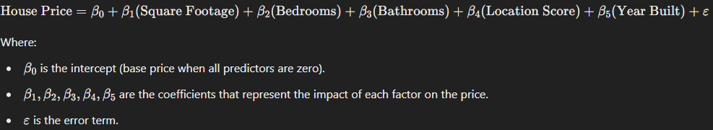

Potential Challenges & Considerations
- Multi-collinearity: Some factors may be highly correlated (e.g., square footage and the number of bedrooms), which can affect model stability.
- Non-linearity: Some relationships might not be purely linear (e.g., location might have a more complex effect).
- Outliers: Extremely expensive or cheap houses could distort the model.
- Feature Selection: Using too many predictors might lead to over-fitting, reducing generalizability.

Conclusion
Linear regression is an effective tool for predicting house prices based on relevant features. By analyzing historical data, we can create a predictive model that helps buyers, sellers, and real estate agents make data-driven decisions.
Question 8.2 Using crime data from http://www.statsci.org/data/general/uscrime.txt (file uscrime.txt, description at http://www.statsci.org/data/general/uscrime.html ), use regression (a useful R function is lm or glm) to predict the observed crime rate in a city with the following data: M = 14.0 So = 0 Ed = 10.0 Po1 = 12.0 Po2 = 15.5 LF = 0.640 M.F = 94.0 Pop = 150 NW = 1.1 U1 = 0.120 U2 = 3.6 Wealth = 3200 Ineq = 20.1 Prob = 0.04 Time = 39.0 Show your model (factors used and their coefficients), the software output, and the quality of fit.
Answer:
The question asks us to perform linear regression analysis on crime data, predict crime rates for a given city, check for multi-collinearity, and visualize results.
We are provided with the data associated for the model, these values serve there purpose as independent variables for the model and can be used to predict the dependent variable which is the Crime Rate.
The following formula was created using the independent variable values provided:
formula <- Crime ~ M + So + Ed + Po1 + Po2 + LF + M.F + Pop + NW + U1 + U2 + Wealth + Ineq + Prob + Time
This formula is then used to fit the linear regression model. Once the model is implemented, we can check the multi-collinearity using the vif function from the car package.
Why is this important?
- Multi-collinearity can distort model estimates.
- We may need to remove or combine correlated variables.
vif() (Variance Inflation Factor) detects multi-collinearity.
High VIF (>10) indicates collinearity, meaning that predictors are highly correlated.
Then in order to check the fit of the model, I create a new city with similar independent values and check my model prediction on the new city.
Further in order to check the model accuracy we can plot the predicted values against the actual values as below:
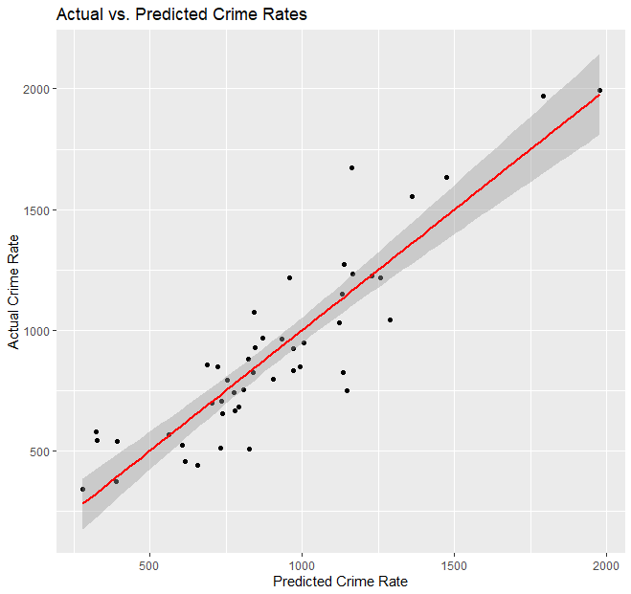
In the end, to evaluate my model, I have generated 4 plots:
Residuals vs. Fitted: Checks for homoscedasticity (equal variance).
Normal Q-Q Plot: Assesses if residuals are normally distributed.
Scale-Location Plot: Checks if residuals spread evenly.
Residuals vs. Leverage: Detects influential outliers.
Doing Residual analysis helps validate regression assumptions. The 4 plots are as below:
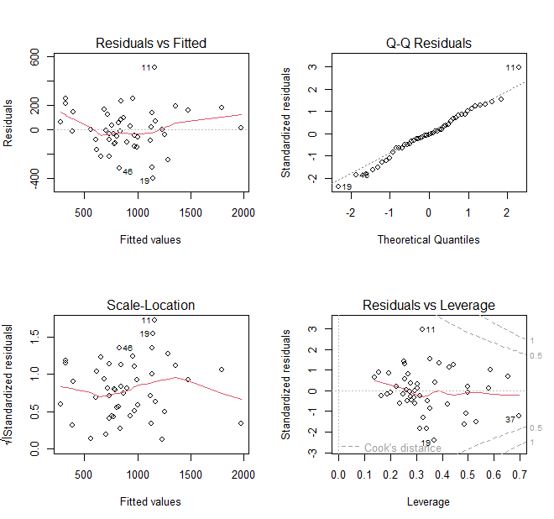
As part of the question, it just asks us to run the model, however I went ahead with performing multi-collinearity and residual analysis to replicate real world modelling.
Lets now understand what each of those are and why is it needed:
Multi-collinearity occurs when two or more independent variables are highly correlated, meaning they provide redundant information in the model. This can distort regression estimates and make it difficult to determine the individual effect of each predictor.

Why is Multi-collinearity a Problem?
- Unstable Coefficients: High correlation inflates the standard errors of coefficients, making them highly sensitive to small changes in the dataset.
- Misleading Statistical Significance: Some predictors may appear insignificant due to inflated p-values, even if they are important.
- Overfitting Risk: Redundant predictors can lead to overfitting, where the model performs well on training data but poorly on new data.
- Interpretability Issues: If two variables are highly correlated, it becomes difficult to determine which one is driving the change in the dependent variable.

How to Detect and Handle Multi-collinearity?
- Variance Inflation Factor (VIF):
  - If VIF > 10, multi-collinearity is a concern.
  - If VIF > 5, it’s worth investigating.
- Solutions:
  - Remove one of the correlated variables (e.g., Po1 and Po2 if they measure similar police presence metrics).
  - Combine correlated variables into a single feature (e.g., average police presence).
  - Use Principal Component Analysis (PCA) to transform correlated variables into uncorrelated components.

What Are Residuals?
Residuals are the differences between the actual and predicted values in a regression model. They help assess whether the model meets the assumptions of linear regression.

Why is Residual Analysis Important?
- Check for Linearity: Residuals should be randomly scattered. If there’s a pattern, the relationship might not be linear.
- Homoscedasticity (Equal Variance Assumption): The spread of residuals should remain constant across fitted values. If variance increases or decreases, the model might be missing important patterns.
- Normality of Residuals: If residuals are normally distributed, predictions are statistically valid.
- Detecting Outliers & Influential Points: Outliers can heavily influence the regression line, leading to misleading conclusions.

Code and Results:
