Question 9.1: Using the same crime data set uscrime.txt as in Question 8.2, apply Principal Component Analysis and 0then create a regression model using the first few principal components. Specify your new model in terms of the original variables (not the principal components), and compare its quality to that of your solution to Question 8.2. You can use the R function prcomp for PCA. (Note that to first scale the data, you can include scale. = TRUE to scale as part of the PCA function. Don’t forget that, to make a prediction for the new city, you’ll need to unscale the coefficients (i.e., do the scaling calculation in reverse)!)
Answer:

What is PCA?
Principal Component Analysis (PCA) is a dimensionality reduction technique used to transform a dataset with potentially correlated variables into a set of uncorrelated variables called principal components (PCs). These components capture the most variance in the data while reducing redundancy.

Why Use PCA?
- Reduce Dimensionality: Helps to remove redundant features and reduce computational complexity.
- Avoid Multicollinearity: Ensures independent predictor variables for better regression models.
- Improve Interpretability: Captures key patterns in data by transforming correlated variables into uncorrelated principal components.
- Enhance Predictive Performance: Improves generalization by focusing on the most important variations.
In order to implement the question, we approach as:
Data Preprocessing:
- The dataset is loaded and scaled to ensure all variables have equal importance during PCA.
Principal Component Analysis (PCA):
- prcomp is used to perform PCA, and we analyze the explained variance to determine the number of components required.
- A scree plot (fviz_eig) is used to visualize the variance contribution.
Regression Model using Principal Components:
- A linear model is built using the selected principal components.
- The model is then translated back to the original variable space for interpretation.
Comparison with Original Regression Model:
- A standard linear regression model using all original variables is built.
- Residual plots and RMSE values are used for performance comparison.

Upon performing the PCA, this is the summary:
Visualising the scree plot we get:
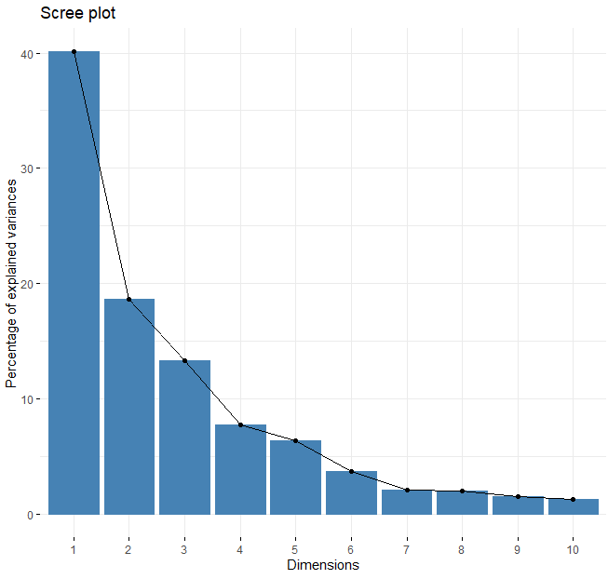
The "elbow" method suggests keeping 3-4 components, as variance contribution significantly drops afterward.

This is the summary of the PCA model:
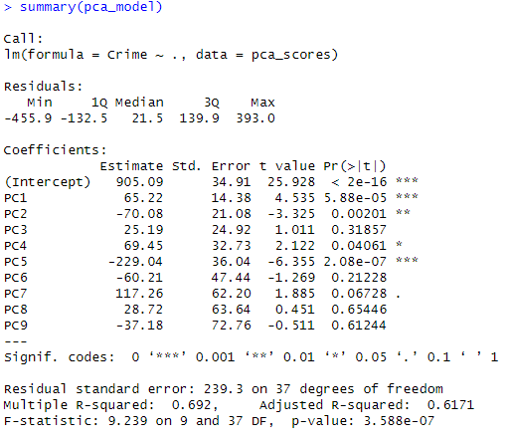
After converting the PC variable coefficients to the original variable space, we get:
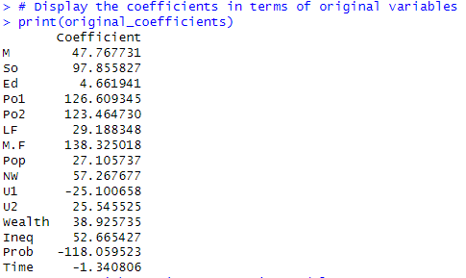

Comparing the regression models we get:
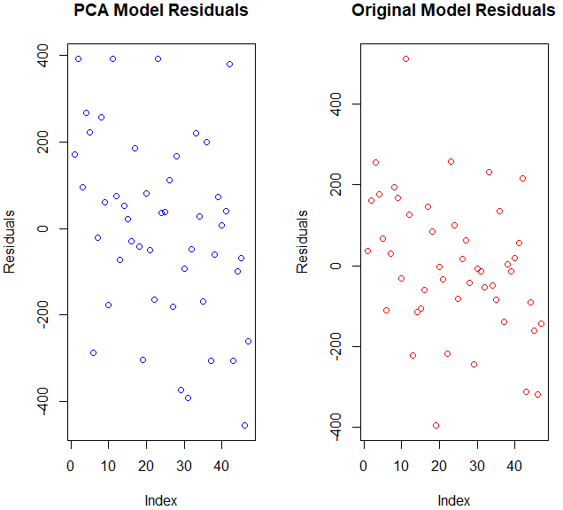
From this we can compare the two models for accuracy using Root Mean Squared Error (RMSE)
> cat("PCA Model RMSE:", pca_rmse, "\n")
PCA Model RMSE: 212.3319
> cat("Original Model RMSE:", original_rmse, "\n")
Original Model RMSE: 169.79

This implies the that PCA didn’t improve the prediction.

Code:
