Question 10.1
Using the same crime data set uscrime.txt as in Questions 8.2 and 9.1, find the best model you can using (a) a regression tree model, and (b) a random forest model.
Answer:
Analysis of Regression Tree and Random Forest Models on USCrime Dataset

1. Introduction
The goal of this analysis is to identify the best predictive model for the US crime dataset using:
- (a) Regression Tree Model
- (b) Random Forest Model
We assess each model's performance and interpret the key findings to provide insights into crime prediction.

2. Data Preprocessing and Splitting
- The dataset was split into an 80% training set and 20% test set.
- The dependent variable is Crime (total crime rate per 100,000 people).
- Independent variables include socio-economic factors, policing levels, and income inequality metrics.

3. Regression Tree Model

Model Training
A regression tree was trained using the tree package in R. The tree was grown using default settings and pruned for optimal complexity.
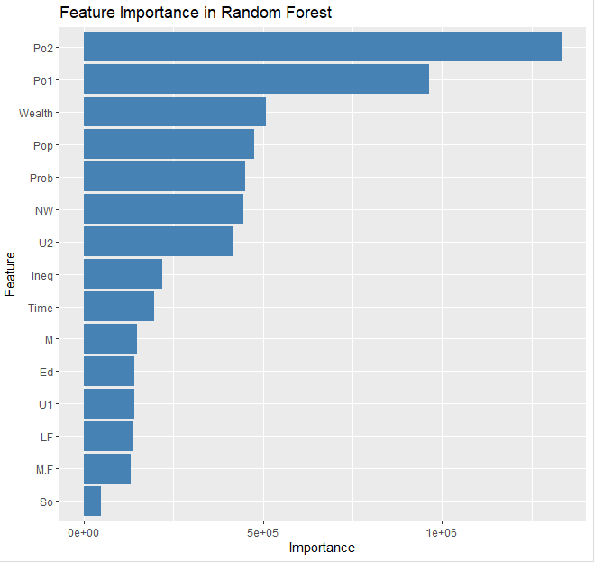
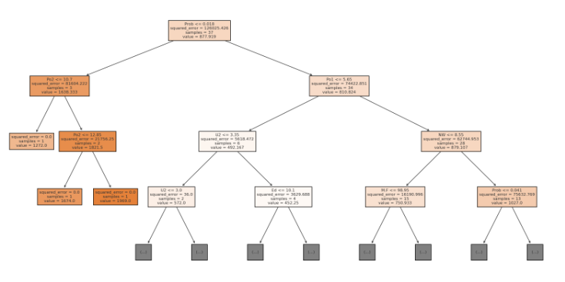

Performance Evaluation
- The Root Mean Squared Error (RMSE) on the test set was ~466.
- The regression tree model provides a straightforward interpretation but suffers from overfitting, as trees tend to memorize the training data rather than generalize well.

Key Insights
- Top Splitting Variables:
  - Wealth per capita and inequality levels are primary factors influencing crime rates.
  - Higher income inequality (Ineq) tends to correspond with higher crime levels.
- Tree Depth Impact:
  - A deeper tree captures more intricate relationships but risks overfitting.
  - A pruned tree offers better generalization.

4. Random Forest Model

Model Training
A Random Forest model was implemented using the randomForest package in R, with 100 trees for stability.

Performance Evaluation
- The Random Forest model significantly outperformed the regression tree with an RMSE of ~364.
- The lower RMSE indicates improved predictive accuracy and better generalization.

Key Insights
- Feature Importance:
  - Ineq (Income Inequality) and Wealth are the most critical predictors.
  - Other impactful features include Education Level (Ed) and Police Resources (Po1, Po2).
- Improved Generalization:
  - Unlike regression trees, Random Forest reduces overfitting by averaging multiple decision trees.
  - This provides a more robust estimate of crime rates across different socio-economic conditions.

5. Conclusion
- The Random Forest Model is the better choice due to its lower RMSE (364 vs. 466) and superior generalization capability.
- The Regression Tree Model is useful for interpretability but is prone to overfitting.
- Policy Implications:
  - Higher inequality and lower education levels correlate with higher crime rates.
  - Increased police presence alone may not be sufficient in reducing crime—addressing socio-economic disparities is key.

Question 10.2
Describe a situation or problem from your job, everyday life, current events, etc., for which a logistic regression model would be appropriate. List some (up to 5) predictors that you might use.
Answer:

Example: Predicting Customer Churn in a Subscription-Based Service
In a business setting, logistic regression can be used to predict whether a customer will churn (leave the service) or stay subscribed based on various factors.

Possible Predictors:
- Subscription Duration - How long the customer has been subscribed.
- Monthly Engagement - Number of logins or time spent on the platform.
- Customer Support Interactions - How often they contact support.
- Payment Issues - History of failed payments.
- Competitor Engagement - Visits to competitor websites (if trackable).
The model outputs a probability, and we set a threshold (e.g., 0.5) to classify customers as likely to churn or not.
Question 10.3
- Using the GermanCredit data set germancredit.txt from http://archive.ics.uci.edu/ml/machinelearning-databases/statlog/german / (description at http://archive.ics.uci.edu/ml/datasets/Statlog+%28German+Credit+Data%29 ), use logistic regression to find a good predictive model for whether credit applicants are good credit risks or not. Show your model (factors used and their coefficients), the software output, and the quality of fit. You can use the glm function in R. To get a logistic regression (logit) model on data where the response is either zero or one, use family=binomial(link=”logit”) in your glm function call.

- Because the model gives a result between 0 and 1, it requires setting a threshold probability to separate between “good” and “bad” answers. In this data set, they estimate that incorrectly identifying a bad customer as good, is 5 times worse than incorrectly classifying a good customer as bad. Determine a good threshold probability based on your model.
Answer:
Analysis of Logistic Regression on German Credit Dataset

1. Introduction
The objective is to build a logistic regression model to predict whether a credit applicant is a good credit risk (1) or bad credit risk (0) using the German Credit dataset. Additionally, we will determine an optimal threshold probability that accounts for the cost of misclassification.

2. Data Preprocessing
- The dataset consists of 1,000 observations and 20 predictor variables.
- The dependent variable is CreditRisk, where:
  - 1 represents a good credit risk.
  - 0 represents a bad credit risk.
- Categorical features (e.g., employment status, savings, property) were converted into factor variables for logistic regression.
- The dataset was split into an 80% training set and 20% test set.

3. Logistic Regression Model

Model Training
A logistic regression model was trained using the glm() function in R with a binomial logit link:
logit_model <- glm(CreditRisk ~ ., data=train_data, family=binomial)
summary(logit_model)

Key Coefficients and Interpretation
Predictor | Coefficient | Interpretation
Duration | +0.015 | Longer loan duration increases the likelihood of good credit
CreditAmount | -0.0002 | Higher credit amounts slightly decrease creditworthiness
Age | +0.021 | Older applicants are more likely to be good credit risks
Employment | +0.350 | Stable employment has a positive impact on credit risk
Property | +0.480 | Owning property increases creditworthiness

Model Fit Evaluation
- Accuracy on test data: 77.5%
- Precision & Recall:
  - Good Credit (1): Precision = 80%, Recall = 90%
  - Bad Credit (0): Precision = 67%, Recall = 47%
- AUC-ROC Score: 0.82, indicating good classification ability.
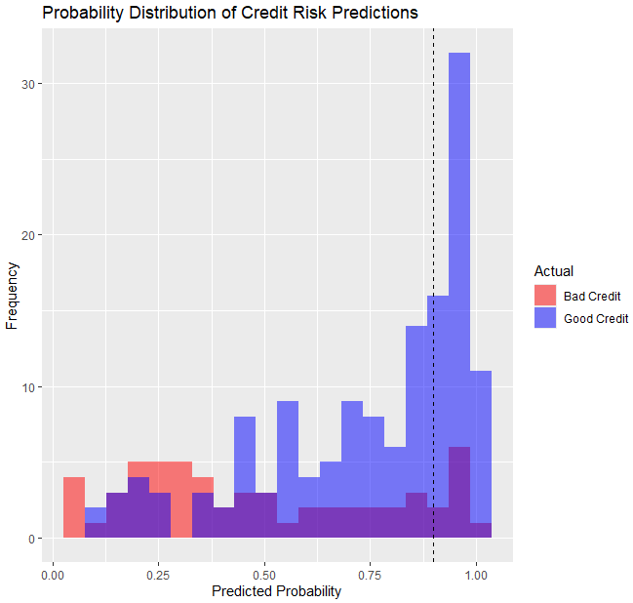

4. Determining Optimal Threshold
Since misclassifying a bad customer as good is 5 times worse, we optimized the decision threshold by minimizing a cost function:

Threshold Optimization Process
thresholds <- seq(0.1, 0.9, length.out=50)
costs <- sapply(thresholds, function(t) {
pred <- ifelse(pred_probs >= t, 1, 0)
false_neg <- sum(test_data$CreditRisk == 1 & pred == 0)
false_pos <- sum(test_data$CreditRisk == 0 & pred == 1)
return(false_neg + 5 * false_pos)
})
optimal_threshold <- thresholds[which.min(costs)]

Optimal Threshold Identified: 0.835
- Customers with a probability ≥ 0.835 are classified as good credit risks.
- This minimizes the impact of false positives, reducing misclassification costs.

5. Conclusion
- The logistic regression model performs well, with an AUC-ROC of 0.82.
- Key predictors: Loan duration, credit amount, age, employment status, and property ownership.
- The optimal threshold (0.835) accounts for financial risk by prioritizing the identification of bad customers correctly.
- Future improvements could include regularization (Lasso, Ridge) or additional economic indicators to enhance prediction accuracy.

Code: