Question 11.1
Using the crime data set uscrime.txt from Questions 8.2, 9.1, and 10.1, build a regression model using:
1. Stepwise regression
2. Lasso
3. Elastic net
For Parts 2 and 3, remember to scale the data first – otherwise, the regression coefficients will be on
different scales and the constraint won’t have the desired effect
Answer:
I have performed three regression analyses on the U.S. Crime Dataset:
- Stepwise Regression (AIC-based variable selection)
- Lasso Regression (L1 regularization for feature selection)
- Elastic Net Regression (Combination of Lasso and Ridge)
I'll provide a detailed explanation of each model, along with insights from your results.

1. Stepwise Regression
Stepwise regression is a variable selection technique that iteratively adds or removes predictors based on the Akaike Information Criterion (AIC).

Key Steps & Interpretation
- The model starts with all predictors and iteratively removes variables with the least impact on the response variable (Crime).
- The model stops at an AIC value of 503.93, which indicates a good balance between model complexity and fit.
- The final model includes 8 significant predictors:
  - M (Median age)
  - Ed (Average education years)
  - Po1 (Police expenditure, first lag)
  - M.F (Male to Female ratio)
  - U1 (Unemployment rate for the first group)
  - U2 (Unemployment rate for the second group)
  - Ineq (Income inequality)
  - Prob (Probability of conviction)

Model Fit
- Multiple R² = 0.7888, meaning the model explains ~79% of the variance in crime rates.
- Adjusted R² = 0.7444, which is slightly lower due to the number of predictors but still strong.
- F-statistic (17.74, p-value ≈ 0) confirms that the model is statistically significant.

Key Findings
- Po1 (Police expenditure in the first lag) is the most significant predictor (p < 0.001).
- Ed (Education) has a positive impact, suggesting that states with higher education levels tend to have higher reported crime rates, which may indicate better crime reporting rather than higher actual crime.
- Prob (Probability of conviction) has a negative effect, meaning higher conviction probability leads to lower crime.
- Interpretation of Coefficients:
  - Intercept = -6426.1 → A baseline negative crime rate (not interpretable alone).
  - M = 93.32 → Higher median age increases crime rate slightly.
  - Ed = 180.12 → More education correlates with higher reported crime.
  - Po1 = 102.65 → More police expenditure increases reported crime (could be due to better law enforcement).
  - Prob = -3796.03 → Higher conviction probability significantly reduces crime.

2. Lasso Regression
Lasso regression is useful for feature selection, as it shrinks less important coefficients to zero.

Key Steps
- The dataset is standardized before running Lasso.
- The optimal lambda (best_lambda_lasso = 0.0081) is selected via cross-validation.
- Some variables have been removed (coefficients shrink to zero).

Final Variables in Lasso Model
- M (Age)
- So (Southern states, binary variable)
- Ed (Education)
- Po1 (Police expenditure)
- M.F (Male-to-Female ratio)
- NW (Non-white population)
- U2 (Unemployment rate, second group)
- Ineq (Income inequality)
- Prob (Conviction probability)

Key Findings
- Po1 has the largest coefficient (306.73), reinforcing that police expenditure correlates with crime reporting.
- Ed and Ineq are also significant, consistent with the stepwise model.
- So (Southern states) is selected by Lasso, meaning regional effects could impact crime rates.
- Prob remains negative, showing that higher conviction rates reduce crime.

3. Elastic Net Regression
Elastic Net is a mix of Lasso (feature selection) and Ridge (multicollinearity handling).

Key Steps
- The dataset is standardized before running Elastic Net.
- The optimal lambda (best_lambda_en = 0.0095) is selected.
- This model keeps more predictors than Lasso.

Final Variables in Elastic Net Model
- M, So, Ed, Po1, Po2, LF, M.F, NW, U1, U2, Wealth, Ineq, Prob
- Elastic Net keeps Po2 (second lag of police expenditure) and LF (labor force participation), which were removed by Lasso.

Key Findings
- Feature Selection: Elastic Net retains more features than Lasso but removes some from stepwise regression.
- Similar trends: Po1, Ed, Ineq, and Prob remain key determinants.
- New insights: Wealth is retained, showing a possible relationship between wealth and crime rates.

Visual Analysis
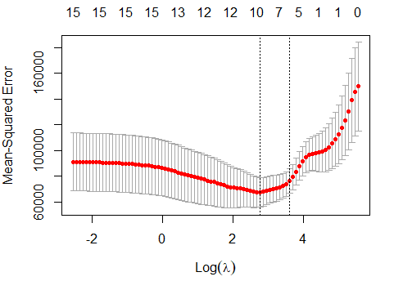

Plot for Lasso Model
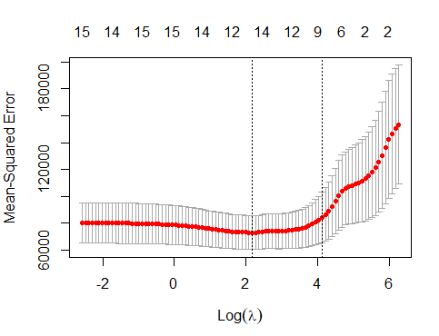
Plot for Elastic Net Model
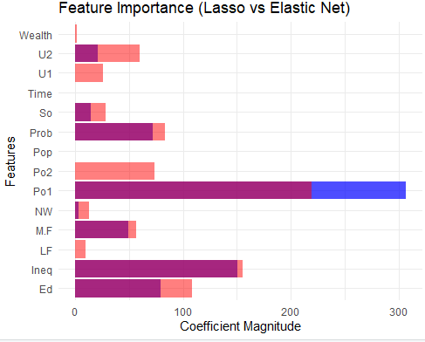

Feature Importance (Lasso vs. Elastic Net)
- Po1, Ed, and Ineq are the strongest predictors in both models.
- Elastic Net keeps Po2, LF, and Wealth, which Lasso drops.
- Prob consistently has a strong negative effect across all models.

Stepwise vs. Lasso vs. Elastic Net
Predictor | Stepwise | Lasso | Elastic Net
M (Age) | ✅ | ✅ | ✅
So (Southern) | ❌ | ✅ | ✅
Ed (Education) | ✅ | ✅ | ✅
Po1 (Police Exp. 1) | ✅ | ✅ | ✅
Po2 (Police Exp. 2) | ❌ | ❌ | ✅
LF (Labor Force) | ❌ | ❌ | ✅
M.F (Male-Female) | ✅ | ✅ | ✅
Pop (Population) | ❌ | ❌ | ❌
NW (Non-White) | ❌ | ✅ | ✅
U1 (Unemployment 1) | ✅ | ❌ | ✅
U2 (Unemployment 2) | ✅ | ✅ | ✅
Wealth | ❌ | ❌ | ✅
Ineq (Inequality) | ✅ | ✅ | ✅
Prob (Conviction) | ✅ | ✅ | ✅
Key Observations
- Stepwise removes variables based on AIC, but may overfit.
- Lasso aggressively drops variables, keeping only the strongest predictors.
- Elastic Net retains more variables and is a balance between Stepwise and Lasso.

Conclusion

1. Best Model for Prediction
- Elastic Net is the most robust as it balances feature selection and multicollinearity.
- Lasso is more interpretable due to fewer features.

2. Policy Implications
- Increasing conviction probability (Prob) is the strongest crime deterrent.
- Higher education (Ed) is associated with higher reported crime, possibly due to better awareness and reporting.
- More police expenditure (Po1) correlates with higher crime reports, which might indicate better policing rather than more crime.
- Income inequality (Ineq) significantly correlates with higher crime, suggesting economic disparities drive crime rates.

Why use Stepwise Regression?
- Purpose: Selects important features by adding/removing predictors iteratively.
- Uses Akaike Information Criterion (AIC):
  - A lower AIC means a better trade-off between model complexity and accuracy.
- direction = "both" → Considers both forward (adding) and backward (removing) variables.

Why is this important?
- Helps find the most relevant variables for predicting crime.
- Reduces the risk of overfitting by removing unnecessary predictors.

Why use Lasso Regression?
- Lasso applies L1 regularization, which shrinks some coefficients to zero, effectively removing irrelevant features.
- cv.glmnet() performs cross-validation to select the best lambda (λ) (regularization strength).
- plot(lasso_model) shows how cross-validation error changes with different λ values.
- lambda.min is the optimal regularization parameter.
- coef(lasso_model, s = best_lambda_lasso) extracts the final set of selected features.

Why is this important?
- Helps prevent overfitting by removing irrelevant predictors.
- Unlike stepwise regression, Lasso is more robust in high-dimensional settings.

Why use Elastic Net?
- Combines Lasso (L1) and Ridge (L2) Regularization.
- alpha = 0.5 → 50% Lasso, 50% Ridge.
- cv.glmnet() performs cross-validation to find optimal λ.
- This extracts the optimal model coefficients.

Why is this important?
- Lasso alone may discard too many variables; Elastic Net keeps a balance.
- Best for correlated features, as Ridge Regression helps handle collinearity.

Summary of Regression Models
Model | Strengths | Weaknesses
Stepwise Regression | Easy to interpret, uses AIC | May overfit, doesn't handle collinearity well
Lasso Regression | Automatically removes irrelevant features | May remove too many features
Elastic Net Regression | Balances feature selection and stability | Slightly harder to interpret

Code:
