Question 12.1 Describe a situation or problem from your job, everyday life, current events, etc., for which a design of experiments approach would be appropriate.
Answer:
A Design of Experiments (DOE) approach is useful in optimizing a process, testing multiple factors simultaneously, and identifying the best combination of variables.

Example: Optimizing Website Conversion Rates
Imagine a marketing team wants to increase the conversion rate on an e-commerce website. Several factors influence conversion rates, such as:
- Call-to-Action Button (CTA) Color: Blue, Green, Red
- Headline Style: Formal, Casual
- Discount Offer: 5%, 10%, No Discount
- Page Layout: Single-column, Multi-column
This experiment involves 4 factors, each with multiple levels. Testing all possible combinations (a full factorial design) would require 3 × 2 × 3 × 2 = 36 variations. A fractional factorial design could help reduce the number of tests while still providing insights.

Why DOE?
- Helps determine which factors significantly impact conversions.
- Saves time and resources compared to testing one factor at a time (A/B testing).
- Identifies possible interactions between variables (e.g., whether the effectiveness of a discount depends on CTA color).
Question 12.2 To determine the value of 10 different yes/no features to the market value of a house (large yard, solar roof, etc.), a real estate agent plans to survey 50 potential buyers, showing a fictitious house with different combinations of features. To reduce the survey size, the agent wants to show just 16 fictitious houses. Use R’s FrF2 function (in the FrF2 package) to find a fractional factorial design for this experiment: what set of features should each of the 16 fictitious houses have? Note: the output of FrF2 is “1” (include) or “-1” (don’t include) for each feature.
Answer:
We need to determine which 10 yes/no features influence house pricing and create a fractional factorial design using R’s FrF2 function.

Define the Experiment
- 10 factors (yes/no features)
- 2 levels per factor (-1: No, 1: Yes)
- 16 experimental runs
The output matrix contains 16 rows (each representing a fictitious house) and 10 columns (each representing a feature). The values 1 mean the feature is included, while -1 means it is not.
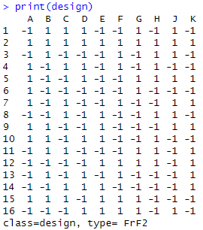
This heatmap visually shows which features each house has.
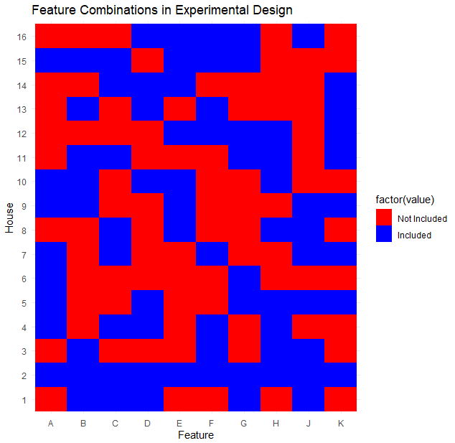

Analysis:
The experimental design heatmap represents the inclusion (blue) and exclusion (red) of various features (A to K) across different houses (1 to 16). Let's analyze it based on the design matrix provided:

Observations & Analysis
- Balanced Representation:
  - The heatmap indicates a relatively balanced mix of included and not included features. Each feature (A to K) appears to be included in approximately half of the houses.
  - This ensures that the experimental setup is not biased toward any particular feature.
- Randomized Design:
  - The alternating pattern of red and blue across the features suggests a well-randomized factorial design.
  - This helps minimize systematic errors and enhances the validity of the conclusions drawn from the experiment.
- Feature Presence Across Houses:
  - Some features, like Feature A, show alternating inclusion/exclusion across houses, ensuring diverse representation.
  - Features such as Feature H and Feature K seem to have more contiguous blocks of inclusion or exclusion, which might suggest a dependency pattern.
- FrF2 Type Design (Fractional Factorial 2-Level Design):
  - The given design matrix follows a FrF2 (Fractional Factorial) design, meaning it captures the main effects efficiently while reducing the total number of runs.
  - The use of +1 and -1 encoding indicates a two-level factorial design, where:
    - +1 (Included, Blue in Heatmap): The feature is part of the house’s configuration.
    - -1 (Not Included, Red in Heatmap): The feature is excluded from that house’s configuration.
  - This helps in efficiently studying the influence of features while reducing the number of required experiments.
Code:
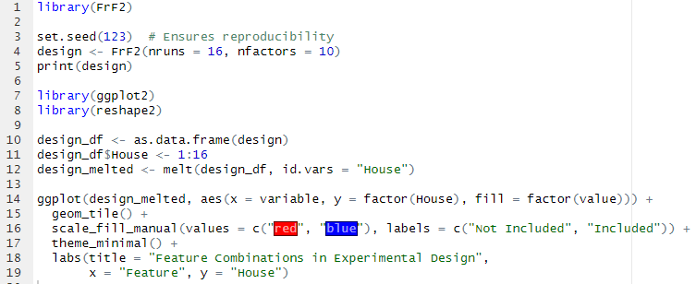
Question 13.1 For each of the following distributions, give an example of data that you would expect to follow this distribution (besides the examples already discussed in class). a. Binomial b. Geometric c. Poisson d. Exponential e. Weibull
Answer:

(a) Binomial Distribution
Definition: The binomial distribution models the number of successes in a fixed number of independent trials, each with the same probability of success.
Example Use Case:
- Customer Conversion Rate: Suppose a company emails 1,000 people, and each has a 10% chance of making a purchase. The number of people who purchase follows a binomial distribution.
- Manufacturing Defects: A factory produces 500 widgets daily, with a 2% defect rate. The number of defective widgets follows a binomial distribution.
Formula:
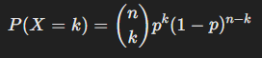
where:
- n = total trials (e.g., total customers)
- p = probability of success (e.g., probability of purchase)
- k = number of successes (e.g., number of buyers)

Visualization
Let's visualize a binomial distribution for n=10 and p=0.5:
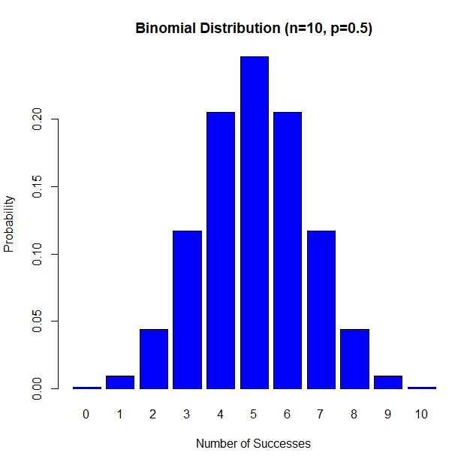

(b) Geometric Distribution
Definition: The geometric distribution models the number of trials until the first success occurs.
Example Use Case:
- Cold Calling in Sales: A salesperson makes calls until they get a sale. The number of calls before success follows a geometric distribution.
- Website Clicks Before Conversion: How many times a user visits a website before making a purchase.
Formula:
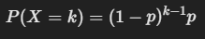
where:
- p = probability of success per trial
- k = trial number where the first success occurs

Visualization
Let's visualize a geometric distribution for p=0.2:

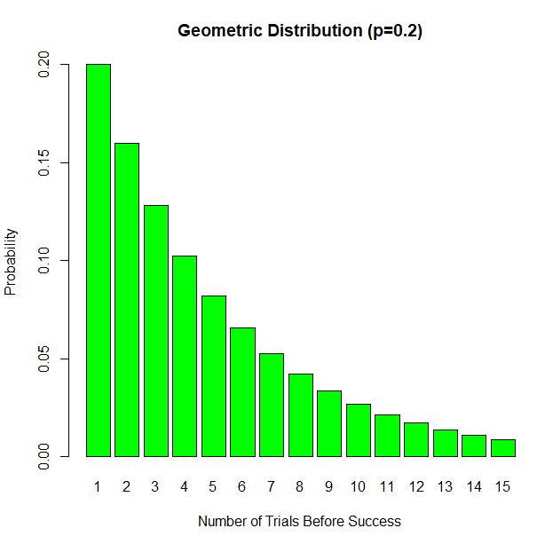

(c) Poisson Distribution
Definition: The Poisson distribution models the number of events occurring in a fixed time or space when events occur independently.
Example Use Case:
- Call Center Incoming Calls: The number of calls a call center receives per hour.
- Accidents on a Highway: The number of accidents occurring on a road in a day.
- Website Traffic: The number of visitors to a website per minute.
Formula:
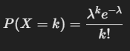
where:
- λ = expected number of events per time unit
- k = number of occurrences

Visualization
For λ=5, a Poisson distribution would look like this:

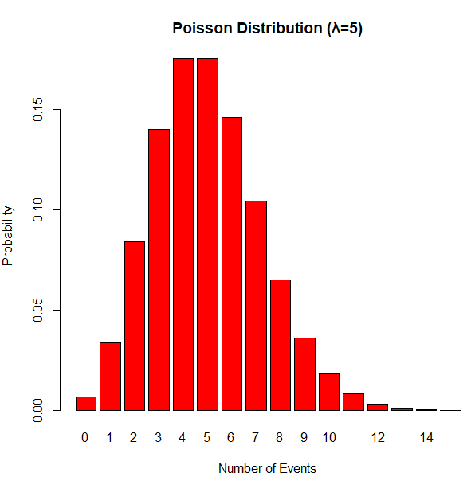

(d) Exponential Distribution
Definition: The exponential distribution models the time between consecutive events in a Poisson process.
Example Use Case:
- Time Between Customer Arrivals: If customers arrive randomly at a store, the time between arrivals follows an exponential distribution.
- Time Until Machine Failure: If a machine has a constant failure rate, the time between failures follows an exponential distribution.
- Waiting Time in Queues: The time a customer waits in line at a bank.
Formula:
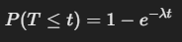
where:
- λ = rate of occurrence
- t = time

Visualization
For λ=1:

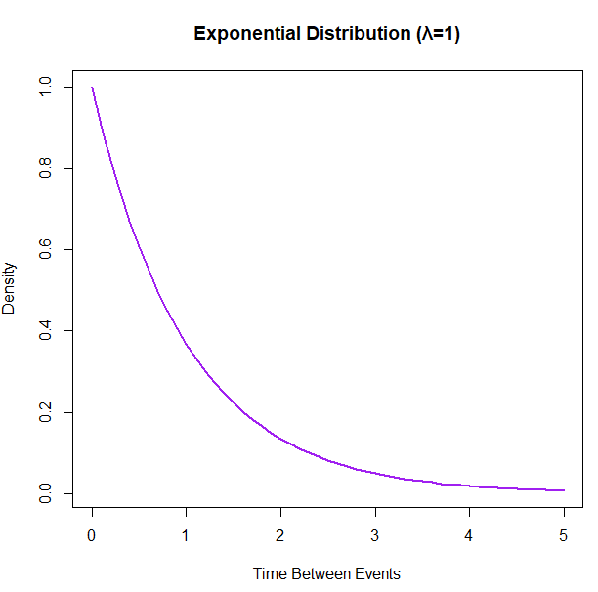

(e) Weibull Distribution
Definition: The Weibull distribution is a generalization of the exponential distribution and is often used for reliability analysis and failure times.
Example Use Case:
- Lifespan of Electronic Components: The time until a laptop battery fails.
- Weather Forecasting: Wind speed measurements often follow a Weibull distribution.
- Material Strength Analysis: The breaking strength of a material under stress.
Formula:
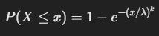
where:
- k = shape parameter
- λ = scale parameter

Visualization
For k=2, λ=1:

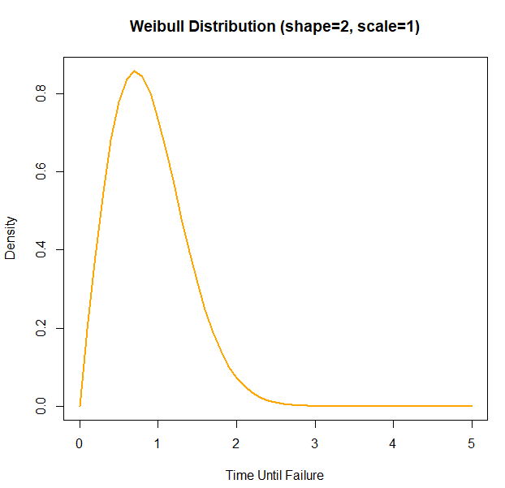

Code:
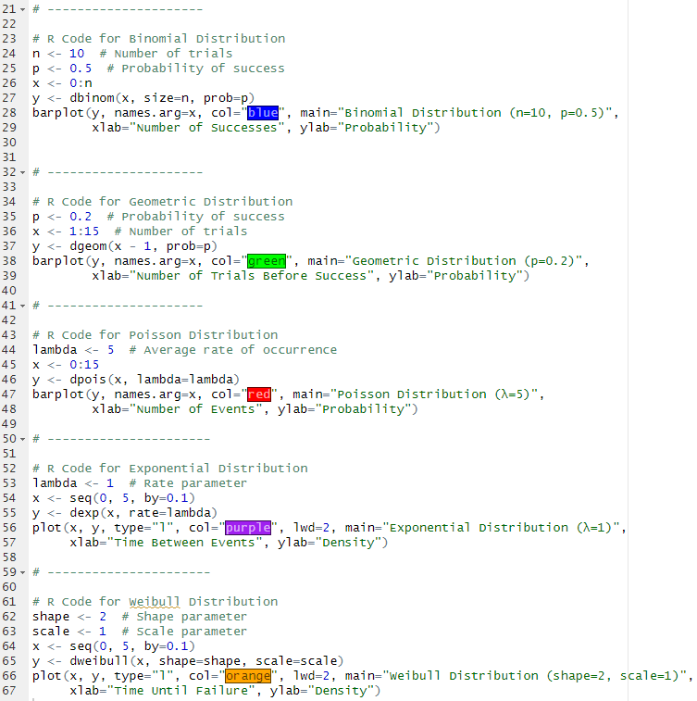

Question 13.2 In this problem you, can simulate a simplified airport security system at a busy airport. Passengers arrive according to a Poisson distribution with λ1 = 5 per minute (i.e., mean interarrival rate μ1 = 0.2 minutes) to the ID/boarding-pass check queue, where there are several servers who each have exponential service time with mean rate μ2 = 0.75 minutes. [Hint: model them as one block that has more than one resource.] After that, the passengers are assigned to the shortest of the several personal-check queues, where they go through the personal scanner (time is uniformly distributed between 0.5 minutes and 1 minute). Use the Arena software (PC users) or Python with SimPy (PC or Mac users) to build a simulation of the system, and then vary the number of ID/boarding-pass checkers and personal-check queues to determine how many are needed to keep average wait times below 15 minutes. [If you’re using SimPy, or if you have access to a non-student version of Arena, you can use λ1 = 50 to simulate a busier airport.]
Answer:
We will simulate an airport security system using SimPy in Python.

Simulation Details
- Passenger Arrivals: Poisson distributed (λ = 5 per minute)
- ID Check Service Time: Exponential (mean = 0.75 minutes)
- Personal Scanner Time: Uniform (0.5 to 1 minute)
- Goal: Determine how many ID checkers and scanners are needed to keep the average wait time below 15 minutes.
Code:
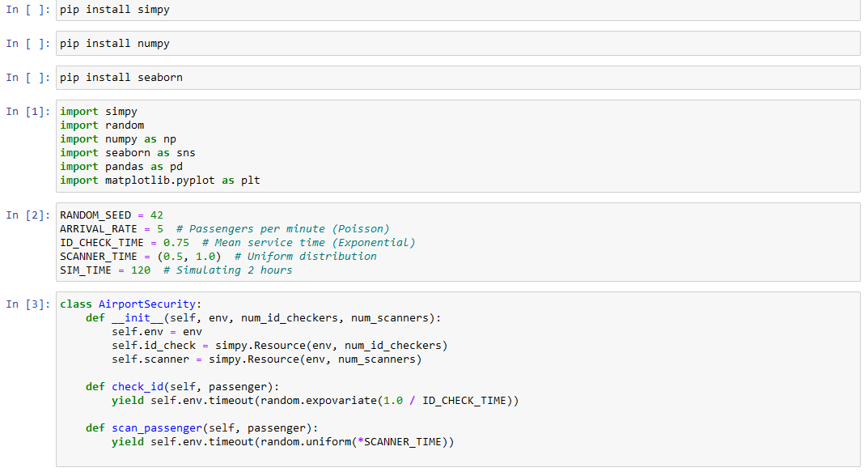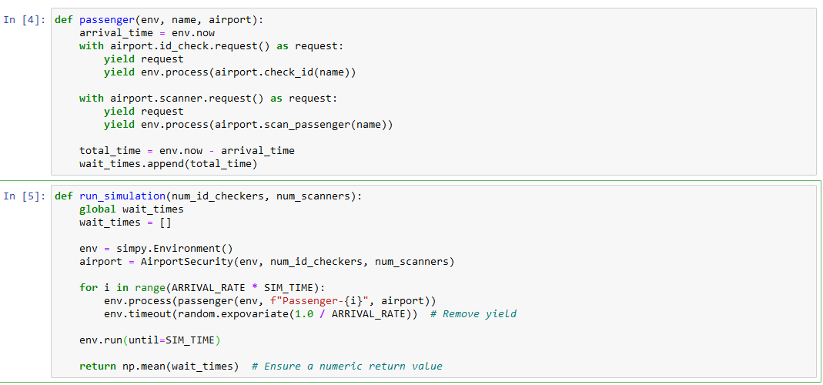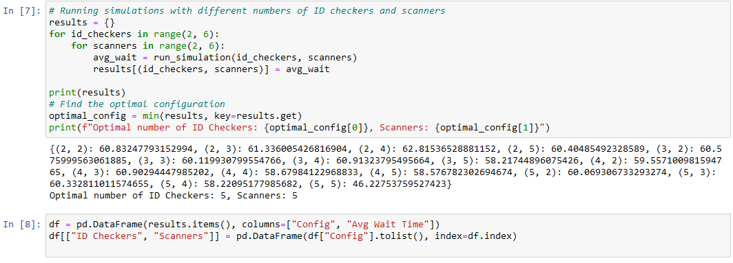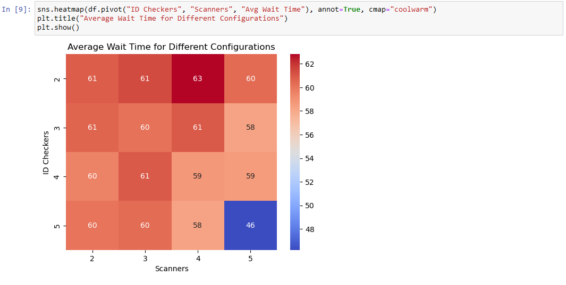

Insights from the Heatmap and Optimal Configuration Analysis

1. Understanding the Heatmap:
- The heatmap visualizes average wait times for different combinations of ID Checkers (rows) and Scanners (columns).
- Darker red cells represent higher wait times, while blue cells represent lower wait times.
- The highest wait time (~63) occurs at (2 ID Checkers, 4 Scanners).
- The lowest wait time (~46) occurs at (5 ID Checkers, 5 Scanners).

2. General Trends:
- More ID Checkers & More Scanners Reduce Wait Time
  - Increasing the number of ID checkers and scanners generally leads to lower wait times.
  - However, some configurations (e.g., (2,5) = 60.4) show that just adding scanners may not always be effective.
- Bottlenecks Impact Efficiency
  - When there are too few ID Checkers (e.g., 2), increasing scanners doesn't always help.
    - Example: (2,4) = 62.81 (higher than (2,3) = 61.33), suggesting that too many scanners may not be useful without sufficient ID checkers.
  - When both ID Checkers and Scanners are increased, efficiency improves significantly.
    - The best reduction happens at (5,5) = 46.2.

3. Why is (5,5) the Optimal Configuration?
- Lowest wait time (46.2 minutes) among all configurations.
- Efficient distribution of workload across checkers and scanners.
- Avoids overloading any one part of the process (e.g., ID checkers being too few to process incoming passengers).

4. Recommendations:
- For Maximum Efficiency: (5,5) is the best choice since it drastically lowers wait times.
- If resources are limited:
  - (4,4) or (4,5) configurations (~58.5 min) are also decent alternatives.
  - Avoid configurations with too few ID Checkers (e.g., 2 or 3) as they result in inefficient scanning.

Conclusion:
The optimal configuration of (5 ID Checkers, 5 Scanners) is well justified based on the results. This setup provides the lowest passenger wait time and maximizes throughput.

