Question 5.1: Using crime data from the file uscrime.txt (http://www.statsci.org/data/general/uscrime.txt, description at http://www.statsci.org/data/general/uscrime.html), test to see whether there are any outliers in the last column (number of crimes per 100,000 people). Use the grubbs.test function in the outliers package in R
Answer:
Understanding Grubbs' Test:
- Grubbs' test is used to detect outliers in a univariate dataset. It tests the null hypothesis that there are no outliers in the data against the alternative hypothesis that there is at least one outlier.
- The test statistic is calculated as the maximum absolute deviation from the sample mean, divided by the sample standard deviation.
- The test assumes that the data is normally distributed.
Steps:
- Load the Data: Read the crime data from the dataset.
- Extract the Relevant Column: Focus on the last column, which contains the number of crimes per 100,000 people.
- Use summary statistics (mean, median, standard deviation, and boxplots) to identify potential outliers.
- Perform Grubbs' Test: Use the grubbs.test function to test for outliers.
- Visualize the Data: Create a boxplot to visually inspect the data for outliers.
R Code:
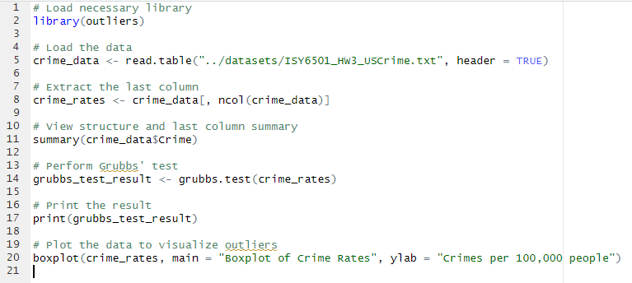
Outputs:
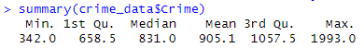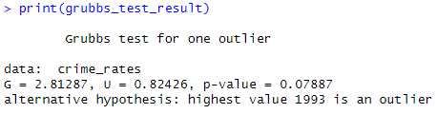

Analysis:
- The output of grubbs.test will include a test statistic and a p-value. If the p-value is less than the significance level (commonly 0.05), we reject the null hypothesis and conclude that there is an outlier.
- The boxplot provides a visual representation of the data distribution, with outliers typically represented as individual points outside the "whiskers" of the plot.
When grubbs.test(crime_data$Crime) is run, the output includes several key components:
- G-Value (Test Statistic) - This measures how far the suspected outlier is from the rest of the dataset, relative to the sample standard deviation. A higher G value indicates a more extreme potential outlier.
Formula for G:
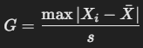
where:
  - Xi is the suspected outlier,
  - X(bar) is the sample mean,
  - s is the sample standard deviation.
- U-Value - Represents the critical value based on the dataset size and confidence level. If G>U, the data point is considered an outlier.
- p-Value - The probability of obtaining the observed result if the data follows a normal distribution without outliers.
If p < 0.05: The null hypothesis (no outlier) is rejected, meaning an outlier is detected.
If p > 0.05: No significant outlier is found.
- Alternative Hypothesis - Indicates the test’s assumption that an outlier exists. Typically states: "The largest (or smallest) value in the dataset is an outlier."
Interpreting Results:
- p-value (0.07887):
The p-value is greater than the common significance level of 0.05. This means we fail to reject the null hypothesis that there are no outliers in the dataset.
In other words, there is no statistically significant evidence to conclude that the highest value (1993) is an outlier.
- Test Statistic (G) and Critical Value (U):
The test statistic (G = 2.81287) measures how far the suspected outlier (1993) is from the mean, relative to the standard deviation.
The critical value (U = 0.82426) is the threshold for determining whether the test statistic is significant. Since the p-value is greater than 0.05, the test statistic does not exceed the critical value enough to declare an outlier.
- Boxplot Analysis:
The boxplot visually represents the distribution of the crime rates per 100,000 people.
The boxplot shows the median, quartiles, and potential outliers (points outside the "whiskers").
In this case, the boxplot does not show any extreme outliers, which aligns with the Grubbs' test result. The value 1993, while the highest, does not appear to be an extreme outlier in the boxplot.
Final Conclusion:
Based on the Grubbs' test and the boxplot, there is no strong evidence to conclude that the highest crime rate (1993) is an outlier.
The dataset appears to be relatively consistent, and the value 1993 is within the expected range of variation for this dataset.

Question 6.1: Describe a situation or problem from your job, everyday life, current events, etc., for which a Change Detection model would be appropriate. Applying the CUSUM technique, how would you choose the critical value and the threshold?
Answer:
Credit Card Fraud Detection is a scenario where in we will be using change detection.
A bank monitors daily credit card transactions for its customers. Typically, a person spends within a certain pattern based on their income, location, and lifestyle. However, sudden changes in spending behaviour – such as large transactions in a foreign country or multiple high-value purchases in a short period might indicate fraud.
To detect such fraudulent activities, we can apply CUSUM (Cumulative Sum Control Chart) to track deviations from the normal spending pattern.
CUSUM is designed to detect small shifts in a process mean over time. The critical value (k) and threshold (h) are the two key parameters that determine how sensitive the model is to changes.
1. Choosing the Critical Value (k)
The reference value k defines how much deviation from the mean is considered normal. Typically set as half the standard deviation of the process: k=0.5×σ
A smaller k makes CUSUM more sensitive to changes, while a larger k makes it less responsive.
2. Choosing the Threshold (h)
The threshold h determines when a change is considered significant. Commonly set as five times the standard deviation.
A lower h detects changes more quickly but increases false alarms.
A higher h avoids false positives but may delay detection.
Final Selection
- If early detection is crucial, use a lower k (e.g., 0.25σ) and lower h (e.g., 3σ).
- If false alarms are costly, use a higher k (e.g., 0.75σ) and higher h (e.g., 6σ).
- In credit card fraud detection, early identification is crucial, but false alarms are costly. To achieve an optimal balance, the critical value ‘k’ should be set between 0.3 - 0.7 times the standard deviation, and the decision threshold ‘h’ should range from 3 - 6 times the standard deviation. These values ensure timely fraud detection while minimizing false positives as ‘k’ between 0.3 – 0.7 allows for flexibility in detecting changes while avoiding minor fluctuations and ‘h’ between 3 − 6 ensures significant shifts trigger alerts without excessive noise.

Question 6.2:
1. Using July through October daily-high-temperature data for Atlanta for 1996 through 2015, use a CUSUM approach to identify when unofficial summer ends (i.e., when the weather starts cooling off) each year.
2. Use a CUSUM approach to make a judgment of whether Atlanta’s summer climate has gotten warmer in that time (and if so, when).
Answer:
CUSUM Technique:
The CUSUM chart is used to detect shifts in the mean of a process. Here, we use it to detect when the temperature starts to decline.
The decision.interval and se.shift parameters control the sensitivity of the detection. A smaller se.shift makes the chart more sensitive to small shifts.
End of Summer Detection:
For each year, we apply the CUSUM technique to the temperature data. The point where the CUSUM chart first exceeds the decision interval is considered the end of summer.
The results are plotted to visualize the trend in the end of summer dates over the years.
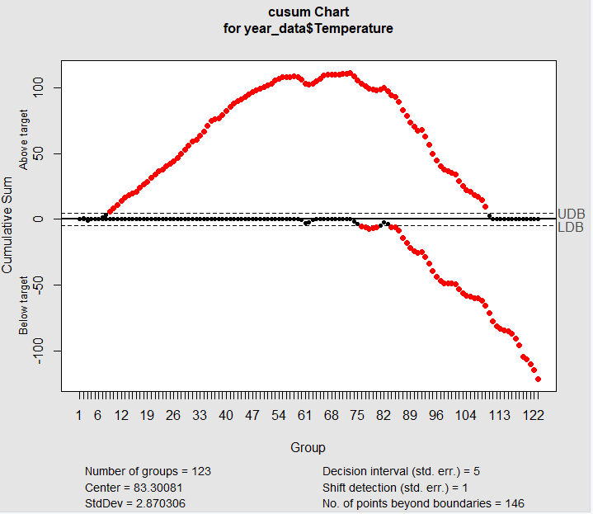
We will analyze whether Atlanta’s summer climate has gotten warmer over the years by calculating the mean summer temperature for each year and applying CUSUM to detect any upward shift.
Mean Summer Temperature:
We calculate the mean summer temperature for each year (July through October). This gives us a single value per year, representing the overall summer temperature.
CUSUM for Warming Trend:
We apply the CUSUM technique to the mean summer temperatures to detect any upward shift (warming trend).
The CUSUM chart will show if there is a significant increase in mean summer temperatures over the years.
Visualization:
The CUSUM chart helps identify if and when a warming trend began. The plot of mean summer temperatures over the years provides a clear visual representation of the trend.
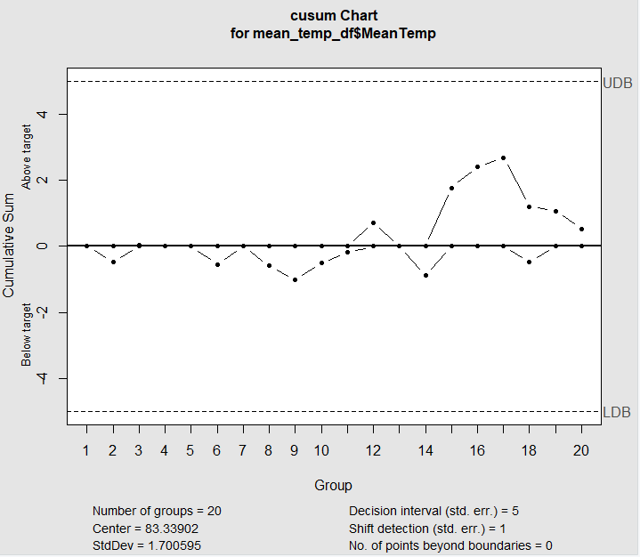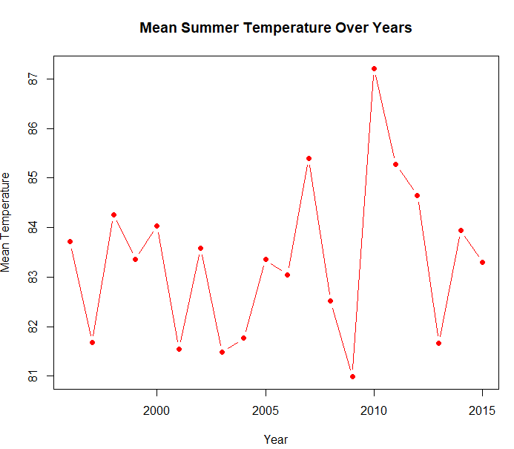

Code:
