Question 7.1: Describe a situation or problem from your job, everyday life, current events, etc., for which exponential smoothing would be appropriate. What data would you need? Would you expect the value of α (the first smoothing parameter) to be closer to 0 or 1, and why?
Answer:
Scenario for Exponential Smoothing
A good example where exponential smoothing would be useful is forecasting daily website traffic. Many businesses need to predict future traffic for capacity planning, marketing strategies, or server optimization.
Required Data:
- Daily visitor counts over time
- Historical trends, including seasonal variations (e.g., weekends vs. weekdays)
- Potential external factors like marketing campaigns
Choice of α (Smoothing Parameter)
- If the traffic fluctuates a lot (high volatility) → α should be closer to 1 to give more weight to recent observations.
- If the traffic follows a stable pattern → α should be closer to 0 to smooth out short-term noise and emphasize long-term trends.
- For website traffic, a moderate α (e.g., 0.2 to 0.5) may be appropriate depending on historical data behavior.

Question 7.2: Using the 20 years of daily high temperature data for Atlanta (July through October) from Question 6.2 (file temps.txt), build and use an exponential smoothing model to help make a judgment of whether the unofficial end of summer has gotten later over the 20 years.
Answer:
We will analyze 20 years of daily high-temperature data for Atlanta (July–October) using exponential smoothing to determine whether the unofficial end of summer has shifted later over time. In order to proceed, firstly we will understand what is Exponential Smoothing Model.
Exponential Smoothing Model
Exponential Smoothing (ES) is a time series forecasting method that applies weighted averages to past observations, with weights that exponentially decrease over time. It is widely used for short-term forecasting because it effectively captures trends and seasonal patterns. Let us now understand the two functions in R to perform exponential smoothing.
Smooth Package’s es() Function
The es() function from the smooth R package implements Exponential Smoothing models in a flexible way, supporting multiple ETS (Error, Trend, Seasonality) models.
Key Parameters:
- model: Defines the model type (e.g., "ZZZ" for automatic selection, "ANA" for additive error, no trend, and additive seasonality).
- h: Forecast horizon (number of future points to predict).
- holdout: If TRUE, a portion of data is reserved for validation.
- interval: Controls prediction intervals (e.g., "prediction", "confidence").
- silent: If FALSE, provides detailed output.
HoltWinters Function
The Holt-Winters model is an extension of exponential smoothing that accounts for both trend and seasonality in time series data. It has two main variations:
Additive: Best for constant seasonal variations.
Multiplicative: Best when seasonal variations increase with time.
The model is defined by three smoothing parameters:
α (alpha): Controls the level smoothing.
β (beta): Controls the trend smoothing.
γ (gamma): Controls the seasonal component smoothing.
The HoltWinters() function implements the Holt-Winters method for time series forecasting.
Key Parameters:
x: Time series object.
alpha: Level smoothing parameter (0 to 1).
beta: Trend smoothing parameter (0 to 1).
gamma: Seasonal smoothing parameter (0 to 1).
seasonal: Type of seasonality ("additive" or "multiplicative").
Analysis:
Here is the raw data visualized to provide a more clear understanding of the dataset.
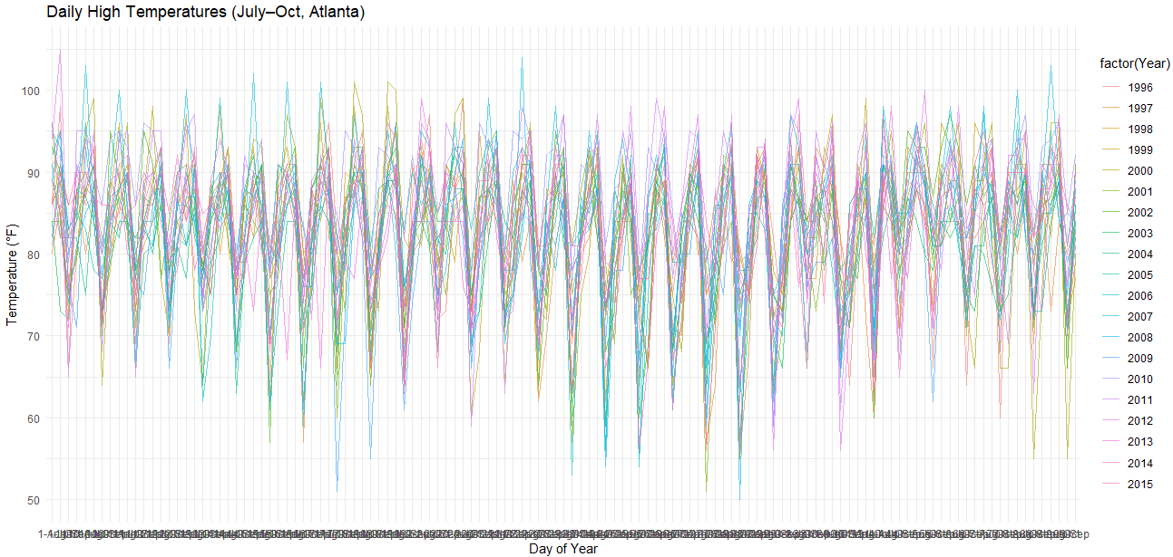
Plotting the temp data as a time series from 1996 to 2015 we get the following graph:
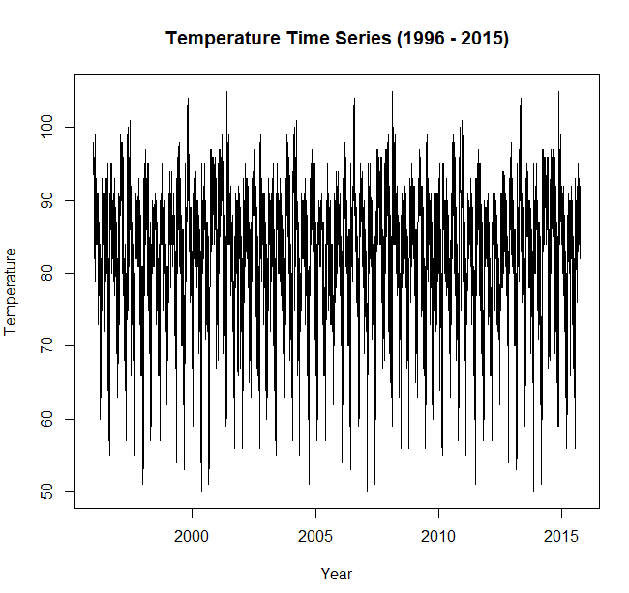
Here is the list of parameters for the Holt-Winters Exponential Smoothing
Holt-Winters exponential smoothing with trend and additive seasonal component.

Call:
HoltWinters(x = temps_ts, beta = TRUE, gamma = TRUE)

Smoothing parameters:
alpha: 0.9405835
beta : TRUE
gamma: TRUE

Here is the plot for after the smoothing:
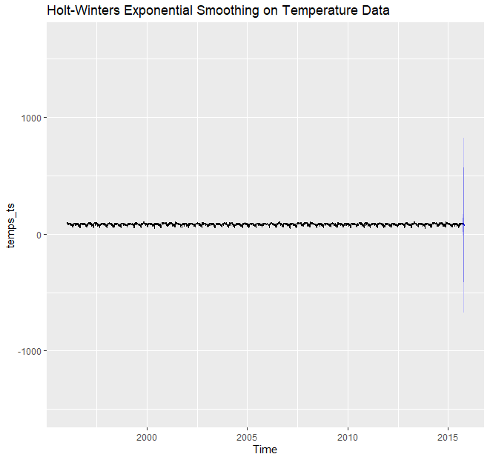

On applying the ES function of Smooth package we get:
Time elapsed: 76.66 seconds
Model estimated using es() function: ETS(AAM)
With optimal initialisation
Distribution assumed in the model: Normal
Loss function type: likelihood; Loss function value: 25151.85
Persistence vector g:
alpha beta gamma
0.0183 0.0000 0.0002

Sample size: 7205
Number of estimated parameters: 370
Number of degrees of freedom: 6835
Information criteria:
AIC AICc BIC BICc
51043.69 51083.87 53590.23 53768.65

Along with the plot:
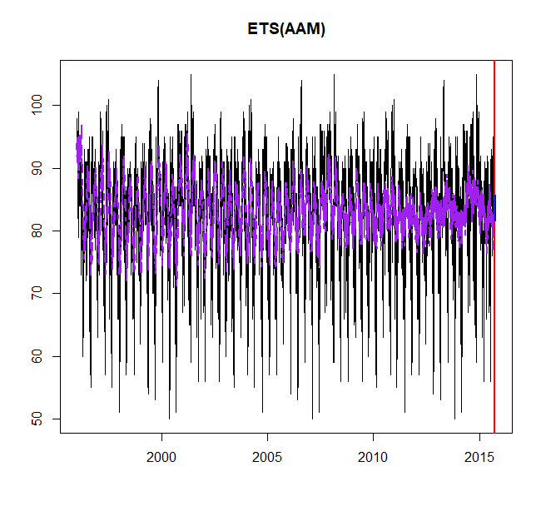
Conclusion:

Analysing the trend we can generate the plot:
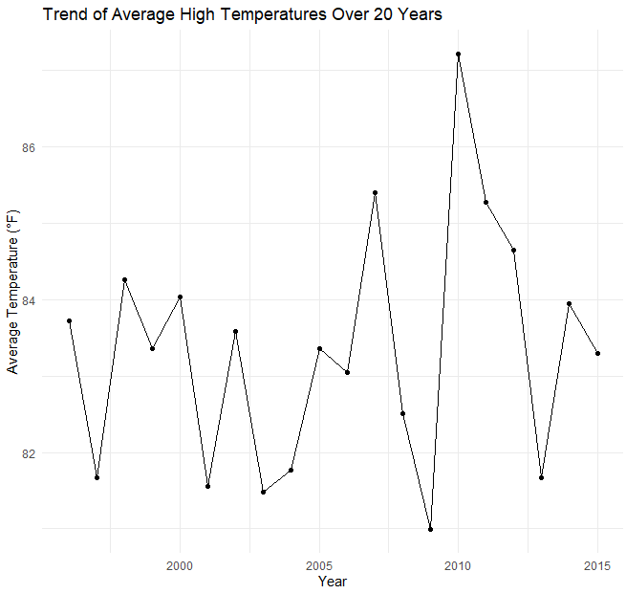
It can thus be concluded that the end of summer has gotten later over the 20 years.

Code:

