Question 2.1
Describe a situation or problem from your job, everyday life, current events, etc., for which a classification model would be appropriate. List some (up to 5) predictors that you might use.
Scenario
A binary classification model can be used to predict whether an email is spam or not.
Predictors
Presence of specific keywords associated with spam emails (e.g., "free," "win," "urgent").
Number of capitalized words and grammatical errors.
Length of the email (number of characters or words).
Sender's domain (trusted vs. unknown).
Presence of suspicious links or attachments.
Question 2.2
Using the support vector machine function ksvm contained in the R package kernlab, find a good classifier for this data. Show the equation of your classifier, and how well it classifies the data points in the full data set.
Answer:
General Equation:
f(x) = w⋅x + b
where,
w = weights (i.e. a1, a2, a3, …, am)
b = intercept (i.e. a0)
Best Weights (a1, a2, a3, …, a15) calculated from the model
Best Intercept b = -0.08966825
Best C = 0.001584893
Best Accuracy = 0.8669725

Since we are using the C-SVM, which is C-Support Vector Classification, we use a hyper parameter “C”. The C hyperparameter tells the SVM optimization how much you want to avoid misclassifying each training example. For large values of C, the optimization will choose a smaller-margin hyperplane if that hyperplane does a better job of getting all the training points classified correctly. Conversely, a very small value of C will cause the optimizer to look for a larger-margin separating hyperplane, even if that hyperplane misclassifies more points. For very tiny values of C, you should get misclassified examples, often even if your training data is linearly separable. [1]
We can plot the model accuracy with respect to value of C to understand how the model works.

Plot (Accuracy – Log10( C ))
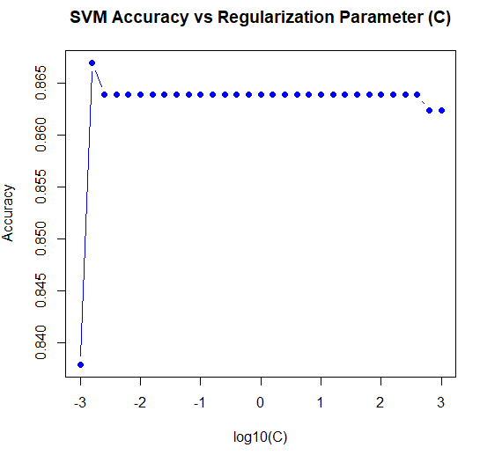

Code:
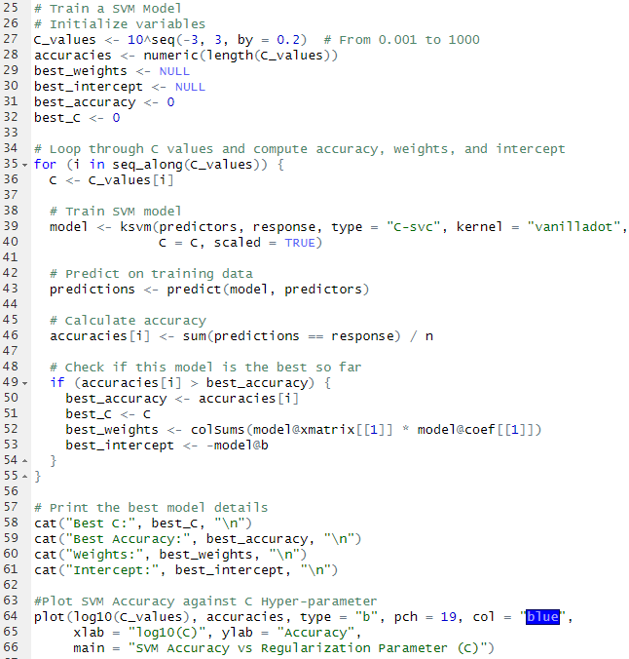

2. Using the k-nearest-neighbors classification function kknn contained in the R kknn package, suggest a good value of k, and show how well it classifies that data points in the full data set.
Answer:

K | Accuracy | K | Accuracy
3 | 0.8149847 | 12 | 0.853211
4 | 0.8149847 | 13 | 0.851682
5 | 0.851682 | 14 | 0.851682
6 | 0.8455657 | 15 | 0.853211
7 | 0.8470948 | 16 | 0.851682
8 | 0.8486239 | 17 | 0.851682
9 | 0.8470948 | 18 | 0.851682
10 | 0.8501529 | 19 | 0.8501529
11 | 0.851682 | 20 | 0.8501529
Accuracy values for different values of K
Best K value = 12
Best Accuracy = 0.853211
Plot of Accuracy against K values
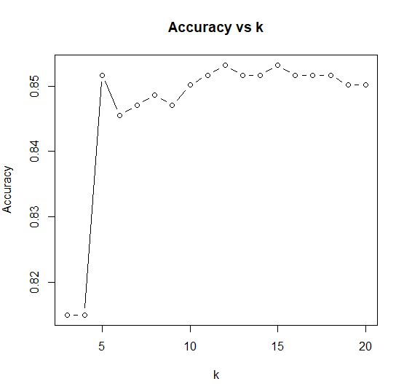
Code:
