Question 3.1.
Using the same data set (credit_card_data.txt or credit_card_data-headers.txt) as in Question 2.2, use the ksvm or kknn function to find a good classifier:
- using cross-validation (do this for the k-nearest-neighbors model; SVM is optional)
- splitting the data into training, validation, and test data sets (pick either KNN or SVM; the other is optional)
Answer:
For this question, I have gone ahead with KNN as my model of choice to simply the process of explanation and produce a tangible output that can be used to draw meaningful insights from. In order to proceed with finding a good classifier, we need to first understand what cross-validation is.
Cross validation is a technique used in machine learning to evaluate the performance of a model on unseen data. It involves dividing the available data into multiple folds or subsets, using one of these folds as a validation set, and training the model on the remaining folds. This process is repeated multiple times, each time using a different fold as the validation set. Finally, the results from each validation step are averaged to produce a more robust estimate of the model’s performance.

Data Preparation
Load Data: The dataset is loaded using read.table and assumes a tabular format with headers.
Remove Missing Values: Missing rows are dropped using na.omit to ensure a clean dataset.
Separate Predictors and Response:
predictors: All columns except the last one.
response: The last column, converted to a factor since it’s a categorical variable.

Part (a): k-NN with Cross-Validation
Cross-Validation Setup (trainControl):
method = "cv": Specifies k-fold cross-validation.
number = 10: 10 folds of cross-validation.
Cross-validation divides the data into 10 parts, training the model on 9 parts and validating on the remaining part. This is repeated for all folds, and results are averaged.
I have chosen 10 fold cross-validation since: A smaller number of folds (e.g., 3) leads to higher bias as the training set is smaller. A larger number of folds (e.g., 20) leads to higher variance since each fold uses a smaller test set. 10-fold cross-validation provides a good trade-off between bias and variance, making it a commonly recommended default.
As part of developing the model, the following actions are done:
- Grid Search (expand.grid): A tuning grid for hyper parameters is created. In this case, it searches over different values of k (number of neighbours), ranging from 1 to 15 in steps of 2.
- Training the Model (train): The train function uses kknn to fit the model. The tuneGrid specifies the hyperparameter grid. trControl passes the cross-validation settings.
- Selecting the Best k: knn_model$bestTune: Returns the best value of k based on cross-validation accuracy.
- Visualization: A plot shows how the accuracy varies with k, helping understand which value of k is optimal.

Best k from cross-validation:
kmax: 3
distance: 5
kernel: 2 Optimal
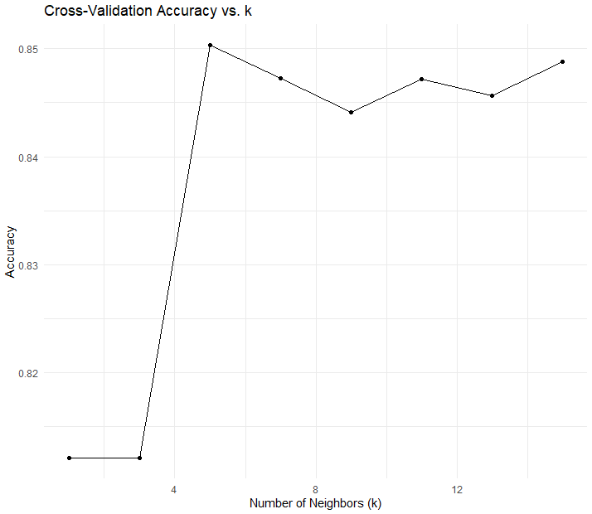

From the above activity we have identified a suitable value that we can use to test, train and validate the model. For the part (b), we need to create a split for train and validation.
Part (b): Data Splitting
- Training, Validation, and Test Sets:
createDataPartition: Splits the data into 60% training and the remaining 40% is split equally into validation and test sets.
- Train the Model (kknn):
Uses the best k from cross-validation.
Includes other parameters like distance = 2 (Euclidean distance) and kernel = "optimal".

The validation results for the model are stored in the variable conf_matrix, which shows the following results:
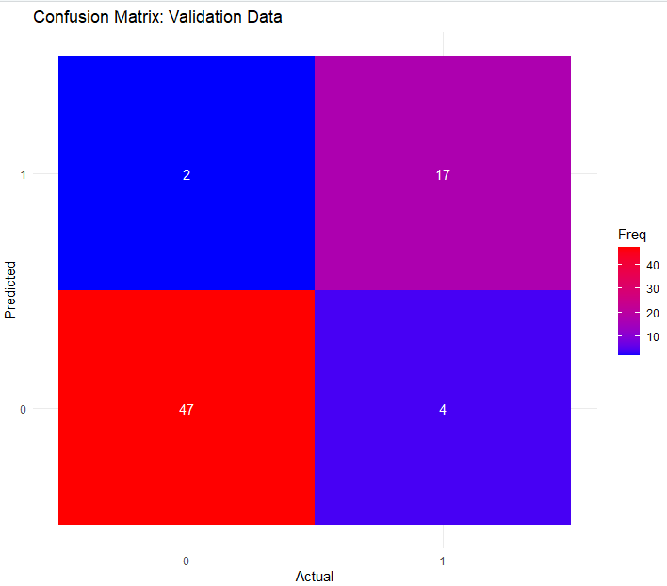
Statistics
Accuracy | 0.9143
95% CI | (0.8227, 0.9679)
No Information Rate | 0.7
P-Value [Acc > NIR] | 1.47E-05
Kappa | 0.7902
Mcnemar's Test P-Value | 0.6831
Sensitivity | 0.9592
Specificity | 0.8095
Pos Pred Value | 0.9216
Neg Pred Value | 0.8947
Prevalence | 0.7
Detection Rate | 0.6714
Detection Prevalence | 0.7286
Balanced Accuracy | 0.8844
Positive' Class | 0

Question 4.1
Describe a situation or problem from your job, everyday life, current events, etc., for which clustering model would be appropriate. List some (up to 5) predictors that you might use.
Answer:
We want to categorize customers based on their purchasing habits to create targeted marketing campaigns. This can help identify distinct customer segments with similar preferences, improving customer satisfaction and driving sales.
Predictors to use:
Average Purchase Value: The average amount spent by a customer per transaction.
Purchase Frequency: The number of purchases made within a specific time frame (e.g., monthly, quarterly).
Product Categories: The types of products a customer frequently buys (e.g., electronics, clothing, groceries).
Purchase Channel: Whether customers tend to buy online, in-store, or via mobile app.
Customer Demographics: Age, gender, or location, which could provide insights into customer preferences.
Question 4.2
Use the R function k-means to cluster the points as well as possible. Report the best combination of predictors, your suggested value of k, and how well your best clustering predicts flower type.
Answer
In order to apply the K-Means clustering and find the optimal ‘k’ value, we can leverage the “Elbow Method” which is a technique used to determine the optimal number of clusters (k) in clustering algorithms such as k-means. It helps balance the trade-off between the number of clusters and the explained variance, aiming to find a value of k that is neither too small nor too large.
As part of the elbow method, I am doing the following:
- Measure Within-Cluster Sum of Squares (WSS):
For each value of k (number of clusters), calculating the Within-Cluster Sum of Squares (WSS), which quantifies how compact the clusters are.
WSS decreases as k increases because adding more clusters reduces the distances within each cluster.
- Plot WSS vs. k:
Creating a plot with k values on the x-axis and WSS on the y-axis.
The plot typically shows a sharp decline in WSS initially, followed by a plateau.
- Find the "Elbow":
The elbow is the point where the rate of decrease in WSS slows significantly.
This point indicates the optimal k, as increasing k beyond this does not substantially improve cluster compactness.
To understand which ‘k’ value is the most suitable for the model, I am running the model for different values of ‘k’ from k=2 to k=10. The reason we are limiting our values of ‘k’ between 2 and 10 is because for lower than 2 there is no classification happening and for more than 10 it is highly likely to come to a situation where every point will correspond to a category, which will give us a situation of over-fitting.
This is the results from the run:

For k = 2 Misclassifications: 50
Cluster |  |  |  | setosa |  |  |  |  |  | versicolor |  |  |  |  |  | virginica
1 |  |  |  | 50 |  |  |  |  |  | 0 |  |  |  |  |  | 0
2 |  |  |  | 0 |  |  |  |  |  | 50 |  |  |  |  |  | 50
For k = 3 Misclassifications: 25
Cluster | setosa |  |  |  |  |  | versicolor |  |  |  |  |  | virginica
1 | 0 |  |  |  |  |  | 39 |  |  |  |  |  | 14
2 | 50 |  |  |  |  |  | 0 |  |  |  |  |  | 0
3 | 0 |  |  |  |  |  | 11 |  |  |  |  |  | 36
For k = 4 Misclassifications: 25
Cluster |  | setosa |  |  |  |  |  | versicolor |  |  |  |  |  | virginica
1 |  | 0 |  |  |  |  |  | 11 |  |  |  |  |  | 36
2 |  | 28 |  |  |  |  |  | 0 |  |  |  |  |  | 0
3 |  | 22 |  |  |  |  |  | 0 |  |  |  |  |  | 0
4 |  | 0 |  |  |  |  |  | 39 |  |  |  |  |  | 14
For k = 5 Misclassifications: 25
Cluster |  |  | setosa |  |  |  |  |  | versicolor |  |  |  |  |  | virginica
1 |  |  | 25 |  |  |  |  |  | 0 |  |  |  |  |  | 0
2 |  |  | 0 |  |  |  |  |  | 2 |  |  |  |  |  | 27
3 |  |  | 25 |  |  |  |  |  | 0 |  |  |  |  |  | 0
4 |  |  | 0 |  |  |  |  |  | 27 |  |  |  |  |  | 21
5 |  |  | 0 |  |  |  |  |  | 21 |  |  |  |  |  | 2
For k = 6 Misclassifications: 25
Cluster |  |  | setosa |  |  |  |  |  | versicolor |  |  |  |  |  | virginica
1 |  |  | 0 |  |  |  |  |  | 27 |  |  |  |  |  | 21
2 |  |  | 0 |  |  |  |  |  | 21 |  |  |  |  |  | 2
3 |  |  | 0 |  |  |  |  |  | 2 |  |  |  |  |  | 27
4 |  |  | 12 |  |  |  |  |  | 0 |  |  |  |  |  | 0
5 |  |  | 17 |  |  |  |  |  | 0 |  |  |  |  |  | 0
6 |  |  | 21 |  |  |  |  |  | 0 |  |  |  |  |  | 0
For k = 7 Misclassifications: 27
Cluster |  |  |  | setosa |  |  |  |  |  | versicolor |  |  |  |  |  | virginica
1 |  |  |  | 0 |  |  |  |  |  | 19 |  |  |  |  |  | 2
2 |  |  |  | 0 |  |  |  |  |  | 22 |  |  |  |  |  | 16
3 |  |  |  | 17 |  |  |  |  |  | 0 |  |  |  |  |  | 0
4 |  |  |  | 0 |  |  |  |  |  | 9 |  |  |  |  |  | 20
5 |  |  |  | 12 |  |  |  |  |  | 0 |  |  |  |  |  | 0
6 |  |  |  | 21 |  |  |  |  |  | 0 |  |  |  |  |  | 0
7 |  |  |  | 0 |  |  |  |  |  | 0 |  |  |  |  |  | 12
For k = 8 Misclassifications: 10
Cluster |  |  |  |  | setosa |  |  |  |  |  | versicolor |  |  |  |  |  | virginica
1 |  |  |  |  | 0 |  |  |  |  |  | 0 |  |  |  |  |  | 20
2 |  |  |  |  | 0 |  |  |  |  |  | 0 |  |  |  |  |  | 12
3 |  |  |  |  | 0 |  |  |  |  |  | 27 |  |  |  |  |  | 5
4 |  |  |  |  | 0 |  |  |  |  |  | 19 |  |  |  |  |  | 1
5 |  |  |  |  | 12 |  |  |  |  |  | 0 |  |  |  |  |  | 0
6 |  |  |  |  | 21 |  |  |  |  |  | 0 |  |  |  |  |  | 0
7 |  |  |  |  | 0 |  |  |  |  |  | 4 |  |  |  |  |  | 12
8 |  |  |  |  | 17 |  |  |  |  |  | 0 |  |  |  |  |  | 0
For k = 9 Misclassifications: 17
Cluster |  |  |  |  |  | setosa |  |  |  |  |  | versicolor |  |  |  |  |  | virginica
1 |  |  |  |  |  | 0 |  |  |  |  |  | 18 |  |  |  |  |  | 15
2 |  |  |  |  |  | 21 |  |  |  |  |  | 0 |  |  |  |  |  | 0
3 |  |  |  |  |  | 0 |  |  |  |  |  | 19 |  |  |  |  |  | 2
4 |  |  |  |  |  | 0 |  |  |  |  |  | 0 |  |  |  |  |  | 3
5 |  |  |  |  |  | 17 |  |  |  |  |  | 0 |  |  |  |  |  | 0
6 |  |  |  |  |  | 12 |  |  |  |  |  | 0 |  |  |  |  |  | 0
7 |  |  |  |  |  | 0 |  |  |  |  |  | 0 |  |  |  |  |  | 20
8 |  |  |  |  |  | 0 |  |  |  |  |  | 0 |  |  |  |  |  | 10
9 |  |  |  |  |  | 0 |  |  |  |  |  | 13 |  |  |  |  |  | 0
For k = 10 Misclassifications: 8
Cluster |  |  |  |  |  | setosa |  |  |  |  |  | versicolor |  |  |  |  |  | virginica
1 |  |  |  |  |  | 12 |  |  |  |  |  | 0 |  |  |  |  |  | 0
2 |  |  |  |  |  | 0 |  |  |  |  |  | 14 |  |  |  |  |  | 4
3 |  |  |  |  |  | 21 |  |  |  |  |  | 0 |  |  |  |  |  | 0
4 |  |  |  |  |  | 0 |  |  |  |  |  | 0 |  |  |  |  |  | 3
5 |  |  |  |  |  | 0 |  |  |  |  |  | 0 |  |  |  |  |  | 16
6 |  |  |  |  |  | 0 |  |  |  |  |  | 2 |  |  |  |  |  | 16
7 |  |  |  |  |  | 0 |  |  |  |  |  | 18 |  |  |  |  |  | 0
8 |  |  |  |  |  | 0 |  |  |  |  |  | 16 |  |  |  |  |  | 2
9 |  |  |  |  |  | 0 |  |  |  |  |  | 0 |  |  |  |  |  | 9
10 |  |  |  |  |  | 17 |  |  |  |  |  | 0 |  |  |  |  |  | 0

This can be summarized as a barplot as:
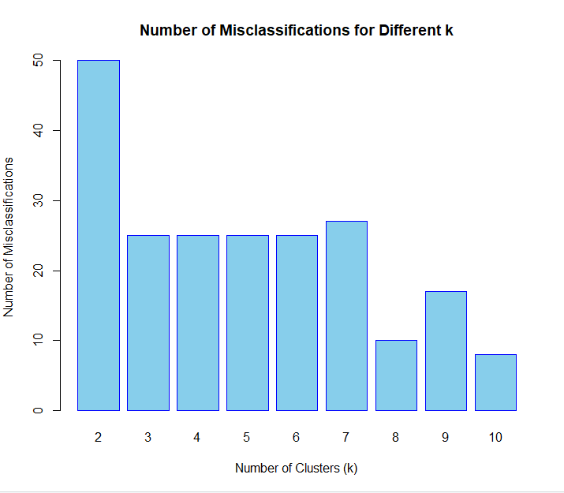

As we can see we see a there is a threshold at k=3, where not much change happens in the model prediction and its misclassification. This can allow us to safely assume that the threshold of k=3 is optimal. This can also be seen through the analysis of the elbow threshold line graph as below:
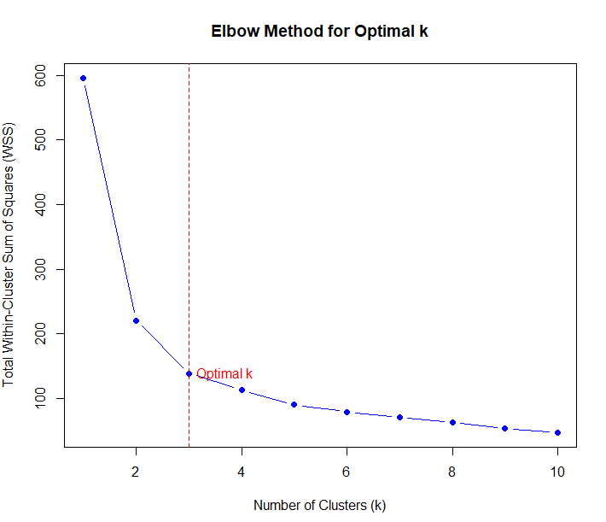
Thus we can conclude these:
Optimal K Value: 3
Confusion Matrix for k=3:
Cluster | setosa | versicolor | virginica
1 | 50 | 0 | 0
2 | 0 | 11 | 36
3 | 0 | 39 | 14

