AI-Generated Visual Content, Source Judgement, and Media Trust
Class 3, Group 6
Zheng Xing, Zhang Gaoxiang, Xiong Yubo, Wang Dexing

Abstract
Recent image-generation models can produce realistic photographs, readable text, and interface-like screenshots. This development creates a practical problem for online media trust because images and screenshots are often treated as evidence in everyday digital communication. This paper examines how university-level respondents judged AI-generated and real visual materials and how much they trusted different types of online images. The paper uses a mixed evidence design: previous experimental studies provide the main research background, while a small-scale Wenjuanxing survey supplies supplementary local evidence. The survey included 18 image-only stimuli across five visual categories: text-bearing visual artifacts, portraits, livestream commerce screenshots, food photographs, and virtual livestream interfaces. After screening, 66 valid responses were analyzed. The overall source-judgement accuracy was 47.4%, with higher accuracy for AI-generated images (52.9%) than for real images or screenshots (41.9%). Trust ratings were moderate: real images received a slightly higher mean trust rating (M = 2.99) than AI-generated images (M = 2.70). These findings suggest that the problem is not only that users may believe AI-generated images, but also that they may become suspicious of real visual evidence. The paper argues that platform labels, content provenance systems, and media literacy education should address both fake images and fake visual contexts.
Keywords: AI-generated images; media trust; screenshots; misinformation; visual evidence

1. Introduction
Generative AI is no longer limited to producing obviously artificial images. Current image-generation tools can produce photorealistic scenes, readable text, and interface-like layouts. OpenAI’s GPT Image 2, for example, is described in official API documentation as a state-of-the-art image generation model for high-quality generation and editing (OpenAI, 2026a). This technical development matters socially because online images are often treated as evidence. A screenshot of a livestream, a social media post, or a chat interface does not merely look like a picture; it appears to carry platform context, comments, prices, usernames, and other cues of authenticity.
This paper focuses on the changing status of visual evidence in an environment where images and screenshots are increasingly easy to generate. Previous research has shown that people often struggle to distinguish AI-generated media from human-created or real media (Frank et al., 2024; Roca et al., 2025). Other studies have shown that realistic AI-synthesized images can make misinformation more persuasive when the images seem to provide evidence for a claim (Guo et al., 2025). At the same time, screenshots occupy a special position in online communication because they are frequently circulated as visual proof rather than as ordinary photographs (Inwood & Zappavigna, 2024).
The central question of this paper is therefore: How accurately did university-level respondents distinguish AI-generated images from real images across common online visual categories, and how did their trust ratings differ by image source and category? To answer this question, the paper combines two forms of evidence. First, it reviews previous studies on synthetic media detection, misinformation, and visual evidence. Second, it reports a small-scale Wenjuanxing survey conducted by the group. Because the local survey has a limited sample size and purposively selected materials, it should be interpreted as supplementary exploratory evidence rather than as a representative experiment. Its value is to connect published research with a concrete classroom-scale investigation of image judgement and media trust.

2. Literature Review

2.1 High-Fidelity AI Images and Screenshot-Like Visuals
The capacity to generate realistic synthetic media has expanded rapidly since the mid-2010s, driven by advances in generative adversarial networks, diffusion models, and multimodal AI systems (Brundage et al., 2018). Image-generation tools have also moved from specialist software into everyday platforms, lowering the cost of producing convincing visual content. Official OpenAI documentation describes GPT Image 2 as a model that supports high-quality image generation and editing and can take text and image inputs (OpenAI, 2026a). For the present paper, the important point is not the technical architecture of any single model, but the broader social consequence: high-fidelity image generation makes synthetic visual content less dependent on obvious visual errors.
AI-generated images are also no longer limited to standalone photographs. They can imitate text-bearing and interface-bearing visuals, such as product cards, posters, livestream screens, chat windows, and screenshot-like artifacts. These formats matter because they are often consumed as contextual evidence. A livestream commerce screenshot, for example, may include comments, prices, avatars, platform icons, discount labels, and a host. Such details can make viewers feel that they are seeing a trace of a real online event rather than a constructed image. As a result, the social risk of AI image generation includes both fake photographs and fake visual contexts.

2.2 Human Ability to Detect AI-Generated Images
A growing body of empirical research suggests that unaided human detection of AI-generated content is limited. Nightingale and Farid (2022) found that AI-synthesized faces were difficult to distinguish from real faces and were even rated as more trustworthy. This finding is important because it challenges the assumption that realism and trustworthiness are reliable signals of authenticity.
Frank et al. (2024) conducted a cross-national study with participants from the United States, Germany, and China. Participants were exposed to AI-generated and human-created media across text, image, and audio modalities and asked to classify each item. The study found that many participants performed close to chance level, and demographic or media-literacy variables did not reliably guarantee accurate detection. In the image domain specifically, Roca et al. (2025) analyzed a large online detection experiment and found that human performance varied across visual categories. These findings indicate that image detection should not be treated as a single uniform ability. Instead, performance may depend on the type of image, the viewer’s expectations, and the cues available in the visual material.

2.3 Screenshots, Visual Evidence, and Media Trust
Research on misinformation and online credibility helps explain why AI-generated visual content can affect trust. False and misleading information can spread widely online (Lazer et al., 2018; Vosoughi et al., 2018), and users often rely on fast credibility cues rather than systematic verification (Metzger & Flanagin, 2013; Pennycook & Rand, 2021). Visual cues are especially powerful because they can make an online claim feel concrete.
Screenshots are a particularly important form of visual evidence. Inwood and Zappavigna (2024) argue that screenshots often legitimize online claims because they appear to preserve a record of a platform event. The screenshot format can make a post, message, or livestream look traceable and shareable. This helps explain why AI-generated screenshots may be persuasive even when viewers are generally aware that synthetic media exists.
The problem also extends to misinformation. Guo et al. (2025) found that realistic AI-synthesized images increased belief in false headlines when the images appeared to provide strong evidence for the claim. DiResta and Goldstein (2024) documented the use of AI-generated images by spammers and scammers on Facebook for audience growth. These studies suggest that synthetic visual content is not only a future risk but already part of platform communication.
Content provenance and labeling systems are relevant responses, but they are incomplete on their own. OpenAI’s current help documentation describes the use of C2PA metadata and SynthID watermarks in OpenAI-generated images (OpenAI, 2026b). Such systems may help users identify AI-generated content, but ordinary users often encounter images after reposting, cropping, compression, screenshotting, or platform re-uploading. Therefore, technical provenance should be combined with user education and platform-level moderation rather than treated as a complete solution.

3. Methodology

3.1 Research Design
This paper uses a mixed evidence design. Previous empirical studies provide the main background for understanding human detection limits and the social effects of synthetic visual media. The group survey provides supplementary local evidence about how a university-level sample judged AI-generated and real online images. This design is appropriate because the local survey is small and exploratory, while the published studies offer broader evidence from larger samples and more controlled experiments.
The local survey focused on two connected questions. First, how accurately did respondents in this sample distinguish AI-generated images from real images across selected online visual categories? Second, how did perceived trust differ by image source and visual category?

3.2 Participants
Participants were recruited through convenience sampling and completed the survey online through Wenjuanxing. A total of 79 responses were collected. Ten responses failed the Q42 attention-check item, and three attention-check passers reported “high school or below” as their current education level. These responses were excluded from the main analysis so that the analytic sample matched the study’s university-level focus. The final analytic sample therefore included 66 valid respondents.
Within the analytic sample, 26 respondents were first-year students, 14 were second-year students, 10 were third-year students, and 16 were fourth-year-or-above students or recent graduates. Most respondents used social media for at least one hour per day, and most had used AI tools either daily or weekly.

3.3 Materials
The survey used image-only materials. It contained 18 visual items: nine AI-generated images and nine real images or screenshots. The materials covered five visual categories: text-bearing visual artifacts, portrait images, livestream commerce screenshots, food photographs, and virtual livestream interfaces. These categories were selected because they represent common forms of online visual content and because some of them contain platform contexts rather than only photographic subjects.
The materials were selected purposively rather than randomly. Therefore, they should not be treated as a statistically representative sample of all online images. Instead, they were designed to compare responses across selected types of online visual evidence. The participant-facing questionnaire did not reveal whether a file was AI-generated or real.
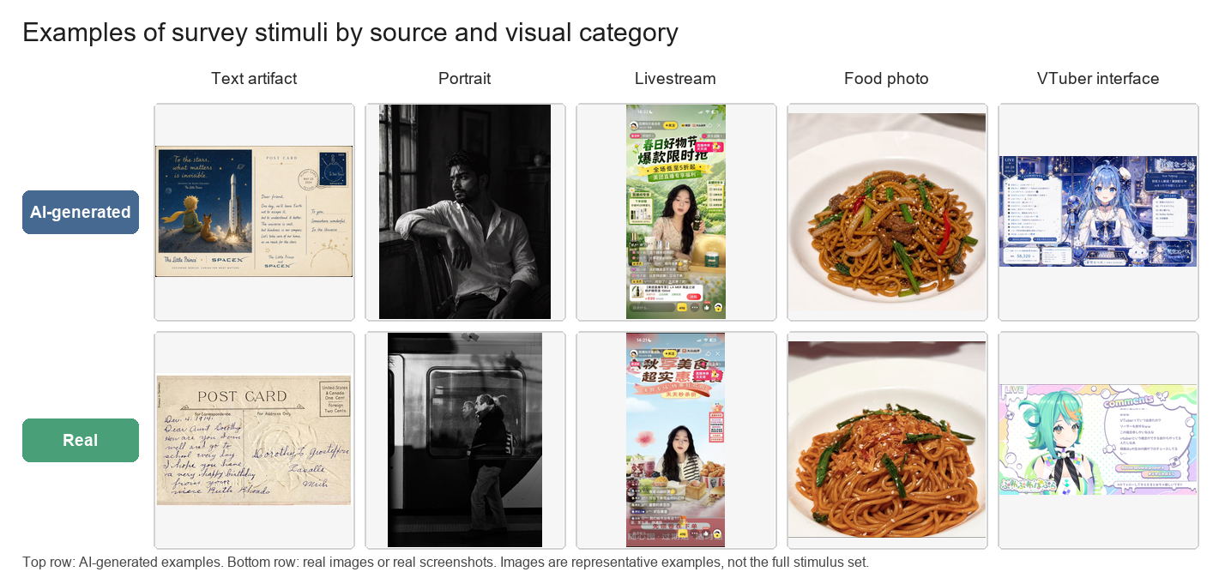
Figure 1. Examples of survey stimuli by source and visual category.

3.4 Procedure
The survey had three sections. First, participants reported their year of study, daily social media use, AI tool use, and self-assessed ability to identify AI-generated or edited online images. Second, participants completed the image task. For each image, they first judged whether the image was real or AI-generated and then rated how trustworthy the same image would seem if it appeared on social media or another online platform. Third, participants answered four media-trust attitude items, one attention-check item, and one optional open-ended question about the cues they used.
No feedback was given during the task so that later answers would not be influenced by earlier corrections. Because the study compared responses across visual categories, the Wenjuanxing version grouped materials of the same type together. During analysis, responses that failed the attention-check item were excluded before detection accuracy and trust scores were calculated.

3.5 Measures
Detection accuracy was calculated as the proportion of correctly classified source-judgement items. For binary accuracy scoring, “definitely real” and “probably real” were counted as correct for real images, while “probably AI-generated” and “definitely AI-generated” were counted as correct for AI-generated images. “Unsure” was treated as incorrect for the main accuracy score.
Trust was measured through one five-point rating for each visual item, from 1 (“not trustworthy at all”) to 5 (“very trustworthy”). Mean trust ratings were calculated by image source and by visual category. Additional attitude items measured general trust in online images and screenshots, the perceived credibility effect of interface elements, verification habits, and self-confidence in visual judgement.

4. Results

4.1 Survey Sample
The Wenjuanxing survey collected 79 responses. Of these, 69 responses passed the Q42 attention-check item, giving an attention-check pass rate of 87.3%. After excluding three attention-check passers who were outside the university-level target group, the final analytic sample included 66 valid responses.
Table 1. Sample screening and final analytic sample
Screening step | Responses
Submitted responses | 79
Passed Q42 attention check | 69
Excluded for non-university-level education | 3
Final analytic sample | 66

4.2 Source-Judgement Accuracy
Across all 18 image source-judgement items, the mean detection accuracy was 47.4%. Accuracy was higher for AI-generated images (52.9%) than for real images or screenshots (41.9%). This pattern indicates that respondents did not simply accept all images as real. Instead, many real images were also treated with suspicion and misclassified as AI-generated.
Table 2. Source-judgement accuracy by visual category
Image category | Accuracy
Livestream commerce screenshots | 58.3%
Text-bearing visual artifacts | 56.8%
Virtual livestream interfaces | 54.5%
Portrait images | 39.8%
Food photographs | 31.1%
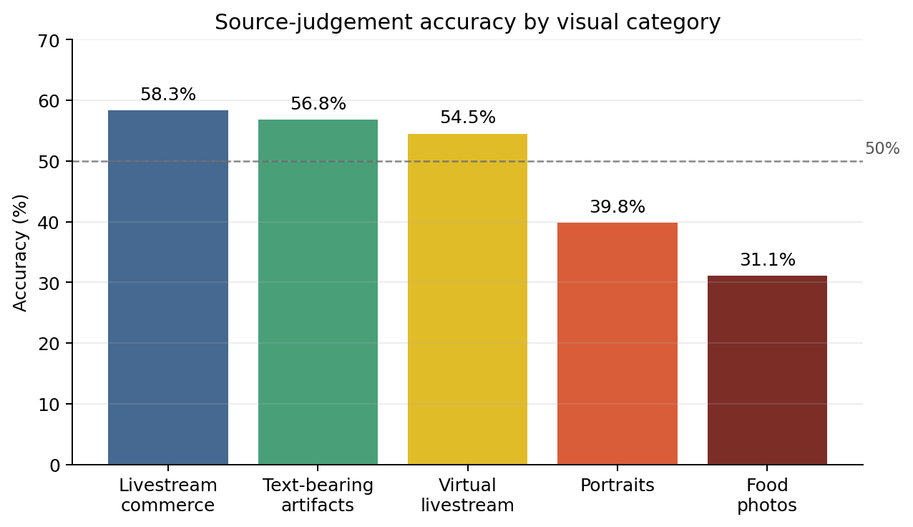
Figure 2. Source-judgement accuracy by visual category.

4.3 Trust Ratings and Attitudes
Trust ratings were measured on a five-point scale from 1 (“not trustworthy at all”) to 5 (“very trustworthy”). Real images received a slightly higher mean trust rating (M = 2.99) than AI-generated images (M = 2.70), but the difference was modest. By category, portrait images received the highest average trust rating (M = 3.14), followed by text-bearing visual artifacts (M = 2.98), virtual livestream interfaces (M = 2.73), livestream commerce screenshots (M = 2.70), and food photographs (M = 2.62).
Table 3. Mean trust ratings by image source and visual category
Group | Mean trust rating
AI-generated images | 2.70
Real images/screenshots | 2.99
Portrait images | 3.14
Text-bearing visual artifacts | 2.98
Virtual livestream interfaces | 2.73
Livestream commerce screenshots | 2.70
Food photographs | 2.62
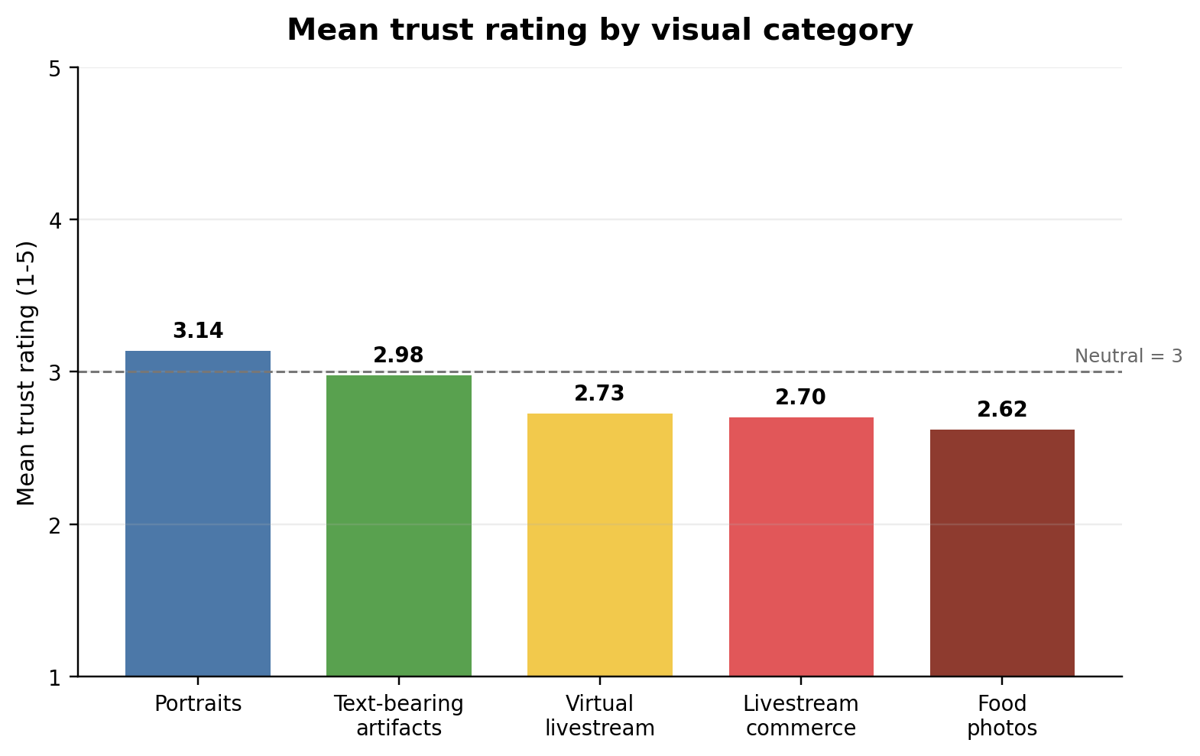
Figure 3. Mean trust rating by visual category.
The attitude items showed a cautious pattern of media trust. Respondents generally did not agree that online images and screenshots usually reflect reality (M = 2.39). At the same time, many respondents agreed that platform elements such as interfaces, comments, or livestream features can make screenshots more believable. Most respondents also reported verification habits: 42 out of 66 agreed or strongly agreed that they would look for sources or context when seeing realistic online images or screenshots.

5. Discussion

5.1 Summary of Findings
The local survey results are consistent with the broader literature on AI-generated media detection. The overall accuracy rate was below 50%, suggesting that respondents in this sample had difficulty distinguishing AI-generated images from real images. The source-level pattern is also important: respondents performed better on AI-generated images than on real images. This indicates that the problem was not only false acceptance of synthetic material, but also excessive suspicion toward authentic visual material.
Category-level results further support this interpretation. Livestream commerce screenshots, text-bearing artifacts, and virtual livestream interfaces produced higher accuracy than portraits and food photographs. Food photographs had the lowest accuracy, which may reflect the fact that polished food photography can look artificial even when it is real. Trust ratings were moderate rather than high, and the difference between real and AI-generated images was relatively small. This suggests that viewers may experience uncertainty even when they do not strongly trust the images.

5.2 Comparison with Previous Studies
The findings align with previous studies showing that human detection of AI-generated media is limited. Frank et al. (2024) found that many participants performed close to chance level across different media types. Roca et al. (2025) also showed that image detection performance varied by content type. The current survey is much smaller, but its descriptive results point in the same direction: general familiarity with AI tools does not automatically produce reliable detection ability.
The results also connect with research on misinformation and visual evidence. Guo et al. (2025) found that realistic AI-synthesized images can strengthen belief in misinformation when they appear to support a claim. In the present survey, AI-generated images did not receive high trust ratings overall, but they were sometimes trusted at levels close to real images. This matters because even moderate trust may be enough to make an online claim appear more credible.
Finally, the findings support Inwood and Zappavigna’s (2024) argument that screenshots often function as visual evidence. Respondents tended to agree that platform elements such as interfaces, comments, and livestream features can make screenshots more believable. Therefore, the risk of AI-generated visual misinformation should not be understood only as a problem of fake photographs. It should also be understood as a problem of fake platform context.

5.3 Possible Explanations
One possible explanation for the low overall accuracy is that respondents relied heavily on surface visual cues. Some real food photographs and portraits looked polished, staged, or digitally processed. Respondents may therefore have classified them as AI-generated. This helps explain why real images had lower accuracy than AI-generated images. The increasing presence of synthetic images may lead users not only to believe some false images but also to doubt real ones.
A second explanation is related to the survey materials. The images were selected purposively, not randomly. The set was designed to compare responses across selected visual categories, including ordinary photographs and screenshot-like images. This design made it possible to compare category-level patterns, but it also limits generalization. The results should therefore be treated as descriptive evidence from a small exploratory survey.
A third explanation concerns visual context. Screenshot-like materials contain contextual cues, such as usernames, comments, platform layout, product labels, prices, or livestream interfaces. These cues can make an image feel less like a standalone picture and more like a record of an online event. Even when viewers are uncertain about the source of an image, such contextual cues may increase the image’s perceived credibility.

5.4 Limitations and Implications
Several limitations should be acknowledged. First, the survey used a small convenience sample of university-level respondents, so the findings should not be generalized to all social media users. Second, the stimulus set contained only 18 images, and differences in topic, image quality, platform style, and visual familiarity may have influenced respondents’ judgements. Third, the original prompts used to generate the AI images were not preserved. Any later prompt appendix should therefore be described as reconstructed documentation rather than an exact record of the original generation process. Finally, because the study used descriptive statistics, it cannot establish causal relationships between image type, trust, and source judgement.
Despite these limitations, the findings have practical implications. Platforms and educators should not assume that users can reliably identify AI-generated images through visual inspection alone. Media literacy education should teach users to verify sources and contexts, not merely to search for visual flaws. Platform labels, content provenance systems, and watermarking may also help, but they should be treated as part of a broader response rather than as a complete solution. As images move across platforms, are compressed, edited, or screenshotted, the reliability of provenance signals may vary.

6. Conclusion
This paper examined AI-generated visual content, source judgement, and media trust through a combination of previous research and a small-scale local survey. The survey results suggest that university-level respondents did not reliably distinguish AI-generated images from real images. The overall accuracy rate was 47.4%, and real images were misclassified more often than AI-generated images. Trust ratings were also moderate, with only a small difference between real and AI-generated images.
The main implication is that the social risk of AI-generated visual content is broader than the production of false images. As synthetic images become more realistic, real visual evidence may also become easier to doubt. This is especially important for screenshot-like materials, which often carry platform cues that make them appear socially credible. Ordinary visual judgement is therefore insufficient for evaluating online images. A more effective response requires platform-level labeling, stronger provenance systems, verification habits, and media literacy education that addresses both fake images and fake visual contexts.

References
Brundage, M., Avin, S., Clark, J., Toner, H., Eckersley, P., Garfinkel, B., Dafoe, A., Scharre, P., Zeitzoff, T., Filar, B., Anderson, H., Roff, H., Allen, G. C., Steinhardt, J., Flynn, C., Héigeartaigh, S. Ó., Beard, S., Belfield, H., Farquhar, S., … Amodei, D. (2018). The malicious use of artificial intelligence: Forecasting, prevention, and mitigation. Future of Humanity Institute. https://arxiv.org/abs/1802.07228
DiResta, R., & Goldstein, J. A. (2024). How spammers and scammers leverage AI-generated images on Facebook for audience growth. Harvard Kennedy School Misinformation Review. https://doi.org/10.37016/mr-2020-151
Frank, J., Herbert, F., Ricker, J., Schönherr, L., Eisenhofer, T., Fischer, A., Dürmuth, M., & Holz, T. (2024). A representative study on human detection of artificially generated media across countries. Proceedings of the 45th IEEE Symposium on Security and Privacy. https://arxiv.org/abs/2312.05976
Guo, S., Zhong, Y., & Hu, X. (2025). People are more susceptible to misinformation with realistic AI-synthesized images that provide strong evidence to headlines. Harvard Kennedy School Misinformation Review. https://doi.org/10.37016/mr-2020-189
Inwood, O., & Zappavigna, M. (2024). The legitimation of screenshots as visual evidence in social media: YouTube videos spreading misinformation and disinformation. Visual Communication. https://doi.org/10.1177/14703572241255664
Lazer, D. M. J., Baum, M. A., Benkler, Y., Berinsky, A. J., Greenhill, K. M., Menczer, F., Metzger, M. J., Nyhan, B., Pennycook, G., Rothschild, D., Schudson, M., Sloman, S. A., Sunstein, C. R., Thorson, E. A., Watts, D. J., & Zittrain, J. L. (2018). The science of fake news. Science, 359(6380), 1094-1096. https://doi.org/10.1126/science.aao2998
Metzger, M. J., & Flanagin, A. J. (2013). Credibility and trust of information in online environments: The use of cognitive heuristics. Journal of Pragmatics, 59, 210-220. https://doi.org/10.1016/j.pragma.2013.07.012
Nightingale, S. J., & Farid, H. (2022). AI-synthesized faces are indistinguishable from real faces and more trustworthy. Proceedings of the National Academy of Sciences, 119(8), e2120481119. https://doi.org/10.1073/pnas.2120481119
OpenAI. (2026a). GPT Image 2 model. OpenAI API. https://developers.openai.com/api/docs/models/gpt-image-2
OpenAI. (2026b). C2PA and SynthID in OpenAI-generated images. OpenAI Help Center. https://help.openai.com/en/articles/8912793-c2pa-and-synthid-in-openai-generated-images
Pennycook, G., & Rand, D. G. (2021). The psychology of fake news. Trends in Cognitive Sciences, 25(5), 388-402. https://doi.org/10.1016/j.tics.2021.02.007
Roca, T., Cintron Roman, A., Torres Vega, J., Duarte, M., Wang, P., White, K., Misra, A., & Lavista Ferres, J. (2025). How good are humans at detecting AI-generated images? Learnings from an experiment. arXiv preprint. https://arxiv.org/abs/2507.18640
Vaccari, C., & Chadwick, A. (2020). Deepfakes and disinformation: Exploring the impact of synthetic political video on deception, uncertainty, and trust in news. Social Media + Society, 6(1). https://doi.org/10.1177/2056305120903408
Vosoughi, S., Roy, D., & Aral, S. (2018). The spread of true and false news online. Science, 359(6380), 1146-1151. https://doi.org/10.1126/science.aap9559

