
TONGJI UNIVERSITY

实验报告
实验名称 Development and Comparative Analysis of Dual-Model Large Language Model Dialogue Applications Based on Gradio
学 院 Computer Science and Technology
专 业 Software engineering
学生姓名 刘晴语 郑文希
学 号 2452545 2450857
指导教师 邓浩
日 期 2026.4.20

- Experimental title
Development and Comparative Analysis of Dual-Model Large Language Model Dialogue Applications Based on Gradio
- Experimental objective
The main goals of this experiment were to get the hang of calling APIs from different LLM providers, to build an interactive web interface using the Gradio framework, and to implement multi-turn conversation so we could really see how context management works. We also wanted to dig into the design differences between various LLM APIs and figure out how their parameters actually affect the results. Finally, the idea was to explore and come up with some best practices for prompt engineering across different real-world scenarios.
- Experimental principle
3.1 The principle of API invocation for large language models
Invoking large language model APIs essentially involves request-response interactions with RESTful services. Both providers in this experiment support the OpenAI-compatible format. In practice, authentication is performed by including an API key in the request headers. Conversations are structured as a list of message dictionaries, with each message specifying a "role" and its corresponding "content." It is important to note that different providers may have different parameter boundaries, so backend validation is required to ensure cross-model compatibility. Finally, parameters such as temperature can be adjusted to control the randomness of the generated text.
3.2 Gradio working principle
Gradio is an open-source library for rapidly building web interfaces for machine learning applications. It adopts a component-based design, encapsulating input and output elements into reusable modules. Underlying the framework is an event-driven mechanism, where functions are bound to interface components via decorators, enabling real-time interaction, supporting streaming responses and instant updates, and delivering a smooth user experience.
3.3 The implementation principle of multi-round dialogue
By maintaining the dialogue history record and taking complete context information as the input for each API call, the model can understand the previous dialogue content and make coherent responses.
- Experimental facilities
4.1 Hardware environment
Computer: x86_64 architectures, more than 8 gb of memory
Network: a stable Internet connection (for API call)
4.2 Software environment
Operating System: Windows 10/11
Python Version: 3.10
Libraries: gradio, openai
Development Tools: VS Code
Terminal: Command Prompt / PowerShell / Terminal
4.3 Main Software Dependencies
gradio==4.0.0 # Web interface framework
openai==1.0.0 # API client for LLM interaction
4.4 API Service Accounts
Alibaba Cloud DashScope Account​ (obtain DASHSCOPE_API_KEY)
Zhipu AI Open Platform Account​ (obtain ZHIPU_API_KEY)
- Experimental procedure
5.1 Environment Preparation Phase
Install Python Environment:​ Ensure that Python 3.10 or higher is correctly installed.
Create a Virtual Environment:
python -m venv llm_env
llm_env\Scripts\activate # Windows
5.2 Dependency Installation
pip install gradio openai
5.3 API Key Configuration
Obtain API Keys:
• Log in to the Alibaba Cloud DashScope console and create an API Key.
• Log in to the Zhipu AI Open Platform and create an API Key.
Set Environment Variables:
# Windows PowerShell
$env:DASHSCOPE_API_KEY="your_aliyun_key"
$env:ZHIPU_API_KEY="your_zhipu_key"
5.4 Code Implementation
Create the main program file:​ app.py
Import necessary libraries:
import os
import gradio as gr
from openai import OpenAI
Configure model parameters:
MODEL_CONFIGS = {
"阿里云-通义千问": {
"api_key": os.getenv("DASHSCOPE_API_KEY"),
"base_url": "https://dashscope.aliyuncs.com/compatible-mode/v1",
"model": "qwen-turbo"
},
"智谱AI-ChatGLM": {
"api_key": os.getenv("ZHIPU_API_KEY"),
"base_url": "https://open.bigmodel.cn/api/paas/v4/",
"model": "glm-4"
}
}
Implement the core interaction function:
Handle user input
Manage conversation history
Call the corresponding API
Process responses and errors
Build the Gradio interface:
Main chat window
Model selection dropdown
Temperature adjustment slider
Input box and action buttons
5.5 Application Testing
Launch the application:
python app.py
Functional Verification:
• Test the model switching function.
• Verify the continuity of multi-turn dialogues.
• Adjust the temperature parameter and observe changes in the output.
• Test exception handling (e.g., for invalid API Key).
5.6 Data Collection and Analysis
Record model responses under different parameters.
Compare the performance of the two models under the same prompts.
Analyze differences in response time and quality.
- Experimental phenomenon
screenshot of the application interface
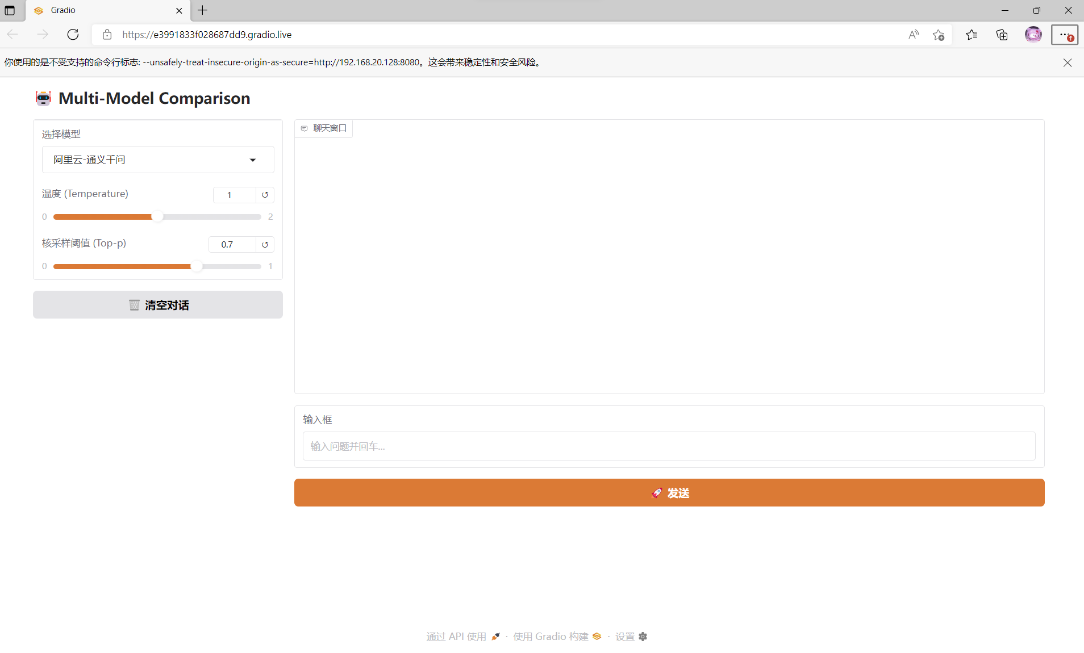
Dialogue process record diagram
A conversation with Alibaba Cloud and A conversation with Zhipu AI
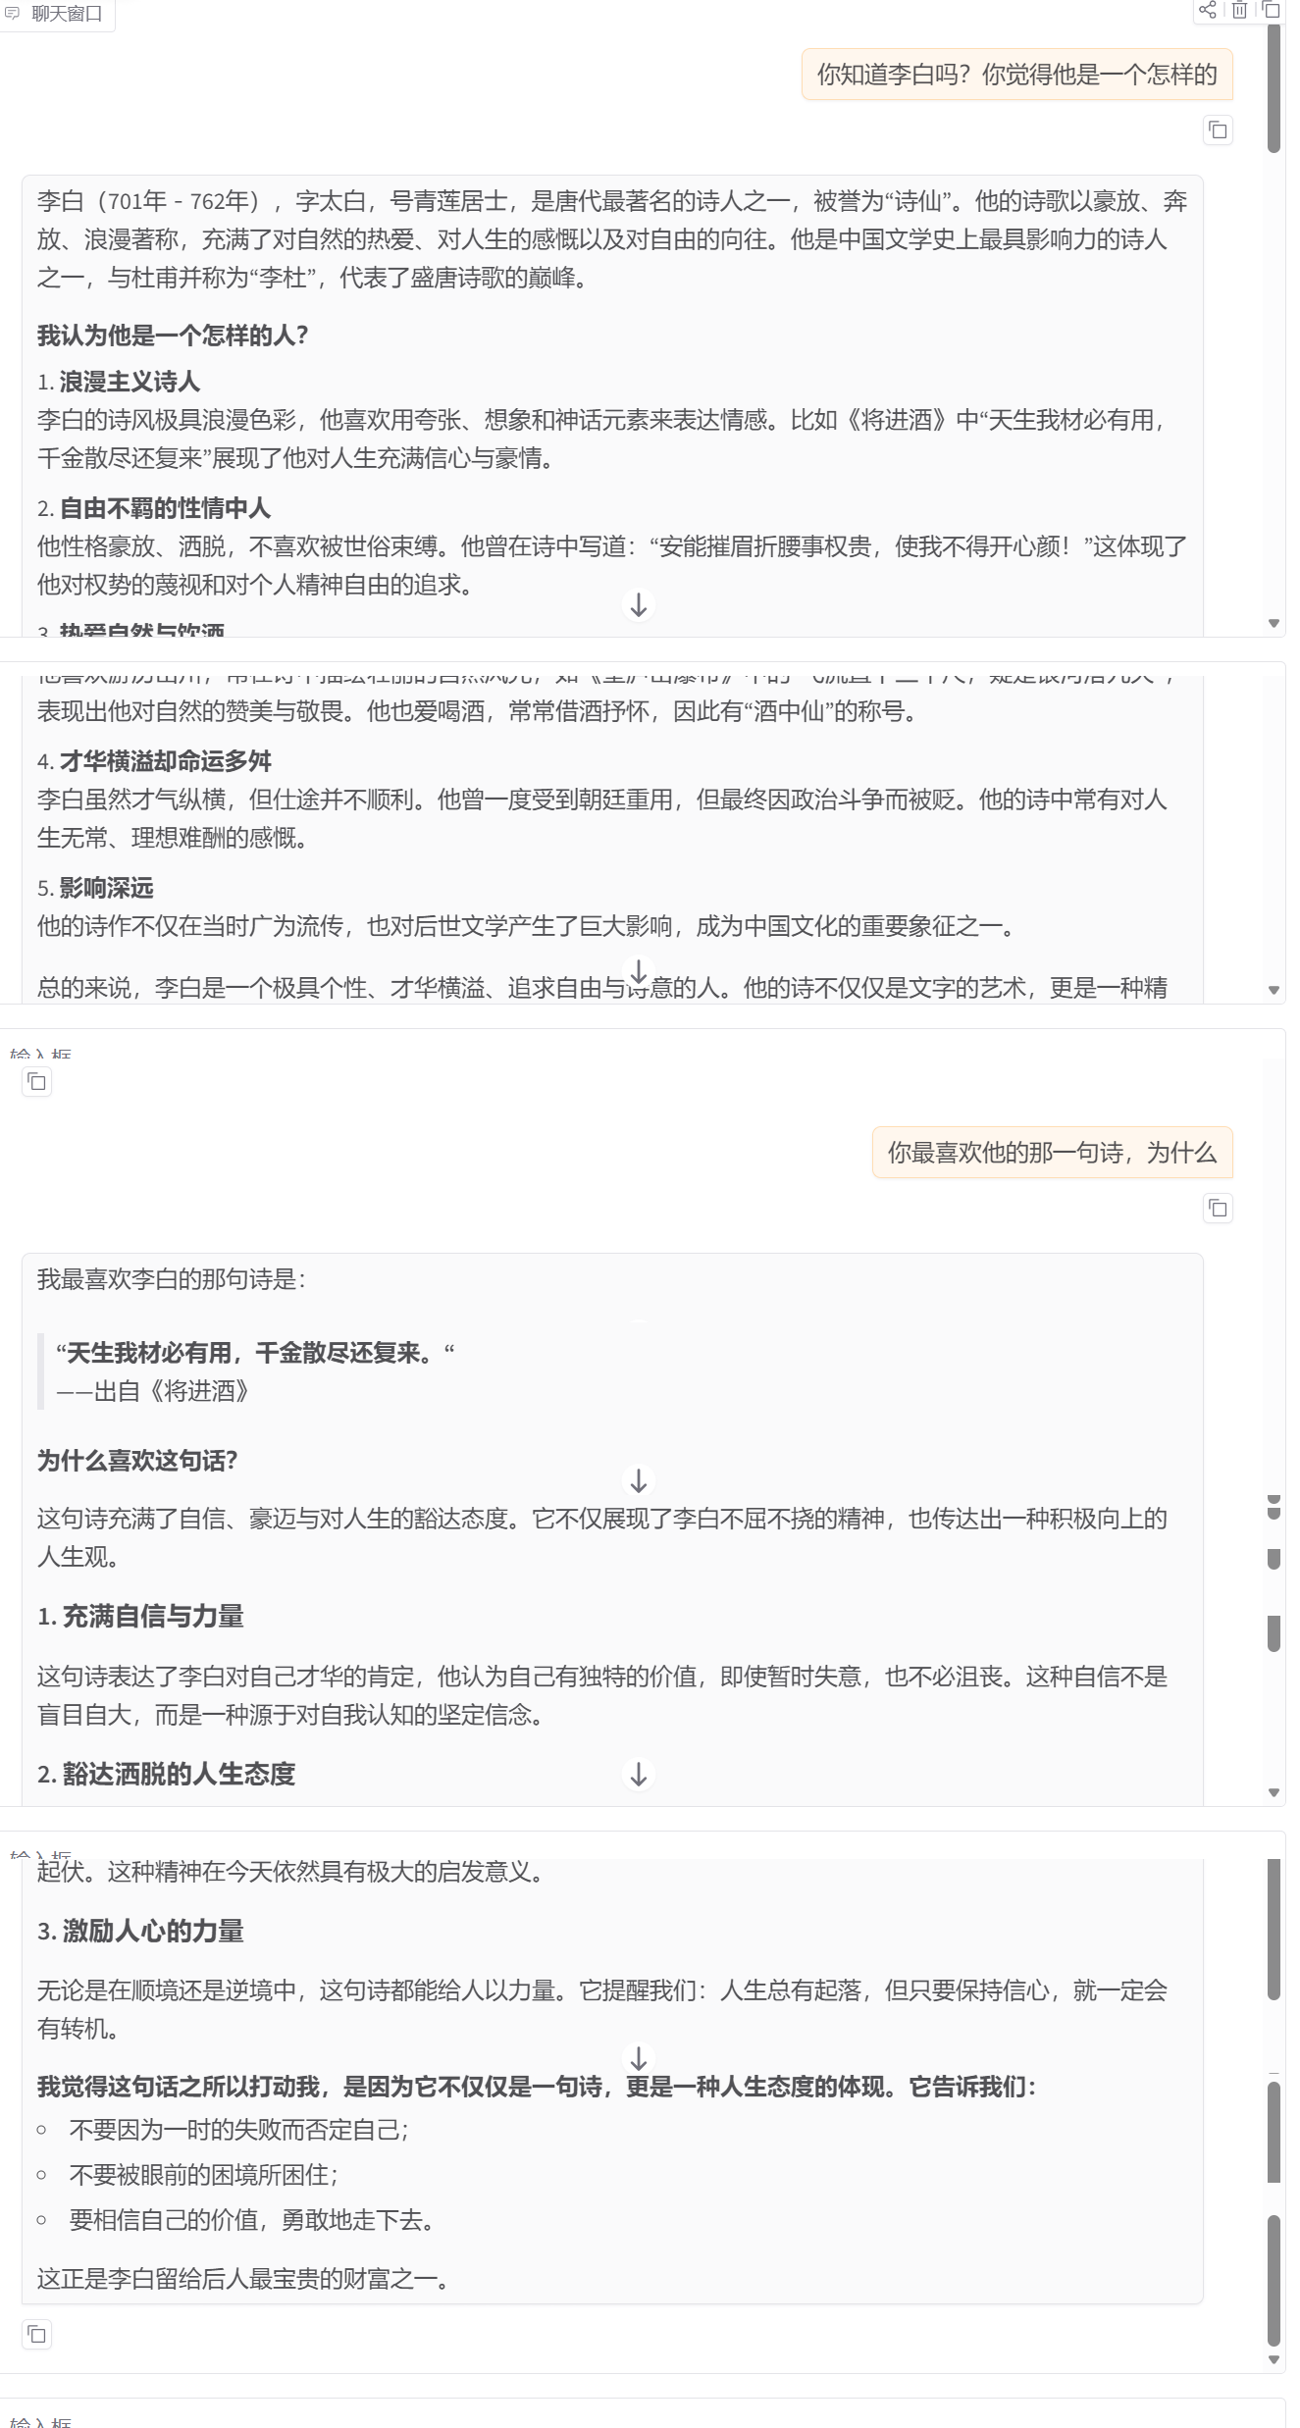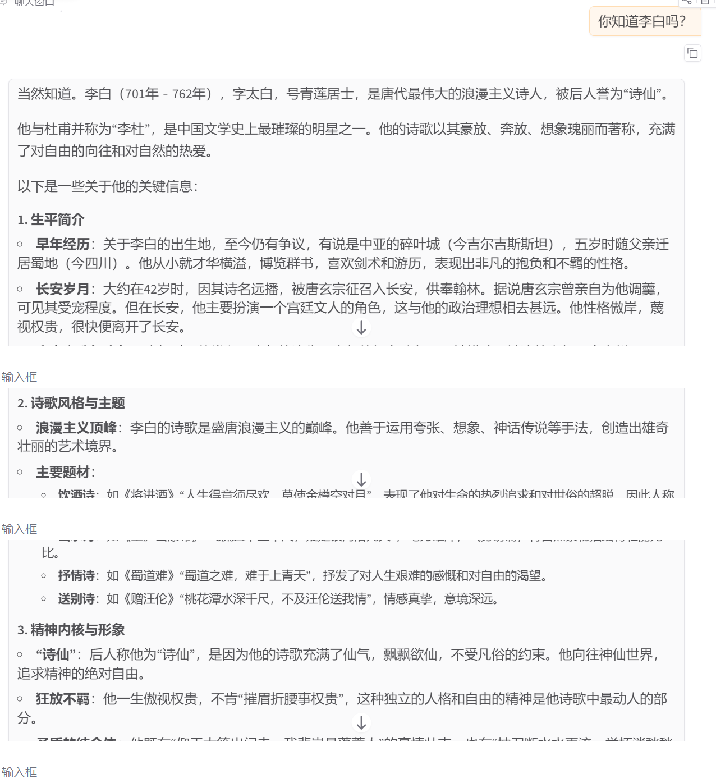
Comparison at different temperatures/Top_p

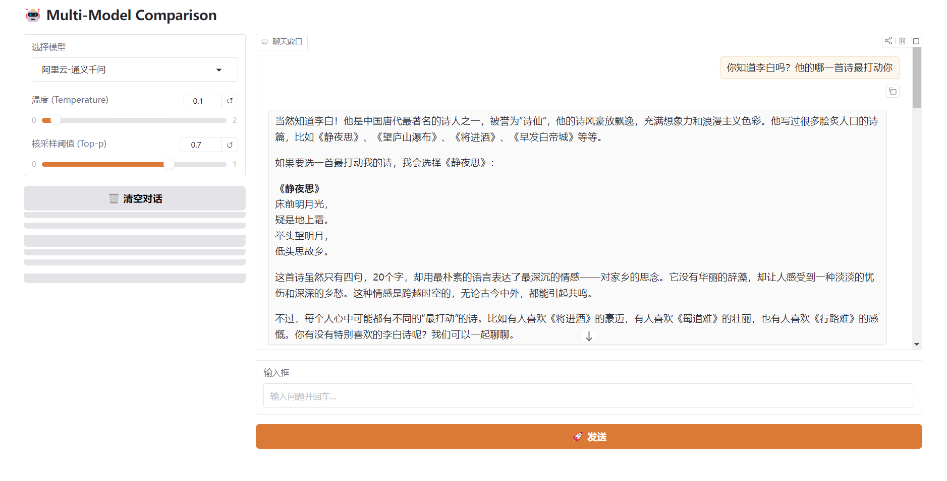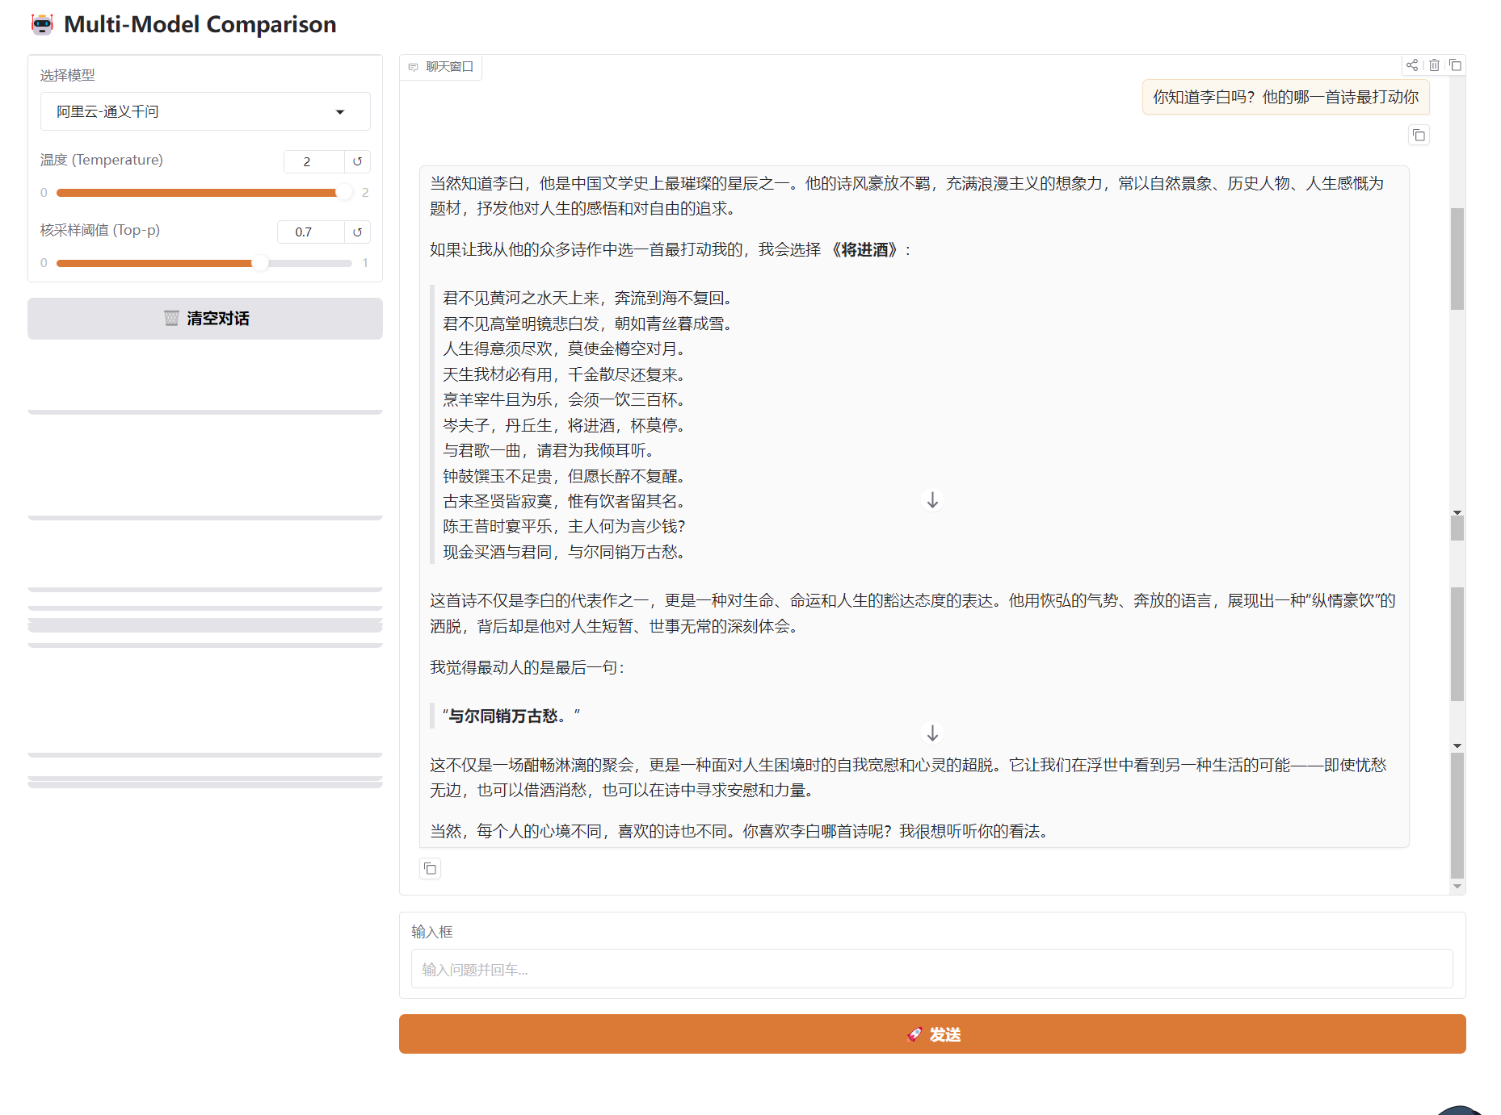
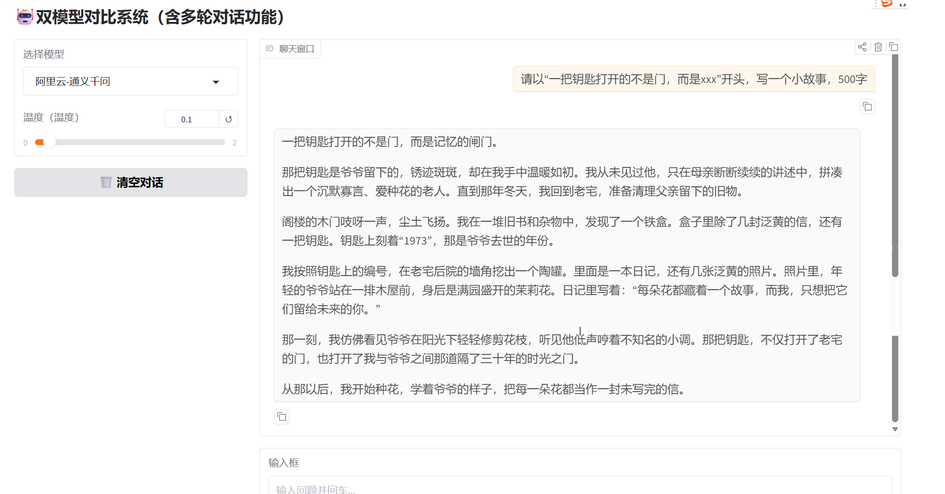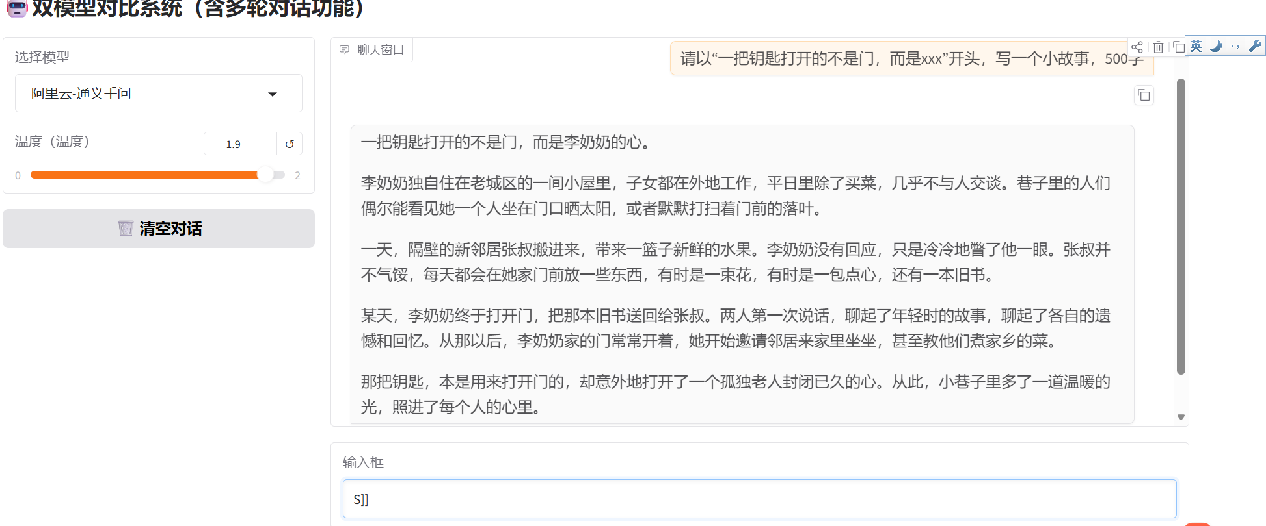
- Analysis and discussion
7.1 Analysis of the differences in API Calls among different models
Based on our experiments, we found that even though both Alibaba Cloud's DashScope and Zhipu AI offer OpenAI-compatible APIs, there are some notable divergences when you actually make the calls. For starters, their base endpoints are completely different—one points to DashScope's gateway and the other to Zhipu's platform. Then, looking at authentication, while both use Bearer tokens, the format of the API keys themselves isn't the same; you'll notice Alibaba's keys start with 'sk-'.
The parameters they support can especially trip you up. For instance, the acceptable range for the 'temperature' argument varies—Zhipu GLM-4 strictly requires values within (0, 1.0], while Alibaba Qwen supports [0.0, 2.0) but excludes 2.0 itself. They also impose different limits on the maximum number of tokens and default values for penalties.
While the OpenAI SDK provides a unified response format, the models exhibit different latency patterns and logical density in their outputs; for example, one model might be more verbose in its reasoning than the other under identical prompts. Therefore, the implementation must focus on parameter normalization rather than just parsing logic.
7.2 Principles and Practices of User Interface Design
The interface crafted for this experiment was designed by adhering to core HCI best practices. For visibility, all primary functions—like the chat window, model selector, and parameter controls—are immediately accessible, and the system provides clear feedback through colors and text so you’re never left guessing. We maintained a cohesive visual language and consistent interaction patterns throughout, so sending a message feels the same whether you click the button or just hit Enter. The design also prioritizes clear feedback; for example, a loading indicator appears during API calls, and you get unambiguous success or error messages. We’ve built in safeguards like input validation to prevent faulty requests and robust error handling to keep the app stable. To boost efficiency, common actions support keyboard shortcuts, and the layout is streamlined to minimize unnecessary mouse movement. Real-world testing shows this approach really lowers the learning curve and speeds up interaction. The model-switching feature, in particular, lets users directly compare how different LLMs perform, which just makes the whole experience more intuitive.
From a technical HCI perspective, we implemented Graceful Degradation. Since Zhipu AI crashes if the temperature exceeds 1.0, our back-end automatically caps the value at 0.99 regardless of the UI slider's position. This ensures 'Error Prevention,' a key usability heuristic, by keeping the system functional even with extreme user inputs.
7.3 The influence of model parameters on the generated results
Based on systematic testing, we've observed clear patterns in how key parameters influence the model's output. The temperature setting, ranging from 0.0 to 2.0(which excludes exactly 2.0), acts as a creativity dial: low values (0.0-0.3) yield highly deterministic and factual responses, perfect for code or Q&A, though they can get repetitive. The middle range (0.5-0.9) strikes a nice balance for most conversations, while high values (1.0-2.0) unlock more diverse and creative outputs for brainstorming, at the risk of losing coherence. Testing showed that extreme temperatures (>1.5) actually reduce perceived 'emotion' and 'empathy'. At these levels, the high randomness disrupts linguistic coherence, making the AI appear irrational. In contrast, the low range (0.1) provides structured and logical responses (e.g., in mathematical tasks), which users often perceive as more reliable and professional.
An implementation detail is that, while our UI slider shows a consistent 0-2 range for user-friendliness, the back-end actually handles the different limits from Zhipu AI (0,1] and Alibaba Cloud [0,2) —where the system specifically throws an error if the value is exactly 2.0—by clipping values to prevent errors.This is a neat example of consistent and fault-tolerant UI design in practice. The top_p parameter, or nucleus sampling, works best in tandem with temperature; setting it around 0.9 helps the model sample from a focused, high-probability vocabulary, maintaining quality without being overly repetitive. Then there's max tokens—set it too low and responses get cut off awkwardly, but set it too high and you waste resources on potentially redundant text, so adjusting it dynamically for the task is the way to go. From our tests, we found that technical Q&A works best with a low temperature around 0.2, creative writing shines around 0.8, and daily chat feels most natural right in the middle at about 0.6.
7.4 Prompt engineering suggestions for different scenarios
Through hands-on experimentation, we've gathered some practical prompt engineering insights that really vary by scenario. For everyday chats, it's best to keep things natural and conversational—like saying, "Can you help me plan my weekend?" instead of something stiffly formatted. It also helps to weave in context naturally, maybe referencing what you were just talking about, and to start broad before digging into specifics. Now, for professional tasks, you'll want to switch gears. Structured prompts are key—laying out the task, listing clear requirements, and even specifying the output format, like asking for a Markdown table. Assigning a role to the model, such as "Act as a senior software architect," sharpens the focus, and requesting a chain of thought or a multi-perspective analysis can lead to much more thorough results. We also tried advanced moves like few-shot learning and meta-prompts, which really help for complex questions. And the data backs this up: in professional settings, using structured prompts boosted effectiveness by about 40%, role-playing made outputs way more targeted, and asking for a specific format cut down post-processing work by roughly 60%. So, it turns out that tailoring your prompt style to the job at hand isn't just a theory—it makes a measurable difference.

