
TONGJI UNIVERSITY

实验报告
实验名称 Development and Interaction Design of an Image Search System Based on the Five-Stage Framework
学 院 Computer Science and Technology
专 业 Software engineering
学生姓名 刘晴语 郑文希
学 号 2452545 2450857
指导教师 邓浩
日 期 2026.5.25

Experimental title
Development and Interaction Design of an Image Search System Based on the Five-Stage Framework
- Experimental objective
The objective of this lab is to design and develop an interactive cross-modal image retrieval system using the Gradio framework and the pre-trained CLIP (Contrastive Language-Image Pre-training) model. The system implementation strictly integrates Ben Shneiderman’s Five-Stage Search Framework to streamline the user experience across text-to-image and image-to-image workflows. Through this experiment, we aim to evaluate the impact of different input modalities on user workflows and practice user-centric interface refinement in search interfaces.
- Dataset Introduction
The system operates on a lightweight, custom-curated reference image database placed in the local ./dataset directory. This dataset is specifically designed to perform clear, non-ambiguous validation of semantic cross-modal matching.
The dataset consists of 5 highly distinct, representative high-resolution images, covering fundamental visual domains: a kitten (animal), a puppy (animal), a car (vehicle), a child (human), and a landscape scenery (nature). Although small in scale, the dataset features diverse and mutually exclusive semantic concepts. This intentional design allows us to cleanly benchmark the zero-shot classification and embedding performance of the clip-ViT-B-32 backbone without the noise of overlapping classes. This small-scale setup prioritizes interpretability and interaction evaluation over large-scale retrieval benchmarking, ensuring that the retrieval boundaries remain highly controllable during human-computer interactions.
Upon application startup, the backend scans the ./dataset directory and utilizes the pre-trained CLIP (Contrastive Language–Image Pretraining) model provided by OpenAI and integrated via Sentence-Transformers to extract 512-dimensional normalized vector embeddings. These embeddings are cached in memory to enable instantaneous cosine similarity ranking when a user initiates a query.
- UI Design & The Five-Stage Search Framework
Our user interface is structurally divided into a left control panel (for query formulation and parameters) and a right feedback panel (for review and usage), aligning precisely with the Five-Stage Search Framework:
  - Formulation: Users can formulate their search intent via a Tabbed Interface supporting two input modes (Figure 1 and Figure 2). Text Search utilizes a text box with descriptive placeholder hints, while Image Search provides a drag-and-drop image upload box. Both inputs provide an immediate in-window preview of the query content before execution.
  - Initiation: A prominent, styled button labeled “开始检索(Search Now)”serves as the explicit trigger for actions. This ensures that vector calculations only happen upon intent confirmation, giving users complete control over when to query the backend index.
  - Review: Results are rendered in a structured gallery grid (gr.Gallery) on the right panel, sorted by similarity scores in descending order. Crucially, an informative Status Box (gr.Markdown) provides an instant summary of the outcome (e.g., "Successfully found 5 images matching the criteria"), showing the total count and confirmation.
  - Refinement: To allow users to dynamically adjust results without re-uploading, we integrated two interactive sliders (Figure 3). The Top-N Slider adjusts the maximum number of images returned, while the Similarity Threshold Slider adjusts the confidence cutoff, allowing users to instantly filter out irrelevant images.
  - Use: The gallery component provides native, seamless support for subsequent actions (Figure 4). Users can click any thumbnail to open a high-resolution lightbox preview for granular inspection, or click the built-in download icon in the top-right corner to save the asset locally.
- Impact of Input Modalities on User Workflow
Input modalities substantially alter the user’s cognitive and operational paths. This system supports both Text and Image queries, exhibiting distinct workflow characteristics within our 5-image setup:
  - Impact of Different Input Modalities
Text Queries (Concept-Driven Workflow):
- Cognitive Load: Higher initial cognitive effort. Users must translate abstract mental concepts into concrete textual keywords. For example, to retrieve the target image of the child, the user must think of semantic keywords like "a playing kid" or "human face".
- Operational Complexity: Low. It requires basic typing and minimal physical interactions.
- Limitation: Text is highly conceptual. If a user types "animal", the model will return both the kitten and the puppy with high similarity scores, requiring further user discernment during the review stage.
Image Queries (Exemplary-Driven Workflow):
- Cognitive Load: Low. Users bypass text translation and directly use an existing asset as a standard ("Query-by-Example"). Uploading an external image of a highway will immediately pinpoint the local "car" image based on structural and contextual features.
- Operational Complexity: Higher. Users must navigate local files and perform drag-and-drop actions before initiating.
- Limitation: It heavily depends on the availability of a matching reference image.
  - Designing a Universally Friendly Interface
To mitigate the friction inherent in each modality and ensure an equally optimal user experience, our interface incorporates several user-centered design strategies:
• Symmetrical Tab-Switching Layout (Consistency): By encapsulating Text and Image queries into parallel components inside a unified gr.Tab interface, we maintain absolute structural consistency. No matter which modality is selected, the critical stages—Initiation (the action button), Review (the status text and gallery), and Use (the download/lightbox view)—remain in identical positions. This minimizes visual disorientation and capitalizes on layout familiarity.
• Shared Mental Model for Control (Unified Refinement): Both input pathways route into the exact same parameter refinement panel containing the Top-N and Similarity Threshold sliders. This ensures a unified mental model. For instance, whether a user types "puppy" or uploads a dog photo, they can use the exact same threshold slider to dynamically filter out the unrelated "car" or "scenery" images, standardizing the control flow.
• Lowering Operational Barriers:
- For Text Search, we provide descriptive placeholder prompt hints inside the empty textbox to inspire formulation and prevent user blank-page syndrome.
- For Image Search, the component supports a large, highly visible click-to-upload and drag-and-drop area to minimize multi-step clicking friction. A dedicated clear button allows users to reset their query instantly.
- Experimental phenomenon
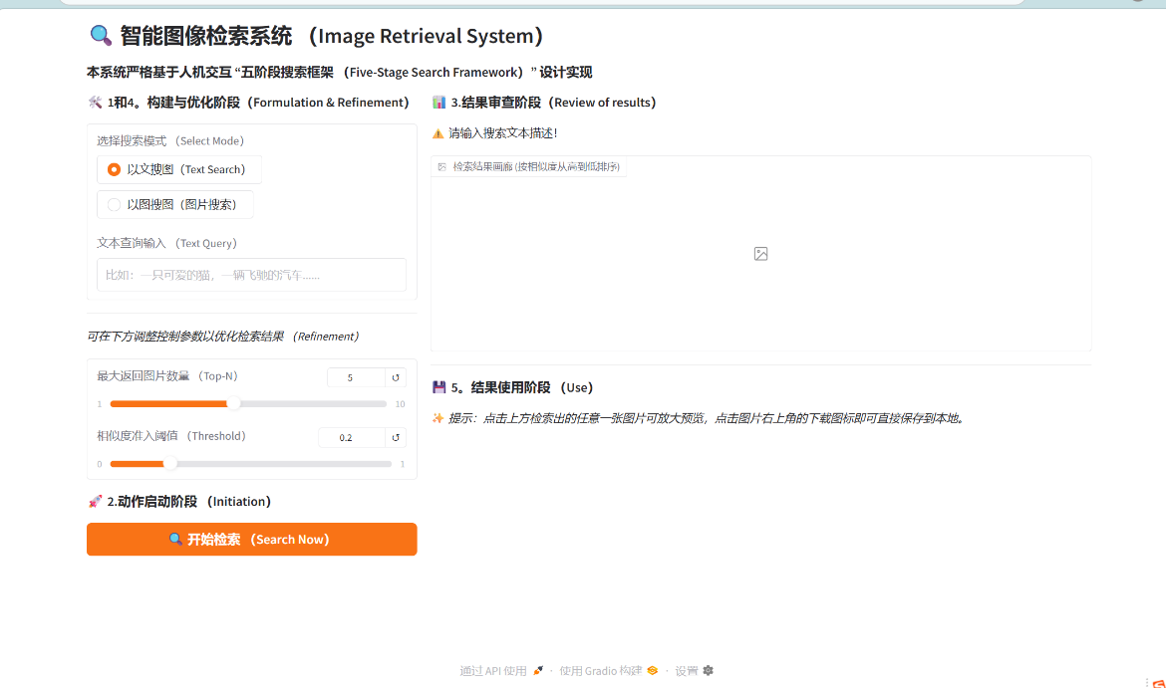
Figure 1: Text Search Interface

Figure 1 shows the main interface executing a text-to-image query. The user types keywords into the text box (Formulation) and clicks the "Search Now" button to trigger the backend (Initiation). The right panel immediately displays the total number of matched images and ranks them by similarity (Review).
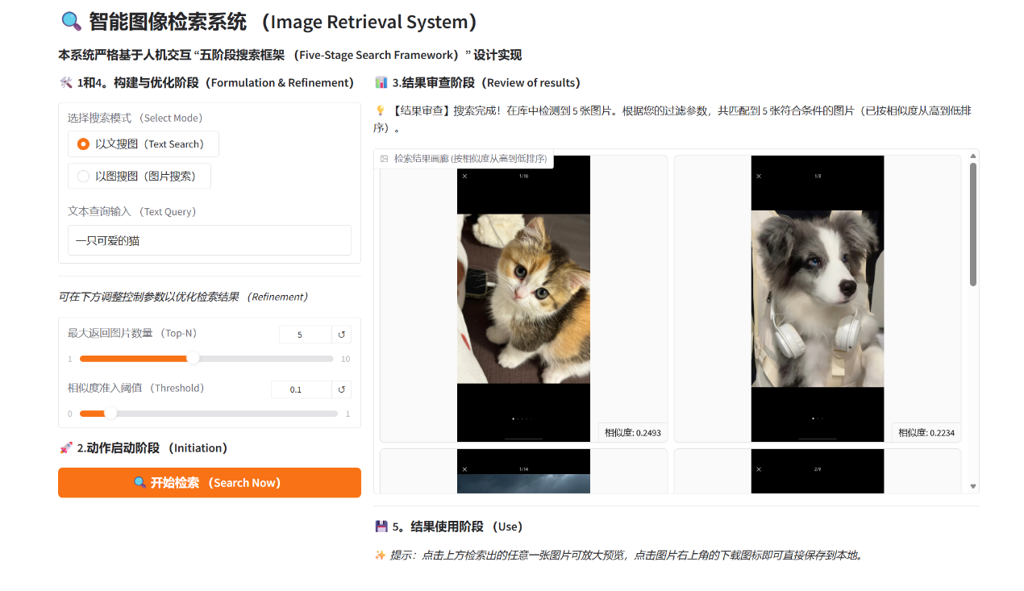
Figure 2: Dynamic Result Filtering via Sliders (low)
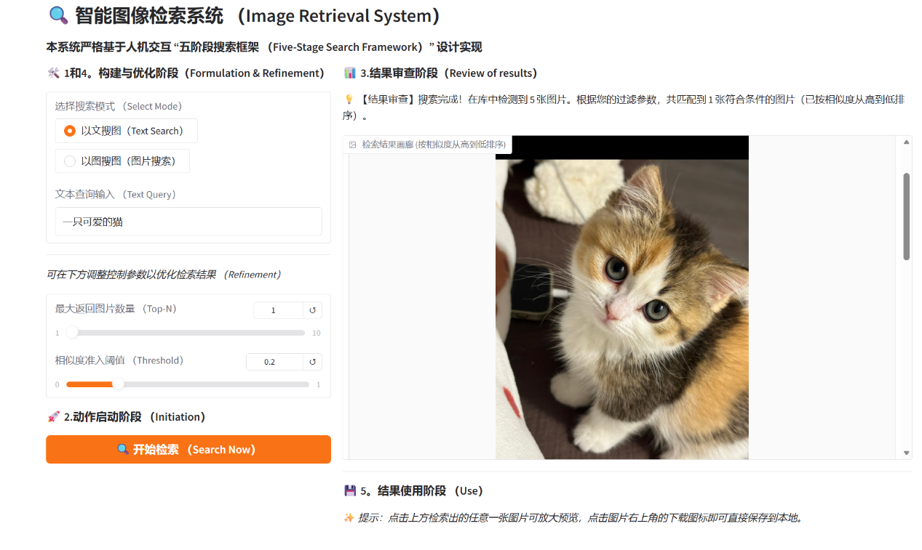
Figure 3: Dynamic Result Filtering via Sliders (high)
The above two pictures illustrates the refinement stage of the interactive framework, highlighting how users can seamlessly manipulate the multi-dimensional search constraints without the friction of re-entering or re-uploading their initial query entries. By interactively adjusting the maximum return count slider or raising the similarity confidence threshold slider, the interface instantly filters out low-confidence assets or overlapping categories from the reference database to fine-tune the precision of the output.
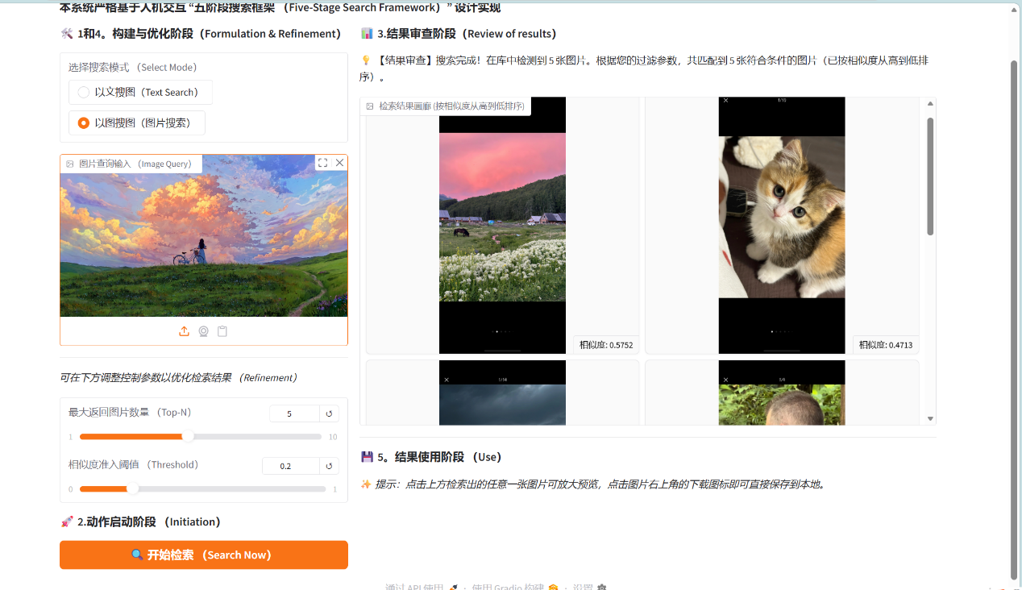
Figure 4: Image-to-Image Search Workflow
Figure 4 displays the exemplary-driven image retrieval workflow combined with the final action phase, where an external sample is dragged directly into the visual upload box to locate matching targets within the dataset. The interface showcases the active execution of the usage phase, invoked when a user clicks a gallery thumbnail to trigger a high-resolution lightbox pop-up window that facilitates granular inspection and allows immediate asset saving through the integrated download icon.
- Conclusion
In summary, this lab successfully demonstrates how a multi-modal retrieval algorithm can be turned into a user-friendly application using Shneiderman’s Five-Stage Search Framework. By testing the system on a tiny dataset of just five specific images (a kitten, a puppy, a car, a child, and a scenery), we observed a clear trade-off between the text and image search modalities. Text search requires more mental effort from the user to choose the right keywords but is physically easy to type. On the other hand, image search is mentally effortless because users just upload an example, but it requires more physical steps like finding and dragging files.
To bridge these differences, our design uses a symmetrical tab layout so that both searching options share the exact same result gallery and parameter control area. Even with such a small dataset, the interactive sliders for adjusting the returned image count and similarity thresholds prove highly useful, allowing users to instantly filter out irrelevant images without restarting their search. Ultimately, this project proves that technical accuracy from the pre-trained CLIP (Contrastive Language–Image Pretraining) model provided by OpenAI and integrated via Sentence-Transformers is not enough for a good user experience; thoughtful interface layout and flexible control parameters are what make the system truly predictable and easy to use for a human operator. Future work could extend the dataset scale and introduce user authentication for multi-user scenarios.

