
Report on 12th project SPL (python)
Name: Elza Morgan, Youssef El Tabib, Mohamed Abozaid, Mohamed Yasser
Registration No.: 18100260, 18102698, 18102968, 18102456
Course code: CS445
Department: CS

Dr: Yasser Fouad
TA: Mahmoud El Morshedy

Contents
Idea of our project: 3
Explanation of our code: 3
Images of our Application Running 15
15

Idea of our project:
Our idea for this project is creating a system for university that can register, view, delete and update students by using python language. When it comes to registering a student, you can enter their information manually or by autofill. This autofill is a function that we have created that reads from any json file type and uploads this specifically file of that student automatically. Moreover, all of this information about the students will be added to the database by using MySQL database. The interaction with the system will be through GUI.

Explanation of our code:
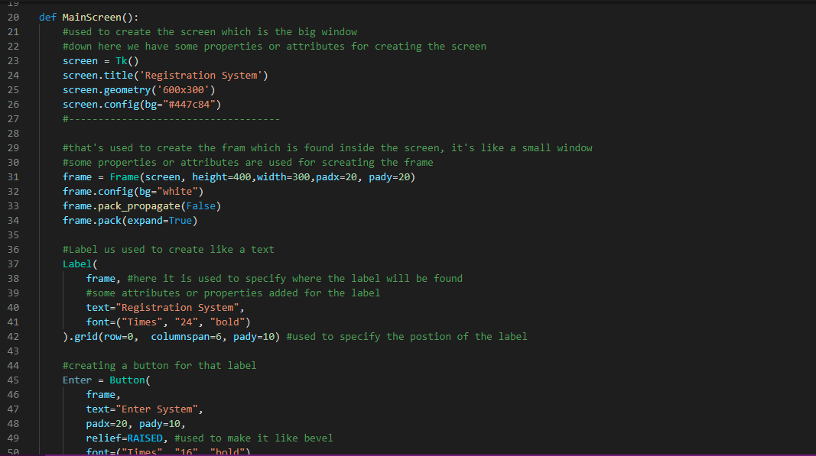

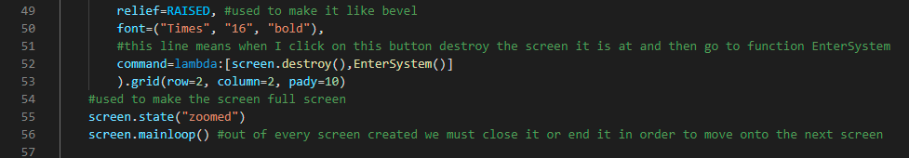

Main() function
This is Main Function that will be displayed, when you run the code. Inside we have created screen to create the layout of the window, we also gave it some properties or attributes to look representable. Inside the screen we have created a frame which is the small box inside the screen we gave it some attributes and properties and we set the position for it. Inside the frame we have created label which is like creating a text we have also added some properties or attributes for it. After we have created a button where it is used to destroy or closes the current screen and calls the next function which is EnterSystem() and that will be at line 52. The function lambda means is that the function will occur when variable or method command is called which is by pressing onto the button. At line 55 means make the screen/window bigger or Fullscreen and at line 56 means close the screen of main menu and enter the new screen called from line 52.
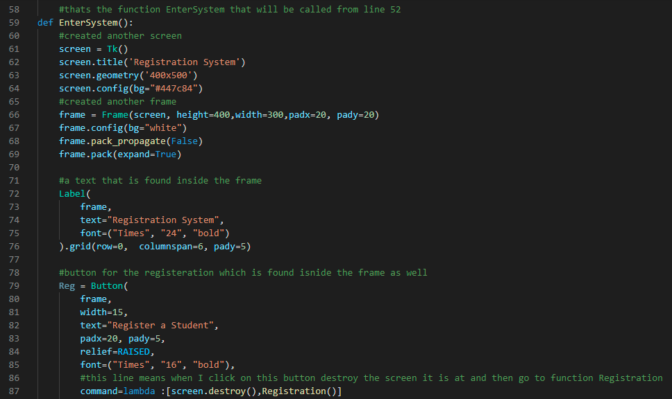
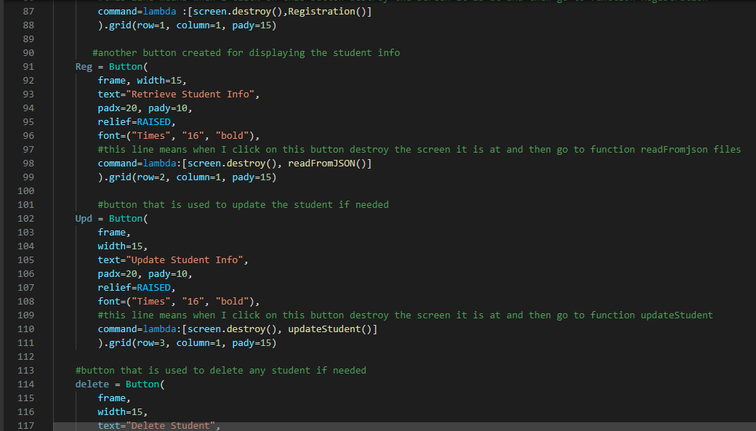
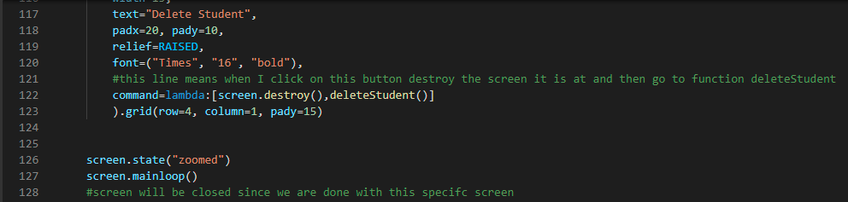

EnterSystem() Function
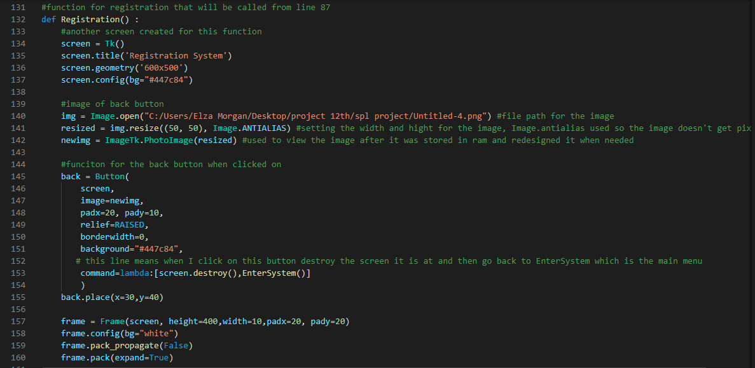
We have created another screen for it, inside it we have created a frame. Inside the frame we have created a label as text which is “registration system”. We have created several buttons in that frame. First for registering student, this function registration will be called at line 87. Second button to retrieve student information by reading from json file, this function readFromJson will be called at line 98. Third button is created is for updating any information about this specific student, this function updateStudent will be called at line 110. Last button created used to delete any student from the database when needed, this function deleteStudent will be called at line 122. At line 126 means make the screen/window bigger or Fullscreen and at line 127 means close the screen of main menu and enter the new screen.

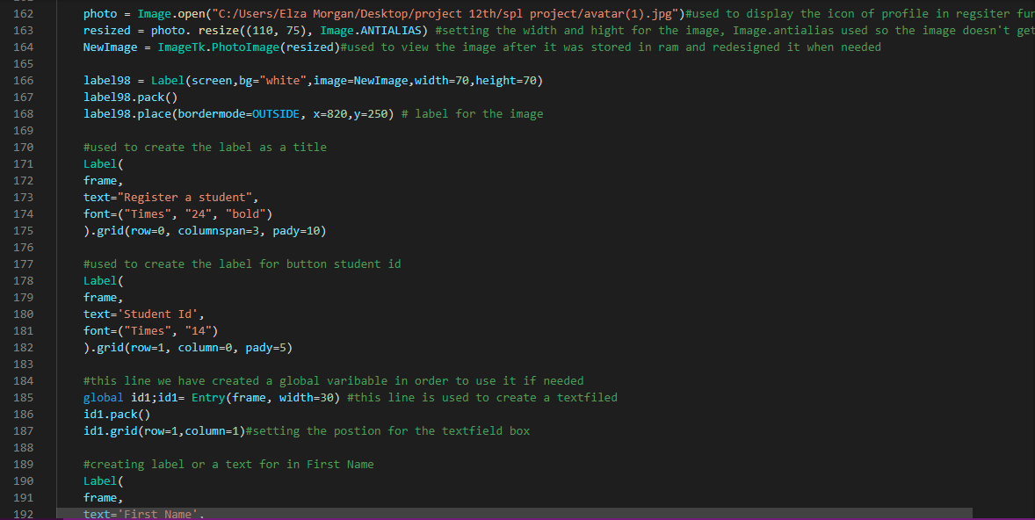

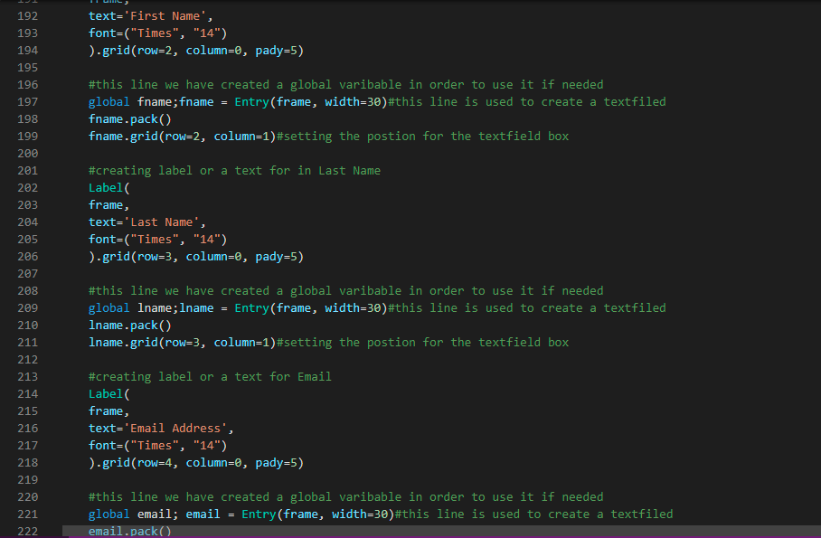

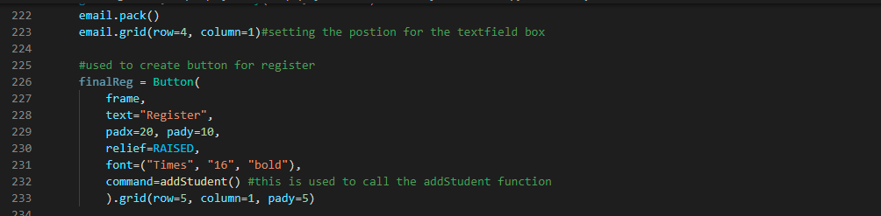
Registration() function:
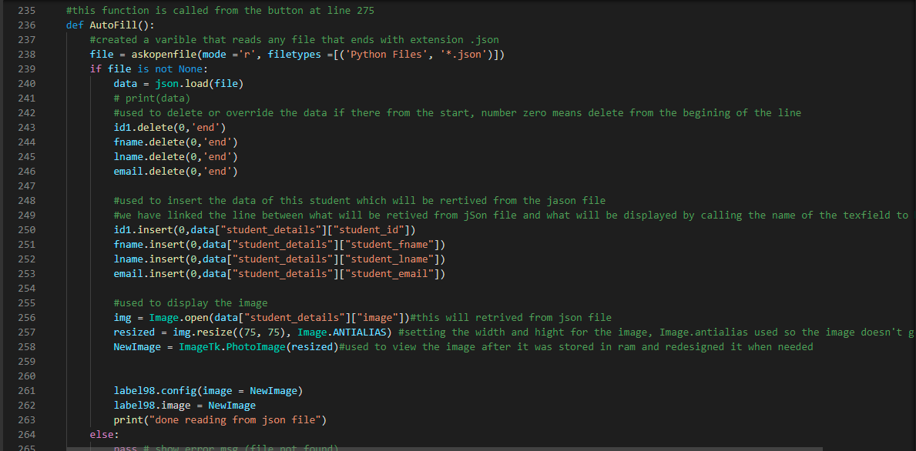
We have created another screen for this function using suitable properties or attributes. Then we inserted an image from the folder, image of back button so when you click on it, it returns you to the main menu screen. Then we have used this image and created a button by variable name called “back” and did the calling back button to main menu at line 153 but before that It will destroy the current screen. Then we have created a frame inside the screen, inside we have added an avatar icon on the right corner. At line 163 the image will be stored at ram and we will do all the editing for this image and then at line 164 means it will take this image that was stored and then it will display it onto the screen. We have created several labels inside this frame. First label created for the student Id we set the suitable property or attribute for it then we have created text filed for it and we have set the suitable attribute or property for it. The variable for it will be set to global because we want to access it later on. Second label created is for first name of the student and we have set text field for it as well as well as the variable that is created is set to be global in order to use it later on. Third label is created for Last Name of the student and we have set text field for it as well as well as the variable that is created is set to be global in order to use it later on. Fourth label is created is email of the student and we have set text field for it as well as well as the variable that is created is set to be global in order to use it later on. After entering the information of the student manually there will be a button used to call the function addstudent().

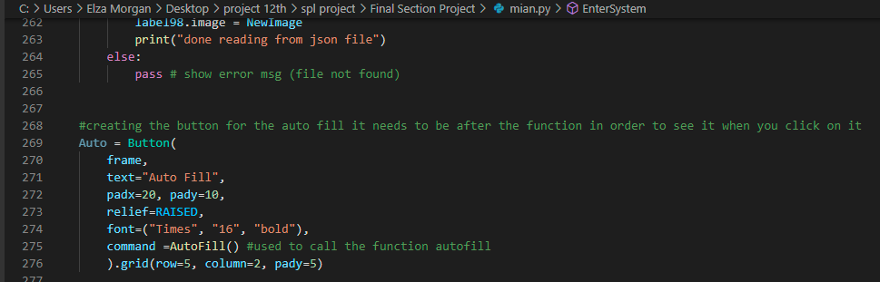

AutoFill() function
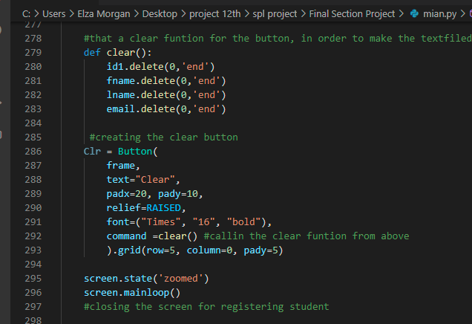
First of all we will read from any type of Json file, when the file is not empty we will load the file that was uploaded from json files and stored in another variable called “data” line from 243 to 246 deletes anything found in text field which overrides it when needed, we included 0 to start from the very start. After the json file is read and stored in variable “data” in order to view it we have called the name of the textfield.insert inside it we have mentioned the position to start to view it and have called the variable ”data” and the name of the object or structure created in json file and then we specify the field and insert the data.from line 256 to 258 is used to retrieve the image path added in json file and then store it and resize it and then add upload it to the system and make it appear. After all, if the file is empty, it will enter the in else and display an error. After creating the function autofill and button is created and to call this function is called at line 275.Function autofill comes under function Registration.

Clear() function
Used to call the text field variables that were known to be globally and we have set the position of from where to clear which the number 0. Then we have created a button so that when you click on it will the function clear and that will be at line 292.
Afterall, at line 295 used to make the screen full screen and 296 used to close the screen for registering student.
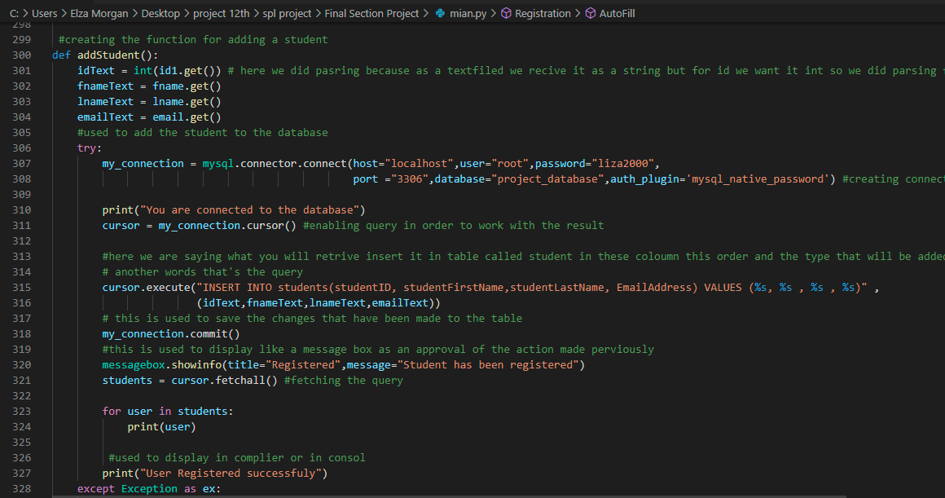
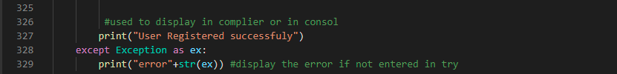

addStudent() function
we will take all the information that was added in the text field and added to a variable that will be used in this function. For id we have made parsing since we want to use it as integer not as a string. Then it will enter the “try” and at line 307 that’s how we connect to the database and then we tried to open connection to enable querying in the database. After words we have created, a query saying insert to the table student’s information that was retrieved from the text field variable and then save the table. Then we save the table since we inserted some stuff to the table. Message will be displayed that this student is added to the database. Then we will take every row from the database and then added to the variable that will be converted to list which is called “students”. Then we will create a for loop to display all the student’s information. If it didn’t enter the try and entered in the exception then it will print the name of the exception error in the console or the terminal.

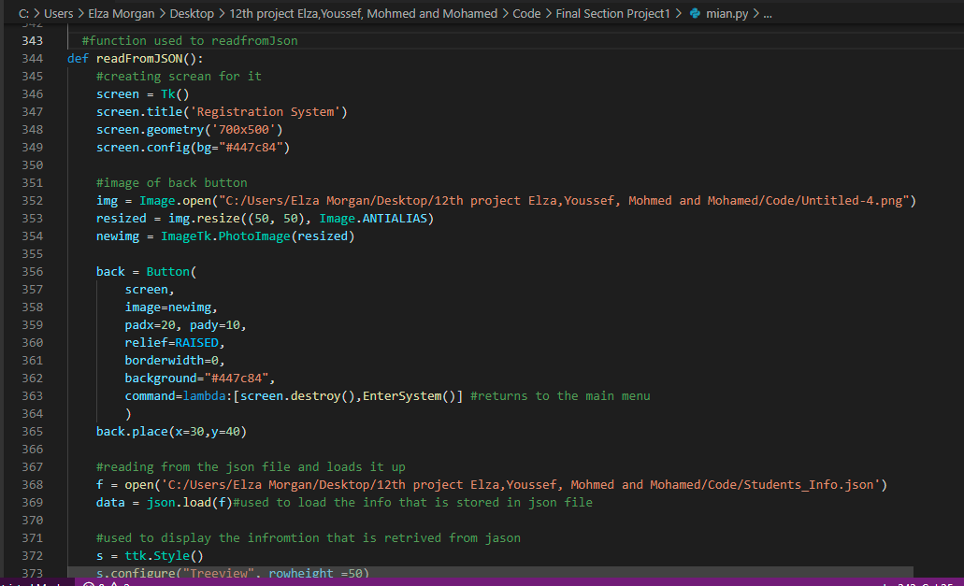

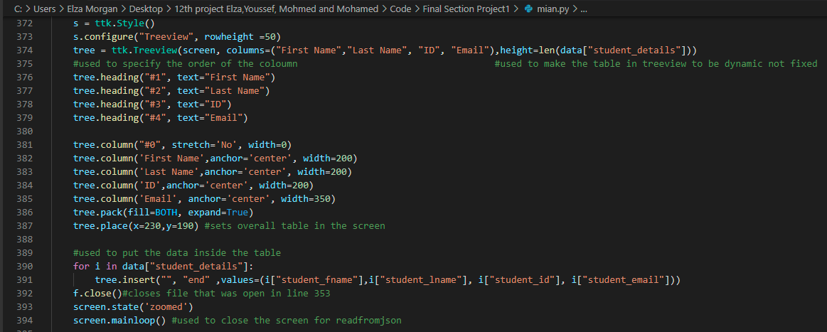

readFromJson() function
a screen is created for this function and we added the attributes or properties needed and we imported the image of the back button and then we have created a button by using this image that calls the main menu at line 352. Then we have opened the file of Json that contains all the information of the students in order to display them all at once and stored them in a variable called “f” then we loaded this file and took the data and stored in another variable called “data”. Then we used TreeView a way to display the data and we have created the columns and give them height and et to be dynamic so that it fits the height based on the given dsata and then we set the order and modified their width. Then we have created position of the whole table in screen. We have created a for loop that passes the name of the object created in json file and prints all the information inside this object in json file every time. Then we will close the file and the screen as well.

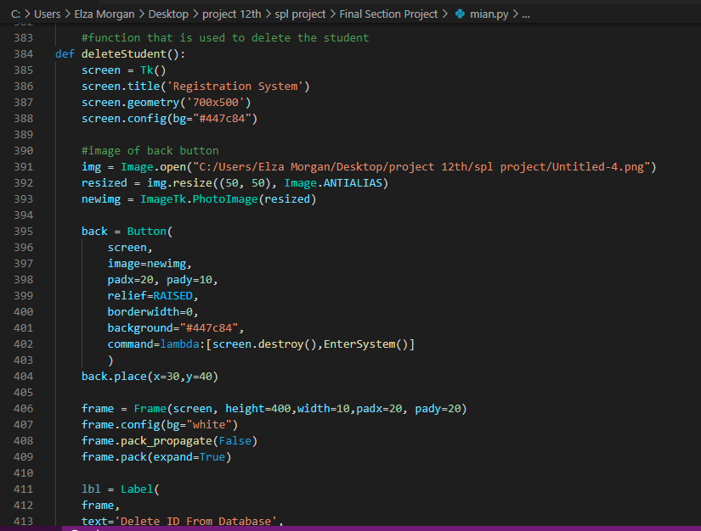
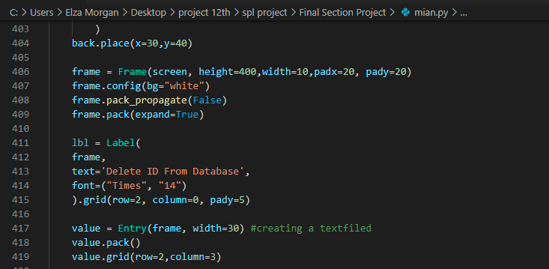

deleteStudent() function
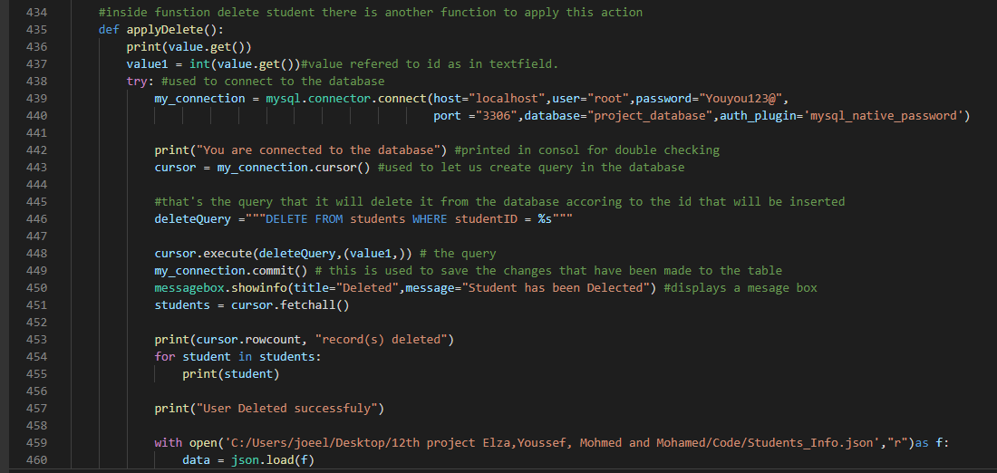
We have created a screen for this function and set the suitable properties or attributes for it. We have imported an image which is the back button and then we have created button that lets you go back to the main menu as you call it at line 402 and destroys the current screen. Then we have created a frame inside the screen and inside the frame we have created a label used to delete the student from database by the Id and by it we created a text filed.

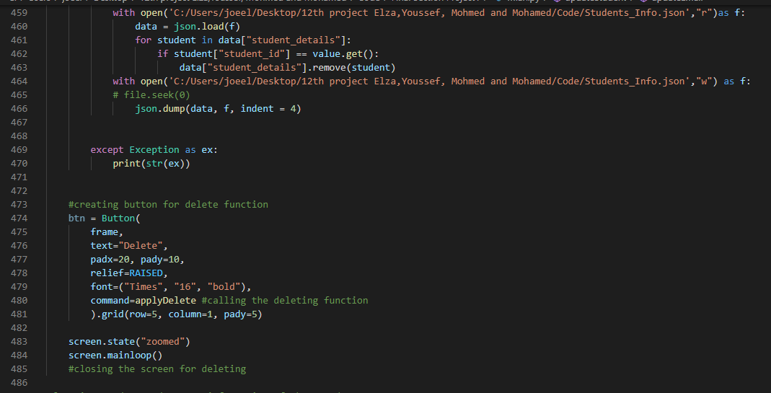

applyDelete() function
we will access the text field of the Id which is called “value” and we will parse it to int in order to use it and search for in the database. Since text field receive it as a string. We have opened connection with the database and then gave permission in order to write a query. We have created a query that delete the student as long as the id is same as found in the database and then save the table because of the changes that we have made. Then a message box will be displayed as approval of the change that is made. Then we will take each row of the database and store in variable “students” as a list and then print it in the terminal or consol. If it didn’t enter the try then it will display the error message. We have created a button that applies this function when called at line 456.Then we have closed the screen for this function. We can delete the student information from the json file as long as the id is equal to the one found in json file.

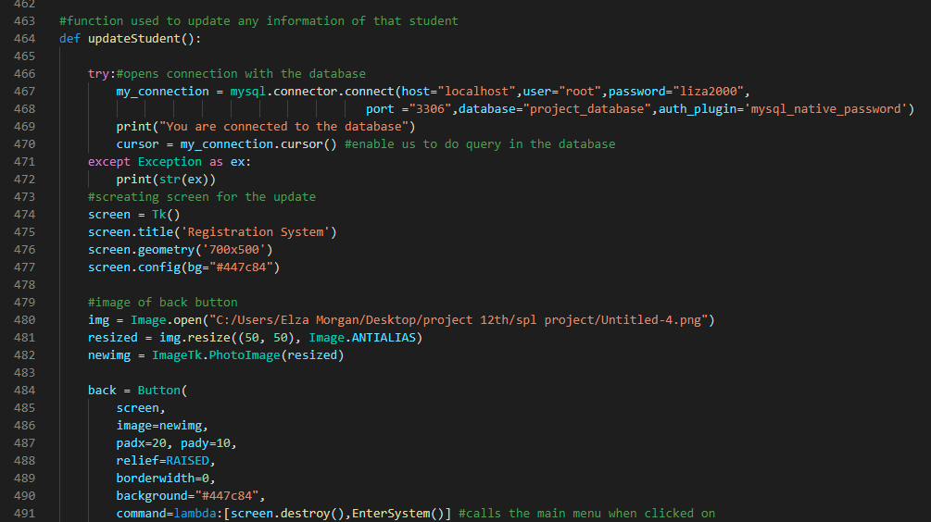

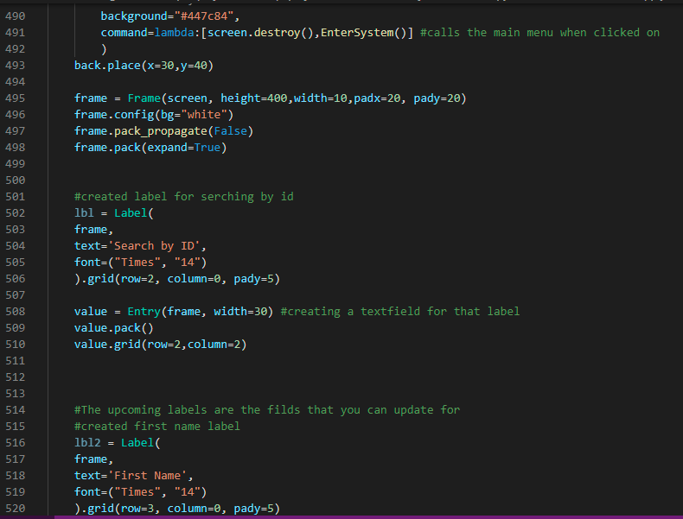

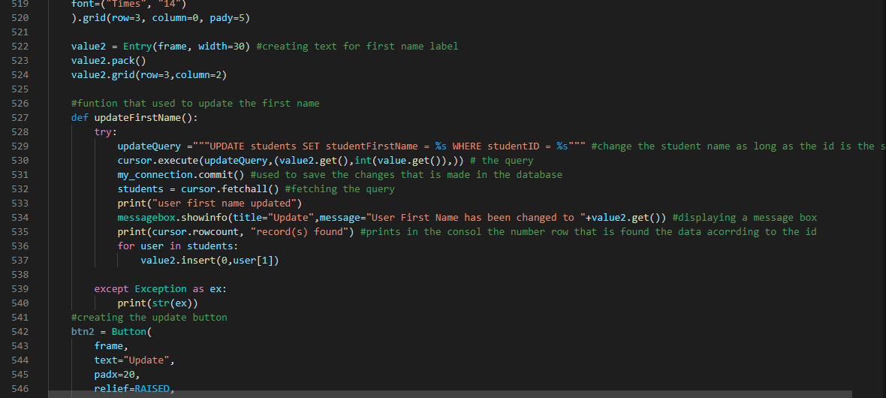
updateStudent() function
we have opened a connection with the database and created an access to the database in order to write a query in the database. If it didn’t create the connection, it will print the error name. Then we have created a screen for this function and we set suitable properties or attributes for it. We have imported an image which is the back button and then we have used it as a button by clicking on it, it will take you to the main menu by calling this function at line 491.Then we have created a frame inside the screen and inside the screen we have created a label for searching this student by the id and then a text field is created by variable called “value”. Another label is created for the First name of the student and a text field which is initialized to variable “value2”.

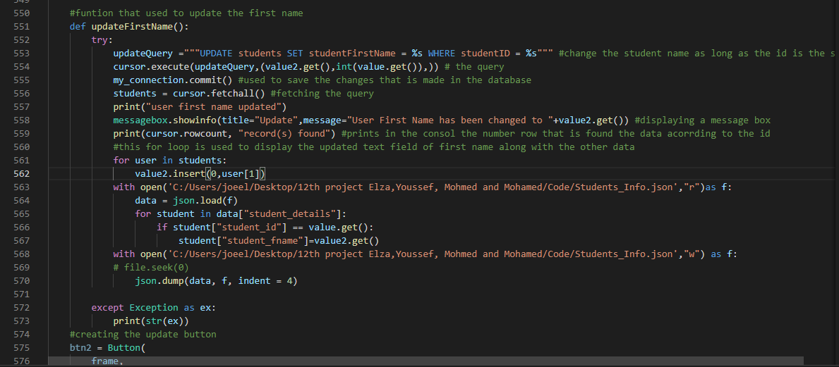

updateFirstName() function
This function is inside the updatestudent function so we don’t have to open the connection. We started directly writing the query, which is as long as the id is same as found in the database update the firstname in the table of students and firstname column. Then display a message box as an approval. Then we have created a for loop that loops over “students” that already stored the updated information about this student and therefore it displays the updated text field along with other information about the students. We have created a button that calls for the function updateFirstname at line 549. Then we have created a label for the lastname and a text field. Moreover, we can update the student first name in json file as well.
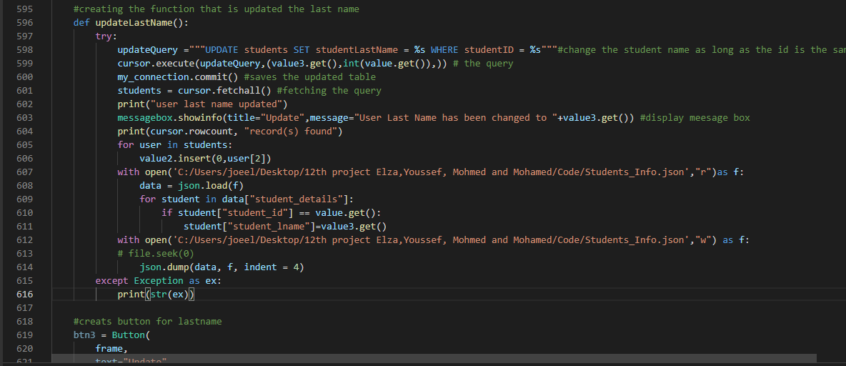

updateLastName() function
This function is inside the updatestudent function so we don’t have to open the connection. We started directly writing the query, which is as long as the id is same as found in the database update the lastname in the table of students and lastname column and then save the changes in the table. Then display a message box as an approval. Then we have created a for loop that loops over “students” that already stored the updated information about this student and therefore it displays the updated text field along with other information about the students. We have created a button that calls for the function updateLastName at line 585. Then we have created a label for the email. and a text field. Moreover, we can update the student last name in json file as well.
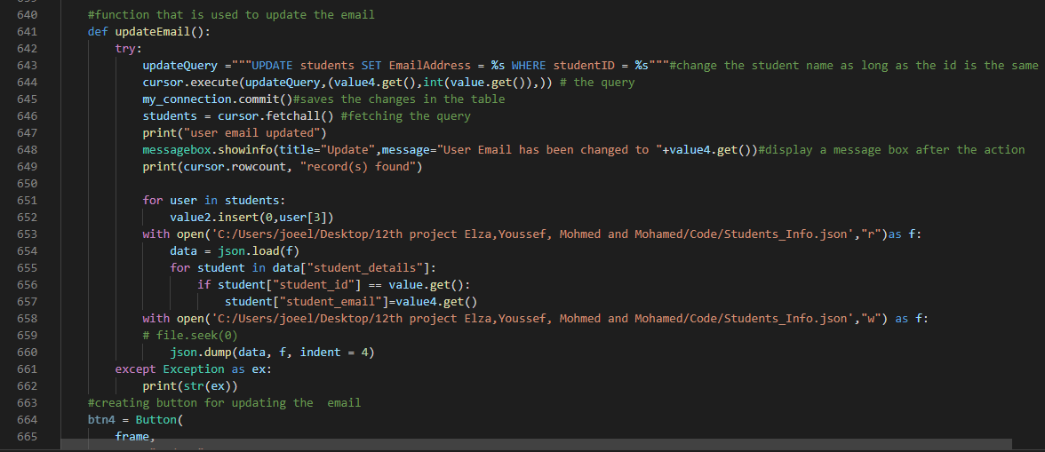

updateEmail() function
This function is inside the updatestudent function so we don’t have to open the connection. We started directly writing the query, which is as long as the id is same as found in the database update the email in the table of students and email column and then save the changes in the table. Then display a message box as an approval. Then we have created a for loop that loops over “students” that already stored the updated information about this student and therefore it displays the updated text field along with other information about the students. We have created a button that calls for the function updateEmail at line 621. Then we have created a label for the email. and a text field. Moreover, we can update the student email in json file as well.

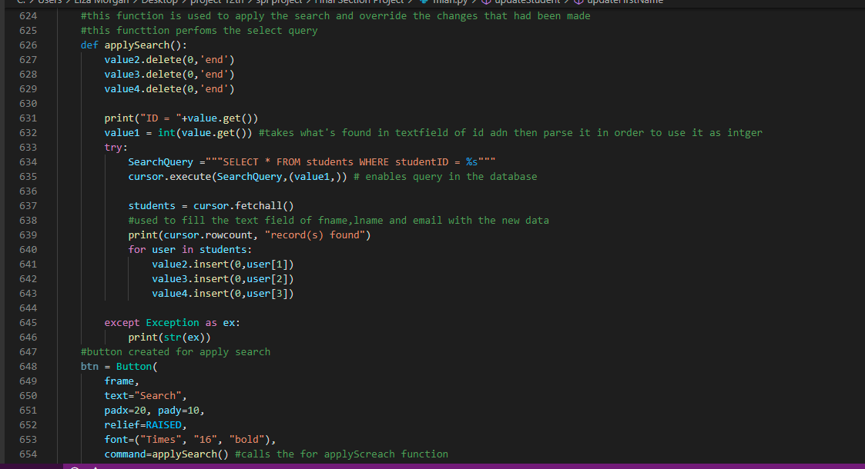

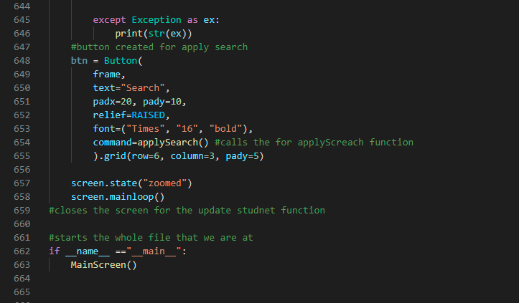

applySearch() function
used to delete everything in the text field and then displays everything on the text field as long as the id is found in the database. We have created the button that will be called by line 654 in order go to applySearch function. Then we have closed the screen for updating.
Line 662 and 663 is used to make the whole file or code start and display the main screen as the code runs and the GUI appears.

Images of our Application Running


