Chapter 4 — Implementation and Results

4.1 Purpose and contribution of the chapter
Having defined the research design in Chapter 3, I now report how I realised that design and what I observed. I frame my contribution as an aligned research-and-application study rather than as the invention of a new HTR architecture. Concretely, I implemented a reproducible English IAM training and evaluation workflow; I fine-tuned TrOCR on the official training and validation partitions and logged the run in full; I compared the transformer against a CRNN+CTC neural baseline and classical Tesseract on the identical full test set of 2,915 lines; and I built an interactive demonstration that places the recogniser in an applied setting. I also cite published IAM CER figures for contextual scale, without claiming protocol-identical superiority.

4.2 Implementation overview
I organised the implementation around the methodological commitments of Chapter 3. I load line images and transcriptions for training and evaluation; I instantiate either the public TrOCR checkpoint or my locally fine-tuned directory for generation; I adapt TrOCR with cross-entropy, AdamW, and early stopping on validation CER; I train and evaluate a separate CRNN+CTC baseline; I compute case-sensitive CER and WER under a shared metric definition; I execute the experiment matrix through evaluation runners; and I expose recognition through a Gradio interface for interactive demonstration. I place detailed module listings in the appendix so that this chapter can remain focused on scientific substance rather than software documentation.

Table 4.1 — Principal implementation components
Component | Role in my study
Dataset I/O | Provides line images and transcriptions for train/eval
TrOCR loading and generation | Instantiates Hub or local checkpoints for inference
TrOCR fine-tuning | Adapts the pretrained model on IAM train/val
CRNN+CTC baseline | Trains and evaluates the neural reference system
Metrics | Computes CER and WER under a shared definition
Evaluation runners | Executes the designed experiment matrix
Demonstration interface | Supports interactive English line transcription

4.3 Experimental procedure

4.3.1 TrOCR fine-tuning
I began fine-tuning from microsoft/trocr-base-handwritten and used the full IAM training and validation sets (6,482 and 976 lines). I employed AdamW with a learning rate of 5×10⁻⁶, a micro-batch size of 1, and gradient accumulation of 8, yielding an effective batch size of 8. I planned a maximum of eight epochs, with early-stopping patience of two validations. I ran training on CUDA; the logged wall-clock time was approximately 88.7 hours.
Under this schedule, validation CER reached its best value of 0.0137 after the first epoch and then deteriorated (0.0162 in epoch 2; 0.0187 in epoch 3). Early stopping therefore terminated training after three epochs, and I exported the best validation checkpoint rather than the final epoch weights. This behaviour matters for interpretation: I completed and logged the adaptation run, yet I did not observe sustained validation improvement.

4.3.2 CRNN+CTC training
I trained the CRNN baseline from scratch on the same IAM partitions with learning rate 1×10⁻³, batch size 8, and fixed input geometry of 32×128. I executed eight epochs under early-stopping patience, with a character set of size 79. Best validation CER remained high (approximately 0.80), already signalling limited competitiveness relative to pretrained TrOCR before I evaluated on the test set.

4.3.3 Evaluation matrix
I followed the design of Chapter 3. My measured full-test claims rest on pretrained TrOCR (E1), fine-tuned TrOCR (E2), CRNN+CTC (E3), and Tesseract (E4), each assessed on the identical IAM test split of 2,915 lines. I use the demonstration run (E5) for the application section only: it is qualitative, may use a tiny demo subset, and I never treat it as a primary CER source.

4.4 Results
In Table 4.2 I report the measured full-test outcomes. I omit demo/smoke scores from this table by design.

Table 4.2 — Measured results on the full IAM English test set
Method | CER | WER | n
TrOCR pretrained | 4.72% | 11.64% | 2915
TrOCR fine-tuned | 4.96% | 12.46% | 2915
CRNN+CTC | 81.82% | 96.56% | 2915
Tesseract | 56.33% | 91.35% | 2915
I obtained a CER of 4.72% and a WER of 11.64% with the pretrained transformer. After fine-tuning, I measured CER 4.96% and WER 12.46%—slightly worse than the Hub checkpoint under my logged early-stopped schedule. For the lightweight CRNN+CTC baseline I obtained CER 81.82% and WER 96.56%. For classical Tesseract in line mode on the same split, I obtained CER 56.33% and WER 91.35%.

Figure 4.1 — CER comparison
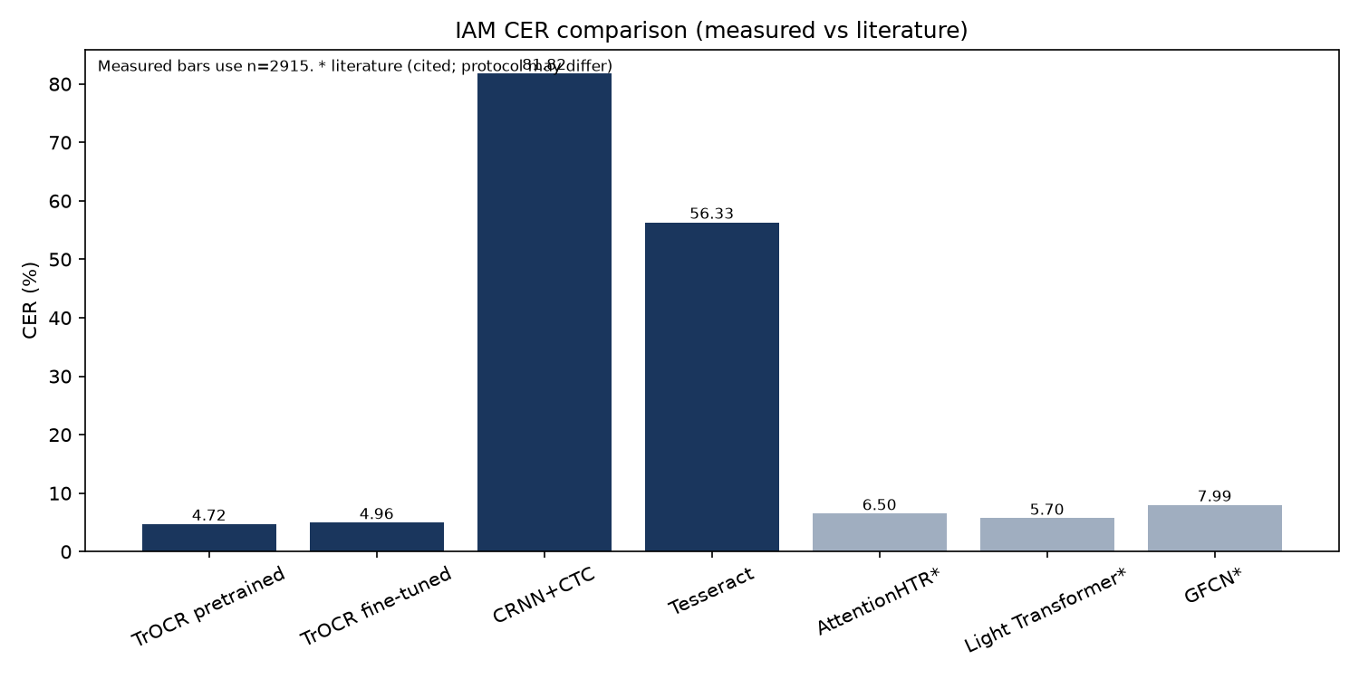
Measured CER values for the systems I evaluated, with selected literature figures shown separately for contextual comparison.

Table 4.3 — Literature CER figures cited for context
Method | CER (IAM) | Source
AttentionHTR | 6.50% | Kass & Vats, 2022
Light Transformer | 5.70% | Barrère et al., 2022
GFCN | 7.99% | Coquenet et al., 2020
I cite these published values only to help locate my scores within the broader IAM literature. I did not re-implement those systems under my preprocessing and split conventions, and I therefore do not assert a matched state-of-the-art ranking.

4.5 Discussion and analysis

4.5.1 Pretrained TrOCR as the principal empirical result
I regard the pretrained TrOCR evaluation as the central positive finding of my study. A CER of 4.72% on 2,915 previously unseen IAM lines shows that a publicly released transformer HTR checkpoint can deliver strong line-level recognition when I assess it under a complete and transparent local protocol. For a master’s investigation concerned with transfer learning rather than architectural invention, I find this result scientifically meaningful: it shows what current pretrained models already achieve before I attempt student-led adaptation.

4.5.2 Interpretation of the fine-tuning outcome
Fine-tuning did not improve test recognition in my experiments. The adapted model’s CER of 4.96% is slightly higher than that of the Hub checkpoint. I interpret this outcome as follows. First, the starting checkpoint is already specialised for English handwriting, so residual headroom on IAM is limited. Second, validation CER worsened after the first epoch, and early stopping rightly preferred the earlier checkpoint; continued training under my logged schedule was not justified by the validation signal. Third, I used a small micro-batch with gradient accumulation, which may be adequate for a feasibility study yet suboptimal for extracting further gains. I therefore treat fine-tuning as an experiment I executed and measured, whose effect under these conditions was neutral to slightly adverse—not as proof that adaptation is universally unhelpful, nor as a failed run.

4.5.3 The CRNN+CTC baseline in perspective
The CRNN+CTC system’s CER of 81.82% confirms a substantial gap relative to TrOCR under the matched data and metrics I used. I ask the reader to interpret this carefully: I designed the baseline to be intentionally lightweight—a compact CNN–BiLSTM–CTC model trained from scratch with fixed 32×128 geometry—and I do not present it as an optimised competitive neural HTR system. I use it for comparative anchoring. The large error rate therefore illustrates, in my setting, the advantage of large-scale pretrained transformers; it does not imply that every CTC architecture would fail equally.

4.5.4 Classical Tesseract as a reference baseline
I used Tesseract as a classical OCR point of comparison on the same full test partition and obtained CER 56.33% and WER 91.35%. The gap to pretrained TrOCR is large, as I expected when applying a general-purpose OCR engine to unconstrained handwriting line images without handwriting-specific adaptation. This result strengthens the case for transformer HTR in my study while remaining modest in claim: I treat Tesseract as a classical reference, not as a tuned handwriting specialist under this protocol.

4.5.5 Error behaviour and qualitative observations
When I inspected high-CER predictions, I observed recurring difficulties with very short references, punctuation-dominated or dash-like strings, and rare or hyphenated tokens. Such lines can inflate per-example CER even when corpus-level error remains comparatively low. These observations caution me against over-interpreting isolated failures and reinforce my reliance on aggregate CER/WER on the full test partition.

4.5.6 Limitations affecting interpretation
I bound my interpretation by the design of the study. I address English line-level IAM only. My literature comparisons are contextual rather than protocol-matched. My fine-tuning schedule was short and early-stopped, and I do not present it as an exhaustive hyperparameter search. I kept the CRNN baseline simple by design. Application/demo scores—especially any smoke or synthetic subset metrics—are illustrative only; I exclude them from Table 4.2 and from my primary thesis claims.

4.6 Application prototype
Beyond offline evaluation, I developed a Gradio-based demonstration for interactive English line transcription, optionally with reference-based CER when ground truth is supplied. I treat the prototype as an applied complement to my experimental programme: it shows that the recognition stack can be used through a non-specialist interface. I keep scientific claims dependent on the full-test E1–E4 runs reported above, not on demo-subset CER.

4.7 Reproducibility statement
I intend every quantitative statement in this chapter to be recoverable from the logged experiment artefacts of the project. I take training hyperparameters from the fine-tuning and CRNN training logs, and test metrics from the corresponding evaluation records. Reproduction follows the project’s documented GPU protocol and evaluation commands. In this way, Chapter 4 remains answerable to the methodological design of Chapter 3 and prepares the reflective synthesis I develop in Chapter 5.

