Use Vivado to build an Embedded System
- Create a Vivado Project Step 1
  - Launch Vivado and create an empty project targeting the ZYBO (having xc7z010clg400-1 device) and using the VHDL language.
    - Open Vivado by selecting Start > All Programs > Xilinx Design Tools > Vivado 2013.4 > Vivado 2013.4
    - Click Create New Project to start the wizard. You will see the Create a New Vivado Project dialog box. Click Next.
    - Click the Browse button of the Project Location field of the New Project form, browse to c:\xup\embedded\labs, and click Select.
    - Enter lab1 in the Project Name field. Make sure that the Create Project Subdirectory box is checked. Click Next.
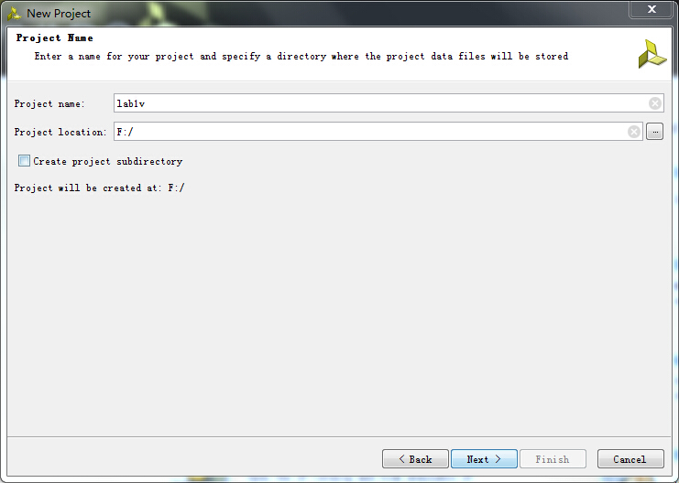

Figure 1. Project Name Entry
    - Select RTL Project in the Project Type form, and click Next.
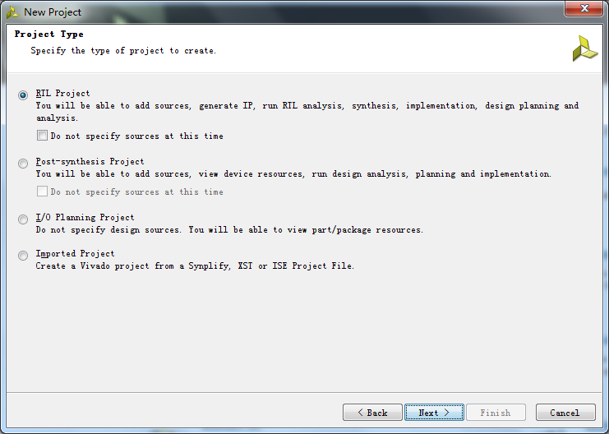
Figure 2
    - Select verilog as the Target language and Mixed as the Simulator language in the Add Sources form, and click Next.
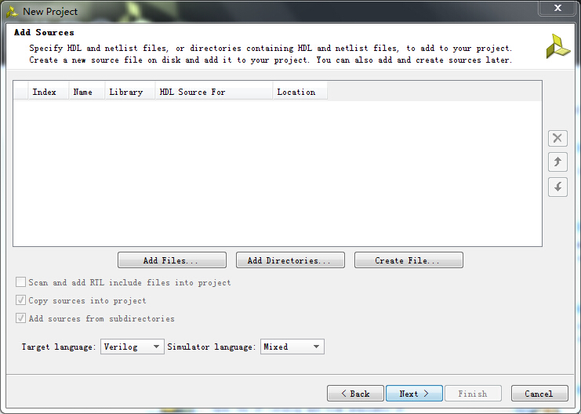

Figure 3. Add sources to new project
    - Click Next two more times to skip Adding Existing IP and Add Constraints
    - In the Default Part form, select Parts, and using various filters shown in the figure below, select xc7z010clg400-1 part as it is on the ZYBO board. Click Next.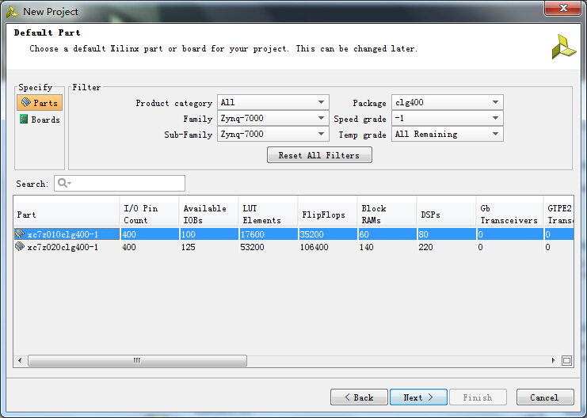
Figure 4. Boards and Parts Selection
    - Check the Project Summary and click Finish to create an empty Vivado project.
- Creating the System Using the IP Integrator Step 2
  - Use the IP Integrator to create a new Block Design, add the ZYNQ processing system block, and import the provided xml file for the ZYBO board.
    - In the Flow Navigator, click Create Block Design under IP Integrator
    - Enter system for the design name and click OK
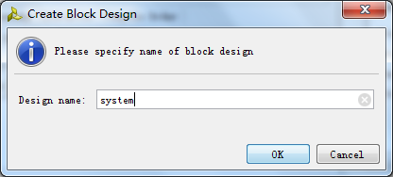
Figure 5. Create New Block Diagram
    - IP from the catalog can be added in different ways. Click on Add IP in the message at the top of the Diagram panel, or click the Add IP icon in the block diagram side bar, press Ctrl + I, or right-click anywhere in the Diagram workspace and select Add IP
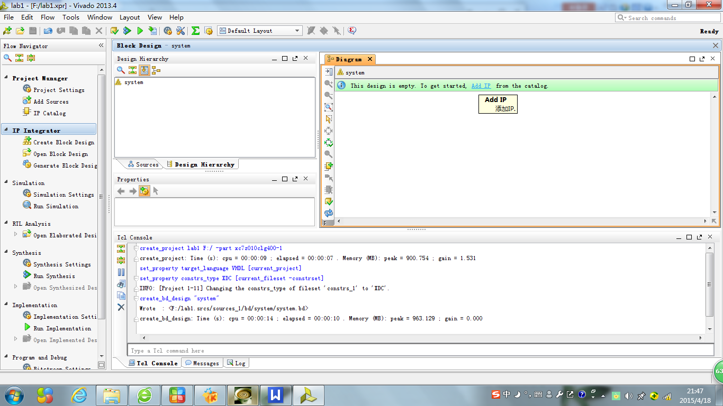
Figure 6. Add IP to Block Diagram
    - Once the IP Catalog is open, type “z” into the Search bar, find and double click on ZYNQ7 Processing System entry, or click on the entry and hit the Enter key to add it to the design.
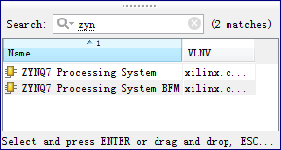

Figure 7. Add Zynq block to the design
    - Notice the message at the top of the Diagram window that Designer Assistance available.
    - Double-click on the added block to open its Customization window.
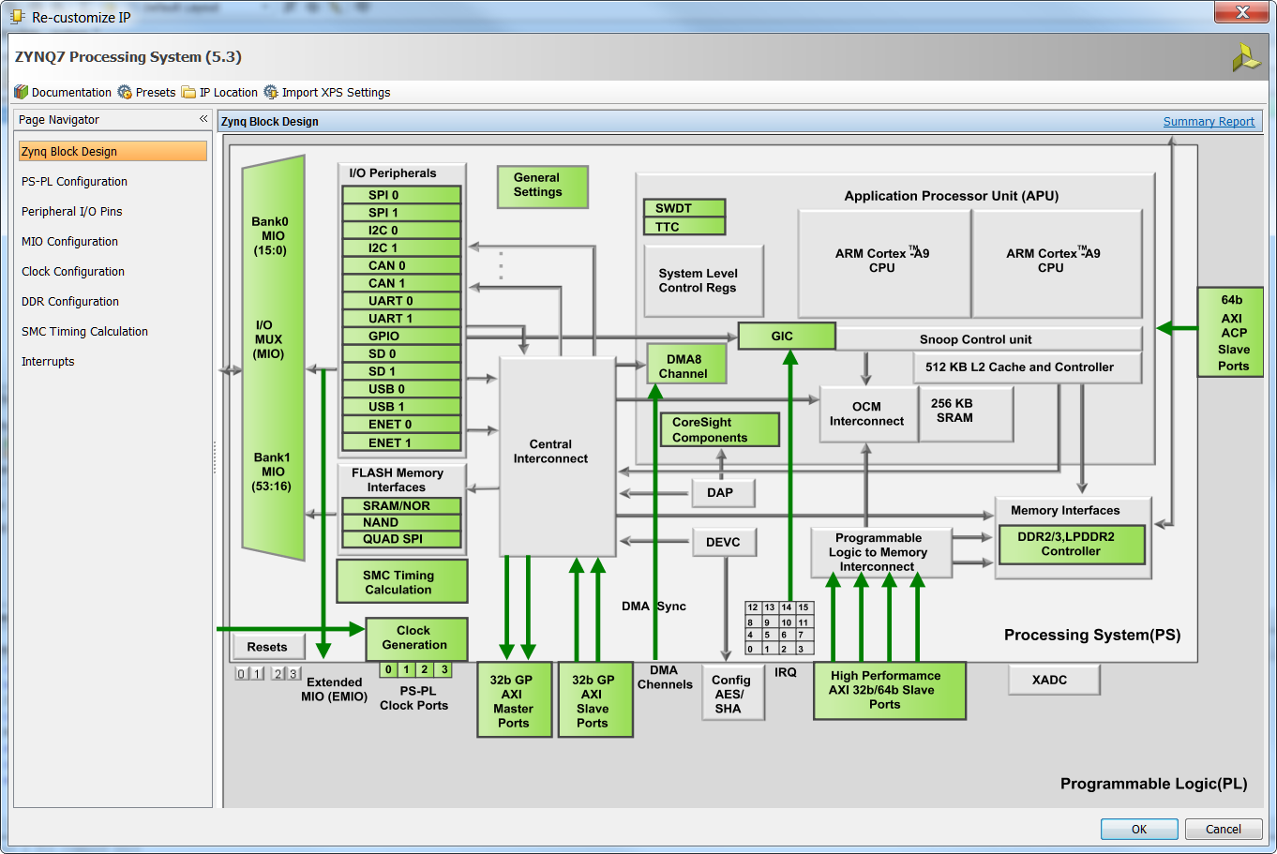
Figure 8. Default configuration form with no peripheral selected
    - Click on the Import XPS Settings button on the top tools bar to import the setting for the ZYBO board using the provided xml file.
    - Click on the browse button, browse to c:\xup\embedded\support, select the provided ps7_system_prj.xml file, and click OK.
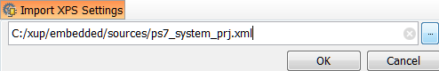
Figure 9. Selecting the xml file
    - Click OK.
    - Click OK to close the Customization window for now.
  - Configure the processing block with just UART 1 peripheral enabled.
    - Click on Run Block Automation and select /processing_system7_1
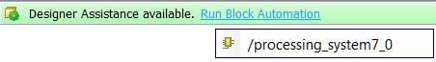
Figure 1. Designer Assistance message
    - Click OK when prompted to run automation
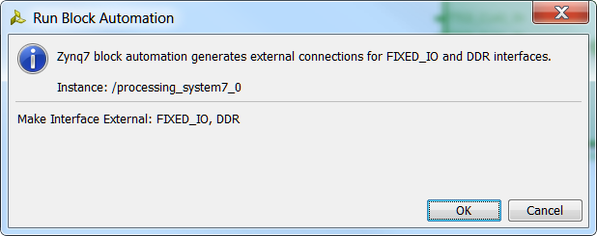
Figure 11. Run Block Automation
Once Block Automation has been complete, notice that ports have been automatically added for the DDR and Fixed IO, and some additional ports are now visible. The imported configuration for the Zynq related to the ZYBO board has been applied which will now be modified.

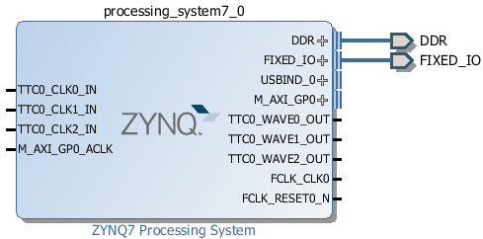
Figure 12 Zynq Block with DDR and Fixed IO ports
    - In the block diagram, double click on the Zynq block to open the Customization window for the Zynq processing system.
    - A block diagram of the Zynq should now be open, showing various configurable blocks of the Processing System.
At this stage, the designer can click on various configurable blocks (highlighted in green) and change the system configuration.
Only the UART is required for this lab, so all other peripherals will be deselected.
    - Click on one of the peripherals (in green) in the IOP Peripherals block, or select the MIO Configuration tab on the left to open the configuration form
    - Expand I/O peripherals if necessary, and deselect all the I/O peripherals except UART 1.
i.e. Remove: ENET 0
USB 0
SD 0
Expand Memory Interfaces to deselect Quad SPI Flash
Expand Application Processor Unit to disable Timer 0.
    - Select the PS-PL Configuration tab on the left. Expand GP Master AXI interface and deselect M AXI GP0 interface. Expand General > Enable Clock Resets and deselect the FCLK_RESET0_N option.
    - Select the Clock Configuration tab on the left. Expand the PL Fabric Clocks and deselect the FCLK_CLK0 option and click OK.
Click on the (Regenerate Layout) button and see the following block diagram.
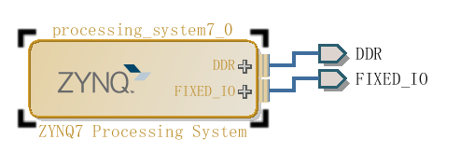

Figure 14. Updated Zynq Block
    - Click on the (Validate Design) button and make sure that there are no errors.
- Generate Top-Level and Export to SDK Step 3
  - Generate IP Integrator Outputs, the top-level HDL, and start SDK by exporting the hardware.
    - In the sources panel, right-click on system.bd, and select Generate Output Products … and click Generate to generate the Implementation, Simulation and Synthesis files for the design
    - Right-click again on system.bd, and select Create HDL Wrapper… to generate the top-level VHDL model. Leave the Let Vivado manager wrapper and auto-update option selected, and click OK
    - Notice that the VHDL file is already Set As the Top module in the design, indicated by the icon
    - Select File > Export > Export hardware for SDK…
    - The Export Hardware for SDK GUI will be displayed. Select the Launch SDK box, and ensure that Export Hardware is already selected, and click OK to export to, and launch SDK. (Save the design if prompted.)
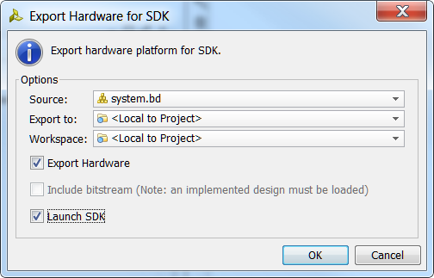
Figure 15. Exporting to SDK
    - Click Save when prompted to save the design.
- Generate Memory TestApp in SDK Step 4
  - Generate memory test application using one of the standard projects template.
    - In SDK, select File > New > Application Project
    - Name the project mem_test, and in the Board Support Package section, leave Create New selected and leave the default name mem_test_bsp and click Next.
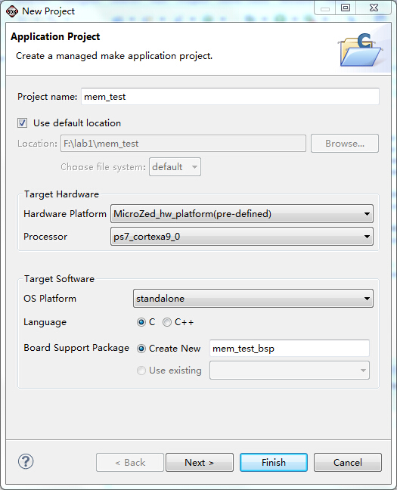

Figure 16. Create new SDK application project
    - Select Memory Tests from the Available Templates window, and click Finish.
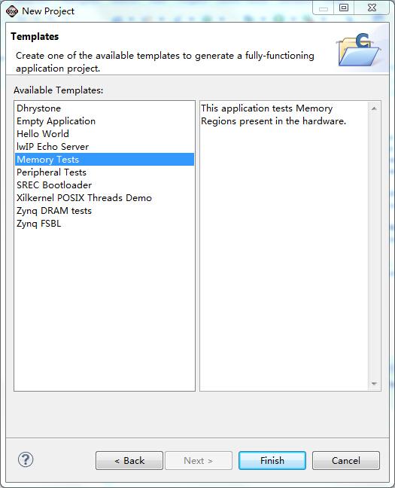

Figure 17. Creating Memory Tests C Project
The mem_test project and the board support project mem_test_bsp will be created and visible in the Project Explorer window of SDK, and the two projects will be automatically built. You can monitor the progress in the Console panel.
    - Open the memorytest.c file in the mem_test project (under src), and change the context
- Test in Hardware Step 5

5.1.Open the serial debugging assistant,and set the baud rate.Run the application,get the result.

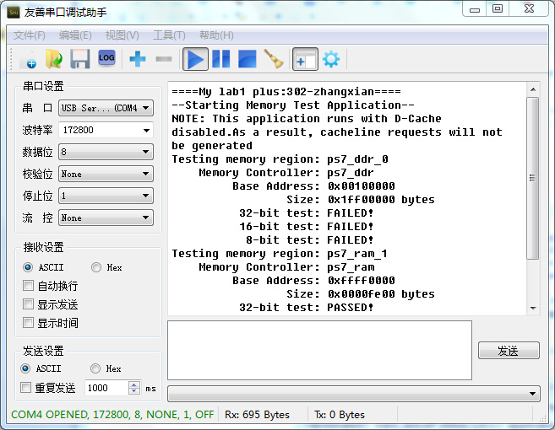

Figure 19

