JOURNAL REVIEW
FINAL PROJECT PURPOSIVE COMMUNICATION

PORSONA, EMMANUEL JR C.
BSCPE 22001
S.Y. 2025-2026

INGENIUM RESEARCH JOURNAL OR
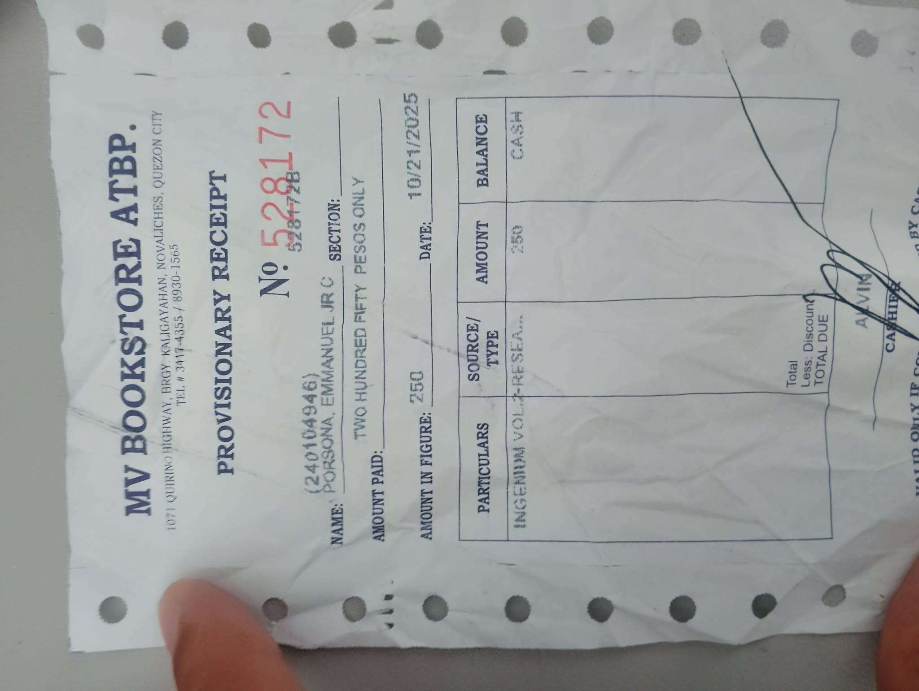



INSERT THE PICTURE OF THE RECEIPT HERE
MAKE SURE THAT THE OR NUMBER IS CLEAR

Research Title: The Development of Vital Signs Monitoring System with Data Output Interface using Arduino Mega
Authors: Joyce Ann Alegre
Christine Joyce Castillo
James Samuel Ferrer
Paula Mae Lagarnia
Rommel Nepomuceno
Main Components:
- Arduino Mega and Arduino Uno
- Temperature, Pulse rate, Oxygen, and Glucose Sensor
- LCD 20x4 and LCD 16x2
- Bluetooth module

Answer the Following Questions:
- What is the main objective of this Research?
The main objective of this research is to develop a vital signs monitoring system that can measure multiple health indicators in one device. Instead of using separate tools, the system combines sensors for temperature, pulse rate, oxygen level, and glucose level into a single setup.

It also aims to make monitoring more convenient by automatically recording the data and sending it to a mobile phone using Bluetooth. Overall, the goal is to create a more efficient and accessible way to monitor a person’s health in real-time.

- What is the Gap that this research tried to fill up?
The research tries to solve the problem of traditional vital sign monitoring being limited and inconvenient. Most existing devices only measure one type of vital sign (like blood pressure), so patients need to use multiple devices just to complete their health check.
This becomes time-consuming, repetitive, and sometimes stressful for patients, especially if they need frequent monitoring.
So, the gap here is the lack of a single, integrated system that can monitor multiple vital signs at once. This study fills that gap by combining different sensors into one system, making the process faster and more practical.

- How this research can help you in designing future prototypes?
This research is really helpful for designing future prototypes because it shows how to integrate multiple sensors into one working system, which is something we also need in our projects. It also gives a clear idea of using experimental prototyping, where you build, test, and improve the system step by step until it works properly. That approach is very useful for our capstone projects.
Another important takeaway is the use of microcontrollers like Arduino Mega and the suggestion to upgrade to more advanced systems like Raspberry Pi for better performance. Overall, this research helps us understand how to design systems that are not just functional, but also practical, user-friendly, and scalable for real-world use.

Research Title: Green Techology Smart Home with Cloud Based AI Application, RFID and Laser Security using ESP32 and Arduino Microcontroller Unit
Authors: Engr. Reynante B. Ponay
Main Components:
- ESP32 and Arduino Uno
- RFID module
- Servo motor

Answer the Following Questions:
- What is the main objective of this Research?
The main objective of this research is to develop a smart home system that can automate household devices while also improving home security.
It focuses on integrating different technologies like ESP32, Arduino, RFID, laser security, and AI (Alexa) into one system so users can control their home using voice commands, mobile apps, or manual switches.
Another goal is to make the system more reliable by adding features like solar power and backup controls in case of Wi-Fi or system failure.

- What is the Gap that this research tried to fill up?
The research addresses the problem that many existing smart home systems are not fully reliable and lack strong security features. Some systems depend too much on Wi-Fi, so when the connection fails, the system also stops working. Others also don’t provide enough protection against unauthorized access.

So, the gap here is the lack of a complete and dependable smart home system that combines automation, security, and backup solutions. This study fills that gap by integrating multiple control options (Alexa, app, manual), dual security systems (RFID and laser), and solar power backup, making the system more stable and secure.

- How this research can help you in designing future prototypes?
This research is helpful because it shows how to design a system that is not just functional, but also reliable and scalable. It gives a good idea on how to combine multiple subsystems like automation, security, and power management into one project, which is very useful for capstone-level prototypes.
It also shows the importance of having backup systems (like solar power and manual control), which is something we can apply to make our own projects more practical in real-world situations. Lastly, it helps us understand how to use modern technologies like IoT, AI assistants, and mobile apps together, which is important if we want our future prototypes to be more advanced and competitive.

Research Title: Hand Gesture Detection Technology using Raspberry Pi Converting Hand Signals into Tagalog Words
Authors: Jomar C. Chavez
Mylen Cortes
Joshua B. Detera
Mark V. Layague
Leila Tabacolde

Main Components:
- Raspberry Pi 4 (main controller)
- 8MP USB Camera (for gesture detection)
- HDMI / LCD Display
- Speaker (for audio output / text-to-speech)
- Solar panel
- 12V battery
- Charge controller
- Step-down converter / power supply

Answer the Following Questions:
- What is the main objective of this Research?
The main objective of this research is to develop a hand gesture detection system that can translate Filipino Sign Language (FSL) into Tagalog words.
It aims to help deaf individuals communicate more easily, especially in public places like government offices. The system uses a camera and AI to recognize hand gestures and convert them into understandable words or speech.

- What is the Gap that this research tried to fill up?
The research addresses the problem of communication barriers between deaf individuals and non-sign language users. In many public services, not everyone understands Filipino Sign Language, which makes it hard for deaf people to communicate their needs.
So, the gap here is the lack of accessible communication tools that can translate sign language into spoken or readable words in real time. This study fills that gap by creating a system that automatically detects gestures and converts them into Tagalog words, making communication easier and more inclusive.

- How this research can help you in designing future prototypes?
This research is very helpful because it shows how to integrate AI, computer vision, and embedded systems into one project. It gives us an idea on how to use tools like TensorFlow, MediaPipe, and Raspberry Pi for real-time detection systems, which is useful if we want to build AI-based prototypes.
Also, it teaches the importance of designing systems that solve real social problems, not just technical projects. For future prototypes, we can apply this by creating systems that are intelligent, inclusive, and user-focused, especially those that help people in real-life situations.

