

Draw It or Lose It

# CS 230 Project Software Design Template

Version 1.0

## Table of Contents

CS 230 Project Software Design Template 1

Table of Contents 2

Document Revision History 2

Executive Summary 3

Design Constraints 3

System Architecture View 3

Domain Model 3

Evaluation 3

Recommendations 5

## Document Revision History

|  |  |  |  |
| --- | --- | --- | --- |
| Version | Date | Author | Comments |
| 1.0 | 17/06/2022 |  | Executive Summary, Design Constraints,  and Domain Model sections are completed. |

## Executive Summary

**Gaming room team of workers wants to develop a web-primarily based version of the Draw-It or Lose-It game. Have multiple groups, have a couple of gamers in line with team, permit simplest unique group names so that players can verify that the name is used, and feature most effective one example of the sport in memory we're requested to layout a game that have these features inside the Given time.**

## Design Constraints

* - To be fully useful in an internet-based totally environment, the game should be written in an internet-based totally language such as JavaScript or Python.
* - You need to create a group and participant objects to allow multiple teams with multiple gamers in line with team.
* - To make sure uniqueness the use of the singleton pattern in recreation and team introduction, you need to validate the sport and group names..
* - Handiest one example of the sport should be in memory by means of the usage of the iterator pattern to create a unique identification for every instance of the game, group, or participant.

## System Architecture View

## Domain Model

Sport, crew, and player instructions each inherit from Entity superclass permitting the attributes and operations contained in Entity to be written as soon as and utilized by every of the classes inheriting from it. The GameService, sport, group, and player classes are all related to each other. They use a 0 to many affiliation which means they may use as typically of the alternative as they need to, or they might use none. The ProgramDriver magnificence drives the package deal and inherits/makes use of the SingletonTester class at the equal time as doing so.

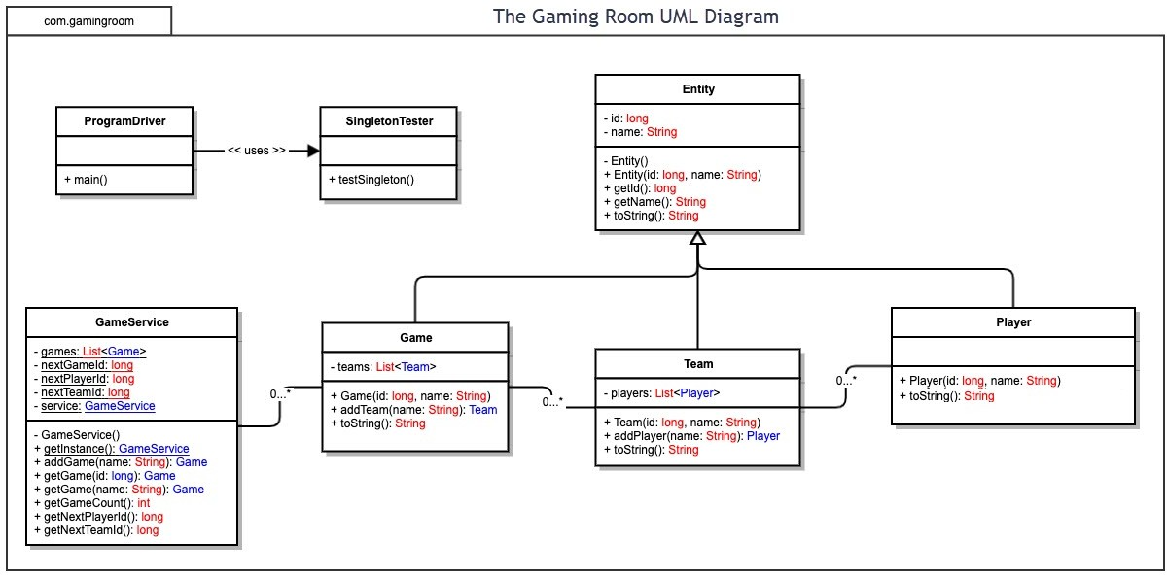

## Evaluation

|  |  |  |  |  |
| --- | --- | --- | --- | --- |
| **Development**  **Requirements** | **Mac** | **Linux** | **Windows** | **Mobile Devices** |
| **Server Side** | Mac does have  Mac OS X server  Available to be used.  According to Apple’s  Internet site, Mac OS X  Server is only $20,  So it would be  Cheaper to  Put in force. Mac,  However, isn't always as  Famous as say  Linux or home windows  For performing  These obligations. | Linux is thrilling  Here because it has  Many  Distributions that  Have server  Competencies. Linux  Server would be  Low-cost, and  Open source  (which gives a  Lot of assets).  No longer many users  Are savvy with  Linux, so you  Could need  Someone who's  Acquainted with Linux  Strolling the  Server | Windows gives  Windows Server.  Looking at  Microsoft’s  Internet site, it'd  Be pricey to  Put into effect, however it  Is absolutely  Functioning.  Home windows is probable  The maximum used  Operating gadget,  So finding users to  Operate home windows  Server could be a  Lot simpler. | Given that mobile  Gadgets do not  Always have the  Electricity that  Computers do,  Website hosting a completelyfledged server on  One won't be the  Excellent choice  As compared to  Computer systems. Running  Servers on cell  Gadgets is the maximum  Fantastic in  Phrases of cost, as  There may be little to  None to get one  Commenced. |
| **Client Side** | Cost might be like  A windows setup,  As these operating  Systems are not  Open source. Time  Could depend upon  Know-how, as  Someone who has  Revel in with  Mac could want  Much less time and  Someone who does  No longer have as a great deal  Experience with  Mac would want  More time. | Cost could be low  (if there even is a  Cost) with Linux,  As it is open  Supply. Most  Time and  Revel in could  Be important, as  Linux isn't always  Generally used  And you'll  Want someone  Who's apt with  Linux and permit  Them time to  Paintings, as Linux can  Be hard even  For a person with  Revel in. | Cost could be like  A windows setup,  As these running  Structures aren't  Open source. Time  Might depend on  Knowledge, as  A person who has  Experience with  Home windows could  Need less time  And someone who  Does no longer have as  A lot experience  With home windows  Could need more  Time. | Fee could now not be  An excessive amount of of an  Problem with cell  Devices. Enjoy  May not be too  A good deal of an problem, as  Mobile devices can  Be less difficult to paintings  With. More time  Might be needed, as  There are multiple  Working structures  And a couple of cell  Gadgets that could  Need to be worked  On. |
|  |  |  |  |  |
| **Development** | Swift would be the  More not unusual  Language used to  Write programs  For Mac. There are  A couple of IDEs that  May be used for  Fast, inclusive of Atom | Eclipse and Atom  Are commonly  Used IDEs on  Linux. Eclipse is  Primarily used for  Java, although it  Can support other  Languages like C+ | Eclipse and visual  Studio are famous  IDEs for home windows.  Visual Studio can  Be used for  Developing in  HTML, C# and  JavaScript among | For iPhones, the  Development tools  Are like those for  Mac, and iOS apps  Are usually written  In rapid, even though iOS  And macOS are  One-of-a-kind in terms of |
| **Tools** |  |  |  |  |
|  |  |  |  |  |

## Recommendations

Analyze the characteristics of and techniques specific to various systems architectures and make a recommendation to The Gaming Room. Specifically, address the following:

1. **Operating Platform**: In terms of platforms , there are variations between, cellular video games and laptop games in the manner it's far used, the operator, the primary event play, the sport layout or even the way the game paintings. We know that each one the games on console structures, laptop and mobile, have their very own function that have advantages and drawbacks All platforms compete to win the rating for the sake of their platform continuity. For rating, all video games structures develop games which can be extra qualified. Those video games will decide the nice of the structures, in order that the sport developers of each platform broaden their video games maximally to compete. So endorsed is windows.
2. **Operating Systems Architectures**: Arm: now not powerful take a look at to x86 has many drawback most possibility on arm arch is cellular gaming.

X86: very effective, big development so easy to expand game on platform like unity and unreal , massive hardware compatibility and help

Word. Proper right here we discussing on arch so intel and amd every included on X86 and sure X86 isn't always consult with particular 32bit it is able to be 64bit on account that now an afternoon 64bit is commonplace.

1. **Storage Management**: As storage side we've got few desire in which hdd is slow and too antique even new console the usage of ssd.

So ssd is suggested preference.

But wait ssd have also many choice like sata and nvme.

If simply into deep and want machine that prepared for future device than moreover consider pcie four.

So preserving in thoughts charge and pace stability q cell nvme ssd is recommended

1. **Memory Management**: As endorsed home windows,every manner on 32-bit Microsoft home windows has its personal virtual deal with space that permits addressing up to 4 gigabytes of reminiscence. Every technique on 64-bit windows has a virtual deal with space of eight terabytes. All threads of a system can get entry to its digital cope with area. However, threads can not get right of entry to reminiscence that belongs to another process, which protects a procedure from being corrupted via another technique.
2. **Distributed Systems and Networks**: Community based multi consumer interplay systems which includes community video games commonly include a database shared most of the gamers which might be physically disbursed and have interaction with each other over the network. Currently community recreation developers must implement the shared database and the inter participant communications from scratch. The paper provides the structure of a allotted machine, Artery, that's specifically designed to assist community recreation packages with the aid of offering a excessive level software software interface and by using taking advantage of utility semantics to optimize the network overall performance. So for it is hard but it is well worth it on online video games.
3. **Security**: As safety facet every sport, there may be a high-quality threat that, in the warmth of the moment, information may be transmitted that you higher keep to yourself. There are numerous threats in your IT. On the one hand, there's a chance of facts loss or get entry to for your account. It'd be even worse in case you go through critical economic harm. While journeying an internet on line casino or gaming on pc and cellphone, you can do lots to reduce this threat.

Thinking about records safety subjects while growing video games software program can also lead to sizeable aggressive benefits. Records controllers are obliged below the GDPR to decrease data collection and processing, the use of, as an example, anonymization or pseudonymization of personal facts where possible.