***Given the provided data, what are three conclusions that we can draw about crowdfunding campaigns?***

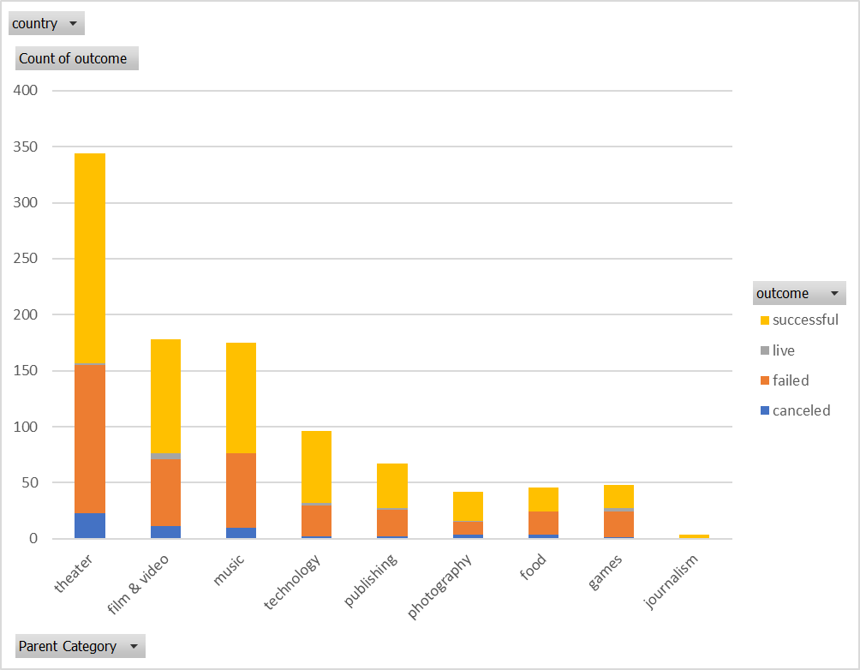

1. The majority of campaigns fell under the “theater” main category, which was about 50% successful

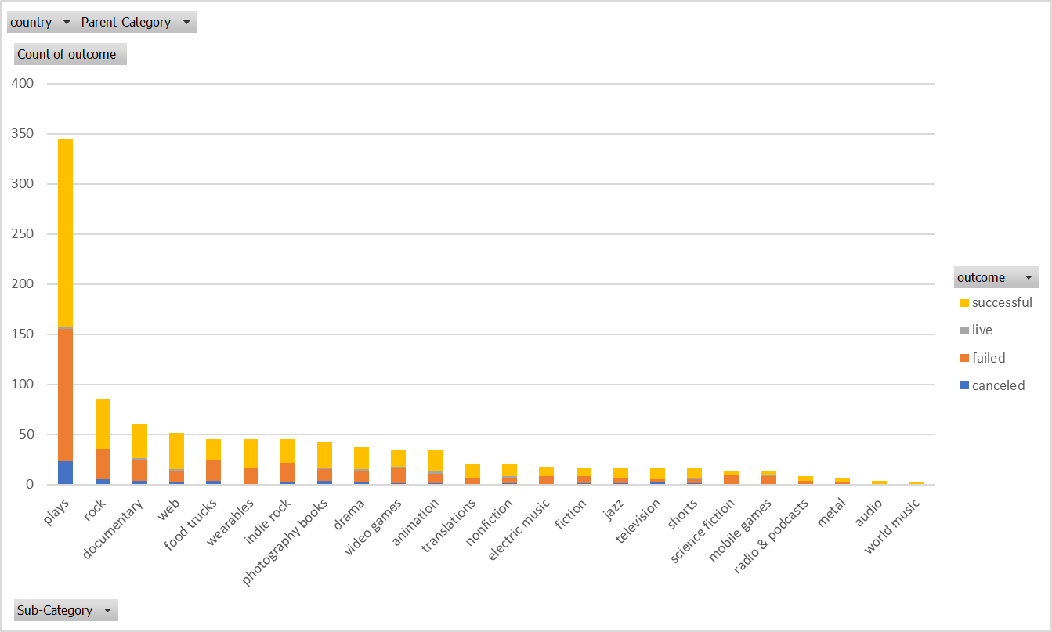

1. The majority of campaigns fell under the “play” subcategory, which was also about 50% successful

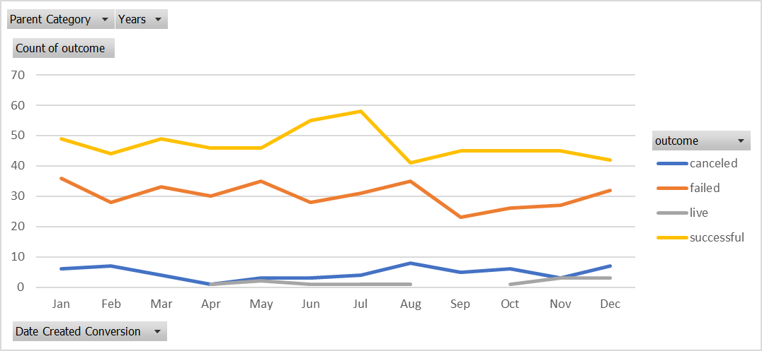

1. The peak amount of successful campaigns was in July

***What are some limitations of this dataset?***

A limitation of this dataset is that there is a rather wide range of data here with large variance, so predictions may not be reliable.

***What are some other possible tables and/or graphs that we could create, and what additional value would they provide?***

We could look at percentage stacked column charts that show us the percentage successful each campaign type was (by category or subcategory). We could also look at percent funded by category to see what the success rates are. We could also look at this by country to see if there is any relationship between country and success rates. Finally, we could look at dates funded to see what time of year the most successful campaigns were.