AI-Based Credit Default Prediction: Model Selection and Responsible AI
YIMAN LI
- Introduction
  - Credit Default Risk: Problem Context and Stakeholders
Credit default prediction is an important problem in financial risk management because lending institutions need to assess whether loan applicants are likely to default on future repayments. These predictions can support loan approval decisions and help lenders manage the financial risks associated with providing credit. Underestimating default risk may expose lenders to financial losses, whereas overestimating risk may result in creditworthy applicants being denied access to loans. Reliable predictions are therefore important for effective risk management and responsible lending.
Assessing default risk requires information about applicants’ financial circumstances and previous credit behaviour, including credit limits, outstanding balances, repayment delays and payment history. By analysing historical credit data, AI models can identify patterns associated with subsequent default outcomes and estimate applicants’ potential credit risk.
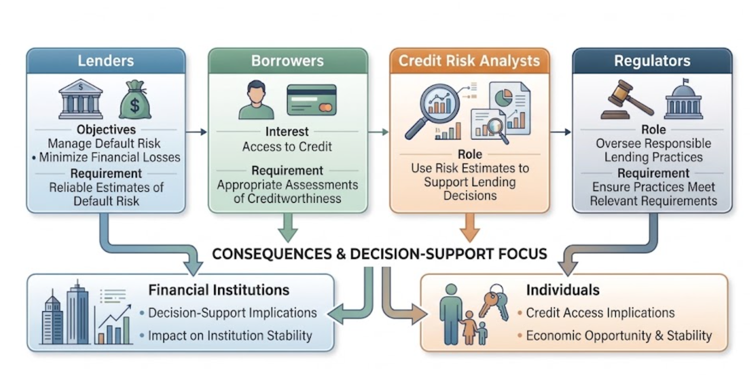
  - Motivation for Using Artificial Intelligence
Credit default prediction is well suited to AI because borrowers' repayment behaviour is shaped by multiple financial factors whose effects depend on the wider context of each borrower's credit profile. These factors include credit limits, outstanding balances, repayment delays, payment amounts and previous repayment history. For example, the same outstanding balance may indicate different levels of risk depending on a borrower's credit limit and repayment history. Similarly, repeated payment delays alongside increasing outstanding balances may reveal risk patterns that are not apparent when these factors are considered separately. Such relationships make credit risk assessment more complex than simply evaluating individual indicators against fixed criteria.​
AI techniques can learn patterns from historical credit data and model relationships between borrower characteristics and default outcomes. Research on loan default prediction has shown that nonlinear relationships and interactions between risk factors can limit the effectiveness of conventional linear model specifications, while machine learning methods can capture these patterns more flexibly [1]. A systematic review of credit scoring research also documents the application of machine learning alongside traditional statistical methods and compares their predictive performance [2]. These findings support the use of AI as an approach to investigating complex credit risk patterns.
  - AI Task Formulation
Credit default prediction is formulated as a supervised binary classification task. The input (X) consists of loan applicants’ financial and credit-related characteristics available at the time of assessment, including credit limits, outstanding balances, repayment status and previous payment history. The target variable (Y) indicates whether an applicant defaults within a defined future period following loan approval, where Y = 1 represents default and Y = 0 represents non-default.
Using historical loan records with known outcomes, the model learns a function f(X) to estimate the probability of default, P(Y = 1 | X). This probability can then be converted into a binary prediction using a classification threshold to support loan approval decisions. The task is formulated as supervised binary classification because the model learns from labelled historical data to predict one of two possible outcomes.
Model performance can be evaluated using accuracy, precision, recall, F1-score and ROC-AUC. Recall is important because missed defaults may expose lenders to financial losses, while precision indicates how often applicants predicted to default actually default. F1-score balances precision and recall, while ROC-AUC measures the model’s ability to distinguish between default and non-default cases across different classification thresholds. Accuracy measures the proportion of predictions that are correctly classified.
- AI Technology Selection and Justification
  - Logistic Regression
Logistic Regression is a supervised learning algorithm commonly used for binary classification. In credit default prediction, it combines borrower characteristics, such as financial and repayment information, to estimate the probability of default. The logistic function maps the model's linear output to a probability between 0 and 1, which can then be compared with a classification threshold to assign a predicted class.
A key advantage of Logistic Regression is its computational efficiency and interpretability. Its coefficients indicate how individual features are associated with the log-odds of default, making the model relatively straightforward to analyse and explain. This is particularly valuable in credit risk assessment, where lending decisions may require clear justification. However, standard Logistic Regression models linear relationships between input features and the log-odds of default. Without additional feature engineering, it may not adequately capture complex nonlinear relationships or interactions between borrower characteristics.
  - XGBoost
XGBoost is an ensemble learning algorithm based on gradient-boosted decision trees. It builds trees sequentially, with each new tree improving the model by reducing the errors made by the existing ensemble. By combining multiple trees, XGBoost can capture nonlinear relationships and interactions among borrower characteristics, making it a suitable candidate for credit default prediction.
Compared with Logistic Regression, XGBoost offers greater flexibility in modelling complex patterns in structured financial data and generally requires less manual specification of nonlinear relationships. However, it typically involves more hyperparameter tuning and computational complexity. Its predictions are also less directly interpretable than Logistic Regression coefficients, which can complicate the explanation of individual lending decisions. Techniques such as SHAP can help explain feature contributions to individual predictions, although these explanations do not establish causal relationships.
  - Comparative Evaluation and Technology Selection
Table 1 compares Logistic Regression and XGBoost against the seven criteria relevant to credit default prediction.
Table 1: Comparative evaluation of Logistic Regression and XGBoost
Evaluation criterion | Logistic Regression | XGBoost
Suitability for the task | Suitable for binary classification and default probability estimation | Suitable for binary classification and complex credit risk patterns
Computational complexity | Low; efficient to train and evaluate | Higher due to multiple trees and parameter tuning
Interpretability | High; model coefficients are directly interpretable | Lower; additional explanation methods are needed
Data requirements | Structured data; complex relationships may require manual feature construction | Structured data; captures nonlinear relationships with less manual feature construction
Predictive performance | Effective baseline, but limited in modelling complex relationships | Strong predictive capability for complex nonlinear patterns
Scalability | Efficient for typical credit classification tasks | Handles large structured datasets, with resource requirements depending on configuration
Implementation difficulty | Relatively easy to implement and tune | Requires more extensive parameter tuning and interpretation
The comparison highlights a trade-off between predictive flexibility and interpretability. Logistic Regression provides an efficient and interpretable baseline, whereas XGBoost can represent nonlinear relationships and feature interactions that may be inadequately captured by a standard linear model. However, greater model complexity does not guarantee better predictive performance. The choice should therefore depend on whether XGBoost achieves a meaningful improvement under a consistent evaluation procedure and whether that improvement justifies the additional computational and explanation costs.
XGBoost is selected as the primary candidate because credit default risk may depend on interactions among financial characteristics, and its tree-based structure can model such relationships [3]. Existing research on European loan default prediction provides empirical support for considering tree-based methods alongside Logistic Regression [1].
- Responsible AI Considerations
  - Fairness and Bias in Training Data
Historical credit data may reflect inequalities in access to lending, causing a machine-learning model to reproduce or amplify existing discrimination [4]. For example, borrowers with limited credit histories may be assessed less reliably when less repayment information is available. Depending on the dataset and modelling context, features such as residential location or employment history may also act as proxies for socioeconomic disadvantage.
To mitigate these risks, lenders should audit model performance across demographic groups using measures such as false positive and false negative rates. Where lawful, demographic data may support fairness testing but should not be misused in individual lending decisions. If significant disparities are identified, institutions should review the data, features and decision thresholds, and apply appropriate mitigation methods [5]. However, fairness metrics may conflict, so reducing statistical disparities alone cannot eliminate discrimination. Ongoing monitoring of lending outcomes and stakeholder impact is therefore necessary.
  - Explainability and Transparency
XGBoost can capture complex relationships but is less directly interpretable than Logistic Regression. This creates a practical challenge when borrowers need understandable reasons for adverse lending decisions. SHAP (SHapley Additive exPlanations) assigns feature contribution values to individual predictions, helping analysts identify the factors that contribute to a high predicted default risk [6].
Lenders should use SHAP to identify the main factors influencing individual predictions and translate these factors into clear, accessible explanations for borrowers. These explanations should be supported by model documentation, validation results and a transparent review process. Borrowers should also have an appropriate channel to question inaccurate information and request a review. This approach improves the transparency of automated credit decisions by helping analysts identify the key factors influencing individual predictions.
  - Privacy
Credit default prediction requires sensitive financial information, including repayment histories, outstanding balances and credit limits. Excessive collection, unauthorised access or secondary use of these data may expose borrowers to privacy violations and undermine trust. Responsible deployment therefore requires data minimisation, purpose limitation, access controls and appropriate retention periods, consistent with applicable data protection requirements [7].
Institutions should collect only information necessary for a clearly defined credit assessment purpose, restrict access to authorised personnel and establish procedures for secure storage and deletion. Data processing practices should also be communicated clearly to borrowers. These measures reduce unnecessary exposure but cannot eliminate all risks, particularly where data are shared with third parties or retained in multiple systems. Regular security reviews and clear responsibility for data governance are therefore necessary throughout the model lifecycle.
  - Human Oversight and Accountability
Automated credit scoring may encourage excessive reliance on model outputs, particularly when predictions appear precise or perform well overall. However, the model may misclassify borrowers whose circumstances differ from its training data, and predictive accuracy alone does not guarantee that an individual lending decision is appropriate.
Lenders should establish a documented review process for cases involving questionable data, unusual circumstances or disputed decisions. Authorised analysts should be able to challenge model recommendations, use appropriate override procedures and record their decisions. These safeguards are consistent with EBA guidance on automated creditworthiness assessment, model monitoring and escalation procedures [8].
- Conclusion
This study examined credit default prediction as a supervised binary classification problem. XGBoost was selected as the primary technique because it can capture nonlinear relationships, while Logistic Regression was retained as an interpretable benchmark. However, XGBoost's actual performance should be validated empirically.
The analysis also highlighted key risks concerning fairness, explainability, privacy and accountability. Responsible deployment requires regular fairness audits, transparent explanations, appropriate data protection and meaningful human oversight. Ultimately, successful AI-based credit assessment must balance predictive performance with fair and accountable lending decisions.
References
- Barbaglia, L., Manzan, S. and Tosetti, E. (2023) ‘Forecasting loan default in Europe with machine learning’. Journal of Financial Econometrics, 21(2), pp. 569–596. https://doi.org/10.1093/jjfinec/nbab010
- Dastile, X., Çelik, T. and Potsane, M. (2020) ‘Statistical and machine learning models in credit scoring: A systematic literature survey’. Applied Soft Computing, 91, article 106263. https://doi.org/10.1016/j.asoc.2020.106263
- Chen, T. and Guestrin, C. (2016) ‘XGBoost: A scalable tree boosting system’. In: Proceedings of the 22nd ACM SIGKDD International Conference on Knowledge Discovery and Data Mining, pp. 785–794. https://doi.org/10.1145/2939672.2939785
- Das, S., Stanton, R. and Wallace, N. (2023) ‘Algorithmic fairness’. Annual Review of Financial Economics, 15, pp. 565–593. https://doi.org/10.1146/annurev-financial-110921-125930
- Kozodoi, N., Jacob, J. and Lessmann, S. (2022) ‘Fairness in credit scoring: Assessment, implementation and profit implications’. European Journal of Operational Research, 297(3), pp. 1083–1094. https://doi.org/10.1016/j.ejor.2021.06.023
- Lundberg, S.M. and Lee, S.-I. (2017) ‘A unified approach to interpreting model predictions’. In: Advances in Neural Information Processing Systems 30, pp. 4765–4774. https://proceedings.neurips.cc/paper/2017/hash/8a20a8621978632d76c43dfd28b67767-Abstract.html
- European Parliament and Council of the European Union (2016) ‘Regulation (EU) 2016/679 of the European Parliament and of the Council of 27 April 2016 on the protection of natural persons with regard to the processing of personal data and on the free movement of such data, and repealing Directive 95/46/EC (General Data Protection Regulation)’. Official Journal of the European Union, L 119, 4 May, pp. 1–88. https://eur-lex.europa.eu/eli/reg/2016/679/oj/eng
- European Banking Authority (2020) Guidelines on loan origination and monitoring (EBA/GL/2020/06), 29 May. https://www.eba.europa.eu/sites/default/files/document_library/Publications/Guidelines/2020/Guidelines%20on%20loan%20origination%20and%20monitoring/884283/EBA%20GL%202020%2006%20Final%20Report%20on%20GL%20on%20loan%20origination%20and%20monitoring.pdf

