Software Requirements Specification
for
Automated Students' Results and courses registration Management Information System (SRR-MIS)
Version 1.0
Prepared by Mai Ibrahim, Mariam Fathy
Egypt-Japan University of Science and Technology
1/4/2024
Table of Contents
Table of Contents ii
Revision History ii
1. Introduction 1
1.1 Purpose 1
1.2 Intended Audience and Reading Suggestions 1
1.3 Product Scope 2
2. Overall Description 2
2.1 Product Perspective 2
2.2 Product Functions 2
2.3 User Classes and Characteristics 3
2.4 Operating Environment 4
2.5 Design and Implementation Constraints 4
2.6 Assumptions and Dependencies 4
3. External Interface Requirements 5
3.1 User Interfaces 5
3.2 Hardware Interfaces 13
3.3 Software Interfaces 13
3.4 Communications Interfaces 13
4. System Features 14
4.1 Login Management 14
4.2 Course Management 14
4.3 Attendance Tracking 15
4.4 Payment Management 15
4.5 Report Generation 16
4.6 GPA Calculator 16
4.7 Calendar Management 17
4.8 Grade Management 17
5. Other Nonfunctional Requirements 18
5.1 Performance Requirements 18
5.2 Safety Requirements 18
5.3 Security Requirements 18
5.4 Software Quality Attributes 19
5.5 Business Rules 19
6. Other Requirements 19
Appendix A: Glossary 20
Appendix B: Analysis Models 21
Appendix C: To Be Determined List 21

Revision History
Name | Date | Reason For Changes | Version

Introduction

Purpose
Automated Students' Results and courses registration Management Information System (SRR-MIS) product serves as a comprehensive solution for educational institutions to efficiently manage student data and administrative tasks, thereby enhancing operational efficiency, improving decision-making, and enhancing the overall educational experience. The primary objectives and goals of the SRR-MIS include streamlining student enrollment and registration processes, accurately tracking student attendance and academic performance, simplifying course scheduling and management, and providing valuable insights through reporting, and analytic. By centralizing student information and automating manual processes, the SRR-MIS reduces administrative burden, minimizes errors, and increases productivity for staff members. Additionally, the SRR-MIS enhances the educational experience for students by providing easy access to academic information, personalized learning resources, and timely communication from teachers and administrators. The SRR-MIS product delivers tangible benefits such as improved operational efficiency, better informed decision-making, enhanced communication and collaboration, and ultimately, a more enriching educational experience for all stakeholders involved.
Key objectives and purposes of the SRR-MIS include:

1. Efficient Course Registration: Simplifying the process of course registration for students and faculty by providing intuitive and user-friendly interfaces. The system should allow students to browse available courses, register for classes, and manage their course schedules conveniently.

2. Comprehensive Academic Records: Centralizing and maintaining accurate records of students' academic performance, including grades, transcripts, and course history. The system should enable authorized users, such as faculty and administrators, to access and update student records as needed.

3. Administrative Efficiency: Automating administrative workflows for tasks such as enrollment management, grading, attendance tracking, and result processing. By reducing manual data entry and paperwork, the system aims to improve administrative efficiency and productivity.

4. Decision Support and Reporting: Providing analytical tools and reporting capabilities to support strategic decision-making and academic planning. The system should generate reports, dashboards, and analytics insights to help administrators assess student performance, monitor enrollment trends, and identify areas for improvement.

Intended Audience and Reading Suggestions
The document is intended for various stakeholders involved in the development, deployment, and maintenance of the SRR-MIS. This includes developers, project managers, system architects, quality assurance testers, and documentation writers.

The SRS is organized into sections that cater to different reader types and interests. Readers are encouraged to start with the overview sections, including the purpose, scope, and objectives of the SRR-MIS. Subsequently, they can delve into specific sections relevant to their roles and responsibilities, such as functional requirements, non-functional requirements, and interface specifications.

Product Scope
The SRR-MIS is designed to streamline and automate the management of students' academic records, course registrations, and examination results within an educational institution. It serves as a centralized information system that facilitates efficient communication, data management, and administrative processes for students, faculty, and administrative staff.

The primary objectives of the SRR-MIS include:
- Simplifying the process of course registration for students and faculty members.
- Providing timely access to students' academic records, including grades, transcripts, and course schedules.
- Enhancing administrative efficiency through automated workflows for enrollment, grading, and reporting.
- Improving data accuracy and integrity by centralizing information and reducing manual data entry errors.
- Supporting strategic decision-making and academic planning through comprehensive reporting and analytics capabilities.

Overall Description

Product Perspective
The "Automated Students' Results and Courses Registration Management Information System (SRR-MIS)" is a product designed to streamline and automate the management of student results and course registration processes. This system serves as a significant enhancement to traditional Student Information Systems (SIS) by introducing novel features aimed at improving efficiency and user experience.

Originating from the need for modernized and efficient management of student-related data and processes, the SRR-MIS system is not a replacement for existing systems but rather a complementary solution that addresses specific shortcomings and introduces innovative functionalities. It aims to provide administrators, faculty members, and students with a comprehensive platform for managing academic records, course enrollment, and related activities.

Product Functions
- User Authentication and Authorization:
- Authenticate users (students, faculty, administrators) securely.
- Authorize access to specific functionalities based on user roles.

- Student Registration:
- Allow students to register for courses online.
- Validate course prerequisites.

- Course Management:
- Enable faculty to create, update, and delete course offerings.
- Manage course schedules, sections, and capacities.

- Result Management:
- Record and maintain student grades and academic records.
- Calculate and display GPA (Grade Point Average) and CGPA (Cumulative Grade Point Average).

- Reporting and Analytics:
- Generate reports, such as grade reports, and academic transcripts.
- Provide analytics tools for administrators to analyze student performance trends.

- Notifications:
- Send notifications about registration deadlines, grade releases, and important announcements.

- System Administration:
- Administer user accounts, roles, and permissions.
- Monitor system health and performance.

- Integration with External Systems:
- Integrate with existing university systems, such as student information databases and learning management systems.
- Support data exchange and interoperability with external services such as bank system.

- User Interface:
- Provide an intuitive and user-friendly interface for easy navigation and interaction.

User Classes and Characteristics
1. Students:
- Characteristics: Students are the primary users of the system. They require access to functionalities such as:
1. View Available Courses.
2. Register, Drop, and Withdraw Courses.
3. Manage Course Schedule.
4. Track Attendance.
5. View Grades and Performance.
6. Update Personal Information.
7. Pay Tuition Fees.
- Privileges: Students allowing them to view their own academic records, register for courses, and interact with course materials.

2. Faculty (Doctors and Teaching Assistants):
- Characteristics: Faculty members include professors (Doctors) and teaching assistants (TAs). They require access to functionalities such as:
Doctors:
1. Create, Drop.
2. Track and Record Attendance.
3. Enter Grades.
4. Manage Teaching Schedule.
5. View Reports.
Teaching Assistants:
1. Track and Record Attendance.
- Privileges: Faculty members allowing them to create and manage courses, enter grades, and access analytical tools for monitoring student performance.

3. Administrators:
- Characteristics: Administrators are staff members responsible for overseeing the overall operation of the system. They require access to functionalities such as:
1. Add/Delete Student.
2. Add/Delete Course.
4. Add/Delete Doctor.
5. Add/Delete TA.
6. Create Reports.
- Privileges: Administrators have the highest level of privileges, granting them access to all system functionalities, including system configuration, data management, and monitoring system performance.

Operating Environment
The Automated Students' Results and Courses Registration Management Information System (SRR-MIS) operates in a web-based environment and is compatible with standard web browsers such as Chrome, Firefox, Safari, and Edge. The operating environment includes:

- Hardware Platform: The system is designed to run on standard hardware configurations, including desktop computers, laptops, tablets, and mobile devices.

- Operating System: The SRR-MIS is designed to be platform-independent and can be accessed from any device with a compatible web browser.

- Software Components: The system relies on web technologies such as HTML, CSS, JavaScript, and server-side scripting languages like Django It also integrate with database management systems (MySQL) for data storage and retrieval.

Design and Implementation Constraints
1. Regulatory Compliance: The system comply with relevant data protection regulations. This impose constraints on data handling, storage, and access control.
2. Security Considerations: The system implement robust security measures to protect sensitive student information, including authentication, encryption, and access control mechanisms.
3. Scalability: The system should be designed to handle a potentially large volume of users and data as the student population grows.
4. Integration with Existing Systems: The SRR-MIS need to integrate with other institutional systems such as bank system. Compatibility and interoperability with these systems must be ensured through standardized interfaces.
5. User Interface Design: The user interface should be intuitive, user-friendly, and accessible to users with varying levels of technical expertise.

Assumptions and Dependencies
1. Third-Party Components: The project assumes the availability and compatibility of third-party components such as web frameworks, database management systems, and authentication libraries. Any changes or limitations in these components may affect the development timeline and functionality.

2. Development Environment: The project assumes access to suitable development environments, including programming tools, version control systems, and testing frameworks. Dependencies on specific development tools should be identified and addressed.

3. Stakeholder Collaboration: The successful completion of the project depends on active collaboration and communication with stakeholders, including administrators, faculty members, and IT personnel. Assumptions regarding stakeholder availability and engagement should be validated throughout the project lifecycle.

4. Data Availability: The project assumes access to relevant student data for testing and implementation purposes. Dependencies on the availability and accuracy of data from institutional databases or other sources should be considered.

5. Training and Support: Assumptions regarding the availability of training resources and technical support for users should be documented. Dependencies on the provision of training sessions and ongoing support services should be addressed in project planning.

External Interface Requirements

User Interfaces
The User Interfaces (UIs) of the Automated Students' Results and Courses Registration Management Information System (SRR-MIS) are designed to provide an intuitive and user-friendly experience for students, faculty, administrators, and other users. The following elements characterize the UI:

Student:

- Login Page:
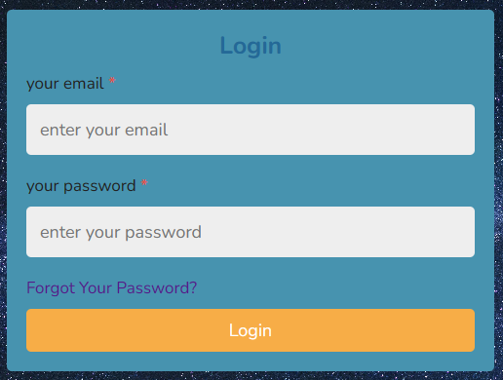

- Home page:
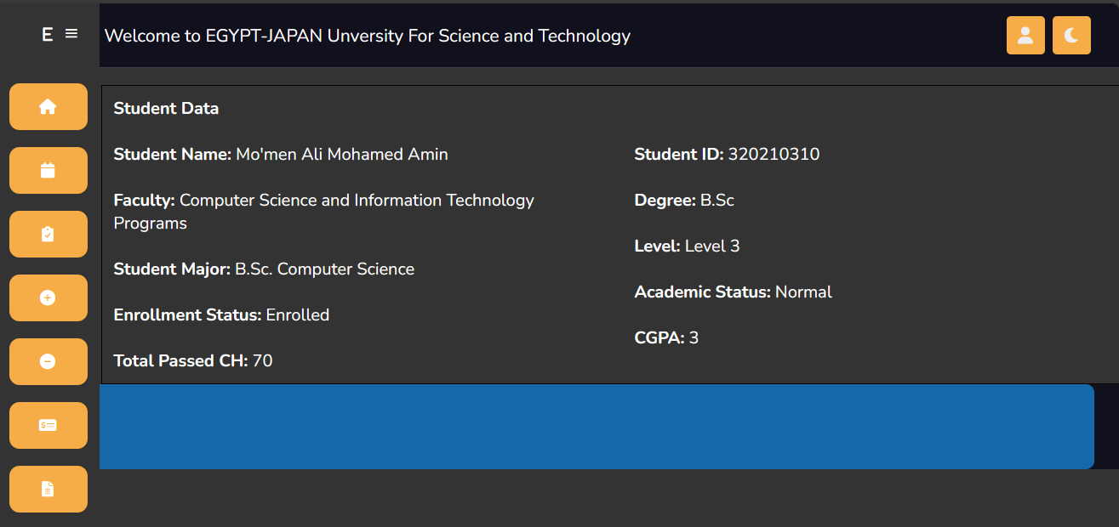

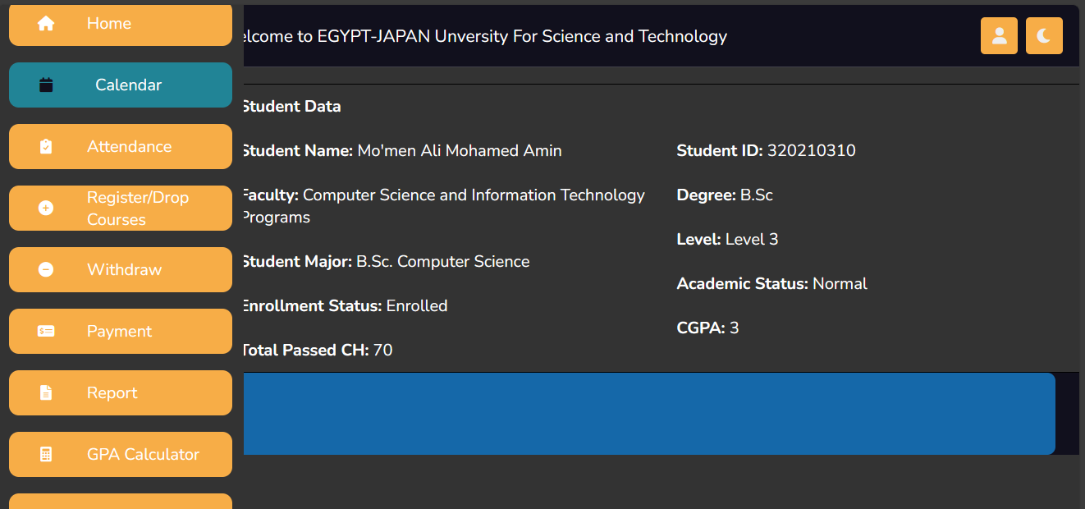
- Menu:

- Profile:

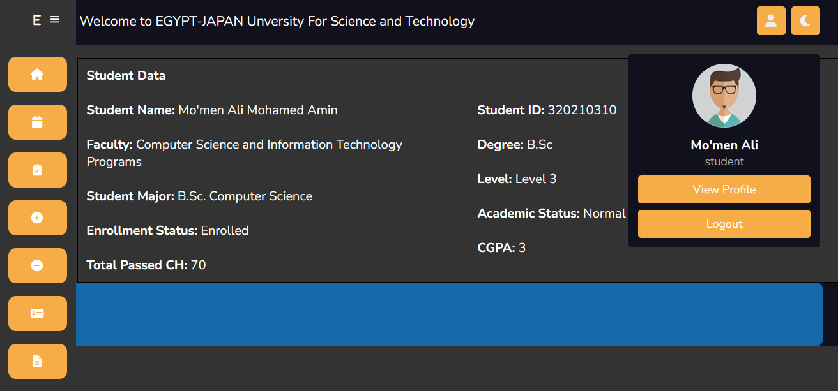
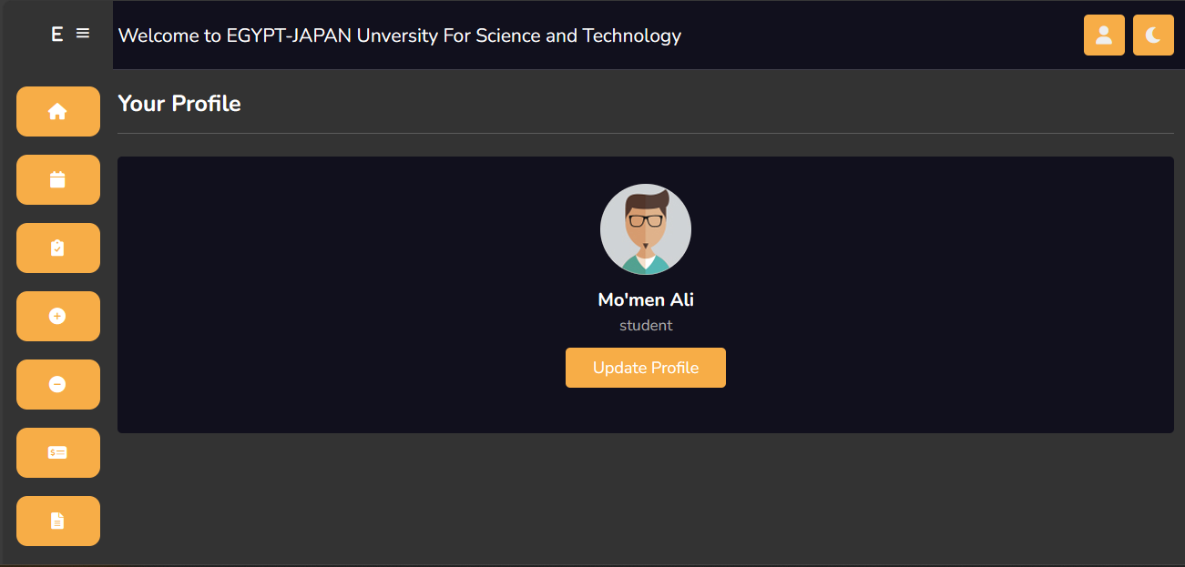
- Profile Page:

- Update Page:

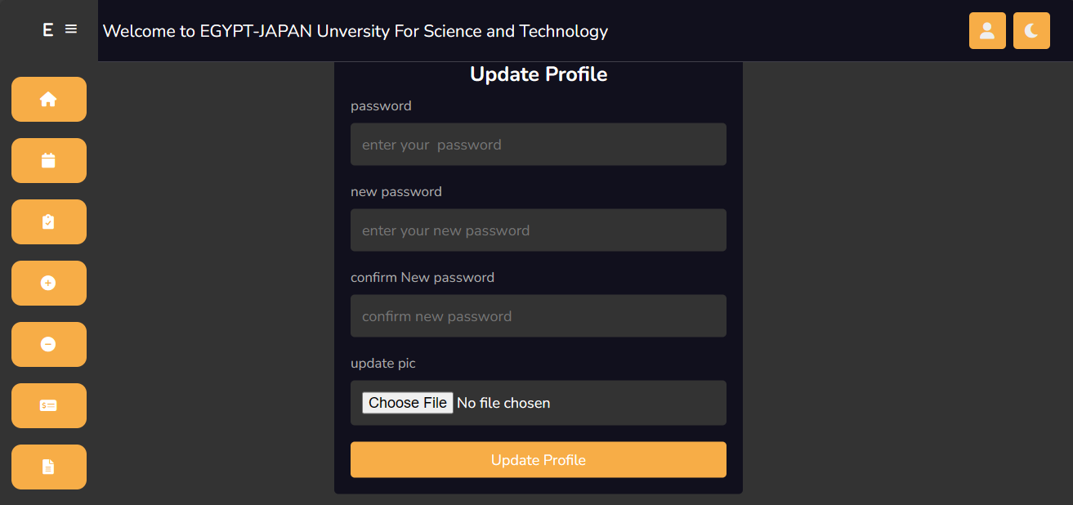
- Calendar Page:
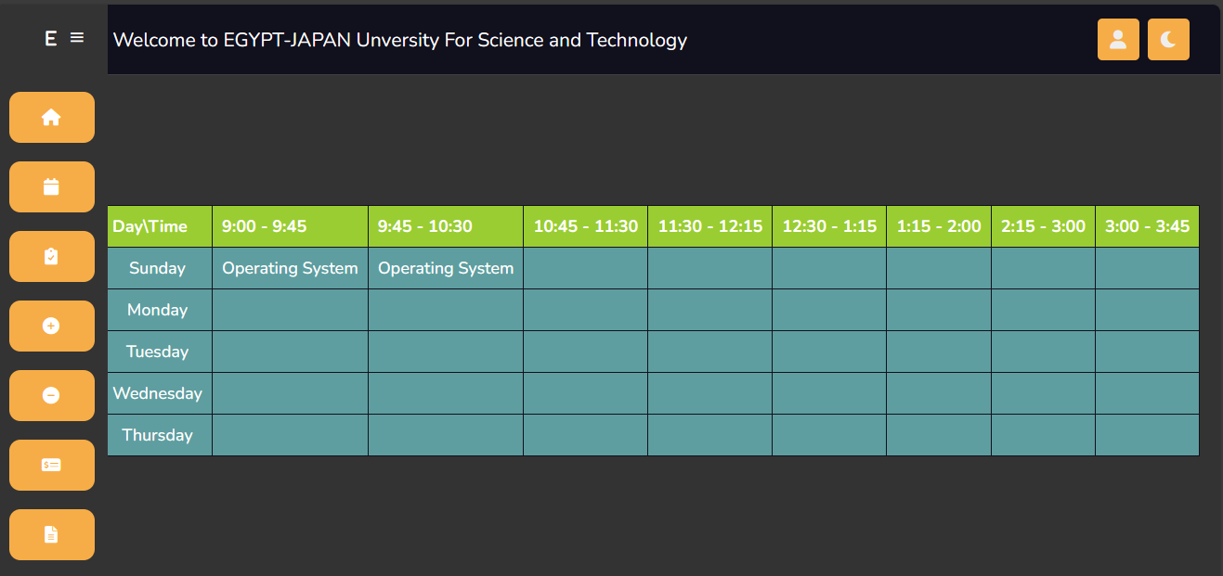
- Attendance Page:

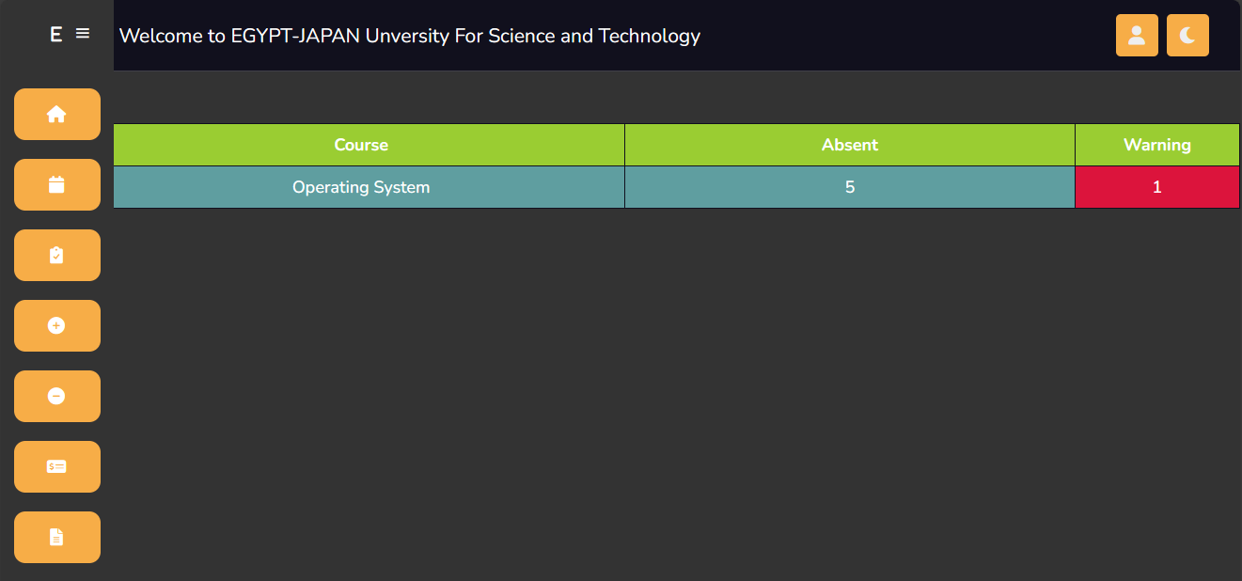
- Add/Drop Courses Page:
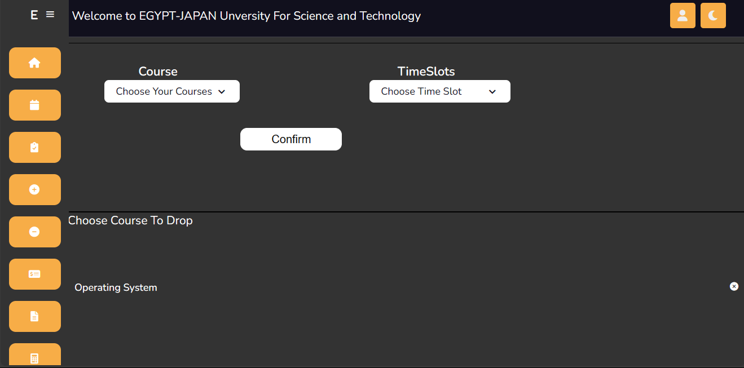
- Withdraw Page:

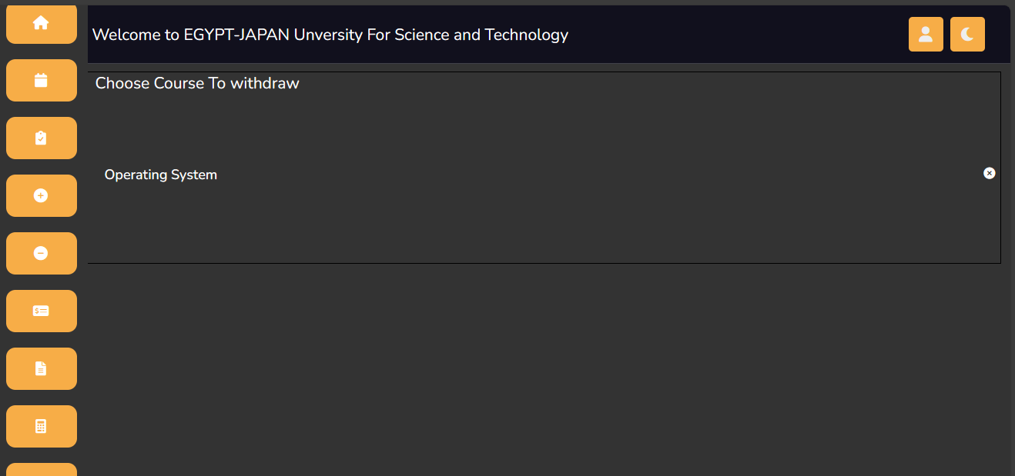
- Payment Page:
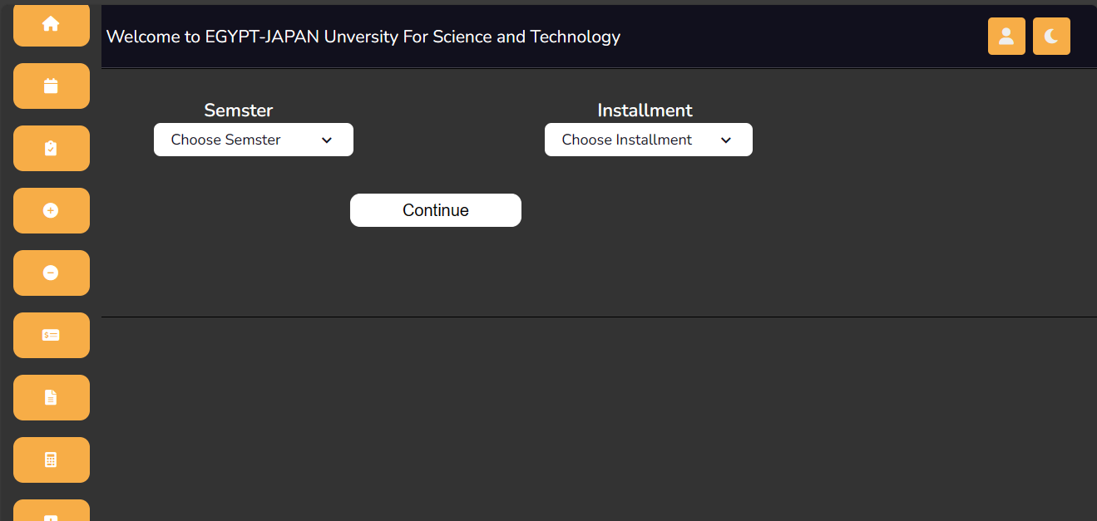

- Report Page:

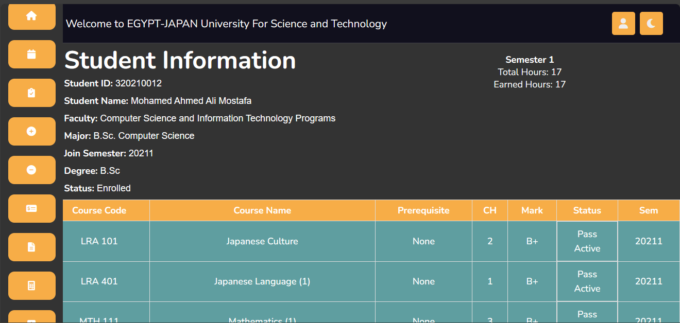
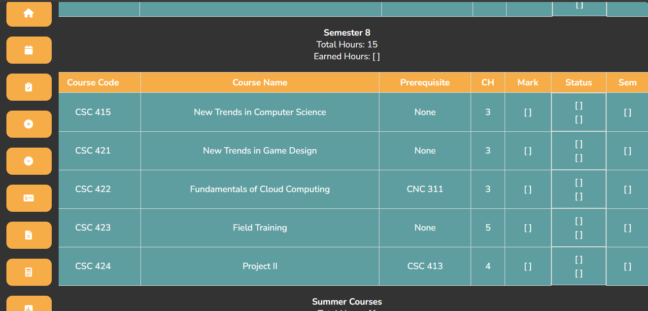
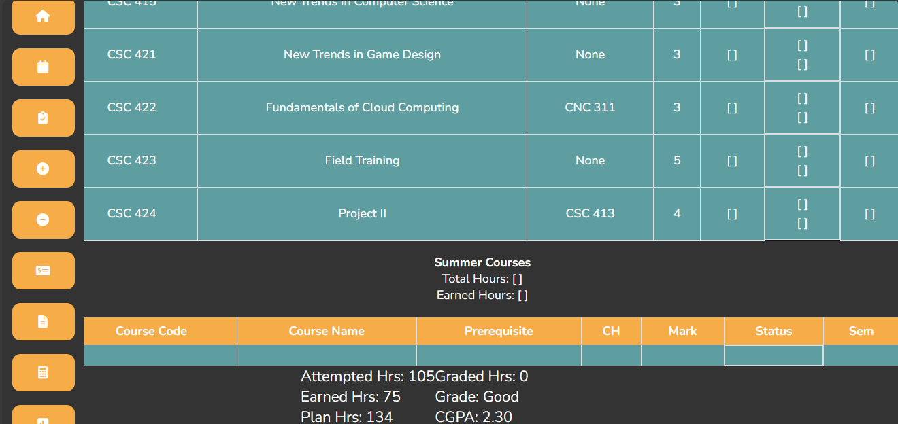
- GPA Calculator Page:
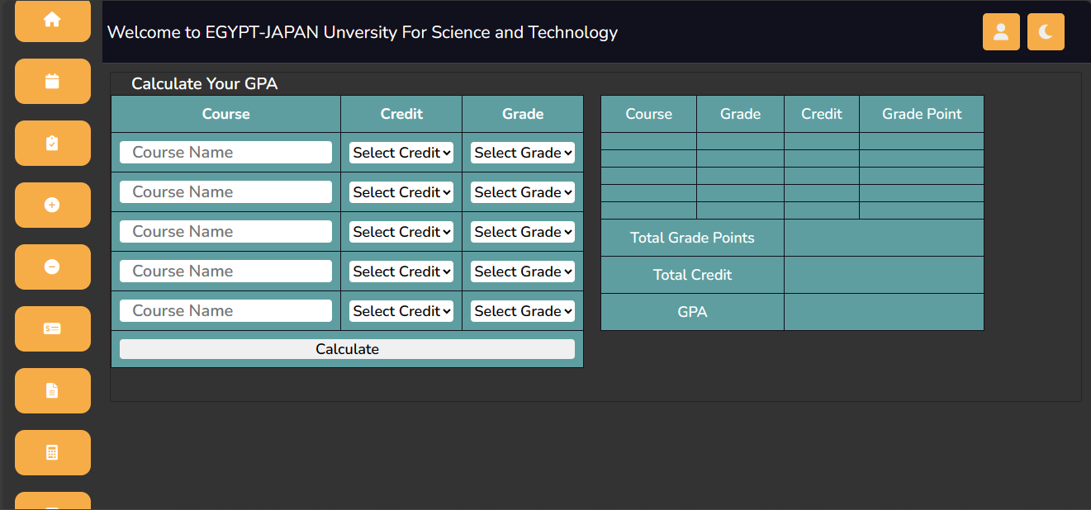

- Result Page:
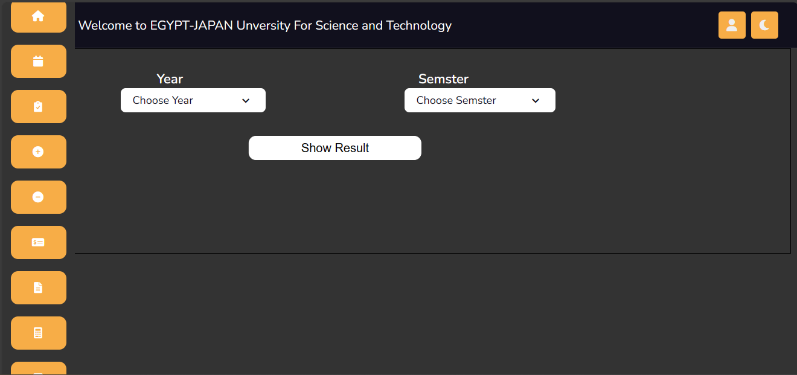

- GUI Standards: The UI design will adhere to established GUI standards and best practices to ensure consistency, usability, and accessibility across all interfaces. This includes the use of clear navigation structures, standardized form elements, and intuitive controls.

- Screen Layout Constraints: Screen layouts will be optimized for different device types and screen sizes, including desktop computers, laptops, tablets, and smartphones. Responsive design principles will be employed to adapt the layout dynamically based on the user's device.

- Standard Buttons and Functions: Common functions such as next, add, drop, print, and cancel will be available on relevant screens to facilitate user interactions.

Hardware Interfaces
The SRR-MIS primarily operates as a web-based application. Users access the system using web browsers, and the software communicates with the underlying hardware through standard web protocols (e.g., HTTP).

Software Interfaces
The SRR-MIS interface with various software components and systems to fulfill its functionality. These interfaces include:

- Database Systems: The SRR-MIS interacts with database systems to store and retrieve student information, course data, grades, and other relevant data. The system may utilize relational database management systems ( MySQL) to manage structured data efficiently.

- Operating Systems: The SRR-MIS is designed to be platform-independent and can be accessed from any device with a compatible web browser.

- Web Technologies: The system utilizes web technologies such as HTML, CSS, JavaScript, and server-side scripting languages (Django) to deliver dynamic web content and handle user interactions. Client-server communication follows standard HTTP protocols.

- Integration with External Systems: The SRR-MIS integrate with external systems such as financial systems to exchange data and facilitate interoperability. Integration involve web services, or data import/export functionality.

Communications Interfaces
The Automated Students' Results and Courses Registration Management Information System (SRR-MIS) incorporates various communications interfaces to facilitate interactions between users, external systems, and the application itself. These interfaces include:

- Email Communication: The system utilizes email communication to send notifications, reminders, and alerts to users, administrators, and stakeholders. Email messages may include registration confirmations, password reset instructions, course enrollment updates, and grade notifications. The system supports standard email protocols such as SMTP (Simple Mail Transfer Protocol) for sending emails and IMAP (Internet Message Access Protocol) or POP3 (Post Office Protocol) for receiving emails.

- Network Server Communications Protocols: The SRR-MIS communicates with network servers to exchange data and information with external systems, including banks for financial transactions and authentication purposes. Communication with network servers typically occurs over secure HTTP connections to ensure data confidentiality and integrity.

- Message Formatting: Email messages, web requests, and data exchanges between the SRR-MIS and external systems adhere to standardized message formatting conventions to ensure compatibility and interoperability. Message formats may include plain text or HTML, depending on the specific communication requirements and data interchange formats.

- Data Transfer Rates and Synchronization Mechanisms: The system ensures efficient data transfer rates and synchronization mechanisms to facilitate real-time or near-real-time communication between different system components and external entities. Asynchronous communication patterns may be employed to handle high volumes of concurrent requests and ensure responsiveness and scalability. Data synchronization mechanisms synchronize data between the SRR-MIS and external systems to maintain data consistency and accuracy across distributed environments.

System Features

Login Management
4.1.1 Description and Priority:
The login page feature provides a secure login mechanism for students, doctors, and teaching assistants to access the system. It is of high priority as it forms the gateway for authorized users to interact with the system.

4.1.2 Stimulus/Response Sequences:
- Stimulus: User navigates to the login page.
Response: System displays the login page with fields for email and password.
- Stimulus: User enters their email and password.
Response: System validates the credentials and grants access if they are correct.
- Stimulus: User enters incorrect or invalid credentials.
Response: System displays an error message indicating invalid credentials and prompts the user to retry.
- Stimulus: User forgets their password.
Response: System provides a "Forgot Password" option and guides the user through the password recovery process.

4.1.3 Functional Requirements:
REQ-1: The system shall authenticate users by verifying their credentials against stored user data.
REQ-2: - The system shall differentiate between student, doctor, and teaching assistant roles.
REQ-3: - The system shall guide users through the password recovery process, such as sending a password reset link to their registered email.
REQ-4: The system shall provide a secure account unlocking process, such as sending a verification code to the user's registered email.

Course Management
4.2.1 Description and Priority:
- This feature allows students to view available courses, register, drop, or withdraw from courses, and manage their course schedule.
- Priority: High

4.2.2 Stimulus/Response Sequences:
- Student selects "View Courses" option
- System retrieves and displays the list of available courses
- Student selects a course to register for
- System verifies course availability and student eligibility
- If eligible, system adds the student to the course roster
- If not eligible or course is full, system displays appropriate message
- Student selects "Drop Course" option
- System removes the student from the course roster
- Student selects "Withdraw from Course" option
- System updates the student's course status to "Withdrawn"

4.2.3 Functional Requirements:
- REQ-1: The system shall retrieve and display a list of available courses.
- REQ-2: The system shall verify student eligibility for course registration.
- REQ-3: The system shall add the student to the course roster upon successful registration.
- REQ-4: The system shall remove the student from the course roster upon course drop.
- REQ-5: The system shall update the student's course status to "Withdrawn" upon course withdrawal.
- REQ-6: The system shall display appropriate messages for eligibility, course availability, and status updates.
- REQ-7: The system shall handle anticipated error conditions, such as invalid inputs or server errors (TBD).

Attendance Tracking
4.3.1 Description and Priority:
- This feature allows students, lecturers, and teaching assistants to track and record attendance for each course.
- Priority: Medium

4.3.2 Stimulus/Response Sequences:
- Lecturer selects a course and attendance tracking option
- System displays the list of enrolled students for the selected course
- Lecturer selects a student and marks attendance (present/absent)
- System records the attendance for the selected student and course
- Student views their attendance record for a specific course

4.3.3 Functional Requirements:
- REQ-1: The system shall display the list of enrolled students for a selected course.
- REQ-2: The system shall allow lecturers to mark attendance for each student.
- REQ-3: The system shall record and store attendance data for each student and course.
- REQ-4: The system shall allow students to view their attendance record for a specific course.
- REQ-5: The system shall handle anticipated error conditions, such as invalid inputs or server errors (TBD).

Payment Management
4.4.1 Description and Priority:
- This feature enables students to make payments for their courses and manages the financial transactions within the system.
- Priority: High

4.4.2 Stimulus/Response Sequences:
- Student selects "Make Payment" option
- System displays the payment options and details (e.g., course fees)
- Student selects a payment method (e.g., credit card, online banking)
- System processes the payment and updates the student's payment status
- System generates a payment receipt or confirmation for the student

4.4.3 Functional Requirements:
- REQ-1: The system shall display the payment options and details for each course.
- REQ-2: The system shall support multiple payment methods (e.g., credit card, online banking).
- REQ-3: The system shall process payments securely and accurately.
- REQ-4: The system shall update the student's payment status upon successful payment.
- REQ-5: The system shall generate a payment receipt or confirmation for the student.
- REQ-6: The system shall handle anticipated error conditions, such as payment failures or system errors (TBD).

Report Generation
4.5.1 Description and Priority:
- This feature allows users, such as administrators, lecturers, and students, to generate various reports based on their roles and needs.
- Priority: Medium

4.5.2 Stimulus/Response Sequences:
- Administrator selects "Generate Enrollment Report" option
- System retrieves enrollment data and generates a report
- Lecturer selects "Generate Attendance Report" option
- System retrieves attendance data and generates a report
- Student selects "Generate Grade Report" option
- System retrieves grade data and generates a report

4.5.3 Functional Requirements:
- REQ-1: The system shall provide various report generation options based on user roles (e.g., enrollment report, attendance report, grade report).
- REQ-2: The system shall retrieve and compile relevant data for report generation.
- REQ-3: The system shall generate reports in a readable and printable format (e.g., PDF, CSV).
- REQ-4: The system shall handle anticipated error conditions, such as data retrieval errors or report generation failures (TBD).

GPA Calculator
4.6.1 Description and Priority:
- This feature enables students to calculate and track their Grade Point Average (GPA) based on their course grades.
- Priority: Medium

4.6.2 Stimulus/Response Sequences:
- Student selects "Calculate GPA" option
- System retrieves the student's enrolled courses and corresponding grades
- System calculates the GPA based on the grading scale and credit hours
- System displays the calculated GPA to the student

4.6.3 Functional Requirements:
- REQ-1: The system shall retrieve the student's enrolled courses and grades for GPA calculation.
- REQ-2: The system shall apply the appropriate grading scale and credit hours for GPA calculation.
- REQ-3: The system shall calculate the GPA accurately based on the retrieved data.
- REQ-4: The system shall display the calculated GPA to the student.
- REQ-5: The system shall handle anticipated error conditions, such as missing grades or invalid data (TBD).

Calendar Management
4.7.1 Description and Priority:
- This feature allows doctors to manage their schedules and appointments within the system.
- Priority: High

4.7.2 Stimulus/Response Sequences:
- Doctor selects "Manage Calendar" option
- System displays the doctor's calendar with available time slots
- Doctor selects an available time slot and creates an appointment
- System updates the calendar and reserves the selected time slot
- System sends appointment confirmation to the patient

4.7.3 Functional Requirements:
- REQ-1: The system shall display the doctor's calendar with available time slots.
- REQ-2: The system shall allow doctors to create appointments by selecting available time slots.
- REQ-3: The system shall update the calendar and reserve the selected time slot upon appointment creation.
- REQ-4: The system shall send appointment confirmations to the respective patients.
- REQ-5: The system shall handle anticipated error conditions, such as time slot conflicts or appointment scheduling errors (TBD).

Grade Management
4.8.1 Description and Priority:
- This feature allows doctors to manage and assign grades to students for their academic performance.
- Priority: Medium

4.8.2 Stimulus/Response Sequences:
- Doctor selects a course and grade management option
- System displays the list of enrolled students for the selected course
- Doctor selects a student and assigns a grade
- System records the grade for the selected student and course

4.8.3 Functional Requirements:
- REQ-1: The system shall display the list of enrolled students for a selected course.
- REQ-2: The system shall allow doctors to assign grades to each student.
- REQ-3: The system shall record and store grade data for each student and course.
- REQ-4: The system shall handle anticipated error conditions, such as invalid inputs or server errors (TBD).

Other Nonfunctional Requirements

Performance Requirements
The SRR-MIS should meet the following performance requirements:
- Response Time: The system should provide fast response times for user interactions, with an average response time of less than 2 seconds for common operations.
- Scalability: The system should be able to handle a growing number of users and data without significant degradation in performance. It should support concurrent access by a large number of users.

- Throughput: The system should be capable of processing a high volume of transactions simultaneously, with a target throughput of at least 100 transactions per second.

- Resource Utilization: The system should utilize system resources efficiently, aiming for optimal memory and CPU usage to minimize hardware requirements.

- Availability: The system should have a high level of availability, aiming for at least 99.9% uptime, with scheduled maintenance windows for system updates and maintenance operations.

Safety Requirements
The SRR-MIS must adhere to the following safety requirements:
- Data Integrity: The system should ensure the integrity of student data, preventing unauthorized access, modification, or deletion.

- Error Handling: The system should handle errors gracefully, providing meaningful error messages to users and preventing system crashes or data corruption.

- Backup and Recovery: The system should have robust backup and recovery mechanisms in place to prevent data loss and enable quick restoration in the event of system failures or disasters.

- Compliance: The system should comply with relevant safety regulations and standards, ensuring the safety and well-being of users and their data.

Security Requirements
The SRR-MIS should meet the following security requirements:

- User Authentication: The system should provide secure user authentication mechanisms, such as username/password or multi-factor authentication, to ensure that only authorized users can access the system.

- Data Privacy: The system should protect sensitive student information, including personal details, academic records, and financial data, by encrypting data in transit and at rest.

- Access Control: The system should enforce role-based access control, allowing users to access only the information and functionality relevant to their roles and responsibilities.

- Audit Trail: The system should maintain an audit trail of user activities, including login attempts, data modifications, and system configuration changes, to facilitate forensic analysis and accountability.

- Security Testing: The system should undergo regular security testing and vulnerability assessments to identify and address potential security risks and vulnerabilities.

Software Quality Attributes
In addition to the functional requirements, the SRR-MIS should exhibit the following software quality attributes:

- Usability: The system should have an intuitive and user-friendly interface, allowing users to easily navigate and perform tasks without extensive training or documentation.

- Reliability: The system should operate reliably, minimizing downtime, errors, and system crashes. It should recover gracefully from failures and provide appropriate error handling mechanisms.

- Maintainability: The system should be designed and implemented in a modular and well-structured manner, allowing for easy maintenance, updates, and bug fixes.

- Performance Efficiency: The system should efficiently utilize system resources, minimizing response times, and maximizing throughput to provide a smooth and responsive user experience.

- Interoperability: The system should be compatible with existing infrastructure and systems commonly used in educational institutions, facilitating integration and data exchange.

- Scalability: The system should be scalable, allowing for future growth in terms of user base, data volume, and system load.

- Security: The system should have robust security measures in place to protect against unauthorized access, data breaches, and other security threats.

Business Rules
The following business rules apply to the SRR-MIS:
- Administrators have the authority to create, manage, and delete user accounts within the system.
- Only authorized personnel, such as lecturers and teaching assistants, can perform course-related functions, such as creating, dropping, and withdrawing courses for students they have problems.
- Students can access and interact with the system only after successful authentication and enrollment in courses.
- Students can update their personal information within the system, ensuring accurate and up-to-date records.
- The system should enforce data privacy rules and restrict access to sensitive information based on user roles and permissions.

Other Requirements
Database Requirements:
- The system should have a robust and scalable database to store and manage the necessary data.
- The database should be designed to handle a large number of users, courses, grades, and other relevant information.
- Data integrity and security measures should be implemented to protect sensitive information.

Internationalization Requirements:
- The system should support multiple languages to cater to a diverse user base.
- It should have language localization capabilities, allowing users to switch between different languages based on their preferences.

Legal Requirements:
- The system should comply with applicable legal requirements, such as data protection regulations (e.g., GDPR).
- User privacy should be ensured, and appropriate consent mechanisms should be implemented for data collection and processing.

Reuse Objectives:
- The project should have objectives related to reusability, such as designing components or modules that can be easily integrated into other systems or future versions of the SIS.
- Code documentation and guidelines should be provided to facilitate code reuse and maintainability.

New Sections:
- System Performance Requirements: Define specific performance requirements, such as response time, throughput, and scalability, to ensure the system can handle the expected user load and provide a seamless user experience.
- Security Requirements: Specify the security measures, authentication mechanisms, and access controls that should be implemented to protect user data and prevent unauthorized access.
- Usability Requirements: Outline usability goals and considerations, such as intuitive interfaces, clear navigation, and user-friendly interactions, to enhance the overall user experience.
- Integration Requirements: Identify any external systems or services that need to be integrated with the SIS and define the requirements and protocols for seamless integration.
- Reporting Requirements: Specify the reporting needs of different stakeholders, such as generating course enrollment reports, attendance reports, and performance analysis reports.
- Mobile Compatibility: If mobile access is required, define the compatibility requirements for mobile devices, such as responsive design, mobile app development, or browser compatibility.
Appendix A: Glossary
- SRS: Software Requirements Specification
- SRR-MIS: Student Registration and Records Management Information System
- GPA: Grade Point Average
- CGPA: Cumulative Grade Point Average
- UI: User Interface
- UX: User Experience
- HTTP: Hypertext Transfer Protocol
- GDPR: General Data Protection Regulation
- SMTP: Simple Mail Transfer Protocol
- IMAP: Internet Message Access Protocol
- POP3: Post Office Protocol

Appendix B: Analysis Models
- Entity-Relationship Diagrams (ERDs)
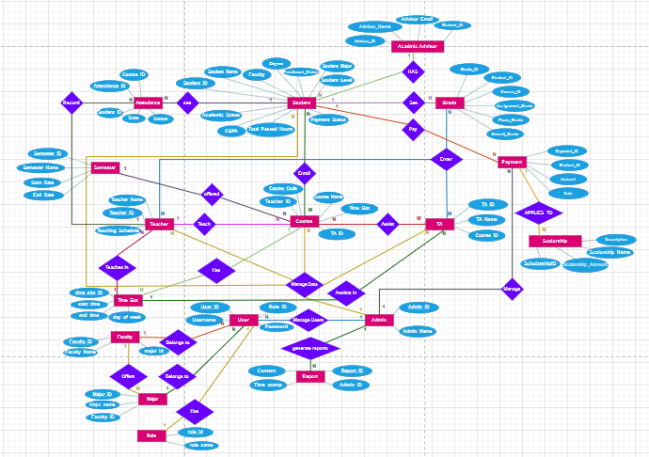

Appendix C: To Be Determined List
- Track and document any remaining TBD references in the SRS, such as undefined requirements, pending decisions, or missing information.

