**BIOE245: Machine Learning in Medical Imaging**

**Homework 3**

Yang Yang and Emaad Khwaja

May 22, 2023

**Brain MRI Segmentation**

In this assignment, you will train and evaluate CNN models for brain MRI segmentation. A PyTorch framework for segmentation is provided for reference.

**Dataset:**

This dataset contains brain MR images together with manual FLAIR abnormality segmentation masks. The images were obtained from The Cancer Imaging Archive (TCIA). They correspond to **110** patients included in The Cancer Genome Atlas (TCGA) lower-grade glioma collection with at least fluid-attenuated inversion recovery (FLAIR) sequence.

Within each patient folder, there are multiple slice images and mask in tif format as shown in the figure. **For each image slice, the dimension is 256x256x3, representing pre-contrast, FLAIR, and post-contrast**. For the corresponding mask, it only provides a **mask with tumor region in FLAIR contrast**.

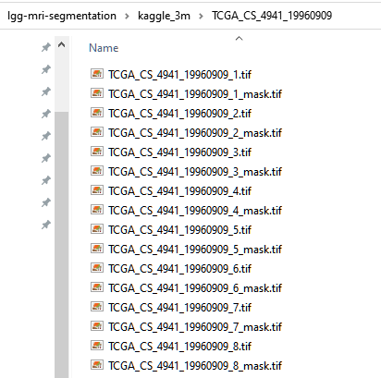

The detailed description for the dataset and sample code can be found here: <https://www.kaggle.com/datasets/mateuszbuda/lgg-mri-segmentation>

**U-NET structure for segmentation**

Please use the following model as a starting point: U-Net model comprises four levels of blocks containing two convolutional layers with batch normalization and ReLU activation function, and one max pooling layer in the encoding part and up-convolutional layers instead in the decoding part. The number of convolutional filters in each block is 32, 64, 128, and 256. The bottleneck layer has 512 convolutional filters. From the encoding layers, skip connections are used to the corresponding layers in the decoding part.

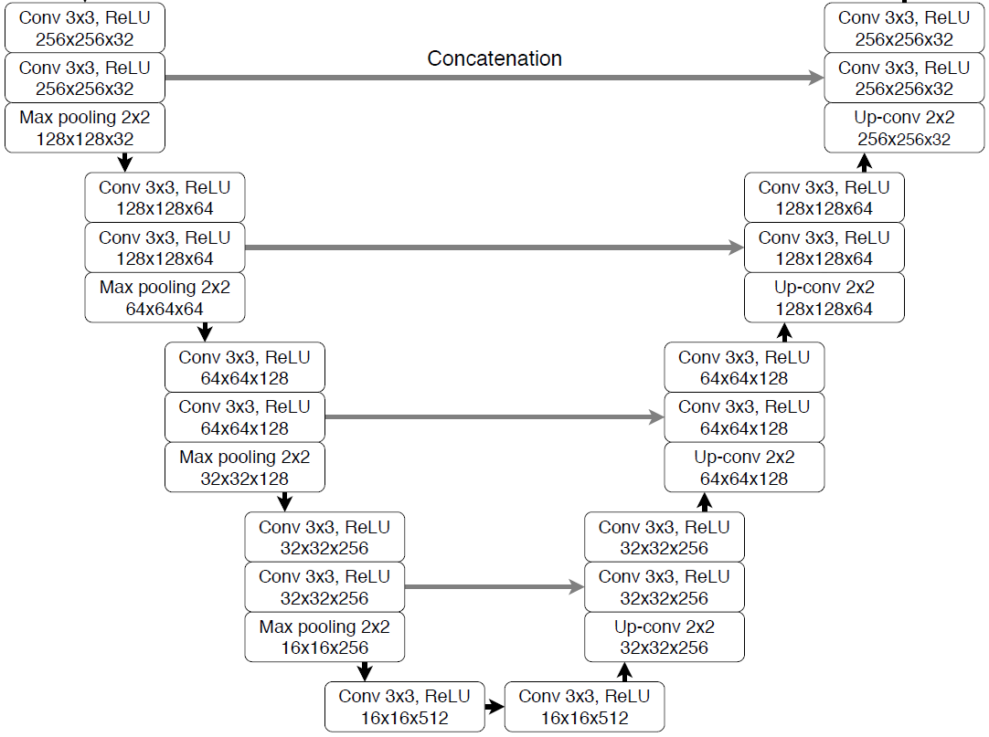

**Tasks A: ONLY using the FLAIR image and corresponding mask to do the following experiments**

1. Explore the provided dataset and split the data into 70% for training, 20% for validating, and 10% for testing at the patient level. Print out your testing dataset patient IDs.
2. Visualize one random example from the training set about the FLAIR image and corresponding segmentation mask.
3. Use a fixed learning rate (0.001) and epoch number (50) to evaluate the performance of the base model.
4. Plot the training curve and report the dice coefficient on the validation set.
5. Play with different learning rates and epoch numbers and repeat step 4.
6. Run the inference on the testing set and report the performance.

**Task B: Use pre-contrast, FLAIR, and post-contrast images and FLAIR segmentation mask to repeat the experiments in Task A**

1. Use the same data split strategy from Task A
2. Visualize one random example from the training set about the three contrast images and corresponding FLAIR segmentation mask.
3. Repeat steps 3 and 6 from Task A
4. Compare the performances between Task A and Task B and discuss your findings.

**Bonus Task:**

* 1. Use a pre-trained encoder, such as ResNet or VGG, as the contracting path of the U-Net model, and train only the expanding path(decoder) for brain segmentation to evaluate the performance of the model.
  2. Use data augmentation techniques, such as random rotations or flips, during training to improve the performance of the model.
  3. Implement a learning rate scheduler to gradually decrease the learning rate during training, and evaluate the performance of the model.