

**INTERNET OF THINGS**

**Wi-Fi CONTROLLED CAR**

**PROJECT REPORT**

By

Emaan Bashir          296190

Arooba Siddiqi               321618

Momina Nadeem 290190

Rimsha Mirza 285718

Sara Imdad 289446

# **INTRODUCTION**

The Wi-Fi controlled car involves the use of IoT technology to remotely control a car over a Wi-Fi connection. This allows the user to remotely operate the car. The user can then access and control the car through a mobile app, giving them complete control over the car's functions. This project represents the convergence of IoT and automotive technology, providing a glimpse into the future of connected transportation.

# **OBJECTIVES**

The primary objectives of this project are to allow the user to remotely control and operate the robot car over a Wi-Fi connection. The other objectives are to explore this domain of IOT technology and use the relevant tools and technologies.

# **APPLICATION REQUIREMENTS:**

**Hardware:**

* Esp32
* L298 Motor Driver
* Breadboard
* Jumper wires
* Batteries (x2)
* Motors (x2)
* Robot Wheels (x2)
* Robot Caster Wheel (x1)
* Robot Car Chassis

**Software:**

* Stable Wi-Fi connection
* Arduino IDE

**GITHUB LINK:**

<https://github.com/EmaanBashir/Wifi-Controlled-Car>

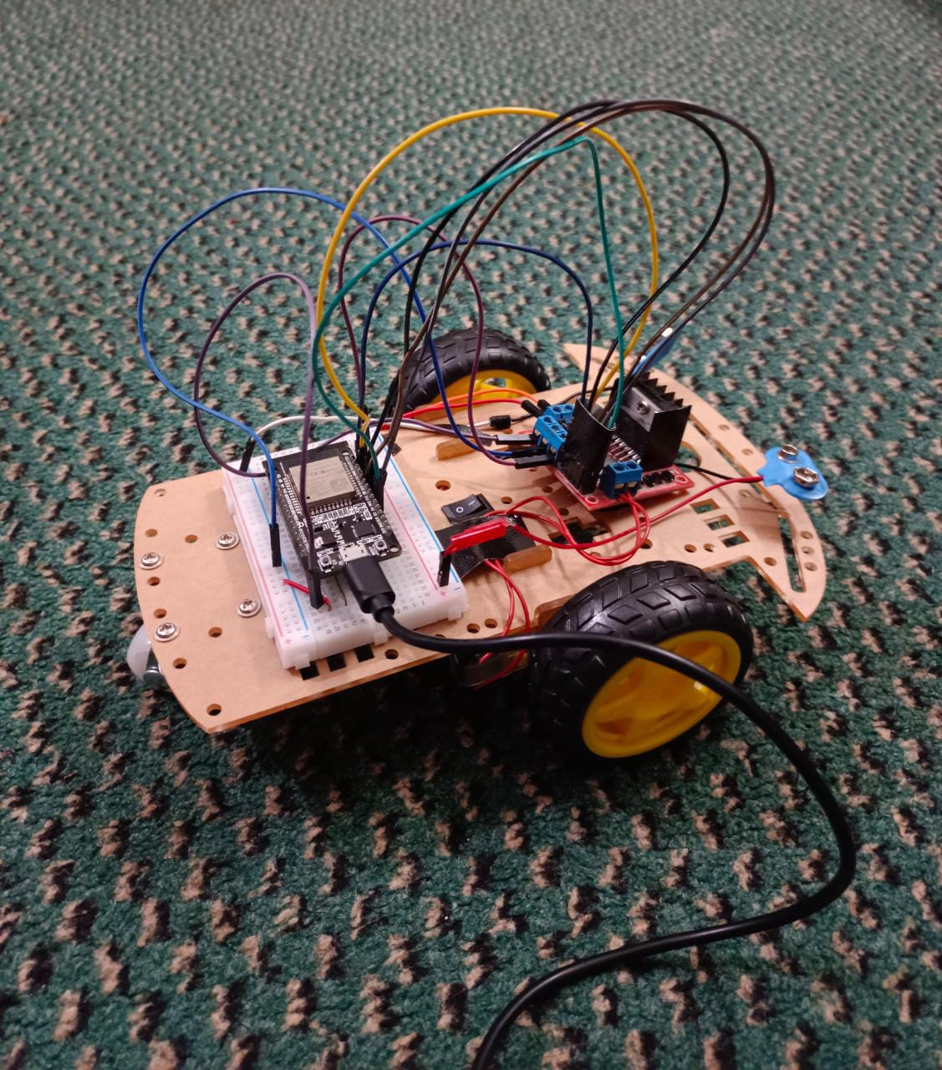

# **DETAILS OF ELECTRONIC EQUIPMENTS**

**Esp32:** The Esp32 is a low-power microcontroller with built-in Wi-Fi and Bluetooth capabilities. It is often used in IoT projects for its ability to connect to and communicate with other devices over a wireless connection.

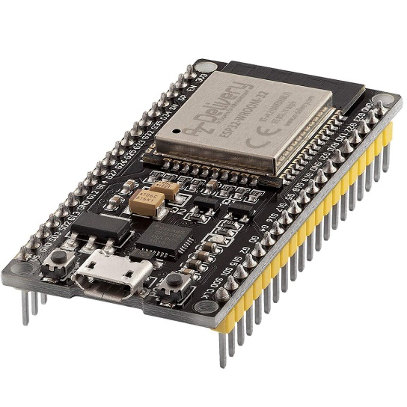

**L298 Motor Driver**: The L298 Motor Driver is a dual H-bridge motor driver that can be used to control the speed and direction of two DC motors. It is often used in robotics projects to control the movement of the robot.

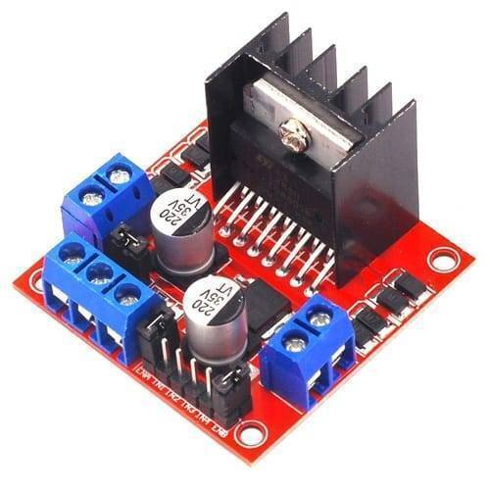

**Breadboard:** A breadboard is a board that allows electronic components to be easily connected with jumper wires.

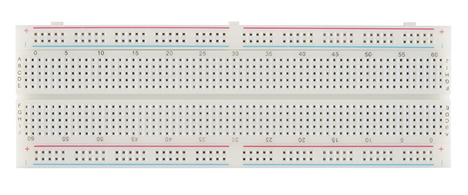

**Jumper wires:** Jumper wires are short, flexible wires that are used to connect electronic components together on a breadboard or circuit board. They come in various lengths and colors, and are typically used to create temporary or prototyping circuits.

**Batteries (x2):** Batteries are a common power source for electronic devices, including robots.

**Motors (x2):** Motors are devices that convert electrical energy into mechanical movement. They are often used in robotics projects to power the movement of the robot.

**Robot Wheels (x2):** Robot wheels are circular components that are attached to motors and used to propel the robot.

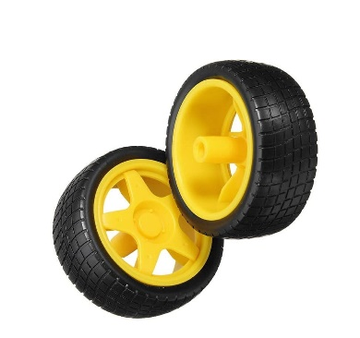

**Robot Caster Wheel (x1):** A robot caster wheel is a small, free-moving wheel that is used to support the weight of a robot and allow it to move easily in any direction. It is often used in conjunction with other wheels or tracks to provide stability to the robot.

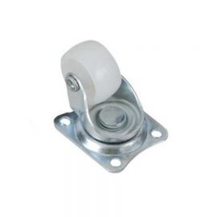

**Robot Car Chassis:** A robot car chassis is the frame or structure of the robot car, upon which all the other components are mounted. It provides support and stability to the robot car.

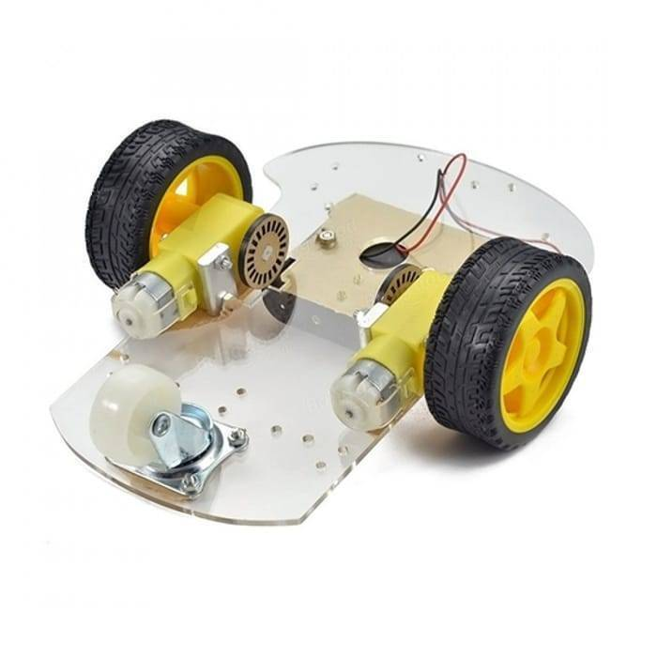

# **DETAIL DESCRIPTION OF POWER CONSUMPTION**

The power consumption of Esp32 increases when its Wi-Fi feature is being used. The power consumption of motors depends on the size of motor. As in this project, small motors are used. Hence, their power consumption is a few watts. Moreover, L298 motor drivers’ power consumption depends on the operating voltage and load being placed on the motors.

The power consumption of L298 motor driver and Esp32 is approximately 7W and 36W respectively.

# **TOOLS AND TECHNOLOGIES**

**Blynk:**

Blynk is a platform that allows users to easily build and control Internet of Things (IoT) projects, including Wi-Fi controlled cars. It provides a user-friendly mobile app and an API that allows users to connect their IoT devices to the Blynk server, and then control and monitor those devices through the app.

**Arduino IDE:**

Arduino IDE is a software application that is used to write and upload code to Arduino boards. It provides a user-friendly interface for writing and debugging code.

In this project, Blynk and Arduino IDE are used in conjunction to control and operate the car over a Wi-Fi connection. The Arduino board, which is connected to the car's motors and other components, are programmed using the Arduino IDE to remotely drive the car. The Blynk app can then be used to access and control the car's functions through the Wi-Fi connection.

# **EXPECTED IMPACT OF THE PROJECT ON SOCIETY AND THE ENVIRONMENT**

A Wi-Fi controlled car can contribute to the development of robotics technology. Even at a small scale, the project could demonstrate the of IoT technology in the field of robotics, potentially inspiring further research, and development in this area.