UNIVERSITY INSTITUTE OF COMPUTING
Bachelor of Computer Applications (BCA)
PROJECT BASED LEARNING (PBL) / CASE STUDY REPORT
on
STEAM – ONLINE GAME DISTRIBUTION PLATFORM
An Educational Software Engineering Case Study
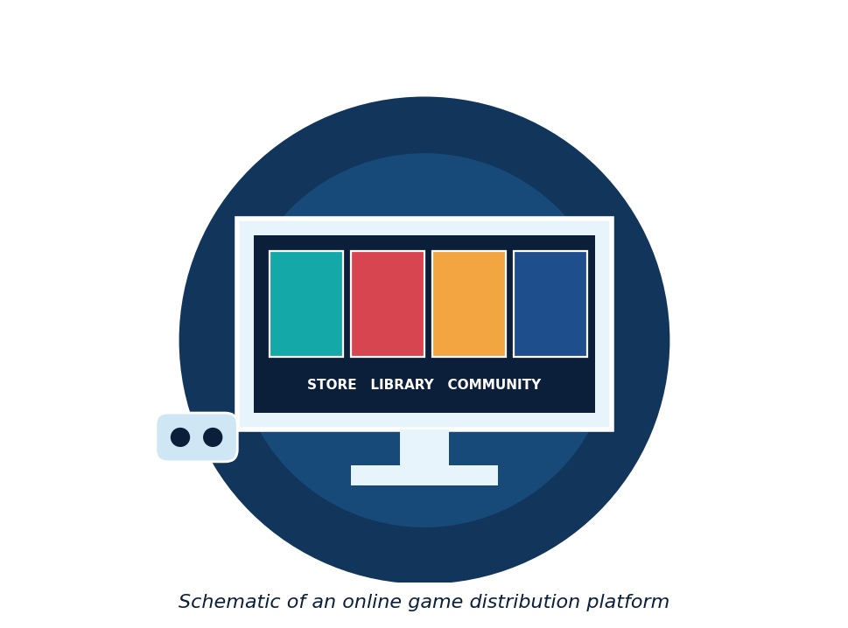
Subject: Software Engineering
Name | Emaan
UID | 25BCD100252
Course | BCA
Semester | 3rd
Submitted To | Jitendra Kumar
Academic Session | 2026–2027
University Institute of Computing

Certificate
This is to certify that the PBL / Case Study report entitled “Steam – Online Game Distribution Platform” is a bonafide work carried out by Emaan, UID 25BCD100252, a student of BCA, 3rd Semester, University Institute of Computing, in partial fulfilment of the requirements of the subject Software Engineering during the Academic Session 2026–2027.
The work has been completed under my guidance and, to the best of my knowledge, has not been submitted elsewhere for any other purpose. This report is an educational software engineering case study.

______________________
Jitendra Kumar
Subject Teacher / Project Guide
Date: ______________ Place: ______________

Declaration
I, Emaan, UID 25BCD100252, a student of BCA, 3rd Semester, University Institute of Computing, hereby declare that this PBL / Case Study report entitled “Steam – Online Game Distribution Platform” is my own work, prepared as part of the subject Software Engineering for the Academic Session 2026–2027.
The information in this report has been collected from textbooks and reliable sources listed in the References section. I have not copied any report or project of another student. I further declare that this is an independent educational case study; the design in this report is my own simplified, conceptual design and does not describe the real internal systems of Valve Corporation or any other company.
Date: ______________
Place: ______________
Signature of Student
Emaan (UID: 25BCD100252)

Acknowledgment
I would like to express my sincere gratitude to my subject teacher and guide, Mr. Jitendra Kumar, for his valuable guidance, encouragement and support throughout this case study. His explanations of Software Engineering concepts helped me understand how real systems are planned, designed and tested.
I am thankful to the University Institute of Computing for giving me the opportunity to work on a Project Based Learning (PBL) topic. I also thank all faculty members for creating a good learning environment.
Finally, I thank my family and friends for their constant support and motivation during the preparation of this report.
Emaan
BCA, 3rd Semester

Abstract
Online game distribution platforms such as Steam let players find, buy, download, update and play games from one place, and let developers publish their games to a large audience. Behind a simple store page and game library there is a large software system that must manage accounts, a catalogue, payments, downloads, updates and community features, while keeping data secure. This report studies a Steam-style game distribution platform as an educational Software Engineering case study.
The report explains the problem statement, objectives and scope, compares older ways of buying and installing games with the proposed platform, and describes the system components. It documents the software requirements and uses standard software engineering models: a layered architecture, a flowchart, a UML use case diagram, Data Flow Diagrams (DFD), an Entity-Relationship (ER) diagram, and UML class, sequence and state diagrams. The Software Development Life Cycle (SDLC), implementation overview, security and risk management, sample test cases and ethical considerations are also discussed, followed by advantages, limitations and future scope.
This work is purely educational. The design is a simplified, conceptual design made by the student; it does not describe the real internal systems of Steam and uses no real user data.
Keywords: Game distribution platform, online store, digital library, payments, SDLC, UML, DFD, ER diagram, software testing, security.

Table of Contents
Certificate i
Declaration ii
Acknowledgment iii
Abstract iv
Table of Contents v
List of Figures vi
List of Tables vii
Abbreviations and Glossary viii
Chapter 1: Introduction 1
Chapter 2: Problem Statement 2
Chapter 3: Objectives 2
Chapter 4: Scope of the Project 3
Chapter 5: Existing System 3
Chapter 6: Proposed System 4
Chapter 7: System Components 5
Chapter 8: Software Requirements 5
Chapter 9: System Architecture 6
Chapter 10: Working of the System 7
Chapter 11: System Flowchart 8
Chapter 12: UML Use Case Diagram 9
Chapter 13: Data Flow Diagram (DFD) 10
Chapter 14: Database Design 11
Chapter 15: UML Design Models 11
Chapter 16: Software Development Life Cycle (SDLC) 13
Chapter 17: Implementation Overview 14
Chapter 18: Security and Risk Management 15
Chapter 19: Software Testing 15
Chapter 20: Ethical and Professional Considerations 16
Chapter 21: Advantages 17
Chapter 22: Limitations 17
Chapter 23: Future Scope 18
Chapter 24: Conclusion 18
References 19
Appendix A: Requirements Traceability Matrix 20

List of Figures
Figure 1.1: Simplified schematic of an online game distribution platform 1
Figure 6.1: Conceptual block diagram of the proposed system 4
Figure 7.1: Main components of the game platform 5
Figure 9.1: Three-layer architecture of the game platform 6
Figure 11.1: Flowchart of buying a game 8
Figure 12.1: UML use case diagram 9
Figure 13.1: Level 0 DFD 10
Figure 13.2: Level 1 DFD 10
Figure 14.1: Entity-Relationship (ER) diagram 11
Figure 15.1: UML class diagram of the main classes 12
Figure 15.2: UML sequence diagram for buying a game 12
Figure 15.3: UML state diagram of a game for a player 13
Figure 16.1: SDLC phases 13

List of Tables
Table 2.1: Main challenges 2
Table 6.1: Existing versus proposed system 4
Table 7.1: Components and their purpose 5
Table 8.1: Functional requirements 5
Table 8.2: Non-functional requirements 6
Table 9.1: Software modules and responsibilities 7
Table 10.1: Examples of system behaviour 7
Table 12.1: Actors and use cases 9
Table 12.2: Use case description: Buy Game 9
Table 14.1: Table structure 11
Table 16.1: SDLC phases and activities 13
Table 18.1: Security measures 15
Table 18.2: Sample risk table 15
Table 19.1: Sample test cases 16
Table A.1: Requirement traceability 20

Abbreviations and Glossary
Abbreviation | Full Form
BCA | Bachelor of Computer Applications
PBL | Project Based Learning
SDLC | Software Development Life Cycle
UML | Unified Modeling Language
DFD | Data Flow Diagram
ER | Entity-Relationship
API | Application Programming Interface
TLS | Transport Layer Security
PCI DSS | Payment Card Industry Data Security Standard
PK / FK | Primary Key / Foreign Key

Term | Meaning
Library | The list of games owned by a player.
Catalogue | The list of all games available in the store.
Payment gateway | An external service that processes payments.
Patch / update | A new version of a game that fixes or improves it.
Developer | A person or studio that publishes games.
Two-factor authentication | An extra login check besides the password.

Chapter 1: Introduction

1.1 Background
Video games were once sold mainly in boxes at shops, and players had to install them from discs. Today many games are sold and delivered over the internet. Online platforms keep a store, a personal library, downloads, updates and community features in one application. Steam is a well-known example of such a platform. This case study uses a Steam-style platform to learn how a large online service is designed.

1.2 Basic Concepts
- Store: a catalogue where players browse, search and buy games.
- Library: the list of games owned by a player, with install and play options.
- Download and update: the platform delivers game files and new versions.
- Community: friends, chat and reviews around games.
- Developer: a person or studio that publishes games on the platform.
Figure 1.1: Simplified schematic of an online game distribution platform

1.3 Why is it a Good Software Engineering Case Study?
A game platform is easy to understand but contains many important ideas: several types of users, a large catalogue, payments, file delivery, security and community features. These make it a good example for learning requirements, design models and the SDLC.

1.4 About this Case Study
This report applies Software Engineering concepts to a Steam-style platform. It uses publicly known features only as examples. The architecture and models shown here are the student’s own simplified, conceptual design; they do not describe how Steam is actually built. It is an independent educational study and uses no real user data.

1.5 Organisation of the Report
Chapters 2 to 4 define the problem, objectives and scope. Chapters 5 to 8 describe the existing and proposed systems, components and requirements. Chapters 9 to 15 present the design models. Chapters 16 to 20 cover SDLC, implementation, security, testing and ethics. Chapters 21 to 24 give advantages, limitations, future scope and the conclusion.

Chapter 2: Problem Statement
Buying games from physical shops is slow and limited. Players must visit a shop, discs can be lost or damaged, patches and updates must be found and installed by hand, and a player’s games are not linked to one account. Developers also find it hard to reach players and to deliver updates quickly.

2.1 Problems with the Traditional Way
- Players must travel to shops and shop stock is limited.
- Discs and boxes can be lost, damaged or become outdated.
- Updates and patches must be found and installed manually.
- There is no single place that lists all of a player’s games.
- Small developers have difficulty reaching players.
- Friends and communities are not connected to the games.

2.2 Problem Definition
The problem is to design software for a game distribution platform that lets players register, search for games, buy them securely, keep them in a personal library, download, install and update them, and connect with friends, while letting developers publish and update games and admins manage users and refunds.

2.3 Key Challenges for Software Engineers
Table 2.1: Main challenges
Challenge | Meaning
Large downloads | Big game files must be delivered reliably and quickly.
Secure payments | Payment data must be handled safely.
Scalability | The system must serve very many players at the same time.
Account security | Accounts and game libraries must be protected from theft.
Usability | The store and library must be simple to use.

Chapter 3: Objectives
The main objectives of this case study are:
- To understand how an online game distribution platform works.
- To identify the functional and non-functional requirements of the system.
- To design the system using an architecture diagram, flowchart, UML diagrams, DFD and ER diagram.
- To apply SDLC phases and basic software testing ideas.
- To study security, payment handling and risk management.
- To understand ethical responsibility in online commerce software.
- To present the work in a clear report.

Chapter 4: Scope of the Project
Scope defines what this case study covers and what it does not cover.

4.1 Included
- Requirements analysis (functional and non-functional).
- Software architecture and database design.
- Flowchart, UML diagrams, DFD and ER diagram.
- SDLC explanation, pseudocode and sample test cases.
- Security, payment and risk discussion.

4.2 Excluded
- Building the complete working software.
- The real internal design or source code of Steam.
- Real user data, real payments or real games.
- Game engines, graphics and gameplay programming.
- Anti-cheat systems and virtual reality features.

4.3 Assumptions
- Users have an internet connection and a computer that can run games.
- Payments are handled by an external payment gateway.
- Every user, game and order has a unique ID.

Chapter 5: Existing System
In the traditional system, games are bought as boxes or discs from shops. The player installs the game from the disc and later searches for patches on websites. Records of purchases are kept only on receipts or in the shop’s system.

5.1 Limitations of the Existing System
- Players must visit shops and depend on available stock.
- Discs can be scratched, lost or stolen.
- Updates and patches are installed manually.
- No single account or library for all games.
- Reviews and friends are not linked to the purchase.
- Developers have limited reach and slow update delivery.

5.2 Software Engineering View
From a software point of view, the traditional system has no central database, no automatic updates and no account security. This shows why a purpose-built online platform is a good case study.

Chapter 6: Proposed System
The proposed system is a Steam-style game platform. Users log in through the access control module, and the main services handle the store, library, downloads and community. Data is stored in a central database. Payments are processed by an external payment gateway, and notifications keep users informed about updates and orders.
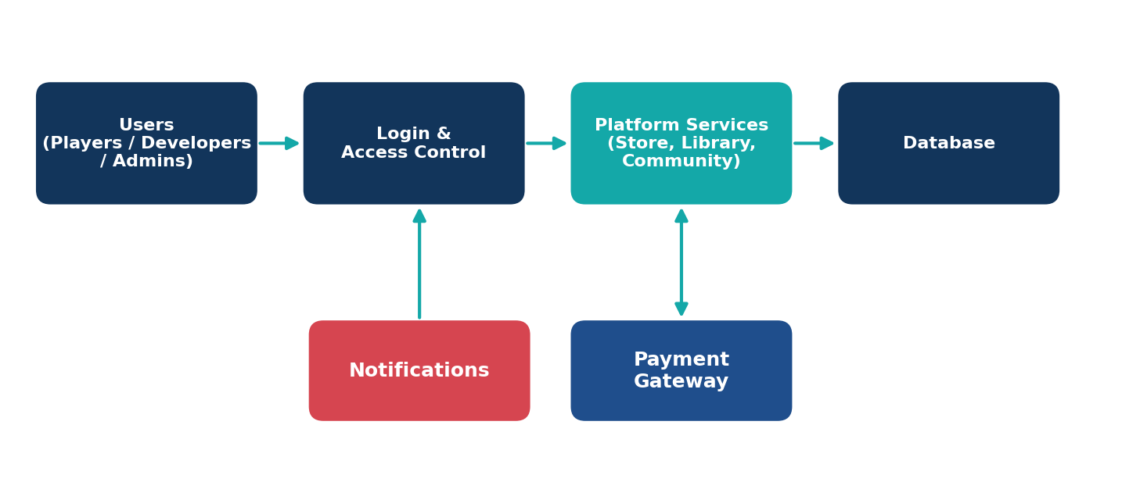
Figure 6.1: Conceptual block diagram of the proposed system

6.1 Key Features
- Registration and login with secure passwords.
- Store with browsing and search of games.
- Shopping cart and secure purchase through a payment gateway.
- Personal game library linked to the account.
- Download, install and automatic update of games.
- Reviews, ratings, friends and chat.
- Developer tools to publish games and release updates.
Table 6.1: Existing versus proposed system
Point | Existing System | Proposed System
Buying | From shops | Online store
Delivery | Discs and boxes | Digital download
Updates | Manual | Automatic
Records | Receipts | Account library
Community | None | Friends and reviews

Chapter 7: System Components
The platform needs several hardware and software components that work together.
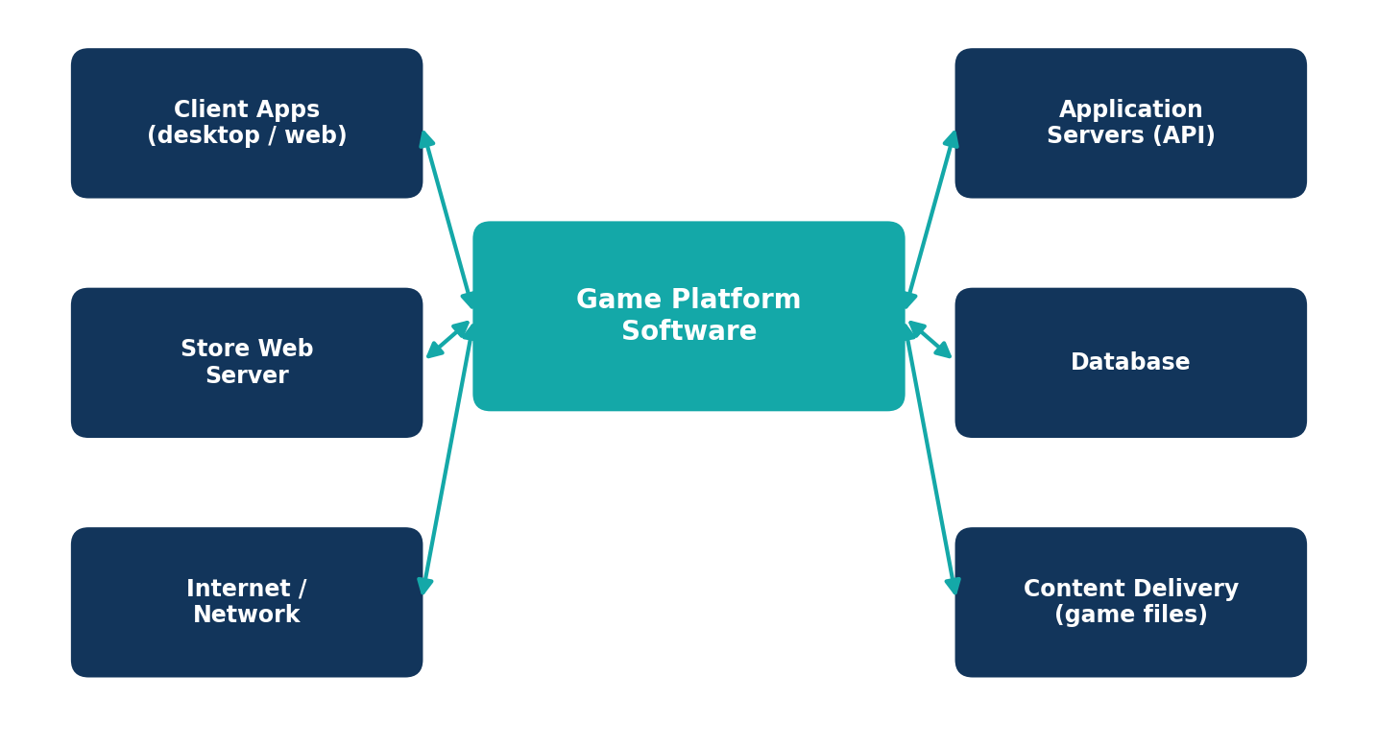
Figure 7.1: Main components of the game platform
Table 7.1: Components and their purpose
Component | Purpose
Client apps | Desktop or web apps that players use for the store and library.
Store web server | Serves the store pages and catalogue to users.
Application servers (API) | Run business rules such as login, cart, orders and library.
Database | Stores users, games, orders, reviews and friends.
Content delivery (game files) | Stores and delivers large game files and updates.
Internet / network | Connects clients, servers and the payment gateway.

Chapter 8: Software Requirements
Requirements describe what the system must do (functional) and how well it must do it (non-functional).
Table 8.1: Functional requirements
ID | Requirement
FR1 | The system shall allow users to register and log in.
FR2 | The system shall allow users to browse and search the game catalogue.
FR3 | The system shall allow users to add games to a cart and buy them through a payment gateway.
FR4 | The system shall keep a library of the games owned by each user.
FR5 | The system shall allow users to download, install and update owned games.
FR6 | The system shall allow users to write reviews and ratings for owned games.
FR7 | The system shall allow users to add friends and chat.
FR8 | The system shall allow developers to publish games and release updates.
FR9 | The system shall allow admins to manage users and handle refund requests.

Table 8.2: Non-functional requirements
Quality | Description
Performance | Store pages and downloads should be fast.
Scalability | The system should handle many users at the same time.
Security | Passwords and payment-related data must be protected.
Availability | The service should be available most of the time.
Usability | Screens should be simple and easy to learn.
Maintainability | The design should be easy to update and fix.

8.3 Constraints
- Payments must go through an external, secure payment gateway.
- A user can access only the games owned by their own account.
- The system depends on the user’s internet connection.

Chapter 9: System Architecture
A three-layer architecture is used: client, application service and data. Each layer talks only to the layer next to it, which keeps the design simple and easier to test.
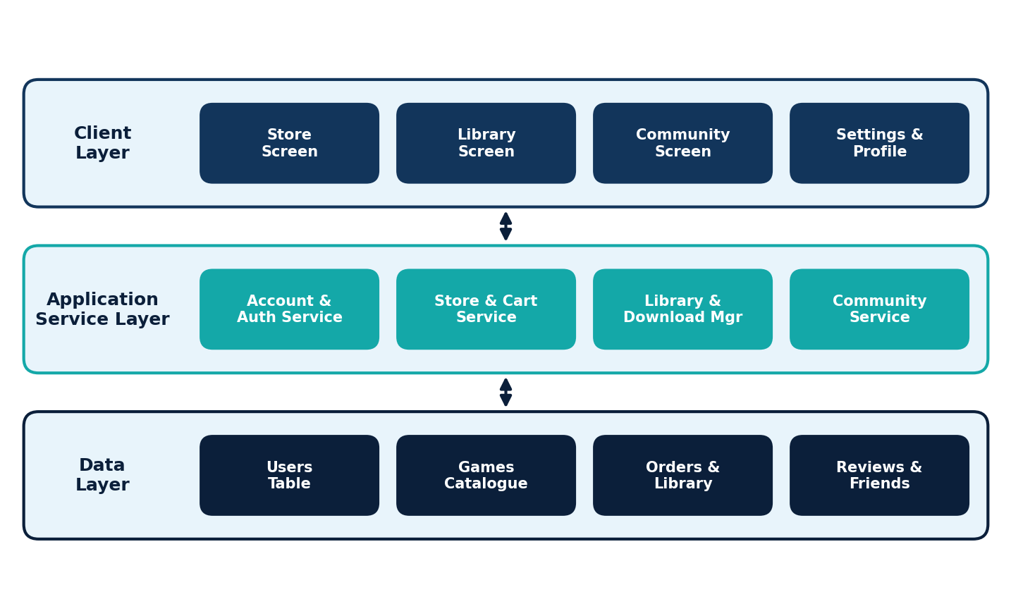
Figure 9.1: Three-layer architecture of the game platform
Table 9.1: Software modules and responsibilities
Module | Responsibility
Account & Auth Service | Register users, check passwords and manage login.
Store & Cart Service | Show the catalogue, manage the cart and create orders.
Library & Download Manager | Keep the user’s library and manage downloads and updates.
Community Service | Handle friends, chat, reviews and ratings.
Developer Portal | Let developers publish games and release updates.
Admin Module | Manage users, refunds and reports.
Database Tables | Store users, games, orders, library, reviews and friends.

Chapter 10: Working of the System
The workflow of the system is explained step by step below.
- The user registers or logs in; the system checks the details.
- The user browses or searches the store and opens a game page.
- The user adds the game to the cart.
- The system checks that the user does not already own the game.
- The payment is sent to the payment gateway, which returns success or failure.
- On success, the order is saved and the game is added to the user’s library.
- The user downloads and installs the game; the platform later offers updates.
- Users can write reviews and chat with friends; developers publish updates.

10.1 Normal and Exceptional Situations
Table 10.1: Examples of system behaviour
Situation | System Response
Wrong password | Access denied; error message shown.
Game already owned | Purchase refused; message shown.
Payment fails | No game added; payment failed message shown.
New version released | User is notified and the game can be updated.

Chapter 11: System Flowchart
The flowchart shows the process of buying a game. The oval is the start or end, rectangles are process steps, diamonds are decisions, and the red boxes are the refusal paths.
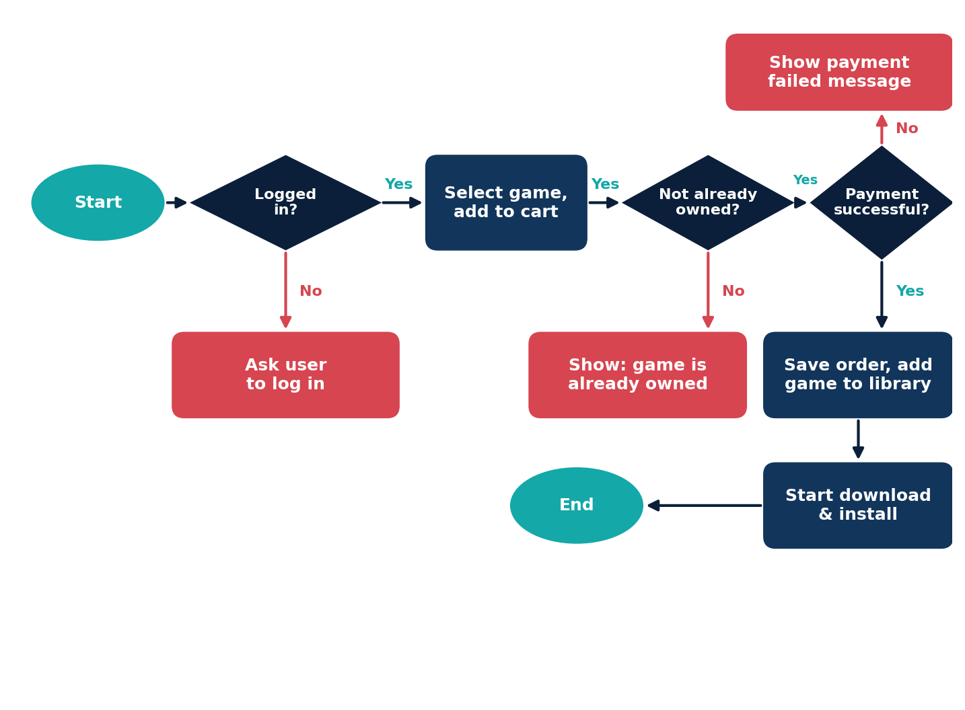
Figure 11.1: Flowchart of buying a game
Explanation: After start, the system checks that the user is logged in. The user selects a game and adds it to the cart. The system checks that the game is not already owned and sends the payment to the gateway. If payment succeeds, the order is saved, the game is added to the library and the download starts. Otherwise a message is shown.

Chapter 12: UML Use Case Diagram
A use case diagram shows the actors (users) and how they interact with the system.
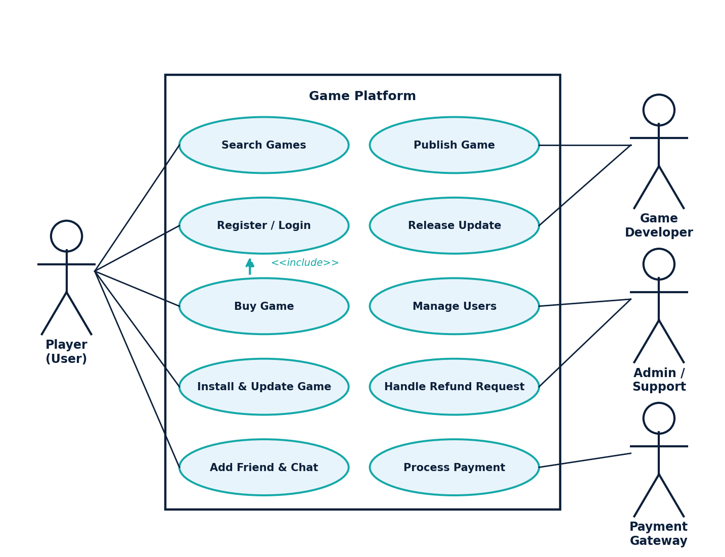
Figure 12.1: UML use case diagram
Table 12.1: Actors and use cases
Actor | Use Cases
Player (User) | Search games, register / login, buy game, install and update game, add friend and chat.
Game Developer | Publish game, release update.
Admin / Support | Manage users, handle refund request.
Payment Gateway | Process payment (external actor).

The dashed line shows that “Buy Game” includes “Register / Login”: a user must log in before buying.
Table 12.2: Use case description: Buy Game
Item | Description
Actor | Player (User)
Precondition | User is logged in and the game is available.
Main flow | 1. User adds the game to the cart. 2. System checks that the game is not owned. 3. System sends the payment to the gateway. 4. Gateway confirms payment. 5. System saves the order and adds the game to the library.
Alternate flow | If the game is already owned or payment fails, the system shows a message and does not add the game.
Postcondition | The game appears in the user’s library and the order is recorded.

Chapter 13: Data Flow Diagram (DFD)
A DFD shows how information moves through a system. Rectangles are external entities, circles are processes, open boxes are data stores, and arrows are data flows.

13.1 Level 0 (Context Diagram)
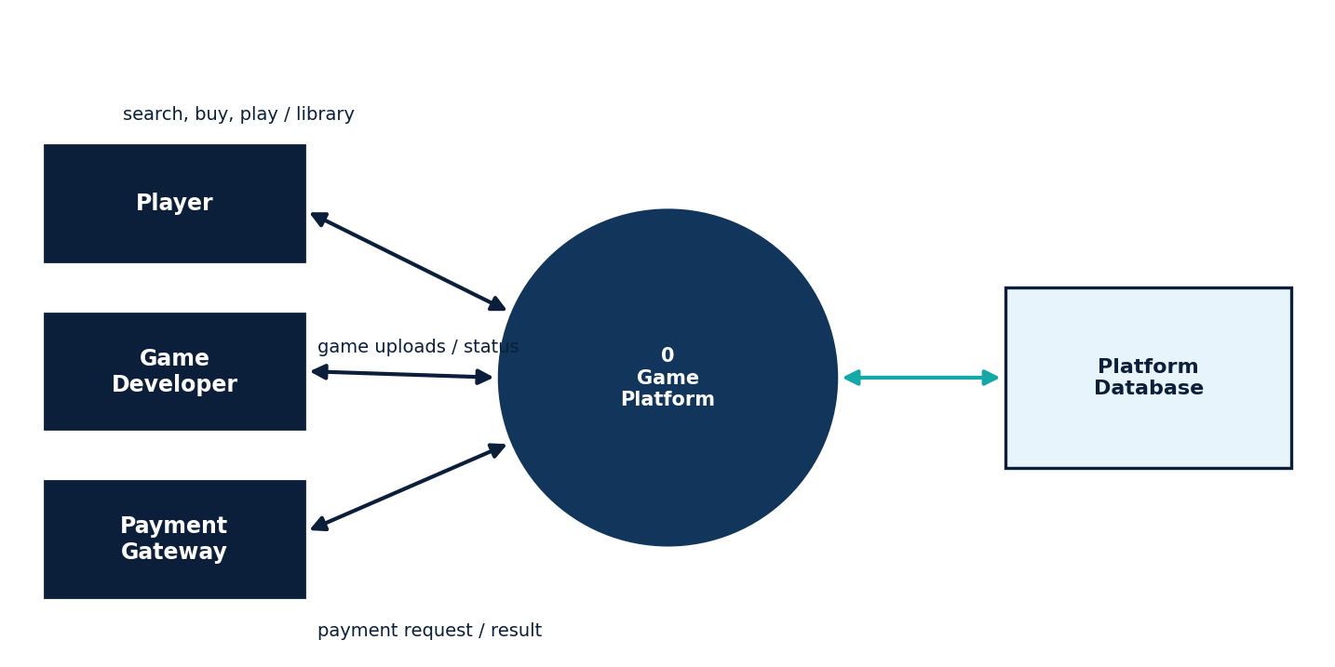
Figure 13.1: Level 0 DFD

13.2 Level 1 DFD
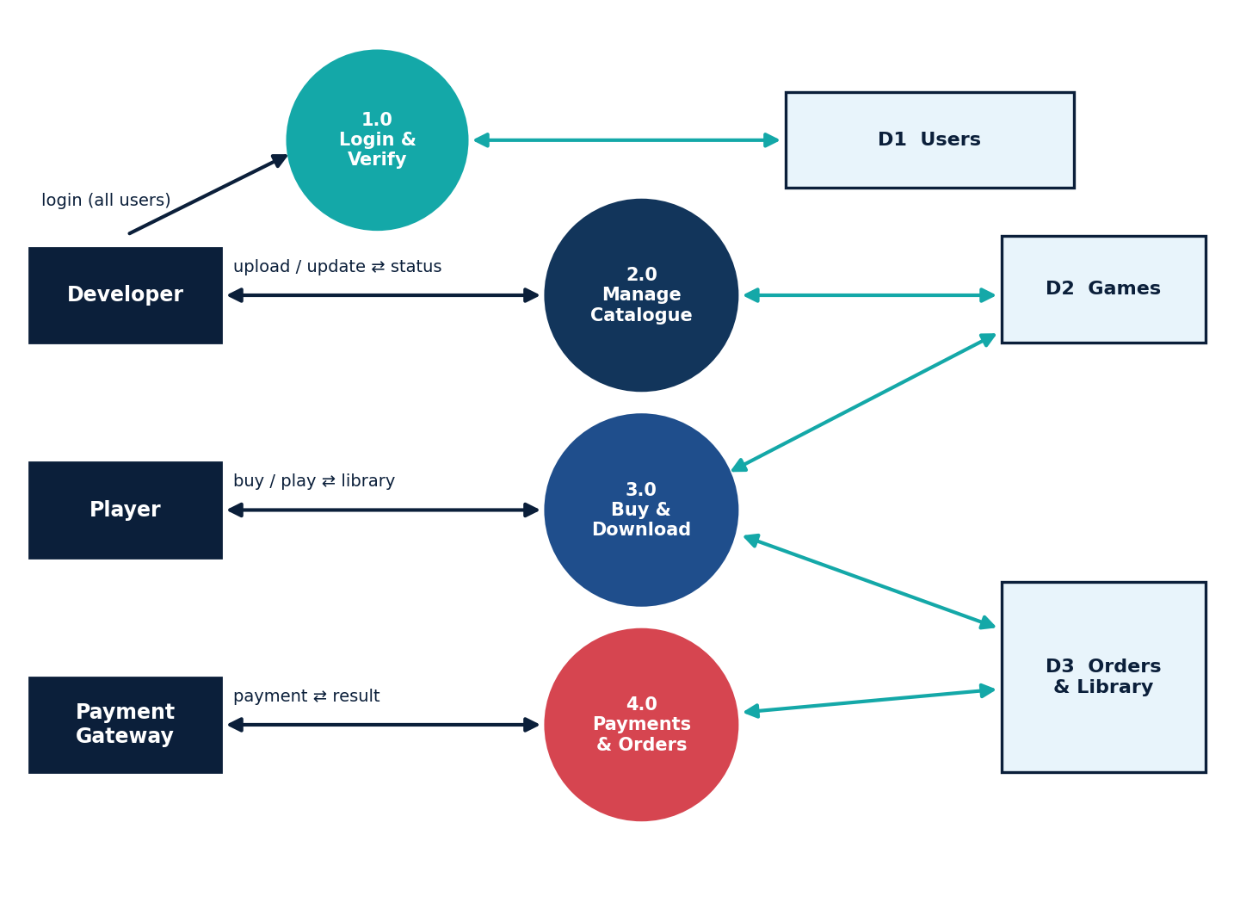
Figure 13.2: Level 1 DFD
Explanation: All users log in through process 1.0, which checks the Users store (D1). Developers send game uploads and updates to process 2.0 (Manage Catalogue), which updates the Games store (D2). Players’ buy and download requests go to process 3.0, which reads D2 and updates the Orders & Library store (D3). Process 4.0 exchanges payment requests and results with the payment gateway and records orders in D3.

Chapter 14: Database Design
The Entity-Relationship (ER) diagram shows the main tables and how they are related. One user makes many purchases, each purchase is for a game, and users write reviews for games.
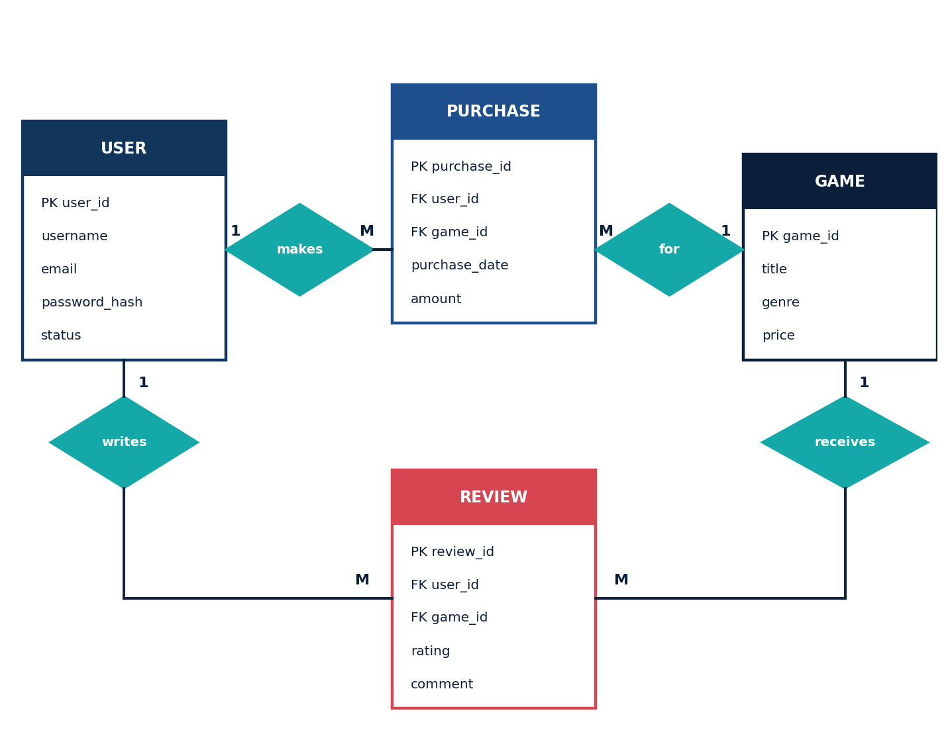
Figure 14.1: Entity-Relationship (ER) diagram
Table 14.1: Table structure
Table | Fields
USER | user_id (PK), username, email, password_hash, status
GAME | game_id (PK), title, genre, price, developer_id (FK)
PURCHASE | purchase_id (PK), user_id (FK), game_id (FK), purchase_date, amount
REVIEW | review_id (PK), user_id (FK), game_id (FK), rating, comment
FRIENDSHIP | user_id (FK), friend_id (FK), status (links two users)

PK means primary key (a unique ID) and FK means foreign key (a link to another table). The library of a user is found from the PURCHASE table. Passwords are stored only as hashes, and full card details are not stored by the platform because the payment gateway handles them.

Chapter 15: UML Design Models
Besides the use case diagram, three more UML diagrams explain the design: the class diagram (structure), the sequence diagram (order of messages) and the state diagram (behaviour over time).

15.1 Class Diagram
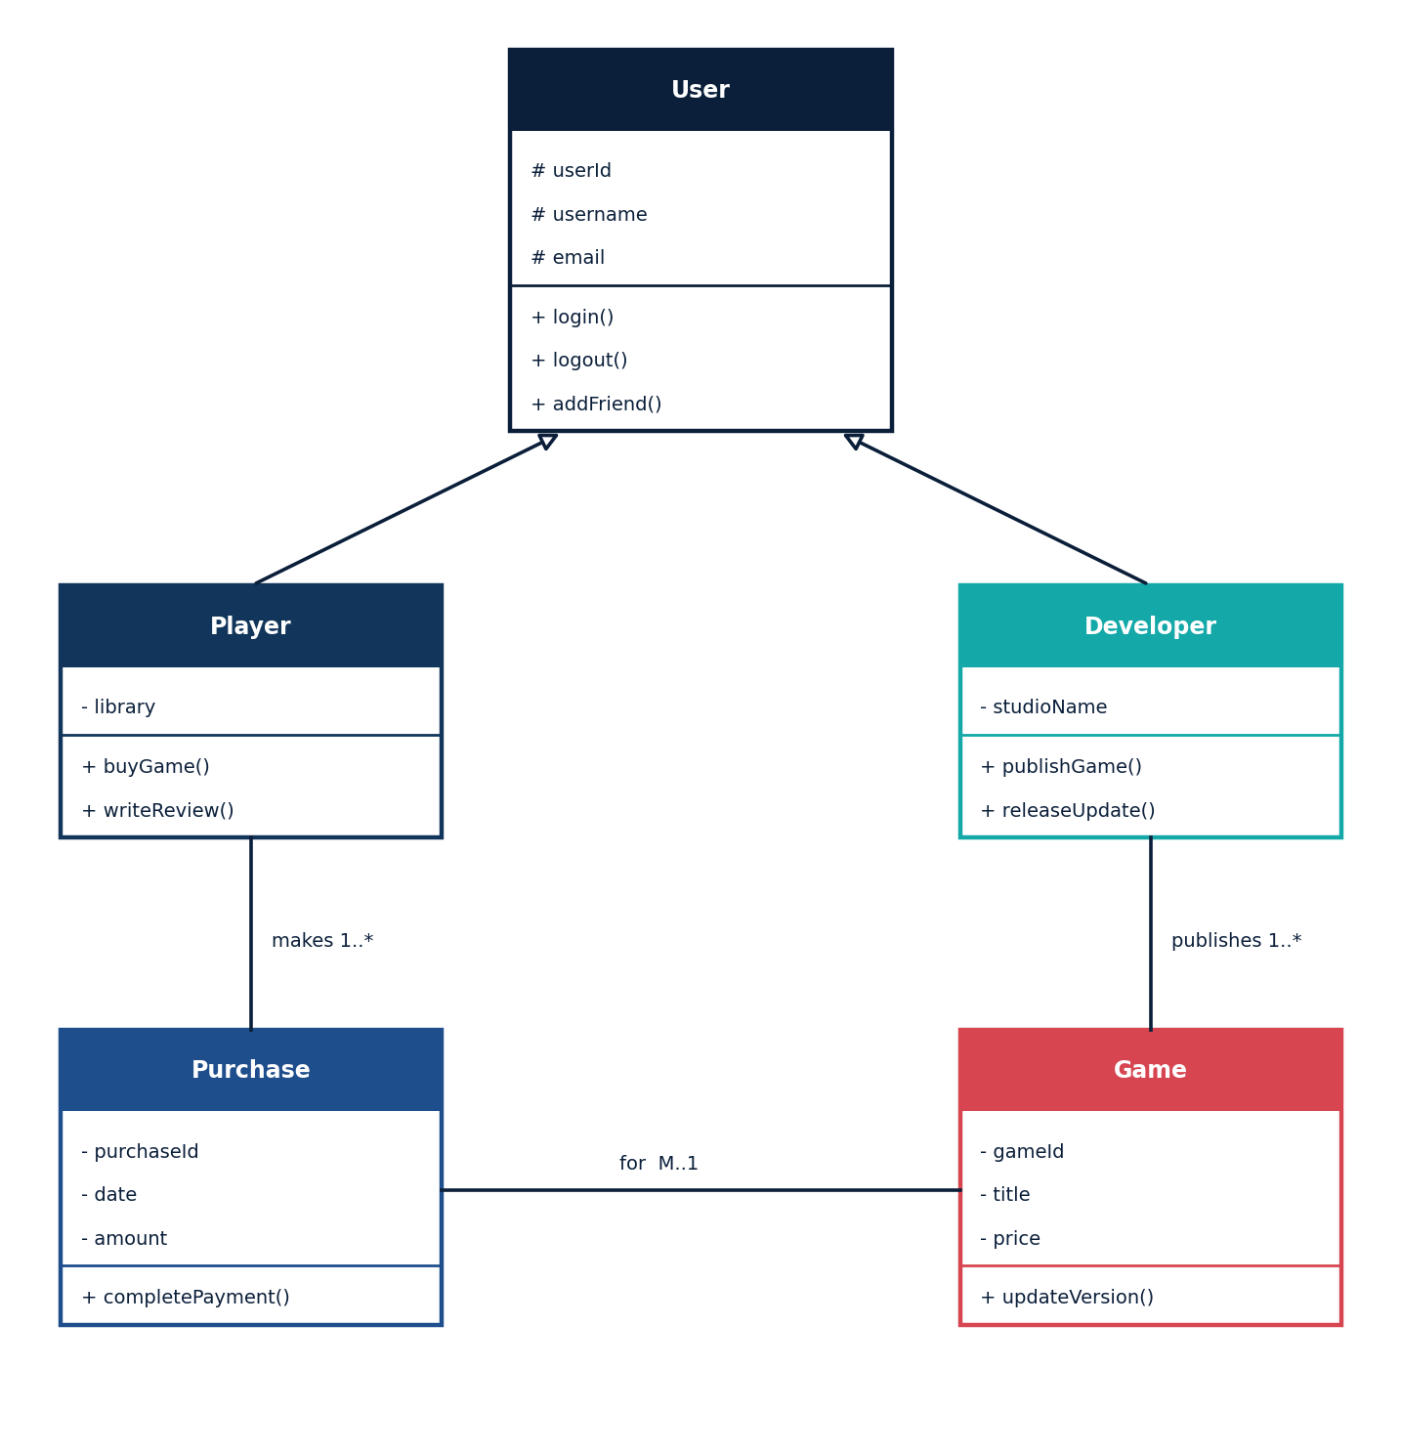
Figure 15.1: UML class diagram of the main classes

15.2 Sequence Diagram
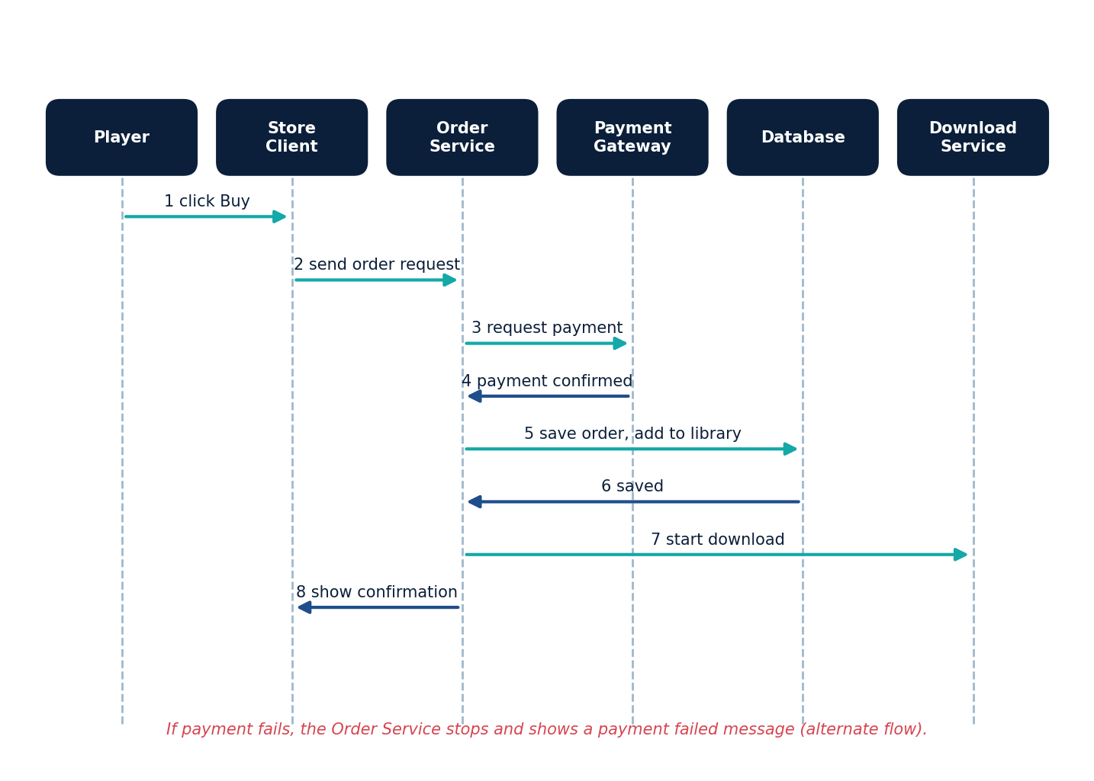
Figure 15.2: UML sequence diagram for buying a game

15.3 State Diagram
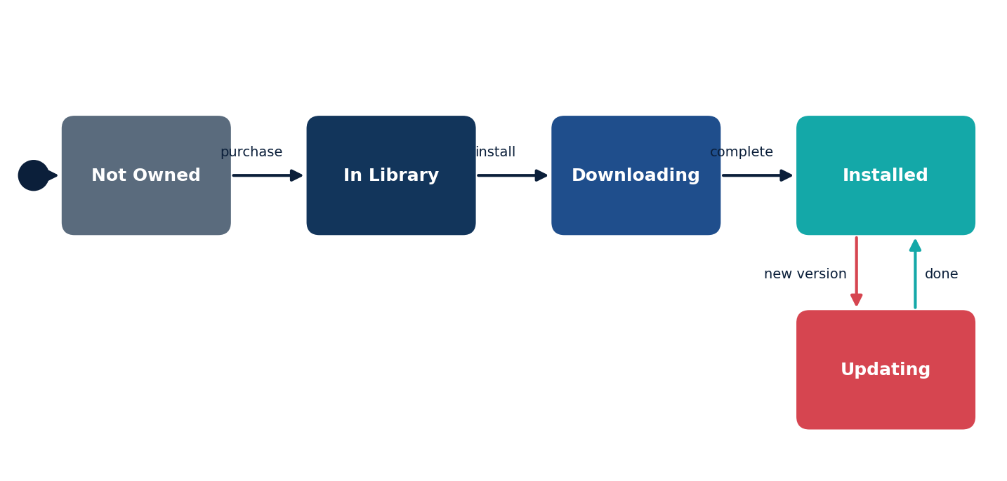
Figure 15.3: UML state diagram of a game for a player
Explanation: A game starts as Not Owned. After purchase it is In Library. When the user chooses install it becomes Downloading and then Installed. When a new version is released it moves to Updating and returns to Installed when the update is done.

Chapter 16: Software Development Life Cycle (SDLC)
SDLC is the step-by-step process of building software.
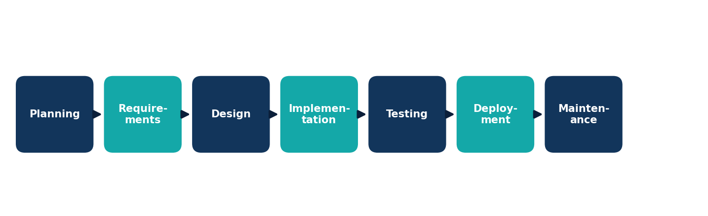
Figure 16.1: SDLC phases
Table 16.1: SDLC phases and activities
Phase | Activity for this case study
Planning | Define goals, scope, users and feasibility.
Requirements | Collect needs of players, developers and admins.
Design | Prepare architecture, database, flowchart, UML and DFD.
Implementation | Code the services, database and client screens.
Testing | Unit, integration, system and acceptance testing.
Deployment | Release the platform to servers and client apps.
Maintenance | Fix bugs, improve performance and add features.

For a platform like this, an iterative approach works well: a first version (login, store, purchase, library) is released and tested, and feedback is used to add downloads, updates and community features in later versions.

Chapter 17: Implementation Overview
This chapter gives a simple idea of how the design can be coded. It is a teaching sketch only.

17.1 Suggested Technology
- Client: a desktop application or HTML, CSS and JavaScript web client.
- Server: Node.js, Python or Java providing an API.
- Database: MySQL or PostgreSQL.
- File delivery: file servers or a content delivery service for game files.
- Payments: an external payment gateway service.
- Each module in the architecture becomes a separate service or class.

17.2 Buy Game Process (Pseudocode)
FUNCTION buy_game(user_id, game_id):
IF NOT is_logged_in(user_id):
RETURN "Please log in"

game = FIND_GAME(game_id)
IF game IS NULL:
RETURN "Game not found"

IF OWNS_GAME(user_id, game_id):
RETURN "Game already owned"

result = PAYMENT_GATEWAY.charge(user_id, game.price)
IF result != "success":
RETURN "Payment failed"

SAVE_PURCHASE(user_id, game_id, TODAY, game.price)
ADD_TO_LIBRARY(user_id, game_id)
START_DOWNLOAD(user_id, game_id)
RETURN "Purchase complete"

17.3 Update Check (Pseudocode)
FUNCTION check_update(user_id, game_id):
installed = GET_INSTALLED_VERSION(user_id, game_id)
latest = GET_LATEST_VERSION(game_id)
IF installed < latest:
NOTIFY(user_id, "Update available")
RETURN TRUE
RETURN FALSE
Note: price values and version numbers come from the platform’s data; they are not fixed by this project.

17.4 Coding Practices
- Keep functions small and test each one alone.
- Validate every input before using it.
- Never trust data sent from the client; check ownership and permissions on the server.
- Use database transactions so that payment, order and library update happen together.
- Use meaningful names and comments for easy maintenance.

Chapter 18: Security and Risk Management
A game platform stores accounts, game libraries and payment-related records, so security is very important. Risk management means identifying, assessing, reducing and monitoring risks.
Table 18.1: Security measures
Area | Measures
Authentication | Login with password; optional two-factor authentication for extra safety.
Password protection | Store passwords only as strong hashes, never as plain text.
Secure payments | Use an external payment gateway; do not store full card details.
Authorisation | Users can access only their own library and account data.
Secure connection | Use encrypted connections (HTTPS / TLS) for all data in transit.
Input validation | Clean all inputs to block injection and script attacks.
Fraud monitoring | Watch for unusual purchases or login attempts.
Audit log | Record important admin actions and refunds.

Table 18.2: Sample risk table
Risk | Possible Effect | Control
Account theft | Loss of library and data | Strong passwords and two-factor authentication
Payment fraud | Financial loss | Payment gateway and fraud monitoring
Data leak | Private data exposed | Access control and encryption
Corrupted download | Game does not run | File checks (hash) after download
Server overload | Store or downloads slow | Scalable design and monitoring
Software defect | Wrong order or library | Reviews and thorough testing

Chapter 19: Software Testing
Testing checks that the software does what it should. The test cases below are samples only.
Table 19.1: Sample test cases
ID | Test Case | Input / Condition | Expected Result
TC01 | Register user | Valid new details | Account created
TC02 | Invalid login | Wrong password | Access denied; error message
TC03 | Search game | Existing title entered | Matching games listed
TC04 | Add to cart | Select an available game | Game appears in the cart
TC05 | Successful payment | Gateway returns success | Order saved; game in library
TC06 | Failed payment | Gateway returns failure | No game added; error shown
TC07 | Buy owned game | Game already in library | Purchase refused with message
TC08 | Download and install | Owned game selected | Game downloads and installs
TC09 | Update available | New version released | User notified; update possible
TC10 | Write review | Owned game, rating entered | Review saved
TC11 | Friend request | Valid user ID entered | Request sent to that user
TC12 | Publish game | Developer uploads valid game | Game appears in the catalogue
TC13 | Refund request | User submits a request | Request recorded for admin

19.1 Levels of Testing
- Unit testing: each module is tested alone.
- Integration testing: modules are tested together.
- System testing: the complete platform is tested.
- Acceptance testing: users check that their needs are met.

19.2 Testing Methods
- Black-box testing: test inputs and outputs without looking at the code.
- White-box testing: test internal paths and decisions in the code.
- Boundary value testing: test at limits such as empty cart or very long review.
- Load testing: check behaviour when many users are active.

Chapter 20: Ethical and Professional Considerations
Software engineers who build online stores and platforms have a responsibility to protect users. The ACM/IEEE Software Engineering Code of Ethics asks engineers to act in the public interest.
- Privacy: protect personal data and purchase history; collect only what is needed.
- Transparency: show prices, terms and refund rules clearly.
- Fairness: treat players and developers equally under the same rules.
- Safety: provide tools to report abuse and support parental controls for younger users.
- Honesty: report known faults and limitations clearly.
- Healthy use: avoid design that encourages excessive playing or spending.
This project follows these ideas by using no real user data and by including security, refund handling and audit features in the design.

Chapter 21: Advantages
A Steam-style game distribution platform offers the following advantages:
- Players can buy games without visiting a shop.
- All owned games are in one library linked to an account.
- Digital downloads cannot be scratched, lost or damaged.
- Updates and patches can be delivered automatically.
- Developers can reach many players and release updates quickly.
- Store search and reviews help players choose games.
- Friends and chat make gaming more social.
- Secure payment through a gateway protects financial data.
- Purchase records make refunds and support easier.
- Notifications keep players informed about updates.
- Modular design makes testing and updates easier.
- Models such as UML, DFD and ER diagrams make the system easy to understand.
- The case study helps students learn the real steps of the SDLC.

Chapter 22: Limitations
This case study and the proposed design also have some limitations:
- The platform needs a stable internet connection for buying and downloading.
- The complete software is not built in this case study.
- Large games need much disk space and download time.
- Players depend on the platform to keep access to their library.
- Server failure or overload can make the store or downloads slow.
- Account theft is a risk if passwords are weak.
- Payment and personal data must be protected very carefully.
- Developing and running such a platform is costly and complex.
- Reviews and ratings can be unfair or misleading.
- Only a conceptual design and sample test cases are presented.
- Testing cannot prove that every possible fault has been found.
- Software updates must be controlled carefully, because new changes can introduce errors.
- Features such as anti-cheat and game streaming are not covered.
- The design does not describe the real internal systems of any company.

Chapter 23: Future Scope
- A mobile app for browsing the store and managing downloads.
- Better game recommendations based on play history, with user privacy respected.
- Cloud saves so that game progress follows the player.
- Stronger fraud detection and account protection.
- Support for game streaming from servers.
- Better tools for developers, such as sales and feedback dashboards.
- Parental controls and play-time reminders.
- A working prototype built in a classroom for the store and library.

Chapter 24: Conclusion
This case study showed how Software Engineering concepts apply to a Steam-style game distribution platform. Requirements, a layered architecture, a flowchart, UML, DFD and ER models, the SDLC, security measures and test cases together help to build dependable software. Secure payments, reliable downloads and account protection are the key design points.
The study also showed why careful testing, security and ethics matter when software handles money and personal data. This is an independent educational project; the design is conceptual and uses no real user data.
The work has improved my understanding of the Software Engineering subject and how its models are used in real problems.

References
- I. Sommerville, Software Engineering, Pearson Education.
- R. S. Pressman and B. R. Maxim, Software Engineering: A Practitioner’s Approach, McGraw-Hill.
- P. Jalote, An Integrated Approach to Software Engineering, Springer.
- R. Elmasri and S. B. Navathe, Fundamentals of Database Systems, Pearson.
- A. S. Tanenbaum and D. J. Wetherall, Computer Networks, Pearson.
- Object Management Group (OMG), Unified Modeling Language (UML) Specification, omg.org.
- PCI Security Standards Council, Payment Card Industry Data Security Standard (PCI DSS), pcisecuritystandards.org.
- ACM/IEEE-CS, Software Engineering Code of Ethics and Professional Practice, acm.org.
- OWASP Foundation, OWASP Top 10 Web Application Security Risks, owasp.org.
- Steamworks Documentation, partner.steamgames.com (for general understanding of platform concepts).

Appendix A: Requirements Traceability Matrix
Traceability links each requirement to a module and a test case, so nothing is left untested.
Table A.1: Requirement traceability
Requirement | Module(s) | Test Case(s)
FR1 Register / login | Account & Auth Service | TC01, TC02
FR2 Browse / search | Store & Cart Service | TC03
FR3 Cart and purchase | Store & Cart Service | TC04, TC05, TC06, TC07
FR4 Game library | Library & Download Manager | TC05
FR5 Download / update | Library & Download Manager | TC08, TC09
FR6 Reviews | Community Service | TC10
FR7 Friends and chat | Community Service | TC11
FR8 Developer publishing | Developer Portal | TC12
FR9 Users and refunds | Admin Module | TC13

