Git checkout – is to switch branches and making the switched branch active

The command is git checkout or git switch.

Before the Command After the Command

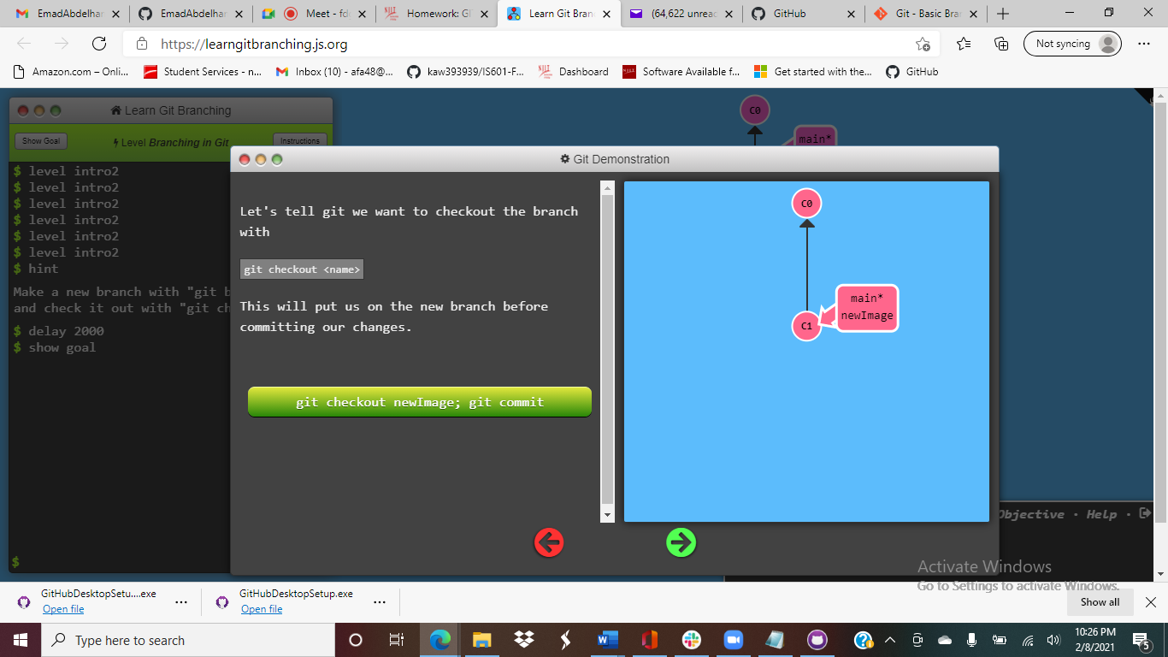 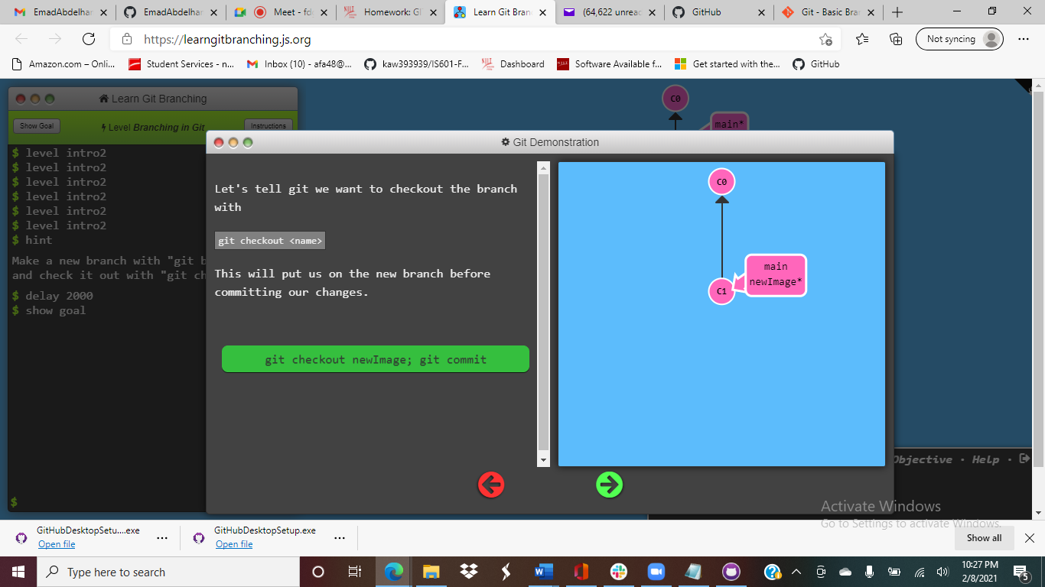

The image is switched to the one with the asterisk.