Commit – a change to a file or set of files; It is like a snapshot of your project

The command to use is – git commit

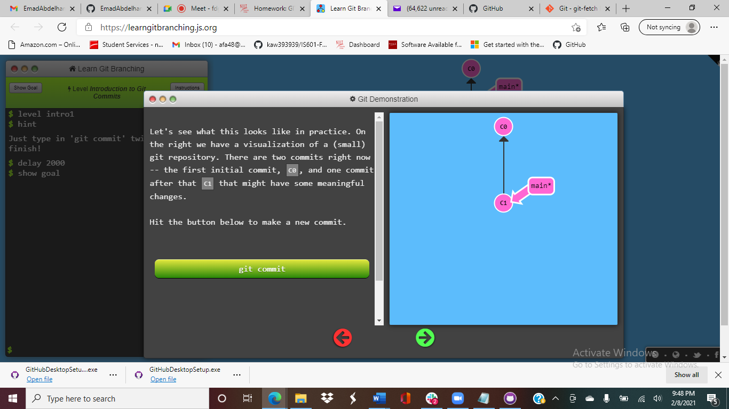 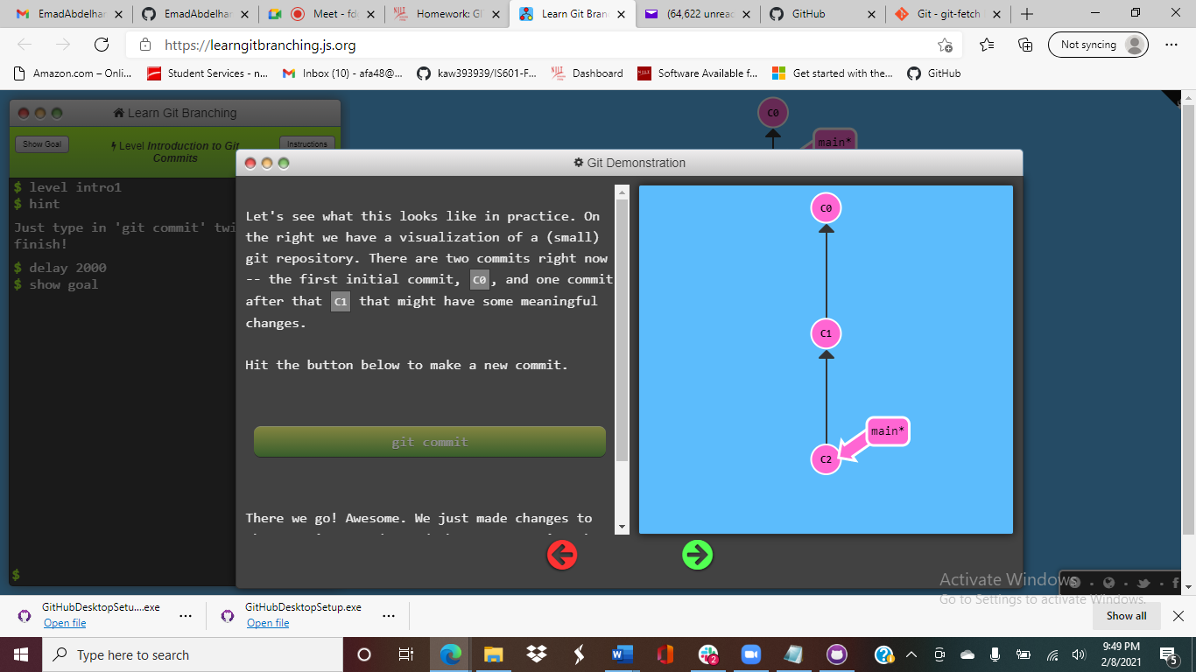

Before the Commit After the Commit