**Git Merge** – is bringing forked history back together again

The command is git merge

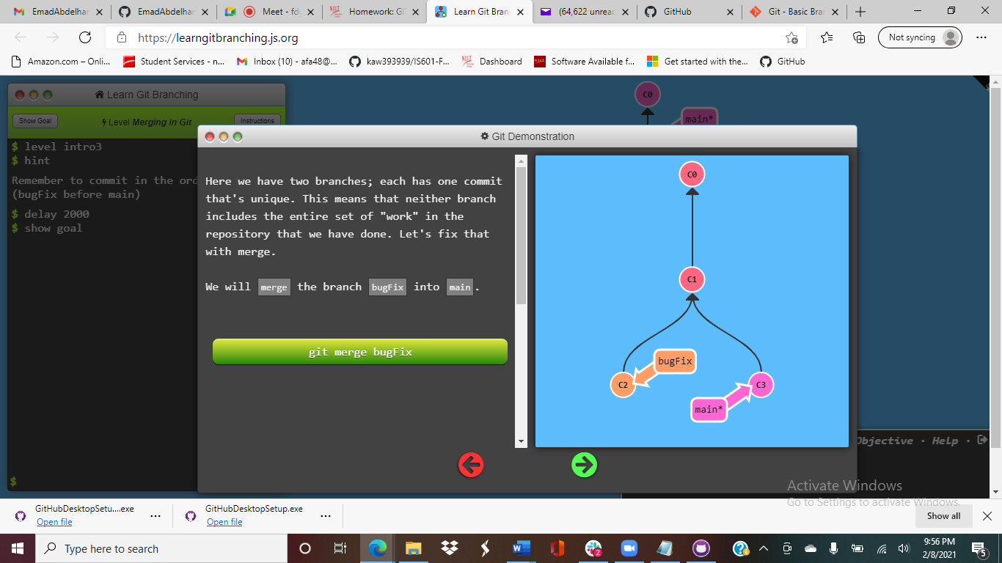 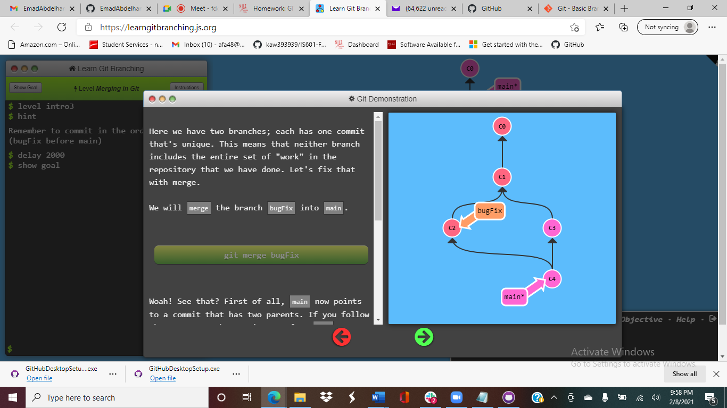

Before the Merge After the Merge