Git Pull: is used to fetch and download content from a remote repository and immediately updates the local repository to match that content. Once the content is downloaded, it is merged. A new merge commit is formed and HEAD branch is updated pointing to the new commit.

So, git pull is a fetch and rebase.

Before git pull

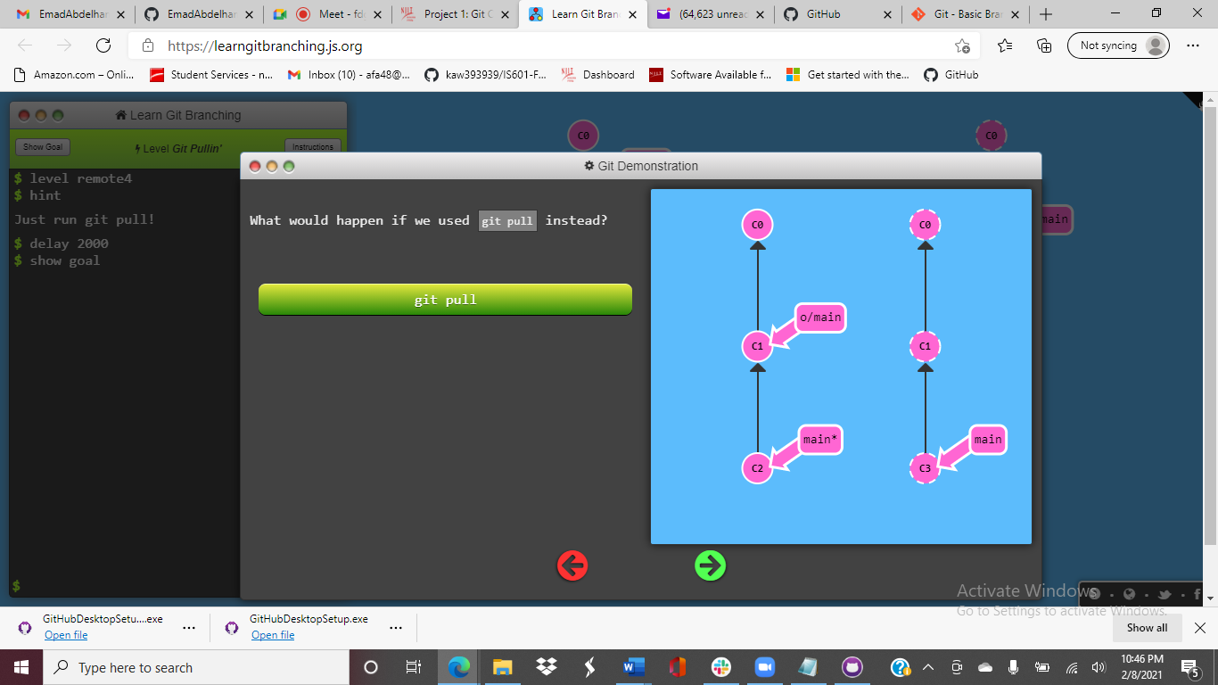

After git pull

